    Joint Video Experts Team (JVET)  of ITU-T SG21 WP3/21 and ISO/IEC JTC 1/SC 29  42nd Meeting, Santa Eulària, ES, 24 April – 1 May 2026 | Document: JVET-AP0052-v2

Title: | AHG11: Improved H-DRF with Weighted Fusion and Optimized YUV Processing
Status: | Input document to JVET
Purpose: | Proposal
Author(s) or  Contact(s): | Xinxin Chen, Junxi Zhang, Zhenzhong Chen  Wuhan University | Email: | {xinxinchen, sissie_zhang, zzchen}  @whu.edu.cn
Source: | Wuhan University
_____________________________

Abstract
This contribution builds on H-DRF (DRF at high operational point) from NNVC-16.0 by introducing a HardSigmoid-based weighted fusion layer, performing optical-flow computation directly in the YUV domain, optimizing quantization for model conversion, and replacing bilinear down/up sampling with Lanczos for YUV420/YUV444 conversion.

The coding gains of the proposed method are reported as follows:
- Int16, SADL implementation, RA, compared to NNVC-15.0 anchor (NNIntra+LOP6):
  - Overall: -2.76% (Y), -2.98% (U), -3.09% (V) EncT: 142% DecT: 2420%
- Int16, SADL implementation, RA, compared to NNVC-15.0 (H-DRF from NNVC-16.0 + NNIntra + LOP6):
  - Overall: -0.28% (Y), -1.79% (U), -3.33% (V) EncT: 100% DecT: 101%

Introduction
H-DRF from JVET-AO0108 [1] has been integrated into NNVC-16.0. In this contribution, H-DRF is enhanced through weighted fusion and optimized YUV-domain processing to achieve better coding performance in NNVC. The main modifications are summarized as follows:
- Frame fusion is changed from simple averaging to HardSigmoid-based weighted fusion.
- YUV-to-RGB conversion is removed from optical-flow computation by keeping H-DRF inference in the YUV domain.
- The quantization method for the GridSample layer is optimized.
- The down/up sampling method for YUV420/YUV444 is changed from bilinear to Lanczos, aligning with the L-DRF inference procedure in NNVC-16.0.

Proposed Method

Network
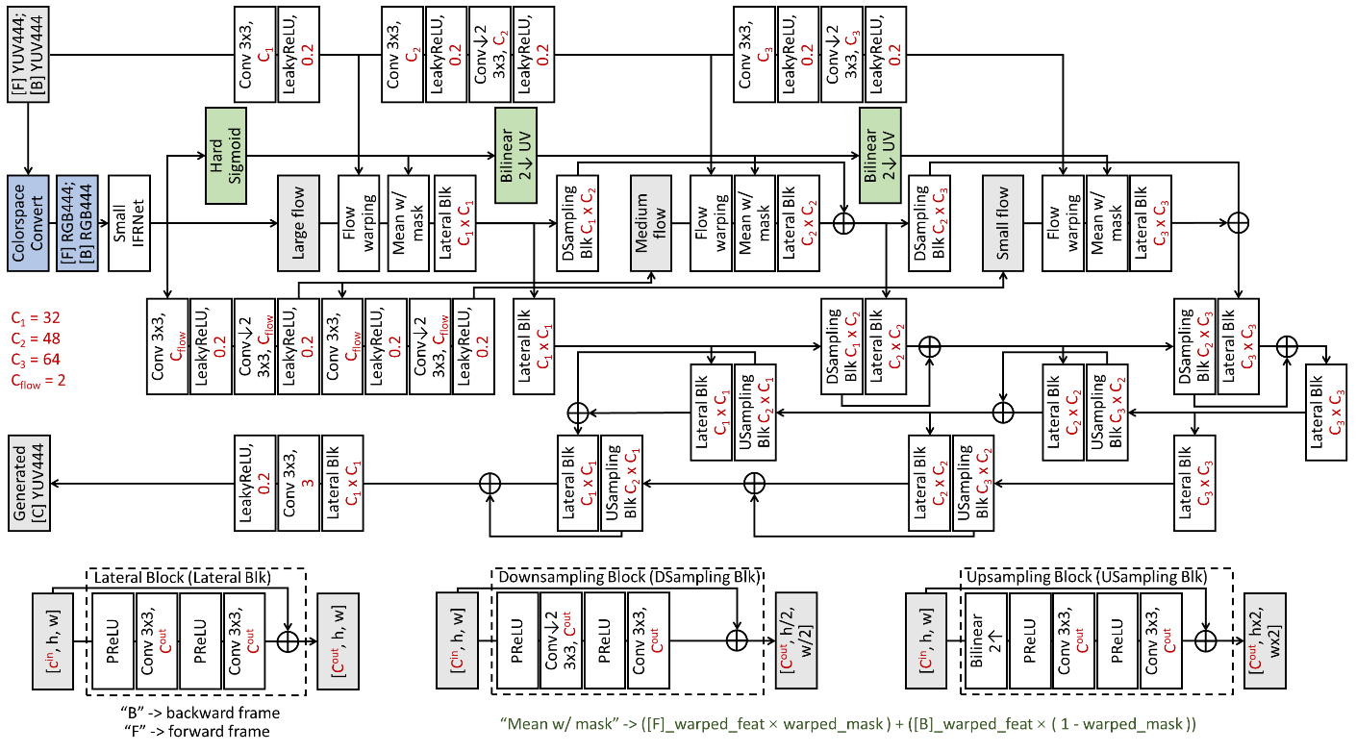
Fig. 1: The architecture changes of the H-DRF network.

Fig. 1 illustrates the architecture changes of the H-DRF network. The green blocks highlight the fusion update: instead of simple averaging, a single-channel tensor is derived from the small IFRNet output and passed through `HardSigmoid` to generate `warped_mask` in [0,1], and `warped_mask` is then used for weighted frame fusion. The blue blocks correspond to the YUV-to-RGB conversion step before optical-flow computation; this step is removed to keep the workflow in the YUV domain and to reduce conversion error during f32-to-i16 deployment.

Quantization
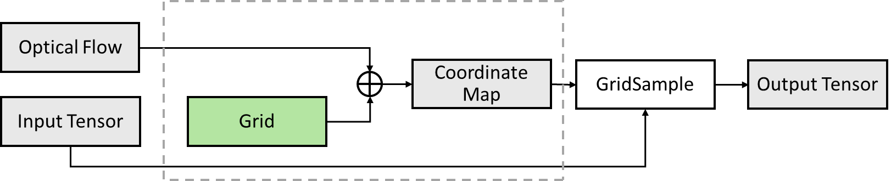

Fig. 2: Processing flow of the GridSample layer.
Fig. 2 shows the processing flow of the `GridSample` layer. `GridSample` uses the input tensor and optical flow to generate a flow-warped output tensor. During grid generation (green block), terms such as 2/(W-1) and 2/(H-1) are involved, which can introduce additional error during float32 to int16 conversion. Therefore, quantization precision of grid generation (green block) is increased when W/H become larger to improve coding performance.

Inference
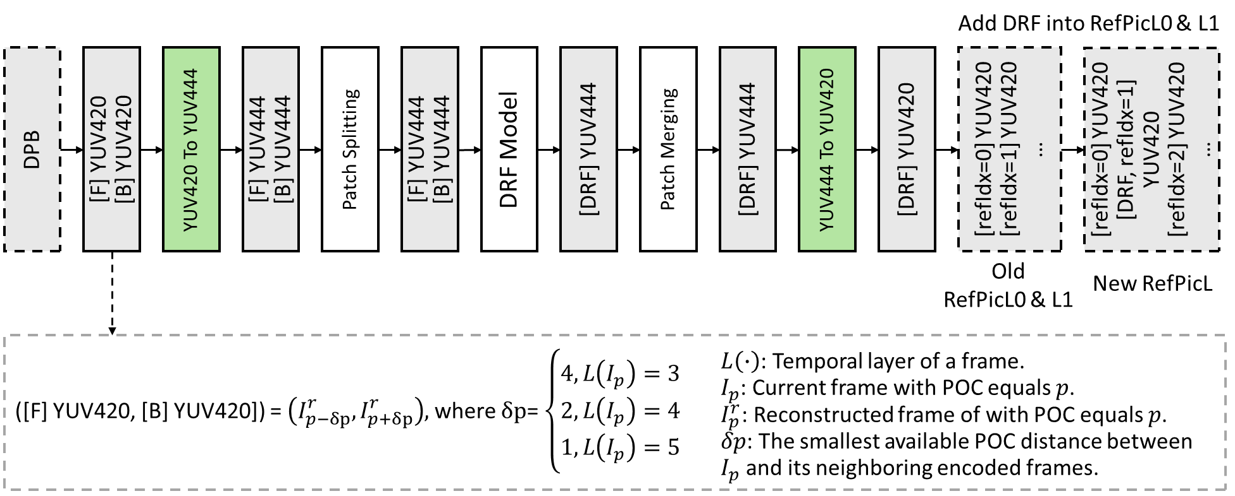
Fig. 3: Inference pipeline diagram of the DRF.
Fig. 3 shows the DRF inference pipeline. The green blocks highlight the YUV420/YUV444 conversion stage, where bilinear interpolation is replaced by Lanczos to align with the L-DRF inference pipeline in NNVC-16.0.

Training
The training information is shown in Table 1.
Table 1: Network information for improved H-DRF model in training
Network Information in Training Stage
Mandatory | GPU Type | GeForce RTX 3090
Mandatory | Framework | PyTorch 1.13.1
Mandatory | Number of GPUs per Task | 2
Mandatory | Epoch | 200
Mandatory | Batch size | 48 x 3 frames (as a triplet)
Mandatory | Loss function | CharbonnierLoss [2] + TernaryLoss [3]
Mandatory | Training time (for 1 model) | 60h
Mandatory | Training data information | Vimeo-90K triplet
Mandatory | Training configurations for generating compressed training data (if different to VTM CTC) | NNVC-14.0, QP{22, 27, 32, 37, 42}
Optional | Number of iterations
Optional | Patch size | 256x256
Optional | Learning rate | 3.5e-4
Optional | Learning rate update strategy
Optional | Optimizer | ADAM
Optional | Preprocessing
Optional | Mini-batch selection process
Optional | Training data update strategy
Optional | Other information

Inference
The inference information is shown in Table 2.
Table 2: Network information for the improved H-DRF model in the inference stage
Network Information in Inference Stage
Mandatory | HW environment
Mandatory | GPU Type | CPU only
Mandatory | Framework | SADL
Mandatory | Number of GPUs per Task | 0
Mandatory | Number of Parameters (Each Model) | 6100K
Mandatory | Total Number of Parameters (All Models) | 6100K
Mandatory | Parameter Precision (Bits) | 16 (I)
Mandatory | Multiply Accumulate (kMAC/pixel) | 477
Optional | Total Conv. Layers
Optional | Total FC Layers
Optional | Total Memory (MB)
Optional | Batch size | 1
Optional | Patch size | 256x256 (with 16 boundary padding)
Optional | Changes to network configuration or weights required to generate rate points
Optional | Peak Memory Usage (Total)
Optional | Peak Memory Usage (per Model)
Optional | Border handling
Optional | Other information

Results
The proposed method is implemented on NNVC-15.0 and evaluated under the NNVC common test conditions [4]. RA results are reported in Table 3 (vs. NNVC-15.0 NNIntra + LOP6) and Table 4 (vs. NNVC-15.0 NNIntra + LOP6 + H-DRF from NNVC-16.0).
Table 3: Performance of Improved H-DRF (Comparing to NNVC-15.0 NNIntra + LOP6)
 | Random access Main10
 | BD-rate Over NNVC-15.0 NNIntra + LOP6
 | Y-PSNR | U-PSNR | V-PSNR | Y-MSIM | U-MSIM | V-MSIM | EncT | DecT CPU
Class A1 | -1.54% | -1.13% | -1.28% | -1.76% | -1.39% | -1.56% | 141% | 2251%
Class A2 | -3.07% | -3.90% | -3.60% | -3.42% | -4.44% | -3.95% | 129% | 2027%
Class B | -2.35% | -2.57% | -2.51% | -2.64% | -3.31% | -2.91% | 157% | 2775%
Class C | -3.96% | -4.19% | -4.79% | -4.83% | -5.56% | -5.94% | 136% | 2458%
Class E
Overall | -2.76% | -2.98% | -3.09% | -3.20% | -3.75% | -3.66% | 142% | 2420%
Class D | -5.08% | -3.25% | -5.15% | -5.03% | -5.53% | -6.87% | 133% | 2203%
Class F | -1.21% | -1.44% | -1.06% | -1.79% | -2.08% | -2.05% | 192% | 6524%
Class H | #VALUE! | #VALUE! | #VALUE! | #VALUE! | #VALUE! | #VALUE! | #DIV/0! | #DIV/0!

Table 4: Performance of Improved H-DRF (Comparing to NNVC-15.0 NNIntra + LOP6 + H-DRF (from NNVC-16.0))
 | Random access Main10
 | BD-rate Over NNVC-15.0 NNIntra + LOP6 + H-DRF (from NNVC-16.0)
 | Y-PSNR | U-PSNR | V-PSNR | Y-MSIM | U-MSIM | V-MSIM | EncT | DecT CPU
Class A1 | 0.04% | -0.19% | -1.91% | 0.02% | -0.01% | -0.40% | 98% | 99%
Class A2 | -0.28% | -2.73% | -3.39% | -0.32% | -2.27% | -2.00% | 98% | 98%
Class B | -0.19% | -1.66% | -3.55% | -0.16% | -1.54% | -1.88% | 100% | 100%
Class C | -0.61% | -2.43% | -4.07% | -0.55% | -2.15% | -3.07% | 101% | 104%
Class E
Overall | -0.28% | -1.79% | -3.33% | -0.26% | -1.54% | -1.93% | 100% | 101%
Class D | -1.37% | -3.50% | -6.29% | -1.06% | -3.44% | -4.98% | 97% | 98%
Class F | -0.19% | -1.04% | -1.17% | -0.26% | -1.03% | -1.30% | 100% | 101%
Class H | #VALUE! | #VALUE! | #VALUE! | #VALUE! | #VALUE! | #VALUE! | #DIV/0! | #DIV/0!

As shown in Table 4, implemented on the NNVC-15.0, compared with the H-DRF model from NNVC-16.0, the improved H-DRF achieves coding gains of 0.28%/1.79%/3.33% in the Y/U/V components, demonstrating the effectiveness of the proposed modifications.

Conclusions
This contribution improves H-DRF (DRF at high operational point) by introducing HardSigmoid-based frame fusion, moving optical-flow computation from RGB to YUV, optimizing quantization for model conversion, and replacing bilinear down/up sampling with Lanczos for YUV420/YUV444 conversion. Under the RA configuration, compared with NNVC-15.0 NNIntra + LOP6 + H-DRF (from NNVC-16.0), overall BD-rate gains of {-0.28%, -1.79%, -3.33%} are achieved for the {Y, U, V} components.

It is recommended to further investigate the proposed method in the next EE.

Reference
- X. Chen, W. Zhang, N. Fu, J. Zhang, Z. Chen, "EE1-4.1: Deep Reference Frame Generation for Inter Prediction Enhancement with Structural Re-parameterization", JVET-AO0108, 41st Meeting, by teleconference, 14-23 January 2026.
- P. Charbonnier, L. Blanc-Feraud, G. Aubert, M. Barlaud, “Two deterministic half-quadratic regularization algorithms for computed imaging”, in Proceedings of the IEEE International Conference on Image Processing, vol. 2, pp. 168-172, 1994.
- S. Meister, J. Hur, S. Roth, “Unflow: Unsupervised learning of optical flow with a bidirectional census loss”, in Proceedings of the AAAI Conference on Artificial Intelligence, vol. 32, no. 1, 2018.
- E. Alshina, F. Galpin, R.-L. Liao, S. Liu, A. Segall. “Common test conditions and evaluation procedures for neural network-based video coding technology”. JVET-AJ2016, 36th Meeting, Kemer, TR, 1–8 November 2024.

Patent rights declaration(s)
Wuhan University does not have any current or pending patent rights relating to the technology described in this contribution.

