    Joint Video Experts Team (JVET)  of ITU-T SG 16 WP 3 and ISO/IEC JTC 1/SC 29/WG 11  42nd Meeting, Santa Eulària, ES, 24 April – 1 May 2026 | Document: JVET-AP0050-v6

Title: | AHG17: Proposal of target bitrates for the HDR and UHD Gaming sequences for the upcoming CfP
Status: | Input document to JVET
Purpose: | Proposal
Author(s) or  Contact(s): | Christian Lehmann  Adam Wieckowski  Benjamin Bross  Jonathan Pfaff  Zishan Li  Johannes Sauer  Timofey Solovyev  Elena Alshina | Tel:  Email: | christian.lehmann@hhi.fraunhofer.de  adam.wieckowski@hhi.fraunhofer.de  benjamin.bross@hhi.fraunhofer.de  jonathan.pfaff@hhi.fraunhofer.de  zishan.li@huawei.com  johannes.sauer@huawei.com  solovyev.timofey@huawei.com  elena.alshina@huawei.com
Source: | Fraunhofer HHI, Huawei Technologies
_____________________________

Abstract
In this proposal, we propose and update a set of UHD SDR and HD HDR gaming sequences to be evaluated as additional candidates for the upcoming CfP. The contribution comprises three distinct sets of synthetic sequences. The Wukong sequences, which have already been evaluated and recommended as candidates, will be presented as an update with rate-matched results for the latest VTM. The Carla sequences have been adapted based on feedback from the subjective viewings in AHG17. Additionally, three new HD HDR gaming sequences, already part of the Gaming CTC, are introduced for evaluation for the next-generation video coding standard. After subsequent viewing of the sequences at the 42nd meeting, it is suggested to add Wukung2 and Carla4 into the CfP draft and do not evaluate the new HD HDR gaming sequences subjectively. We consider HDR gaming, especially with the ground truth auxiliary metadata, a relevant use case that should be covered in evaluated in some way at the CfP as well. Hence, we propose to evaluate this HD HDR gaming category only objectively as we do it for the submitted R5 rate points. Furthermore, we consider streaming of gaming content in a RA configuration a relevant use case and propose to also evaluate this category objectively as well. A proposed modified draft CfP is attached to this document.

Proposed sequences

Wukong
The Wukong sequences introduced in [1] have already been reviewed and subjectively evaluated across several iterations. Since the final target bitrates are defined in [2] during the telephone call on 2026-03-10, this proposal presents the results for the dense QP set as well as the rate-matched rate points, using the latest VTM version, VTM-23.14, for the following UHD SDR sequences. The pictures shown are previews from the original sequences:
Wukong1 | 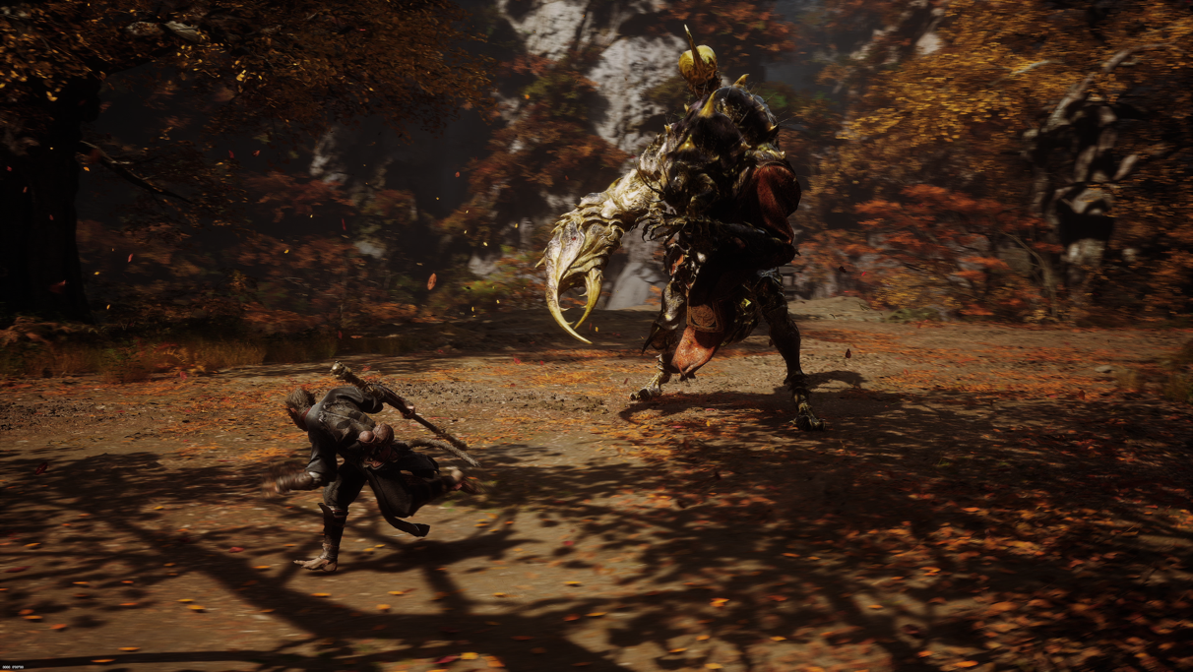
Wukong2 | 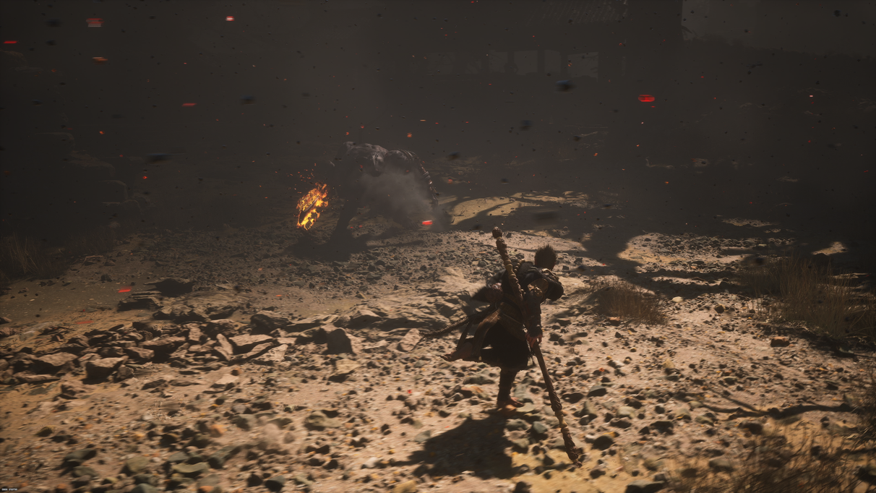
Wukong3 | 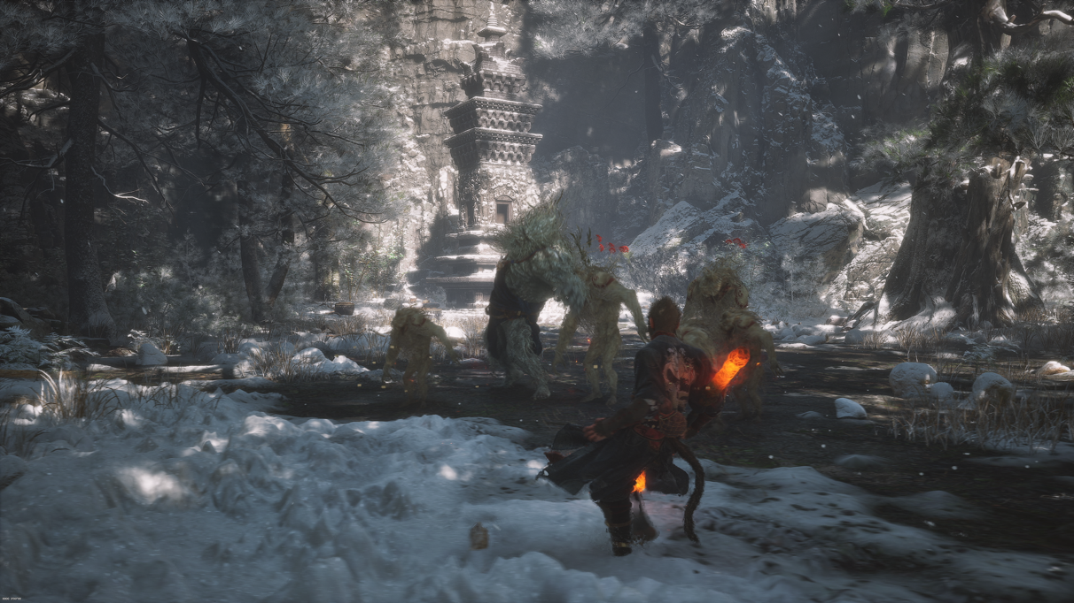

Carla
The Carla sequences were introduced in [3] and subjectively evaluated during the AHG17 in-person meeting in February 2026 in Aachen. Feedback from the meeting was acted upon, and the sequences have been adjusted with the following changes:
- YUV range changed from full range to limited
- Rendering quality improved and blurring removed by adjusting Carla simulator settings
The following three UHD SDR sequences should be considered for use in the CfP. The pictures shown are previews from the original sequences:
Carla3 | 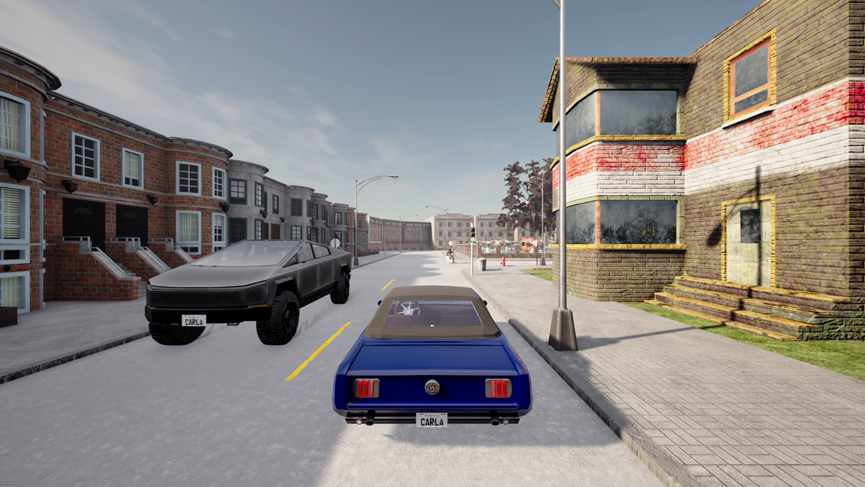
Carla4 | 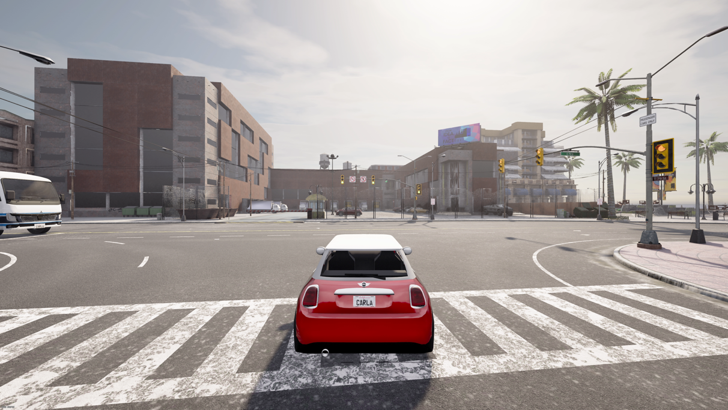
Carla5 | 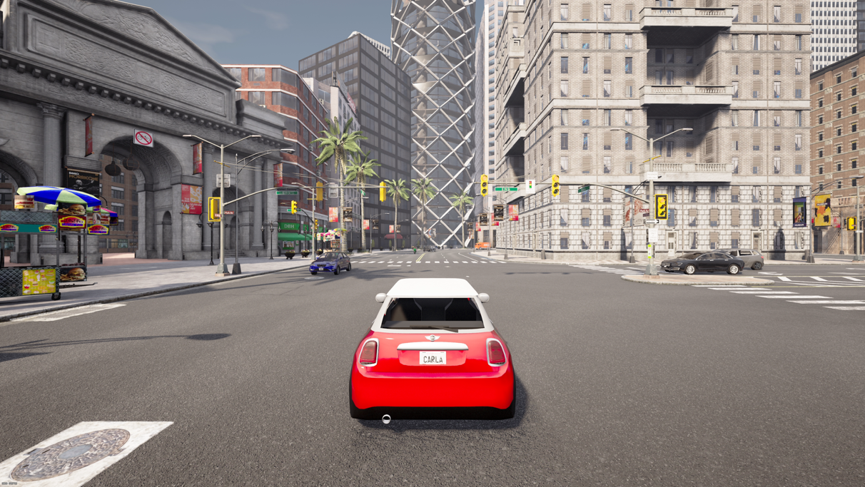

G3
The G3 class is part of the CTC for gaming applications [4]. This class includes three HD HDR (PQ) sequences which also includes auxiliary metadata (e.g. camera parameters). These sequences are considered for use in the CfP as they represent a typical state-of-the-art gaming scenario, featuring a modern rendering engine and fast movement that are representative of many games where players move quickly through the environment.
Since there is currently no HDR Gaming content category, the draft CfP text for categories should be reconsidered.
The G3 class in the Gaming CTC consists of the following sequences. The pictures shown are previews from the original sequences and do not include the PQ EOTF:
ARPG2_HDR | 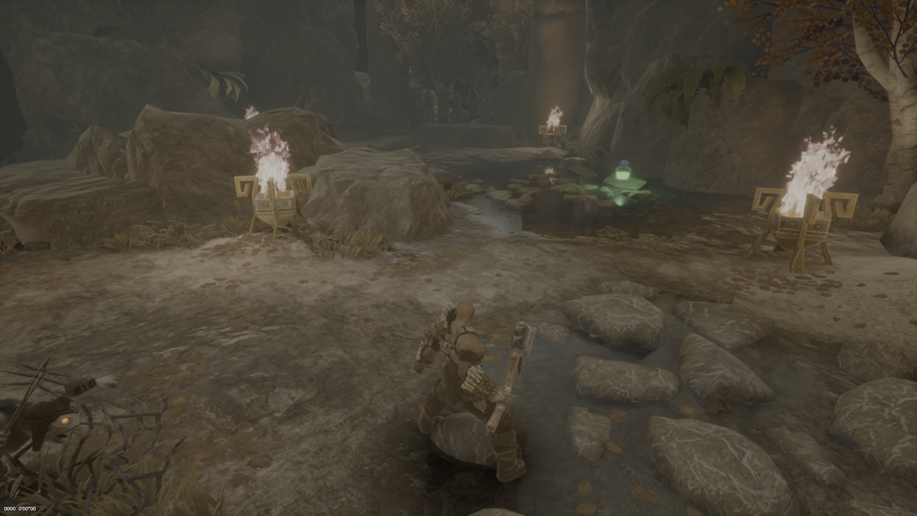
DesertTown3_HDR | 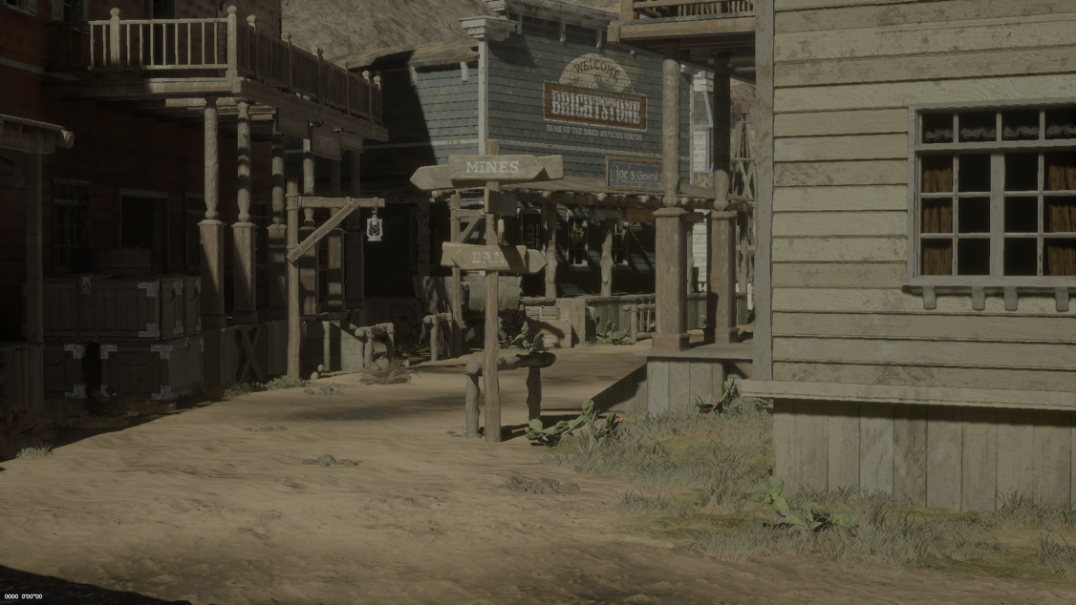
SunsetTemple3_HDR | 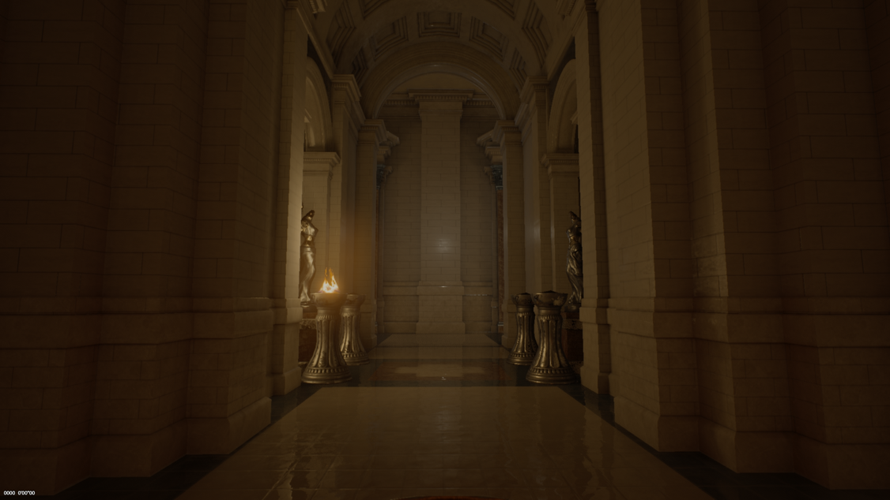

Sequence parameter
All Carla UHD SDR sequences sharing the same parameters:
- Resolution: 3840x2160
- Frame rate: 60 fps
- Number of frames: 600
- Bit depth: 8 bit
- Color space: YUV, BT. 709
- Chroma subsampling: 4:2:0 (chroma sample location 0)
All Wukong UHD SDR sequences sharing the following parameters:
- Resolution: 3840x2160
- Frame rate: 60 fps
- Number of frames: 600
- Bit depth: 10 bit
- Color space: YUV, BT. 709
- Chroma subsampling: 4:2:0 (chroma sample location 0)
All G3 HD HDR sequences sharing the following parameters:
- Resolution: 1920x1080
- Frame rate: 60 fps
- Number of frames: 600
- Bit depth: 10 bit
- Color space: YUV, HDR PQ BT.2020, 1000-nit ST-2084, limited color range
- Chroma subsampling: 4:2:0 (chroma sample location 2)

Sequence and bitstream download location
All sequences can be obtained from the VQA server using the ‘jvet-dl’ account.
The Carla original sequences are available at:
https://vqa.lfb.rwth-aachen.de/index.php/apps/files/files/1691957?dir=/jvet/ahg/candidates/JVET-AP0044/LimitedRange
The Wukong1 original sequence is available at:
https://vqa.lfb.rwth-aachen.de/index.php/apps/files/files/1638113?dir=/jvet/ahg/candidates/JVET-AN0053/yuv
The Wukong2 and Wukong3 original sequences are available at:
https://vqa.lfb.rwth-aachen.de/index.php/apps/files/files/1643039?dir=/jvet/ctc/gaming/G2
All G3 gaming sequences can be downloaded at:
https://vqa.lfb.rwth-aachen.de/index.php/apps/files/files/550121?dir=/jvet/ctc/gaming/G3
The bitstreams are located at:
https://vqa.lfb.rwth-aachen.de/index.php/apps/files?dir=/jvet/ahg/candidates/JVET-AP0050

Checksums
Size | Sequence name | md5um
HD HDR  1920x1080 | ARPG2_HDR_1920x1080_60fps_10bit_420.yuv | 6eabdb7f0827afa5b0ecb95208b069c1
HD HDR  1920x1080 | DesertTown3_HDR_1920x1080_60fps_10bit_420.yuv | 8b91f2c5630b592d8bc0e30c6e33b758
HD HDR  1920x1080 | SunTemple3_HDR_1920x1080_60fps_10bit_420.yuv | e9766660f098c63a5874605a89bf6ccf
UHD SDR  3840x2160 | Carla3_3840x2160_60fps_8bit_420.yuv | f19a46250aafb999b37e83f834895222
UHD SDR  3840x2160 | Carla4_3840x2160_60fps_8bit_420.yuv | 360dee13c047252af13cf1af5c7cca58
UHD SDR  3840x2160 | Carla5_3840x2160_60fps_8bit_420.yuv | 11db5b51ad88b53ab46c0d7953601e8c
UHD SDR  3840x2160 | Wukong1_3840x2160_60fps_10bit_420.yuv | 5accafb1c16ecc961740cd90286ca9b8
UHD SDR  3840x2160 | Wukong2_3840x2160_60fps_10bit_420.yuv | 8da88d4168684a66623616d2d1112211
UHD SDR  3840x2160 | Wukong3_3840x2160_60fps_10bit_420.yuv | af3f9598bcfbbf76be2df7e0f30d39a6

RD plots
In the following the RD plots for the default VTM LDB configuration as well as the VTM-LDB GOPBasedRPR configuration with additional enabling BIM=2 is shown. All results of the dense QP set are shown in Annex. The bitstreams are available at:

RD plots of UHD SDR sequences
The plot shows the LDB default configuration of all UHD SDR sequences as solid lines and the GOPBasedRPR +BIM=2 configuration as dotted lines.

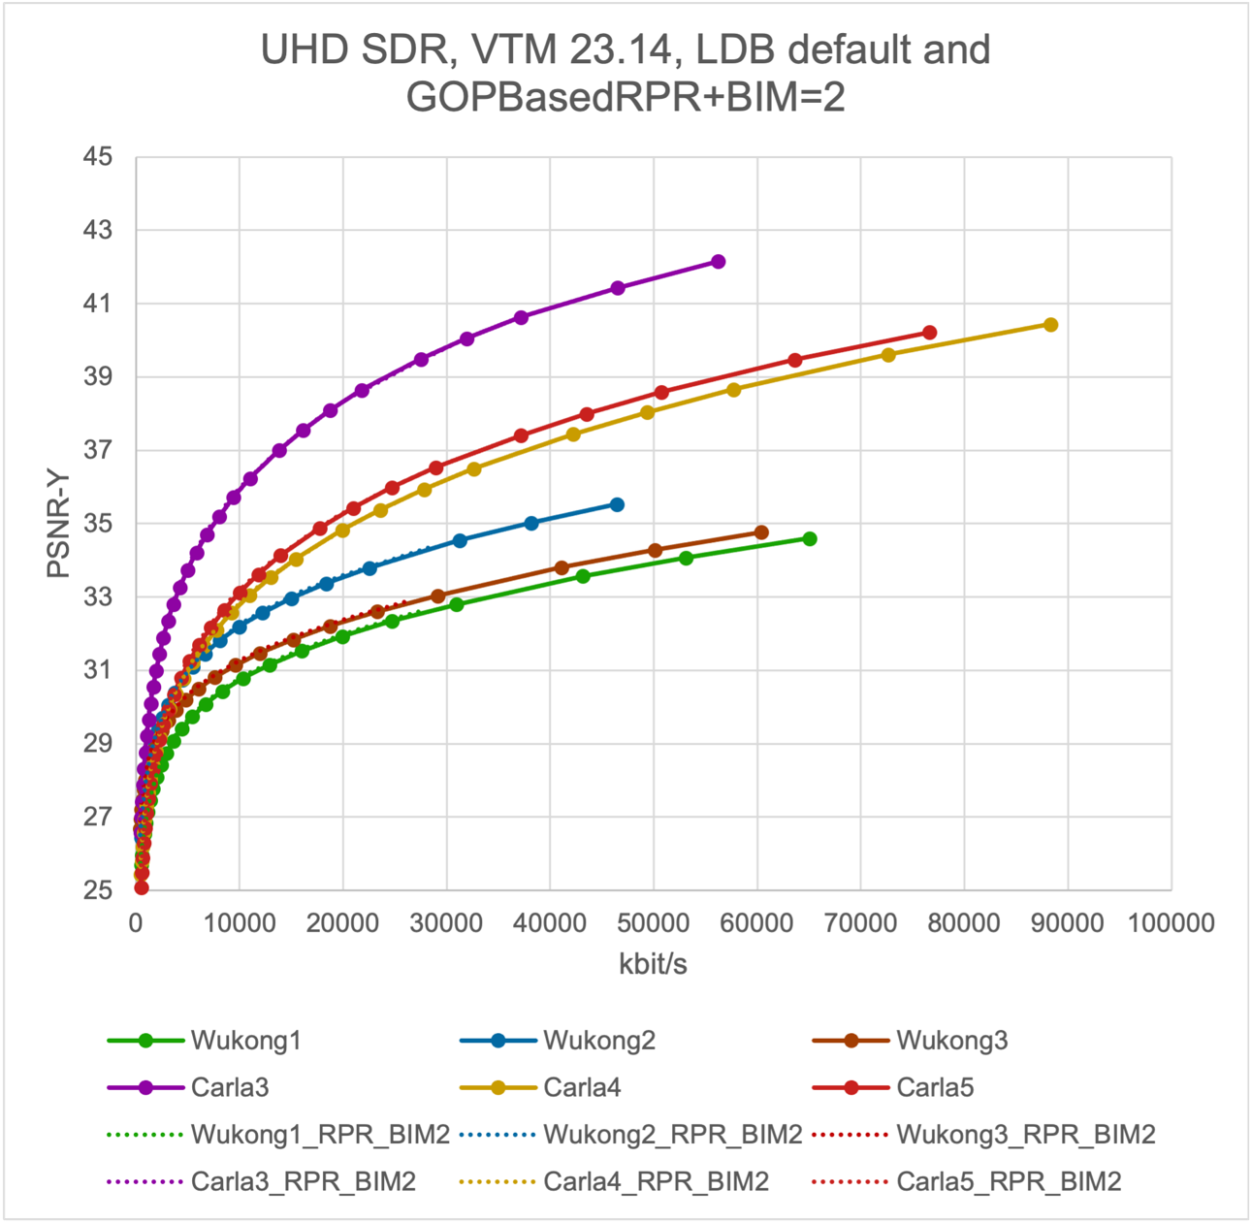

RD plots of HD HDR sequences
The plot shows the LDB default configuration of the HD HDR sequences as solid lines and the GOPBasedRPR +BIM=2 configuration as dotted lines.
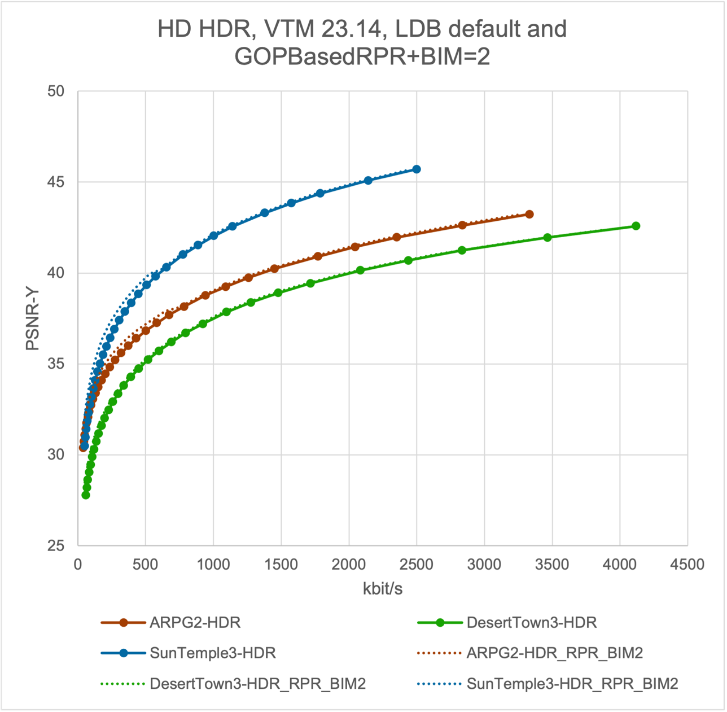

Proposed Target Bitrates
All proposed sequences are considered in the gaming category which uses following encoder configuration:
- low-delay scenario with B pictures (LB)
- following the JVET common test condition and software reference configurations
- no picture reordering is applied between decoder processing and output
- 10 second full sequence length should be used
Based on a dense QP set available in Annex, a visual evaluation by an expert viewing was conducted. The viewing used two 65-inch LG OLED screens (LG OLED65E97LA) with UHD resolution (3840x2160). The displays were connected to an HDMI splitter connected to a DeckLink 8K Pro G2 video board using HDMI. The HD content was centered in the display with mid-gray padding around it. Participants sat at a 1.5H viewing distance from the display. The test involved 6 experts. The test setup always shoed the original content first, followed by the processed video. Experts were to determine the highest bitrate at which the output remains very close to the original, as well as the lowest bitrate at which the scene remains recognizable.
Having determined the lower and upper bitrate limits, the two intermediate target rates were computed using:
$$RateFactor=\sqrt[3]{\left(\frac{R4}{R1}\right)}$$
$$R2=R1*RateFactor$$
$$R3=R2*RateFactor$$
The additional fifth rate point has been calculated by using R5=R4*2

 | Target bit rates [kbit/s]
Sequences name | Rate 1 | Rate 2 | Rate 3 | Rate 4 | Rate 5
ARPG2_HDR | 200 | 400 | 700 | 1300 | 2600
DesertTown3_HDR | 150 | 250 | 450 | 800 | 1600
SunsetTemple3_HDR | 200 | 350 | 600 | 1000 | 2000

 | Target bit rates [kbit/s]
Sequences name | Rate 1 | Rate 2 | Rate 3 | Rate 4 | Rate 5
Carla3 | 700 | 1600 | 3600 | 8000 | 16000
Carla4 | 1000 | 2200 | 5000 | 11000 | 22000
Carla5 | 1100 | 2200 | 4300 | 8500 | 17000

The target bitrates for Wukong are already defined in [2] and are shown here for completeness only.
 | Target bit rates [kbit/s]
Sequences name | Rate 1 | Rate 2 | Rate 3 | Rate 4 | Rate 5
Wukong1 | 800 | 1800 | 4500 | 10000 | 20000
Wukong2 | 800 | 2000 | 4500 | 12000 | 24000
Wukong3 | 800 | 2000 | 5000 | 15000 | 30000

Rate-Matching results
The rate-matching results are shown below consist of the bitrate and PSNR results. The QP and QPIncrementFrame settings are also provided so that the results can be reproduced for a cross-check.
The rate-matched bitstreams are available at:
https://vqa.lfb.rwth-aachen.de/index.php/apps/files?dir=/jvet/ahg/candidates/JVET-AP0050

Rate matching for the VTM default configuration
All results have been obtained by running VTM-23.14 in default (regular) configuration.
Rate-matched results for Carla LDB default configuration:
Sequence | Target rate | RP | QP | QPIncrement Frame | Bitrate [kbps] | PSNR |  |  | Runtime[s] |  | ratematch
 |  |  |  |  |  | Y | U | V | encT | decT | ratematch
Carla3 | 700 | 1 | 48 | 370 | 698.62 | 28.155 | 39.377 | 38.978 | 71856 | 102.7 | 99.80%
Carla3 | 1600 | 2 | 43 | 511 | 1598.35 | 30.488 | 41.627 | 40.981 | 128036 | 123.3 | 99.90%
Carla3 | 3600 | 3 | 37 | 7 | 3598.50 | 32.818 | 42.889 | 42.178 | 213771 | 142.3 | 99.96%
Carla3 | 8000 | 4 | 33 | 591 | 7988.06 | 35.191 | 44.436 | 43.644 | 364458 | 171.9 | 99.85%
Carla3 | 16000 | 5 | 29 | 575 | 15979.58 | 37.524 | 46.021 | 45.183 | 570773 | 205.2 | 99.87%
Carla4 | 1000 | 1 | 46 | 191 | 999.98 | 27.424 | 38.109 | 40.172 | 101773 | 113.7 | 99.99%
Carla4 | 2200 | 2 | 42 | 471 | 2194.78 | 29.083 | 39.795 | 42.107 | 177502 | 136.3 | 99.76%
Carla4 | 5000 | 3 | 37 | 279 | 4986.04 | 30.971 | 40.882 | 43.25 | 314851 | 163.1 | 99.72%
Carla4 | 11000 | 4 | 32 | 39 | 10987.21 | 33.078 | 42.418 | 44.402 | 539815 | 190.3 | 99.88%
Carla4 | 22000 | 5 | 29 | 313 | 21956,82 | 35,119 | 43,762 | 45,688 | 792011 | 223 | 99.80%
Carla5 | 1100 | 1 | 46 | 430 | 1099.23 | 27.392 | 38.462 | 39.938 | 110760 | 117.8 | 99.93%
Carla5 | 2200 | 2 | 41 | 2 | 2199.85 | 29.118 | 40.144 | 41.694 | 182870 | 142.2 | 99.99%
Carla5 | 4300 | 3 | 38 | 575 | 4293.94 | 30.777 | 40.923 | 42.476 | 291612 | 164.1 | 99.86%
Carla5 | 8500 | 4 | 34 | -1 | 8478.64 | 32.649 | 42.192 | 43.428 | 470778 | 188.3 | 99.75%
Carla5 | 17000 | 5 | 30 | 402 | 16903.09 | 34.657 | 43.725 | 44.971 | 718848 | 222.3 | 99.43%

Rate-matched results for G3 LDB default configuration:
Sequence | Target rate | RP | QP | QPIncrement Frame | Bitrate [kbps] | PSNR |  |  | Runtime[s] |  | Rate match
 |  |  |  |  |  | Y | U | V | encT | decT | Rate match
ARPG2_HDR | 200 | 1 | 40 | 495 | 199.62 | 34.395 | 47.735 | 49.936 | 21462 | 25.4 | 99.81%
ARPG2_HDR | 400 | 2 | 35 | 267 | 399.95 | 36.178 | 48.486 | 50.739 | 37657 | 32.0 | 99.99%
ARPG2_HDR | 700 | 3 | 31 | 130 | 698.06 | 37.802 | 49.052 | 51.306 | 59077 | 36.4 | 99.72%
ARPG2_HDR | 1300 | 4 | 27 | 114 | 1298.29 | 39.836 | 49.775 | 52.004 | 97021 | 48.5 | 99.87%
ARPG2_HDR | 2600 | 5 | 23 | 287 | 2597.00 | 42.287 | 50.687 | 52.731 | 156850 | 57.5 | 99.88%
DesertTown_HDR | 150 | 1 | 44 | 439 | 149.80 | 31.046 | 46.352 | 48.48 | 17673 | 18.9 | 99.87%
DesertTown_HDR | 250 | 2 | 40 | 375 | 249.75 | 32.758 | 47.192 | 49.483 | 26932 | 22.4 | 99.90%
DesertTown_HDR | 450 | 3 | 36 | 582 | 449.53 | 34.741 | 48.062 | 50.257 | 42431 | 28.0 | 99.89%
DesertTown_HDR | 800 | 4 | 31 | 0 | 797.00 | 36.708 | 48.563 | 50.725 | 64466 | 34.6 | 99.62%
DesertTown_HDR | 1600 | 5 | 27 | 245 | 1598.85 | 39.126 | 49.35 | 51.342 | 107351 | 45.6 | 99.93%
SunsetTemple_HDR | 200 | 1 | 40 | 407 | 199.63 | 35.814 | 47.725 | 50.494 | 19432 | 24.8 | 99.82%
SunsetTemple_HDR | 350 | 2 | 35 | 54 | 349.27 | 37.912 | 48.769 | 51.577 | 30824 | 29.7 | 99.79%
SunsetTemple_HDR | 600 | 3 | 31 | 274 | 599.17 | 40.043 | 49.564 | 52.367 | 49222 | 35.6 | 99.86%
SunsetTemple_HDR | 1000 | 4 | 28 | 583 | 998.75 | 42.026 | 50.179 | 53.042 | 73821 | 41.0 | 99.87%
SunsetTemple_HDR | 2000 | 5 | 23 | 427 | 1996.61 | 44.872 | 51.252 | 53.881 | 127015 | 55.4 | 99.83%

Rate-matched results for Wukong LDB default configuration:
Sequence | Target rate | RP | QP | QPIncrement Frame | Bitrate [kbps] | PSNR |  |  | Runtime[s] |  | Rate match
 |  |  |  |  |  | Y | U | V | encT | decT | Rate match
Wukong1 | 800 | 1 | 48 | 153 | 799.24 | 26.616 | 36.099 | 36.135 | 86129 | 88.9 | 99.90%
Wukong1 | 1800 | 2 | 44 | 351 | 1797.64 | 27.959 | 37.507 | 37.391 | 158702 | 110.4 | 99.87%
Wukong1 | 4500 | 3 | 39 | 66 | 4496.62 | 29.442 | 38.812 | 38.538 | 281375 | 141.6 | 99.92%
Wukong1 | 10000 | 4 | 36 | 508 | 9988.46 | 30.725 | 40.069 | 39.369 | 448593 | 172.6 | 99.88%
Wukong1 | 20000 | 5 | 32 | 9 | 19994.33 | 31.936 | 40.926 | 40.104 | 656949 | 207.2 | 99.97%
Wukong2 | 800 | 1 | 48 | 311 | 797.6008 | 27.581 | 38.108 | 37.196 | 76120 | 83.1 | 99.70%
Wukong2 | 2000 | 2 | 43 | 415 | 1998.71 | 29.284 | 40.172 | 39.086 | 155292 | 106.8 | 99.94%
Wukong2 | 4500 | 3 | 38 | 3 | 4498.38 | 30.747 | 41.647 | 40.587 | 275088 | 129.1 | 99.96%
Wukong2 | 12000 | 4 | 34 | 561 | 11996.60 | 32.547 | 43.136 | 42.118 | 504647 | 170.2 | 99.97%
Wukong2 | 24000 | 5 | 30 | 133 | 23948.21 | 33.955 | 44.285 | 43.29 | 744548 | 207.0 | 99.78%
Wukong3 | 800 | 1 | 47 | 367 | 799.92 | 27.906 | 41.899 | 41.758 | 85547 | 84.2 | 99.99%
Wukong3 | 2000 | 2 | 42 | 52 | 1994.47 | 29.113 | 43.553 | 43.492 | 165470 | 104.1 | 99.72%
Wukong3 | 5000 | 3 | 38 | 93 | 4987.74 | 30.254 | 44.587 | 44.692 | 294888 | 126.6 | 99.75%
Wukong3 | 15000 | 4 | 34 | 551 | 14990.46 | 31.817 | 45.478 | 45.709 | 565097 | 168.5 | 99.94%
Wukong3 | 30000 | 5 | 30 | 26 | 29726.51 | 33.072 | 46.298 | 46.601 | 837558 | 214.9 | 99.09%

Rate matching for the VTM GOPBasedRPR + BIM=2 configuration
All results have been obtained by running VTM-23.14.
Rate-matched results for Carla LDB, GOPBasedRPR + BIM=2 configuration:
Sequence | Target rate | RP | QP | QPIncrement Frame | Bitrate [kbps] | PSNR |  |  | Runtime[s] |  | ratematch
 |  |  |  |  |  | Y | U | V | encT | decT | ratematch
Carla3 | 700 | 1 | 47 | 269 | 698.59 | 28.475 | 39.878 | 39.328 | 73169 | 73.0 | 99.80%
Carla3 | 1600 | 2 | 42 | 393 | 1598.41 | 30.612 | 41.799 | 41.044 | 132555 | 125.0 | 99.90%
Carla3 | 3600 | 3 | 37 | 475 | 3595.37 | 32.931 | 43.064 | 42.273 | 228915 | 146.0 | 99.87%
Carla3 | 8000 | 4 | 32 | 396 | 7989.55 | 35.279 | 44.552 | 43.719 | 394312 | 173.2 | 99.87%
Carla3 | 16000 | 5 | 28 | 306 | 15994.31 | 37.581 | 46.086 | 45.179 | 605188 | 212.4 | 99.96%
Carla4 | 1000 | 1 | 45 | 119 | 992.84 | 27.529 | 38.063 | 40.451 | 106126 | 113.8 | 99.28%
Carla4 | 2200 | 2 | 41 | 455 | 2196.25 | 29.186 | 39.823 | 42.419 | 190073 | 139.1 | 99.83%
Carla4 | 5000 | 3 | 36 | 247 | 4990.26 | 31.046 | 41.228 | 43.39 | 347750 | 171.3 | 99.81%
Carla4 | 11000 | 4 | 32 | 400 | 10966.74 | 33.041 | 42.361 | 44.461 | 581293 | 187.2 | 99.70%
Carla4 | 22000 | 5 | 28 | 306 | 15994.31 | 37.581 | 46.086 | 45.179 | 605188 | 212 | 99.96%
Carla5 | 1100 | 1 | 45 | 258 | 1099.75 | 27.566 | 38.394 | 40.04 | 113666 | 119.4 | 99.98%
Carla5 | 2200 | 2 | 41 | 419 | 2196.89 | 29.217 | 40.242 | 41.86 | 191506 | 143.2 | 99.86%
Carla5 | 4300 | 3 | 37 | 359 | 4296.61 | 30.836 | 41.038 | 42.709 | 315269 | 168.2 | 99.92%
Carla5 | 8500 | 4 | 33 | 351 | 8472.54 | 32.675 | 42.329 | 43.639 | 508715 | 191.3 | 99.68%
Carla5 | 17000 | 5 | 29 | 110 | 16958.01 | 34.764 | 43.748 | 45.062 | 772722 | 224 | 99.75%

Rate-matched results for G3 LDB. GOPBasedRPR + BIM=2 configuration:
Sequence | Target rate | RP | QP | QPIncrement Frame | Bitrate [kbps] | PSNR |  |  | Runtime[s] |  | Rate match
 |  |  |  |  |  | Y | U | V | encT | decT | Rate match
ARPG2_HDR | 200 | 1 | 39 | 423 | 199.62 | 34.97 | 48.171 | 50.338 | 16287 | 8.7 | 99.81%
ARPG2_HDR | 400 | 2 | 34 | 14 | 399.90 | 36.608 | 48.797 | 50.973 | 33451 | 13.7 | 99.98%
ARPG2_HDR | 700 | 3 | 31 | 306 | 699.56 | 37.882 | 49.121 | 51.341 | 60263 | 38.3 | 99.94%
ARPG2_HDR | 1300 | 4 | 27 | 294 | 1298.79 | 39.92 | 49.773 | 52.009 | 99494 | 45.6 | 99.91%
ARPG2_HDR | 2600 | 5 | 23 | 391 | 2598.03 | 42.357 | 50.739 | 52.794 | 158796 | 54.8 | 99.92%
DesertTown_HDR | 150 | 1 | 43 | 305 | 149.08 | 31.508 | 46.766 | 48.937 | 19646 | 12.9 | 99.39%
DesertTown_HDR | 250 | 2 | 39 | 211 | 249.87 | 33.048 | 47.392 | 49.628 | 30718 | 18.4 | 99.95%
DesertTown_HDR | 450 | 3 | 35 | 260 | 449.82 | 34.841 | 48.113 | 50.244 | 46415 | 25.3 | 99.96%
DesertTown_HDR | 800 | 4 | 31 | 256 | 798.27 | 36.712 | 48.648 | 50.736 | 66419 | 35.0 | 99.78%
DesertTown_HDR | 1600 | 5 | 26 | 19 | 1598.67 | 39.236 | 49.385 | 51.336 | 113608 | 45.5 | 99.92%
SunsetTemple_HDR | 200 | 1 | 39 | 527 | 199.70 | 36.737 | 48.296 | 51.153 | 15610 | 9.2 | 99.85%
SunsetTemple_HDR | 350 | 2 | 35 | 576 | 349.42 | 38.539 | 49.084 | 51.971 | 26928 | 12.1 | 99.84%
SunsetTemple_HDR | 600 | 3 | 31 | 489 | 598.24 | 40.121 | 49.645 | 52.424 | 50197 | 35.1 | 99.71%
SunsetTemple_HDR | 1000 | 4 | 27 | 287 | 999.08 | 42.162 | 50.254 | 53.022 | 76327 | 41.0 | 99.91%
SunsetTemple_HDR | 2000 | 5 | 23 | 531 | 1998.48 | 44.91 | 51.289 | 53.929 | 128822 | 53.4 | 99.92%

Rate-matched results for Wukong LDB. GOPBasedRPR + BIM=2 configuration:
Sequence | Target rate | RP | QP | QPIncrement Frame | Bitrate [kbps] | PSNR |  |  | Runtime[s] |  | Rate match
 |  |  |  |  |  | Y | U | V | encT | decT | Rate match
Wukong1 | 800 | 1 | 47 | 98 | 798.73 | 26.686 | 36.09 | 36.137 | 102930 | 85.3 | 99.84%
Wukong1 | 1800 | 2 | 43 | 335 | 1799.40 | 27.997 | 37.511 | 37.37 | 170480 | 112.1 | 99.97%
Wukong1 | 4500 | 3 | 38 | 52 | 4499.86 | 29.493 | 38.83 | 38.521 | 307174 | 142.2 | 100.00%
Wukong1 | 10000 | 4 | 35 | 413 | 9997.28 | 30.786 | 40.107 | 39.374 | 486458 | 171.8 | 99.97%
Wukong1 | 20000 | 5 | 32 | 421 | 19986.04 | 31.998 | 40.81 | 39.993 | 699482 | 210 | 99.93%
Wukong2 | 800 | 1 | 47 | 164 | 799.33 | 27.704 | 38.397 | 37.392 | 105170 | 75.0 | 99.92%
Wukong2 | 2000 | 2 | 42 | 341 | 1998.12 | 29.357 | 40.235 | 39.171 | 180067 | 106.4 | 99.91%
Wukong2 | 4500 | 3 | 38 | 528 | 4495.33 | 30.802 | 41.495 | 40.481 | 301394 | 130.7 | 99.90%
Wukong2 | 12000 | 4 | 33 | 399 | 11994.85 | 32.612 | 43.264 | 42.246 | 534316 | 173.4 | 99.96%
Wukong2 | 24000 | 5 | 30 | 351 | 23952.31 | 34.022 | 44.216 | 43.221 | 779825 | 210 | 99.80%
Wukong3 | 800 | 1 | 46 | 284 | 799.73 | 28.018 | 42.171 | 41.955 | 101160 | 75.8 | 99.97%
Wukong3 | 2000 | 2 | 41 | 28 | 1999.56 | 29.206 | 43.717 | 43.68 | 189989 | 104.6 | 99.98%
Wukong3 | 5000 | 3 | 37 | 42 | 4992.90 | 30.337 | 44.528 | 44.659 | 328757 | 129.2 | 99.86%
Wukong3 | 15000 | 4 | 33 | 289 | 14968.53 | 31.843 | 45.514 | 45.769 | 625849 | 184.3 | 99.790%
Wukong3 | 30000 | 5 | 30 | 186 | 29932.85 | 33.122 | 46.212 | 46.519 | 874401 | 212.0 | 99,78%

BD-Rates
When comparing the GOPBasedRPR+BIM=2 configuration to the default VTM LDB configuration following BD-rates can be obtained for VTM-23.14 configuration:

Sequence | BD-rate (piecewise cubic) |  |  | BD-rate (cubic)
Sequence | Y | U | V | Y | U | V
Carla3 | -4.74% | -9.45% | -5.38% | -4.76% | -8.72% | -4.61%
Carla4 | -3.25% | -6.99% | -12.61% | -3.27% | -6.52% | -14.26%
Carla5 | -3.25% | -5.12% | -10.22% | -3.25% | -6.30% | -9.79%
Carla3-4-5 | -3.75% | -7.19% | -9.41% | -3.76% | -7.18% | -9.56%

Sequence | BD-rate (piecewise cubic) |  |  | BD-rate (cubic)
Sequence | Y | U | V | Y | U | V
Wukong1 | -2.91% | -0.67% | 1.16% | -2.91% | -0.66% | 1.15%
Wukong2 | -3.83% | -0.76% | -1.71% | -3.82% | -0.92% | -1.82%
Wukong3 | -5.91% | -6.20% | -6.65% | -5.99% | -8.42% | -8.35%
Wukong 1-2-3 | -4.22% | -2.54% | -2.40% | -4.24% | -3.33% | -3.01%

Sequence | BD-rate (piecewise cubic) |  |  | BD-rate (cubic)
Sequence | Y | U | V | Y | U | V
ARPG2-HDR | -8.84% | -16.78% | -12.81% | -8.45% | -16.63% | -12.62%
DesertTown3-HDR | -5.55% | -10.46% | -6.60% | -5.54% | -10.29% | -6.78%
SunTemple3-HDR | -9.66% | -14.69% | -15.77% | -9.51% | -15.02% | -16.80%
G3 | -8.02% | -13.98% | -11.73% | -7.83% | -13.98% | -12.07%

Rate matching for reduced runtime configuration
Additional results and bitstreams for the VTM 0.2x runtime configuration have been uploaded. While the results are not discussed in the current document, they can be studied using the CSV files available at the given download location:
https://vqa.lfb.rwth-aachen.de/index.php/apps/files?dir=/jvet/ahg/candidates/JVET-AP0050

The results for LDB default (regular) configuration are in the ‘rt3_reg’ folder. The LDB with GOPBasedRPR+BIM=2 results are in the ‘rt3_rpr’ folder.

References
- “AHG4/AHG15/AHG17: 4K gaming sequences featuring “Black Myth:Wukong””, Joint Video Experts Team (JVET), 40th Meeting, Geneva, October 2025, Doc. JVET-AN0053.
- “AHG17: AhG meeting notes”, Joint Video Experts Team (JVET), 42nd Meeting, Santa Eulària, April 2026, Doc. JVET-AP0041.
- “AhG17/AhG15: New gaming sequences with auxiliary information captured from Carla driving Simulator”, Joint Video Experts Team (JVET), 42nd Meeting, Santa Eulària, April 2026, Doc. JVET-AP0044.
- “Common Test Conditions (CTC) for gaming applications”, Joint Video Experts Team (JVET), 41st Meeting, Teleconference, January 2026, Doc. JVET-AO2027.

License and Copyright

CARLA Copyright
Sequences were obtained using the Carla simulator (https://github.com/carla-simulator/carla).
CARLA specific code is distributed under the MIT License.
CARLA specific assets are distributed under the CC-BY License.
https://github.com/carla-simulator/carla/tree/0.9.16?tab=readme-ov-file#licenses

Wukong Copyright
The proposed test sequences in this document and all intellectual property rights therein remain the property of Game Science Interactive Technology Co., Ltd..
The following uses are allowed for the proposed sequences:
- Can be used in ISO/IEC JTC1 SC29 and ITU-T SG21 for the purpose of development, testing and promulgation of video coding standards.
- Can be published in technical papers.
- Can be played at technology research and development events.
The following uses are not allowed for the proposed sequences:
- Do not publish snapshots in product brochures.
- Do not redistribute video with a commercial product.
- Do not use in television shows, commercials, or movies.

G3 sequences Copyright
This video sequences and auxiliary data (collectively "Data") may only be used for the purpose of developing, testing and promulgating technology standards developed by ISO/IEC JTC 1/SC 29 WG 5 or ITU-T SG 16 VCEG standardization groups (Purpose), under Huawei Technologies owned or controlled copyrights, by individual(s) or organization (s) that participates, contributes or is part of such standardization group (User(s)).

• The DesertTown3 sequence and auxiliary data are rendered using the "Western Desert Town" Unreal Engine assets created by KK Design available at https://www.unrealengine.com/marketplace/en-US/product/western-desert-town .
• The SunTemple3 sequence and auxiliary data are rendered using the “Sun Temple” Unreal Engine assets created by Epic Games available at https://www.unrealengine.com/marketplace/en-US/product/sun-temple .
• The ARPG2 sequence and auxiliary data are rendered using the “Action RPG” Unreal Engine assets created by Epic Games available at https://www.unrealengine.com/marketplace/en-US/product/action-rpg-01 .
All these assets are licensed by their respective owners and it is the User’s responsibility to comply with the license terms that are provided by such owner. Huawei Technologies claims no ownership nor liability on these assets.

RESTRICTIONS: No license whatsoever is implied except from this expressed limited personal, non-sublicensable, non-transferrable authorization. In particular no right under any patent of Huawei Technologies or its affiliates is granted.
Any other use is strictly prohibited. This Data cannot be distributed or otherwise disposed of or made available (via internet or otherwise), broadcasted, disclosed to third parties (except to other User(s) who agreed with the present terms and conditions), used for providing any services to third parties or for any commercial use, nor copied (except as technically necessary for the Purpose), modified, adapted, translated, exchanged, publicly performed (even for demonstration or educational purposes), integrated, without limitation. This Data and all intellectual property rights, titles and interests therein, are and remain the exclusive property of Huawei Technologies or its affiliates.

NO WARRANTY: This Data is supplied "as is" and without any warranty of any kind, expressed or implied, including but not limited to any warranty for accuracy or performance, fitness for a general or particular purposes, or any warranty arising by statute or by law, or non-infringement of any third parties rights. In no event will Huawei Technologies be liable for damages of any kind, including without limitation, any special, indirect, incidental, or consequential damages even if Huawei Technologies has been advised of the possibility of such damages.
Huawei Technologies may terminate this license at any time for any reason upon notice to User(s). In such situation, the relevant User(s) shall inform any Secondary User of such termination and make sure that such Secondary User shall cease to use the video.
This authorization is governed by the laws of China without regard to conflict of laws. It shall be exclusively submitted to the competent people's court in Longgang District, Shenzhen City in the event of a dispute not settled amicably.
BY USING THIS DATA USER(S) AGREES AND ACCEPTS THE ABOVE MENTIONED TERMS AND CONDITIONS. IF USER(S) DOES NOT AGREE TO THESE TERMS AND CONDITIONS, IT SHALL NOT ACCESS OR OTHERWISE USE THIS DATA. DO NOT REMOVE OR MODIFY HUAWEI TECHNOLOGIES OR ITS AFFILIATES NAMES, SIGNS, LOGOS, NOTICES OF/IN THE DATA.

Patent rights declaration(s)
Fraunhofer HHI and Huawei do not have any current or pending patent rights relating to the technology described in this contribution.

Annex
Dense QP test results for VTM-23.14 (default), LDB configuration for Carla 3,4,5:
Sequence | QP | Rate | PSNR |  |  | MS-SSIM |  |  | Runtime[s]
Sequence | QP | Rate | Y | U | V | Y | U | V | EncT | DecT
Carla3 | 22 | 56158,2 | 42,149 | 49,2694 | 48,4487 | 0,99986 | 0,99996 | 0,99995 | 784756 | 235,2
Carla3 | 23 | 46441,7 | 41,4277 | 48,8166 | 47,9702 | 0,99983 | 0,99995 | 0,99994 | 684782 | 228,0
Carla3 | 24 | 37125,4 | 40,6259 | 48,2948 | 47,44 | 0,99979 | 0,99994 | 0,99993 | 615552 | 186,9
Carla3 | 25 | 31889,0 | 40,0531 | 47,8573 | 47,001 | 0,99976 | 0,99994 | 0,99992 | 576853 | 174,6
Carla3 | 26 | 27479,5 | 39,4866 | 47,4261 | 46,5668 | 0,99972 | 0,99993 | 0,99991 | 551067 | 169,3
Carla3 | 27 | 21735,5 | 38,6442 | 46,8929 | 46,038 | 0,99965 | 0,99992 | 0,9999 | 491127 | 140,1
Carla3 | 28 | 18719,4 | 38,0939 | 46,4838 | 45,6367 | 0,99959 | 0,99991 | 0,99989 | 482406 | 154,8
Carla3 | 29 | 16096,3 | 37,5453 | 46,0324 | 45,1938 | 0,99952 | 0,9999 | 0,99987 | 442556 | 157,2
Carla3 | 30 | 13812,3 | 37,0014 | 45,6858 | 44,8436 | 0,99944 | 0,99989 | 0,99986 | 409982 | 217,7
Carla3 | 31 | 10968,1 | 36,2283 | 45,2649 | 44,4419 | 0,99931 | 0,99987 | 0,99984 | 327742 | 352,0
Carla3 | 32 | 9371,3 | 35,7126 | 44,8029 | 44,0192 | 0,99921 | 0,99986 | 0,99983 | 291356 | 139,1
Carla3 | 33 | 8011,0 | 35,1978 | 44,4405 | 43,6476 | 0,99909 | 0,99984 | 0,99981 | 268056 | 130,5
Carla3 | 34 | 6824,9 | 34,702 | 43,9777 | 43,2055 | 0,99896 | 0,99982 | 0,99979 | 242501 | 119,5
Carla3 | 35 | 5822,7 | 34,2121 | 44,0021 | 43,1998 | 0,99881 | 0,99982 | 0,99979 | 217947 | 113,7
Carla3 | 36 | 4947,0 | 33,734 | 43,5271 | 42,8007 | 0,99865 | 0,9998 | 0,99976 | 196747 | 108,2
Carla3 | 37 | 4213,8 | 33,2657 | 43,2813 | 42,5521 | 0,99846 | 0,99979 | 0,99975 | 179632 | 105,6
Carla3 | 38 | 3586,6 | 32,8022 | 42,865 | 42,1534 | 0,99826 | 0,99977 | 0,99973 | 164521 | 108,2
Carla3 | 39 | 3063,5 | 32,3453 | 42,8599 | 42,1673 | 0,99803 | 0,99977 | 0,99973 | 151200 | 110,9
Carla3 | 40 | 2612,5 | 31,8943 | 42,4281 | 41,7719 | 0,99778 | 0,99975 | 0,9997 | 133994 | 116,9
Carla3 | 41 | 2239,5 | 31,4439 | 42,4424 | 41,7679 | 0,99749 | 0,99975 | 0,9997 | 125291 | 107,9
Carla3 | 42 | 1912,7 | 30,9933 | 42,0385 | 41,3826 | 0,99718 | 0,99972 | 0,99967 | 114635 | 100,1
Carla3 | 43 | 1639,1 | 30,5472 | 41,6785 | 41,0299 | 0,99682 | 0,99969 | 0,99964 | 101430 | 108,2
Carla3 | 44 | 1401,8 | 30,0999 | 41,2671 | 40,6419 | 0,99642 | 0,99966 | 0,99961 | 91726 | 107,5
Carla3 | 45 | 1199,0 | 29,6517 | 40,7487 | 40,2514 | 0,99597 | 0,99962 | 0,99957 | 81207 | 240,5
Carla3 | 46 | 1024,2 | 29,2089 | 40,3916 | 39,9123 | 0,99547 | 0,99959 | 0,99954 | 73662 | 143,9
Carla3 | 47 | 874,0 | 28,7582 | 39,9471 | 39,4688 | 0,9949 | 0,99955 | 0,9995 | 64377 | 87,6
Carla3 | 48 | 744,8 | 28,3156 | 39,5303 | 39,1387 | 0,99428 | 0,9995 | 0,99946 | 59023 | 72,7
Carla3 | 49 | 632,5 | 27,8787 | 39,1293 | 38,7753 | 0,99358 | 0,99945 | 0,99941 | 53277 | 70,5
Carla3 | 50 | 538,0 | 27,4293 | 38,4967 | 38,2561 | 0,9928 | 0,99938 | 0,99935 | 50843 | 66,2
Carla3 | 51 | 456,1 | 27,0029 | 38,3037 | 37,9478 | 0,99195 | 0,99934 | 0,99932 | 44618 | 73,6
Carla4 | 22 | 76571,9 | 40,2193 | 47,2967 | 48,4337 | 0,99979 | 0,99994 | 0,99995 | 1005720 | 262,5
Carla4 | 23 | 72580,5 | 39,6094 | 46,6646 | 48,4074 | 0,99976 | 0,99993 | 0,99995 | 881833 | 243,0
Carla4 | 24 | 57652,7 | 38,6541 | 46,1261 | 47,9342 | 0,99969 | 0,99991 | 0,99994 | 817402 | 272,4
Carla4 | 25 | 49296,5 | 38,0372 | 45,6807 | 47,5252 | 0,99964 | 0,9999 | 0,99993 | 810528 | 245,1
Carla4 | 26 | 42169,4 | 37,4357 | 45,2491 | 47,1177 | 0,99957 | 0,99989 | 0,99992 | 708104 | 204,4
Carla4 | 27 | 32584,3 | 36,4984 | 44,7417 | 46,6458 | 0,99945 | 0,99987 | 0,99991 | 642495 | 194,0
Carla4 | 28 | 27770,1 | 35,9368 | 44,3557 | 46,267 | 0,99935 | 0,99985 | 0,9999 | 680603 | 217,4
Carla4 | 29 | 23547,3 | 35,3749 | 43,9306 | 45,8556 | 0,99924 | 0,99983 | 0,99989 | 622388 | 190,7
Carla4 | 30 | 19891,9 | 34,8281 | 43,5872 | 45,5115 | 0,99912 | 0,99982 | 0,99988 | 592033 | 325,3
Carla4 | 31 | 15391,6 | 34,041 | 43,1739 | 45,1222 | 0,99889 | 0,99979 | 0,99986 | 521592 | 222,7
Carla4 | 32 | 12954,6 | 33,5348 | 42,7314 | 44,7118 | 0,99872 | 0,99977 | 0,99985 | 460199 | 150,7
Carla4 | 33 | 10907,7 | 33,0412 | 42,376 | 44,3709 | 0,99853 | 0,99974 | 0,99983 | 394828 | 173,6
Carla4 | 34 | 9183,4 | 32,5698 | 41,9485 | 43,9509 | 0,99831 | 0,99971 | 0,99982 | 355925 | 172,3
Carla4 | 35 | 7738,9 | 32,1061 | 41,9534 | 43,9272 | 0,99807 | 0,99971 | 0,99982 | 315106 | 356,9
Carla4 | 36 | 6486,9 | 31,6527 | 41,515 | 43,4531 | 0,9978 | 0,99968 | 0,99979 | 277890 | 128,1
Carla4 | 37 | 5466,5 | 31,2142 | 41,1015 | 43,4598 | 0,9975 | 0,99965 | 0,9998 | 251618 | 138,7
Carla4 | 38 | 4588,7 | 30,7794 | 40,6484 | 43,0626 | 0,99717 | 0,9996 | 0,99977 | 226983 | 115,8
Carla4 | 39 | 3841,1 | 30,357 | 40,6742 | 43,0271 | 0,99681 | 0,99961 | 0,99977 | 204414 | 113,8
Carla4 | 40 | 3216,1 | 29,9463 | 40,2217 | 42,5804 | 0,99642 | 0,99956 | 0,99975 | 176784 | 112,3
Carla4 | 41 | 2700,1 | 29,5511 | 40,2604 | 42,6335 | 0,99601 | 0,99956 | 0,99975 | 164269 | 113,3
Carla4 | 42 | 2261,8 | 29,1628 | 39,8547 | 42,171 | 0,99556 | 0,99951 | 0,99972 | 146416 | 114,3
Carla4 | 43 | 1895,8 | 28,7865 | 39,4707 | 41,7415 | 0,99509 | 0,99946 | 0,9997 | 128477 | 110,5
Carla4 | 44 | 1591,7 | 28,4108 | 39,0729 | 41,3613 | 0,99458 | 0,9994 | 0,99967 | 112445 | 105,2
Carla4 | 45 | 1338,0 | 28,0372 | 38,6999 | 40,9005 | 0,99401 | 0,99934 | 0,99963 | 96846 | 119,0
Carla4 | 46 | 1130,7 | 27,6771 | 38,3599 | 40,4184 | 0,99341 | 0,99929 | 0,99959 | 88552 | 150,1
Carla4 | 47 | 953,7 | 27,3049 | 37,8242 | 39,949 | 0,99273 | 0,99921 | 0,99954 | 75714 | 197,0
Carla4 | 48 | 808,0 | 26,9337 | 37,4629 | 39,4369 | 0,99199 | 0,99915 | 0,99949 | 67625 | 79,3
Carla4 | 49 | 691,3 | 26,5711 | 37,1087 | 39,1135 | 0,99119 | 0,99908 | 0,99944 | 61199 | 74,2
Carla4 | 50 | 588,4 | 26,1844 | 36,5831 | 38,3427 | 0,99025 | 0,999 | 0,99938 | 56231 | 71,3
Carla4 | 51 | 501,2 | 25,7988 | 36,3312 | 38,0639 | 0,98922 | 0,99893 | 0,99931 | 49599 | 68,7
Carla4 | 52 | 429,3 | 25,4364 | 35,8886 | 37,6116 | 0,98817 | 0,99886 | 0,99926 | 44841 | 76,0
Carla5 | 22 | 76572,0 | 40,2193 | 47,2967 | 48,4337 | 0,99979 | 0,99994 | 0,99995 | 1005721 | 262,6
Carla5 | 23 | 63563,8 | 39,4634 | 46,8455 | 48,0061 | 0,99975 | 0,99993 | 0,99994 | 918362 | 273,2
Carla5 | 24 | 50725,6 | 38,5862 | 46,3359 | 47,5241 | 0,99968 | 0,99992 | 0,99993 | 846058 | 242,5
Carla5 | 25 | 43482,6 | 37,994 | 45,9148 | 47,1133 | 0,99962 | 0,99991 | 0,99993 | 776629 | 229,6
Carla5 | 26 | 37096,7 | 37,3992 | 45,4932 | 46,6973 | 0,99955 | 0,99989 | 0,99992 | 729574 | 214,8
Carla5 | 27 | 28916,2 | 36,5362 | 45,0085 | 46,2496 | 0,99943 | 0,99988 | 0,99991 | 643927 | 201,0
Carla5 | 28 | 24673,2 | 35,9821 | 44,6184 | 45,8608 | 0,99934 | 0,99986 | 0,9999 | 671707 | 357,0
Carla5 | 29 | 20936,0 | 35,4266 | 44,1772 | 45,4574 | 0,99923 | 0,99985 | 0,99988 | 639115 | 175,0
Carla5 | 30 | 17737,4 | 34,883 | 43,844 | 45,0809 | 0,9991 | 0,99983 | 0,99987 | 577268 | 326,5
Carla5 | 31 | 13880,1 | 34,13 | 43,4417 | 44,6713 | 0,99888 | 0,99981 | 0,99986 | 506387 | 301,7
Carla5 | 32 | 11769,5 | 33,6186 | 43,0046 | 44,2506 | 0,99871 | 0,99979 | 0,99984 | 449168 | 160,1
Carla5 | 33 | 9966,0 | 33,1188 | 42,6244 | 43,8508 | 0,99851 | 0,99977 | 0,99982 | 390725 | 169,0
Carla5 | 34 | 8478,6 | 32,6489 | 42,1921 | 43,4277 | 0,99829 | 0,99974 | 0,9998 | 355533 | 284,9
Carla5 | 35 | 7157,6 | 32,1632 | 42,1904 | 43,3847 | 0,99804 | 0,99974 | 0,9998 | 307232 | 137,1
Carla5 | 36 | 6042,3 | 31,6909 | 41,736 | 42,9578 | 0,99776 | 0,99971 | 0,99978 | 278328 | 134,6
Carla5 | 37 | 5138,1 | 31,2467 | 41,3596 | 42,9475 | 0,99746 | 0,99968 | 0,99978 | 247071 | 118,3
Carla5 | 38 | 4317,4 | 30,7921 | 40,9241 | 42,4776 | 0,99711 | 0,99964 | 0,99975 | 224937 | 123,1
Carla5 | 39 | 3640,2 | 30,3495 | 40,9304 | 42,486 | 0,99674 | 0,99965 | 0,99976 | 196333 | 128,5
Carla5 | 40 | 3076,0 | 29,9269 | 40,4573 | 42,0336 | 0,99634 | 0,9996 | 0,99973 | 165370 | 124,7
Carla5 | 41 | 2597,4 | 29,5102 | 40,5104 | 42,054 | 0,9959 | 0,99961 | 0,99973 | 151867 | 101,3
Carla5 | 42 | 2186,9 | 29,1045 | 40,0878 | 41,5963 | 0,99544 | 0,99956 | 0,9997 | 141549 | 105,1
Carla5 | 43 | 1856,7 | 28,7121 | 39,7014 | 41,2533 | 0,99495 | 0,99952 | 0,99967 | 126733 | 120,2
Carla5 | 44 | 1567,6 | 28,3046 | 39,2849 | 40,8383 | 0,99439 | 0,99947 | 0,99963 | 107730 | 100,0
Carla5 | 45 | 1332,7 | 27,9083 | 38,8261 | 40,4241 | 0,99378 | 0,99941 | 0,99959 | 97210 | 96,4
Carla5 | 46 | 1134,5 | 27,5098 | 38,565 | 40,038 | 0,99311 | 0,99937 | 0,99956 | 94181 | 101,7
Carla5 | 47 | 968,6 | 27,1067 | 38,0755 | 39,498 | 0,99235 | 0,9993 | 0,9995 | 79286 | 112,3
Carla5 | 48 | 831,0 | 26,7057 | 37,6203 | 38,9132 | 0,99153 | 0,99924 | 0,99944 | 70350 | 94,1
Carla5 | 49 | 712,6 | 26,3011 | 37,301 | 38,6148 | 0,9906 | 0,99917 | 0,9994 | 62961 | 76,0
Carla5 | 50 | 610,3 | 25,8986 | 36,9407 | 38,1556 | 0,98959 | 0,99912 | 0,99934 | 57576 | 70,6
Carla5 | 51 | 522,8 | 25,4835 | 36,3673 | 37,7741 | 0,98844 | 0,99902 | 0,99927 | 51471 | 69,1
Carla5 | 52 | 446,7 | 25,0762 | 36,3154 | 37,2546 | 0,98719 | 0,999 | 0,9992 | 45812 | 71,6

Dens QP test results for VTM-23.14 (default), LDB configuration for HD HDR sequences:
Sequence | QP | Rate | PSNR |  |  | MS-SSIM |  |  | Runtime[s]
Sequence | QP | Rate | Y | U | V | Y | U | V | EncT | DecT
ARPG2* | 22 | 3332,4 | 43,2295 | 51,0528 | 52,9584 | 0,99983 | 0,99997 | 0,99998 | 142094 | 41,3
ARPG2* | 23 | 2837,5 | 42,6211 | 50,8961 | 52,9152 | 0,99979 | 0,99996 | 0,99998 | 127708 | 51,6
ARPG2* | 24 | 2352,6 | 41,957 | 50,4911 | 52,5504 | 0,99975 | 0,99996 | 0,99998 | 131441 | 48,8
ARPG2* | 25 | 2045,1 | 41,4287 | 50,486 | 52,4471 | 0,99971 | 0,99996 | 0,99998 | 111444 | 77,2
ARPG2* | 26 | 1771,7 | 40,9068 | 50,1176 | 52,3077 | 0,99966 | 0,99996 | 0,99997 | 99358 | 58,7
ARPG2* | 27 | 1452,0 | 40,2335 | 49,9616 | 52,0817 | 0,99959 | 0,99996 | 0,99997 | 83091 | 54,1
ARPG2* | 28 | 1259,5 | 39,7394 | 49,7301 | 51,9711 | 0,99954 | 0,99995 | 0,99997 | 72075 | 41,0
ARPG2* | 29 | 1092,7 | 39,2505 | 49,6261 | 51,7647 | 0,99947 | 0,99995 | 0,99997 | 65272 | 37,8
ARPG2* | 30 | 941,5 | 38,7649 | 49,3672 | 51,5912 | 0,99939 | 0,99995 | 0,99997 | 59507 | 39,9
ARPG2* | 31 | 783,2 | 38,1525 | 49,3301 | 51,5054 | 0,99928 | 0,99995 | 0,99997 | 50008 | 35,7
ARPG2* | 32 | 674,3 | 37,7005 | 48,9482 | 51,2482 | 0,99919 | 0,99994 | 0,99997 | 45079 | 34,8
ARPG2* | 33 | 583,6 | 37,2543 | 48,9299 | 51,1591 | 0,99909 | 0,99994 | 0,99997 | 39733 | 35,7
ARPG2* | 34 | 501,9 | 36,8291 | 48,5959 | 51,0453 | 0,99898 | 0,99994 | 0,99997 | 35207 | 33,4
ARPG2* | 35 | 431,1 | 36,4026 | 48,5666 | 50,8091 | 0,99887 | 0,99994 | 0,99996 | 31682 | 29,9
ARPG2* | 36 | 372,4 | 35,9963 | 48,4301 | 50,6931 | 0,99874 | 0,99994 | 0,99996 | 27720 | 26,5
ARPG2* | 37 | 320,7 | 35,6005 | 48,3851 | 50,4695 | 0,99861 | 0,99994 | 0,99996 | 24833 | 24,1
ARPG2* | 38 | 275,3 | 35,2096 | 48,1005 | 50,3347 | 0,99847 | 0,99993 | 0,99996 | 23059 | 29,4
ARPG2* | 39 | 237,4 | 34,8222 | 48,0428 | 50,0993 | 0,99832 | 0,99993 | 0,99996 | 20707 | 29,2
ARPG2* | 40 | 204,1 | 34,4572 | 47,7548 | 49,9727 | 0,99817 | 0,99993 | 0,99996 | 18127 | 27,5
ARPG2* | 41 | 176,3 | 34,0953 | 47,6947 | 49,7912 | 0,99802 | 0,99992 | 0,99995 | 16195 | 26,2
ARPG2* | 42 | 150,6 | 33,734 | 47,3691 | 49,4606 | 0,99785 | 0,99992 | 0,99995 | 14136 | 25,0
ARPG2* | 43 | 131,0 | 33,4063 | 47,3022 | 49,2928 | 0,9977 | 0,99992 | 0,99995 | 12707 | 24,2
ARPG2* | 44 | 112,3 | 33,061 | 46,9899 | 48,937 | 0,99752 | 0,99991 | 0,99995 | 11448 | 23,9
ARPG2* | 45 | 98,4 | 32,7285 | 46,9572 | 48,9121 | 0,99736 | 0,99991 | 0,99995 | 10353 | 23,7
ARPG2* | 46 | 85,4 | 32,3928 | 46,6024 | 48,5164 | 0,99718 | 0,9999 | 0,99994 | 9015 | 22,6
ARPG2* | 47 | 75,6 | 32,0818 | 46,5219 | 48,4829 | 0,99702 | 0,9999 | 0,99994 | 7697 | 21,3
ARPG2* | 48 | 65,2 | 31,7381 | 46,2085 | 48,1313 | 0,99683 | 0,9999 | 0,99994 | 6874 | 20,3
ARPG2* | 49 | 58,3 | 31,417 | 46,0785 | 48,0261 | 0,99666 | 0,99989 | 0,99993 | 5678 | 17,5
ARPG2* | 50 | 51,2 | 31,0819 | 45,7069 | 47,5965 | 0,99646 | 0,99989 | 0,99993 | 5904 | 20,7
ARPG2* | 51 | 46,1 | 30,7412 | 45,595 | 47,4541 | 0,99628 | 0,99988 | 0,99993 | 4947 | 12,7
ARPG2* | 52 | 40,6 | 30,3826 | 45,2175 | 47,0152 | 0,99607 | 0,99988 | 0,99992 | 4703 | 13,3
DesertTown3* | 22 | 4119,4 | 42,5806 | 50,5321 | 52,1094 | 0,99985 | 0,99996 | 0,99997 | 156863 | 43,5
DesertTown3* | 23 | 3466,1 | 41,9465 | 50,3394 | 52,0627 | 0,99982 | 0,99996 | 0,99997 | 141315 | 41,5
DesertTown3* | 24 | 2836,0 | 41,2477 | 49,9728 | 51,7682 | 0,99978 | 0,99996 | 0,99997 | 121767 | 58,1
DesertTown3* | 25 | 2437,8 | 40,695 | 49,9859 | 51,6792 | 0,99974 | 0,99996 | 0,99997 | 111420 | 62,2
DesertTown3* | 26 | 2085,4 | 40,14 | 49,6141 | 51,5817 | 0,9997 | 0,99995 | 0,99997 | 102488 | 66,7
DesertTown3* | 27 | 1716,3 | 39,4343 | 49,465 | 51,3819 | 0,99963 | 0,99995 | 0,99997 | 83228 | 76,6
DesertTown3* | 28 | 1477,7 | 38,9012 | 49,2676 | 51,3176 | 0,99957 | 0,99995 | 0,99997 | 76459 | 36,5
DesertTown3* | 29 | 1275,5 | 38,3745 | 49,1776 | 51,1631 | 0,9995 | 0,99995 | 0,99996 | 69409 | 34,5
DesertTown3* | 30 | 1095,7 | 37,849 | 48,9733 | 51,0028 | 0,99942 | 0,99994 | 0,99996 | 61996 | 30,3
DesertTown3* | 31 | 922,1 | 37,2018 | 48,9357 | 50,9084 | 0,99931 | 0,99994 | 0,99996 | 56307 | 29,7
DesertTown3* | 32 | 794,6 | 36,7027 | 48,5527 | 50,7233 | 0,9992 | 0,99994 | 0,99996 | 50944 | 30,2
DesertTown3* | 33 | 689,6 | 36,2011 | 48,5914 | 50,6547 | 0,99908 | 0,99994 | 0,99996 | 45931 | 27,6
DesertTown3* | 34 | 598,4 | 35,715 | 48,2174 | 50,5896 | 0,99895 | 0,99993 | 0,99996 | 42092 | 30,7
DesertTown3* | 35 | 519,2 | 35,2397 | 48,1789 | 50,3206 | 0,9988 | 0,99993 | 0,99996 | 37980 | 28,7
DesertTown3* | 36 | 450,6 | 34,7485 | 48,063 | 50,2589 | 0,99863 | 0,99993 | 0,99996 | 34661 | 25,5
DesertTown3* | 37 | 391,5 | 34,2863 | 47,964 | 49,9688 | 0,99844 | 0,99993 | 0,99995 | 33011 | 30,8
DesertTown3* | 38 | 339,4 | 33,8164 | 47,5894 | 49,8916 | 0,99823 | 0,99992 | 0,99995 | 27696 | 20,9
DesertTown3* | 39 | 296,5 | 33,3634 | 47,5614 | 49,6472 | 0,998 | 0,99992 | 0,99995 | 25160 | 20,7
DesertTown3* | 40 | 258,6 | 32,9179 | 47,195 | 49,5492 | 0,99775 | 0,99991 | 0,99995 | 22663 | 18,8
DesertTown3* | 41 | 227,1 | 32,4707 | 47,1706 | 49,3495 | 0,99746 | 0,99991 | 0,99994 | 20585 | 19,9
DesertTown3* | 42 | 197,7 | 32,0226 | 46,7542 | 49,0645 | 0,99714 | 0,9999 | 0,99994 | 18328 | 19,9
DesertTown3* | 43 | 174,8 | 31,592 | 46,7302 | 48,8511 | 0,9968 | 0,9999 | 0,99994 | 16536 | 19,0
DesertTown3* | 44 | 153,0 | 31,1601 | 46,3508 | 48,4919 | 0,99643 | 0,99989 | 0,99993 | 14643 | 17,4
DesertTown3* | 45 | 135,9 | 30,7292 | 46,3247 | 48,5366 | 0,99603 | 0,99989 | 0,99993 | 13242 | 16,8
DesertTown3* | 46 | 119,5 | 30,294 | 45,9679 | 48,1645 | 0,99558 | 0,99988 | 0,99993 | 11811 | 15,5
DesertTown3* | 47 | 106,2 | 29,8811 | 45,911 | 48,1535 | 0,99512 | 0,99988 | 0,99993 | 10750 | 15,7
DesertTown3* | 48 | 93,9 | 29,4504 | 45,4999 | 47,7411 | 0,99461 | 0,99987 | 0,99992 | 9727 | 16,3
DesertTown3* | 49 | 84,6 | 29,0471 | 45,413 | 47,6768 | 0,99408 | 0,99987 | 0,99992 | 8712 | 16,9
DesertTown3* | 50 | 74,5 | 28,6195 | 44,9651 | 47,2839 | 0,99348 | 0,99986 | 0,99991 | 7719 | 15,8
DesertTown3* | 51 | 66,9 | 28,2033 | 44,8431 | 47,2568 | 0,99285 | 0,99985 | 0,99991 | 6375 | 15,5
DesertTown3* | 52 | 60,0 | 27,7857 | 44,4481 | 46,8037 | 0,99218 | 0,99984 | 0,99991 | 5801 | 16,7
SunTemple3* | 22 | 2500,0 | 45,7117 | 51,5982 | 54,0602 | 0,99989 | 0,99997 | 0,99998 | 120288 | 46,2
SunTemple3* | 23 | 2142,5 | 45,0859 | 51,342 | 53,974 | 0,99987 | 0,99997 | 0,99998 | 107432 | 59,8
SunTemple3* | 24 | 1787,5 | 44,3763 | 50,9732 | 53,6415 | 0,99984 | 0,99997 | 0,99998 | 93994 | 45,2
SunTemple3* | 25 | 1574,9 | 43,8402 | 50,941 | 53,4827 | 0,99981 | 0,99997 | 0,99998 | 96197 | 49,6
SunTemple3* | 26 | 1379,5 | 43,3027 | 50,5617 | 53,3458 | 0,99978 | 0,99996 | 0,99998 | 75417 | 39,4
SunTemple3* | 27 | 1140,7 | 42,5578 | 50,3789 | 53,1186 | 0,99974 | 0,99996 | 0,99998 | 61418 | 37,4
SunTemple3* | 28 | 1004,1 | 42,0394 | 50,1808 | 53,0414 | 0,9997 | 0,99996 | 0,99998 | 55473 | 35,7
SunTemple3* | 29 | 886,9 | 41,5247 | 50,0389 | 52,802 | 0,99966 | 0,99996 | 0,99998 | 50642 | 29,4
SunTemple3* | 30 | 776,1 | 41,0089 | 49,8083 | 52,5946 | 0,99961 | 0,99995 | 0,99997 | 56112 | 41,1
SunTemple3* | 31 | 654,9 | 40,3114 | 49,7527 | 52,5038 | 0,99953 | 0,99995 | 0,99997 | 46069 | 37,8
SunTemple3* | 32 | 573,3 | 39,8233 | 49,3506 | 52,2164 | 0,99947 | 0,99995 | 0,99997 | 39088 | 33,4
SunTemple3* | 33 | 506,5 | 39,3345 | 49,3358 | 52,1321 | 0,9994 | 0,99995 | 0,99997 | 34923 | 28,3
SunTemple3* | 34 | 446,6 | 38,8536 | 48,9655 | 51,9845 | 0,99932 | 0,99994 | 0,99997 | 28379 | 23,1
SunTemple3* | 35 | 394,2 | 38,3479 | 48,9087 | 51,6984 | 0,99923 | 0,99994 | 0,99997 | 25743 | 25,2
SunTemple3* | 36 | 347,7 | 37,8707 | 48,7368 | 51,5799 | 0,99914 | 0,99994 | 0,99997 | 24929 | 36,1
SunTemple3* | 37 | 306,6 | 37,3991 | 48,5142 | 51,2413 | 0,99903 | 0,99994 | 0,99997 | 22809 | 32,1
SunTemple3* | 38 | 268,9 | 36,9097 | 48,1516 | 51,0265 | 0,99891 | 0,99993 | 0,99996 | 21973 | 40,3
SunTemple3* | 39 | 239,0 | 36,4371 | 48,0904 | 50,8318 | 0,99878 | 0,99993 | 0,99996 | 18824 | 32,3
SunTemple3* | 40 | 210,2 | 35,9661 | 47,7347 | 50,5649 | 0,99863 | 0,99993 | 0,99996 | 15400 | 22,5
SunTemple3* | 41 | 187,2 | 35,5048 | 47,6274 | 50,3313 | 0,99848 | 0,99992 | 0,99996 | 14053 | 21,2
SunTemple3* | 42 | 163,6 | 35,0149 | 47,2635 | 49,9606 | 0,9983 | 0,99992 | 0,99996 | 12532 | 19,5
SunTemple3* | 43 | 145,7 | 34,5728 | 47,1888 | 49,6867 | 0,99811 | 0,99991 | 0,99995 | 11307 | 18,8
SunTemple3* | 44 | 127,7 | 34,1037 | 46,7583 | 49,2152 | 0,99791 | 0,99991 | 0,99995 | 10366 | 20,1
SunTemple3* | 45 | 114,9 | 33,6514 | 46,7022 | 49,157 | 0,99769 | 0,9999 | 0,99995 | 9706 | 19,3
SunTemple3* | 46 | 100,1 | 33,1984 | 46,3005 | 48,7241 | 0,99745 | 0,9999 | 0,99994 | 8613 | 18,0
SunTemple3* | 47 | 89,7 | 32,7717 | 46,2018 | 48,6141 | 0,99722 | 0,99989 | 0,99994 | 7915 | 17,8
SunTemple3* | 48 | 78,8 | 32,306 | 45,8146 | 48,1265 | 0,99695 | 0,99988 | 0,99994 | 7166 | 18,7
SunTemple3* | 49 | 70,5 | 31,8757 | 45,6646 | 47,9948 | 0,99668 | 0,99988 | 0,99993 | 6471 | 20,0
SunTemple3* | 50 | 62,1 | 31,4138 | 45,2617 | 47,4978 | 0,99637 | 0,99987 | 0,99993 | 5868 | 18,7
SunTemple3* | 51 | 56,3 | 30,9693 | 45,0652 | 47,2715 | 0,99606 | 0,99986 | 0,99992 | 5399 | 18,2
* The sequence name originally consists of seqname_HDR, the ‘_HDR’ is not added here only for lack of space

