    Joint Video Experts Team (JVET)  of ITU-T SG21 WP3/21 and ISO/IEC JTC 1/SC 29  41st Meeting, by teleconference, 14–23 January 2026 | Document: JVET-AO0218

Title: | Non-EE2: Intra LfnstIdx Prediction
Status: | Input document to JVET
Purpose: | Proposal
Author(s) or  Contact(s): | Yifan Wang  Roman Chernyak  Shan Liu | Email: | yifanywang@global.tencent.com chernyak@global.tencent.com  shanl@global.tencent.com
Source: | Tencent
_____________________________

Abstract
In this contribution, a new way to signal the intra LFNST index is proposed. The proposed prediction method tests the possible inverse transforms and utilizes the boundary continuity metric as the prediction criterion. The proposed method is tested on ECM-19.0, and the simulation results are summarized as follows:
AI: -0.01%(Y), -0.17%(U), -0.14%(V), 98.4% (EncT), 98.9% (DecT)

Introduction
In ECM-19.0, a fixed 2-bit syntax element is used to represent the LFNST/NSPT index for intra blocks. 0 specifies LFNST/NSPT is disabled, and 1-3 specifies the kernel index within the kernel set. The following table shows how LfnstIdx is signalled in ECM.

if ( CuPredMode[ chType ][ x0 ][ y0 ] == MODE_INTRA ) {
lfnst_idx | ae(2)
}
Table 1: lfnst_idx signalling in ECM
lfnst_idx specifies whether and which one of the two low frequency non-separable transform kernels in a selected transform set is used. lfnst_idx equal to 0 specifies that the low frequency non-separable transform is not used in the current coding unit. When lfnst_idx is not present, it is inferred to be equal to 0.

Proposal
In this proposal, we propose a method to improve the signaling of the LfnstIdx variable for intra luma blocks. As Figure 1 shows, the dequantized coefficients are tested using possible inverse transform kernels. Then, the boundary continuity cost is calculated for each possible inverse transform kernel. The inverse transform kernel index with the smallest cost is the prediction of proposed method which will be saved to a new PredLfnstIdx variable.
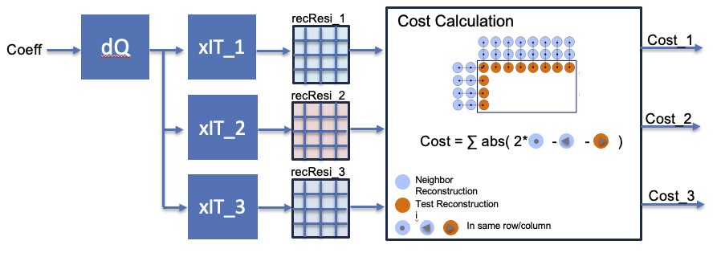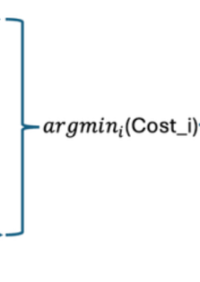
Figure 1: Illustration of PredLfnstIdx derivation of proposed method.
The following syntax elements are used to replace the existing intra lfnst_idx signalling as Table 2 shows.

if (pred_lfnstIdx_allowed_flag ){
lfnst_flag | ae(1)
if (lfnst_flag){
lfnst_pred_flag | ae(1)
if(!lfnst_pred_flag){
lfnstIdx_remainder | ae(1)
}
}
}
else{ // existing LfnstIdx coding
Table 2: Illustration of signalling of proposed method
lfnst_flag specifies whether the non-separable transform is used in current coding unit. lfnst_flag equal to 1 specifies that the non-separable transform is being used in current coding unit, equal to 0 specifies that the non-separable transform is not being used in current coding unit. When lfnst_flag is not present, it is inferred to be equal to 0.
lfnst_pred_flag specifies whether the predicted transform kernel is the transform kernel applied to the luma transform blocks in the current coding unit. lfnst_pred_flag equal to 1 specifies that the predicted transform kernel is the transform kernel applied to the luma transform blocks in the current coding unit, equal to 0 specifies that the predicted transform kernel is not the transform kernel applied to the luma transform blocks in the current coding unit.
lfnstIdx_remainder specifies which transform kernel is applied to the luma transform blocks in the current coding unit. lfnstIdx_remainder equal to 0 specifies that the first transform kernel that is not the predicted transform kernel is the transform kernel used. lfnstIdx_remainder equal to 1 specifies that the second transform kernel that is not the predicted transform kernel is the transform kernel used.
Figure 2 shows the flow chart to derive the variable LfnstIdx using in the proposed method.
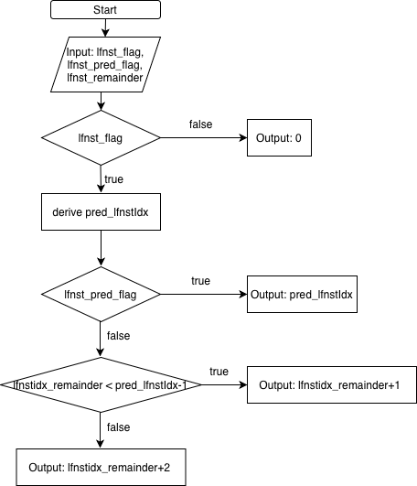
Figure 2: Illustration of LfnstIdx derivation through the proposed method.
More explicit version of LfnstIdx variable derivation based on PredLfnstIdx and lfnstIdx_remainder when lfnst_pred_flag is false is shown in the Table 3.

PredLfnstIdx | lfnstIdx_remainder | LfnstIdx
1 | 0 | 2
1 | 1 | 3
2 | 0 | 1
2 | 1 | 3
3 | 0 | 1
3 | 1 | 2
Table 3: Derivation of LfnstIdx variable based on PredLfnstIdx and lfnstIdx_remainder when lfnst_pred_flag is false
To implement the proposed methods, the following limitations are made to avoid conflicts with the existing methods in ECM-19:
- If MDIR is allowed, the proposed method is disabled.
- If the proposed method is allowed, sign prediction is disabled.
As a results, the proposed method shows slight compression improvement with visible complexity reduction that comes from fewer number of inverses transforms this method requires. More specifically the current method requires only three full inverse transforms, while the sign prediction method uses one full inverse transform and up to 16 sparse inverse transforms to construct the template, resulting in less complexity.

Experimental Results
The simulations are conducted on ECM-19.0 [1] under CTC [2].

 | All Intra Main10
 | Over ECM-19.0
 | Y | U | V | EncT | DecT | YUV1411
Class A1 | -0.03% | -0.16% | -0.11% | 98.2% | 100.4% | -0.04%
Class A2 | -0.02% | -0.18% | -0.13% | 98.2% | 99.7% | -0.04%
Class B | -0.01% | -0.14% | -0.14% | 98.4% | 98.3% | -0.02%
Class C | 0.00% | -0.20% | -0.22% | 99.2% | 98.8% | -0.02%
Class E | -0.03% | -0.18% | -0.06% | 97.9% | 97.8% | -0.04%
Overall | -0.01% | -0.17% | -0.14% | 98.4% | 98.9% | -0.03%
Class D | -0.03% | -0.47% | -0.28% | 100.3% | 98.6% | -0.08%
Class F | 0.01% | 0.01% | -0.16% | 97.4% | 98.1% | 0.00%
Class TGM | 0.00% | -0.03% | -0.03% | 97.8% | 98.9% | 0.00%

Conclusion
The proposed intra LfnstIdx prediction method shows minor consistent coding efficiency improvement and consistent runtime reduction over ECM-19.0 which is aligned with the theoretical analysis. It is proposed to investigate intra LfnstIdx prediction in the next round of EE.

References
- ECM-19.0, https://vcgit.hhi.fraunhofer.de/ecm/ECM/-/tags/ECM-19.0.
- M. Karczewicz, Y. Ye, “Common test conditions and evaluation procedures for enhanced compression tool testing”, JVET-AI2017, Sep. 2024.

Patent rights declaration(s)
Tencent may have current or pending patent rights relating to the technology described in this contribution and, conditioned on reciprocity, is prepared to grant licenses under reasonable and non-discriminatory terms as necessary for implementation of the resulting ITU-T Recommendation | ISO/IEC International Standard (per box 2 of the ITU-T/ITU-R/ISO/IEC patent statement and licensing declaration form).

