    Joint Video Experts Team (JVET)  of ITU-T SG21 WP3/21 and ISO/IEC JTC 1/SC 29  41st Meeting, by teleconference, 14–23 January 2026 | Document: JVET-AO0173-v3

Title: | [AHG11] A Hybrid Framework Integrating End-to-End Learned Intra-Frame Codec with Conventional Codec
Status: | Input document to JVET
Purpose: | Proposal
Author(s) or  Contact(s): | Nannan Zou  A. Burakhan Koyuncu  Antti Hallapuro  Francesco Cricri  Honglei Zhang  Jukka Ahonen  Miska M. Hannuksela | Email: | nannan.zou@nokia.com  burakhan.koyuncu@nokia.com  antti.hallapuro@nokia.com  francesco.cricri@nokia.com  honglei.1.zhang@nokia.com  jukka.1.ahonen@nokia.com  miska.hannuksela@nokia.com
Source: | Nokia
_____________________________

Abstract
This contribution proposes a hybrid framework that integrates end-to-end learned intra-frame compression (NLIC) methods with conventional compression techniques. The framework involves using NLIC-coded intra frames and VTM-coded inter frames. Furthermore, for each intra frame, the encoder decides whether to code it with NLIC or with VTM. Two sets of results are provided, depending on whether the NLIC was optimized by means of perceptual finetuning (PFT). With this hybrid framework, under the Random-Access configuration, the resulting BD-rates over NNVC-15.0 VTM (with NN tools off) anchor are reported to be as follows:
The system optimized with MSE and rate losses (no perceptual finetuning):
Overall -0,66 % (Y), -2,90 % (Cb), -1,31 % (Cr)
Additionally, the Random-Access simulation results are evaluated with 8 perceptual metrics, the resulting perceptual BD-rates over NNVC-15.0 VTM (with NN tools off) anchor are reported to be as follows:
 | AVG | msssim Torch | vif | fsim | nlpd | iw-ssim | vmaf | psnrHVS | lpips
W/O PFT | -1,57% | -1,87% | -2,17% | -1,15% | -0,90% | -1,57% | -0,64% | -0,66% | -2,69%
W/ PFT | -5,59% | -8,48% | -4,57% | -3,33% | -3,18% | -6,91% | -1,16% | -1,24% | -11,49%

Introduction
Recent research on end-to-end (E2E) learned image codecs has demonstrated superior performance [1] compared to the state-of-the-art conventional codecs like VVC. However, in the domain of video coding, E2E learned video codecs have yet to reach the performance levels achieved by non-learned codecs such as VVC, especially when evaluated on the Random-Access configuration. Moreover, conventional video codecs provide broader application support and are characterised by lower decoding complexity.
Therefore, we propose a hybrid framework that leverages the high performance of E2E learned intra-frame codecs (NLICs) while retaining the advantages of conventional video codecs for efficient video coding. In the proposed framework, we are aiming to use the reconstructed NLIC-coded intra frames as reference pictures to code inter frames by a conventional codec. Specifically, intra frames are temporarily encoded by both the NLIC and the standard VTM encoder, and the encoding method with lower rate-distortion cost is chosen. The decoder will invoke either the NLIC intra decoding or the VTM intra decoding, depending on the decision made by the encoder, and the resulting reconstructed intra frame is used as reference frame for inter-frame decoding. The method described here operates at the granularity of the entire fame.
In JVET-AJ0208 [2] and JVET-AA0063 [3], approaches related to the one proposed in this contribution are described. In JVET-AJ0208, DCVC-FM [4] was used as the NLIC for coding intra frames; frame-level decision was performed about either using NLIC-coded intra frames as reference frames for VTM-coding of intra frames, or normal VTM-coding of intra frames. Results for classes C and D showed gains in both luma and chroma components over a VTM anchor with LMCS tool off. In JVET-AA0063, a variant of a codec proposed as a JPEG-AI CfP response was used as the NLIC intra codec (YUV-420 format, trained with MSE loss); frame-level decision was performed about using either NLIC-coded intra frames or VTM-coded intra frames as reference frames for VTM-coding of inter-frames; results showed luma gains and chroma losses in RA configuration by using low-quality encoding configurations (QPs 32, 37, 42, 47).
In JVET-AK0146 [6], JVET-AL0203 [7], JVET-AM0057 [8] and JVET-AN0224 [9], similar systems to the one proposed in this document were presented. The main differences with respect to the current proposal are the following:
- In JVET-AK0146, the training dataset included DIV2K images, JPEG-AI images, and frames sampled with intra period 32 from BVI-DVC, UVG, CLIC2021, and TVD sequences. In JVET-AL0203, JVET-AM0057, JVET-AN0224 and the current contribution, the used dataset is different compared to JVET-AK0146.
- In JVET-AK0146, the NLIC complexity was 3.64 MMACs/pixel for the encoder and 8.54 MMACs/pixel for the decoder, with a total of 244.18 M parameters; in JVET-AL0203, the NLIC complexity was 2.97 MMACs/pixel for the encoder and 5.51 MMACs/pixel for the decoder, with a total of 225.82 M parameters; in JVET-AM0057 and JVET-AN0224, the NLIC complexity is 1.69 MMACs/pixel for the encoder and 2.25 MMACs/pixel for the decoder, with a total of 97.72 M parameters; in the current contribution, the NLIC complexity is 767 KMACs/pixel for the encoder and 1330 KMACs/pixel for the decoder, with a total of 187.58 M parameters
- In JVET-AK0146, the system was evaluated only based on PSNR as the quality metric (i.e., PSNR-based BD-rate). In addition to PSNR-based evaluation, JVET-AL0203 also included a perceptual evaluation of the system which was trained with MSE and rate losses only. In JVET-AM0057, JVET-AN0224 and the current contribution, we provide a perceptual evaluation of two systems: one trained using MSE and rate losses only, and the other further finetuned with a perceptual training loss (MS-SSIM) in addition to MSE, as the distortion term.
- In the current contribution, we rebased our framework on top of the latest NNVC software.

Methods
The proposed method uses an E2E learned intra-frame codec (NLIC) as one candidate codec for coding intra frames. The NLIC was designed for YUV420 format. We have trained 5 different NLIC models, corresponding to respective 5 bitrates or quality levels. In particular, the 5 models were trained to achieve the bitrates of VTM intra coding when sequence QPs are 22, 27, 32, 37, 42. It is to be noted that with some well-studied technologies a single model can be trained that achieves all required bitrates [4]. The following figure illustrates the architecture of the NLIC.
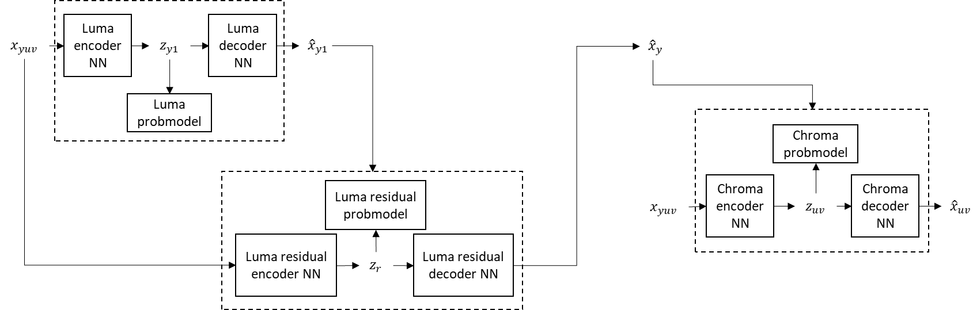

The NLIC was first trained by using MSE and rate losses for the PSNR-based evaluation. Subsequently, it was finetuned with a combination of MSE, MS-SSIM and rate losses for achieving higher perceptual quality. The training dataset was LSDIR dataset [5].
The complexity of our NLIC is 767 KMACs/pixel for the encoder (reduced by 79% compared to JVET-AK0146) and 1330 KMACs/pixel for the decoder (reduced by 84% compared to JVET-AK0146). The model size is 187.58 M parameters. It is to be noted that the NLIC has not been optimized in terms of complexity and size.
Firstly, the input I-frame is temporarily encoded using both the NLIC and the standard VTM encoding process. Next, the encoder decides whether to use the standard VTM-coded frame or the NLIC-coded frame based on their performance. If the encoder decides to use the NLIC coded intra frame, the decoded frame from the NLIC is added to VTM’s decoded picture buffer and is used as a reference frame for inter-frame prediction. Additionally, the NLIC bitstream for the coded intra frame is included in the video bitstream. Conversely, if the standard VTM-coded frame is selected, the NLIC bitstream for the coded intra frame is not included in the video bitstream.
A new NAL unit type was introduced to indicate the presence of an NLIC-coded intra frame and embed its corresponding bitstream. Neural network coded intra picture header was introduced to transfer data for NLIC encoded picture.

Results
The proposed method is tested according to the NNVC CTC (full length sequences for QP 22-42). In our experiments, NNVC-15.0 VTM (with NN tools off) serves as the anchor and the proposed method is also built on top of it. The AI results, RA results, and perceptual evaluation results are shown in the following tables. For the evaluation of the system without perceptual finetuning (W/O FPT), the distortion metric used for switching is MSE. In contrast, for the system with perceptual finetuning (W/ FPT), the distortion metric used for switching is MS-SSIM. Additionally, only the luma component is considered in the perceptual evaluation. It is to be noted that, in the reported AI results, input intra frames are intra frames from the RA configuration (i.e., they are a subset of the intra frames usually used in AI configuration). However, according to NNVC CTCs, QPs of intra frames in AI configuration are different from QPs of intra frames in RA configuration.
For the NLIC optimized with MSE and rate losses (no perceptual finetuning), the AI results and RA results are showed in the following tables:
 |  | All Intra Main10
 |  | BD-rate Over NNVC-15.0 VTM
 |  | Y-PSNR |  | U-PSNR |  | V-PSNR
Class A1 |  | 0,00 % |  | 0,00 % |  | 0,00 %
Class A2 |  | 0,00 % |  | 0,00 % |  | 0,00 %
Class B |  | 0,00 % |  | 0,00 % |  | 0,00 %
Class C |  | 0,00 % |  | 0,00 % |  | 0,00 %
Overall |  | 0,00 % |  | 0,00 % |  | 0,00 %
Class D |  | 0,00 % |  | 0,00 % |  | 0,00 %
 | Random access Main10
 | BD-rate Over NNVC-15.0 VTM
 | Y-PSNR |  | U-PSNR |  | V-PSNR
Class A1 | 0,18 % |  | -0,65 % |  | 0,84 %
Class A2 | -1,49 % |  | -4,85 % |  | -2,03 %
Class B | -0,77 % |  | -5,15 % |  | -2,02 %
Class C | -0,52 % |  | -0,30 % |  | -1,50 %
Overall | -0,66 % |  | -2,90 % |  | -1,31 %
Class D | -0,89 % |  | -2,19 % |  | -3,17 %

For the NLIC finetuned further with MSE, MS-SSIM and rate losses (i.e., with perceptual finetuning), the PSNR-based AI results and RA results are showed in the following tables:

 |  | All Intra Main10
 |  | BD-rate Over NNVC-15.0 VTM
 |  | Y-PSNR |  | U-PSNR |  | V-PSNR
Class A1 |  | 19,59 % |  | 102,13 % |  | 41,11 %
Class A2 |  | 15,28 % |  | 30,98 % |  | 49,74 %
Class B |  | 16,64 % |  | 24,00 % |  | 26,00 %
Class C |  | 6,40 % |  | 25,04 % |  | 23,79 %
Overall |  | 14,23 % |  | 41,30 % |  | 33,18 %
Class D |  | 1,90 % |  | 20,73 % |  | 22,03 %
 | Random access Main10
 | BD-rate Over NNVC-15.0 VTM
 | Y-PSNR |  | U-PSNR |  | V-PSNR
Class A1 | 2,90 % |  | 1,84 % |  | 0,55 %
Class A2 | -0,23 % |  | -6,48 % |  | -2,38 %
Class B | 0,22 % |  | -7,82 % |  | -5,81 %
Class C | 0,87 % |  | 5,06 % |  | 3,61 %
Overall | 0,84 % |  | -2,19 % |  | -1,34 %
Class D | 0,02 % |  | 4,95 % |  | 5,31 %

The resulting perceptual BD-rates over NNVC-15.0 VTM (with NN tools off) anchor are reported to be as follows:

 |  | Perceptual Evaluation All Intra BD-rate (QP=22, 27, 32, 37, 42)
 |  | BD rate vs NNVC-15.0VTM
Test | AVG | msssim Torch | vif | fsim | nlpd | iw-ssim | vmaf | psnrHVS | lpips
Proposal W/O PFT | 0,0% | 0,0% | 0,0% | 0,0% | 0,0% | 0,0% | 0,0% | 0,0% | 0,0%
Proposal  W/ PFT | -13,90% | -24,03% | 1,38% | -19,20% | -9,94% | -21,73% | -12,58% | -5,64% | -11,18%

 |  | Perceptual Evaluation Random Access BD-rate (QP=22, 27, 32, 37, 42)
 |  | BD rate vs NNVC-15.0VTM
Test | AVG | msssim Torch | vif | fsim | nlpd | iw-ssim | vmaf | psnrHVS | lpips
Proposal W/O PFT | -1,57% | -1,87% | -2,17% | -1,15% | -0,90% | -1,57% | -0,64% | -0,66% | -2,69%
Proposal  W/ PFT | -5,59% | -8,48% | -4,57% | -3,33% | -3,18% | -6,91% | -1,16% | -1,24% | -11,49%

In the following table, we provide average decoding-time measurements of I-frames for VTM and NLIC, respectively. For NLIC, the decoding time is measured both on CPU and GPU for low and high coding quality. The results were respectively obtained on a single AMD EPYC 9475F @ 3.65GHz CPU and an A100 GPU.

 | Runtime (s) for high quality (QP 22)
 | VTM | NLIC (GPU) |  | NLIC (CPU)
 | Decoder | Decoder |  | Decoder
 | Decoder | Absolute | Relative to VTM | Absolute | Relative to VTM
Class A | 5.71 | 4.20 | 0.74 | 1448.95 | 254
Class B | 2.73 | 1.85 | 0.68 | 576.69 | 211
Class C | 0.78 | 1.06 | 1.36 | 121.21 | 155
Class D | 0.23 | 0.38 | 1.65 | 45.12 | 196

 | Runtime (s) for low Quality (QP 42)
 | VTM | NLIC (GPU) |  | NLIC (CPU)
 | Decoder | Decoder |  | Decoder
 | Decoder | Absolute | Relative to VTM | Absolute | Relative to VTM
Class A | 2.27 | 3.80 | 1.67 | 1449.31 | 638
Class B | 1.05 | 1.65 | 1.57 | 578.81 | 551
Class C | 0.28 | 0.52 | 1.86 | 120.79 | 431
Class D | 0.08 | 0.37 | 4.63 | 45.05 | 563
The results show that NLIC has a higher CPU decoding time compared to VTM for all classes, because the NLIC has not been optimized in terms of complexity. However, using GPU, which is a more proper hardware platform for a neural network, the NLIC decoding is comparable to VTM decoding for most classes.

Visual examples
In this section, we provide a few examples in order to assess the impact of the NLIC (both W/O PFT and W/ PFT) visually other than by means of objective metrics. We show pictures coded with anchor, with NLIC W/O PFT and with NLIC W/ PFT. Both intra and inter pictures are provided. For each example picture, we provide related objective metrics as reference. As can be observed, higher values of reported perceptual metrics correlate with visually higher quality. Also, it can be observed that finetuning the NLIC on a perceptual metric (MS-SSIM) further improves the perceptual metrics and the visual quality. Finally, it can be observed that perceptual improvements can be propagated from intra frames to inter frames.
Intra frames (D_BasketballPass, frame 256, simulation sequence QP=37):
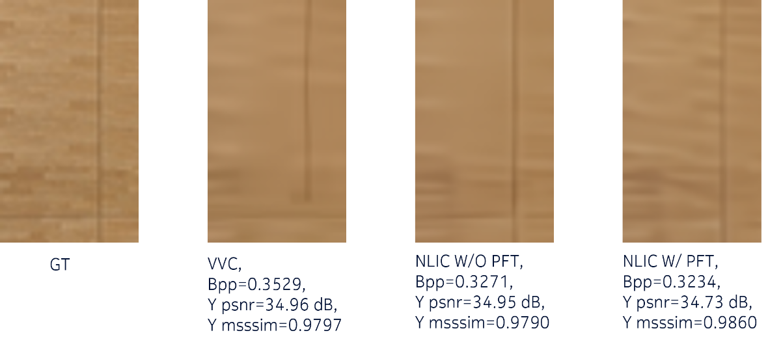
Inter frames (D_BasketballPass, frame 270, simulation sequence QP=37):
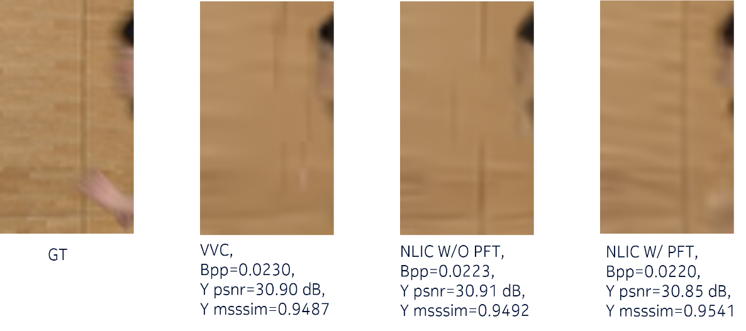

Conclusion

In this contribution, we propose a hybrid framework featuring an E2E learned intra codec coupled with a traditional video codec, demonstrating performance gains over the anchor. In the future, we plan to further reduce the complexity of the NLIC and improve the gains of the proposed hybrid framework.
It is recommended to continue the EE1 tests on studying the combination of NLIC and conventional coding, where intra-frame coding may be performed by an NLIC and inter-frame coding is performed by VTM, and include our proposed technology. Additionally, it is recommended to evaluate proposals also based on perceptual metrics.

References
- H.Zhang, F.Cricri, H.R.Tavakoli, E.Aksu and M.M.Hannuksela. “Leveraging Progressive Model and Overfitting for Efficient Learned Image Compression.” arXiv preprint arXiv:2210.04112. 2022.
- F.Brand, T.Solovyev and E.Alshina. “AHG11: Towards Incorporating End-To-End Learning-Based Image Coding into Traditional Codec.” JVET-AJ0208. November 2024.
- Y.He, B.Wang, E.Alshina and J.Sauer. “AHG11: A hybrid codec using E2E image coding combined with VVC video coding.” JVET-AA0063. July 2022.
- Li, Jiahao, Bin Li, and Yan Lu. "Neural video compression with feature modulation." Proceedings of the IEEE/CVF Conference on Computer Vision and Pattern Recognition. 2024.
- Li, Yawei, et al. "Lsdir: A large scale dataset for image restoration." Proceedings of the IEEE/CVF Conference on Computer Vision and Pattern Recognition. 2023.
- N.Zou, A.Hallapuro, F.Cricri, H.Zhang, M.M.Hannuksela. “AGH11: A Hybrid Framework Integrating End-to-End Learned Image Codec with Conventional Codec.” JVET-AK0146, January 2025.
- N.Zou, A.Hallapuro, F.Cricri, H.Zhang, A.B.Koyuncu, J.Ahonen, M.M.Hannuksela. “AGH11: A Hybrid Framework Integrating End-to-End Learned Image Codec with Conventional Codec.” JVET-AL0203, March 2025.
- N.Zou, A.Hallapuro, F.Cricri, H.Zhang, A.B.Koyuncu, J.Ahonen, M.M.Hannuksela. “AGH11: A Hybrid Framework Integrating End-to-End Learned Image Codec with Conventional Codec.” JVET-AM0057, June 2025.
- N.Zou, A.Hallapuro, F.Cricri, H.Zhang, A.B.Koyuncu, J.Ahonen, M.M.Hannuksela. “AGH11: A Hybrid Framework Integrating End-to-End Learned Image Codec with Conventional Codec.” JVET-AN0224, Octobor 2025.

Patent rights declaration(s)
Nokia may have current or pending patent rights relating to the technology described in this contribution and, conditioned on reciprocity, is prepared to grant licenses under reasonable and non-discriminatory terms as necessary for implementation of the resulting ITU-T Recommendation | ISO/IEC International Standard (per box 2 of the ITU-T/ITU-R/ISO/IEC patent statement and licensing declaration form).

