    Joint Video Experts Team (JVET)  of ITU-T SG21 WP3/21 and ISO/IEC JTC 1/SC 29  41st Meeting, by teleconference, 14–23 January 2026 | Document: JVET-AO0123-v1

Title: | AHG18: Standalone network simulation application on top of ULL software
Status: | Input document to JVET
Purpose: | Proposal
Author(s) or  Contact(s): | Kirill Malyshev  Ivan Gribushin  Vyacheslav Khamidullin  Maxim Sychev  Sergey Ikonin  Elena Alshina | Email: | sergey.ikonin@huawei.com  elena.alshina@huawei.com
Source: | Huawei Technologies
_____________________________

Abstract
This document proposes the software modifications on top of AHG18 simulation software allowing to use network simulation as standalone application separated from encoding and decoding process. The standalone application, similarly to JVET-AK0057, parses Annex B format bitstream, and provides a flexibility for testing of various video coding solutions under desired network scenario using pre-encoded uncorrupted bitstreams, and is applicable for broadcasting scenario with no feedback. The proposed modifications keep the network model behavior same as described in CTC document JVET-AN2039 and implemented in JVET-AO0047, providing the capability of configuring network transmission priorities using configuration file additionally. Option to link network model with encoding application is also remains, which makes possible to test unicast scenario using VTM based software.

Introduction
The AHG18 simulation software includes VTM encoder, decoder, and network model with packetization and emulation of transmission based on pre-recorded packet trace files. The jitter buffer included into network model collects NAL units back from packets received by the time constrained by the latency restriction. In the current version of AHG18 software the network model is linked together with encoder application. Such configuration allows to emulate feedback channel to enable adjustment of encoding process depending on delivery status of specific NAL units in unicast scenario.
Encoder App

Decoder
Encoder
Network model
Packet trace file
Jitter buffer
Latency restriction, ms
feedback, optional
Decoder App

Figure 1 Current AHG18 simulation software architecture
The current proposal introduces an option to link network simulation as standalone application. The standalone network application provides more flexibility for testing 3rd party video coding solutions under desired network scenario using pre-encoded uncorrupted bitstreams. Such functionality was discussed during AHG18 conversation for supporting CfP responses based on different SW-bases. Moreover, the independent network model provides more clarity in simulation by restricting access to network state by the encoder/decoder applications. It should be noted that standalone network simulation application can only be used for testing of broadcast scenario since feedback channel to encoding side would not be possible. For unicast scenario an option of linking network model with encoder application still can be used.

Network App
The figure below illustrated the network model linked is standalone application encapsulating network transmission functionality.

Figure 2 Proposed architecture modification separating network simulation to a standalone application
Encoder App

Network App

Decoder App

Decoder
Encoder
Network model
Packet trace file
Jitter buffer
Latency restriction, ms
Following concept of JVET-AK0057 the network application can parse Annex-B bitstreams, perform packetization and network simulation same way as current AHG18 software, and store only NAL units successful received under latency restriction limitations.
The network application obtains settings and bitstream data as input, processes each Access Unit by network model simulation, handles the transmission and receiving packets, and finally writes the processed data to an output file.
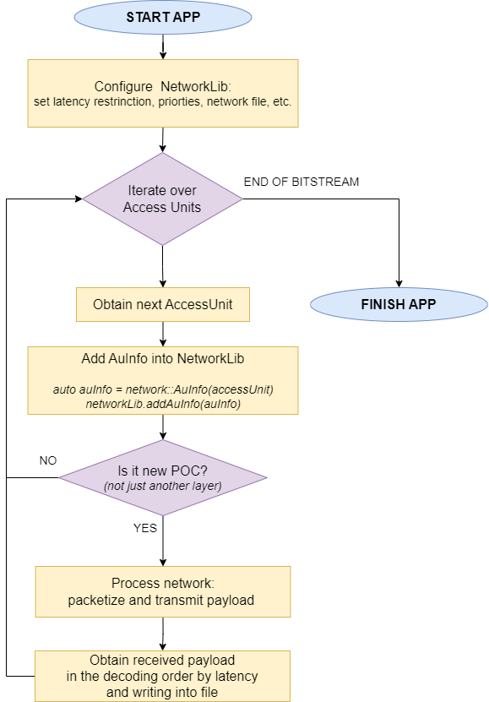
Figure 3 Flowchart of main pipeline of the standalone network application
Raw bitstream processing follows same mechanisms as in other standalone applications like StreamMergeApp and parcat. Iterating over NAL units and AccessUnit construction is implemented inside AccessUnitGenerator class. Some of NAL units are parsed to obtain necessary information not included in NAL unit header (e.g. POC value). The main function obtains the AccessUnit and sends it to NetworkLib that performs transmission simulation and storing only NAL units that were successfully received under the latency constraint.

Building
To use network simulation functionality JVET_AK0193_NETWORK_MODEL macro (enabled by default) should be turned on.
The building process following VTM-based applications practice
cmake .. -D CMAKE_BUILD_TYPE=Release
cmake --build . -j --target NetworkApp

Network configuration file format
The current contribution further introduces the configuration file format to specify network emulation settings including transmission priorities in a convenient way. The following options are introduced to configure network model application:
A TrafficTypeEntry keyword is introduced to be used in configuration file to specify the network behaviour in respect to specific parts of the bitstream. The example of such a configuration for ULL VTM anchor is as follows:
# Checking conditions in the TrafficTypeEntry<id> order
# <...>Num = -1 means ALL
# TrafficTypeEntry Priority LayerIDs TemporalIDs NALUTypes LifeTime Bypass
# Any NAL_UNIT_PREFIX_APS
TrafficTypeEntry0: 0 -1 -1 17 512 0
# Any remaining NALU
TrafficTypeEntry1: 1 -1 -1 -1 512 0
This file contains table that describes different traffic types which should be transmitted separately, possible with different priorities and lifetime settings.
Fields of the table:
- Priority: integer value from 0 to 7, where 0 means the highest priority, such packet will be sent to network first
- LayerIDs: set of spatial layers separated by comma
- TemporalIDs: set of temporal layers separated by comma
- NALUTypes: set of NAL unit types separated by comma
- LifeTime: packet lifetime
- Bypass: bypass the network model without actual transmission
Columns 2-4 define the rules for determining TrafficType for the target NAL Units. The rules are applied for TrafficTypeEntry<id> iteratively in the increasing id order until rules for some TrafficTypeEntry will be satisfied. Singe value -1 in columns 2-4 means that rules are being applied for all possible values corresponded to particular column. Asterisk (*) in column LifeTime correspond to lifetime equal to the value LatencyRestriction.
More examples are presented below.
ULL SVTM anchor:
# TrafficTypeEntry Priority LayerIDs TemporalIDs NALUTypes LifeTime Bypass
# LayerId=0, NAL_UNIT_PREFIX_APS
TrafficTypeEntry0: 0 0 -1 17 512 0
# LayerId=1, NAL_UNIT_PREFIX_APS, set lifetime equal latency
TrafficTypeEntry1: 2 -1 -1 17 * 0
# Any remaining NALU for LayerId=0
TrafficTypeEntry2: 1 0 -1 -1 512 0

# Any remaining NALU (LayerId=1), set lifetime equal latency
TrafficTypeEntry3: 2 -1 -1 -1 * 0

ULL VTM JVET-AO0048 including data partitioning NAL units B (type=28):
# TrafficTypeEntry Priority LayerIDs TemporalIDs NALUTypes LifeTime Bypass
# Any NAL_UNIT_PREFIX_APS
TrafficTypeEntry0: 0 -1 -1 17 512 0
# Any NAL_UNIT_B, set lifetime equal latency
TrafficTypeEntry1: 2 -1 -1 28 * 0
# Any remaining NALU
TrafficTypeEntry2: 1 -1 -1 -1 512 0
ULL SVTM JVET-AO0048 including data partitioning NAL units B (type=28):
# TrafficTypeEntry Priority LayerIDs TemporalIDs NALUTypes LifeTime Bypass
# LayerId=0, NAL_UNIT_PREFIX_APS
TrafficTypeEntry0: 0 0 -1 17 512 0
# LayerId=1, NAL_UNIT_PREFIX_APS
TrafficTypeEntry1: 2 -1 -1 17 * 0
# Any NAL_UNIT_B, set lifetime equal latency
TrafficTypeEntry2: 2 -1 -1 28 * 0
# Any remaining NALU
TrafficTypeEntry3: 1 -1 -1 -1 512 0

Usage example
Example of the run command line is specified below:
./NetworkAppStatic -fr <FrameRate> -f <FrameNumber> --MaxLayers=<SpatialLayersNum> \
--PacketTracePath=<TraceFile> --PacketTraceStartLine=<TraceStartLine> \
--LatencyRestriction=<Latency> -c <traffic_settings.cfg> \
--BitstreamFileInput=<InputCleanBitsreamPath> \
--BitstreamFileOutput=<OutputBitsreamPath>

Network Lib
Network simulation part can be linked to encoder application as it is currently implemented in AHG18 simulation software. Such configuration makes possible to enable feedback channel functionality in unicast scenario (Figure 1). JVET_AK0193_NETWORK_MODEL macro should be turned on for using network simulation functionality. The same set of options as for standalone application may be used. The network model will be activated only if PacketTracePath option is set. If this option is not specified the encoder app will do encoding in a regular way producing clean channel uncorrupted bitstream. Additionally, feedback related options such as UseFeedback and FeedbackDelay may be set.
Being linked with encoder application the network library enables support of network configuration file specified in section 3. The example of command line supporting this functionality is as follows:
./bin/EncoderAppStatic -c cfg/encoder_lowdelay_vtm.cfg \
-c cfg/alternative-addon/reduced_runtime3.cfg -q 22 -f 64 -fr 50 \
-i BasketballDrive_1920x1080_50fps_8bit_420.yuv -wdt 1920 -hgt 1080 \
-b simulated.bin -o clean_rec.yuv -v 6 \
--InputBitDepth=8 --OutputBitDepth=8 --DecodingRefreshType=1 \
--PacketTracePath=<TraceFile> --PacketTraceStartLine=<TraceStartLine> \
--LatencyRestriction=<Latency> -c <traffic_settings.cfg> \
--UseFeedback=1 --FeedbackDelay=40

Conclusion
This document describes the software modifications on top of AHG18 simulation software allowing to use network simulation as standalone application separated from encoding and decoding process using Annex B bitstream format. The standalone application provides a flexibility for testing of various video coding solutions under desired network scenario using pre-encoded uncorrupted bitstreams, and can be applicable for broadcasting scenario with no feedback. Option to link network model with encoding application is also remains, which makes possible to test unicast scenario using VTM based software. The network model behavior is kept the same as described in CTC document JVET-AN2039 and implemented in JVET-AO0047. Additionally, the capability of using more convenient configuration file to configure network transmission priorities is further provided.
It is proposed to add described above software modifications to AHG18 software branch.

Patent rights declaration(s)
Huawei Technologies does not have any current or pending patent rights relating to the technology described in this contribution.

