    Joint Video Experts Team (JVET)  of ITU-T SG21 WP3/21 and ISO/IEC JTC 1/SC 29  41st Meeting, by teleconference, 14 – 23 January 2026 | Document: JVET-AO0053_v1

Title: | [AHG19] Response to the questionnaire on VVC hardware encoder implementation challenges
Status: | Input document to JVET
Purpose: | Information
Author(s) or  Contact(s): | Muxuan Wu  Jianhua Yu (HiSilicon)  Yin Zhao  Elena Alshina (Huawei) | Tel:  Email: | yin.zhao@huawei.com
Source: | HiSilicon Technologies, Huawei Technologies
_____________________________

Abstract
This contribution introduces an example of hardware encoder architecture and summarizes some major differences between hardware encoder and reference model. Besides, it provides answers to the AHG19 questionnaire on VVC hardware encoder implementation challenges.

An example of hardware encoder architecture
This section introduces an encoder architecture that is in favored by the proponent.

3-stage encoding pipeline
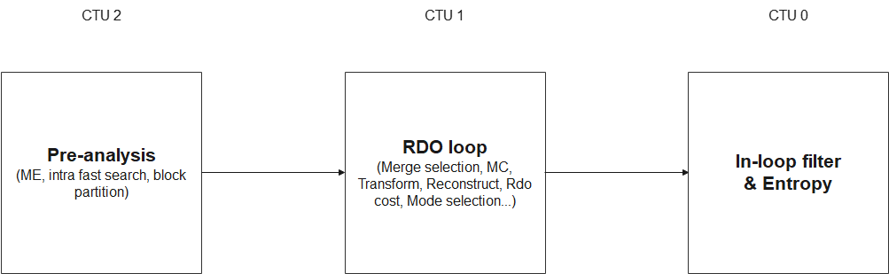
Figure 1. A 3-stage CTU hardware encoding pipeline
In the hardware architecture, the computation of each CTU is divided into three pipeline stages (as shown in Figure 1):
- Pre-analysis
- RDO loop
- In-loop filter and entropy coding
These three stages operate in parallel, and each stage must be completed within the time constraints specified by the hardware specifications (as shown in Figure 2).
The RDO loop stage is the primary source of computation and complexity. The computations within the RDO loop are in general similar to the “compressCtu()” function in the VTM reference software, which is highly complex. Therefore, to reduce the computational complexity of the RDO loop, some of the computations are transferred to the pre-analysis stage, and pre-selection of coding tools by the pre-analysis stage is used to reduce the number of operations in the RDO loop stage, such as motion estimation, intra fast search and block partition reduction.
The third stage involves entropy encoding and the reconstruction of pixels after applying the in-loop filter. To avoid increasing the data storage requirements for frame-level operations due to the in-loop filter, the in-loop filter is performed on a per-CTU basis. This imposes certain limitations on frame-level parameter calculation, as it is not possible to perform statistical analysis using the pixels of the current frame.

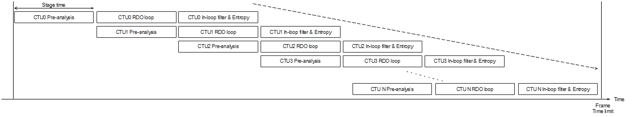
Figure 2. Frame latency of the 3-stage pipeline

More details on Stage 1
Stage 1 selects the coding mode for RDO (Rate-Distortion Optimization) and performs some pre-processing of certain coding modes. The purpose is to reduce the computational load in Stage 2 (RDO loop), such as reducing the number of RDO candidates per CU and pre-computing parameters that do not depend on the coding order between CUs. The first stage of computation will minimize dependencies between CUs, making it easier for hardware architects to optimize the computational cost.
In addition, since the coding results of the left CTU (Coding Tree Unit) have not yet been generated, these coding results cannot be referenced during the computation process. The first stage of computation typically includes motion vector (MV) search, pre-selection of intra-prediction modes, and restrictions on coding tree partitioning.

More details on Stage 2
Stage 2 is the most important and complex RDO operation in the encoding process, and it determines the CU partitioning, coding mode, and reconstructed pixels before the in-loop filters based on the RDO results.
In hardware design, different CU sizes are processed in parallel, and the time limit for processing large CU sizes is increased (as shown in Figure 3). Therefore, it is required to complete the computation of a CU64x64 within the CTU unit time, while it is also necessary to sequentially compute 256 CU4x4 within the same CTU unit time.
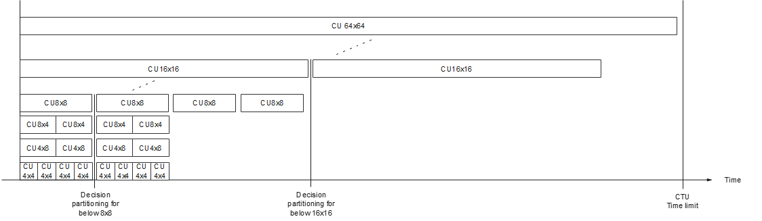
Figure 3. Parallel computation between CU sizes
Once the variety of CU sizes increases, the computational workload of the RDO loop will also increase accordingly. Therefore, a preprocessing step is performed in the first stage to limit the total number of CU sizes, for example, adaptively disabling the RDO for CU64x64 or CU4x4, or restricting Binary Tree (BT) partitioning to try only one of horizontal and vertical BT modes, thereby reducing the maximum computational load required by the RDO loop.
Each CU must perform RDO across multiple coding modes. Parallel processing is employed to extend the available computation time for each RDO evaluation (as shown in Figure 4). The RDO procedure includes prediction, transform, quantization, inverse transform, dequantization, and reconstruction, and RD cost calculation (including bits estimation and distortion calculation). This sequence forms the primary critical path in the encoder pipeline. Hardware designers typically optimize the parallelism of each operation to satisfy stringent timing constraints.
Although not every merge mode requires an RDO-based decision, the evaluation of merge modes depends on the execution order of CUs in a RDO loop, since the merge candidates of a CU rely on reconstructed MVs of neighboring blocks. Consequently, the SAD-based pre-decision for merge modes is performed prior to executing the RDO process for those merge modes.
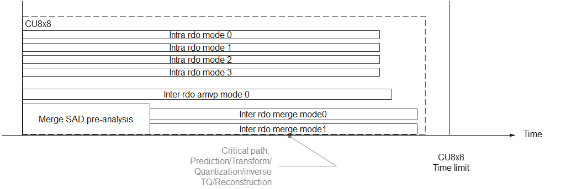
Figure 4. Example of Parallel RDO for CU8x8
In hardware architecture design, multiple RDO computations are processed in parallel to meet time constraints. To improve circuit utilization, hardware architects often use pixel-level pipeline architectures to share computational resources along the RDO path. However, this also increases the computation time for each CU. Therefore, designing an RDO loop that meets the worst-case time constraints while optimizing the required computational resources is a major challenge.

More details on Stage 3
Stage 3 encodes the content of the current CTU into the output bitstream and generates the reconstructed pixels after applying the in-loop filters. For each CTU, both the filter parameters and the filtered pixels must be computed. Since Adaptive Loop Filtering (ALF) employs frame-level filter parameters, these parameters cannot be estimated solely based on the current CTU. Therefore, the filter parameters used for the current CTU are derived from statistics accumulated from previously processed frames, thereby avoiding additional frame-level data storage for parameter estimation.
Within the ALF module, two processing units are employed: one dedicated to estimating the filter parameters for the current frame, and another responsible for making filtering decisions based on the already-available filter parameters.

Response to the AHG19 questionnaire
Response to the questionnaire is in the attachment of the proposal. Some of our opinions are related to the 3-stage encoding architecture mentioned in Section 1.

Conclusion and suggestions
Some differences between hardware encoder and VTM reference software are introduced in this proposal. Critical path and the ratio between coding gain and chip area consumption are two critical aspects to decide the implementation of certain tools in hardware encoder. Increasing parallelism of coding tools can make hardware encoder implementation easier. Coding tools that do not rely on RDO are generally more friendly for hardware encoder implementation. According to our engineering experience, it is worthwhile to implement a coding tool requiring additional RDO if this tool can bring at least 1% coding gain by increasing 1 RDO.
It is recommended to consider the 3-stage pipeline as one of the hardware encoder architectures for reference during the development of the next-generation standard. Since AHG19 is conceiving a hardware encoding mimicking simulation framework on top of test models, it is recommended to consider implementing a similar framework on top of VTM.

Patent rights declaration(s)
HiSilicon Technologies Co. Ltd. may have current or pending patent rights relating to the technology described in this contribution and, conditioned on reciprocity, is prepared to grant licenses under reasonable and non-discriminatory terms as necessary for implementation of the resulting ITU-T Recommendation | ISO/IEC International Standard (per box 2 of the ITU-T/ITU-R/ISO/IEC patent statement and licensing declaration form).
Huawei Technologies Co. Ltd. may have current or pending patent rights relating to the technology described in this contribution and, conditioned on reciprocity, is prepared to grant licenses under reasonable and non-discriminatory terms as necessary for implementation of the resulting ITU-T Recommendation | ISO/IEC International Standard (per box 2 of the ITU-T/ITU-R/ISO/IEC patent statement and licensing declaration form).

