    Joint Video Experts Team (JVET)  of ITU-T SG21 WP3/21 and ISO/IEC JTC 1/SC 29  41st Meeting, by teleconference, 14–23 January 2026 | Document: JVET-AO0052-v2

Title: | AHG17/AHG18: Suggested CfP text for ultra-low latency and packet loss resilience category
Status: | Input document to JVET
Purpose: | Proposal
Author(s) or  Contact(s): | Sergey Ikonin  Xiang Ma  Elena Alshina | Email: | sergey.ikonin@huawei.com  maxiang6@huawei.com  elena.alshina@huawei.com
Source: | Huawei Technologies
_____________________________

Abstract
This contribution suggests a text for functionality test on ultra-low latency and packet loss resilience as specific category for future Call for Proposals. Based on contribution JVET-AN0204, JVET-AN2039 ULL CTC, CfE evaluation discussion, and discussion of AHG18 teleconference summarised in JVET-AO0049 a marked-up version of JVET-AO0045 “Draft Joint Call for Proposals on video compression with capability beyond VVC (initial text)” covering ultra-low latency and packet loss resilience category is provided.
In 2nd revision of the document the suggested CfP testing procedure was optimized towards the conditions used in CfE evaluation. The total amount of tests required for one submission is 80, including 40 unicast, and 40 broadcast tests.
In 3rd revision of the document some references to latest communication standard contributions (6G and Wi-Fi) on requirements and use cases concerning low latency has been added.

Introduction
Addressing the requirements mentioned in sections 9 “Packet loss resilience” 6 “End-to-end delay” of the document WG2/N 448 “Draft of use cases and requirements for potential next-generation video coding standard beyond VVC capability” this contribution proposes to include ultra-low latency and packet loss resilience as specific category for future joint Call for Proposals.
Based on previous discussions of AHG18, contribution JVET-AN0204 suggesting first version of CfP test, ULL CTC document JVET-AN2039, CfE evaluation discussion of JVET 40th meeting, and discussion of AHG18 teleconference summarised in JVET-AO0049 this contribution suggests a text for functionality test on ultra-low latency and packet loss resilience as specific category for future Call for Proposals as marked-up version of JVET-AO0045 “Draft Joint Call for Proposals on video compression with capability beyond VVC (initial text)” uploaded with this contribution. Following the style of JVET-AO0045 the marked-up version also contains related meeting notes marked by yellow.
Following up the discussion, in the second revision of the document the suggested CfP testing setup was simplified towards the conditions used during CfE evaluation. The Gaming sequences were further removed from broadcasting scenario in order to have same number of sequences in each scenario.
The total amount of tests required for one single submission: 80 = 40 (unicast) + 40 (broadcast). The evaluation of anchor would require another 80 tests.

Study on Use Cases and Service Requirements

6G 3GPP
Document “Study on 6G Use Cases and Service Requirements” [2] contains multiple use cases and requirements towards 6G development. The section 9.11 “Use case on real time VR live service with determinizing user experience” of that document is cited here as example relevant to the context of the current discussion.
The section 9.11 considers immersive real time services such as VR, which has high amount of data to be transmitted. With high data rates required the user experience can hardly be guarantied at the condition when a user is at poor coverage or a bandwidth limited place. With the advent of advanced algorithm (AI or non-AI), it can help to recover the information of the receiving end even when the receiving end lost a part of information incurred by the poor communication link, which is called “Error tolerant communication”.
AI-based video encoding and decoding method called GRACE [3] is considered as an example of such error tolerant coding method helping to provide deterministic user experience.
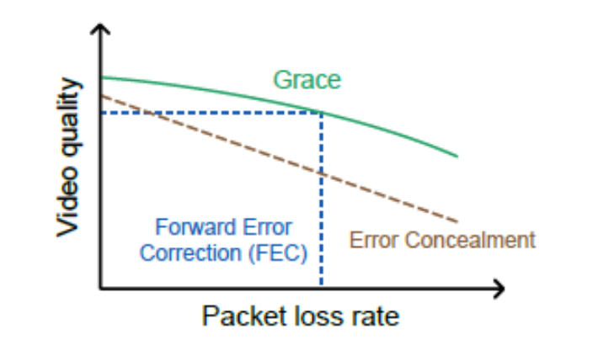
Figure 1Illustration of the video quality achieved by different loss-resilient schemes, operating under the same bandwidth budget, across varying packet loss rates [3]
Furthermore, since the VR/AR content is usually composed of multiple kinds, the application can divide it into categories with different importance. An example is shown in the table below
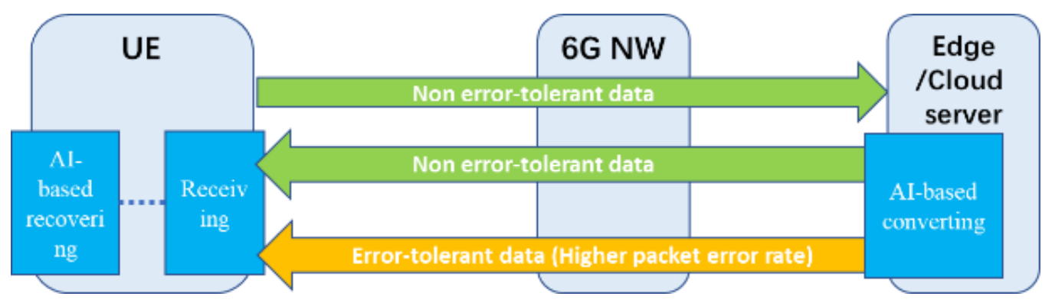
Figure 2 Error-tolerant data transmission for real time immersive service [2]
When a communication link status is bad, the communication can transmit error tolerant data with high error rate or even no transmitting while still guaranteeing the low error loss rate for the non-error tolerant data, It hence greatly reduces the transmission burden while using the a proper algorithm (e.g. using AI model) to guarantee a deterministic user experience such as restore the missed content at the receiving end, which can achieve the same level of user experience (e.g. QoE) compared to a good communication link condition

Wi-Fi 7/8 IEEE SA
Starting from Wi-Fi 7 standard development (Jan 2019) IEEE Standard Association recognized importance of low latency requirement and trying to solve low latency communication problem [4].
During development of Wi-Fi 8 (P802.11bn) standard in “Project Authorization Request” document [5] it was noted that the low latency and packet error resilience problem are not solved yet and in the future plans low latency problem will not reduce totally:
“• at least one mode of operation capable of reducing latency by 25% for the 95th percentile of the latency distribution compared to the Extremely High Throughput MAC/PHY operation and
• at least one mode of operation capable of reducing MAC Protocol Data Unit (MPDU) loss by 25% compared to the Extremely High Throughput MAC/PHY operation for a given scenario, especially for transitions between BSSs“

Wi-Fi 9 IEEE SA
During latest Wi-Fi meeting held in January 2026 people are discussing proposals and requirements in context of next generation Wi-Fi 9 development. Several contributions are emphasizing importance of continuing solving low latency problem.
Namely, documents “Exploring Evolution to Emerging Concepts Beyond 11bn” [6] and “Next 802.11 generation after 11bn” [7] contain use cases and requirements towards Wi-Fi 9 development. It was mentioned that Wi-Fi 7/8 technologies currently do not expect to fully satisfy the requirements for low latency and reliability requirements.
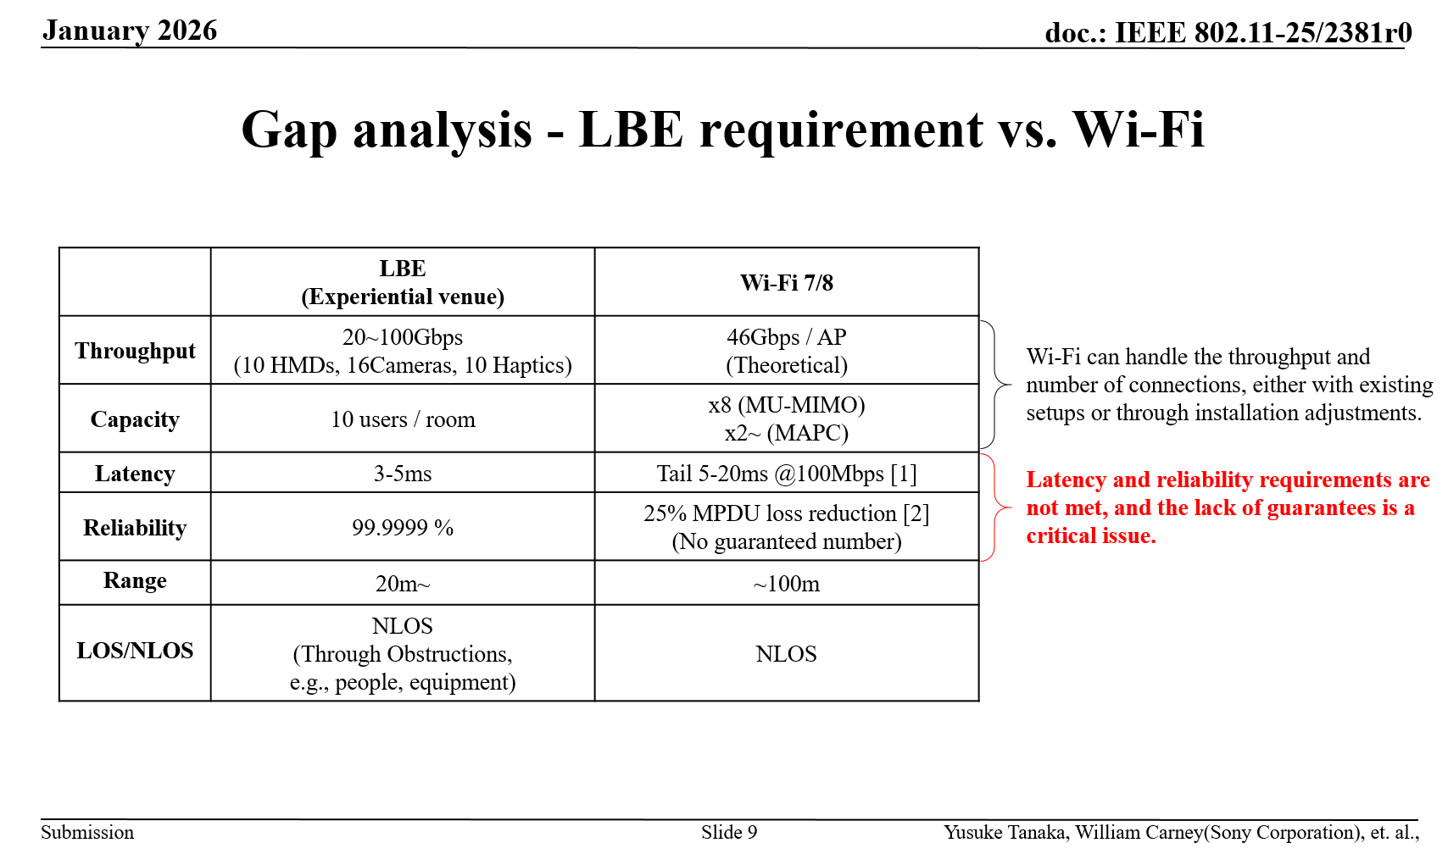
Figure 3 Location Based Entertainment (LBE) requirements for low latency and reliability [6]
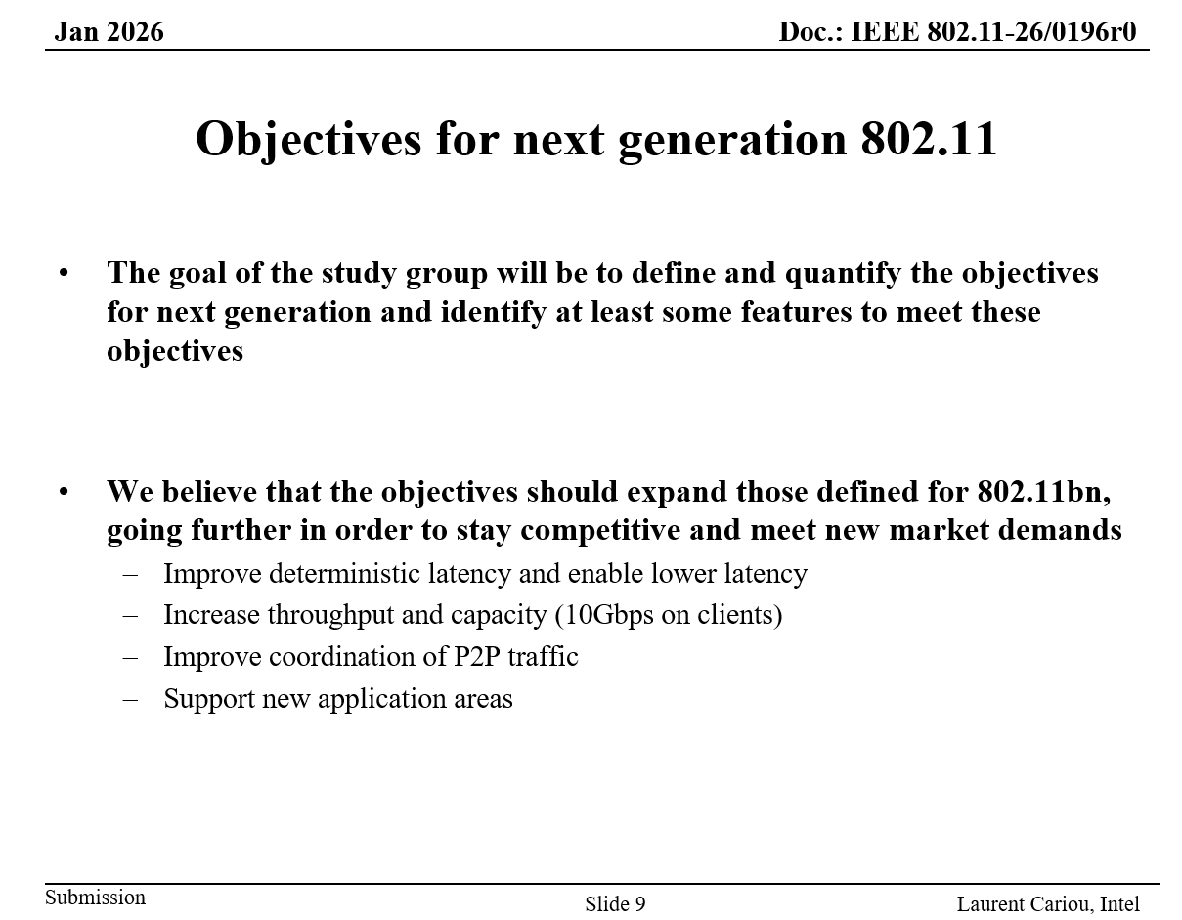
Figure 4 Objectives for next generation 802.11 (Wi-Fi 9) [7]
I can be concluded that low latency scenario is still in focus in current and future standards under development.

References
- “Draft of use cases and requirements for potential next-generation video coding standard beyond VVC capability”, ISO/IEC SC 29/WG 2 document N 448 and ITU-T Q6/21 document VCEG-BX25, April 2025
- “Study on 6G Use Cases and Service Requirements”, document 22.870/1.0.1, December 2025
- Cheng Y, Zhang Z, Li H, et al. "GRACE: Loss-Resilient Real-Time Video through Neural Codecs". 21st USENIX Symposium on Networked System Design and Implementation (NSDI 24). 2024: 509-531. ((GRACE: Loss-Resilient Real-Time Video through Neural Codecs | USENIX).
- P802.11be Project Authorization Request, IEEE Standard Association, 2019-2023, https://www.ieee802.org/11/PARs/P802_11be_PAR_Detail.pdf
- P802.11bn Project Authorization Request, IEEE Standard Association, 2023-2027, https://grouper.ieee.org/groups/802/11/PARs/P802.11bn_PAR.pdf
- “Exploring Evolution to Emerging Concepts Beyond 11bn” IEEE 802.11-25/2381r0, Sony Corporation, January 2026, https://mentor.ieee.org/802.11/dcn/25/11-25-2381-00-0wng-exploring-evolution-to-emerging-concepts-beyond-11bn.pptx
- “Next 802.11 generation after 11bn”, IEEE 802.11-26/0196r0, Intel, January 2026, https://mentor.ieee.org/802.11/dcn/26/11-26-0196-00-0wng-next-generation-after-802-11bn.pptx

