    Joint Video Experts Team (JVET)  of ITU-T SG21 WP3/21 and ISO/IEC JTC 1/SC 29  41st Meeting, by teleconference, 14–23 January 2026 | Document: JVET-AO0047-v2

Title: | AHG18: Simulation software for ULL CTC JVET-AN2039
Status: | Input document to JVET
Purpose: | Proposal
Author(s) or  Contact(s): | Vyacheslav Khamidullin  Kirill Malyshev  Ivan Gribushin  Maxim Sychev  Sergey Ikonin  Elena Alshina | Email: | sergey.ikonin@huawei.com  elena.alshina@huawei.com
Source: | Huawei Technologies
_____________________________

Abstract
This contribution describes the simulation software submitted for AGH18 on ultra-low latency and packet loss resilience based on contribution JVET-AN2039. The purpose of this document is to give an introduction and help to be familiar with software. The document describes main modifications of encoder and decoder applications of VTM, entry point for network transmission emulation, and basic logic of main modules. The software also includes the fixes of JVET-AN0081 approved by 40th JVET meeting. The software is available as a branch at https://vcgit.hhi.fraunhofer.de/jvet-ahg-ull/VVCSoftware_VTM/-/tree/jvet-an2039.

Introduction
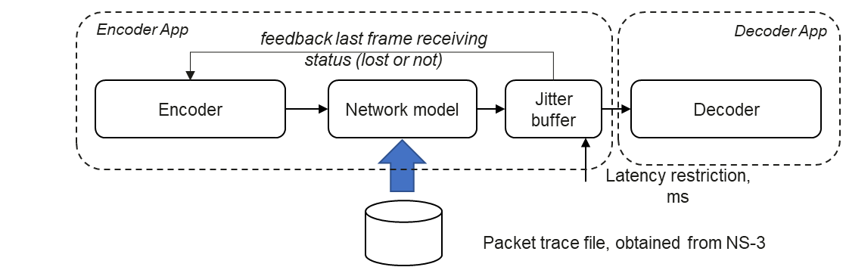
To simulate video communication under ultra-low latency restriction in practical communication channel a following test environment based on VTM v23.5 has been constructed:
The test environment includes VTM Encoder, Network model, and Jitter buffer model combined in Encoder App. Depending on transmission status frame maybe available for decoding or not. The receiving status is identified by Jitter buffer and feedback to Encoder in order to adjust the reference picture to be used instead of missed one. The NAL units received in time are stored to the disk and can be decoder by Decoder App in a usual way. Decoder application has just one modification allowing to identify missed frames and repeat the last successfully decoded frame instead of missed one. This contribution incorporates materials described in the documents JVET-AK0193, JVET-AL0200, JVET-AL0201, JVET-AM0109, JVET-AM0202, JVET-AM0203, JVET-AM0204, JVET-AN0045, JVET-AN0046, JVET-AN0081.

How to build
Follow the next steps to build the software.
- Clone AhG18 repository:
git clone https://vcgit.hhi.fraunhofer.de/jvet-ahg-ull/VVCSoftware_VTM.git
- Checkout to branch jvet-an2039
git checkout jvet-an2039
- Update submodule to get HDRTools
git submodule update --init --recursive
- Build VTM as usual:
mkdir build
cd build
cmake .. -D CMAKE_BUILD_TYPE=Release
make -j
- Follow HDRTools build instructions at HDRTools/README.md:
cd HDRTools
mkdir build && cd build
cmake .. -D CMAKE_BUILD_TYPE=Release
make -j
Now everything is ready to run the tests.

How to run

Encoder
The following sample can be used to run single layer VTM encoder with network simulation enabled without network priorities on Wi-Fi trace in scenario unicast with feedback delay set to 40 ms and latency restriction set to 16 ms.
./bin/EncoderAppStatic -c ./cfg/encoder_lowdelay_vtm.cfg -c \
./cfg/alternative-addon/reduced_runtime3.cfg -q 22 -f 600 -fr 60 \
-i MarketPlace_1920x1080_60fps_10bit_420.yuv -wdt 1920 -hgt 1080 -b bitstream.bin -v 7 \
--InputBitDepth=10 --OutputBitDepth=10 \
--LatencyRestriction=16 \
--UseFeedback=1 --FeedbackDelay=40 \
--PacketTracePath=cfg/wifi_simulation_trace/018.5mbps_room16x8_bw20MHz_2nbs1.5mbps.csv \
--PacketTraceStartLine=200726 \
--PocMsbCycleFlag=1 --PocMsbCycleLen=2

The following sample can be used to run scalable encoder with network simulation enabled with network priorities on 5G trace in scenario broadcast without feedback delay and latency restriction set to 16 ms from precalculated encoder bitstream using DebugBitstream option.
./bin/EncoderAppStatic -c ./cfg/multi-layer/two_layers.cfg --Level=6.2 \
--OlsModeIdc=2 --NumOutputLayerSets=2 --OlsOutputLayer1="1 0" \
-l0 -c ./cfg/encoder_lowdelay_vtm.cfg -l0 -c ./cfg/alternative-addon/reduced_runtime3.cfg \
-l0 -q 37 -l0 -i MarketPlace_960x540_60fps_10bit_420.yuv -l0 -wdt 960 -l0 -hgt 540 \
-l1 -c ./cfg/encoder_lowdelay_vtm.cfg -l1 -c ./cfg/alternative-addon/reduced_runtime3.cfg \
-l1 -q 22 -l1 -i MarketPlace_1920x1080_60fps_10bit_420.yuv -l1 -wdt 1920 -l1 -hgt 1080 \
-f 600 -fr 60 -b bitstream.bin \
--IntraPeriod=64 --DecodingRefreshType=1 -v 7 --InputBitDepth=10 --OutputBitDepth=10 \
--LatencyRestriction=16 --UseFeedback=0 \
--PacketTracePath=cfg/5g_simulation_trace/049Mbps_Office30m_bw16MHz_IF2video_10udp.csv \
--PacketTraceStartLine=149462 \
-l0 --TrafficIDPrefixAps=0 -l0 --TrafficID=1 \
-l1 --TrafficIDPrefixAps=7 -l1 --PacketLifeTimePrefixAps=16 \
-l1 --TrafficID=7 -l1 --PacketLifeTime=16 \
--DebugBitstream=/SVTM-SPATIAL/dQP15/IP1SEC/QP22/bin/MarketPlace_1920x1080_60fps_10bit_420.bin \
--PocMsbCycleFlag=1 --PocMsbCycleLen=2

Decoder
The following command line can be used to decode obtained bitstream:
./bin/DecoderAppStatic -b bitstream.bin ./dec.yuv --OutputBitDepth=10 \
--NumFrames=600 --SkipFramesWithLostRef=1
Here NumFrames specifies to decoder how many frames were originally encoded since this information cannot be available from bitstream. In case of tail of bitstream is lost and decoding application will repeat last successfully decoded frame until the total frames reaches the specified number.

Additional command line options

Encoder
The following options were introduced to encoder application:
--LatencyRestriction=<ms>: Specifies latency restriction in ms.
--PacketTracePath=</path/to/packet/trace/file> : Path to packet trace file.
--PacketTraceStartLine=<line_num> : Start line for packet trace file.
--PacketTraceEndLine=<line_num> : End line for packet trace file.
--BypassIDR: Bypass network model for IDR, will be transmitted without loss. Debug option, disabled by default.
--BypassStream: Bypass network model for stream (e.g. layer 0) that will be transmitted without loss. Debug option, disabled by default.
--UseFeedback: Use feedback channel for frame delivery status.
--FeedbackDelay=<ms>: Feedback channel delay in ms.
--TrafficID=[0-7]: Traffic type ID for network prioritization, lower ID has higher priority.
--PacketLifeTime=<ms>: Time of staying packet in sending buffer in ms.
--TrafficIDPrefixAps=[0-7]: Traffic type ID of packet with PREFIX_APS for network prioritization, lower ID has higher priority.
--PacketLifeTimePrefixAps=<ms>: Time of staying packet with PREFIX_APS in sending buffer in ms.
--BitsForPoc: Number of bits that is used in the decoding process for picture order count.
--PocMsbCycleFlag: For I-SLICEs specifies that the ph_poc_msb_cycle_present_flag syntax element is present in PH syntax structures referring to the SPS.
--PocMsbCycleLen: Specifies the length, in bits, of the ph_poc_msb_cycle_val syntax elements, when present in PH syntax structures referring to the SPS.

Decoder
The following option was introduced to decoder application:
--NumFrames=<num>: Number of frames requested to produce by decoder. Can be useful if tail of bitstream is lost and decoder cannot know how many frames was originally encoded. If specified, the last decoded frame will be repeated till total decoded frames number reaches specified value.
--SkipFramesWithLostRef: Skip decoding frames with lost reference.

Software description
The software modifications required to enable encoding with network simulations are enclosed by JVET_AK0193_NETWORK_MODEL macro defined in TypeDef.h.
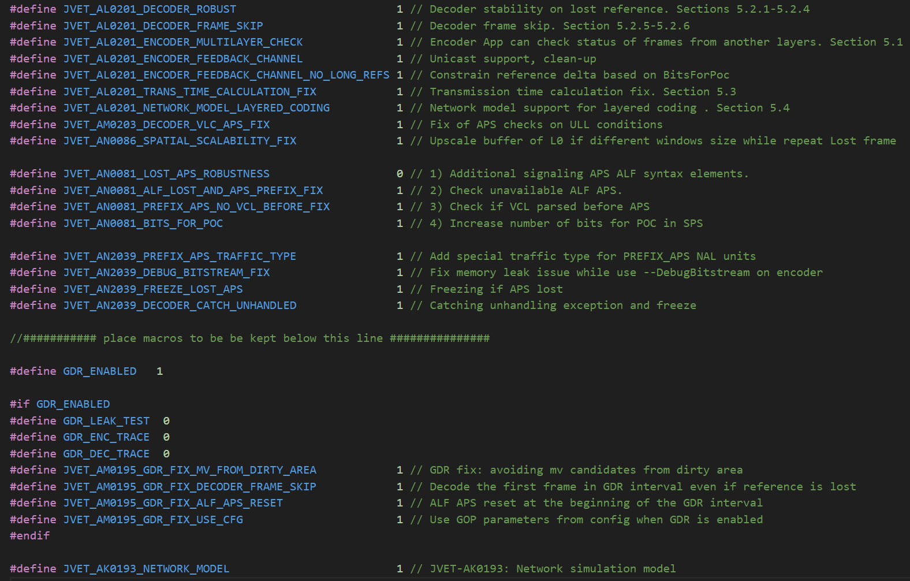
Besides the network model the software modifications include fixes for GDR, APS and overall decoder stability with references to corresponding JVET contributions containing detailed description. During preparation of the software additional modifications were made to support functionality of JVET-AN2039 CTC document and increase stability of the decoder at extreme cases.

Encoder
The main entry point for encoder simulation is located in outputAU function. In original VTM implementing is used to store encoded bitstreams of access unit to the disk once encoding slice is complete.
Encoder call stack:
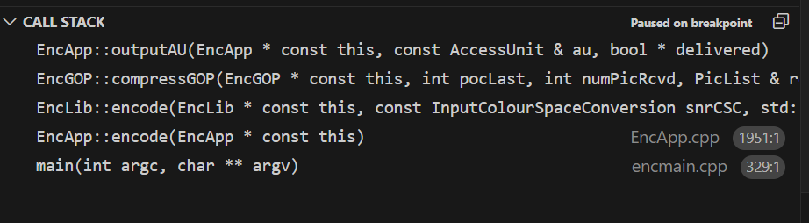

outputAU - network simulation entry point
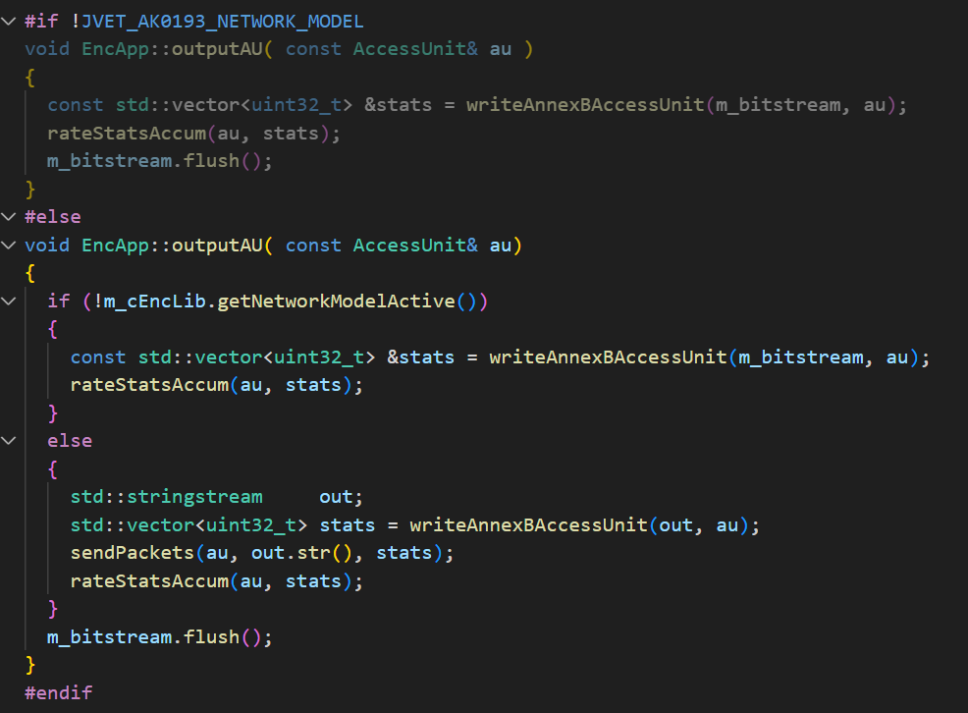

Network model
If JVET_AK0193_NETWORK_MODEL macro is enabled the outputAU function is overridden introducing the following logic. If packet trace file is not specified then application behaviour is same as default – just store bitstream to the disk. Otherwise, if packet trace is specified the frame bitstream is written to string buffer corresponding sending payload of current slice and sent to sendPackets function which accumulates the packet in the sending buffer. After several layer coding completed (in case of multi-layer coding) the sending buffer contains all the packets related to the current frame. The network transmission itself is emulated by colling networkModel->process() in encmain.cpp. At this stage the packets are selected from sending buffer according to transmission priority (once enabled) and information from packet trace file is applied to identify the transmission status and transmission time of every packet.
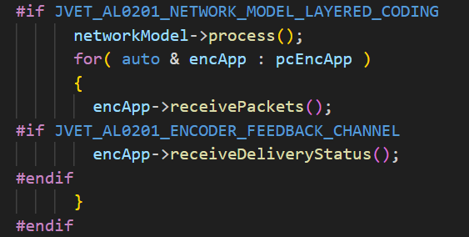
The function encApp->receivePackets() emulates the receiving packet and processing it by jitter buffer. The jitter buffer controls the integrity of received NAL units by the moment specified in latency restriction parameter. Once NAL unit is complete it is stored to the disk for future processing by decoder. If NAL unit is incomplete it is dropped and corresponding notification is sent to encoder in case feedback channel is enabled.

Regular transmission model
Packets of every frame are transmitted one-by-one (without any priority mechanism) and retransmitted during their lifetime. Packet lifetime is a common mechanism used in Wi-Fi and 5G to control retransmission logic. The sending buffer of the router keeps each specific packet in the buffer until lifetime is over. During this time router keeps retransmitting the packet in case of transmission fail. The packet lifetime is set equal to default value of 512 ms (as in Wi-Fi and 5G).

Priority transmission model
Modern transmission protocols have various priority mechanisms (JVET-AM0188, JVET-AM0201). Such mechanisms may be very useful for ULL video transmission scenarios. An approximated transmission priority model is used. The model operates by traffic ID (from 0 to 7) which may correspond to different layers, NAL unit types, data partitions, or any other categories depending on information importance. Based on traffic ID two features are specified:
- Sending order priority
- Traffic ID specific packet lifetime
Stream A
Sending buffer
(packets A/B)
Stream B
Channel
router
Figure 1 Transmission priorities model

Sending order priority
For some coding solutions the bitstream may consists of several parts (at least two) of different importance: stream A and stream B. Where stream A contains more important information critical for frame reconstruction, and stream B contains less important information. Transmission priority enables sending stream A packets before the packets of stream B.
For example, in scalable coding case L0 is considered as stream A and L1 as stream B. Another example is a data partitioning used in AVC containing bitstream of two parts A and B following the same transmission priority logic.

Packet lifetime adjustment
The tuning of lifetime can be useful to solve the network overflow problem. Outdated packets can be discarded as soon as they expire and cannot be used for decoding due to latency restriction. As latency restriction is the deadline of frame delivery thus lifetime of stream B packets is set equal to latency restriction. For stream A packets the lifetime is kept as default value of 512ms.

Decoder
The modifications of Decoder application include storing of last successfully decoded picture in internal YUV buffer. Once gap in POC order is identified the stored picture is repeated for the dumping and corresponding message outputted to the user. Similar dumping repetition is performed if number of outputted pictures is less then requested by command line parameter.

Automated script for searching network bandwidth points
The proposed automation script (./scripts/bandwidth_point_selection/bandwidth_point_selection.py) takes average bitrate of specific coded sequence as input parameter and searches for the interval with 2-4x times larger average network capacity. Due to channel fluctuation in 10% of frames the instant channel bandwidth should drop below average video bitrate (low goodput ratio), which is another precondition. Below is an example of how to run it, and expected output:
python scripts/bandwidth_point_selection/bandwidth_point_selection.py \
--config scripts/bandwidth_point_selection/config.yaml
Script returns list of found startlines in trace file sorted by distance from target 10% of low goodput ratio:
Displaying 3 out of 3 found startlines
Startlines:
535193 20150 385759
Low goodput ratio:
0.075 0.068 0.054
For each found startline a channel capacity plot is saved as a picture to allowing to see the channel profile:
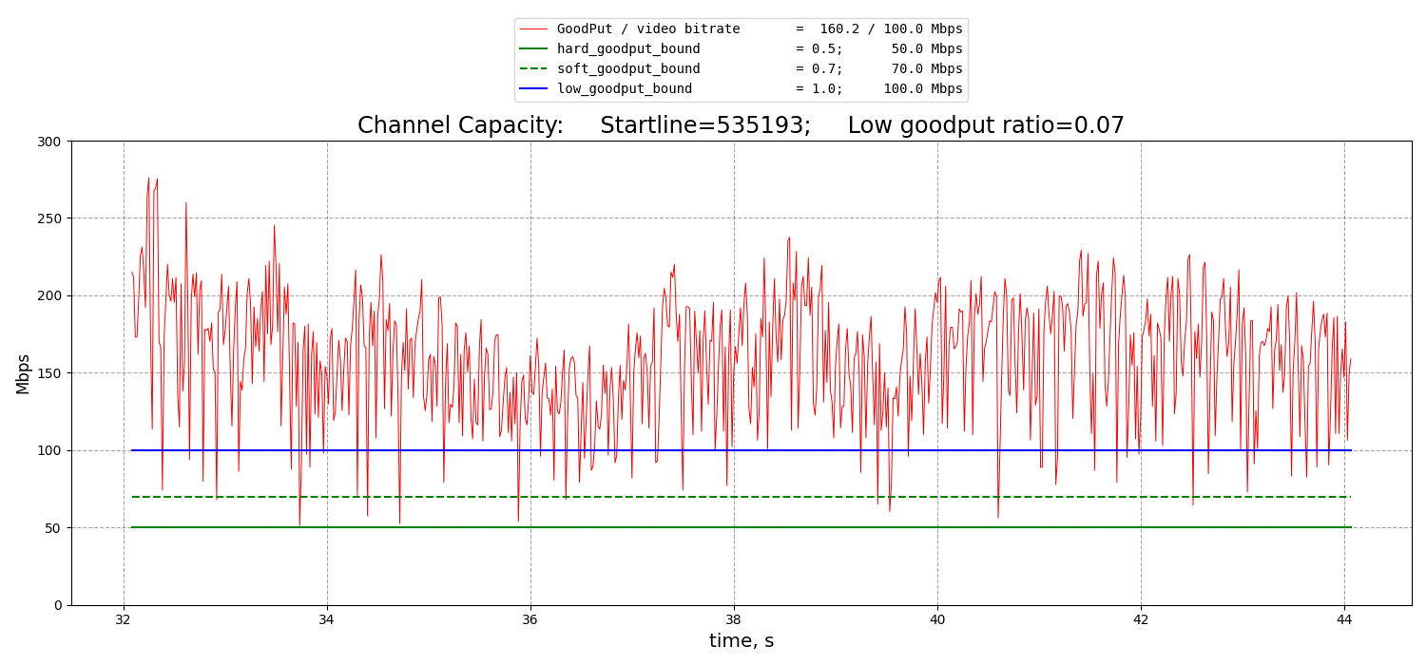
Figure 2: Example of found start line for bandwidth point for target video bitrate 100 Mbps (solid blue line), with average channel capacity 160 Mbps, and dropping instant capacity below required average video bitrate in 7% of cases.
All the script parameters are configurable. Furthermore, an extended set of tweaking parameters can be used if desired criteria cannot by satisfied with a given trace file. The details of configuration tweaking and recommendation can be found in JVET-AN0046. Selected trace file and start line can be used in main simulation by specifying parameters --PacketTracePath and --PacketTraceStartLine.

How to run CTC tests
The described SW package contains python script allowing to run all the CTC simulations, collect the results in a format suitable to direct inputting to excel template of JVET-AN2039 also uploaded with current contribution. The script ull_run_sample.py is located in a root directory. The performing simulations contains 3 main steps: clean channel, broadcast and unicast scenarios. The broadcast test case can use clean streams for faster simulations since encoder behavior is unchanged. The following settings are required to be set up before starting the simulations:
- Set YUV_DATASET_PATH as path to folder with YUV files,
- Set YUV_DOWNSET_PATH as path to folder with YUV files which have downscaled resolution with 0.5 factor. Required for multi-layer codec configuration with spatial scalability.
ENCODER_PATH, DECODER_PATH, HDRTOOL_PATH can be changed due to specific platform and user locations.
The script uses pandas, numpy and tqdm packages that should be installed into python environment.

Downscaled YUV obtaining
The SHM software (https://vcgit.hhi.fraunhofer.de/jvet/SHM.git, tag SHM-12.4) was used for obtaining downscaled YUV files. The input width and height should be reduced by 2 times for output; input and output bit depths should be same. Use the following example for generating downscaled dataset:
./bin/TAppDownConvertStatic <input-width> <input-height> input_video_4096x2048_10bits.yuv <output-width> <output-height> output_video_2048x1024_8bits.yuv <input-bit-depth> <output-bit-depth>

Pre-encoded clean streams obtaining
The broadcast (no feedback) is one of the test cases. The clean streams can be used for faster simulations. For preparing clean streams following the next steps:
- Checkout to tag VTM-23.5 and build,
- Run script: python ull_run_sample.py --test clean-broadcast-vtm – for single-layer, results will be stored in ./RESULTS-ULL/Clean/BROADCAST/VTM-LDB,
- Run script: python ull_run_sample.py --test clean-broadcast-svtm – for multi-layer, results will be stored in ./RESULTS-ULL/Clean/BROADCAST/SVTM-LDB,
- After completing simulation specify the path by setting PREENCODED_STREAMS variable.
The results can be found in table-all-clean.txt suitable for direct inputting to excel template at a place corresponding to clean channel simulation. The same flow can be applied to obtain clean channel result for unicast scenario specifying clean-unicast-vtm and clean-unicast-svtm for single and multi-layer VTM accordingly.

ULL simulations
The following steps are required to be set before starting simulations:
- Checkout to jvet-an2039 and build,
- Set PREENCODED_STREAMS paths for VTM and SVTM which were obtained during 8.2. The paths must refer to folders with streams from the broadcast test scenario.
The broadcast scenario tests can be started via following commands:
- python ull_run_sample.py --test priorON-broadcast-vtm - VTM, single layer, priorities on
- python ull_run_sample.py --test priorOFF-broadcast-vtm - VTM, single layer, priorities off
- python ull_run_sample.py --test priorON-broadcast-svtm - SVTM, multi layer, priorities on
- python ull_run_sample.py --test priorOFF-broadcast-svtm - SVTM, multi layer, priorities off
The unicast scenario tests can be started via following commands:
- python ull_run_sample.py --test priorON-unicast-vtm - VTM, single layer, priorities on
- python ull_run_sample.py --test priorOFF-unicast-vtm - VTM, single layer, priorities off
- python ull_run_sample.py --test priorON-unicast-svtm - SVTM, multi layer, priorities on
- python ull_run_sample.py --test priorOFF-unicast-svtm - SVTM, multi layer, priorities off
The optional arguments can be set from command line:
- --num-processes – the number of parallel processes, should be set according with available resources (RAM, disk space, number of CPU). The default number is 8.
- --output – the output folder for collecting results (logs, streams). The default is ./RESULTS-ULL.
Git hash commit, date time and command line stores in file with “commit_<git hash commit>.txt” template name.
The additional functionality of script allows to aggregate metrics while simulations still not complete or needs to re-aggregate summary:
- Set ONLY_METRICS = 1,
- Repeat command that was used for starting simulations.
Another script option allows to re-start failed tasks due to any reasons, for example end of free space or running out of RAM during parallel testing. After finishing the simulations:
- Set RESTART_FAILED = 1,
- Repeat command that was used for starting simulations.
After simulation completion the results are collected in a file table-all.txt in a format suitable for direct inputting to excel template.

Test results
The simulation results according to JVET-AN2039 are as follows. In the tables below the encoding and decoding time are the subjects of further verification.

Transmission priority channel

Broadcast scenario
 | Broadcast w/o feedback, transmission priority on, try #Average, QP 22
PSNR vs Latency | BD-PSNR |  | SVTM over VTM
at QP 22 | Y | U | V | Freeze | Delta Freeze | EncT | DecT
Class A | 12.5 | 6.9 | 6.6 | -79.6% | 82.7 -> 3% | 129% | 531%
Class B | 10.7 | 4.9 | 6.3 | -68.1% | 68.1 -> 0% | 131% | 397%
Gaming | 6.1 | 5.4 | 4.2 | -54.6% | 54.6 -> 0% | 136% | 295%
Overall | 9.9 | 5.6 | 5.8 | -67.6% | 68.4 -> 0.8% | 132% | 397%
 | Broadcast w/o feedback, transmission priority on, try #Average, Latency 16
PSNR vs Rate | BD-Rate |  | SVTM over VTM
at Latency 16 | Y | U | V |  |  | EncT | DecT
Class A | 0.0% | 0.0% | 0.0% |  |  | 131% | 1004%
Class B | 0.0% | 0.0% | 0.0% |  |  | 133% | 992%
Gaming | 0.0% | 0.0% | 0.0% |  |  | 139% | 1017%
Overall | 0.0% | 0.0% | 0.0% |  |  | 134% | 1002%
 | Broadcast, Clean channel
Clean channel | BD-Rate |  | SVTM over VTM
 | Y | U | V |  |  | EncT | DecT
Class A | 5.4% | 12.6% | 9.0% |  |  | 130% | 124%
Class B | 5.1% | 14.8% | 18.0% |  |  | 129% | 122%
Gaming | 3.7% | 12.1% | 13.5% |  |  | 126% | 112%
Overall | 4.8% | 13.5% | 14.3% |  |  | 128% | 120%

Unicast scenario
 | Unicast w/ feedback, transmission priority on, try #Average, QP 22
PSNR vs Latency | BD-PSNR |  | SVTM over VTM
at QP 22 | Y | U | V | Freeze | Delta Freeze | EncT | DecT
Class A | #N/A | #N/A | #N/A | #N/A | #N/A | #N/A | #N/A
Class B | 3.3 | 1.3 | 2.0 | -24.6% | 24.6 -> 0% | 129% | 158%
Gaming | 2.2 | 2.0 | 1.5 | -20.4% | 20.4 -> 0% | 126% | 137%
Overall | 2.9 | 1.6 | 1.8 | -23.0% | 23 -> 0% | 128% | 150%
 | Unicast w/ feedback, transmission priority on, try #Average, Latency 16
PSNR vs Rate | BD-Rate |  | SVTM over VTM
at Latency 16 | Y | U | V |  |  | EncT | DecT
Class A | #N/A | #N/A | #N/A |  |  | #N/A | #N/A
Class B | 74564.1% | 93731.4% | 91682.8% |  |  | 148% | 413%
Gaming | 342654.4% | 203134.2% | 457.8% |  |  | 144% | 333%
Overall | 175097.9% | 134757.4% | 57473.4% |  |  | 147% | 381%
 | Unicast, Clean channel
Clean channel | BD-Rate |  | SVTM over VTM
 | Y | U | V |  |  | EncT | DecT
Class A | #N/A | #N/A | #N/A |  |  | #N/A | #N/A
Class B | 5.1% | 10.3% | 12.8% |  |  | 127% | 141%
Gaming | 3.9% | 9.8% | 10.7% |  |  | 129% | 140%
Overall | 4.7% | 10.1% | 12.0% |  |  | 128% | 140%

Regular no-priority channel

Broadcast scenario
 | Broadcast w/o feedback, transmission priority off, try #Average, QP 22
PSNR vs Latency | BD-PSNR |  | SVTM over VTM
at QP 22 | Y | U | V | Freeze | Delta Freeze | EncT | DecT
Class A | 3.5 | 2.6 | 2.3 | -15.8% | 82.7 -> 66.9% | 132% | 197%
Class B | 4.6 | 2.3 | 2.5 | -23.3% | 67.5 -> 44.2% | 132% | 209%
Gaming | 2.7 | 2.5 | 2.1 | -17.3% | 54.3 -> 37% | 135% | 175%
Overall | 3.8 | 2.4 | 2.3 | -19.6% | 68 -> 48.4% | 133% | 196%
 | Broadcast w/o feedback, transmission priority off, try #Average, Latency 16
PSNR vs Rate | BD-Rate |  | SVTM over VTM
at Latency 16 | Y | U | V |  |  | EncT | DecT
Class A | 0.0% | 0.0% | 0.0% |  |  | 135% | 211%
Class B | 0.0% | 0.0% | 0.0% |  |  | 135% | 222%
Gaming | -54.1% | -55.1% | -52.7% |  |  | 139% | 232%
Overall | -14.8% | -15.0% | -14.4% |  |  | 136% | 221%
 | Broadcast, Clean channel
Clean channel | BD-Rate |  | SVTM over VTM
 | Y | U | V |  |  | EncT | DecT
Class A | 5.4% | 12.6% | 9.0% |  |  | 130% | 124%
Class B | 5.1% | 14.8% | 18.0% |  |  | 129% | 122%
Gaming | 3.7% | 12.1% | 13.5% |  |  | 126% | 112%
Overall | 4.8% | 13.5% | 14.3% |  |  | 128% | 120%

Unicast scenario
 | Unicast w/ feedback, transmission priority off, try #Average, QP 22
PSNR vs Latency | BD-PSNR |  | SVTM over VTM
at QP 22 | Y | U | V | Freeze | Delta Freeze | EncT | DecT
Class A | #N/A | #N/A | #N/A | #N/A | #N/A | #N/A | #N/A
Class B | -0.6 | -0.5 | -0.5 | -4.5% | 26.2 -> 21.7% | 125% | 128%
Gaming | -1.6 | -1.7 | -1.5 | -1.0% | 21.1 -> 20.1% | 126% | 112%
Overall | -1.0 | -0.9 | -0.9 | -3.2% | 24.3 -> 21.1% | 125% | 122%
 | Unicast w/ feedback, transmission priority off, try #Average, Latency 16
PSNR vs Rate | BD-Rate |  | SVTM over VTM
at Latency 16 | Y | U | V |  |  | EncT | DecT
Class A | #N/A | #N/A | #N/A |  |  | #N/A | #N/A
Class B | 652.1% | 227330.0% | 216162.0% |  |  | 146% | 167%
Gaming | 833.4% | 286.7% | 17.6% |  |  | 141% | 150%
Overall | 720.1% | 142188.8% | 135107.8% |  |  | 144% | 160%
 | Unicast, Clean channel
Clean channel | BD-Rate |  | SVTM over VTM
 | Y | U | V |  |  | EncT | DecT
Class A | #N/A | #N/A | #N/A |  |  | #N/A | #N/A
Class B | 5.1% | 10.3% | 12.8% |  |  | 127% | 141%
Gaming | 3.9% | 9.8% | 10.7% |  |  | 129% | 140%
Overall | 4.7% | 10.1% | 12.0% |  |  | 128% | 140%

Patent rights declaration(s)
Huawei Technologies does not have any current or pending patent rights relating to the technology described in this contribution.

