    Joint Video Experts Team (JVET)  of ITU-T SG21 WP3/21 and ISO/IEC JTC 1/SC 29  40th Meeting, Geneva, CH, 03 – 12 October 2025 | Document: JVET-AN0279-v1

Title: | Crosscheck of JVET-AN0234 (Non-EE2: On filtering condition for angular modes)
Status: | Input document to JVET
Purpose: | Proposal
Author(s) or  Contact(s): | Luhang Xu | Email: | xuluhang@oppo.com
Source: | OPPO
_____________________________

Abstract
This document reports the crosscheck results of JVET-AN0234.​ The block size of enabling the smooth filtering of the reference samples and switching the interpolation filter for the intra angular prediction is modified. It is reported that on top of ECM-18.0, the overall coding performance for {Y, U, V} are:
{-0.01%, 0.02%, 0.04%} for AI configuration when the block size is modified from 32 to 64,
{-0.01%, 0.04%, 0.04%} for AI configuration when the block size is modified from 32 to 256.

Introduction
In ECM-18.0, the mode-dependent intra smoothing (MDIS) condition ​​determines​​ whether to apply the reference sample smoothing filter and which interpolation filter to use in angular intra prediction.

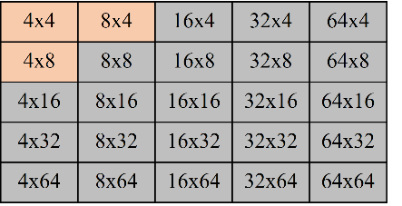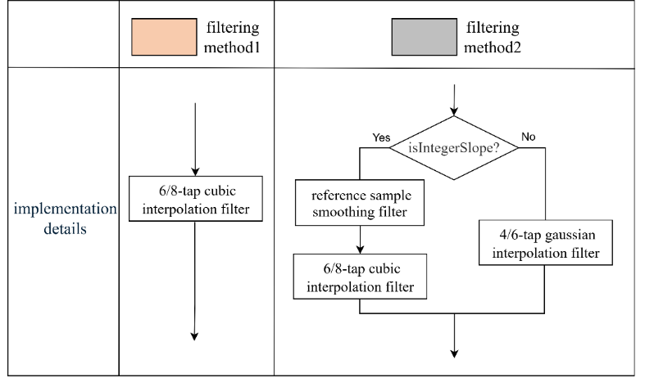
Fig.1 Detailed Procedures of filtering operation to derive intra prediction
The filtering operation is illustrated in Fig.1.
For current block size is greater than 32(gray blocks), if all of following conditions are true:
- minDistVerHor is greater than intraHorVerDistThres[nTbS];
- The current block size is greater than 32;
- the angular mode has an integer slope.
the MDIS condition is true, {1, 2, 1}-smoothing filter is applied for reference samples, and the 6/8-tap cubic interpolation filter will be used. Otherwise, 6/8-tap gaussian interpolation filter will be used.
For the block size is less than or equal to 32(orange blocks), a single solution 6/8-tap cubic interpolation filter will be used.
Therefore, more condition check is needed for the gray blocks ​​to switch between the cubic and gaussian interpolation filters based on the integer slope condition. ​
There are two tests in the proposal. The first test is to modified the block size to 64. The second test is ​​to modify the block size to 256.

The software is crosschecked and it is confirmed the implementation matched to the description. The simulation results from crosschecker are also matched to the results from the proponents.

Experimental results
First test: block size is modified to 64.
 | All Intra Main 10
 | Over ECM18.0
 | Y | U | V | EncT | DecT | EncVmPeak | DecVmPeak
Class A1 | 0.00% | 0.08% | 0.00% | % | % | 100.0% | 100.1%
Class A2 | 0.00% | -0.04% | 0.00% | % | % | 100.0% | 100.0%
Class B | 0.00% | 0.01% | 0.10% | % | % | 100.9% | 100.0%
Class C | -0.02% | -0.01% | -0.04% | % | % | 100.0% | 100.0%
Class E | -0.03% | 0.08% | 0.10% | % | % | 102.0% | 100.0%
Overall | -0.01% | 0.02% | 0.04% | % | % | 100.6% | 100.0%
Class D | -0.03% | -0.14% | 0.02% | % | % | 100.1% | 100.0%
Class F | -0.06% | -0.14% | -0.24% | % | % | 100.3% | 100.0%

Second test: block size is modified to 256.
 | All Intra Main 10
 | Over ECM18.0
 | Y | U | V | EncT | DecT | EncVmPeak | DecVmPeak
Class A1 | 0.01% | 0.04% | -0.02% | % | % | 99.9% | 100.1%
Class A2 | -0.02% | -0.04% | 0.01% | % | % | 100.0% | 100.0%
Class B | 0.01% | 0.00% | 0.08% | % | % | 101.8% | 100.0%
Class C | -0.03% | 0.05% | 0.01% | % | % | 100.0% | 100.0%
Class E | -0.06% | 0.13% | 0.11% | % | % | 101.0% | 99.9%
Overall | -0.01% | 0.04% | 0.04% | % | % | 100.6% | 100.0%
Class D | 0.01% | 0.03% | 0.03% | % | % | 100.1% | 100.0%
Class F | -0.10% | 0.08% | -0.17% | % | % | 103.5% | 99.9%

