    Joint Video Experts Team (JVET)  of ITU-T SG21 WP3/21 and ISO/IEC JTC 1/SC 29  40th Meeting: Geneva, CH, 3–12 October 2025 | Document: JVET-AN0212_v1

Title: | AHG17: Description of NNVC-based CfE response
Status: | Input document to JVET
Purpose: | Report
Author(s) or  Contact(s): | Donghyun Kim, Sung-Chang Lim  Timofey Solovyev, Johannes Sauer, Johan Pardo, Panqi Jia, Alexander Karabutov, Elena Alshina  Hyukmin Kwon, Hyunsuk Ko  Franck Galpin, Thierry Dumas, Edouard Francois  Yun Li, Marta Karczewicz  Ziyue Xiang, Roman Chernyak, Shan Liu | Tel:  Email: | +491624302163  kimddng@etri.re.kr, sclim@etri.re.kr  solovyev.timofey@huawei.com, johannes.sauer@huawei.com, johan.esprit.pardo1@huawei.com,  panqi.jia@huawei.com, karabutov.alexander@huawei.com,  elena.alshina@huawei.com  hspeedkwon@hanyang.ac.kr hyunsuk@hanyang.ac.kr  franck.galpin@interdigital.com  thierry.dumas@interdigital.com  edouard.francois@interdigital.com  yli30@qti.qualcomm.com  martak@qti.qualcomm.com  alanzxiang@global.tencent.com, chernyak@global.tencent.com  shanl@global.tencent.com
Source: | Electronics and Telecommunications Research Institute (ETRI), Huawei Technologies, HYU – Hanyang Univ. (HYU), Interdigital, Qualcomm, Tencent (alphabetic order)
_____________________________

Abstract
This contribution summarizes and analyzes results obtained in the Call for Evidence (CfE) responses which were built as combinations of tools available in the recent NNVC tool-box. Responses are provided in the constrained encoder run time category. The goal of those responses is to demonstrate compression performance vs encoder complexity trade-off provided by learnable technologies. This response also serves as sanity check for technologies trained off-line, since at CfE performance is checked under test conditions substantially different from NNVC training and testing conditions. For target run time ‘×0.2’ (which is twice faster than HM at CfE rates) performance of ‘VTM default’ was achieved, while at target run time ‘×1’ 11% gain over VTM was demonstrated. Normative changes to the anchor are limited to just tool tools for all (except just one) of operation points.

Introduction
Call for Evidence document [1] specifies several configurations of VTM (and also ECM) which allows comparison for not only ultimate compression which can be achieved w/o limitation on encoder run time but also performance vs encoder run time trends. NNVC is a tool box of learnable algorithms improving video compression. Algorithms were trained using agreed data sets, and the training was verified by cross-checker (this development aspect is different from ECM tools process).
Adaptive resolution coding (known as GOP-based RPR) is a technology including learnable design elements. The encoder decision on scaling factor and QP for each GOP is based on criteria with parameters (thresholds) obtained empirically, de facto learning-based technology. Since GOP-based RPR can be applied to the anchor, two responses with and w/o GOP-based RPR are provided in order to differentiate impact from normative (NNVC tools only) and non-normative (NNVC tools together with GOP-based RPR modifications).
Development principals of those CfE responses are as follows:
- Only tools available in NNVC-14.1 were used,
- SADL implementation for NN-based tools, int 16 quantized models,
- No multi-pass coding (content adaptive NN-based filters are not used),
- No pre-/post-processing other than MCTF.
Several encoder-only techniques such as time-distortion optimization (TDO) and filter restriction depending on hierarchical depth, were developed during this CfE response preparation which allow drastically reduce decoder run-time of NNVC tools with minimal performance effect.
Two types of NNVC bitstreams were generated as responses in encoder-constrained category:
- ‘×5’ and ‘×1’ not including RPR, actual encoder run time is ‘×5.7’ and ‘×1.1’ respectively.
- ‘×0.2’, ‘×0.5’, ‘×1’, ‘×2’ and ‘×5’ with RPR enabled, actual encoder run time is ‘×0.23’, ‘×0.51’, ‘×1.1’, ‘×2.0’ and ‘×5.4’ respectively.
The run time ratios reported here were computed using rules specified in JVET-AM2026:
1) Run times for all rate points are summed for each sequence;
2) The geometric mean is computed across all sequences;
3) The ratio to anchor run time is computed.
According to JVET-AM2026 an alternate way to aggregate run times may be additionally used when evaluating responses (those results will be provided in the later sections). Run time ratios differ between different testers, even between different runs of the same encoder, but deviation is within 10% of target run time. Proponents believe that run time targets are matched close enough for meaningful comparison of solutions in encoder constrained category.
JVET-AM2026 specifies the following CfE test categories:
- SDR RA UHD/4K (SRU class): CrowdRun, DrivingPOV3, FireDance, HallwayScene
- SDR RA HD (SRH class): DucksTakeOff, DrivingPOV4, Seeking, Umbrella
- SDR LB HD (SLH class): Beatriz, GregoryCactus2, GregoryScarf2, OfficeWalkAtWall
- HDR RA 4K (HRU class): AMS06, MeridianHDR2, NeptuneFountain3R1, SparksWelding
- HDR RA Cropped 8K (HRC class): ChandelierCropBR, FashionLadyCrop1, WaterfallForest, WomenFootball
- Gaming LB HD (GLH class): DOTA2s360, GTAVs090, Level1, Minecraft
- UGC RA (URH class): Camellia, Hobby-w5xz-backpack, NightLandscapeRunning, Sports-76a2-iceball, VerticalVideo-3709-snow, VerticalVideo-3d96-walk
Responses are provided for all classes.

Description of NNVC tools and encoder modifications used in CfE responses

NN-based in-loop filters (NNLF)
Several generations of neural network-based in-loop filters were developed by NNVC community. The most recent versions LOP6 as it is NNVC-14.1 (default) and HOP5 available in NNVC-14.1 were used in those responses. Description of filters can be found in [2]. No retraining or other adjustment of filters were done.

Neural network-based intra (NN-Intra)
First design element adopted to NNVC was NN-Intra. This tool can be seen as more advanced version of MIP in VVC. Default version of NN-Intra from NNVC-14.1 w/o retraining or other adjustment was used in those responses. Description can be found in [2].

Deep reference frame (DRF)
Deep reference frame is NN-Inter was added to NNVC recently. For high-performance version ‘×5’ (only NNVC, w/o RPR) this technology was enabled. Technology was applied w/o re-training or modification. Description can be found in [2].

GOP based RPR
Configuration of GOP based RPR and performance under CfE test conditions are described in [3]. Re-sampling filters from VVC were used w/o modification. RPR was enabled only in one of two CfE responses. Coding in lower resolution reduces both encoder and decoder run time. As it was demonstrated in [3] at CfE test conditions GOP based RPR also brings performance benefits.

Time-distortion optimization (TDO)
NNLF can be enabled with block-level control. Encoder-only mechanism of enabling NN-based in-loop filters based on boundary strength analysis is a part of NNVC [2]. Target rates for CfE are lower than JVET CTC, this is why Lambda values in TDO encoder decision were modified compared to NNVC version. This technology speeds up decoder and introduces minor performance drop (less than 0.1%). More details about this technique can be found in [4].

Filter restriction depending on hierarchical depth (NnlfMaxHierLayerIdx)
NN-based filter causes significant increment of decoder run time. In-loop filter improves quality of pictures which will be used as reference pictures. Parts of the pictures with low temporal ID or/and coded with lower QP are more likely to be used as reference in motion compensation, and so use of in-loop filter makes more sense for those pictures. Encoder-only technology, which disables NN-based in-loop filter entirely for whole picture based on hierarchical depth, was used in described CfE responses. Disabling NNLF at picture level substantially reduces both encoder and decoder run time. More details about this technique can be found in [5].

NNVC settings for different encoder run time targets
NN-Intra technology is enabled in all configurations of those CfE responses. VTM version of LMCS was disabled in some configurations, since it was found not useful at CfE test conditions. Chroma QP offset was adjusted to balance Luma / Chroma BD-rate.
Configurations of NNVC tools are summarized in the Table 1 below. Normative changes to VVC/H.266 are limited to just tool tools: NN-based Intra and NN-based loop filter. Only for the one variant (NNVCx5) the third tools (DRF) was enabled.

Table 1. Tools combinations in NNVC-based CfE responses and compression performance relatively to the CfE anchor
CfE Response | Target run time | CFG | NN-Intra | NN-filter | RPR | TDO | Filter max hier. depth | DRF
NNVC tools only | ×1 | RA | yes | LOP6 | no | no | NA | no
NNVC tools only | ×1 | LDB | yes | LOP6 | no | no | NA | no
NNVC tools only | ×5 | RA | yes | HOP5 | no | no | 4 | yes
NNVC tools only | ×5 | LDB | yes | HOP5 | no | no | NA | no
NNVC with RPR | ×0.2 | RA | yes | LOP6 | yes | yes | 3 | no
NNVC with RPR | ×0.2 | LDB | yes | LOP6 | yes | yes | 1 | no
NNVC with RPR | ×0.5 | RA | yes | LOP6 | yes | yes | 4 | no
NNVC with RPR | ×0.5 | LDB | yes | LOP6 | yes | yes | NA | no
NNVC with RPR | ×1 | RA | yes | LOP6 | yes | yes | NA | no
NNVC with RPR | ×1 | LDB | yes | LOP6 | yes | yes | 1 | no
NNVC with RPR | ×2 | RA | yes | HOP5 | yes | no | 3 | no
NNVC with RPR | ×2 | LDB | yes | HOP5 | yes | no | 1 | no
NNVC with RPR | ×5 | RA | yes | HOP5 | yes | no | NA | no
NNVC with RPR | ×5 | LDB | yes | HOP5 | yes | no | NA | no
More details about NNVC SW settings (including command lines) used for those CfE responses generation are provided in the ANNEX A.

Table 2. Summary of performance of NNVC-based CfE response in comparison with reference VTM and ECM configurations (all numbers reported relatively to relatively to the CfE anchor VTM23.11 default).
Reference | Run time indicator | BD-rate (PSNRY) | EncTime Ratio | DecTime Ratio
VTM | ‘×0.2’ | 15% | 0.23 | 1
VTM | ‘×0.3’ | 4% | 0.45 | 1
VTM | ‘×0.5’ | 1% | 0.74 | 1
VTM | ‘×1’ | 0% | 1.0 | 1
VTM | ‘×2’ | 0% | 1.5 | 1
ECM | ‘×2’ | -12% | 6.6 | 9
ECM | ‘×5’ | -19% | 11 | 13
ECM | default | -22% | 21 | 14
NNVC only | ‘×1’ | -8% | 1.1 | 53
NNVC only | ‘×5’ | -12% | 5.7 | 2302
NNVC with RPR | ‘×0.2’ | 0% | 0.23 | 12
NNVC with RPR | ‘×0.2’ | -8% | 0.51 | 23
NNVC with RPR | ‘×1’ | -11% | 1.1 | 25
NNVC with RPR | ‘×2’ | -13% | 2.0 | 416
NNVC with RPR | ‘×5’ | -15% | 5.6 | 1106
BD-rate performance (based on PSNR-Y), encoder and decoder run time ratios relatively to CfE anchor (VTM23.11 default) for NNVC-based CfE responses is summarized in the Table 2. For the comparison the performance and encoder/decoder run time ratios of VTM and ECM in reference configurations recommended in [1] also shown in the Table 2.
It must be noted that run time of ECM and VTM configurations selected as reference point for this CfE were decided based on JVET CTC. At CfE test conditions encoder run time ratios to VTM default appear to be very different.

Figure 1 NNVC CfE responses in comparison with VTM and ECM reference configurations.

It must be noted that NNVC only CfE response variant with target run time uses design elements (NN-Intra and LOP6) identical to the default NNVC settings. From summary of performance in Table 2 we see 8% BD-rate gain over VTM default, which is consistent with NNVC-14.1 performance under NNVC CTC [6]. The performance of NNVC tools remains the same under CfE test conditions (in opposite to ECM which shows 4% lower gain under CfE test conditions compared to JVET CTC). Decoding run time in submitted NNVC-based CfE responses is less scary compared to NNVC CTC thanks to TDO and filter restriction based on hierarchical depth.
Plot in Figure 1 shows a comparison of objective performance (PNSR-Y) for NNVC-based CfE responses in comparison with ECM and VTM reference operation points. Numbers next to the plot shows decoder run time ratio. Encoder and decoder run time shown here are measured on CPU. SADL implementation for NNVC-tools was used. Compression performance of the fastest reference configuration of ECM can be achieved by using NNVC tools keeping encoder run time ×1 of VTM default. All configurations described in CfE responses here are faster than the fastest reference ECM configuration (‘ECMx2’).

Detailed results

Only NNVC tools (no RPR case)
Test results relatively to VTM23.11 (‘VTMx1’) CfE anchor for pure NNVC (no RPR) CfE response are reported in the Table 3. Per sequence results can be found in the ANNEX B.
It should be mentioned that ‘NNVCx1’ is normatively identical to NNVC14.1 default configuration. NNVC14.1 (default) performance under NNVC CTC is 8% gain in random access cfg and 6.1 % gain in low-delay B cfg. Results demonstrated under CfE test conditions (different sequences and significantly lower rates) are very consistent.
Table 3. ‘No RPR’ CfE response results (BD-rate reported and relatively to CfE anchor VTM23.11 default)
Reference: |  |  | Tested: | NNVC x1
VTMx1 | Random access
 | BD-rate Over VTMx1
 | Y-PSNR | U-PSNR | V-PSNR | Y-MSIM | U-MSIM | V-MSIM | EncT | DecT
SDR RA UHD/4K | -9.3% | -7.2% | -1.2% | -11.2% | -16.7% | -4.5% | 98% | 5638%
SDR RA HD/2K | -7.2% | -14.3% | -5.6% | -8.0% | -17.2% | -8.6% | 86% | 5067%
HDR RA 4K | -8.6% | 3.9% | 4.1% | -8.6% | -1.6% | -6.7% | 97% | 5872%
HDR RA Cropped 8K | -11.7% | -0.9% | -1.0% | -13.2% | -4.6% | -1.5% | 103% | 5735%
UGC RA | -7.9% | -5.4% | -5.6% | -7.6% | -11.7% | -6.6% | 112% | 5590%
Overall | -8.8% | -4.8% | -2.2% | -9.6% | -10.5% | -5.7% | 100% | 5575%
 | Low delay B
 | BD-rate Over VTMx1
 | Y-PSNR | U-PSNR | V-PSNR | Y-MSIM | U-MSIM | V-MSIM | EncT | DecT
SDR LB HD | -6.6% | -2.1% | -3.1% | -8.9% | -1.6% | -1.7% | 122% | 5749%
Gaming LB HD | -4.6% | -15.9% | -6.1% | -5.0% | -17.9% | -9.8% | 118% | 4641%
Overall | -5.6% | -9.0% | -4.6% | -7.0% | -9.7% | -5.7% | 120% | 5166%

Reference: |  |  | Tested: | NNVC x5
VTMx1 | Random access
 | BD-rate Over VTMx1
 | Y-PSNR | U-PSNR | V-PSNR | Y-MSIM | U-MSIM | V-MSIM | EncT | DecT
SDR RA UHD/4K | -13.9% | -18.8% | -15.8% | -15.4% | -27.5% | -19.5% | 569% | 235548%
SDR RA HD/2K | -12.1% | -25.1% | -22.9% | -12.3% | -28.6% | -26.5% | 394% | 231757%
HDR RA 4K | -11.2% | -15.8% | -12.4% | -10.7% | -20.8% | -28.9% | 589% | 268299%
HDR RA Cropped 8K | -14.3% | -8.8% | -10.6% | -15.7% | -11.4% | -11.4% | 677% | 244258%
UGC RA | -14.3% | -18.1% | -15.6% | -13.6% | -24.6% | -20.0% | 697% | 269755%
Overall | -13.3% | -17.4% | -15.5% | -13.6% | -22.8% | -21.2% | 584% | 251192%
 | Low delay B
 | BD-rate Over VTMx1
 | Y-PSNR | U-PSNR | V-PSNR | Y-MSIM | U-MSIM | V-MSIM | EncT | DecT
SDR LB HD | -9.7% | 1.1% | 9.0% | -10.7% | -4.0% | 3.4% | 566% | 227111%
Gaming LB HD | -8.7% | -14.6% | 3.8% | -8.2% | -14.9% | 8.5% | 506% | 190944%
Overall | -9.2% | -6.8% | 6.4% | -9.4% | -9.5% | 5.9% | 535% | 208244%

NNVC tools with RPR
Test results relatively to VTM23.11 (‘VTMx1’) CfE anchor for NNVC with RPR CfE response are reported in the Table 4 Per sequence results can be found in the ANNEX B.

Table 4. ‘NNVC with RPR’ CfE response results (BD-rate reported and relatively to CfE anchor VTM23.11 default)
Reference: |  |  | Tested: | NNVC RPR x0.2
VTMx1 | Random access
 | BD-rate Over VTMx1
 | Y-PSNR | U-PSNR | V-PSNR | Y-MSIM | U-MSIM | V-MSIM | EncT | DecT
SDR RA UHD/4K | -5.1% | -15.7% | -6.6% | -9.1% | -20.2% | -6.2% | 18% | 769%
SDR RA HD/2K | 3.6% | -12.2% | -6.9% | 2.7% | -15.3% | -10.1% | 23% | 1453%
HDR RA 4K | -2.8% | 26.1% | 25.7% | -4.7% | 20.8% | 22.1% | 22% | 881%
HDR RA Cropped 8K | -14.1% | 13.5% | 2.9% | -16.9% | 9.0% | 4.2% | 18% | 597%
UGC RA | 7.7% | -9.4% | -8.7% | 8.5% | -14.1% | -7.6% | 30% | 1667%
Overall | -1.2% | -0.5% | 0.4% | -2.8% | -4.9% | -0.3% | 23% | 1044%
 | Low delay B
 | BD-rate Over VTMx1
 | Y-PSNR | U-PSNR | V-PSNR | Y-MSIM | U-MSIM | V-MSIM | EncT | DecT
SDR LB HD | 0.6% | 13.2% | 20.2% | -5.1% | 7.7% | 13.3% | 21% | 1380%
Gaming LB HD | 8.2% | 22.7% | 35.0% | 5.6% | 17.3% | 27.5% | 27% | 1624%
Overall | 4.4% | 17.9% | 27.6% | 0.3% | 12.5% | 20.4% | 24% | 1497%

Reference: |  |  | Tested: | NNVC RPR x0.5
VTMx1 | Random access
 | BD-rate Over VTMx1
 | Y-PSNR | U-PSNR | V-PSNR | Y-MSIM | U-MSIM | V-MSIM | EncT | DecT
SDR RA UHD/4K | -13.0% | -22.8% | -13.4% | -17.4% | -27.8% | -13.7% | 42% | 1371%
SDR RA HD/2K | -3.5% | -22.1% | -16.4% | -4.9% | -25.1% | -19.3% | 54% | 2736%
HDR RA 4K | -9.5% | 12.2% | 6.4% | -11.5% | 8.4% | 4.1% | 46% | 1401%
HDR RA Cropped 8K | -19.7% | 1.8% | -7.1% | -22.4% | -2.5% | -5.5% | 43% | 1076%
UGC RA | -4.5% | -20.9% | -19.2% | -4.8% | -25.9% | -20.3% | 63% | 2867%
Overall | -9.5% | -11.3% | -10.8% | -11.5% | -15.6% | -11.8% | 50% | 1826%
 | Low delay B
 | BD-rate Over VTMx1
 | Y-PSNR | U-PSNR | V-PSNR | Y-MSIM | U-MSIM | V-MSIM | EncT | DecT
SDR LB HD | -7.6% | 8.6% | 11.2% | -13.1% | 7.4% | 10.7% | 48% | 3731%
Gaming LB HD | -0.8% | 9.1% | 22.0% | -3.5% | 6.4% | 17.3% | 57% | 4353%
Overall | -4.2% | 8.9% | 16.6% | -8.3% | 6.9% | 14.0% | 52% | 4030%

Reference: |  |  | Tested: | NNVC RPR x1
VTMx1 | Random access
 | BD-rate Over VTMx1
 | Y-PSNR | U-PSNR | V-PSNR | Y-MSIM | U-MSIM | V-MSIM | EncT | DecT
SDR RA UHD/4K | -17.3% | -26.3% | -16.7% | -21.7% | -31.9% | -17.6% | 105% | 2339%
SDR RA HD/2K | -7.0% | -25.6% | -19.5% | -7.8% | -28.4% | -22.3% | 122% | 4503%
HDR RA 4K | -12.9% | 8.8% | 4.0% | -14.5% | 4.0% | 0.6% | 109% | 2067%
HDR RA Cropped 8K | -22.6% | -1.8% | -10.4% | -24.8% | -6.4% | -10.4% | 94% | 1758%
UGC RA | -8.1% | -21.1% | -21.4% | -7.6% | -26.2% | -21.3% | 130% | 4017%
Overall | -13.1% | -13.9% | -13.6% | -14.6% | -18.5% | -14.8% | 113% | 2835%
 | Low delay B
 | BD-rate Over VTMx1
 | Y-PSNR | U-PSNR | V-PSNR | Y-MSIM | U-MSIM | V-MSIM | EncT | DecT
SDR LB HD | -8.3% | -4.4% | -1.5% | -13.2% | -9.5% | -6.9% | 111% | 1315%
Gaming LB HD | -3.4% | -0.2% | 9.9% | -3.9% | -5.5% | 2.9% | 113% | 1533%
Overall | -5.9% | -2.3% | 4.2% | -8.5% | -7.5% | -2.0% | 112% | 1420%

Reference: |  |  | Tested: | NNVC RPR x2
VTMx1 | Random access
 | BD-rate Over VTMx1
 | Y-PSNR | U-PSNR | V-PSNR | Y-MSIM | U-MSIM | V-MSIM | EncT | DecT
SDR RA UHD/4K | -18.3% | -21.5% | -18.4% | -22.1% | -26.7% | -20.3% | 166% | 28593%
SDR RA HD/2K | -8.3% | -22.6% | -20.5% | -8.7% | -25.3% | -23.1% | 215% | 53300%
HDR RA 4K | -15.0% | 14.4% | 13.2% | -16.0% | 8.6% | 1.2% | 190% | 32516%
HDR RA Cropped 8K | -25.0% | 3.5% | -7.7% | -27.1% | -2.5% | -8.0% | 151% | 20824%
UGC RA | -10.7% | -15.9% | -12.3% | -9.9% | -20.4% | -16.0% | 299% | 60153%
Overall | -15.0% | -9.1% | -9.4% | -16.1% | -13.9% | -13.5% | 206% | 37900%
 | Low delay B
 | BD-rate Over VTMx1
 | Y-PSNR | U-PSNR | V-PSNR | Y-MSIM | U-MSIM | V-MSIM | EncT | DecT
SDR LB HD | -10.9% | 5.1% | 12.5% | -15.3% | -4.7% | 5.8% | 185% | 48412%
Gaming LB HD | -6.8% | 3.2% | 20.3% | -6.6% | -1.1% | 20.1% | 202% | 57246%
Overall | -8.9% | 4.2% | 16.4% | -10.9% | -2.9% | 12.9% | 193% | 52644%

Reference: |  |  | Tested: | NNVC RPR x5
VTMx1 | Random access
 | BD-rate Over VTMx1
 | Y-PSNR | U-PSNR | V-PSNR | Y-MSIM | U-MSIM | V-MSIM | EncT | DecT
SDR RA UHD/4K | -20.7% | -23.7% | -20.2% | -24.8% | -30.3% | -22.8% | 420% | 87364%
SDR RA HD/2K | -9.0% | -22.2% | -20.3% | -9.3% | -25.5% | -23.6% | 519% | 142911%
HDR RA 4K | -16.1% | 14.0% | 14.9% | -17.3% | 6.5% | 0.0% | 525% | 91325%
HDR RA Cropped 8K | -27.2% | 2.0% | -8.3% | -29.3% | -4.5% | -9.1% | 397% | 60573%
UGC RA | -11.0% | -14.0% | -9.9% | -10.1% | -19.9% | -14.6% | 1203% | 159427%
Overall | -16.3% | -9.3% | -8.9% | -17.4% | -15.2% | -14.1% | 599% | 106174%
 | Low delay B
 | BD-rate Over VTMx1
 | Y-PSNR | U-PSNR | V-PSNR | Y-MSIM | U-MSIM | V-MSIM | EncT | DecT
SDR LB HD | -12.9% | 11.4% | 25.0% | -16.4% | 4.5% | 22.2% | 435% | 109426%
Gaming LB HD | -7.9% | 6.3% | 30.7% | -7.2% | 6.3% | 35.6% | 514% | 114569%
Overall | -10.4% | 8.9% | 27.8% | -11.8% | 5.4% | 28.9% | 473% | 111968%

Discussion of results
By CfE description it was not required to match encoder run time for each sequence. Per sequence results analysis shows that encoder run time ratio varies in a wide range. According to [1] run time should be first summed up (all rate points) then ratios to anchor should be computed, then GEOMEAN used for averaging. The highest target rate point has the biggest contribution to the encoding and decoding run time. If one takes into account only the highest rate run time, then EncTime Ratios varies less and ends up with smaller increase of encoding run time. Alternative averaging of run time is shown in the Table 5. Considering high number of responses in encoder run time constrained category way of controlling encoder run time requires further discussion.

Table 5 Run time averaging: CfE rules and alternative rules.

Codec | Run time indicator | BD-rate (PSNRY) | CfE rules: SUM, Ratio, GMEAN |  | Alternative rules: MAX, Ratio, GMEAN
Codec | Run time indicator | BD-rate (PSNRY) | EncTime Ratio | DecTime Ratio | EncTime Ratio | DecTime Ratio
NNVC only | ‘×1’ | -8.0% | 1.1 | 53 | 0.9 | 50
NNVC only | ‘×5’ | -12.2% | 5.7 | 2302 | 3.6 | 2114

Visual quality examples
Visual quality in comparison with VTM23.11 default (CfE anchor) for the extreme cases (the best and the worst BD-rate measured in PSNR and MS-SSIM) are shown on figures in this section.

Figure 2 HRC1 (Chandelier) R2 (600 kbps) VTM23.11 (default) on a left, CfE response (NNVC with RPR) at ×1/2 encoder run time on a right, BD-rate based on PSNR-Y shows CfE response has 30% gain vs CfE anchor for this case.
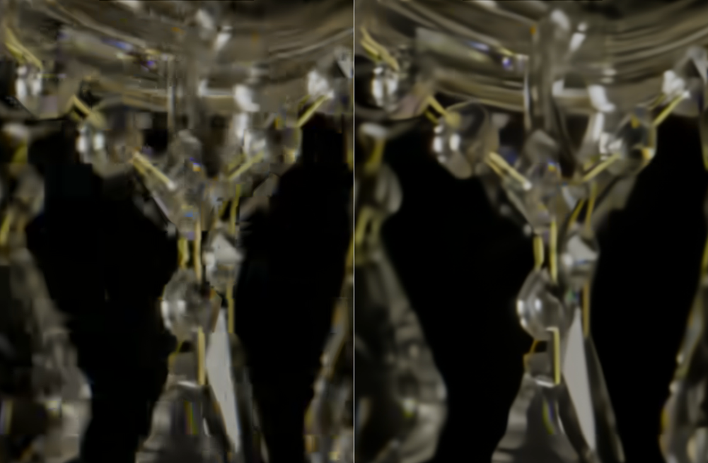

Figure 3 HRC2 (Fashionlady) R1 (200 kbps) VTM23.11 (default) on a left, CfE response (NNVC with RPR) at ×1/5 encoder run time on a right, BD-rate based on PSNR-Y shows CfE response has 23% gain vs CfE anchor for this case.

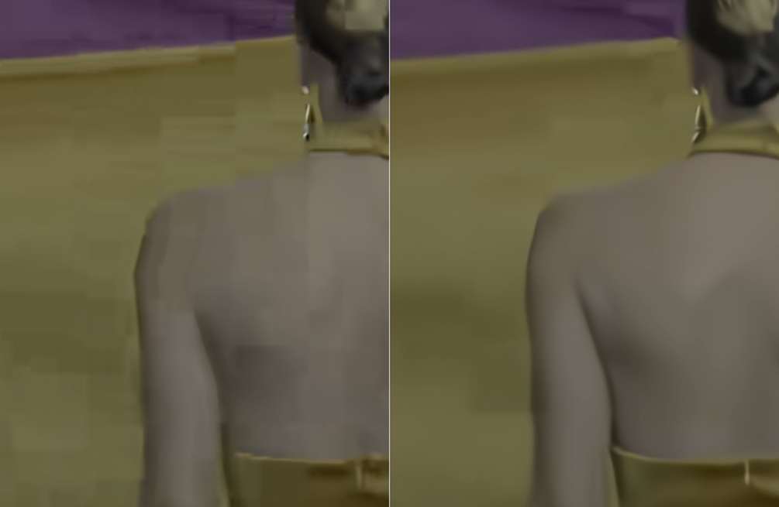

Figure 4 URH6 (VerticalVideo-3d96-walk) R4 (600 kbps) VTM23.11 (default) on a left, CfE response (NNVC with RPR) at ×1/5 encoder run time on a right, BD-rate based on PSNR-Y shows CfE response has 14% drop vs CfE anchor for this case.
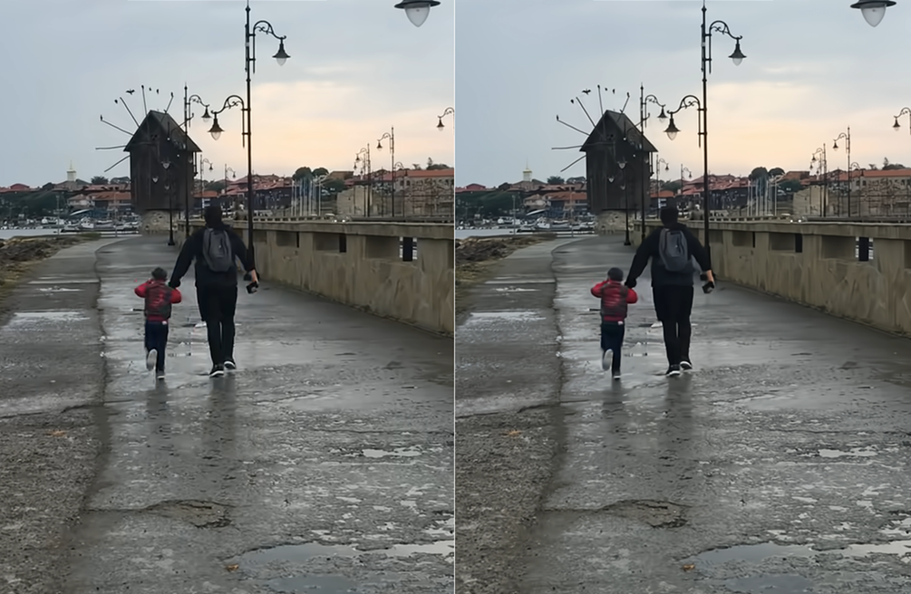

Conclusions
Learnable technologies allow to achieve compression performance gain without or with minimal encoder search and so are beneficial to the use cases with constrained encoder run time. Using minimal set of NNVC technologies, VTM default performance was achieved with significantly lower encoder run time (×0.2 of VTM default). At the encoder speed close to VTM default (×1), substantial PSNR, MS-SSIM gain over VTM default with clearly visible visual quality improvement has been achieved. Development of learnable technologies (as well as any technologies which contain high number of parameters) requires careful cross-check of training (which was a part of NNVC tools development). Compression gain on NNVC tools remains the same at CfE test condition as with NNVC CTC. Several encoders only modifications which bring substantial encoder and decoder complexity reduction were developed during NNVC-based CfE responses preparation. It is suggested to continue development of codec solution for constrained encoder run time use case, and seriously consider NNVC tools for next generation video coding standard. For tools with a high number of parameters, training process cross-checking should be recommended to ensure reproducibility and reliability of reported performance. When such cross-checking is not feasible, a detailed description of the training process — including the procedure for dataset preparation — should be requested to allow to better understand and reproduce the results.

References
- J.-R. Ohm, M. Wien, F. Bossen Joint Call for Evidence on video compression with capability beyond VVC JVET-AM2026.
- F. Galpin, Yue Li, Yun Li, D. Rusanovskyy, T. Shao, J. Ström, L. Wang Description of algorithms version 12 and software version 14 in neural network-based video coding (NNVC) JVET-AM2019
- Y. Sun, Y. Zhao, J. Sauer, J. Pardo, P. Jia, T. Solovyev, E. Alshina (Huawei) [AHG17] [ Performance of GOP based RPR under CfE test conditions JVET-AN0052.
- H. Kwon, H. Ko, D. Kim, S.-C. Lim AHG14: Extension of the QP range for TDO lambda in NNVC S/W JVET-AN0054
- F. Galpin, E. François (InterDigital) AhG11: Filter restriction depending on hierarchical depth JVET-AN0215
- F. Galpin (chair), R. Chang, Yue Li, Yun Li, M. Santamaria, J. N. Shingala, Z. Xie (vice chairs), JVET AHG report: NNVC software development (AHG14), JVET-AN0014

ANNEX A

CfE Response | Target run time | cfg | NN-filter | RPR | Filt. Max depth | DRF | NNVC SW command line options
NNVC tools only | ×1 | RA | LOP6 | no | NA | no | -c cfg/encoder_randomaccess_nnvc.cfg  -c cfg/alternative-addon/reduced_runtime1.cfg  --NnlfModelName=models/nnlf_lop6_model_int16.sadl  --PrefixAbsolutePathsToGraphsOutput=models/intra  --CbQpOffset=1 --CrQpOffset=1
NNVC tools only | ×1 | LDB | LOP6 | no | NA | no | -c cfg/encoder_lowdelay_nnvc.cfg  -c cfg/nn-based/lop6.cfg  --NnIntraPred=1  --LMCSEnable=0  --NnlfModelName=models/nnlf_lop6_model_int16.sadl  --PrefixAbsolutePathsToGraphsOutput=models/intra
NNVC tools only | ×5 | RA | HOP5 | no | 4 | yes | -c cfg/encoder_randomaccess_nnvc.cfg  --NnlfMaxHierLayerIdx=4  -c cfg/nn-based/HOP5.cfg  --NnlfModelName=models/nnlf_hop5_model_int16.sadl  --PrefixAbsolutePathsToGraphsOutput=models/intra  --NnicOption=1  --NnicModelPath=models/deep_reference_frame/drf_large_model_int16.sadl
NNVC tools only | ×5 | LDB | HOP5 | no | NA | no | -c cfg/encoder_lowdelay_nnvc.cfg  -c cfg/nn-based/HOP5.cfg  --NnIntraPred=1  --NnlfModelName=models/nnlf_hop5_model_int16.sadl  --PrefixAbsolutePathsToGraphsOutput=models/intra
NNVC with RPR | ×0.2 | RA | LOP6 | yes | 3 | no | -c cfg/encoder_randomaccess_vtm.cfg  -c cfg/nn-based/lop6.cfg  --NnIntraPred=1  -c cfg/nn-based/nnsr/rpr.cfg -c cfg/nn-based/nnsr/nnsr_classA_multiRatio.cfg  -c cfg/alternative-addon/reduced_runtime3.cfg  --NnlfMaxHierLayerIdx=3  --NnlfModelName=models/nnlf_lop6_model_int16.sadl  --PrefixAbsolutePathsToGraphsOutput=models/intra
NNVC with RPR | ×0.2 | LDB | LOP6 | yes | 1 | no | -c cfg/encoder_lowdelay_vtm.cfg  -c cfg/nn-based/lop6.cfg  --NnIntraPred=1  -c cfg/rpr/gopBasedRPR.cfg  -c cfg/alternative-addon/reduced_runtime3.cfg  --NnlfMaxHierLayerIdx=1  --LMCSEnable=0  --CbQpOffset=1 --CrQpOffset=1  --NnlfModelName=models/nnlf_lop6_model_int16.sadl  --PrefixAbsolutePathsToGraphsOutput=models/intra
NNVC with RPR | ×0.5 | RA | LOP6 | yes | 4 | no | -c cfg/encoder_randomaccess_vtm.cfg  -c cfg/nn-based/lop6.cfg  --NnIntraPred=1  -c cfg/nn-based/nnsr/rpr.cfg  -c cfg/nn-based/nnsr/nnsr_classA_multiRatio.cfg  -c cfg/alternative-addon/reduced_runtime2.cfg  --NnlfMaxHierLayerIdx=4  --NnlfModelName=models/nnlf_lop6_model_int16.sadl  --PrefixAbsolutePathsToGraphsOutput=models/intra
NNVC with RPR | ×0.5 | LDB | LOP6 | yes | NA | no | -c cfg/encoder_lowdelay_vtm.cfg  -c cfg/nn-based/lop6.cfg  --NnIntraPred=1  -c cfg/rpr/gopBasedRPR.cfg  -c cfg/alternative-addon/reduced_runtime2.cfg  --LMCSEnable=0 --CbQpOffset=1 --CrQpOffset=1  --NnlfModelName=models/nnlf_lop6_model_int16.sadl  --PrefixAbsolutePathsToGraphsOutput=models/intra
NNVC with RPR | ×1 | RA | LOP6 | yes | NA | no | -c cfg/encoder_randomaccess_vtm.cfg  -c cfg/nn-based/lop6.cfg  --NnIntraPred=1  -c cfg/nn-based/nnsr/rpr.cfg  -c cfg/nn-based/nnsr/nnsr_classA_multiRatio.cfg  --NnlfModelName=models/nnlf_lop6_model_int16.sadl  --PrefixAbsolutePathsToGraphsOutput=models/intra
NNVC with RPR | ×1 | LDB | LOP6 | yes | 1 | no | -c cfg/encoder_lowdelay_vtm.cfg  -c cfg/nn-based/lop6.cfg  --NnIntraPred=1  -c cfg/rpr/gopBasedRPR.cfg  --NnlfMaxHierLayerIdx=1  --LMCSEnable=0 --CbQpOffset=1 --CrQpOffset=1  --NnlfModelName=models/nnlf_lop6_model_int16.sadl  --PrefixAbsolutePathsToGraphsOutput=models/intra
NNVC with RPR | ×2 | RA | HOP5 | yes | 3 | no | -c cfg/encoder_randomaccess_vtm.cfg  -c cfg/nn-based/HOP5.cfg  --NnIntraPred=1  -c cfg/nn-based/nnsr/rpr.cfg  -c cfg/nn-based/nnsr/nnsr_classA_multiRatio.cfg  --NnlfMaxHierLayerIdx=3  --NnlfModelName=models/nnlf_hop5_model_int16.sadl  --PrefixAbsolutePathsToGraphsOutput=models/intra
NNVC with RPR | ×2 | LDB | HOP5 | yes | 1 | no | -c cfg/encoder_lowdelay_vtm.cfg  -c cfg/nn-based/HOP5.cfg  --NnIntraPred=1  -c cfg/rpr/gopBasedRPR.cfg  --NnlfMaxHierLayerIdx=1  --LMCSEnable=0 --CbQpOffset=2 --CrQpOffset=2  --NnlfModelName=models/nnlf_hop5_model_int16.sadl  --PrefixAbsolutePathsToGraphsOutput=models/intra
NNVC with RPR | ×5 | RA | HOP5 | yes | NA | no | -c cfg/encoder_randomaccess_vtm.cfg  -c cfg/nn-based/HOP5.cfg  --NnIntraPred=1  -c cfg/nn-based/nnsr/rpr.cfg  -c cfg/nn-based/nnsr/nnsr_classA_multiRatio.cfg  --NnlfModelName=models/nnlf_hop5_model_int16.sadl  --PrefixAbsolutePathsToGraphsOutput=models/intra
NNVC with RPR | ×5 | LDB | HOP5 | yes | NA | no | -c cfg/encoder_lowdelay_vtm.cfg  -c cfg/nn-based/HOP5.cfg  --NnIntraPred=1  -c cfg/rpr/gopBasedRPR.cfg  --LMCSEnable=0 --CbQpOffset=2 --CrQpOffset=2  --NnlfModelName=models/nnlf_hop5_model_int16.sadl  --PrefixAbsolutePathsToGraphsOutput=models/intra

ANNEX B

 | NNVC_x1
 | Y-PSNR | U-PSNR | V-PSNR | Y-ssim | U-ssim | V-ssim
CrowdRun | -8% | -11% | -1% | -8% | -17% | -5%
DrivingPOV3 | -7% | -10% | 2% | -8% | -14% | 0%
FireDance | -13% | -6% | -2% | -19% | -17% | -8%
HallwayScene | -10% | -2% | -4% | -11% | -19% | -5%
DucksTakeOff | -7% | -38% | -32% | -7% | -41% | -37%
DrivingPOV4 | -7% | -13% | 2% | -8% | -15% | -2%
Seeking | -7% | -5% | 5% | -7% | -10% | 1%
Umbrella | -8% | -1% | 2% | -10% | -3% | 4%
AMS06 HLG | -7% | -1% | -13% | -7% | -3% | -11%
MeridianHDR2 PQ | -8% | 2% | 1% | -7% | -4% | -15%
NeptuneFountain3R1 | -8% | 9% | 17% | -9% | -6% | -9%
SparksWelding PQ | -10% | 6% | 11% | -11% | 7% | 8%
ChandelierCropBR PQ | -16% | 0% | -2% | -19% | 0% | -1%
FashionLadyCrop1 | -13% | 3% | -4% | -18% | -4% | -1%
WaterfallForest HLG | -8% | 0% | 12% | -9% | -1% | 10%
WomenFootball HLG | -9% | -7% | -10% | -8% | -13% | -14%
Camellia | -8% | -8% | -2% | -8% | -9% | -4%
Hobby-w5xz-backpack | -10% | -7% | -9% | -10% | -10% | -12%
NightLandscapeRunn. | -8% | -23% | -18% | -9% | -28% | -22%
Sports-76a2-iceball | -10% | 15% | -2% | -9% | 3% | -2%
VerticalVideo-snow | -7% | -3% | 3% | -6% | -14% | 3%
VerticalVideo-walk | -4% | -7% | -4% | -4% | -13% | -3%
Beatriz | -4% | 0% | -5% | -7% | -5% | -6%
GregoryCactus2 | -6% | -5% | 4% | -6% | -7% | 1%
GregoryScarf2 | -7% | -12% | -8% | -8% | -16% | -9%
OfficeWalkAtWall | -9% | 9% | -3% | -15% | 22% | 7%
DOTA2s360 | -4% | -15% | -6% | -4% | -11% | -9%
GTAVs090 | -6% | -18% | -12% | -7% | -22% | -15%
Level1 | -5% | -16% | 0% | -5% | -17% | 1%
Minecraft | -4% | -15% | -5% | -4% | -22% | -16%
Total | -8% | -6% | -3% | -9% | -10% | -6%

 | NNVC_x5
 | Y-PSNR | U-PSNR | V-PSNR | Y-ssim | U-ssim | V-ssim
CrowdRun | -14% | -25% | -22% | -14% | -29% | -24%
DrivingPOV3 | -14% | -21% | -19% | -15% | -25% | -21%
FireDance | -14% | -11% | -7% | -18% | -23% | -15%
HallwayScene | -14% | -18% | -15% | -15% | -33% | -19%
DucksTakeOff | -10% | -51% | -41% | -9% | -55% | -51%
DrivingPOV4 | -16% | -24% | -15% | -17% | -27% | -20%
Seeking | -11% | -12% | -7% | -11% | -16% | -10%
Umbrella | -12% | -14% | -29% | -13% | -16% | -25%
AMS06 HLG | -12% | -36% | -35% | -10% | -39% | -40%
MeridianHDR2 PQ | -12% | -11% | -5% | -10% | -14% | -17%
NeptuneFountain3R1 | -9% | -14% | -6% | -10% | -30% | -55%
SparksWelding PQ | -13% | -3% | -4% | -13% | -1% | -4%
ChandelierCropBR PQ | -18% | -6% | -14% | -21% | -7% | -17%
FashionLadyCrop1 | -16% | 0% | -2% | -20% | -5% | -1%
WaterfallForest HLG | -12% | -15% | -8% | -13% | -14% | -6%
WomenFootball HLG | -12% | -14% | -18% | -10% | -20% | -21%
Camellia | -18% | -21% | -20% | -16% | -21% | -22%
Hobby-w5xz-backpack | -16% | -18% | -23% | -15% | -20% | -25%
NightLandscapeRunn. | -13% | -30% | -19% | -12% | -34% | -25%
Sports-76a2-iceball | -20% | 0% | -9% | -21% | -7% | -19%
VerticalVideo-snow | -11% | -12% | -5% | -10% | -30% | -15%
VerticalVideo-walk | -8% | -28% | -17% | -7% | -34% | -15%
Beatriz | -5% | 4% | 6% | -7% | -3% | 2%
GregoryCactus2 | -9% | 5% | 25% | -7% | 4% | 18%
GregoryScarf2 | -10% | -8% | -1% | -11% | -15% | -3%
OfficeWalkAtWall | -14% | 4% | 6% | -17% | -2% | -4%
DOTA2s360 | -7% | -10% | 9% | -6% | -3% | 23%
GTAVs090 | -9% | -18% | -12% | -9% | -27% | -12%
Level1 | -8% | -15% | 13% | -7% | -8% | 25%
Minecraft | -10% | -15% | 6% | -11% | -22% | -3%
Total | -12% | -15% | -10% | -12% | -19% | -14%

 | NNVC with RPR_x0.2
 | Y-PSNR | U-PSNR | V-PSNR | Y-ssim | U-ssim | V-ssim
CrowdRun | 1% | -15% | -6% | -2% | -20% | -11%
DrivingPOV3 | -4% | -6% | 16% | -9% | -14% | 12%
FireDance | -12% | -12% | -9% | -16% | -16% | -10%
HallwayScene | -5% | -30% | -27% | -9% | -31% | -16%
DucksTakeOff | -1% | -34% | -32% | -2% | -37% | -36%
DrivingPOV4 | 9% | -11% | 2% | 11% | -13% | -3%
Seeking | 3% | -3% | 5% | 2% | -7% | -1%
Umbrella | 3% | -2% | -2% | 1% | -5% | 0%
AMS06 HLG | 0% | -10% | -22% | 0% | -16% | -23%
MeridianHDR2 PQ | 1% | 6% | 8% | 2% | 2% | 0%
NeptuneFountain3R1 | -3% | 45% | 60% | -7% | 32% | 60%
SparksWelding PQ | -10% | 62% | 56% | -14% | 65% | 51%
ChandelierCropBR PQ | -26% | 27% | 16% | -29% | 23% | 17%
FashionLadyCrop1 | -23% | 24% | -5% | -28% | 16% | 2%
WaterfallForest HLG | 2% | 3% | 4% | -1% | 2% | 3%
WomenFootball HLG | -9% | 0% | -3% | -9% | -6% | -5%
Camellia | -1% | -15% | -11% | -1% | -15% | -13%
Hobby-w5xz-backpack | 2% | -14% | -10% | 0% | -17% | -13%
NightLandscapeRunn. | 6% | -25% | -22% | 7% | -29% | -23%
Sports-76a2-iceball | 7% | 7% | -4% | 6% | -2% | -3%
VerticalVideo-snow | 17% | 7% | 11% | 20% | -1% | 18%
VerticalVideo-walk | 15% | -16% | -16% | 18% | -22% | -11%
Beatriz | 3% | 14% | 14% | -4% | 6% | 7%
GregoryCactus2 | 3% | 26% | 57% | 2% | 16% | 44%
GregoryScarf2 | 3% | 22% | 22% | 0% | 14% | 16%
OfficeWalkAtWall | -5% | -9% | -13% | -18% | -4% | -14%
DOTA2s360 | 7% | 24% | 41% | 8% | 23% | 31%
GTAVs090 | 8% | 22% | 21% | 6% | 13% | 17%
Level1 | 4% | 19% | 39% | 2% | 18% | 40%
Minecraft | 14% | 26% | 39% | 7% | 15% | 22%
Total | 0% | 4% | 8% | -2% | 0% | 5%

 | NNVC with RPR_x0.5
 | Y-PSNR | U-PSNR | V-PSNR | Y-ssim | U-ssim | V-ssim
CrowdRun | -4% | -22% | -13% | -7% | -27% | -17%
DrivingPOV3 | -12% | -10% | 12% | -17% | -17% | 8%
FireDance | -18% | -20% | -17% | -23% | -27% | -19%
HallwayScene | -18% | -39% | -35% | -22% | -40% | -27%
DucksTakeOff | -5% | -43% | -40% | -5% | -46% | -44%
DrivingPOV4 | -4% | -24% | -11% | -5% | -27% | -16%
Seeking | -2% | -10% | -4% | -3% | -14% | -8%
Umbrella | -4% | -11% | -10% | -6% | -14% | -9%
AMS06 HLG | -4% | -17% | -30% | -4% | -22% | -31%
MeridianHDR2 PQ | -10% | -8% | -13% | -11% | -11% | -16%
NeptuneFountain3R1 | -9% | 26% | 32% | -12% | 17% | 30%
SparksWelding PQ | -15% | 48% | 37% | -19% | 50% | 34%
ChandelierCropBR PQ | -30% | 19% | 6% | -33% | 15% | 8%
FashionLadyCrop1 | -30% | 4% | -18% | -35% | -3% | -11%
WaterfallForest HLG | -5% | -7% | -5% | -7% | -8% | -5%
WomenFootball HLG | -14% | -8% | -11% | -15% | -14% | -14%
Camellia | -6% | -20% | -18% | -6% | -20% | -19%
Hobby-w5xz-backpack | -4% | -18% | -18% | -6% | -21% | -20%
NightLandscapeRunn. | -4% | -34% | -30% | -5% | -39% | -34%
Sports-76a2-iceball | -6% | -6% | -15% | -6% | -15% | -16%
VerticalVideo-snow | -4% | -19% | -9% | -4% | -27% | -9%
VerticalVideo-walk | -3% | -28% | -26% | -3% | -33% | -23%
Beatriz | -7% | 2% | 2% | -13% | -4% | -3%
GregoryCactus2 | -3% | 32% | 44% | -4% | 29% | 45%
GregoryScarf2 | -6% | 7% | 12% | -8% | 0% | 9%
OfficeWalkAtWall | -14% | -6% | -14% | -27% | 5% | -8%
DOTA2s360 | 2% | 9% | 22% | 1% | 10% | 14%
GTAVs090 | -4% | 8% | 12% | -5% | 4% | 12%
Level1 | -4% | 10% | 32% | -5% | 9% | 36%
Minecraft | 2% | 10% | 22% | -4% | 2% | 7%
Total | -8% | -6% | -3% | -11% | -10% | -5%

 | NNVC with RPR_x1
 | Y-PSNR | U-PSNR | V-PSNR | Y-ssim | U-ssim | V-ssim
CrowdRun | -10% | -27% | -19% | -11% | -32% | -22%
DrivingPOV3 | -15% | -14% | 9% | -19% | -21% | 5%
FireDance | -23% | -24% | -20% | -30% | -33% | -23%
HallwayScene | -22% | -41% | -38% | -26% | -42% | -31%
DucksTakeOff | -6% | -45% | -43% | -6% | -49% | -47%
DrivingPOV4 | -7% | -25% | -13% | -8% | -28% | -16%
Seeking | -7% | -16% | -10% | -7% | -20% | -14%
Umbrella | -8% | -15% | -13% | -10% | -17% | -12%
AMS06 HLG | -7% | -19% | -30% | -6% | -25% | -32%
MeridianHDR2 PQ | -14% | -9% | -12% | -14% | -11% | -16%
NeptuneFountain3R1 | -13% | 27% | 28% | -16% | 13% | 23%
SparksWelding PQ | -18% | 37% | 31% | -21% | 39% | 27%
ChandelierCropBR PQ | -31% | 16% | 4% | -34% | 13% | 4%
FashionLadyCrop1 | -34% | 1% | -20% | -38% | -7% | -15%
WaterfallForest HLG | -8% | -12% | -9% | -10% | -14% | -11%
WomenFootball HLG | -18% | -13% | -16% | -17% | -18% | -19%
Camellia | -9% | -22% | -19% | -9% | -22% | -21%
Hobby-w5xz-backpack | -9% | -20% | -21% | -9% | -22% | -23%
NightLandscapeRunn. | -8% | -36% | -32% | -8% | -42% | -36%
Sports-76a2-iceball | -10% | -4% | -16% | -8% | -13% | -15%
VerticalVideo-snow | -7% | -18% | -14% | -6% | -25% | -10%
VerticalVideo-walk | -5% | -26% | -25% | -4% | -32% | -23%
Beatriz | -10% | -5% | -3% | -16% | -12% | -9%
GregoryCactus2 | -4% | 4% | 16% | -4% | -3% | 7%
GregoryScarf2 | -5% | 4% | 5% | -7% | -4% | 0%
OfficeWalkAtWall | -15% | -21% | -24% | -27% | -19% | -26%
DOTA2s360 | -2% | 1% | 12% | -1% | 2% | -1%
GTAVs090 | -4% | -4% | 0% | -5% | -12% | -6%
Level1 | -5% | 2% | 19% | -5% | 1% | 21%
Minecraft | -3% | 1% | 9% | -5% | -13% | -3%
Total | -11% | -11% | -9% | -13% | -16% | -11%

 | NNVC with RPR_x2
 | Y-PSNR | U-PSNR | V-PSNR | Y-ssim | U-ssim | V-ssim
CrowdRun | -10% | -26% | -23% | -12% | -30% | -26%
DrivingPOV3 | -17% | -8% | -6% | -21% | -15% | -12%
FireDance | -22% | -14% | -12% | -27% | -20% | -15%
HallwayScene | -24% | -38% | -34% | -28% | -41% | -28%
DucksTakeOff | -9% | -50% | -38% | -8% | -54% | -49%
DrivingPOV4 | -9% | -20% | -14% | -10% | -21% | -17%
Seeking | -7% | -9% | -2% | -7% | -13% | -6%
Umbrella | -9% | -11% | -27% | -10% | -12% | -22%
AMS06 HLG | -10% | -37% | -37% | -9% | -38% | -39%
MeridianHDR2 PQ | -18% | 1% | 6% | -17% | -3% | 1%
NeptuneFountain3R1 | -13% | 38% | 47% | -16% | 16% | 9%
SparksWelding PQ | -19% | 55% | 36% | -22% | 59% | 33%
ChandelierCropBR PQ | -37% | 19% | -7% | -40% | 12% | -12%
FashionLadyCrop1 | -34% | 15% | -4% | -38% | 4% | -3%
WaterfallForest HLG | -10% | -12% | -7% | -11% | -11% | -4%
WomenFootball HLG | -19% | -8% | -13% | -19% | -15% | -13%
Camellia | -11% | -15% | -12% | -10% | -14% | -12%
Hobby-w5xz-backpack | -11% | -14% | -18% | -10% | -16% | -20%
NightLandscapeRunning | -11% | -28% | -18% | -10% | -31% | -23%
Sports-76a2-iceball | -15% | 3% | -5% | -16% | -4% | -14%
VerticalVideo-snow | -10% | -13% | -4% | -8% | -27% | -16%
VerticalVideo-walk | -7% | -28% | -17% | -5% | -32% | -11%
Beatriz | -11% | 3% | 10% | -16% | -10% | 5%
GregoryCactus2 | -7% | 21% | 40% | -6% | 16% | 29%
GregoryScarf2 | -8% | 14% | 15% | -9% | 2% | 8%
OfficeWalkAtWall | -18% | -18% | -15% | -30% | -26% | -18%
DOTA2s360 | -5% | 9% | 32% | -3% | 16% | 44%
GTAVs090 | -7% | -2% | -3% | -7% | -20% | -9%
Level1 | -8% | 2% | 30% | -7% | 8% | 37%
Minecraft | -8% | 4% | 23% | -10% | -9% | 8%
Total | -13% | -6% | -3% | -15% | -11% | -6%

 | NNVC with RPR_x5
 | Y-PSNR | U-PSNR | V-PSNR | Y-ssim | U-ssim | V-ssim
CrowdRun | -12% | -26% | -24% | -13% | -31% | -27%
DrivingPOV3 | -17% | -6% | -5% | -22% | -13% | -11%
FireDance | -28% | -25% | -19% | -35% | -36% | -24%
HallwayScene | -26% | -38% | -34% | -30% | -41% | -28%
DucksTakeOff | -10% | -50% | -36% | -9% | -54% | -48%
DrivingPOV4 | -9% | -18% | -13% | -10% | -20% | -16%
Seeking | -8% | -9% | -4% | -7% | -14% | -7%
Umbrella | -9% | -11% | -28% | -10% | -13% | -24%
AMS06 HLG | -10% | -35% | -36% | -9% | -37% | -38%
MeridianHDR2 PQ | -18% | 2% | 10% | -17% | -1% | 2%
NeptuneFountain3R1 | -15% | 38% | 50% | -19% | 11% | 5%
SparksWelding PQ | -22% | 51% | 35% | -24% | 53% | 31%
ChandelierCropBR PQ | -37% | 19% | -8% | -40% | 12% | -12%
FashionLadyCrop1 | -39% | 10% | -5% | -44% | -3% | -6%
WaterfallForest HLG | -11% | -13% | -6% | -13% | -13% | -4%
WomenFootball HLG | -21% | -9% | -15% | -20% | -15% | -14%
Camellia | -11% | -15% | -11% | -10% | -14% | -12%
Hobby-w5xz-backpack | -12% | -13% | -19% | -11% | -16% | -21%
NightLandscapeRunning | -11% | -26% | -14% | -11% | -31% | -21%
Sports-76a2-iceball | -16% | 7% | -1% | -16% | -2% | -11%
VerticalVideo-snow | -9% | -11% | -1% | -8% | -26% | -13%
VerticalVideo-walk | -6% | -27% | -13% | -4% | -30% | -9%
Beatriz | -10% | 4% | 15% | -15% | -7% | 9%
GregoryCactus2 | -9% | 45% | 69% | -7% | 41% | 60%
GregoryScarf2 | -11% | 11% | 19% | -12% | 0% | 20%
OfficeWalkAtWall | -22% | -14% | -2% | -32% | -16% | 0%
DOTA2s360 | -6% | 9% | 39% | -4% | 16% | 58%
GTAVs090 | -8% | 6% | 6% | -8% | -4% | 7%
Level1 | -8% | 7% | 44% | -7% | 17% | 56%
Minecraft | -9% | 4% | 33% | -10% | -3% | 21%
Total | -15% | -4% | 1% | -16% | -10% | -3%

