    Joint Video Experts Team (JVET)  of ITU-T SG21 WP3/21 and ISO/IEC JTC 1/SC 29  40th Meeting: Geneva, CH, 3–12 October 2025 | Document: JVET-AN0189-v1

Title: | AHG17/AHG10: On perceptual coding for next-generation video coding standard
Status: | Input document to JVET
Purpose: | Proposal
Author(s) or  Contact(s): | Yin Zhao  Alexander Karabutov  Tiansheng Guo  Panqi Jia  Elena Alshina | Email: | yin.zhao@huawei.com  elena.alshina@huawei.com
Source: | Huawei Technologies
_____________________________

Abstract
NNVC and ECM have been developed with MSE-oriented optimization and evaluated with PSNR-BD-rate. It is suggested to consider perceptually oriented coding tools in the development of next-generation video coding standard.

Introduction
Mean Squared Error (MSE) has been identified not highly correlated to visual quality, since it does not reflect the masking effects of human vision. Many codecs have perceptual optimization options (e.g., AQ mode in x265 and QPA in VTM). Product codecs are often deployed with perceptual optimization, even though the perceptual optimization often introduces certain amount of PSNR drop.
In the development of previous standards (e.g., VVC, HEVC), the CTC are mostly based on PSNR metric. It is expected that perceptual tuning can be done by encoder vendors based on the coding tools defined by the standard. However, the ultimate target for video coding visual quality, not PSNR. This paradigm of developing a standard may have two limitations:
- The perceptual tuning capability of the standard may not be well tested and verified during the standard development phase.
- The CTC which emphasizes PSNR may not encourage the development of normative perceptual optimization tools.
Therefore, we suggest that JVET should consider establishing CTC for next-generation standard more directly towards perceptual quality. It is also suggested to consider normative perceptual coding tools in the next-generation video coding standard, since they may contribute to coding efficiency improvement beyond the capability of previous standards.

Some perceptual coding tools in previous proposals
This section provides a brief summary of several perceptual coding tools that we have identified in the previous JCTVC or JVET proposals. The first three are normative coding tools.

Table 1. Some perceptual coding related proposals
Doc number | Title | Perceptual coding technology
JCTVC-H0477 | On Just Noticeable Distortion Quantization in the HEVC Codec | Decoder-side quantization step based on average pixel intensity of prediction block (i.e., exploiting luminance masking effect)
JVET-L0360 | CE7: Adaptive residual scaling (CE7.2.1, CE7.2.2, CE7.2.3) | Decoder-side residual scaling based on luminance and variance of neighboring reconstructed pixels (i.e., exploiting luminance and contrast masking effects)
JVET-AM0057 | AHG11: A Hybrid Framework Integrating End-to-End Learned Image Codec with Conventional Codec | Perceptual finetuning AI intra coding model, improving perceptual quality and having more coding gain in terms of perceptual metrics
JVET-J0025 | Description of SDR, HDR and 360° video coding technology proposal by Samsung, Huawei, GoPro, and HiSilicon – mobile application scenario | Encoder-only perceptual rate distortion optimization (section 3.1.1)
JVET-L0210 | CE7: Adaptive quantization via perceptually optimized QP adaptation (Test 7.2.6) | Encoder-only CTU-wise subjectively optimized QP adaptation

An example of perceptual optimization
JPEG AI [1] is an example of codec that is optimized towards perceptual quality. JPEG AI training is based on a loss function of weighted MSE and MsSSIM, therefore the model natively exploits luminance and contrast masking of human vision to some extent. In this section, three examples of JPEG AI coded images and VTM coded images of CfE sequences at close bitrates are provided, as shown in Figure 1 to Figure 3. In this experiment, VTM 23.11 (default RA configuration, -f 1) and JPEG AI Base OP (i.e., ~40kmac/pix encoder and ~22 kmac/pix decoder) are used. VTM QPs for the images are around 27 ~ 32 (i.e., the highest rate point QP of the CfE anchor minus 5, under which most regions of decoded images are of good quality), and JPEG AI coded images are matched to a close bitrate of the VTM coded images for comparison.
When rate is not sufficient, VTM coded images tend to lose textures on lower contrast regions in the image, creating large blurred area which is easily noticed by human eyes. JPEG AI coded images have more balanced visual quality distribution across different regions and visually keep more details of the image, although a few small regions may have lower visual quality compared with VTM if looking closely to the screen. Unfortunately, JPEG AI coded images have lower PSNR values than VTM coded images.
PSNR, MsSSIM and VMAF scores are also provided in the tables below the figures. From these samples, MsSSIM and VMAF seem to be more correlated to subjective quality than PSNR. PSNR and MS-SSIM are calculated using HDRTools v0.24, and VMAF is calculated using VMAF v2.3.1.

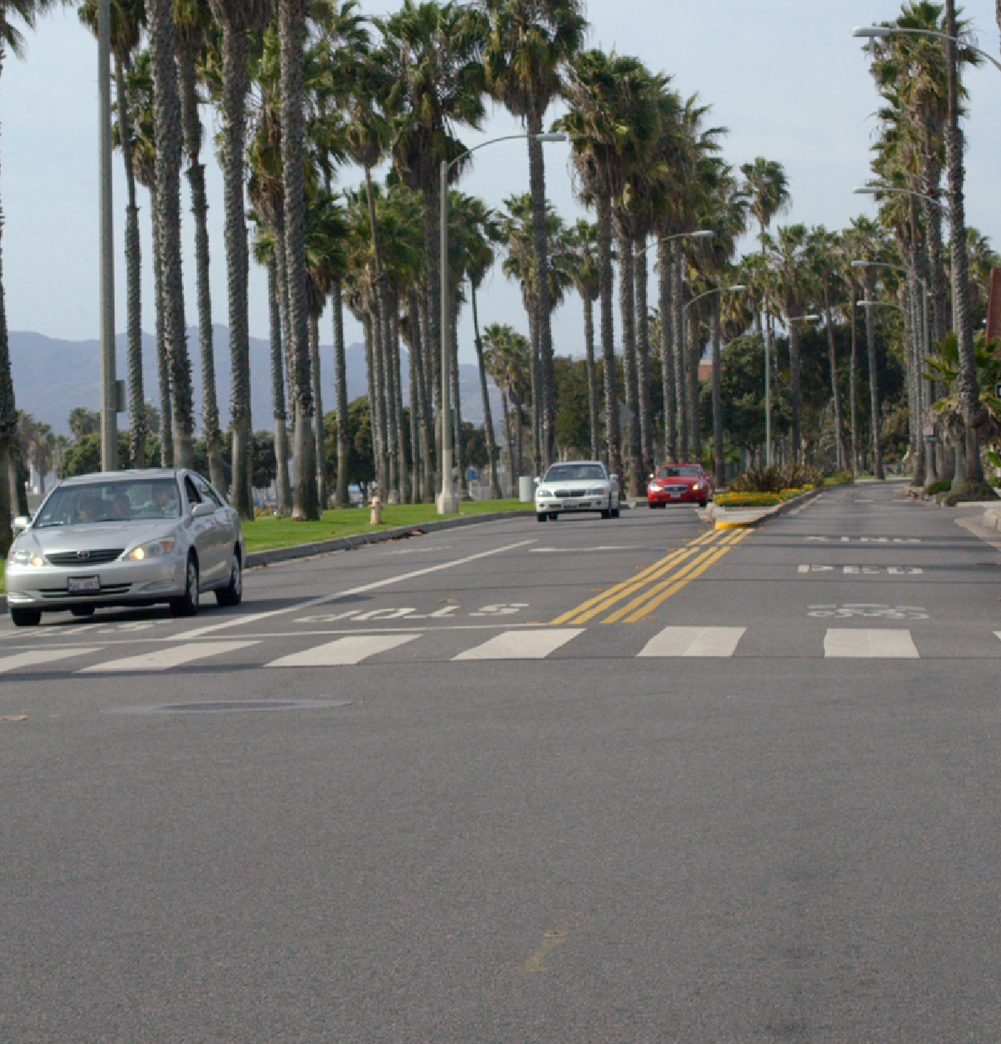


DrivingPOV4 | kbps | Y-  PSNR | U-  PSNR | V-  PSNR | Y-  MsSSIM | U-  MsSSIM | V-  MsSSIM | VMAF
VTM (frame QP 27) | 67349.3 | 39.920 | 44.158 | 42.861 | 0.9977 | 0.9743 | 0.9846 | 96.837
JPEG AI BOP | 67023.8 | 38.736 | 42.531 | 42.155 | 0.9974 | 0.9727 | 0.9584 | 96.811
Figure 1. Visual comparison on DrivingPOV4. Top: Original image. Bottom left: VTM coded. Bottom right: JPEG AI coded.


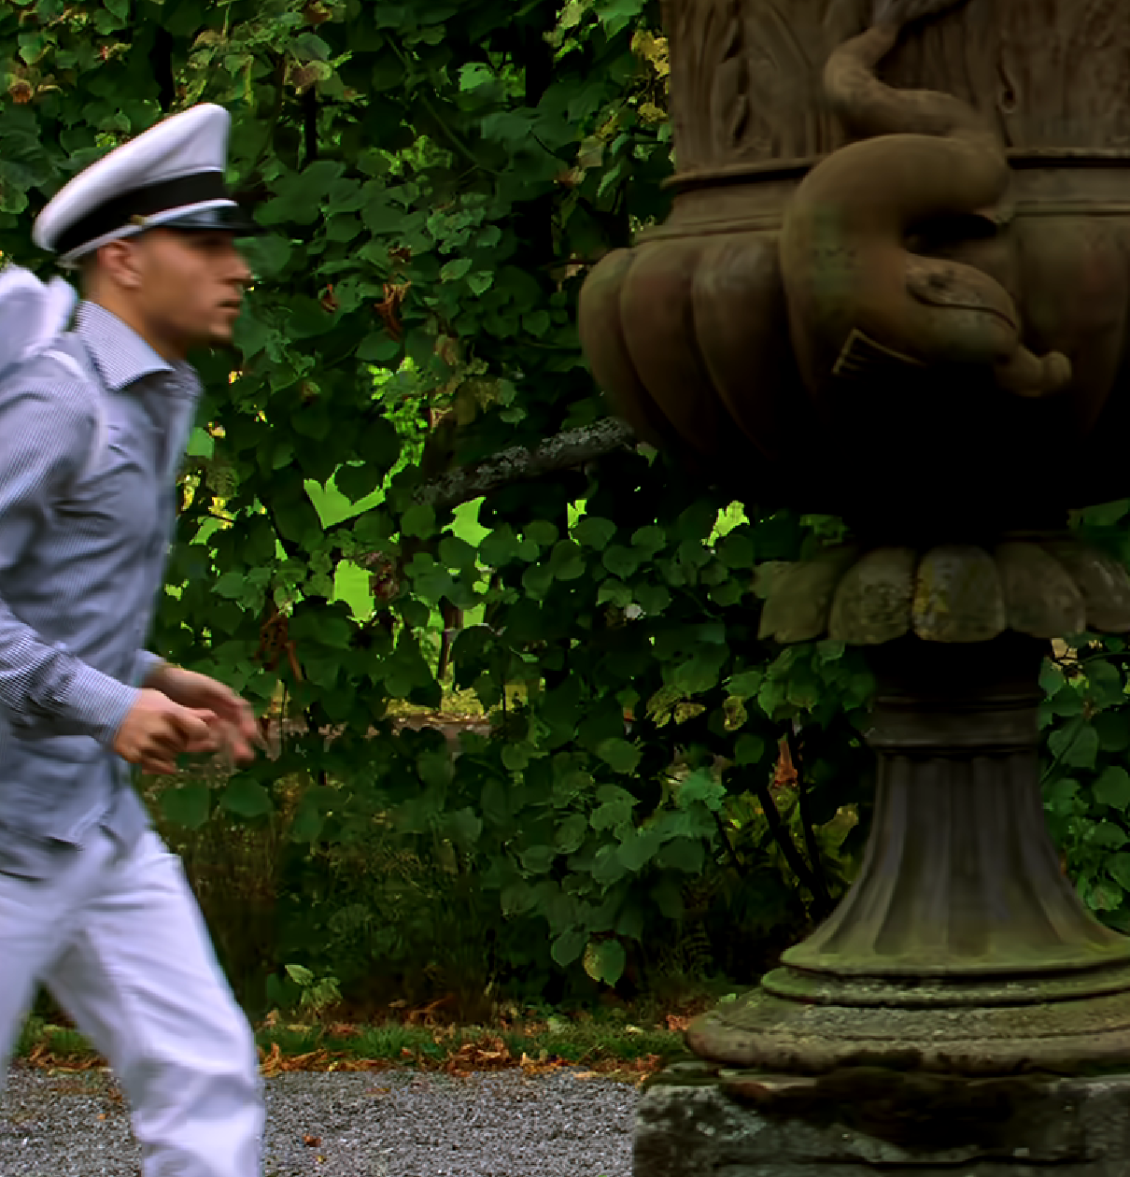

Seeking | kbps | Y-  PSNR | U-  PSNR | V-  PSNR | Y-  MsSSIM | U-  MsSSIM | V-  MsSSIM | VMAF
VTM (frame QP 32) | 45002.4 | 33.460 | 35.885 | 35.904 | 0.9960 | 0.9960 | 0.9841 | 90.037
JPEG AI BOP | 44162.4 | 32.879 | 34.798 | 34.358 | 0.9963 | 0.9954 | 0.9796 | 91.252
Figure 2. Visual comparison on Seeking. Top: Original image. Bottom left: VTM coded. Bottom right: JPEG AI coded.

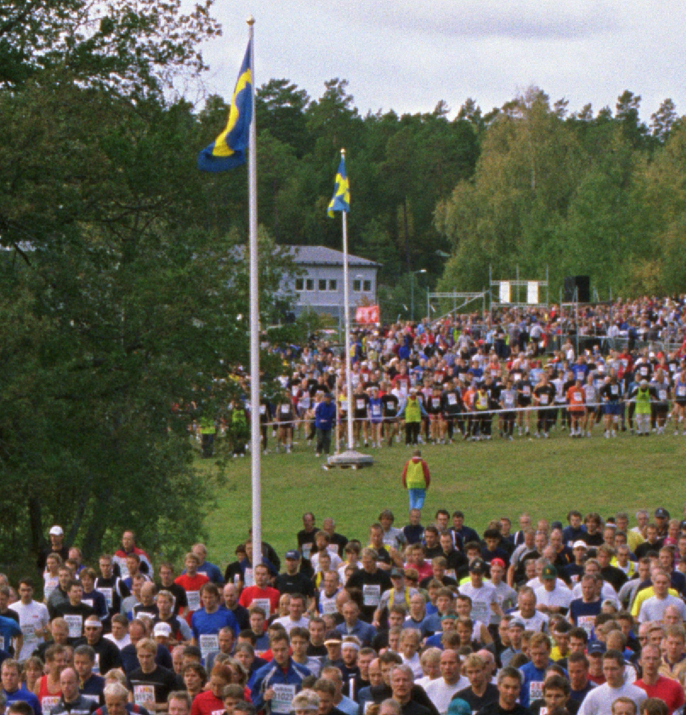
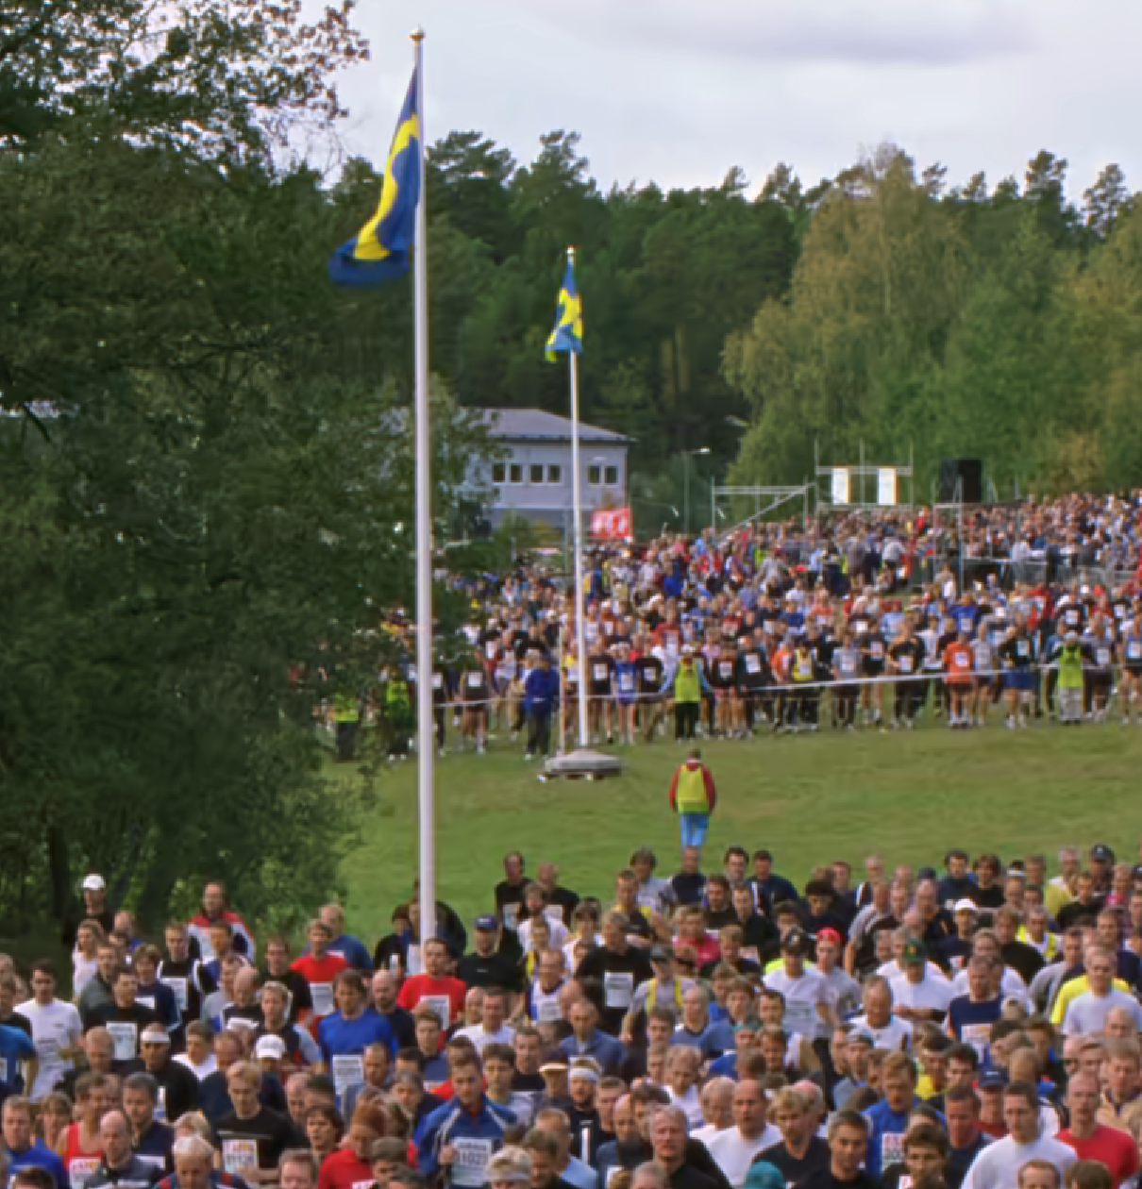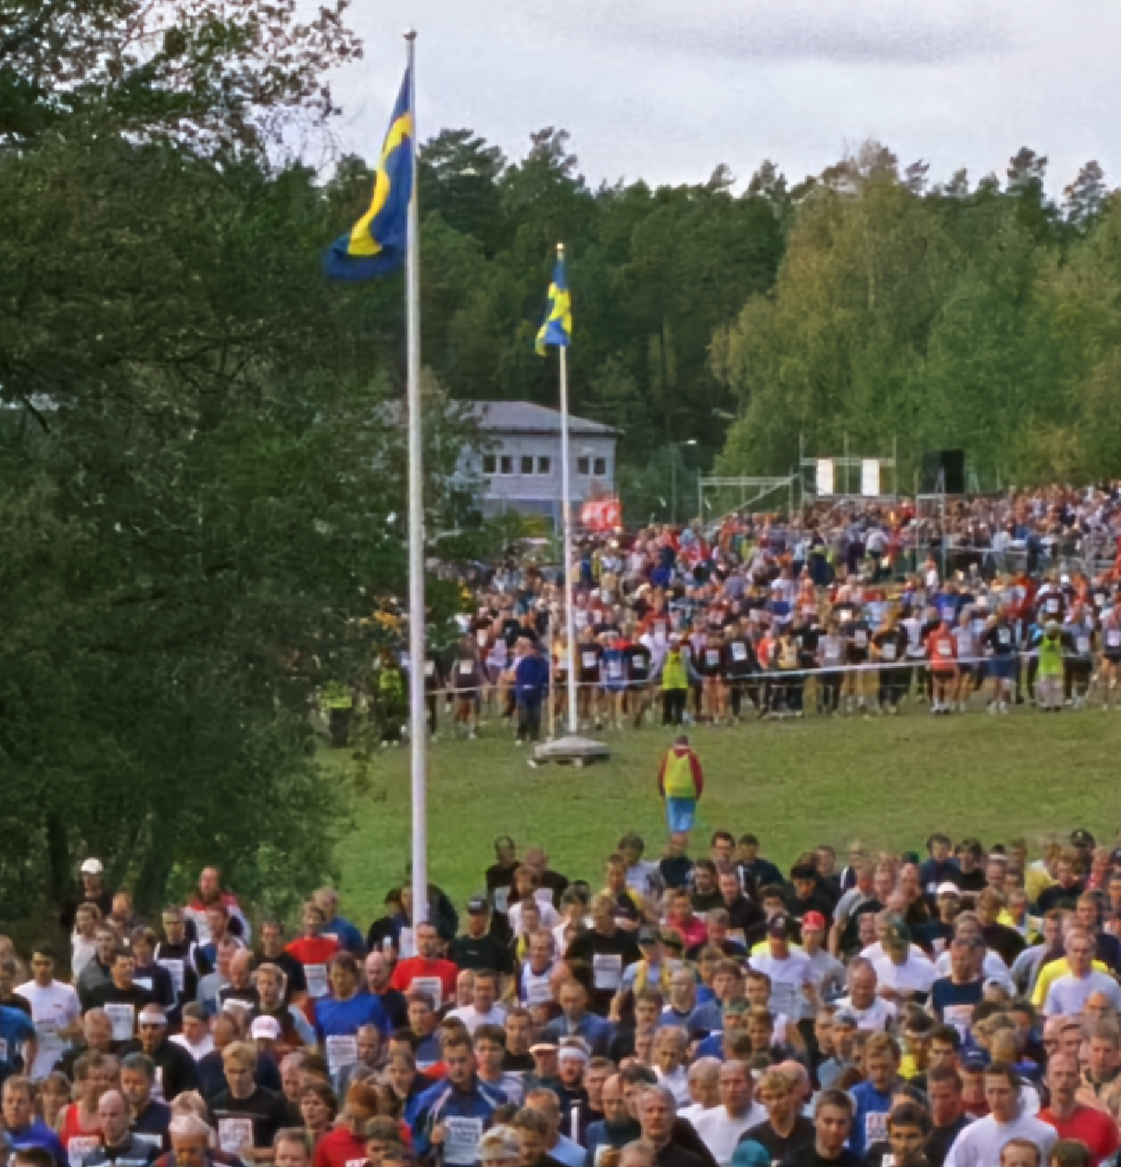

CrowdRun | kbps | Y-  PSNR | U-  PSNR | V-  PSNR | Y-  MsSSIM | U-  MsSSIM | V-  MsSSIM | VMAF
VTM (frame QP 30) | 124178.0 | 35.692 | 38.092 | 39.049 | 0.9957 | 0.9915 | 0.9838 | 92.691
JPEG AI BOP | 122949.2 | 35.760 | 35.994 | 36.706 | 0.9964 | 0.9882 | 0.9791 | 93.361
Figure 3. Visual comparison on CrowdRun. Top: Original image. Bottom left: VTM coded. Bottom right: JPEG AI coded.

Conclusions and Suggestions
A MSE-optimized codec tends to create blurred low-texture area in the decoded images, in middle and low bitrate coding, due to neglecting the masking effects of human vision. Product encoders often need extra efforts for perceptual optimization (e.g., block-based QP adjustment) to address this issue.
It is suggested to consider developing the next generation standard more directly towards perceptual quality. Using perceptual metrics that are subjectively correlated better than PSNR in evaluation framework may solicit coding technologies to achieve higher perceptual quality than previous standards, as illustrated in Figure 4. Ms-SSIM, VMAF and other metrics that meet this purpose are recommended to be considered in the future CTC.
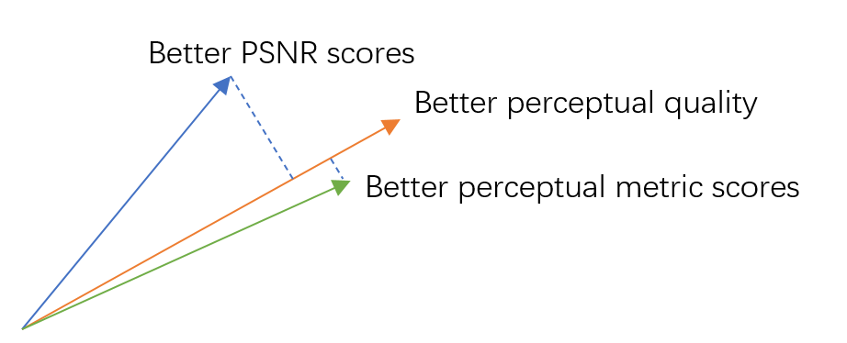
Figure 4. Better visual quality may be achieved when a codec is optimized towards a more subjectively correlated metric than PSNR.

Besides, it is recommended to investigate objective metrics with better correlation with human vision during the preparation of CfP, in AhG17 and perhaps with the help from AG5. We suggest adding this to the mandate of AhG17.
JVET subjective test data (e.g., CfE/CfP test data) may be used to evaluate the subjective correlation of candidate metrics. A call for objective quality metrics for video coding quality assessment may be issued to solicit more reliable metrics beyond what we have been familiar with.

References
[1] JPEG AI reference software, https://gitlab.com/wg1/jpeg-ai/jpeg-ai-reference-software

Annex: JPEG AI simulation script
- Encoding (with rate matching):
python -m src.reco.coders.encoder {INPUTFILE} {BITSTREAMFILE} -r {OUTPUTFILE} --cfg cfg/tools_off.json cfg/oper_point/bop.json -target_bpps {TARGETBPP} --use_yuv 1 -model.bitrate_matcher.default_target_rates {TARGETBPP} -model.bitrate_matcher.default_models {MODEL_IDX} -model.bitrate_matcher.default_beta_disp_log {BDL}
- Decoding:
python -m src.reco.coders.decoder {BITSTREAMFILE} {OUTPUTFILE}

Table 2. Encoding parameters for each sequence
 | DrivingPOV4 | Seeking | CrowdRun
{TARGETBPP} | 53 | 42 | 28
{MODEL_IDX} | 2 | 1 | 1
{BDL} | -402 | -96 | -60

Patent rights declaration(s)
Huawei Technologies may have current or pending patent rights relating to the technology described in this contribution and, conditioned on reciprocity, is prepared to grant licenses under reasonable and non-discriminatory terms as necessary for implementation of the resulting ITU-T Recommendation | ISO/IEC International Standard (per box 2 of the ITU-T/ITU-R/ISO/IEC patent statement and licensing declaration form).

