    Joint Video Experts Team (JVET)  of ITU-T SG21 WP3/21 and ISO/IEC JTC 1/SC 29  40th Meeting: Geneva, CH, 3–12 October 2025 | Document: JVET-AN0079-v4

Title: | AHG18: Proposed methodology and test conditions for ultra-low latency and packet loss resilience performance evaluation
Status: | Input document to JVET
Purpose: | Proposal
Author(s) or  Contact(s): | Sergey Ikonin  Ivan Gribushin  Xiang Ma  Elena Alshina  Sachin Deshpande | Email: | sergey.ikonin@huawei.com  elena.alshina@huawei.com  sdeshpande@sharplabs.com
Source: | Huawei Technologies, Sharp Labs of America, Inc.
_____________________________

Abstract
In the past several JVET meetings, several documents discussing aspects related to AHG18 were discussed, the related techniques and test conditions were discussed comprehensively. This contribution proposes an evaluation methodology and suggests test conditions based on the discussion targeting further AHG18 work. Comparing with the current AHG18 test condition, which only contains Wi-Fi connection case, the 5G network constraints are additionally proposed, full VTM tool set is enabled, with a wide bitrate range, LDB and spatial scalability testing conditions are further supported. The contribution also suggests the objective quality metrics calculation methodology, accompanied with an excel template for quality plots construction and summary results collecting.

Introduction
This contribution is based on JVET-AL0176, in which, an initial test conditions were proposed, including quality indicators such as average PSNR, worst-case PSNR, and frame freeze ratio to assess the reconstruction quality evaluated in unicast and broadcast scenarios under ultra-low latency and packet loss resilience conditions using short-distance Wi-Fi connection.
During AhG18 discussions several comments, suggestions, and further extension were proposed by the group, namely in contributions JVET-AM0109, JVET-AM0202, JVET-AM0204, JVET-AM0222, JVET-AM0325, which were incorporated into this updated version of ULL CTC document. Namely, the following aspects are added:
- Full VTM tool set enabled
- Wide QP range
- Low delay B configuration
- Spatial scalability
- 5G communication patterns and corresponding packet trace files
- More Wi-Fi traces to support high QP tests
- Transmission priority model
- Reduced-runtime-3 configuration corresponding to real-time scenario

Test sequences
High resolution class A2 and B of JVET CTC are suggested to be used reflecting high-quality content for general purpose screen casting scenario, as well as Gaming content reflecting popular cloud gaming scenario. The detailed description of the sequences, formats and location can be found in [1]
Table 1 defines the set of test sequences to be used for ultra-low latency conditions. All frames (as defined by frame count in the table) shall be processed for all sequences and test cases described below.
For each sequence the single QP for testing is defined with corresponding bandwidth point (packet trace file and start line) for simulation.
Table 1 Test sequences
Class | Sequence name | Frame count | Frame rate | Bit depth | Unicast, w/ feedback | Broadcast, w/o feedback
Gaming HD | DOTA2s360 | 550 | 60 | 8 | + | +
Gaming HD | GTAVs090 | 600 | 60 | 8 | + | +
Gaming HD | Minecraft | 600 | 60 | 8 | + | +
A2 | CatRobot | 300 | 60 | 10 |  | +
A2 | DaylightRoad2 | 600 | 60 | 10 |  | +
A2 | ParkRunning3 | 500 | 50 | 10 |  | +
B | MarketPlace | 600 | 60 | 10 | + | +
B | RitualDance | 600 | 60 | 10 | + | +
B | Cactus | 500 | 50 | 8 | + | +
B | BasketballDrive | 500 | 50 | 8 | + | +
B | BQTerrace | 600 | 60 | 8 | + | +
The table below specifies bandwidth rate points for VTM anchor . In the test the bitrate should match anchor’s bitrate with +/- 5% of tolerance interval.
Table 2 Test sequences and bandwidth points
Class | Sequence name | QP | Bitrate,  Mbps | Wi-Fi bandwidth point | 5G bandwidth point
Gaming HD | DOTA2s360 | 22 | 12.4 | WFBP-05 | TBA
Gaming HD | GTAVs090 | 22 | 35.2 | WFBP-09
Gaming HD | Minecraft | 22 | 41.8 | WFBP-09
A2 | CatRobot | 22 | 23.8 | WFBP-06
A2 | DaylightRoad2 | 22 | 37.4 | WFBP-06
A2 | ParkRunning3 | 22 | 118.8 | WFBP-10
B | MarketPlace | 22 | 15.9 | WFBP-05
B | RitualDance | 22 | 10.8 | WFBP-05
B | Cactus | 22 | 12.9 | WFBP-05
B | BasketballDrive | 22 | 15.7 | WFBP-05
B | BQTerrace | 22 | 38.6 | WFBP-09
Gaming HD | DOTA2s360 | 27 | 4.5 | WFBP-03 | 5GBP-1
Gaming HD | GTAVs090 | 27 | 12 | WFBP-05
Gaming HD | Minecraft | 27 | 14 | WFBP-05
A2 | CatRobot | 27 | 9.0 | WFBP-04 | 5GBP-2
A2 | DaylightRoad2 | 27 | 9.8 | WFBP-04 | 5GBP-2
A2 | ParkRunning3 | 27 | 44.2 | WFBP-09 | TBA
B | MarketPlace | 27 | 5.8 | WFBP-03 | 5GBP-1
B | RitualDance | 27 | 5.3 | WFBP-03 | 5GBP-1
B | Cactus | 27 | 4.2 | WFBP-03 | 5GBP-1
B | BasketballDrive | 27 | 5.3 | WFBP-03 | 5GBP-1
B | BQTerrace | 27 | 5.1 | WFBP-03 | 5GBP-1
Gaming HD | DOTA2s360 | 32 | 1.9 | WFBP-02 | TBA
Gaming HD | GTAVs090 | 32 | 4.7 | WFBP-03 | 5GBP-1
Gaming HD | Minecraft | 32 | 4.9 | WFBP-03 | 5GBP-1
A2 | CatRobot | 32 | 4.5 | WFBP-03 | 5GBP-1
A2 | DaylightRoad2 | 32 | 4.6 | WFBP-03 | 5GBP-1
A2 | ParkRunning3 | 32 | 19.3 | WFBP-05
B | MarketPlace | 32 | 2.6 | WFBP-02
B | RitualDance | 32 | 2.7 | WFBP-02
B | Cactus | 32 | 2.0 | WFBP-02
B | BasketballDrive | 32 | 2.5 | WFBP-02
B | BQTerrace | 32 | 4.2 | WFBP-02
Gaming HD | DOTA2s360 | 37 | 0.9 | WFBP-01 | TBA
Gaming HD | GTAVs090 | 37 | 2.0 | WFBP-02
Gaming HD | Minecraft | 37 | 2.0 | WFBP-02
A2 | CatRobot | 37 | 2.5 | WFBP-02
A2 | DaylightRoad2 | 37 | 2.4 | WFBP-02
A2 | ParkRunning3 | 37 | 8.8 | WFBP-04 | 5GBP-2
B | MarketPlace | 37 | 1.2 | WFBP-01
B | RitualDance | 37 | 1.5 | WFBP-01
B | Cactus | 37 | 1.0 | WFBP-01
B | BasketballDrive | 37 | 1.3 | WFBP-01
B | BQTerrace | 37 | 0.9 | WFBP-01
Table 3 and Table 4 define the set of bandwidth points, corresponding packet trace file and start line for simulation.
Table 3 Wi-Fi bandwidth points
Bandwidth point | Packet trace file | Start line | Average channel capacity in 10s range
WFBP-01 | 004.4mbps_room10x5_bw20MHz_5nbs1.5mbps.csv | 66522 | 4.4 Mbps
WFBP-02 | 015.1mbps_room10x5_bw20MHz_5nbs1.1mbps.csv | 259209 | 7.3 Mbps
WFBP-03 | 014.9mbps_room10x5_bw20MHz_2nbs3.5mbps.csv | 24245 | 13.5 Mbps
WFBP-04 | 014.9mbps_room10x5_bw20MHz_2nbs3.5mbps.csv | 138392 | 16 Mbps
WFBP-05 | 018.5mbps_room16x8_bw20MHz_2nbs1.5mbps.csv | 200726 | 32 Mbps
WFBP-06 | 057mbps_room16x8_bw20MHz_nb20mbps_255s.csv | 333907 | 71 Mbps
WFBP-07 | 045.9mbps_room10x5_bw20MHz_2nbs2.0mbps.csv | 139286 | 76 Mbps
WFBP-08 | 080mbps_room16x8_bw20MHz_nb10mbps_140s.csv | 87476 | 91 Mbps
WFBP-09 | 080mbps_room16x8_bw20MHz_nb10mbps_140s.csv | 298053 | 92 Mbps
WFBP-10 | 237mbps_room16x8_bw80MHz_nb20mbps_255s.csv | 1430973 | 235 Mbps
Wi-Fi packet trace files are located in folder ./cfg/wifi_simulation_trace/ of AHG18 simulation software [6].
Table 4 5G bandwidth points
Bandwidth point | Paket trace file | Start line | Average channel capacity in 10s range
5GBP-1 | 017.3Mbps_band16MHz.csv | 34679 | 15.6 Mbps
5GBP-2 | 017.7Mbps_band32MHz.csv | 12859 | 16.4 Mbps
5G packet trace files are located in folder ./cfg/5g_simulation_trace/ of AHG18 simulation software [6].

Test conditions for latency constrained scenario
- Low delay B (./cfg/encoder_lowdelay_vtm.cfg config of VTM)
- QP 22, 27, 32, 37 are evaluated mandatory, and QP 42, 47 optionally
- Coding condition: reduced runtime 3, as specified in ./cfg/alternative-addon/reduced_runtime3.cfg of AHG18 simulation software [6]
- Network bandwidth point as specified in Table 2.
- Reconstruction quality is evaluated against four latency restrictions: 16, 24, 32 and 50ms.
- The first IDR picture is bypassed through network model without loss and delay to have key SPS/PPS information delivered, and allow to have at least first picture decoded.

Reported Metrics
- Average PSNR for Y, Cb and Cr
- Freeze ratio: portion of frames that were replaced by last received frame
- Worst case PSNR: reconstruction quality of worst 5% and 10% of frames for Y, Cb and Cr
- Encoding and decoding runtime

Test cases

Unicast scenario
- Feedback channel is available, feedback time 40ms. The encoder is allowed to adjust the reference picture list based on the feedback.

Broadcast scenario
- No feedback channel is allowed. Periodic IRAP frame insertion every ~1 second.

Clean channel performance verification
To verify BD-rate overhead of assessed methods the clean channel performance following conditions described in section 4 of current document, with no latency restriction and no packet trace file specified (network model disabled) should be reported.

Network connection types
Reconstruction performance is evaluated in different last mile connection types:

Wi-Fi connection
The Wi-Fi connection is configured to emulate office or home usage scenario using NS-3 simulator. See section 11.3 for further details.

5G connection
The 5G connection is configured to emulate office or home usage scenario using NS-3 simulator. See section 11.4 for details.
Reconstruction performance is evaluated in regular channel model (section 8.4) and channel model with transmission priorities (section 8.5).

Anchors

Single layer VTM
Regular single layer VTM.

Scalable VTM
2-layers spatial scalability with 2x downscaled base layer coded with QP offset 15.

Transmission channel emulation
To simulate video communication service under ultra-low latency restriction in Wi-Fi and 5G networks a following test environment based on VTM has been constructed:
Decoder
Encoder
Network model
Packet trace file
Jitter buffer
Latency restriction, ms
feedback, optional
Figure 1 Ultra-low latency video communication test environment
The test environment includes VTM Encoder, Decoder, Network model with packetization and transmission emulation based on pre-recorded packet trace file, and Jitter Buffer collecting NAL units back from packets received by the time constrained by the latency restriction. It should be noted that the jitter buffer compensates for packet delay variation at the receiver, and is sometimes referred to as a de-jitter buffer. The latency restriction is command line parameter specified in milliseconds and can be configured to any number. In current scenario only communication latency is considered, all other processing times are assumed to be zero.

Network channel model
Network channel model emulates the transmission and obtains packet losses and delays based on pre-recorded packet trace from NS-3 network simulator (see section 11 for further details).
For every sequence and QP the corresponding bandwidth point is specified in Table 2 to approximately match the network channel capacity to the average bitrate of the coded sequence. The bandwidth point consists of packet trace file and start-line, as specified in Table 3 and Table 4.

Overfitting prevention
To avoid test overfitting the startlines of each bandwidth points are supposed to be randomly shifted in 0 to 1 second range. Three such randomized starting points should be defined and the performance should be evaluated by statistical averaging across these starting points. The shift is randomly selected every meeting cycle.

Jitter buffer and latency model
Jitter buffer is a common approach used by current applications to mitigate network transmission problems. The buffer is introduced at the receiver side to compensate the network jitter and make the playback smoother. Jitter buffer collects all packets corresponding to the encoded frame, then output them to the decoder at certain time controlled by the latency constraint. The packets that arrive later than the output time are considered as lost.
In the unicast scenario when channel feedback is enabled the frame loss information is reported to the sending side in order to let encoder to change the reference picture. The feedback delay is equal to latency restriction plus feedback time.

Regular transmission model
Packets of every frame are transmitted one-by-one (without any priority mechanism) and retransmitted during their lifetime. Packet lifetime is a common mechanism used in Wi-Fi and 5G to control retransmission logic. The sending buffer of the router keeps each specific packet in the buffer until lifetime is over. During this time router keeps retransmitting the packet in case of transmission fail. The packet lifetime is set equal to default value of 512 ms (as in Wi-Fi and 5G).

Transmission priority model
Modern transmission protocols have various priority mechanisms (JVET-AM0188, JVET-AM0201). Such mechanisms may be very useful for ULL video transmission scenarios. An approximated transmission priority model is used. The model operates by traffic ID (from 0 to 7) which may correspond to different layers, NAL unit types, data partitions, or any other categories depending on information importance. Based on traffic ID two features are specified:
- Sending order priority
- Traffic ID specific packet lifetime
Stream A
Sending buffer
(packets A/B)
Stream B
Channel
router
Figure 2 Transmission priorities model

Sending order priority
For some coding solutions the bitstream may consists of several parts (at least two) of different importance: stream A and stream B. Where stream A contains more important information critical for frame reconstruction, and stream B contains less important information. Transmission priority enables sending stream A packets before the packets of stream B.
For example, in scalable coding case L0 is considered as stream A and L1 as stream B. Another example is a data partitioning used in AVC containing bitstream of two parts A and B following the same transmission priority logic.

Packet lifetime adjustment
The tuning of lifetime can be useful to solve the network overflow problem. Outdated packets can be discarded as soon as they expire and cannot be used for decoding due to latency restriction. As latency restriction is the deadline of frame delivery thus lifetime of stream B packets is set equal to latency restriction. For stream A packets the lifetime is kept as default value of 512ms.

Software
The ULL metrics evaluation framework is based on AGH18 simulation software and is located at: https://vcgit.hhi.fraunhofer.de/jvet-ahg-ull/VVCSoftware_VTM. More details can be found in section 11.1

Conclusion
It is suggested to use described above methodology and test conditions in context of AHG18 work.

Annex A

ULL metrics evaluation framework
The Figure 3 illustrates the ULL metrics evaluation framework based on AHG18 simulation software and HDR tools. The more detailed description can be found in JVET-AL0201 [2]. The corresponding reporting template is provided with contribution.
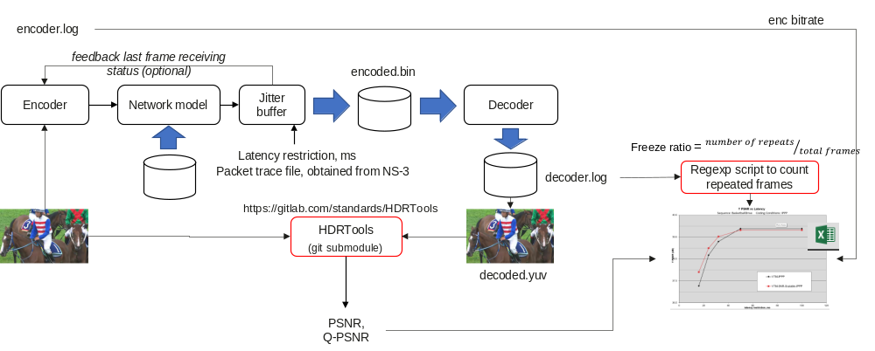
Figure 3 ULL metric calculation framework

Packet trace files generation
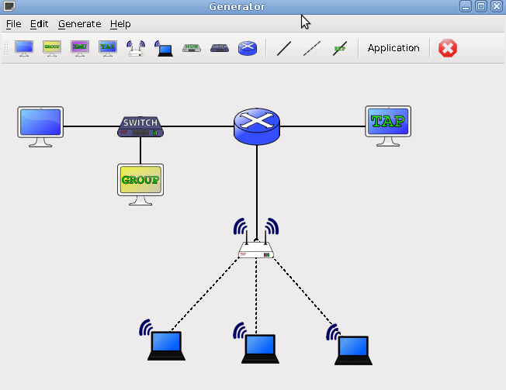
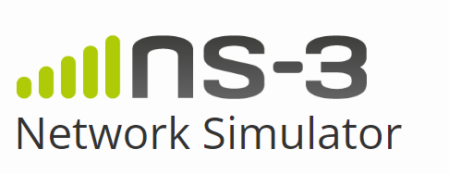
The packet trace files were obtained using NS-3 simulator [3], [4]. The more details can be found in JVET-AK0193 [5].
Packet trace file
Figure 4 Packet trace file generation using NS-3 simulator

Wi-Fi scenario
The NS-3 simulator was configured to emulate office or home usage scenario with following exemplary parameters:
- 16m x 8m room.
- 1 Wi-Fi station (STA) connected to Access Point (AP) down streaming the video VVC encoded video under evaluation with low latency constrain.
- Wi-Fi parameters: X MHz bandwidth, TX power = 16 dBm (~40mW).
- Neighboring interfering Wi-Fi network is located in a room of same size, but on the next floor (+3m height) and shifted to the right. Interfering traffic is emulated by Y Mbps neighborhood interference.
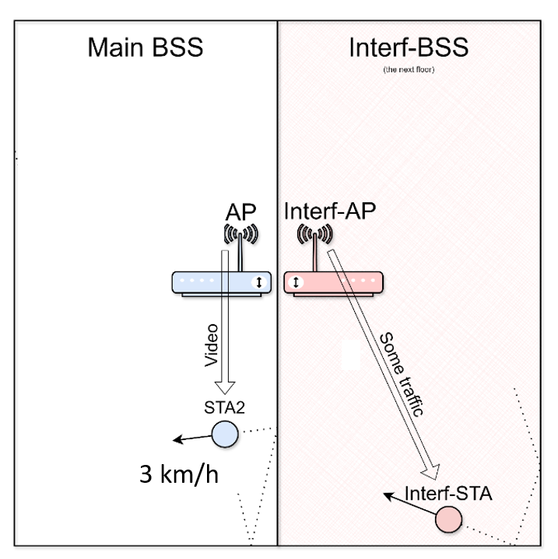
- STAs are moving in their rooms with a speed of 3 km/h (walking speed).
Figure 5 Physical room configuration used for NS-3 simulation
Varying the physical room and Wi-Fi configuration parameters packet trace files with different average channel bitrate can be obtained. Depending on values of channel bandwidth X MHz and interfering bitrate Y Mbps bandwidth points with different channel goodput were generated.

5G scenario
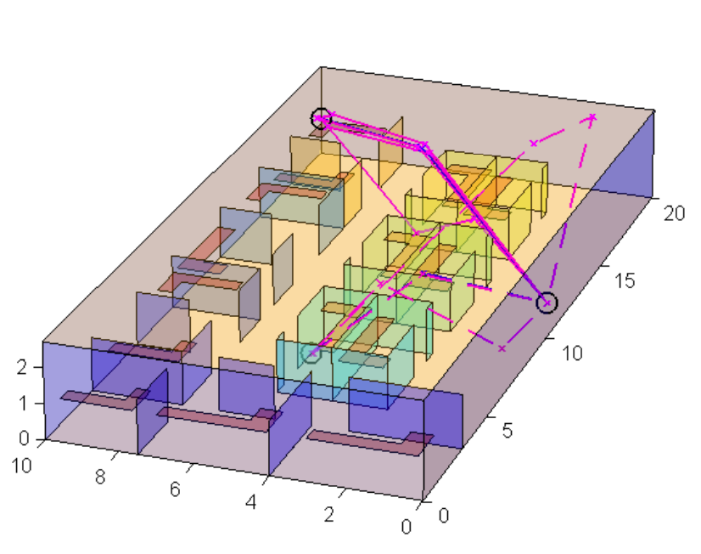
Figure 6 Indoor office scenario
A realistic office environmental model is attained by explicitly considering walls, screens, desks, chairs and people. The environmental model geometry is given by the dimensions of the rooms, cubicle offices and tables. The width and depth of these objects are illustrated in the Figure 6.
UE devices move according to the random mobility 2D model within a cell (square with ISD).

Carrier Frequency | 3.6 GHz (FR1)
DL x UL organization | TDD, 8x2
Numerology | 60 kHz, TTI = 250 us
Bandwidth | 10-50 MHz
Inter-side distance | 20-30 m
BS/UE antenna elements | 16/4
UE (Train) mobility | Up to avg. 3 km/h
UE distribution | 100% Indoor, Random
Channel modeling | 3GPP 38.901 Mixed Indoor Office [1]
Traffic (downlink) | - single full-buffer flow  - multiple (<10) UDP Poisson  (0.5-1 Mbps) flows  - a few (x265) flows
Scheduler | SU Rank=2, Proportional Fair

References
- “VTM and HM common test conditions and software reference configurations for SDR 4:2:0 10 bit video”, Joint Video Experts Team (JVET), 37th Meeting, Geneva, January 2025, Doc. JVET-AK2010.
- “AHG18: Performance evaluation of VTM under proposed ULL test conditions and proposed software modifications”, Joint Video Experts Team (JVET), 38th Meeting, Online, April 2025, Doc. JVET-AL0201.
- https://www.nsnam.org/
- Wireless Next Generation (WNG) Standing Committee within IEEE 802.11, doc: IEEE 11-24-1139-01-0wng, https://mentor.ieee.org/802.11/dcn/24/11-24-1139-01-0wng-ns-3-rel-42-43-wi-fi-model-updates-and-network-simulations.pptx
- “Low latency Wi-Fi transmission simulation and suggestions on codec requirements”, Joint Video Experts Team (JVET), 37th Meeting, Geneva, January 2025, Doc. JVET-AK0193.
- https://vcgit.hhi.fraunhofer.de/jvet-ahg-ull/VVCSoftware_VTM

Patent rights declaration(s)
Huawei Technologies does not have any current or pending patent rights relating to the technology described in this contribution.
Sharp Labs of America, Inc., may have current or pending patent rights relating to the technology described in this contribution and, conditioned on reciprocity, is prepared to grant licenses under reasonable and non-discriminatory terms as necessary for implementation of the resulting ITU-T Recommendation | ISO/IEC International Standard (per box 2 of the ITU-T/ITU-R/ISO/IEC patent statement and licensing declaration form).

