    Joint Video Experts Team (JVET)  of ITU-T SG21 WP3/21 and ISO/IEC JTC 1/SC 29  40th Meeting, Geneva, CH, 03 – 12 October 2025 |  |  | Document: JVET-AN0052-v4
Title: | [AHG17] Performance of GOP based RPR under CfE test conditions
Status: | Input document to JVET
Purpose: | Proposal
Author(s) or  Contact(s): | Y. Sun, Y. Zhao, J. Sauer, J. Pardo, P. Jia, T. Solovyev, E. Alshina | Email: | elena.alshina@huawei.com
Source: | Huawei Technologies
_____________________________

Abstract
This document reports test results for GOP based RPR enabled in VTM SW under CfE test conditions. Objective metrics results as well as visual examples are provided. Video examples are attached as part of the package.

Introduction
If resolution of video is high, content is not very complex, but required level of quality is moderate or low, then often down-sampling, coding in lower resolution and then up-sampling provides better results than coding in full resolution. This approach is very widely used. VVC standard supports RPR functionality, which allows changing the scaling factor for video during coding. VTM SW which was used for CfE anchor generation provides an example for encoder decision on scaling factor and QP without multi-pass encoding. First picture in each GOP is down-sampled and up-sampled before coding. Decision on scaling factor is based on PSNR computed between pristine and distorted by down-/up-sampling. Scaling factor decided this way is used for the whole GOP. This feature can be enabled by command line option ‘--GOPBasedRPR=1’.
Target rates selected for CfE are very low (compared to CTC JVET uses for standard development). Many sequences in CfE test set are relatively easy to encode.
This contribution analyses an effect of GOP based RPR has under CfE test conditions [1].

Test conditions
The same sequences as in CfE test set were used for testing. Full length simulations have been conducted. For simplicity no close rate matching to target rates was used. Tests were conducted with QPs equal to integer QP which provides rate matching for CfE anchor (VTM 23.11 default, ‘x1’) configuration. Reduced encoder complexity configurations (so-called reduced run time 1, 2, 3, referred below as ‘rr1, ‘rr2’, and ‘rr3’) were tested with the same QPs as VTM default.
The only modification done is enabling GOP based RPR. All tests are compliant with VVC standard and can be obtained with VTM SW.
Quality metrics measured in full resolution, using PSNR and MS-SSIM reported in encoder log and confirmed by measured by HDRTools.

Test results
The Table 1 below summarizes all test results. BD-rate in PSNR and MS-SSIM, as wells as encoder and decoder run-times are reported relatively to CfE anchor VTM23.11 default (VTM_rr0 in the table). Left part of the table reports results of tests in random access configuration and right part is for low-delay-B tests.

 | Low delay B
Test name | Y-PSNR | U-PSNR | V-PSNR | Y-MSIM | U-MSIM | V-MSIM | EncT | DecT CPU
VTM_rr0_GOPBasedRPR | -2% | -6% | -5% | -4% | -5% | -5% | 100% | 89%
VTM_rr1_GOPBasedRPR | -1% | -4% | -3% | -4% | -3% | -3% | 71% | 91%
VTM_rr2_GOPBasedRPR | 2% | -1% | -1% | -2% | -1% | 0% | 42% | 84%
VTM_rr3_GOPBasedRPR | 11% | 12% | 14% | 6% | 13% | 13% | 21% | 78%
VTM_rr0 | 0% | 0% | 0% | 0% | 0% | 0% | 100% | 100%
VTM_rr1 | 1% | 2% | 2% | 1% | 2% | 2% | 72% | 106%
VTM_rr2 | 5% | 4% | 5% | 2% | 4% | 5% | 43% | 104%
VTM_rr3 | 16% | 20% | 21% | 14% | 20% | 20% | 22% | 96%
Table 1 Summary of test results

 | Random access
Test name | Y-PSNR | U-PSNR | V-PSNR | Y-MSIM | U-MSIM | V-MSIM | EncT | DecT CPU
VTM_rr0_GOPBasedRPR | -5% | -12% | -13% | -7% | -11% | -12% | 92% | 68%
VTM_rr1_GOPBasedRPR | -4% | -10% | -12% | -6% | -10% | -11% | 67% | 70%
VTM_rr2_GOPBasedRPR | -1% | -9% | -11% | -4% | -8% | -9% | 39% | 68%
VTM_rr3_GOPBasedRPR | 7% | 2% | 0% | 4% | 2% | 2% | 19% | 64%
VTM_rr0 | 0% | 0% | 0% | 0% | 0% | 0% | 100% | 100%
VTM_rr1 | 1% | 1% | 1% | 1% | 1% | 1% | 76% | 102%
VTM_rr2 | 4% | 3% | 3% | 3% | 3% | 4% | 46% | 103%
VTM_rr3 | 15% | 19% | 21% | 15% | 18% | 20% | 23% | 97%
Results in the Table 1 show that enabling RPR brings substantial BD-rate gain under CfE test conditions and significantly reduces both encoding and decoding run-time.
Figure 1 visualizes the trends of compression performance (measured in PNSR-Y and MS-SSIM-Y) vs encoder complexity in random access (on a left) and low-delay-B (or a right) configurations.

Figure 1 Compression performance vs encoder complexity trends: brown curve – VTM, blue curve – VTM with GOPbasedRPR enabled. Numbers next to the curves show decoder run time ratio relatively tot eh anchor.
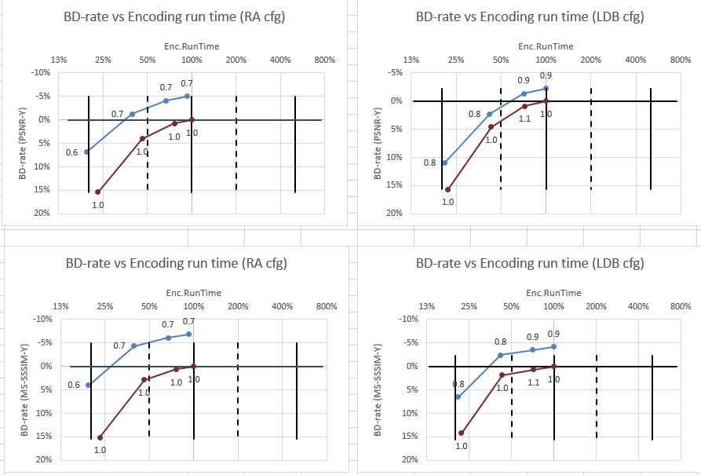

Per sequence analysis
Of course, enabling GOP based RPR doesn’t help in all cases under CfE test conditions. The Table 2 shows per sequence test results for VTM (default, ‘rr0’) with RPR vs one w/o RPR.
It is easy to see that there is no BD-rate drop (both in PSNR and MS-SSIM, for Luma and Chroma components) due to enabling RPR. This confirms that encoder decision on scaling factor in VTM SW are adequate. This encoder logic (seems) comes from [2].
For 10 out of 30 test sequences (1/3) we see zero BD-rate in the Table 2. This means that for none of the target rates in CfE test conditions reduced resolution coding was selected by encoder.
But for remaining 2/3 of test sequences at least for some target rates and GOPs the reduced resolution coding provides better results compared to the full resolution coding. Similar observation was done in [3].

Table 2 Per sequence test results under CfE test conditions.
 | VTM23.11 default with GOPBasedRPR vs VTM23.11 default
 | Y-PSNR | U-PSNR | V-PSNR | Y ms-ssim | U ms-ssim | V ms-ssim
CrowdRun | -2.3% | -3.3% | -4.0% | -3.2% | -3.8% | -4.1%
DrivingPOV3 | -8.3% | -17.1% | -14.0% | -12.1% | -18.8% | -15.6%
FireDance | -12.5% | -22.7% | -22.7% | -18.2% | -23.4% | -21.9%
HallwayScene | -15.5% | -37.9% | -36.8% | -18.3% | -30.0% | -27.3%
DucksTakeOff | 0.0% | 0.0% | 0.0% | 0.0% | 0.0% | 0.0%
DrivingPOV4 | -1.5% | -2.5% | -2.6% | -2.6% | -2.3% | -2.0%
Seeking | 0.0% | 0.0% | 0.0% | 0.0% | 0.0% | 0.0%
Umbrella | 0.0% | 0.0% | 0.0% | 0.0% | 0.0% | 0.0%
AMS06 HLG | 0.0% | 0.0% | 0.0% | 0.0% | 0.0% | 0.0%
MeridianHDR2 PQ | -8.0% | -23.1% | -26.3% | -8.6% | -21.0% | -22.7%
NeptuneFountain3R1 PQ | -5.4% | -30.3% | -48.8% | -9.3% | -24.7% | -41.8%
SparksWelding PQ | -6.2% | -13.7% | -9.9% | -8.0% | -13.5% | -10.5%
ChandelierCropBR PQ | -8.4% | -6.9% | -9.2% | -10.4% | -8.7% | -7.8%
FashionLadyCrop1 | -21.8% | -32.9% | -45.1% | -26.7% | -34.5% | -39.0%
WaterfallForest HLG | -2.0% | -1.2% | -5.0% | -3.2% | -1.2% | -2.6%
WomenFootball HLG | -10.1% | -13.8% | -15.5% | -11.2% | -15.8% | -14.4%
Camellia | -0.2% | -0.5% | -1.2% | -0.6% | -0.7% | -1.6%
Hobby-w5xz-backpack | -0.6% | -4.4% | -5.9% | -4.0% | -5.7% | -7.8%
NightLandscapeRunning | -0.9% | -2.1% | -2.5% | -1.5% | -3.3% | -3.8%
Sports-76a2-iceball | -1.4% | -15.4% | -20.8% | -5.1% | -11.5% | -17.4%
VerticalVideo-3709-snow | -3.5% | -17.9% | -17.8% | -4.7% | -18.0% | -17.8%
VerticalVideo-3d96-walk | -1.5% | -8.6% | -7.6% | -3.1% | -5.5% | -6.7%
Beatriz | -6.3% | -14.7% | -11.4% | -10.7% | -15.9% | -12.7%
GregoryCactus2 | 0.0% | 0.0% | 0.0% | 0.0% | 0.0% | 0.0%
GregoryScarf2 | -0.9% | -2.2% | -2.4% | -1.3% | -2.5% | -3.2%
OfficeWalkAtWall | -11.0% | -28.9% | -27.7% | -21.5% | -25.6% | -23.2%
DOTA2s360 | 0.0% | 0.0% | 0.0% | 0.0% | 0.0% | 0.0%
GTAVs090 | 0.0% | 0.0% | 0.0% | 0.0% | 0.0% | 0.0%
Level1 | 0.0% | 0.0% | 0.0% | 0.0% | 0.0% | 0.0%
Minecraft | 0.0% | 0.0% | 0.0% | 0.0% | 0.0% | 0.0%
The only class GOP based RPR doesn’t show compression benefits is gaming sequences. For this class, at the selected target rates video codec re-design is the only way to reduce rates.
UGC content class is not 4K resolution, but GOP based RPR provides gain for all sequences in this class. Many of UGC videos come from the cloud. It might happen that during transmission from capturing device to cloud reduced resolution coding was used.
The maximum BD-rate gain is observed for Fashion Lady (cropped 8K sequence), Hallway Scene and Fire Dance (both are relatively noisy).
For Fashion Lady video sequence RD-curves for PNSR Y, U and V are shown on Figure 2, curves are not crossing, also rates for tests and anchor are very close, which confirms high quality of RPR encoder decision logic in VTM and leaves no doubt about BD-rate numbers reported.
Among 4 K (or cropped 8K) sequences Seeking, Umbrella and AMS06 HLG cannot get coding benefits from RPR (similar to gaming content) and so require codec redesign to reduce bits.
Figure 2 Examples of RD-curves
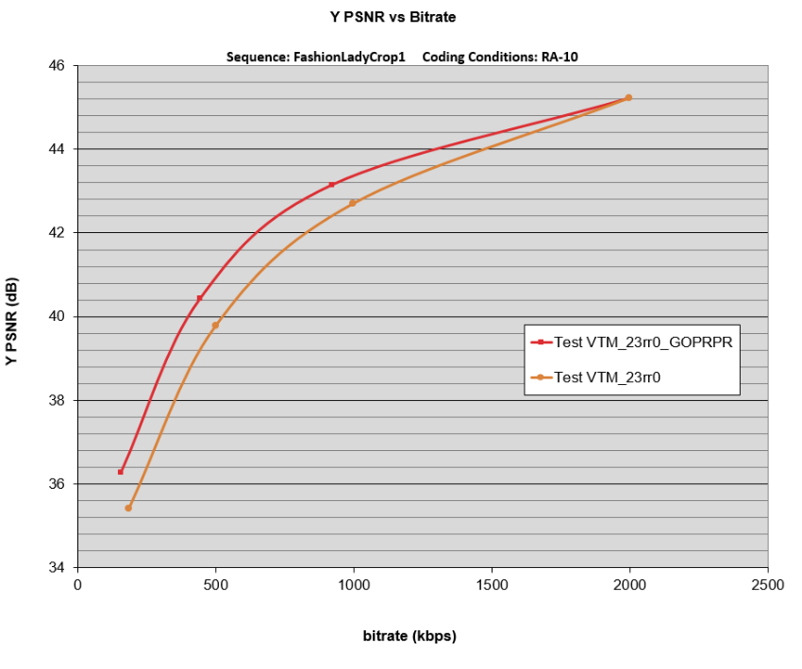
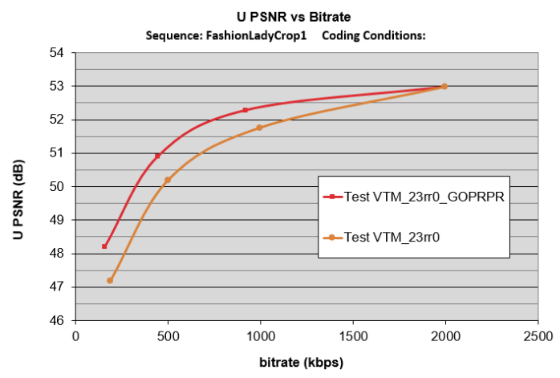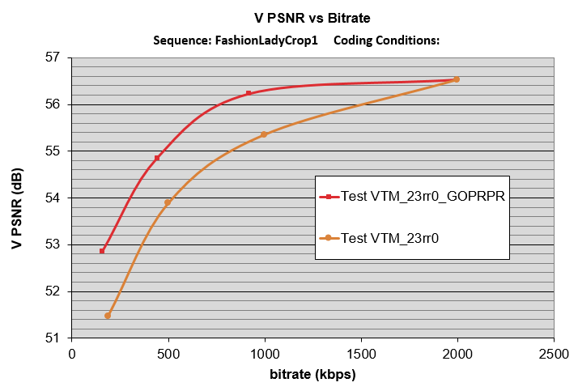

Visual examples
Several visual quality (still images) examples are demonstrated in this section. Video examples are uploaded to [4].
Illustrations in this section clearly confirm that under CfE test condition GOP based RPR clearly improves visual quality.

Figure 3 Fashion Lady: full resolution coding of a left, RPR enabled on a right (the lowest rate, second the lowest rate, second the highest rate).
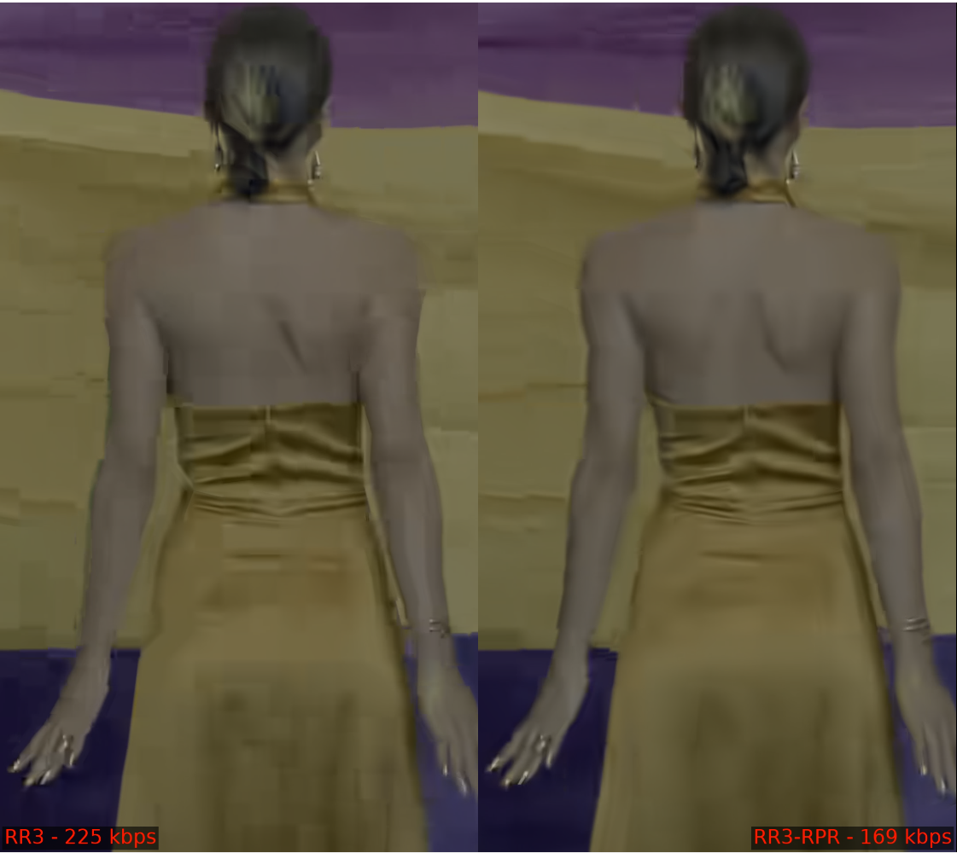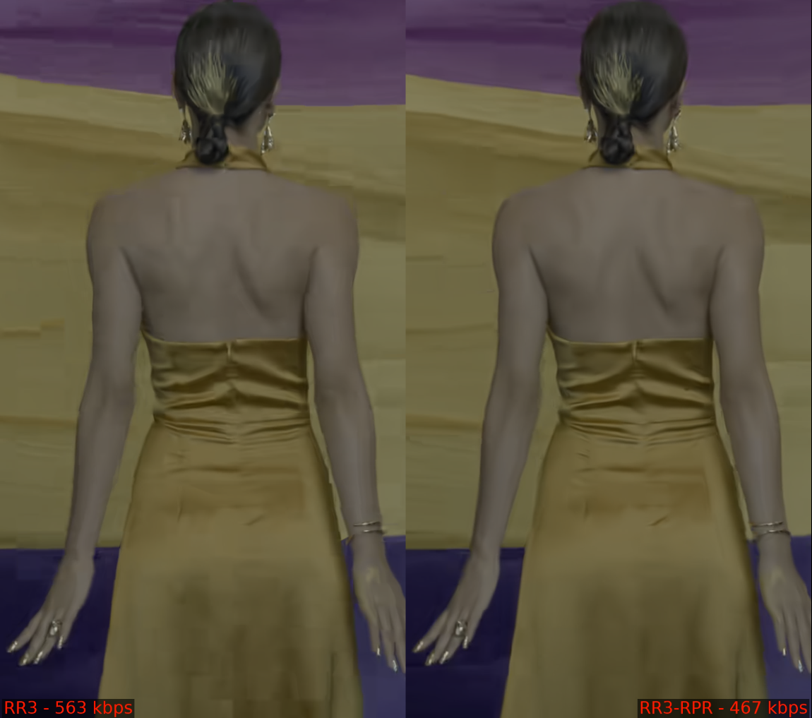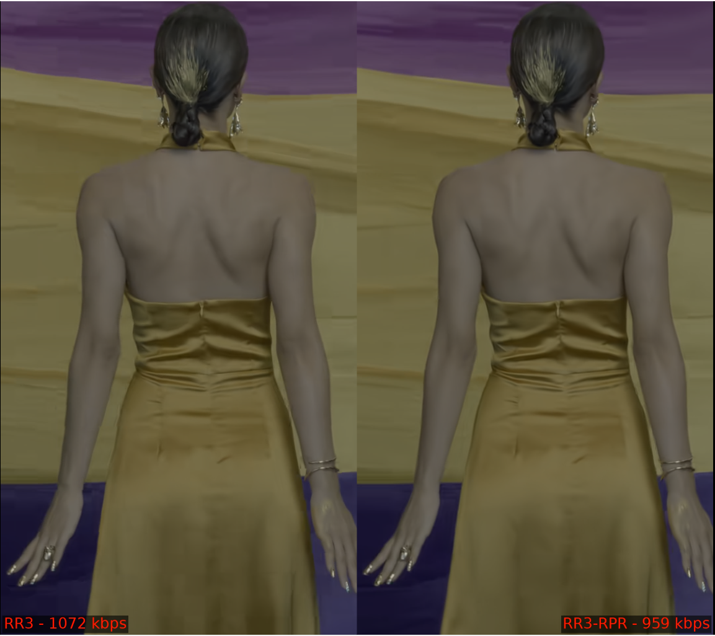

Figure 4 Vertical Snow: full resolution coding of a left, RPR enabled on a right (four different target rates from the lowest to the highest).
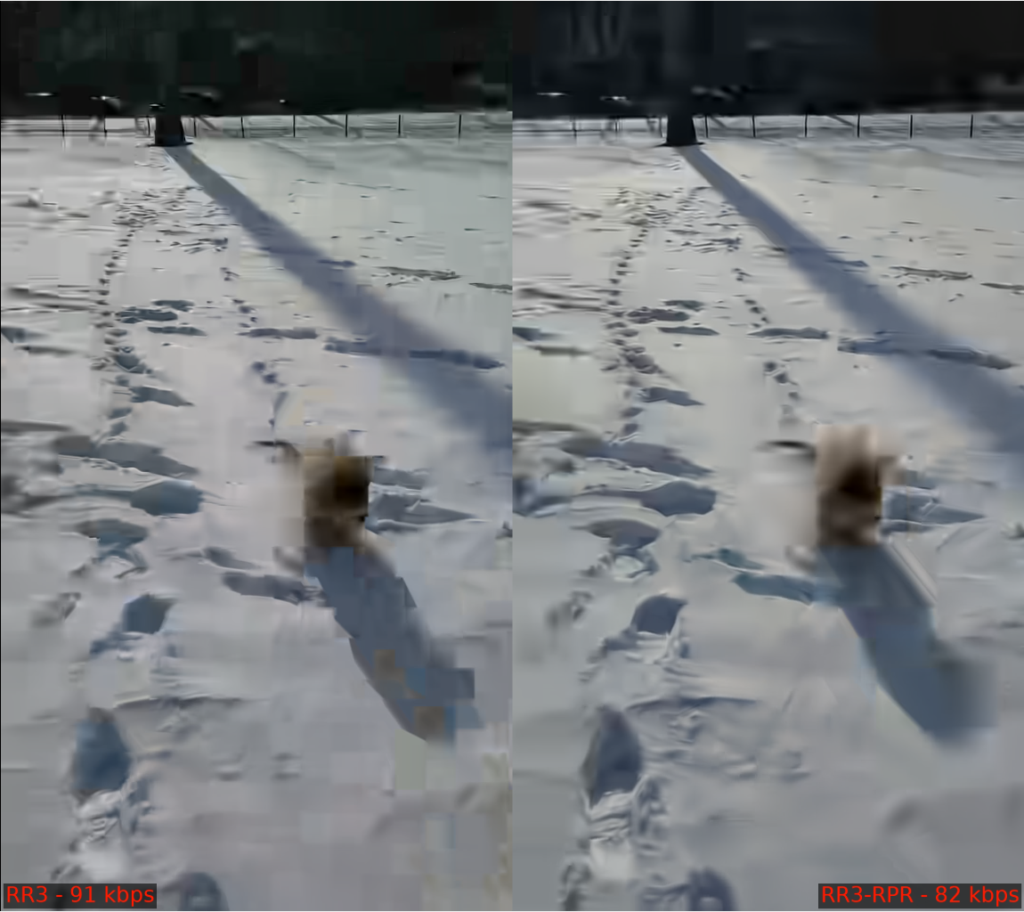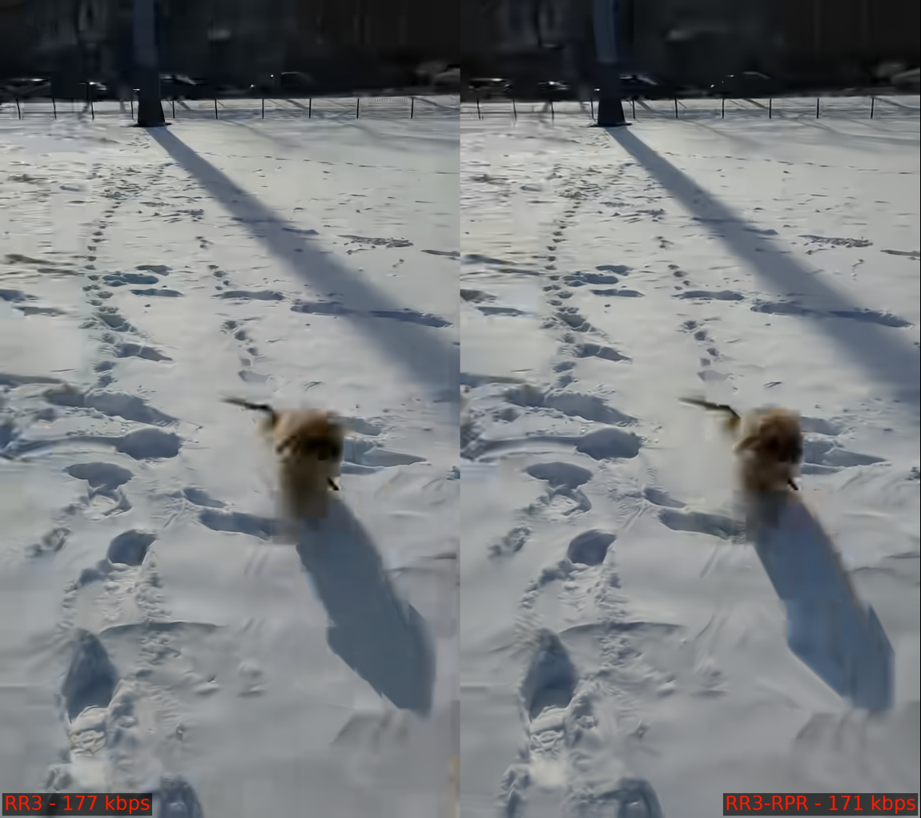
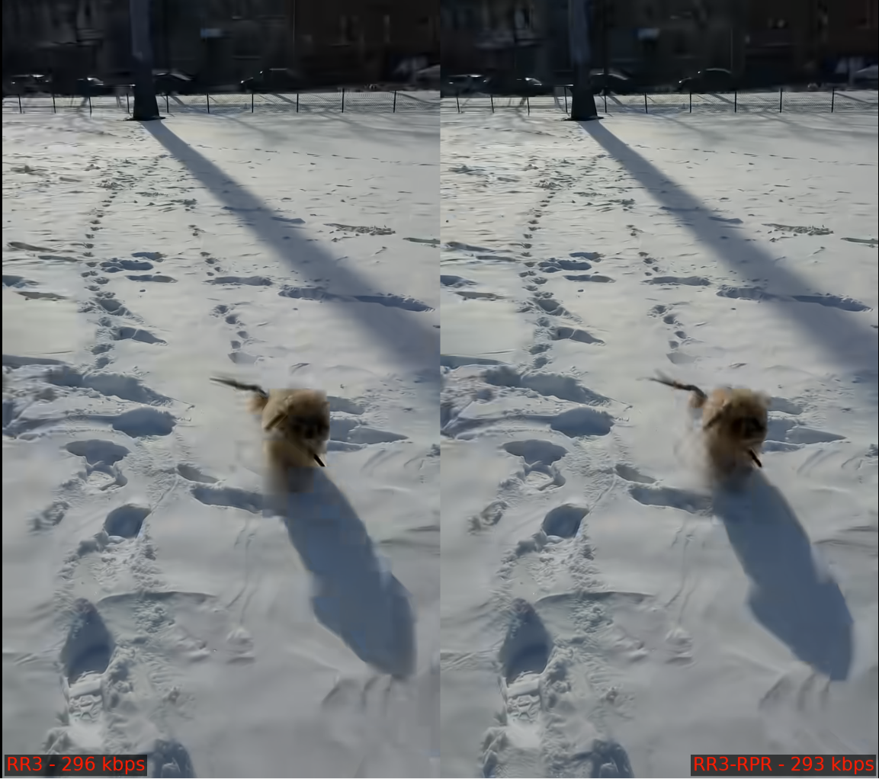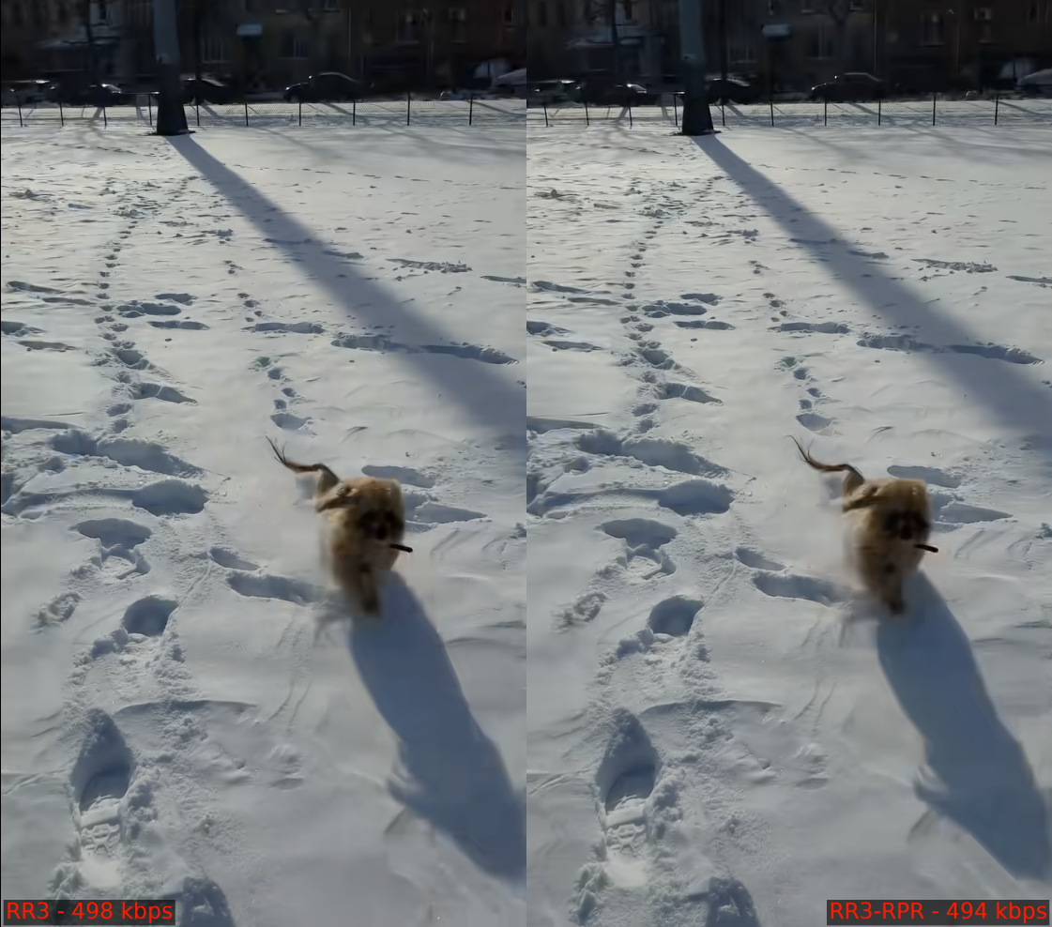

CfE results analysis
Plot below section summarizes the objective performance results (BD-rate computed based on PSNR Y) for several CfE responses as well as for ECM reference. Results for VTM with RPR enabled are indicates by red diamonds.
It is reasonable to make comparison with coding solutions with similar encoding run time. For example, at ‘×1’ preset both JVET-AN0267 and JVET-AN0212 have a good chance to show visual benefits by higher than CfE anchor MOS w/o overlapping confidential intervals. But if RPR is enabled for anchor then the most likely confidential intervals will overlap.

Figure 5 Summary of CfE results in comparison with VTM & RPR: BD-rate (PSNR Y) of vertical axis, encoding run time ratio – horizontal axis.
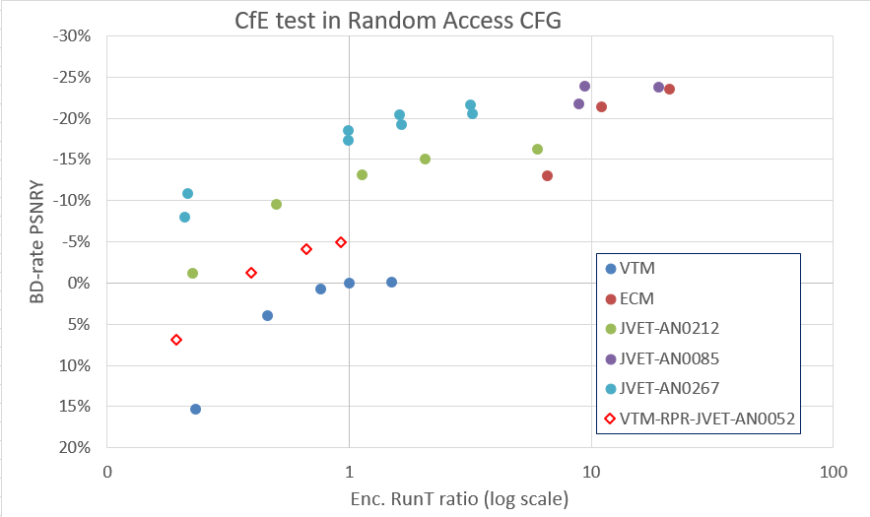

Discussion and conclusion
- Test results and visual examples demonstrated in this contribution clearly show that under CfE test conditions anchor performance can be substantially improved by GOP based RPR. Conducting CfE (and CfP in a future) and defining common test conditions for next-gen standard based on a strong anchor would help develop new technologies and prove improved capability over the existing standards. Comparison with substantially penalized anchor makes results of CfE questionable and will cause negative effect out of JVET.
- It is not necessary to constrain that GOP based RPR shall not be used in submission. It is proposed to enable GOP based RPR for CfE/CfP anchor. This would change visual quality and would require selection of new target rates. But simulations (both encoder and decoder) will become faster.
- We would like to emphasize that 1/3 of CfE sequences do not benefit from GOP based RPR, i.e., adaptive reduced resolution coding, and re-design of video codec to improve its coding efficiency at the original scale seems very needed. It is recommended to include more sequences of this kind into the test set (in order to avoid competition of adaptive resolution technologies and focus on video codec improvement).

Recommended actions
- Enable GOPBasedRPR in CfE anchor
- Reconsider a set of video sequences
  - replace or down-sample test videos which are too easy to encode
- Reselect target rates
- Ideally conduct a new round of CfE to confirm evidence

Acknowledgement
We would like to thank Google, Tencent and Samsung who cross-checked results independently.

References
- J.-R. Ohm, M. Wien, F. Bossen Joint Call for Evidence on video compression with capability beyond VVC JVET-AM2026
- J. Nam, S. Yoo, J. Lim, S. Kim (LGE) EE1-2.1: Updates on RPR encoder and post-filter JVET-AC0078
- G. Clare (bcom), F. Henry (Orange), M. Tarchouli (Ateme), M. Riviere (Ateme) AHG17: Resampling test for large resolution sequences JVET-AL0154
- https://drive.google.com/drive/folders/1vXQOO9iL-VdeOky_tM6dmInzztl3LzpL

