    Joint Video Experts Team (JVET)  of ITU-T SG21 WP3/21 and ISO/IEC JTC 1/SC 29  40th Meeting: Geneva, CH, 3–12 October 2025 | Document: JVET-AN0050-v1

Title: | AHG18: An Introduction to 5G Latency/Throughput Measurement and Real-time Monitoring for ULL Application Scenarios
Status: | Input document to JVET
Purpose: | Information
Author(s) or  Contact(s): | Bora Jeon  Sungmin Kim | Email: | borajeon25@tta.or.kr  mylumbokim@lguplus.co.kr
Source: | LG uplus Co.,Ltd.
_____________________________

Abstract
This contribution reports experimental results of latency and throughput measurements in a 5G mobile network. It also describes a method for monitoring latency in real time. The method is based on measuring the inter-arrival time of periodically transmitted packets. This approach can be applied to systems that need to transmit video for real-time safety over mobile networks. It is also considered advantageous for supporting ultra-low latency application scenarios in MPEG.

Introduction
In ULL(Ultra-Low Latency) environments, the demand for real-time video streaming services over public mobile networks is steadily increasing. Among the services, safety-critical applications such as tele-operated driving are also expected to operate over the mobile networks. Therefore, mobile communication systems are required to meet the requirements of such safety-related services. For instance, 3GPP has initiated standardization work on tele-operated driving, and derived network requirements specifying a 25 Mbps uplink throughput and a 5 ms end-to-end latency to support tele-operated vehicles traveling at speeds up to 250 km/h [1]. In addition, Mate reported that, for HEVC HD video streaming on fast-moving vehicles, the throughput and E2E latency requirements were 10 Mbps and 20 ms, respectively [2]. Furthermore, Tao from U.S. National Institute of Standards and Technology (NIST) mentioned that tele-operation is feasible when the end-to-end (E2E) latency remains below 300 ms, and that even with an E2E latency below 500 ms, low-speed tele-operation at 30 km/h is still achievable [3].
To investigate whether such safety-critical applications can be supported over current public mobile networks, we measured the throughput and latency of a 5G public mobile network in South Korea. The experimental conditions are as follows:
- Driving route: downtown in Seoul
- Vehicle speed: < 80km/h
- Video streaming: H.264 with 1M bps, 2.5M bps, and 7M bps
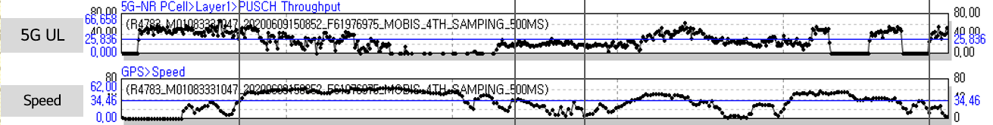
Fig.1 An example of experimental results: 5G uplink throughput
Fig.1 shows the measurement results of the uplink throughput of a 5G network in urban areas of South Korea. And, the distribution of the throughput is as follows:
- 5-10 Mbps : 24.57% of the total route
- 10-20 Mbps : 20.33% of the total route
- 20-32 Mbps : 19.67% of f the total route
- 32-38 Mbps : 5.74% of the total route
- Above 38 Mbps : 29.69% of the total route
The end-to-end (E2E) latency remained consistently at around 200 ms, of which the network latency accounted for approximately 70 ms. However, the network latency occasionally fluctuated, and in extreme cases, delays of several seconds were observed.
As a result, the throughput was adequate to support a single video stream, whereas the latency was not consistently stable. These findings indicate that, when utilizing current 5G mobile networks, safety-critical ULL applications require mechanisms to predict and compensate for variations in network latency.

Mobile network monitoring method for ULL applications
Fast-moving objects such as vehicles frequently switch base stations, making it difficult to measure uplink latency precisely in real time. Nevertheless, as shown in Section 1, the 5G mobile network generally maintained stable latency, with only occasional fluctuations. Therefore, even without exact measurements, predicting latency variations would be highly beneficial for ULL applications.

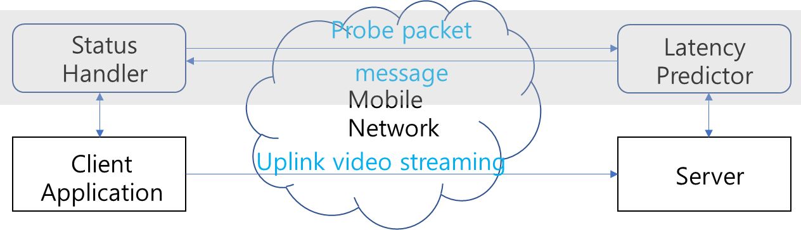
Fig. 2 Throughput-Controlled Remote Driving System Architecture [4]

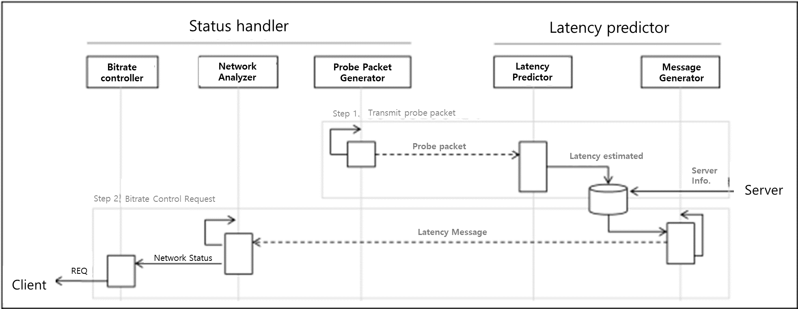
Fig. 3 Interworking Procedure [4]

To support this, the Telecommunication Technology Association (TTA) in South Korea has specified a standard [4]. Fig. 2 shows the block diagram of an application requiring uplink video streaming with the standard applied. As shown in the figure, the standard consists of a status handler and a latency predictor, and it can be easily integrated into existing applications. The status handler periodically transmits probe packets to the latency predictor, which measures the inter-arrival time of the received packets and thereby predicts variations in mobile network latency. Fig. 3 illustrates the interworking procedure between the status handler and the latency predictor.

Conclusion
With the rapid increase of real-time streaming services over mobile networks, issues such as sudden drops in throughput or temporary increases in latency occur frequently. When safety-critical services such as autonomous or tele-operated driving rely on public mobile networks, it is essential to account for network conditions using methods such as the TTA Korea Standard [4].

References
[1] 3GPP TS 22.186 v18.0.1 (2024-03), "3rd Generation Partnership Project; Technical Specification Group Services and System Aspects; Enhancement of 3GPP support for V2X scenarios; Stage 1 (Release 18)." https://www.etsi.org/deliver/etsi_ts/122200_122299/122261/18.16.00_60
[2] Mate Boban, Apostolos Kousaridas, Konstantinos Manolakis, Joshep Eichinger, and Wen Xu, "Connected Roads of the Future: Use Cases, Requirements, and Design Considerations," IEEE Vehicular Technology Magazine, Vol. 13, Issue 3, Sept. 2018 https://ieeexplore.ieee.org/document/8410403
[3] Tao Zhang, "Toward, Automated Vehicle Teleoperation: Vision, Opportunities, and Challenges," Journal of IEEE Internet of Things, Vol. 7, No. 12, Dec. 2020 https://ieeexplore.ieee.org/document/9214882
[4] TTAK.KO-06.0597, "Throughput Control Method for Remote Vehicle based on Public Mobile Network." 2023 https://committee.tta.or.kr/data/standard_view.jsp?kor_standard=%3F%3F%3F%3F&nowSu=2&pk_num=TTAK.KO-06.0597&rn=1&rn1=Y

Patent rights declaration(s)
LG uplus Corporation may have current or pending patent rights relating to the technology described in this contribution and, conditioned on reciprocity, is prepared to grant licenses under reasonable and non-discriminatory terms as necessary for implementation of the resulting ITU-T Recommendation | ISO/IEC International Standard (per box 2 of the ITU-T/ITU-R/ISO/IEC patent statement and licensing declaration form).

