    Joint Video Experts Team (JVET)  of ITU-T SG21 WP3/21 and ISO/IEC JTC 1/SC 29  40th Meeting: Geneva, CH, 3–12 October 2025 | Document: JVET-AN0049-v1

Title: | AHG18: Teleconference on ultra-low latency and packet loss resilience
Status: | Input document to JVET
Purpose: | Report
Author(s) or  Contact(s): | S. Ikonin, S. Wenger, V. Zakharchenko (co-chairs)  S. Deshpande, J. Ström, X. Ma, C. Kim, S. Puri, S. Fößel (vice-chairs) | Email: | sergey.ikonin@huawei.com  swenger@global.tencent.com  vlad.zakharchenko@nokia.com
Source: | AHG18
_____________________________

Abstract
This document summarizes discussions during teleconference of AHG18 on Ultra-low latency and packet loss resilience that have taken place between the 39th and 40th JVET meetings.

AHG mandates
- Investigate and identify test conditions, evaluation criteria and evaluation methodology, supporting a set of end-to-end latency targets in a range of 25-100 ms.
- Investigate creation of practical simulation software based on VTM, including network transmission aspects, and conduct performance evaluation.
- Identify potential requirements and feasibility of standard based technologies to support ultra-low delay requirements, including packet loss resilient decoding.
- Investigate packet loss resilient technologies beyond VVC supporting ultra-low delay coding for interactive and live broadcasting scenarios.
- Coordinate with AHG4 on investigating visual impact of data losses.

Meeting of 2025-08-21
The teleconference was conducted on August 21, 2025, at 17:00 UTC. In total 27 experts attended the discussion.
Agenda of the teleconference was as follows:
- JVET-AN0046: On test conditions for ultra-low latency and packet loss resilience with full QP range
  - Network bandwidth point selection automation script
  - LDP/LDB simulations in full QP range
  - Spatial Scalability
- AHG18 software, MRs status
  - MR2: Full VTM
  - MR3: GDR fix
- JVET-AN0045: Codec software for ultra-low latency and packet loss resilience (related to JVET-AM0218)
  - Software overview
  - Transmission priority model

Discussion

JVET-AN0046: On test conditions for ultra-low latency and packet loss resilience with full QP range
The document JVET-AN0046 was presented addressing comments of last JVET meeting concerning ULL CTC design (see JVET-AM0109, JVET-AM0202, JVET-AM0204, JVET-AM0222, JVET-AM0325), and following topics were discussed.

Network bandwidth point selection automation script
As was discussed last JVET meeting the wider range of QP is desirable to explore, extending from currently exercised QP22. That extension would require matching between video bitrate and channel capacity to experience decoding stability and reconstruction quality problems caused by network behaviour, which are subject of interest of AhG18. To make this matching the automation script was introduces.
The proposed automation script (bandwidth_point_selection.py. uploaded with v2 of JVET-AN0046 contribution) takes average bitrate of specific coded sequence as input parameter and searches for the interval with 1.3 - 2.5x times larger average network capacity. Due to channel fluctuation in 20% of frames the instant channel bandwidth should drop below average video bitrate (low goodput ratio), which is another precondition. Below is an example of how to run it, and expected output:
python bandwidth_point_selection.py --bitrate 45 --config config.yaml
Script returns list of found startlines in trace file sorted by distance from 20% of low good put ratio:

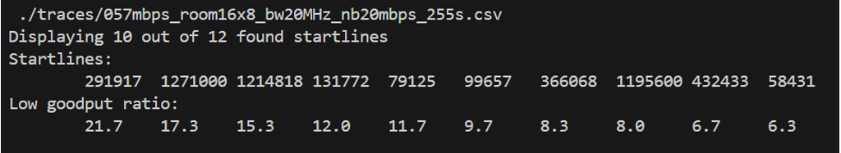
For each found startline a channel capacity plot is saved as a picture to allowing to see the channel profile:
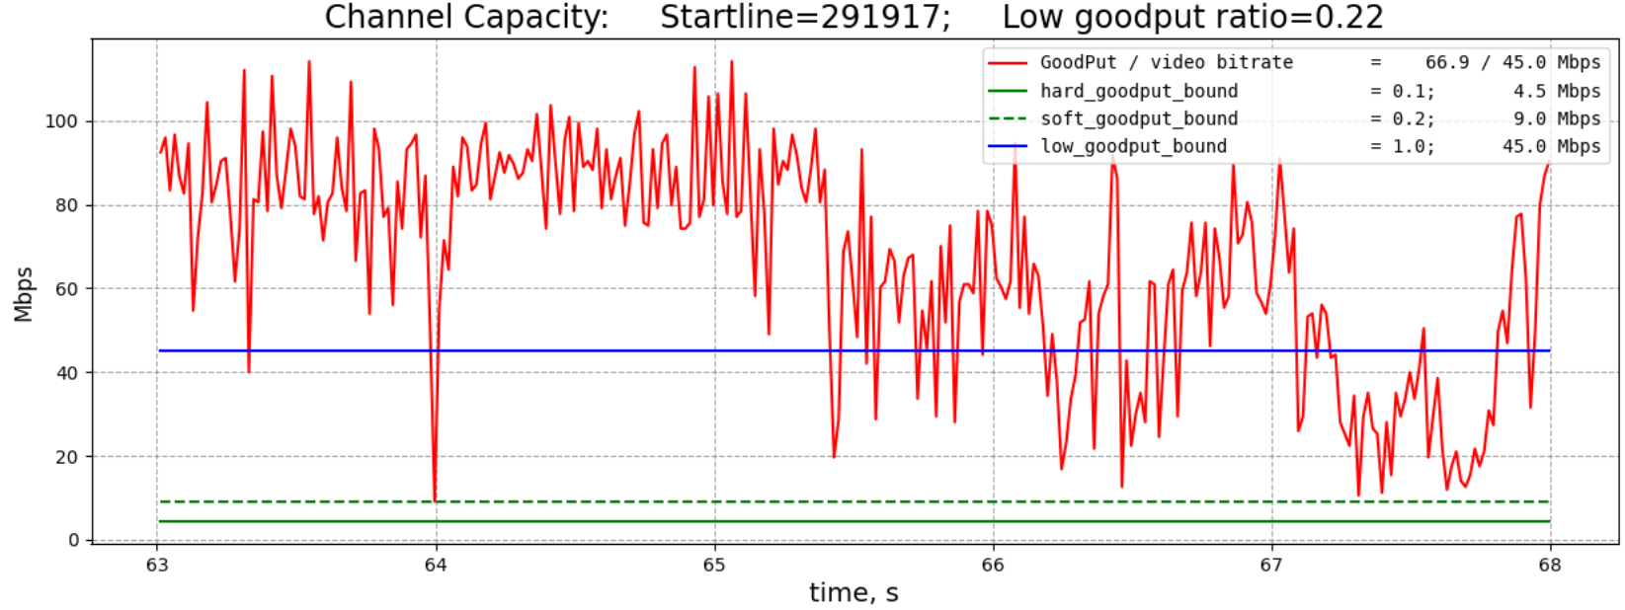
Figure 1: example of found start line for bandwidth point
All the script parameters are configurable. The details of configuration tweaking and recommendation can be found in Annex A of JVET-AN0046.

LDP/LDB simulations in full QP range
Using automated scripts described above and newly generated packet trace files (uploaded with contribution) the bandwidth rate points for LDP/B configuration for QP 22/27/32/37 were obtained.
Using ULL testing methodology of JVET-AL0176 and BD-PSNR approach as was proposed in JVET-AM0325 the simulation results comparing single layer and multilayer approach for different QP were obtained, as in exemplary table below:
Table 6 BR-PSNR gain in dB of 2-layer SNR scalability vs single layer, QP22
 |  |  | LDB w/o feedback, bypassIDR
 |  |  | SVTM Over VTM
 | Y | U | V | Freeze | EncT | DecT
Class A1 | 7.30 | 4.53 | 4.92 | -36.8%
Class A2 | 3.40 | 1.91 | 1.97 | -23.5%
Class B | 3.58 | 1.69 | 2.20 | -25.1% | #NUM! | #NUM!
Class C | #VALUE! | #VALUE! | #VALUE! |  | #NUM! | #NUM!
Class E | #VALUE! | #VALUE! | #VALUE! |  | #NUM! | #NUM!
Overall | 4.55 | 2.52 | 2.88 | -27.8% | #NUM! | #NUM!
Class D | #VALUE! | #VALUE! | #VALUE! |  | #NUM! | #NUM!
Class F | #VALUE! | #VALUE! | #VALUE! |  | #NUM! | #NUM!
The table shows BD-PSNR numbers of SNR scalable VTM vs single layer VTM, illustrating average PSRN improvement at the same latency restriction. Comparing LDB and LDP the advantage of scalable approach is consistent. It was further observed that with increasing of QP it became lower. It was also commented that for QP 37 the bitrate could be quite low, much lower than standard RTP payload size of 1460 and packetization rounding effect may affect the results at very low bitrates. Another comment was that ULL aims to be targeted to high quality services where ultra-low latency can bring presence effect. In that aspect low QP cases are more relevant.
A question was raised by participating expert on how to interpret the freeze percentage in the summary table. It was clarified by reporter that interpretation can be similar to BD-PSNR method, like average freeze rate reduction at the same latency restriction, see picture below.
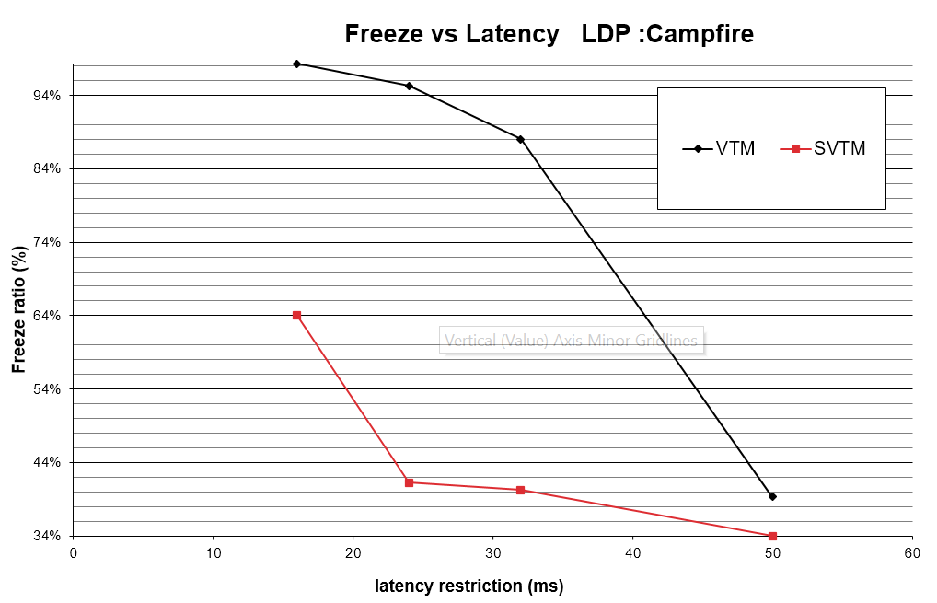
For reference the information about BD-Rate efficiency was also providing, showing that gain of LDB over LDP is 4% and over IPP with single reference is about 15%. Encoder complexity of LDB vs LDP is 140%.
In conclusion it was summarized that the network bandwidth points for simulation in a full QP 22-37 are available. The list of specific packet trace files and start points for simulation for each test sequence and QP is provided in contribution JVET-AN0046. It was suggested to use it for ULL CTC construction.

Spatial Scalability
The spatial scalability was verified and confirmed to be functionally runnable by AhG18 simulation software with using MR2 (full VTM tool set) version. A small patch is necessary to upscale frozen based layer picture to calculate reconstructed PSNR numbers in automated way. A patch can be provided as separate MR.

AHG18 software, MRs status

MR2: Full VTM
The code of pending MR2 on full VTM tool set enabling was cross-checked and results for class B were reproduced. Simulation for class A is still running. Few issues were identified and reported in MR during cross-check that were resolved by the proponent. According to crosschecker comments the code itself is verified and confirmed to be ok. It was agreed that after confirmation of class A results by email the MR2 can be merged to ull-master branch of AhG18 simulation software.

MR3: GDR fix
Still needs to be verified.

JVET-AN0045: Codec software for ultra-low latency and packet loss resilience (related to JVET-AM0218)
The contribution JVET-AN0045 includes the source code of the software related to document JVET-AM0218 “AHG18: Solution beyond scalable coding for ultra-low latency and packet loss resilience” presented and 39th JVET meeting in Daejeon, Korea. The video demonstration related to the contribution was also presented during the demo session. The presented ULL coding technology was comprehensively discussed with experts, and many experts expressed the interest about the details. After further polishing and in order to complement AHG18 research activity the software is provided with this contribution. The software is provided as a git patch on top of VTM-based simulation software used in AhG18. It was suggested to study the software and consider to use it for experiments in context of AhG18 work.

Software overview
The overview of the software was provided, including the building and running instructions in order to reproduce results reported in the document following test conditions of JVET-AL0176 and BD-PSNR calculation method of JVET-AM0325.
 | IPPI w/o feedback, bypassIDR, bypass L0
 | Over ScalableVTM, dB
 | Y | U | V | Freeze
Class A1 | 1.5 | 1.3 | 0.4 | 0,0%
Class A2 | 2.6 | 2.0 | 2.0 | 0,0%
Class B | 2.6 | 1.8 | 2.1 | 0,0%
Class C | #VALUE! | #VALUE! | #VALUE!
Class E | #VALUE! | #VALUE! | #VALUE!
Overall | 2.3 dB | 1.7 dB | 1.6 dB | 0,0%
Class D | #VALUE! | #VALUE! | #VALUE!
Class F | #VALUE! | #VALUE! | #VALUE!
Table 1 BD-PSNR numbers in dB of average reconstruction quality improvement in respect to latency restriction of 16, 24, 32 and 50ms
Compared to and on top of a 2-layer SNR scalability with transmission priority mechanism the gain of the ULL coding technology is 2.3 dB of Luma PSNR on average, with about 3% overhead for multiple chunks.
The key software modifications controlled by corresponding macros were briefly introduced:
Several macros were introduced to make logical separation of key modifications parts:
#define JVET_AM0218 1 // JVET-AM0218
#if JVET_AM0218
#define JVET_AM0218_DATA_PARTITIONING 1 // Data partitioning
#define JVET_AM0218_MULTI_CABAC 1 // Parallel CABAC implementation
#define JVET_AM0218_LOST_STREAM_HANDLE 1 // Handle lost stream in bitstream parsing process
#define JVET_AM0218_LAF 1 // Enable LAF filter
#define JVET_AM0218_ERROR_MASK 1 // Error mask generation for LAF
#endif
- JVET_AM0218_MULTI_CABAC – multi CABAC wrapper to support multiple entropy coded streams.
- JVET_AM0218_DATA_PARTITIONING – interface modifications to support data partitioning, multiple entropy coding chunks, and accepting multiple NAL units at the decoder side.
- JVET_AM0218_LOST_STREAM_HANDLE – handles lost entropy coding stream during parsing process.
- JVET_AM0218_LAF – enables NN-based loss aware loop filter (LAF) .
- JVET_AM0218_ERROR_MASK – generates error mask based on lost NAL units of stream B to be used by LAF filter

Network model was refactored comparing to current version of AhG18 software to support transmission priority model, and aiming to make network simulation part cleaner and simpler.
During the discussion a question about Loss-Aware Filter (LAF) was raised whether structure of the filter was sufficiently described. Another participating expert commented that source code and the model weight are available for the study from the contribution. It was further suggested by presenter to refer to initial contribution JVET-AM0218 concentring filter structure and illustration of subjective effect:
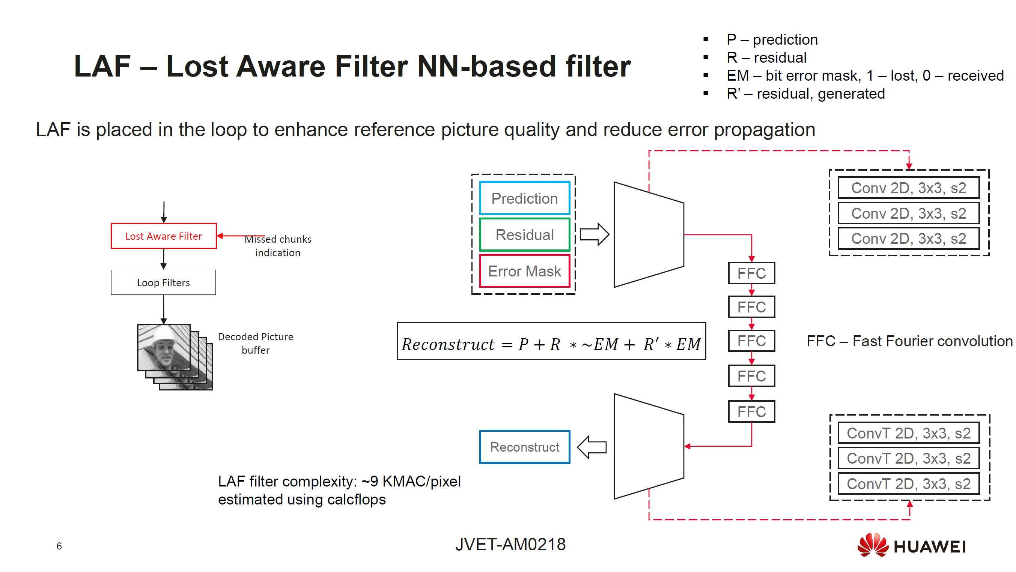
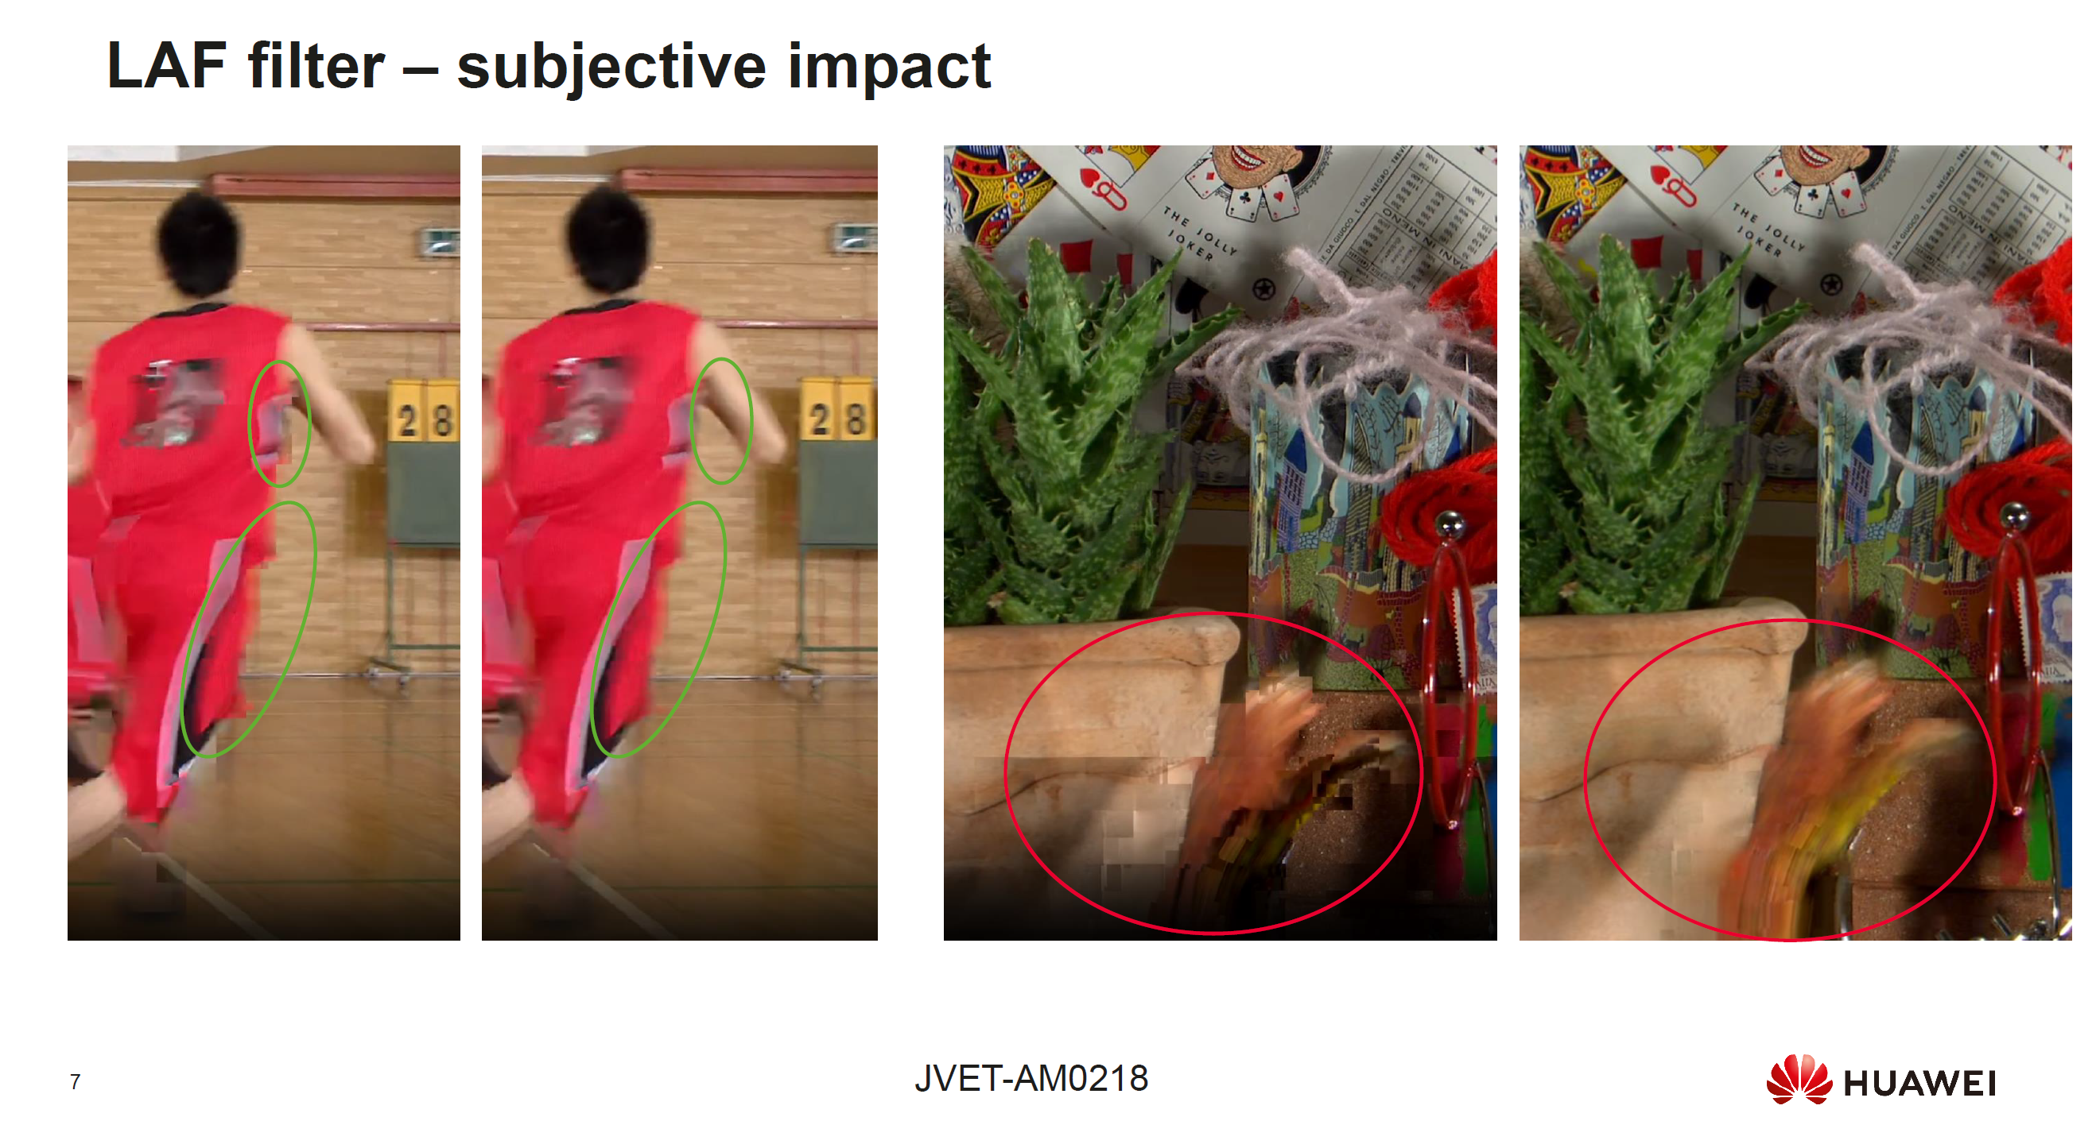
Another aspect concerning conformance point and normative behavior of LAF loop filter was questioned. It was clarified by proponent that LAF filter is a kind of ‘semi-normative’, and is applied only on decoder side, and only in case of packet loss. In case of no loss the filter is not applied. Similarly, encoder has nothing to do with this filter, and does not need to apply it as well.

Transmission priority model
Modern transmission protocols have various priority mechanisms (JVET-AM0188, JVET-AM0201). Such mechanisms may be very useful for ULL video transmission scenarios. This contribution proposes an approximated priority model for testing of coding technologies in ULL video transmission scenario. The model introduces traffic ID which may correspond to different layers, NAL unit types, data partitions. Based on traffic ID two main features are introduced:
- Sending order priority
- Packet stays in sending buffer until packet lifetime is over
Figure 1: Transmission priorities scheme
Layer 1
Sending buffer
(packets A/B)
Layer 0
Channel
router
streamA/B

Sending order priority
Some coding solution, for example, scalable coding may imply different priority of information importance. In current solution two traffic categories are introduced for better delivery key important information like Layer0.
If data partitioning is enabled and bitstream consist of two parts: stream A and stream B, where stream A contain more important critical information, and stream B contain information that can be lost, transmission prioritization means that stream A packets in a sending buffer are sent first. It can be configured by setting parameters TrafficID and TrafficIDB in software: stream with lower value of traffic ID is sent first. Potentially, more traffic categories (IDs) can be introduced.

Packet lifetime
Packet lifetime is common mechanism used in Wi-Fi and 5G to control retransmission logic. The sending buffer of the router keeps each specific packet in the buffer until lifetime is over. During this time router keeps retransmitting the packet in case of transmission fail. The current software emulates this behavior in network model.
The tuning of lifetime can be useful to solve the network overflow problem. Outdated packets can be discarded as soon as they expire and cannot be used for decoding due to latency restriction. As latency restriction is the deadline of frame delivery thus lifetime of non-critical parts can be set equal to latency restriction, but lifetime of critical parts can set longer.
The modern transmission protocols allow to define lifetime in dependence of traffic ID. It can be mimic by setting parameters PacketLifeTime and PacketLifeTimeB in the software.
During the discussion the question was rise whether the simulation reported in the documents uses bypassing of IDR pictures and layer 0. In respond it was confirmed by the proponent that in running script example the bypass of L0 and IDR is enabled to emulated behavior reported in JVET-AM0218. Additionally, it was clarified that software is configurable and allows disable bypassing L0 (as well as IDR picture).
Answering question of another participating expert, if bypassL0 is disabled, base layer will experience of risk of loosing packets as well, turning out to video freeze effect. However, from initial internal experiments it was observed that due to priority mechanism the freezing time was dramatically reduced. These experiments are supposed to be continued and further reported in the revision of the contribution.
During the discussion a generic question was raised by participating expert about how the behavior on packet loss can fit to standard landscape. That was not a practice for the years before.
Another expert commented that normative reaction on broken bitstream could be part of recommendation. The application designers, for example of video conferencing solutions face that problem. And system level standards mandate the behavior in such scenario. From video coding community providing recommendations on what is sensible to do in case of losses would also possible and beneficial.
It was concluded that such discussion deserves a broader audience.
Meeting closed at 17:50h UTC.

Annex

Participants list of AhG meeting on 2025-08-21
- Alan Stein (V-Nova - US)
- Anthony TRIOUX (Xidian Univ. - CN）
- Canh Nguyen (Dolby - US)
- Dmytro Rusanovskyy (Nokia - US)
- Elena Alshina (Huawei - DE)
- Ivan Gribushin (Huawei - RU)
- Jacek Konieczny (TCL-PL)
- Jacob Ström (Ericsson - SE)
- Jens-Rainer Ohm (RWTH - DE)
- Joachim Keinert (Fraunhofer IIS -DE)
- Keiichirō Takada (Sharp - JP)
- Lulin Chen (MediaTek - US)
- Maxim Sychev (Huawei - RU)
- Peng Yin (Dolby - US)
- Ping Wu (ZTE - UK)
- Roman Chernyak (Tencent - US)
- Sachin Deshpande (Sharp - US)
- Saurabh Puri (InterDigital - CA)
- Sergey Ikonin (Huawei - RU)
- Shuai Zhao (Qualcomm - US)
- Siegfried Foessel (Fraunhofer-DE)
- Stephan Wenger (Tencent - US)
- Tae Meon Bae (Sharp - US)
- Takeshi Chujoh (KDDI - JP)
- Vasily Rufitskiy (TCL - CN)
- Vladyslav Zakharchenko (Nokia - US)
- Vyacheslav Khamidullin (Huawei - RU)

