    Joint Video Experts Team (JVET)  of ITU-T SG21 WP3/21 and ISO/IEC JTC 1/SC 29  40th Meeting: Geneva, CH, 3–12 October 2025 | Document: JVET-AN0046-v1

Title: | AHG18: On test conditions for ultra-low latency and packet loss resilience with full QP range
Status: | Input document to JVET
Purpose: | Proposal
Author(s) or  Contact(s): | Sergey Ikonin  Ivan Gribushin  Vyacheslav Khamidullin  Boris Shevchenko  Elena Alshina | Email: | sergey.ikonin@huawei.com  elena.alshina@huawei.com
Source: | Huawei Technologies
_____________________________

Abstract
In 39th JVET meeting several comments and suggestions concerning ULL CTC were discussed, mainly based on contributions JVET-AM0109, JVET-AM0202, JVET-AM0204, JVET-AM0222, JVET-AM0325. This contribution follows up this discussion and addresses the comments in aspects of LDP/LDB configuration, broader QP range, spatial scalability, new packet trace files and automatic bandwidth rate points selection for matching channel capacity to video bitrate.

Introduction
One of the important suggestions during ULL CTC discussion in 39th JVET was request on extension of test conditions from QP22 to wider range normally used in JVET. Another suggestion was to exercise full VTM functionality including multiple references and bi-prediction. As was discussed during the meeting that extension would require matching between video bitrate and channel capacity to experience decoding stability and reconstruction quality problems caused by network behaviour, which are subject of interest of AhG18. To do this matching it is proposed to use automatic script uploaded with this contribution.

Automated scripts for searching network bandwidth points
Contribution JVET-AL0176 introduced packet trace files obtained from NS-3 network simulator. The matching between video bitrate and network capacity has been made manually by searching proper interval for testing in a trace file. To automate this process and make possible to quickly find proper interval it is proposed to use the script searching the interval based on criteria.
The proposed automation script (bandwidth_point_selection.py. uploaded with contribution) takes average bitrate of specific coded sequence as input parameter and searches for the interval with 1.3 - 2.5x times larger average network capacity. Due to channel fluctuation in 20% of frames the instant channel bandwidth should drop below average video bitrate (low goodput ratio), which is another precondition. Below is an example of how to run it, and expected output:
python bandwidth_point_selection.py --bitrate 45 --config config.yaml
Script returns list of found startlines in trace file sorted by distance from 20% of low good put ratio:

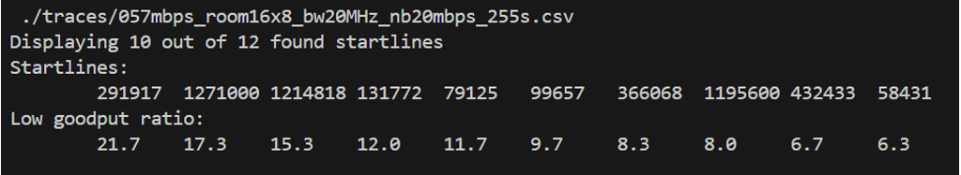
For each found startline a channel capacity plot is saved as a picture to allowing to see the channel profile:
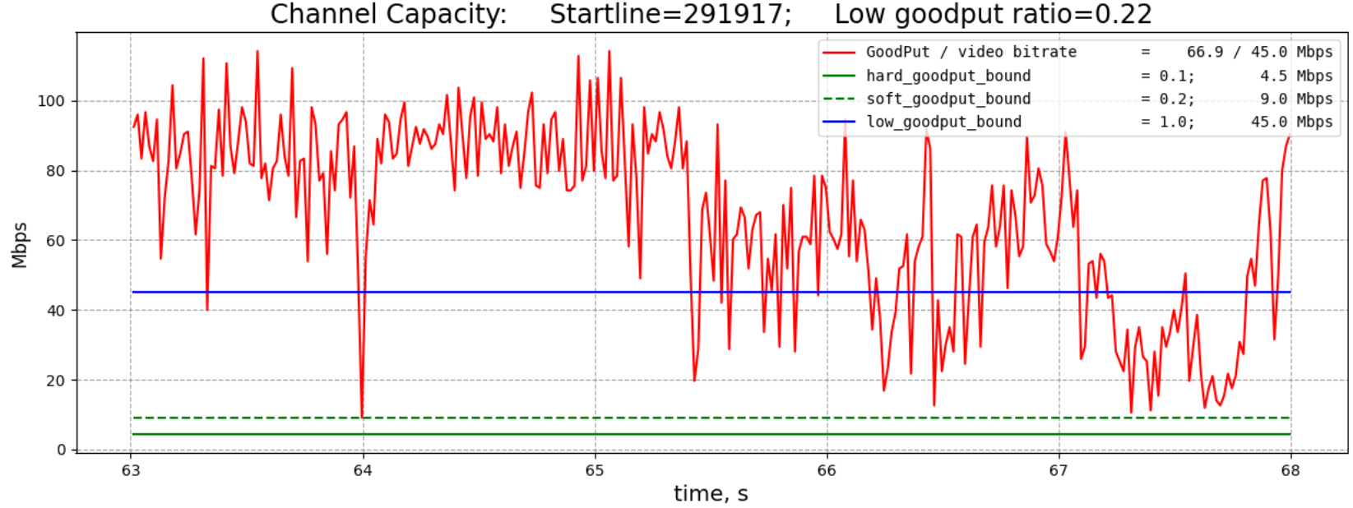
Figure 1: example of found start line for bandwidth point
All the script parameters are configurable. Furthermore, an extended set of tweaking parameters can be used if desired criteria cannot by satisfied with a given trace file. The details of configuration tweaking and recommendation can be found in Annex A.

LDB/LDP simulation with full QP range
Using automated scripts described above and new packet trace files the bandwidth rate points for LDP/B configuration and using runtime-reduced-3 encoder settings. The BD-rate difference between LDP and LDB is not that high ~4%. So, the same bandwidth points can be used. The test conditions follow JVET-AL0176. The AhG18 simulation software of MR2: Full VTM tool set was used for obtain the simulation results.
Below are simulation results comparing single layer and SNR scalable 2-layer VTM as in JVET-AL0176. for full QP set 22-37.

QP22
Table 6 BR-PSNR gain in dB of 2-layer SNR scalability vs single layer, QP22
 |  |  | LDB w/o feedback, bypassIDR
 |  |  | SVTM Over VTM
 | Y | U | V | Freeze | EncT | DecT
Class A1 | 7.30 | 4.53 | 4.92 | -36.8%
Class A2 | 3.40 | 1.91 | 1.97 | -23.5%
Class B | 3.58 | 1.69 | 2.20 | -25.1% | #NUM! | #NUM!
Class C | #VALUE! | #VALUE! | #VALUE! |  | #NUM! | #NUM!
Class E | #VALUE! | #VALUE! | #VALUE! |  | #NUM! | #NUM!
Overall | 4.55 | 2.52 | 2.88 | -27.8% | #NUM! | #NUM!
Class D | #VALUE! | #VALUE! | #VALUE! |  | #NUM! | #NUM!
Class F | #VALUE! | #VALUE! | #VALUE! |  | #NUM! | #NUM!
 |  |  | LDP w/o feedback, bypassIDR
 |  |  | SVTM Over VTM
 | Y | U | V | Freeze | EncT | DecT
Class A1 | 5.78 | 3.46 | 3.81 | -29.1%
Class A2 | 3.49 | 1.91 | 1.92 | -23.9%
Class B | 3.68 | 1.67 | 2.13 | -25.3% | #NUM! | #NUM!
Class C | #VALUE! | #VALUE! | #VALUE! |  | #NUM! | #NUM!
Class E | #VALUE! | #VALUE! | #VALUE! |  | #NUM! | #NUM!
Overall | 4.20 | 2.22 | 2.53 | -25.9% | #NUM! | #NUM!
Class D | #VALUE! | #VALUE! | #VALUE! |  | #NUM! | #NUM!
Class F | #VALUE! | #VALUE! | #VALUE! |  | #NUM! | #NUM!

QP27
Table 7 BR-PSNR gain in dB of 2-layer SNR scalability vs single layer, QP27
 |  |  | LDB w/o feedback, bypassIDR
 |  |  | SVTM Over VTM
 | Y | U | V | Freeze | EncT | DecT
Class A1 | 3.45 | 1.96 | 2.18 | -21.4%
Class A2 | 3.70 | 1.97 | 1.91 | -29.4%
Class B | 4.25 | 1.85 | 2.39 | -30.4% | #NUM! | #NUM!
Class C | #VALUE! | #VALUE! | #VALUE! |  | #NUM! | #NUM!
Class E | #VALUE! | #VALUE! | #VALUE! |  | #NUM! | #NUM!
Overall | 3.88 | 1.91 | 2.20 | -27.6% | #NUM! | #NUM!
Class D | #VALUE! | #VALUE! | #VALUE! |  | #NUM! | #NUM!
Class F | #VALUE! | #VALUE! | #VALUE! |  | #NUM! | #NUM!
 |  |  | LDP w/o feedback, bypassIDR
 |  |  | SVTM Over VTM
 | Y | U | V | Freeze | EncT | DecT
Class A1 | 3.51 | 1.90 | 2.20 | -21.4%
Class A2 | 3.67 | 1.96 | 1.91 | -29.2%
Class B | 4.06 | 1.79 | 2.29 | -29.8% | #NUM! | #NUM!
Class C | #VALUE! | #VALUE! | #VALUE! |  | #NUM! | #NUM!
Class E | #VALUE! | #VALUE! | #VALUE! |  | #NUM! | #NUM!
Overall | 3.80 | 1.87 | 2.16 | -27.4% | #NUM! | #NUM!
Class D | #VALUE! | #VALUE! | #VALUE! |  | #NUM! | #NUM!
Class F | #VALUE! | #VALUE! | #VALUE! |  | #NUM! | #NUM!

QP32
Table 8 BR-PSNR gain in dB of 2-layer SNR scalability vs single layer, QP32
 |  |  | LDB w/o feedback, bypassIDR
 |  |  | SVTM Over VTM
 | Y | U | V | Freeze | EncT | DecT
Class A1 | 3.40 | 1.85 | 2.22 | -23.9%
Class A2 | 2.36 | 1.24 | 1.43 | -23.7%
Class B | 1.01 | 0.32 | 0.39 | -16.2% | #NUM! | #NUM!
Class C | #VALUE! | #VALUE! | #VALUE! |  | #NUM! | #NUM!
Class E | #VALUE! | #VALUE! | #VALUE! |  | #NUM! | #NUM!
Overall | 2.03 | 0.99 | 1.17 | -20.3% | #NUM! | #NUM!
Class D | #VALUE! | #VALUE! | #VALUE! |  | #NUM! | #NUM!
Class F | #VALUE! | #VALUE! | #VALUE! |  | #NUM! | #NUM!
 |  |  | LDP w/o feedback, bypassIDR
 |  |  | SVTM Over VTM
 | Y | U | V | Freeze | EncT | DecT
Class A1 | 3.34 | 1.82 | 2.17 | -23.3%
Class A2 | 2.54 | 1.35 | 1.56 | -24.1%
Class B | 1.19 | 0.38 | 0.46 | -17.1% | #NUM! | #NUM!
Class C | #VALUE! | #VALUE! | #VALUE! |  | #NUM! | #NUM!
Class E | #VALUE! | #VALUE! | #VALUE! |  | #NUM! | #NUM!
Overall | 2.15 | 1.03 | 1.23 | -20.7% | #NUM! | #NUM!
Class D | #VALUE! | #VALUE! | #VALUE! |  | #NUM! | #NUM!
Class F | #VALUE! | #VALUE! | #VALUE! |  | #NUM! | #NUM!

QP37
Table 9 BR-PSNR gain in dB of 2-layer SNR scalability vs single layer, QP37
 |  |  | LDB w/o feedback, bypassIDR
 |  |  | SVTM Over VTM
 | Y | U | V | Freeze | EncT | DecT
Class A1 | 1.82 | 0.85 | 0.76 | -16.5%
Class A2 | 1.13 | 0.63 | 0.59 | -15.1%
Class B | -0.67 | -0.61 | -0.74 | -5.3% | #NUM! | #NUM!
Class C | #VALUE! | #VALUE! | #VALUE! |  | #NUM! | #NUM!
Class E | #VALUE! | #VALUE! | #VALUE! |  | #NUM! | #NUM!
Overall | 0.50 | 0.13 | 0.03 | -11.0% | #NUM! | #NUM!
Class D | #VALUE! | #VALUE! | #VALUE! |  | #NUM! | #NUM!
Class F | #VALUE! | #VALUE! | #VALUE! |  | #NUM! | #NUM!
 |  |  | LDP w/o feedback, bypassIDR
 |  |  | SVTM Over VTM
 | Y | U | V | Freeze | EncT | DecT
Class A1 | 0.99 | 0.39 | 0.27 | -11.9%
Class A2 | 0.93 | 0.51 | 0.47 | -13.2%
Class B | -0.47 | -0.50 | -0.56 | -7.4% | #NUM! | #NUM!
Class C | #VALUE! | #VALUE! | #VALUE! |  | #NUM! | #NUM!
Class E | #VALUE! | #VALUE! | #VALUE! |  | #NUM! | #NUM!
Overall | 0.31 | 0.02 | -0.05 | -10.21% | #NUM! | #NUM!
Class D | #VALUE! | #VALUE! | #VALUE! |  | #NUM! | #NUM!
Class F | #VALUE! | #VALUE! | #VALUE! |  | #NUM! | #NUM!
It can be seen that relative gain of scalable vs single layer is stable across the different configuration. At the same time with increasing of QP the gain is reduced.

LDB vs LDP vs IPP
Below is initial reference information about comparison of different low delay configurations suitable for real-time applications. In summary, LDB provides about 4% of BD-rate gain over LDP, and about 15% over IPP in single layer and scalable configurations. Encoding time of LDB is roughly 40% higher, and can reach 34 hours for single layer and 47 hours for scalable for 300 frames coding scenario. However, it should be noted that periodic I frame insertion potentially can help to parallelize the encoding.
Table 1 LDB performance vs. LDP and IPP, single layer
 | LDB
 | Over IPP |  |  |  |  |  | Over LDP
 | Y | U | V | EncT | DecT |  | Y | U | V | EncT | DecT
Class A1 | -10.97% | -15.20% | -22.32% | 98.5% | 69.5% |  | -2.48% | -4.03% | -5.59% | 134.0% | 100.3%
Class A2 | -10.99% | -25.93% | -24.46% | 106.3% | 71.5% |  | -2.60% | -5.60% | -5.46% | 141.3% | 93.8%
Class B | -21.24% | -38.66% | -38.81% | 94.5% | 62.9% |  | -5.50% | -9.00% | -8.82% | 138.1% | 97.8%
Class C | #VALUE! | #VALUE! | #VALUE! | #DIV/0! | #DIV/0! |  | #VALUE! | #VALUE! | #VALUE! | #DIV/0! | #DIV/0!
Class E
Overall (Ref) | -15.6% | -28.8% | -30.4% | 99.9% | 68.6% |  | -3.9% | -6.7% | -7.0% | 138.8% | 98.1%
Table 2 LDB performance vs. LDP and IPP, 2-layer SNR scalability
 | SVTM LDB
 | Over SVTM IPPP |  |  |  |  | Over SVTM LDP
 | Y | U | V | EncT | DecT | Y | U | V | EncT | DecT
Class A1 | -11.44% | -15.96% | -23.14% | 110.6% | 78.3% | -2.52% | -3.91% | -5.64% | 138.2% | 98.8%
Class A2 | -10.53% | -24.89% | -23.66% | 117.9% | 82.0% | -2.51% | -5.20% | -5.27% | 142.5% | 100.2%
Class B | -20.74% | -37.32% | -37.65% | 98.1% | 65.3% | -5.27% | -8.37% | -8.25% | 137.8% | 95.3%
Class C | #VALUE! | #VALUE! | #VALUE! | #DIV/0! | #DIV/0! | #VALUE! | #VALUE! | #VALUE! | #DIV/0! | #DIV/0!
Class E
Overall (Ref) | -15.4% | -28.1% | -29.9% | 108.1% | 75.1% | -3.8% | -6.3% | -6.7% | 139.4% | 98.4%
Table 3 Maximum encoding time of LDB LDP, 300 frames, single layer
 |  | EncTime, hrs
LDB | MAX | 34
 | MIN | 2
LDP
 | MAX | 23
 | MIN | 2
Table 4 Maximum encoding time of LDB LDP, 300 frames, 2-layer SNR scalability
 |  | EncTime, hrs
LDB
 | MAX | 47
 | MIN | 4
LDP
 | MAX | 31
 | MIN | 3

Clean channel SVTM vs VTM
Table 5 BD-Rate overhead of 2-layer SNR scalability
 |  |  | LDB clean channel
 |  |  | SVTM Over VTM
 | Y | U | V |  | EncT | DecT
Class A1 | 13.09% | 18.66% | 18.43% |  | 150% | 164%
Class A2 | 11.57% | 20.73% | 15.50% |  | 148% | 168%
Class B | 10.93% | 23.30% | 26.92% |  | 137% | 148%
Class C | #DIV/0! | #DIV/0! | #DIV/0! |  | #NUM! | #NUM!
Class E | #DIV/0! | #DIV/0! | #DIV/0! |  | #NUM! | #NUM!
Overall | 11.70% | 21.33% | 21.49% |  | 144% | 157%
Class D | #DIV/0! | #DIV/0! | #DIV/0! |  | #NUM! | #NUM!
Class F | #DIV/0! | #DIV/0! | #DIV/0! |  | #NUM! | #NUM!
 |  |  | LDP clean channel
 |  |  | SVTM Over VTM
 | Y | U | V |  | EncT | DecT
Class A1 | 12.92% | 18.72% | 18.67% |  | 146% | 167%
Class A2 | 11.46% | 20.46% | 15.40% |  | 147% | 157%
Class B | 10.56% | 23.47% | 27.79% |  | 138% | 151%
Class C | #DIV/0! | #DIV/0! | #DIV/0! |  | #DIV/0! | #DIV/0!
Class E
Overall | 11.45% | 21.35% | 21.93% |  | 142% | 157%
Class D | #DIV/0! | #DIV/0! | #DIV/0! |  | #DIV/0! | #DIV/0!
Class F | #DIV/0! | #DIV/0! | #DIV/0! |  | #DIV/0! | #DIV/0!

New trace files
To support wider QP new trace files with lower capacity were generated by NS-3 simulator similar way as it described in JVET-AL0176. To reduce the capacity the number of the users in the same room interfering with each other were increased to 3.
Table 10 Newly generated packet trace files
# | Packet trace file | Channel bandwidth  X MHz
1 | 016mbps_room16x8_bw20MHz_255s.csv | 20
2 | 022mbps_room16x8_bw20MHz_255s.csv | 20
Videos encoded with high QP points especially have quite a low bitrate. Direct configuring of Wi-Fi with capacity below 10 mbps is challenging. To solve the problem the trace files the trace were obtained by subsampling of 237mbps_room16x8_bw80MHz_nb20mbps_255s.csv trace file, as approximation for low bitrate scenario.
Table 11 Downscaled trace files
# | Packet trace file | Scaling factor
3 | 002.7mbps_room16x8_bw80MHz_nb20mbps_ds.csv | 90
4 | 004.0mbps_room16x8_bw80MHz_nb20mbps_ds.csv | 60
5 | 006.0Mbps_room16x8_bw80MHz_nb20mbps_ds.csv | 40
Combining with currently used trace files from JVET-AL0176 eight files in total
Table 12 Currently used trace files
# | Packet trace file | Channel bandwidth  X MHz
6 | 057mbps_room16x8_bw20MHz_nb20mbps_255s.csv | 20
7 | 080mbps_room16x8_bw20MHz_nb10mbps_140s.csv | 20
8 | 237mbps_room16x8_bw80MHz_nb20mbps_255s.csv | 80

Network bandwidth points for full QP range
Sequence name | QP | Class | bitrate, LDB | bitrate, LDP | Startline | Trace file
RitualDance | 22 | B | 9.6 | 10.2 | 36021 | 022mbps_room16x8_bw20MHz_255s.csv
MarketPlace | 22 | B | 11.0 | 12.8 | 36021 | 022mbps_room16x8_bw20MHz_255s.csv
BasketballDrive | 22 | B | 15.7 | 17.7 | 116493 | 016mbps_room16x8_bw20MHz_255s.csv
Cactus | 22 | B | 13.0 | 15.5 | 116493 | 016mbps_room16x8_bw20MHz_255s.csv
BQTerrace | 22 | B | 31.7 | 42.3 | 333907 | 057mbps_room16x8_bw20MHz_nb20mbps_255s.csv
FoodMarket4 | 22 | A1 | 17.5 | 18.5 | 116493 | 016mbps_room16x8_bw20MHz_255s.csv
Tango | 22 | A1 | 25.6 | 29.0 | 333907 | 057mbps_room16x8_bw20MHz_nb20mbps_255s.csv
Campfire | 22 | A1 | 65.8 | 77.9 | 87476 | 080mbps_room16x8_bw20MHz_nb10mbps_140s.csv
CatRobot | 22 | A2 | 23.8 | 25.7 | 333907 | 057mbps_room16x8_bw20MHz_nb20mbps_255s.csv
DaylightRoad2 | 22 | A2 | 36.6 | 40.2 | 333907 | 057mbps_room16x8_bw20MHz_nb20mbps_255s.csv
ParkRunning3 | 22 | A2 | 116.7 | 127.2 | 1430973 | 237mbps_room16x8_bw80MHz_nb20mbps_255s.csv
RitualDance | 27 | B | 4.7 | 4.9 | 378091 | 016mbps_room16x8_bw20MHz_255s.csv
MarketPlace | 27 | B | 3.8 | 4.0 | 378091 | 016mbps_room16x8_bw20MHz_255s.csv
BasketballDrive | 27 | B | 5.2 | 5.6 | 378091 | 016mbps_room16x8_bw20MHz_255s.csv
Cactus | 27 | B | 4.2 | 4.5 | 378091 | 016mbps_room16x8_bw20MHz_255s.csv
BQTerrace | 27 | B | 4.8 | 5.5 | 378091 | 016mbps_room16x8_bw20MHz_255s.csv
FoodMarket4 | 27 | A1 | 8.1 | 8.4 | 36021 | 022mbps_room16x8_bw20MHz_255s.csv
Tango | 27 | A1 | 8.3 | 8.6 | 36021 | 022mbps_room16x8_bw20MHz_255s.csv
Campfire | 27 | A1 | 13.9 | 14.8 | 116493 | 016mbps_room16x8_bw20MHz_255s.csv
CatRobot | 27 | A2 | 9.0 | 9.4 | 36021 | 022mbps_room16x8_bw20MHz_255s.csv
DaylightRoad2 | 27 | A2 | 10.0 | 10.5 | 36021 | 022mbps_room16x8_bw20MHz_255s.csv
ParkRunning3 | 27 | A2 | 43.7 | 46.2 | 87476 | 080mbps_room16x8_bw20MHz_nb10mbps_140s.csv
RitualDance | 32 | B | 2.4 | 2.5 | 23852 | 004.0mbps_room16x8_bw80MHz_nb20mbps_ds.csv
MarketPlace | 32 | B | 1.7 | 1.8 | 23852 | 004.0mbps_room16x8_bw80MHz_nb20mbps_ds.csv
BasketballDrive | 32 | B | 2.5 | 2.6 | 23852 | 004.0mbps_room16x8_bw80MHz_nb20mbps_ds.csv
Cactus | 32 | B | 2.0 | 2.1 | 23852 | 004.0mbps_room16x8_bw80MHz_nb20mbps_ds.csv
BQTerrace | 32 | B | 1.8 | 1.9 | 23852 | 004.0mbps_room16x8_bw80MHz_nb20mbps_ds.csv
FoodMarket4 | 32 | A1 | 4.2 | 4.4 | 378091 | 016mbps_room16x8_bw20MHz_255s.csv
Tango | 32 | A1 | 4.2 | 4.4 | 378091 | 016mbps_room16x8_bw20MHz_255s.csv
Campfire | 32 | A1 | 6.9 | 7.3 | 378091 | 016mbps_room16x8_bw20MHz_255s.csv
CatRobot | 32 | A2 | 4.5 | 4.7 | 378091 | 016mbps_room16x8_bw20MHz_255s.csv
DaylightRoad2 | 32 | A2 | 4.8 | 5.0 | 378091 | 016mbps_room16x8_bw20MHz_255s.csv
ParkRunning3 | 32 | A2 | 19.1 | 20.1 | 116493 | 016mbps_room16x8_bw20MHz_255s.csv
RitualDance | 37 | B | 1.3 | 1.3 | 15902 | 002.7mbps_room16x8_bw80MHz_nb20mbps_ds.csv
MarketPlace | 37 | B | 0.9 | 0.9 | 15902 | 002.7mbps_room16x8_bw80MHz_nb20mbps_ds.csv
BasketballDrive | 37 | B | 1.3 | 1.4 | 15902 | 002.7mbps_room16x8_bw80MHz_nb20mbps_ds.csv
Cactus | 37 | B | 1.0 | 1.0 | 15902 | 002.7mbps_room16x8_bw80MHz_nb20mbps_ds.csv
BQTerrace | 37 | B | 0.8 | 0.8 | 15902 | 002.7mbps_room16x8_bw80MHz_nb20mbps_ds.csv
FoodMarket4 | 37 | A1 | 2.3 | 2.4 | 23852 | 004.0mbps_room16x8_bw80MHz_nb20mbps_ds.csv
Tango | 37 | A1 | 2.4 | 2.5 | 23852 | 004.0mbps_room16x8_bw80MHz_nb20mbps_ds.csv
Campfire | 37 | A1 | 3.8 | 4.0 | 35777 | 006.0Mbps_room16x8_bw80MHz_nb20mbps_ds.csv
CatRobot | 37 | A2 | 2.5 | 2.5 | 23852 | 004.0mbps_room16x8_bw80MHz_nb20mbps_ds.csv
DaylightRoad2 | 37 | A2 | 2.5 | 2.5 | 23852 | 004.0mbps_room16x8_bw80MHz_nb20mbps_ds.csv
ParkRunning3 | 37 | A2 | 8.8 | 9.1 | 36021 | 022mbps_room16x8_bw20MHz_255s.csv

Spatial scalability
The spatial scalability was verified and confirmed to be runnable without crashes based on full VTM version submitted in MR2: https://vcgit.hhi.fraunhofer.de/jvet-ahg-ull/VVCSoftware_VTM/-/merge_requests/2.
However, for correct YUV outputting and PSNR calculation using ULL scripts the base layer picture needs to be upscaled. The following modification has been made in decoder application to support that for layer 0 was added in repeatLostFrames method of DecApp class:
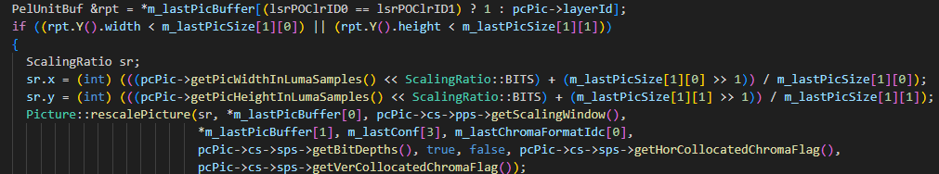
Figure 2: Illustration of software code modification for spatial scalability support.

The following command line has been used for encoding:
./bin/EncoderAppStatic
-c cfg/multi-layer/two_layers.cfg --Level=6.2 --OlsModeIdc=2 --NumOutputLayerSets=2 \
--OlsOutputLayer1="1 0" \
-l0 -c ./cfg/encoder_lowdelay_vtm.cfg -l0 -c ./cfg/alternative-addon/reduced_runtime3.cfg \
-l0 -q 22 -l0 -i BasketballDrive_960x540_50fps_8bit_420.yuv -l0 -wdt 960 -l0 -hgt 540 \
-l1 -c ./cfg/encoder_lowdelay_vtm.cfg -l1 -c ./cfg/alternative-addon/reduced_runtime3.cfg \
-l1 -q 22 -l1 -i BasketballDrive_1920x1080_50fps_8bit_420.yuv -l1 -wdt 1920 -l1 -hgt 1080 \
-f 300 -fr 50
-b BasketballDrive_1920x1080_50fps_8bit_420-LDB-SVTM_lat16.bin -o /dev/null -v 7
--InputBitDepth=8 --OutputBitDepth=8 --IntraPeriod=64 --DecodingRefreshType=1
--PacketTracePath=./cfg/wifi_simulation_trace/057mbps_room16x8_bw20MHz_nb20mbps_255s.csv \
--PacketTraceStartLine=333907
--BypassIDR=1 --UseFeedback=0 --RetransmissionTimes=50 --LatencyRestriction=16
And following for decoding:
./bin/DecoderAppStatic
-b BasketballDrive_1920x1080_50fps_8bit_420-LDB-SVTM_lat16.bin \
-o BasketballDrive_1920x1080_50fps_8bit_420-LDB-SVTM-lat16.yuv \
--OutputBitDepth=8 --NumFrames=300 --SkipFramesWithLostRef=1
The configuration encoder_lowdelay_vtm.cfg and two_layers.cfg files are same as in VTM.
For downscaling of source YUV nearest neighbor method was used. For upscaling of reconstructed base layer picture, the resampling filter of VTM implemented in Picture::rescalePicture with default settings was used.

Conclusion
- Automatic bandwidth selection script allows to quickly find testing points.
- LDP/LDB configurations are supported by current AhG18 simulation software.
- Spatial scalability can also be support with small patch of decoding application to upscale base layer picture for automatic PSNR calculation on reconstructed YUV. The patch can be provided as MR to ULL SW.
- The network bandwidth points found by the script covers full QP range, and can be used for CTC construction.
It is proposed to add new trace files, bandwidth points selection script to separate branch of AhG18 simulation software for experimenting.
It is proposed to use reported network bandwidth points for CTC construction of AhG18 experiments.

Patent rights declaration(s)
Huawei Technologies does not have any current or pending patent rights relating to the technology described in this contribution.

Annex A Network bandwidth points selection script configuration
Below are the details of tweaking of bandwidth points selection script. You may refer to that if default settings cannot find any simulation points with given trance file and desired bitrate.

Configurable parameters
Selection script allows to find new suitable testing bandwidth points from any type of network connection trace files. As input you need to configure set of parameters from Tables 1-3 in config.yaml.
For simplification you can define only testing video bitrate from command line and use default values of other parameters.
Parameter name | Default value | Description
bitrate | - | Average video bitrate.
num_frames | 300 | Number of frames.
fps | 60 | Fps determines size of each frame interval in ms. For example, for fps = 60 each frame interval will be 16.7 ms.
Table 1: Initial parameters for selection script.
In the Table 2 parameters define how found bandwidth points will be sorted.
Parameter name | Default value | Description
low_goodput_bound | 1.0 | Bound for frame intervals with low goodput. These frame intervals need to have goodput lower than low_goodput_bound * bitrate.
low_goodput_ratio | 0.2 | Target ratio of frame intervals with goodput lower than low_goodput_bound * bitrate. Output startlines will be sorted by distance from this target value.
min_distance | 2.5 | Minimum distance in seconds between output startlines.
num_startlines | 10 | Number of top startlines in output of selection.
Table 2: Parameters for selection script corresponding to sorting results.
In the next Table mandatory parameters are presented. If selection script finds no bandwidth points you can relax some parameters following the description.
Parameter name | Default value | Description
target_goodput_scale | [1.3, 2.5] | Average goodput on whole num_frames interval must be in range [1.3, 2.5] * bitrate.  If selection script finds no bandwidth points, [1.3, 4.0] or even [1.0, 5.0] can be used, but [1.3, 2.5] is preferred.
hard_goodput_bound | 0.1 | Goodput of each frame interval must be  > hard_goodput_bound * bitrate.  To avoid intervals with too low goodput or connection lost.
soft_goodput_bound | 0.2 | Goodput of several frame intervals can be lower than soft_goodput_bound * bitrate.
num_soft_goodput_frames | 0 | Number of frame intervals with goodput lower than soft_goodput_bound must not exceed num_soft_goodput_frames.  Recommended values of this parameter are {0, 1, 2 or 3}, but 0 is preferred.
goodput_deviation_scale | [0.7, 1.5] | Goodput of each part of bandwidth point must be in range [0.7, 1.5] * average goodput of whole bandwidth point.
num_goodput_deviation_parts | 3 | Each part of num_goodput_deviation_parts of bandwidth point mustn’t have strong deviation from average goodput of bandwidth point.
Table 3: Parameters for selection script corresponding to mandatory conditions for bandwidth points.
The main idea for searching suitable bandwidth points is no any frames with zero or close to zero goodput, because if the channel capacity is 0 therefore no any technology can help and the connection is lost. The second idea is ensuring sufficient variability in channel capacity from frame by frame including time intervals with goodput lower than video average bitrate.

Detailed instruction on how to use
- configure searching parameters in config.yaml
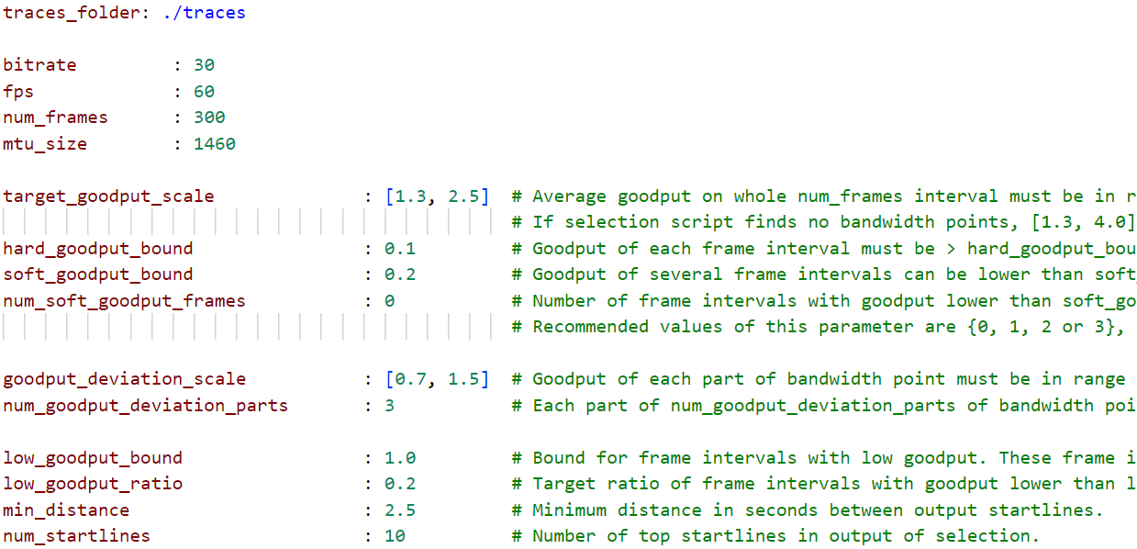
Figure 1: example of config.yaml
- run script with command:
python bandwidth_point_selection.py --config config.yaml --bitrate 45
--traces_folder traces --output_folder selection
- script was tested for python 3.7.6
Firstly, script shows all config parameters:
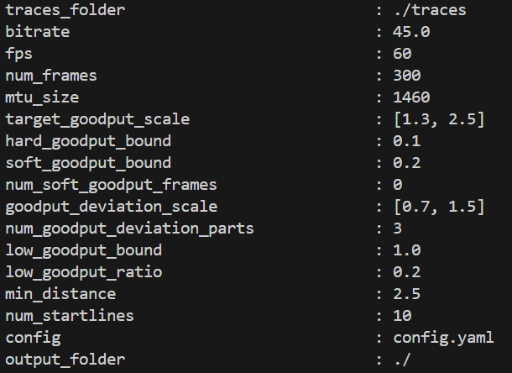
Secondly, script prints sorted selected bandwidth points for each trace file in input folder:
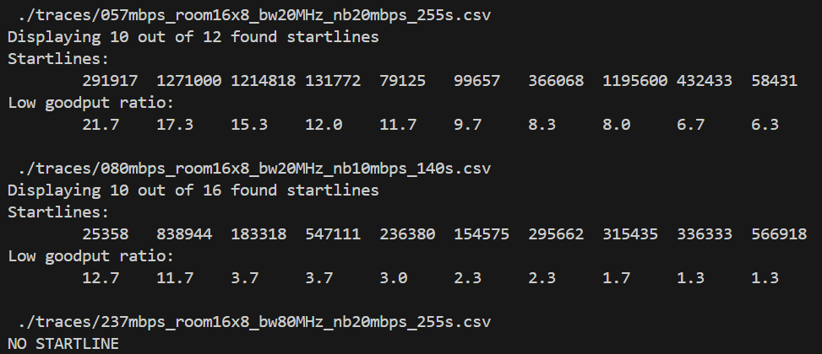
If no any suitable bandwidth points in trace file than script prints “NO STARTLINE”.
Results of script execution are collected in output_folder/bandwidth_points/{name_of_trace_file}:
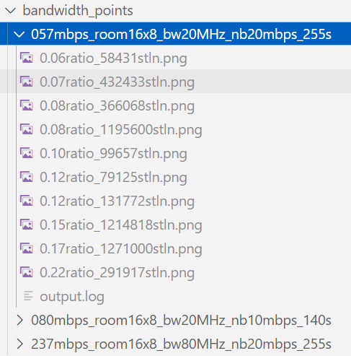
For each found startline plot of channel capacity is saved in picture format:
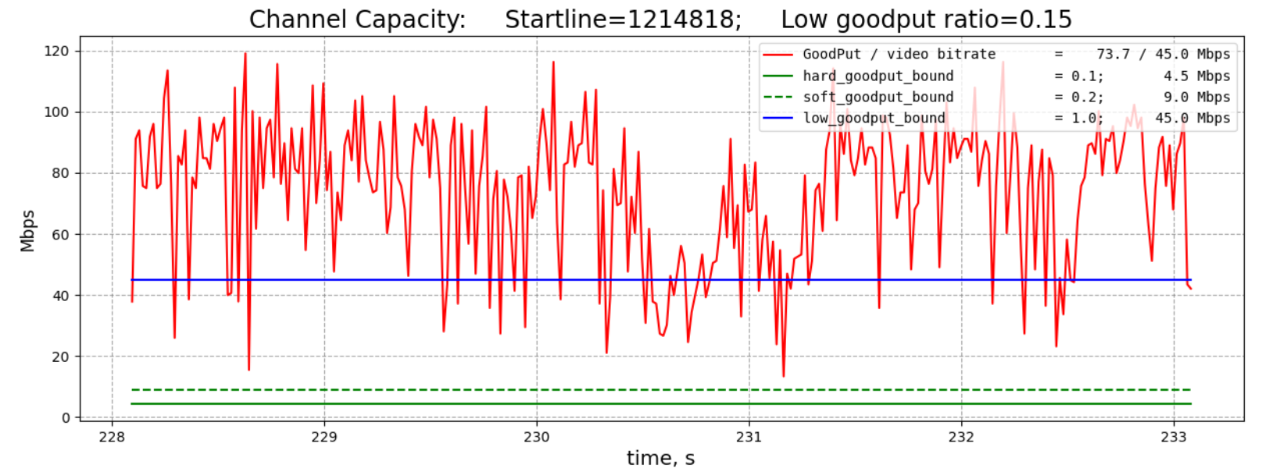
Also, simulation output results are saved in log file output.log.

