    Joint Video Experts Team (JVET)  of ITU-T SG21 WP3/21 and ISO/IEC JTC 1/SC 29  39th Meeting, Daejeon, KR, 26 June – 4 July 2025 | Document: JVET-AM2019-v2

Title: | Description of algorithms version 12 and software version 14 in neural network-based video coding (NNVC)
Status: | Output document of JVET
Purpose: | Proposal
Author(s) or  Contact(s): | Franck Galpin  Yue Li  Yun Li  Dmytro Rusanovskyy  Tong Shao  Jacob Ström  Liqiang Wang | Email: | franck.galpin@interdigital.com  yue.li@bytedance.com  yli30@qti.qualcomm.com  dmytro.rusanovskyy@nokia.com  tong.shao@dolby.com  jacob.strom@ericsson.com  liqiangwang@tencent.com
Source: | InterDigital, Bytedance, Qualcomm, Nokia, Dolby, Ericsson, Tencent
_____________________________

Abstract
This document is version 12 of a description of algorithms and software for Neural Network-based Video Coding. Due to a lack of synchronization between the document and the software development, it corresponds with a software codebase released as NNVC 14. It includes the coding features and encoding methods implemented in NNVC software that are under coordinated exploration study by the Joint Video Exploration Team (JVET) of ITU-T VCEG and ISO/IEC MPEG as potential neural network video coding technology beyond the capabilities of VVC. The groups are working together on this exploration activity in a joint collaboration effort known as the Joint Video Exploration Team (JVET) to evaluate compression technology designs proposed by their experts in this area.
Contents
Abstract 1
1 Introduction 4
2 Scope 4
3 NNVC software usage 4
4 Algorithm description of Neural Network-based Video Coding Software 8
4.1 LOP - Low complexity operation point - neural network-based loop filter 8
4.1.1 Neural network 8
4.1.2 Residue scaling 11
4.1.3 Combination with deblocking filters 12
4.1.4 Non-normative time distortion optimization 12
4.1.5 Inference details 12
4.2 VLOP - Very Low complexity operation point - neural network-based loop filter 13
4.2.1 Network Architecture and Training 13
4.2.2 VLOP Inference 15
4.3 HOP - High Operating Point model 15
4.3.1 Overview of HOP1 to HOP3 15
4.3.2 HOP4/HOP5 Network Architecture 16
4.3.3 HOP4 Inference 17
4.3.4 Model usage aspects 18
4.3.5 Pre-processing of chroma 19
4.3.6 Adaptive inference granularity 19
4.3.7 Picture boundary padding 19
4.3.8 Base QP adjustment 19
4.3.9 Blending with DBF 20
4.3.10 Encoder-only optimization 20
4.3.11 Temporal filter 21
4.3.12 Decoder complexity optimization 21
4.3.13 Residual offset adjustment 21
4.3.14 Inference details 21
4.4 NNIP - Neural network-based intra prediction 22
4.4.1 Neural network inference 22
4.4.2 Preprocessing and postprocessing 23
4.4.3 Adaptation of the derivation of the list of MPMs 24
4.4.4 Signaling of the neural network-based intra prediction mode 24
4.4.5 Transformation of the context and the neural network prediction 26
4.4.6 Description of the neural networks belonging to the neural network-based intra prediction mode 26
4.4.7 Combination of the neural network-based intra prediction mode and ISP 27
4.5 Adaptive LOP/VLOP - Content-adaptive neural networks loop-filter 28
4.5.1 Neural network 28
4.5.2 Content adaptation 28
4.5.3 Inference details 28
4.5.4 Encoder 29
4.5.5 Decoder 30
4.5.6 Other loop filters 30
4.5.7 Decomposed content-adaptive neural networks loop-filter 30
4.6 Content-adaptive neural network post-filter 30
4.6.1 Neural network 30
4.6.2 Content adaptation 31
4.6.3 Inference details 31
4.7 NNSR - Neural network-based super resolution 32
4.7.1 Neural network for luma component 32
4.7.2 GOP level encoding resolution decision 32
4.7.3 Inference details 33
4.8 DRF – Deep Reference Frame 35
4.8.1 Neural network 35
4.8.2 Deep reference frame generation and insertion 35
4.8.3 Modification of TMVP 36
4.8.4 Inference details 36
4.9 Hybrid end-to-end intra coding 36
4.9.1 Multi-layer encoding (NN-coded reference frame) 37
4.10 Small ad-hoc deep learning (SADL) library 38
5 Training description of Neural Network-based Video Coding Software 39
5.1 LOP - Low operating point neural network-based loop filter 39
5.2 VLOP - Very Low operating point neural network-based loop filter set 40
5.3 HOP - High Operating Point model training 40
5.3.1 Overview 40
5.3.2 Training characteristics 41
5.3.3 Prerequisite 41
5.3.4 Training Model stage I 42
5.3.5 Training Model stage II 44
5.3.6 Training stage III 45
5.4 NNIP - Neural network-based intra prediction 45
5.5 Content-adaptive neural network post-filter 46
5.5.1 Decomposed content-adaptive neural network loop-filter 46
5.6 Content-adaptive neural network loop-filter 47
5.7 NNSR - Neural network-based super resolution 47
5.8 DRF – Deep Reference Frame training procedure 47
6 References 47

Introduction
This document provides algorithm description, encoding methods, and training methods of the neural network-based coding tools implemented in Neural Network-based Video Coding (NNVC) software. The neural network-based tools (NN-based tools) are to enhance or replace conventional modules in the existing VVC design [2]. The implementation of NN-based tools in NNVC are based on Small Ad-hoc Deep Learning (SADL) library [3]. It is recommended to refer to the software repository of NNVC [4] for the detailed information of VTM, which is the base of NNVC and the SADL documentation for the detailed usage of SADL.
From NNVC-14.0, the base of the software is based on the newest version of VTM. Deprecated code has also been removed. Previous NNVC software based on VTM-11.0 can be found in the branch VTM-11.0_nnvc.

Scope
The NNVC reference software is provided to demonstrate a reference implementation of encoding techniques and the decoding process, as well as the training methods for neural network-based video coding explored in JVET. The reference software can be accessed via
https://vcgit.hhi.fraunhofer.de/jvet-ahg-nnvc/VVCSoftware_VTM.
The branch of the software is NNVC (the master branch being the original VTM).
This document provides an algorithm description, an encoder-side description, and a training description of the NNVC, which serves as a tutorial for the algorithm and encoding model implemented in the NNVC software, as well as the training method of the tools in NNVC software. The purpose of this document is to share a common understanding of the coding features, and the reference encoding methods supported in the NNVC software, in order to facilitate the assessment of the technical impact of new technologies during the exploration work.

NNVC software usage
We describe the several variants which can be used in NNVC. Combination of these models can be used, wherever it makes sense. Current official models for anchors are in bold.

Variant | Command-line | Model name | Comment | Reference
NN intra | --NnIntraPred=1 | --PrefixAbsolutePathsToGraphsOutput= models/intra | Used for NNVC anchor | JVET-AI0130
LOP2 | --NnlfOption=1 | --NnlfModelName= nnlf_lop2_model_int16.sadl | Anchor ILF method for JVET-AF, AG, AH meetings | JVET-AF0043
LOP2 b | --NnlfOption=1 | --NnlfModelName= nnlf_lop2_AH0042 _model_int16.sadl | Improved training for LOP2 | JVET-AH0042
LOP3 | --NnlfOption=3 | --NnlfModelName= nnlf_lop3_model_int16.sadl | NNVC anchor since JVET-AI | JVET-AH0080
LOP3 AH0081 | --NnlfOption=3 | --NnlfModelName= nnlf_lop3_AH0081_model_int16.sadl | LOP3 with 3 stages training | JVET-AH0081
LOP4 | -NnlfOption=3 | --NnlfModelName= nnlf_lop4_model_int16.sadl | LOP4 | JVET-AJ0054/66
LOP5 | -NnlfOption=3 | --NnlfModelName= nnlf_lop5_model_int16.sadl | LOP5 | JVET-AK0150, AK0195
LOP6 | -NnlfOption=3 | --NnlfModelName= nnlf_lop6_model_int16.sadl | LOP6 | JVET-AL0084, JVET-AL0246
VLOP | --NnlfOption=1 | --NnlfModelName= nnlf_vlop_model_int16.sadl |  | JVET-AH0051
VLOP2 | --NnlfOption=3 | --NnlfModelName= nnlf_vlop2_model_int16.sadl | VLOP2 architecture aligned to LOP3 | JVET-AI0107
VLOP3 | --NnlfOption=3 | --NnlfModelName= nnlf_vlop3_model_int16.sadl |  | JVET-AJ0054/66
VLOP4 | --NnlfOption=3 | --NnlfModelName= nnlf_vlop4_model_int16.sadl | VLOP with attention mechanism | JVET-AM0135
HOP1 | --NnlfOption=1 | --NnlfModelName= nnlf_hop_model_int16.sadl |  | JVET-AF0041
HOP3 | --NnlfOption=1 | --NnlfModelName= nnlf_hop3_model_int16.sadl
HOP4 | --NnlfOption=4 | --NnlfModelName= nnlf_hop4_model_int16.sadl |  | JVET-AH0205 &  JVET-AH0189
HOP5 | --NnlfOption=5 | --NnlfModelName= nnlf_hop5_model_int16.sadl |  | JVET-AI0172  JVET-AJ0166
LOP2 adaptive | --NnlfOption=1 | Encoder and decoder:  --NnlfModelName=  nnlf_lop2_model_int16.sadl  Encoder only (split RA):  --NnfuEnabled=1  --NumNnfus=1  --NnfuPayloadFileName0=  /path/to/nnr/bitstream  --NnfuModelFileName0=  /path/to/sequence/qp/segment/model  Decoder only:  --NnfuOutputFileStem=  </path/to/file/stem>  --NnlfArch=lop2 |  | JVET-AH0096
LOP3 adaptive | --NnlfOption=3 | Encoder and decoder:  --NnlfModelName=  nnlf_lop3_model_int16.sadl  Encoder only (split RA):  --NnfuEnabled=1  --NumNnfus=1  --NnfuPayloadFileName0=  /path/to/nnr/bitstream  --NnfuModelFileName0=  /path/to/sequence/qp/segment/model  Decoder only:  --NnfuOutputFileStem=  </path/to/file/stem>  --NnlfArch=lop3 |  | JVET-AI0111
LOP4 adatptive | --NnlfOption=3 | Encoder and decoder:  --NnlfModelName=  nnlf_lop4_model_int16.sadl  Encoder only (split RA):  --NnfuEnabled=1  --NumNnfus=1  --NnfuPayloadFileName0=  /path/to/nnr/bitstream  --NnfuModelFileName0=  /path/to/sequence/qp/segment/model  Decoder only:  --NnfuOutputFileStem=  </path/to/file/stem>  --NnlfArch=lop4 |  | JVET-AK0311
LOP4  Decomposed adaptive | --NnlfOption=3 | Encoder and decoder:  --NnlfModelName=  nnlf_lop4_model_int16.sadl  Encoder only (split RA):  --NnfuEnabled=1  --NumNnfus=1  --NnfuPayloadFileName0=  /path/to/decomposed/nnr/bitstream  --NnfuModelFileName0=  /path/to/sequence/qp/segment/model  Decoder only:  --NnfuOutputFileStem=  </path/to/file/stem>  --NnlfArch=lop4 |  | JVET-AL0169  &  JVET-AL0185
VLOP adaptive | --NnlfOption=1 | Encoder and decoder:  --NnlfModelName=  nnlf_vlop_model_int16.sadl  Encoder only (split RA):  --NnfuEnabled=1  --NumNnfus=1  --NnfuPayloadFileName0=  /path/to/nnr/bitstream  --NnfuModelFileName0=  /path/to/sequence/qp/segment/model  Decoder only:  --NnfuOutputFileStem=  </path/to/file/stem>  --NnlfArch=vlop |  | JVET-AI0157
NNSR | -c nn-based/nnsr/nnsr.cfg | -c nn-based/nnsr/ nnsr_classA_multiRatio.cfg |  | JVET-AJ0056
RPR | -c nn-based/nnsr/rpr.cfg | -c nn-based/nnsr/ nnsr_classA_multiRatio.cfg
NNPF | --SEINNPFCEnabled=1  --SEINNPFAEnabled=1 | --LCModelPath=  models/NnlfSetLC/LC_int16_model0.sadl,  models/NnlfSetLC/LC_int16_model1.sadl,  models/NnlfSetLC/LC_int16_model2.sadl,  models/NnlfSetLC/LC_int16_model3.sadl  --NnpfModelPath=/path/to/sequence/qp/segment/model | Check cfg/nn-based/nnpf/ for full params | JVET-AC0055
DRF | --NnicOption=1 | --NnicModelPath="models/deep_reference_frame/drf_large_model_int16.sadl" |  | JVET-AM0175
Hybrid intra (Basic) | -c cfg/external_base_layer/two_layers.cfg  -l0 -c cfg/external_base_layer/encoder_external_intra_vtm.cfg |  | Needs to be combined with one of the set of options below | JVET-AM0050
Encode and decode NN frame during runtime | -l0 --EncodeAIReference=1  -l0 --IncludeExternalBitstream=1  --ExternalPictureBitDepth=10 |  | Requires scripts (e.g. run_NN_encoder.sh) to be present which call the AI coder. Examples are given, more details in README | JVET-AM0050
Use pre-coded YUV file | -l0 --ExternalPictureInputFile=Campfire_3840x2160_10bit_NN_coded_Intra.yuv  -l0 –ExternalPictureCSV= Campfire_3840x2160_10bit_NN_coded_Intra.csv  --ExternalPictureBitDepth=10 |  | Also needs to be added to decoder, except if -l0 --IncludeExternalBitstream=1 and bistream files are given in the csv  For CSV syntax see README | JVET-AM0050

Algorithm description of Neural Network-based Video Coding Software

LOP - Low complexity operation point - neural network-based loop filter

Neural network
The network structure of the low complexity operation point CNN based loop filter version 6 (LOP6) is shown in Figure 1. The inputs to the loop filter are reconstructed luma and chroma samples (Rec), predicted luma and chroma samples (Pred), boundary strength information for luma and chroma (BS), base QP (QPbase), slice QP (QPslice), and block prediction information (IPB).

 | d1 |  | d2 |  | d3 |  | d4 |  | d5 |  | d6
 | 16 |  | 8 |  | 4 |  | 2 |  | 2 |  | 64
C |  | CY1 |  | CUV1 |  | CY |  | CUV |  | Ca
32 |  | 176 |  | 96 |  | 32 |  | 32 |  | 32

RecY  [1,144,144] |  |  | RecUV  [2,72,72] |  |  |  | PredY  [1,144,144] |  |  | PredUV  [2,72,72] |  |  |  |  | BS  [3, 144, 144] |  |  |  |  |  |  | QPbase  [1, 144, 144] |  |  |  |  | QPblock  [1, 144, 144] |  |  |  | IPB  [1, 144, 144]
DCT |  |  |  |  |  |  | DCT |  |  |  |  |  |  |  | 2↓ |  |  |  |  |  |  | 2↓ |  |  |  |  | 2↓ |  |  |  | 2↓
[6,72,72 ] |  |  |  |  |  |  | [6,72,72 ] |  |  |  |  |  |  |  | [3,72,72] |  |  |  |  |  |  | [1,72,72 ] |  |  |  |  | [1,72,72 ] |  |  |  | [1,72,72 ]
CONV3×3, 6, d1 |  |  |  |  |  |  | CONV3×3, 6, d2 |  |  |  |  |  |  |  | CONV1×1, 3, d3 |  |  |  |  |  |  | CONV1×1, 1, d4 |  |  |  |  | CONV1×1, 1, d4 |  |  |  | CONV1×1, 1, d5
(d1, d2,d3, d4, d4, d5)
 |  |  |  |  |  |  |  | [ d1+ d2+ d3+ d4+ d4+ d5 = d7,72,72 ]
 |  |  |  |  |  |  |  | CONV, 1×1, d7, d6
 |  |  |  |  |  |  |  | PReLU
 |  |  |  |  |  |  |  | dwCONV, 3×1, d6, d6, 2↓
 |  |  |  |  |  |  |  | [ d6,36,72 ]
 |  |  |  |  |  |  |  | dwCONV, 1×3, d6, d6, 2↓
 |  |  |  |  |  |  |  | [ d6,36,36 ]
 |  |  |  |  |  |  |  | CONV, 1×1, d6, 2C
 |  |  |  |  |  |  |  | PReLU
 |  |  |  |  |  |  |  | [2C,36,36 ]
CONV, 1×1, C, CY1 |  |  |  |  |  |  |  |  |  |  |  |  |  |  | CONV, 1×1, C, CUV1
BBBlock (1), CY1 |  |  |  |  |  |  |  |  |  |  |  |  |  |  | BBBlock_uv (1), CUV1
[ CY1,34,34 ] |  |  |  |  |  |  |  |  |  |  |  |  |  |  | [ CUV1,34,34 ]
BBBlock (1), CY1 |  |  |  |  |  |  |  |  |  |  |  |  |  |  | BBBlock_uv (1), CUV1
[ CY1,32,32 ] |  |  |  |  |  |  |  |  |  |  |  |  |  |  | [ CUV1,32,32 ]
TwinBlock, CY1 |  |  |  |  |  |  |  |  |  |  |  |  |  |  | BBBlock_uv (0), CUV1
TwinBlock, CY1 |  |  |  |  |  |  |  |  |  |  |  |  |  |  | BBBlock_uv (0), CUV1
TwinBlock, CY1 |  |  |  |  |  |  |  |  |  |  |  |  |  |  | BBBlock_uv (0), CUV1
TripleBlock, CY1 |  |  |  |  |  |  |  |  |  |  |  |  |  |  | CONV, 1×1, CUV1, CUV
CONV, 1×1, CY1, CY
 |  |  |  |  |  |  |  |  |  |  |  |  |  |  |  |  |  |  | add
dwCONV, 3×1, CY, CY |  |  |  |  |  |  |  |  |  |  |  |  |  |  |  |  |  |  | dwCONV, 3×1, CUV, CUV
dwCONV, 1×3, CY, CY |  |  |  |  |  |  |  |  |  |  |  |  |  |  |  |  |  |  | dwCONV, 1×3, CUV, CUV
CONV, 1×1, CY, CY |  |  |  |  |  |  |  |  |  |  |  |  |  |  |  |  |  |  | CONV, 1×1, CUV, CUV
PReLU |  |  |  |  |  |  |  |  |  |  |  |  |  |  |  |  |  |  | PReLU
CONV, 1×1, CY, 16 |  |  |  |  |  |  |  |  |  |  |  |  |  |  |  |  |  |  | CONV, 1×1, CUV, 8
[ 16,32,32 ] |  |  |  |  |  |  |  |  |  |  |  |  |  |  |  |  |  |  | [ 8,32,32 ]
Shuffle(2)
[ 4,64,64 ]
IDCT |  |  |  |  |  |  |  |  |  |  |  |  |  |  |  |  |  |  | IDCT
[ 1,128,128 ] |  |  |  |  |  |  |  |  |  |  |  |  |  |  |  |  |  |  | [ 2,64,64 ]

BBBlock (x)  Twin Block  Tripple Block | BBBlock_uv (x)  Attention  DW Block
   | [ C1,h,w ]
  PReLU
  CONV, 1×1, C1, C
  dwCONV, 3×1, C, C |  |  |  | crop(2x)
  dwCONV, 1×3, C, C
  crop(2x)
  CONV, 1×1, C, C1
   |  | add
   | [ C1,h-((x==1)?2:0),w-((x==1)?2:0)]
  BBBlock_parallel
   |  | [ C1,h,w ]
   | PReLU
   | CONV, 1×1, C1, C
  dwCONV, 1×3, C, C |  |  | dwCONV, 3×1, C, C
   | add
   | CONV, 1×1, C, C1
   |  |  | add
   |  | [ C1, h, w]
  [ C1,h,w ]
  BBBlock_parallel
  BBBlock_parallel
  PReLU
  add
  Attention
  [ C1,h,w]
  [ C1,h,w ]
  BBBlock_parallel
  BBBlock_parallel
  BBBlock_parallel
  PReLU
  add
  Attention
  [ C1,h,w]
   | [ CUV1,h,w ]
  PReLU
  CONV, 1×1, CUV1, C
  dwCONV, 3×3, C, C |  |  |  | crop(2x)
  crop(2x)
  CONV, 1×1, C CUV1
   |  | add
   | [ CUV1,h-((x==1)?2:0),w-((x==1)?2:0)]
   |  |  | [ C1,h,w ]
   | CONV, 1×1, C1, Ca
   | PReLU
  MaxPool, 2×2, 2↓ |  |  |  |  |  |  | CONV, 1×1, Ca, Ca
  DW Block |  |  |  |  |  |  | PReLU
  BiLinear, 2×2, 2↑
   |  |  |  | add
   |  |  |  | Conv, 1x1, Ca, C1
   |  |  |  | HardSigmoid
   |  |  |  | mult
   |  |  |  |  | [ C1,h,w ]
   | [ Ca,h,w ]
  dwCONV 1×3, Ca, Ca |  |  | dwCONV 3×1, Ca, Ca
   | add
   | CONV, 1×1, Ca, Ca
   | PReLU
   |  | add
   | [ Ca,h,w ]
Figure 1. Architecture of low operation point (LOP) complexity CNN filter set.
The luma samples of Rec and Pred inputs are transformed, i.e., an input luma block of size WxH is transformed by a 2x2 DCT-II transform for each 2x2 subblock and reshaped into (W/2)x(H/2)x4, where 4 represents four frequency channels. The transformed luma samples are then concatenated with the chroma U and V channels to form a size of (W/2)x(H/2)x6.
An example of reconstruction samples with size 128x128 is shown in Figure 2. First, eight surrounding samples in each direction are used to create a patch size of 144x144. The input luma of size 144x144x1 is transformed and reshaped into 72x72x4. For chroma reconstruction samples, because of upsampling of 2, each 2x2 subblock is constant and there is no need to apply transform. Thus, it can be directly downsampled by 2 to get to 72x72x2. The upsampling of 2 in chroma is kept to retain compatibility with the current training, due to that in the training data, the chroma data is already upsampled and saved together with luma. In a more efficient implementation, both upsampling and downsampling can be skipped with identical results.
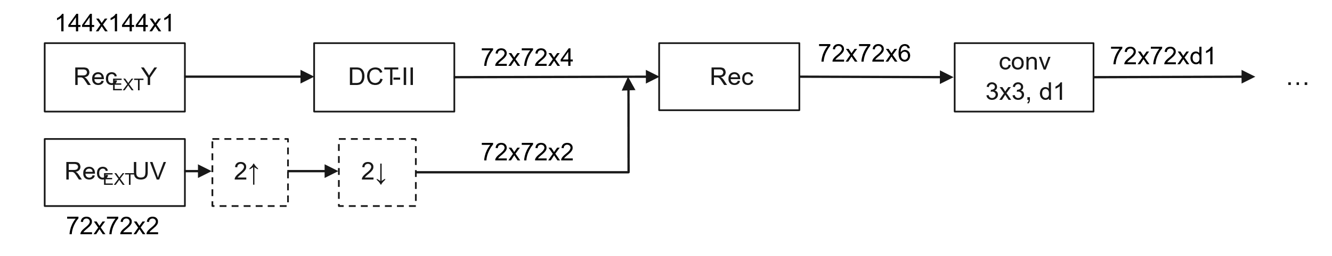
Figure 2. An example of applying the transform and reshaping to the reconstruction samples.
For QPbase and QPslice, since they are constant, there is no need to apply transform and they are directly reshaped to (W/2)x(H/2)x1. For IPB, as there is only luma information, it is transformed and reshaped into (W/2)x(H/2)x4.
The transformed inputs are processed by convolution layers with kernel sizes of 3x3 or 1x1 and concatenated for fusion and transition. In the fusion and transition module, separable convolutions of 1x3 and 3x1 and downsampling with a factor of 2 are used. The network then splits into two branches, one branch for luma and one branch for chroma. Each branch consists of sequential backbone blocks, and each backbone block consists of a PReLU, a convolution layer with a 1x1 kernel, separable convolution layers with 1x3 and 3x1 kernels, and a convolution layer with a 1x1 kernel. Some backbone blocks (type A) use no padding (padding=(0,0), which means that the output will be smaller than the input, whereas other (type B) keep the size the same. This means that the patch size will be decreased from 36x36 (before the backbone blocks) to 32x32 (after the backbone blocks). At the output side, PixelShuffle is applied to luma output, and inverse DCT is applied to both luma and chroma, such that the outputs get back to the same spatial size as the block to be reconstructed, i.e., a patch size of 128x128.
As shown in Figure 1, in the luma branch, the first 2 BBBlocks are the same as LOP5 backbone block. The backbone blocks in the TwinBlocks and TripleBlocks are BBBlock_parallel. More specifically, in BBBlock_parallel, the first two layers are PReLU and 1x1 convolution and, after these, the C channel maps will be input to the 1x3 and 3x1 paths independently. The 1x3 path has the 1x3 depth-wise separable convolutional layer with C input channels and C output channels, while the 3x1 path has the 3x1 depth-wise separable convolutional layer with C input channels and C output channels. The outputs of the two paths are added together by element-wise adding, and then sent to the last 1x1 convolutional layer. In the luma branch, there are 3 TwinBlocks followed by 1 TripleBlock.
Each TwinBlock or TripleBlock has an Attention module, the detailed architecture of which is shown in Figure 1. The number of attention channel C_{a} in the Attention module is 32 for the luma branch. Before the first TwinBlock, there are two backbone blocks with cropping, which effectively reduce the spatial dimension in the feature domain.
The chroma branch is however configured with only backbone blocks without Attention modules using 3x3 DW convolutions. The number of BBBlock_uvs is set to 5.
Luma feature is also utilized for the prediction of chroma as shown in Fig. 1, where a the luma feature is extracted before the tail block and concatenated with the chroma feature for further process.

Residue scaling
When a NN filter is being applied to reconstructed pictures, a scaling factor is derived and signaled for each color component in the slice header. The derivation is based on least square method. The difference between the input samples and the NN filtered samples (residues) are scaled by the scaling factors before being added to input samples.

Combination with deblocking filters
As shown in Figure 3, the reconstructed samples before Deblocking Filter are fed into the low complexity NN filter (NNLF), then final filtered samples are generated by blending the result of NNLF and Deblocking Filter.
$R_{Refine}$ = ${w×R}_{NN} + (1-w)×R_{DB}$

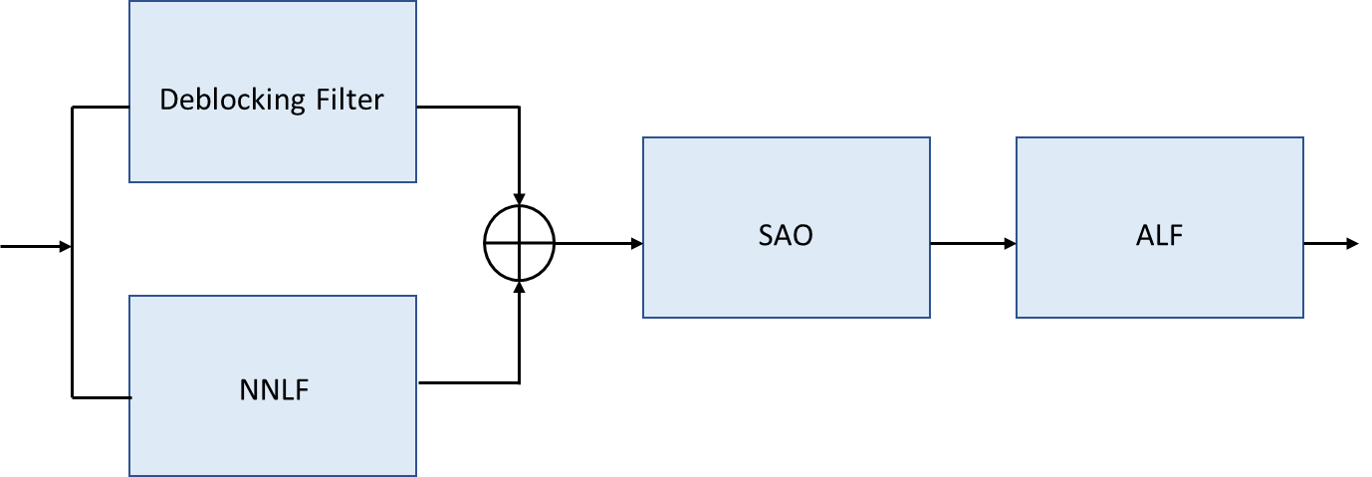
Figure 3. Parallel fusion of the NNLF and Deblocking Filter’s outputs

Non-normative time distortion optimization
To reduce decoder complexity, a BS partition-based tool is proposed. The BS partition is the area enclosed by BS edges. It can be assumed that if the number of BS partitions for a block is small, filtering is less effective than in another block with many BS partitions. To determine whether filtering is effective for a given block, the following cost function is proposed:
$$Cost=D+λ*(\# of LOP filtered blocks)$$
where D represents the distortion between the original samples and the final filtered samples in a slice. The final filtered samples may include both NNLF-filtered and unfiltered samples. $λ$ is a predefined value based on the slice QP, and the number of NNLF-filtered blocks is controlled by the BS partition threshold. Based on this cost function, the encoder determines whether filtering should be applied to each block. This tool is disabled by default.
The algorithm process is as follows:
- Calculate the number of BS partition for each block.
- Calculate the filtered and unfiltered distortions for each block.
- Set the BS partition threshold to the number of BS partitions obtained from each block and compute the costs for all cases.
- Determine the on/off conditions for all blocks based on the lowest cost.

Inference details
SADL (see Section 3.5) is used for performing the inference of the CNN filters. Both floating point-based and fixed point-based implementations are supported. In the fixed-point implementation, both weights and feature maps are represented with int16 precision using a dynamic quantization method. The network information in the inference stage is provided in Table 1.
Table 1 Network Information of low complexity filter set in Inference Stage
Network Information in Inference Stage
Mandatory | HW environment:
Mandatory | GPU Type | N/A
Mandatory | Framework: | SADL
Mandatory | Number of GPUs per Task | 0
Mandatory | Total Parameter Number | 247k
Mandatory | Parameter Precision (Bits) | float: 32  int: 16
Mandatory | Memory Parameter (MB) | float: 0.988 MB  int: 0.494 MB
Mandatory | Multiply Accumulate (kMAC/pixel) | 16.6
Optional
Optional | Total Conv. Layers | 96
Optional | Total FC Layers | 0
Optional | Total Memory (MB)
Optional | Batch size: | 1
Optional | Patch size | 128x128, 256x256
Optional | Changes to network configuration or weights required to generate rate points
Optional | Peak Memory Usage
Optional | Other information:

VLOP - Very Low complexity operation point - neural network-based loop filter
NN-based ILF of a very low complexity (5kMAC/pixel) was proposed and adopted into NNVC. The network architecture is similar to that of LOP6, and the inference uses the same implementation as LOP6.

Network Architecture and Training
The VLOP4 NN architecture and its parameters are shown in Figure 4. VLOP4 is defined as a modification of the LOP architecture by adjusting the number of channels and backbone blocks to achieve a target complexity level. In addition, the architecture is further adjusted to improve the parallelization. Figure 4 illustrates only the parts of the architecture that are different from LOP6.

 | d1 |  | d2 |  | d3 |  | d4 |  | d5 |  | d6
 | 8 |  | 4 |  | 2 |  | 1 |  | 1 |  | 64
C |  | CY1 |  | CUV1 |  | CY |  | CUV |  | Ca
- |  | 80 |  | 32 |  | 32 |  | 16 |  | 32

RecY  [1,144,144] |  |  | RecUV  [2,72,72] |  |  |  | PredY  [1,144,144] |  |  | PredUV  [2,72,72] |  |  |  |  |  | BS  [3, 144, 144] |  |  |  |  |  |  | QPbase  [1, 144, 144] |  |  | QPblock  [1, 144, 144] |  |  |  | IPB  [1, 144, 144]
DCT |  |  |  |  |  |  | DCT |  |  |  |  |  |  |  |  | 2↓ |  |  |  |  |  |  | 2↓ |  |  | 2↓ |  |  |  | 2↓
[6,72,72 ] |  |  |  |  |  |  | [6,72,72 ] |  |  |  |  |  |  |  |  | [3,72,72] |  |  |  |  |  |  | [1,72,72 ] |  |  | [1,72,72 ] |  |  |  | [1,72,72 ]
CONV3×3, 6, d1 |  |  |  |  |  |  | CONV3×3, 6, d2 |  |  |  |  |  |  |  |  | CONV1×1, 3, d3 |  |  |  |  |  |  | CONV1×1, 1, d4 |  |  | CONV1×1, 1, d4 |  |  |  | CONV1×1, 1, d5
(d1, d2,d3, d4, d4, d5)
 |  |  |  |  |  |  |  | [ d1+ d2+ d3+ d4+ d4+ d5 = d7,72,72 ]
 |  |  |  |  |  |  |  | CONV, 1×1, d7, d6
 |  |  |  |  |  |  |  | PReLU
 |  |  |  |  |  |  |  | dwCONV, 3×1, d6, d6, 2↓
 |  |  |  |  |  |  |  | [ d6,36,72 ]
 |  |  |  |  |  |  |  | dwCONV, 1×3, d6, d6, 2↓
 |  |  |  |  |  |  |  | [ d6,36,36 ]
 |  |  |  |  |  |  |  | CONV, 1×1, d6, CY+CUV
 |  |  |  |  |  |  |  | PReLU
 |  |  |  |  |  |  |  | [CY+CUV,36,36 ]
CONV, 1×1, CY, CY1 |  |  |  |  |  |  |  |  |  |  |  |  |  |  |  | CONV, 1×1, CUV, CUV1
BBBlock (1), CY1 |  |  |  |  |  |  |  |  |  |  |  |  |  |  |  | BBBlock (0), CUV1
[ CY1,34,34 ] |  |  |  |  |  |  |  |  |  |  |  |  |  |  |  | CONV, 1×1, CUV1, CUV
BBBlock (1), CY1
[ CY1,32,32 ]
TwinBlock, CY1
TripleBlock, CY1
CONV, 1×1, CY1, CY
 |  |  |  |  |  |  |  |  |  |  |  |  |  |  |  |  |  |  |  | dwCONV, 3×1[0,0], CUV, CUV
dwCONV, 3×1, CY, CY |  |  |  |  |  |  |  |  |  |  |  |  |  |  |  |  |  |  |  | dwCONV, 1×3[0,0], CUV, CUV
dwCONV, 1×3, CY, CY |  |  |  |  |  |  |  |  |  |  |  |  |  |  |  |  |  |  |  | [CUV, 34, 34]
CONV, 1×1, CY, CY |  |  |  |  |  |  |  |  |  |  |  |  |  |  |  |  |  |  |  | CONV, 1×1, CUV, CUV
PReLU |  |  |  |  |  |  |  |  |  |  |  |  |  |  |  |  |  |  |  | PReLU
CONV, 3×3, CY, 16 |  |  |  |  |  |  |  |  |  |  |  |  |  |  |  |  |  |  |  | CONV, 3×3[0,0], CUV, 8
[ 16,32,32 ] |  |  |  |  |  |  |  |  |  |  |  |  |  |  |  |  |  |  |  | [ 8,32,32 ]
Shuffle(2)
[ 4,64,64 ]
IDCT |  |  |  |  |  |  |  |  |  |  |  |  |  |  |  |  |  |  |  | IDCT
[ 1,128,128 ] |  |  |  |  |  |  |  |  |  |  |  |  |  |  |  |  |  |  |  | [ 2,64,64 ]

BBBlock (x) for Y and UV  (Note: C and C1 are referred to as CY and CY1 for Y branch, respectively, and as CUV and CUV1 for UV branch.)  Twin Block  Tripple Block | Attention  DW Block
   | [ C1,h,w ]
  PReLU
  CONV, 1×1, C1, C
  dwCONV, 3×3, C, C |  |  |  | crop(2x)
  crop(2x)
  CONV, 1×1, C C1
   |  | add
   | [ C1,h-((x==1)?2:0),w-((x==1)?2:0)]
  [ CY1,h,w ]
  BBBlock(0)
  BBBlock(0)
  PReLU
  add
  Attention
  [ CY1,h,w]
  [ CY1,h,w ]
  BBBlock(0)
  BBBlock(0)
  BBBlock(0)
  PReLU
  add
  Attention
  [ CY1,h,w]
  [ CY1,h,w ]
  CONV, 1×1, CY1, Ca
  PReLU
  MaxPool, 2×2, 2↓
  DW Block
  BiLinear, 2×2, 2
  add
  Conv, 1x1, Ca, CY1
  HardSigmoid
  mult
  [ CY1,h,w ]
  [ Ca,h,w ]
  dwCONV, 3×3, Ca, Ca
  CONV, 1×1, Ca, Ca
  PReLU
  add
  [ Ca,h,w ]

Figure 4. Architecture of NN based ILF for Very Low Operation Point, VLOP4 (5kMAC/pixel).
VLOP4 model available in the reference NNVC SW has been trained using Stage 3 LOP2 dataset following an improved LOP2 training procedure, see documents JVET-AI0107 for details, except that the “milestones” parameter is set to [46, 51, 55].

VLOP Inference
VLOP4 inference process is aligned with the LOP6 inference. Both floating point and fixed-point arithmetic are supported, with respective models (nnlf_vlop4_model_float.sadl, nnlf_vlop4_model_int16.sadl) available in the reference NNVC SW. The VLOP4 network information in the inference stage is provided in Table 2.
Table 2 Network Information of low complexity filter set in Inference Stage
Network Information in Inference Stage
Mandatory | HW environment:
Mandatory | GPU Type | N/A
Mandatory | Framework: | SADL
Mandatory | Number of GPUs per Task | 0
Mandatory | Total Parameter Number | 72730
Mandatory | Parameter Precision (Bits) | float: 32  int: 16
Mandatory | Memory Parameter (MB) | float: 0.30 MB  int: 0.16 MB
Mandatory | Multiply Accumulate (kMAC/pixel) | 5.09
Optional
Optional | Total Conv. Layers | 54
Optional | Total FC Layers | 0
Optional | Total Memory (MB)
Optional | Batch size: | 1
Optional | Patch size | 128x128, 256x256
Optional | Changes to network configuration or weights required to generate rate points
Optional | Peak Memory Usage
Optional | Other information:

HOP - High Operating Point model

Overview of HOP1 to HOP3
More details of HOP design, training and results can be found in:
- HOP design and training choices: JVET-AD0380 [5] “BoG report on NN-filter design unification”.
- Training progress: JVET-AE0042 [6] “AhG14 & AHG11: Report on AhG teleconference on high operation point (HOP) unified filter training”.
- HOP training results: JVET-AE0191 [7] “AhG11: EE1-0 High Operation Point model”.
- HOP training procedure and results: JVET-AE0289 [8] “AhG11: HOP training process and models”.
- HOP official models for partial training 2: JVET-AE0291 [9] “AhG11: Performance of the NNVC HOP with quantized Stage II model”.
- HOP full results: JVET-AF0041 [10] AhG11: HOP full results.
- HOP2 architecture: Retraining of HOP using JVET-AF0155, JVET-AF0180.
- HOP3 architecture: JVET-AG0174.

HOP4/HOP5 Network Architecture
NN-based ILF of a High Operational Point (HOP), targeting complexity of 470kMAC/pixel, was initially developed as Unified Filter Archiecture in JVET-AD0380 and adopted to NNVC (HOP1) from JVET-AF041. HOP4 is an evolution development of the Unified Filter Architecture and reuses its training and inference implementations.
In this architecture, input data consisting of reconstructed YUV samples (with UV data being spatially upsampled to the Y resolution) and supplementary data: prediction information, deblocking parameters (BS), quantization (QPBase, QPSlice) and coding mode information, are being processed in parallel by the HeadBlock (HB) and concatenated. The output of the HB is being processed by Fusion and Transition Block (FTB) that implements data fusion and spatial downsampling. Output of the FTB undergoes a processing by the Backbone consisting of a sequence of Backbone Blocks (BB). Filtering is finalized by Tailblock and luma/chroma separation.
HOP4 is defined as a modification of the HOP3 architecture with introduction of the Attention mechanism, implementation of which is shown in Figure 6. Its backbone consists of 24 backbone blocks (BB) with two of these blocks (id=8 and id=15) being enhanced with Attention (BB+A). The modules affected by Attention mechanism introduction are shown in red color in Figure 5.
HOP5 is a complexity/performance optimization of the HOP4 architecture. Comparing to the HOP4, 3x3 group convolution in the attention block is set to a group of 8, and the number of residue blocks reduced to N=23 and resulting complexity of 466 kMAC/ pixel. Originally, there is no changes to the inference process, comparing to HOP4. However, an improvement by using split block with shared signalling is further introduced, which allow the inference process to be fully compatible with HOP1 to HOP3.
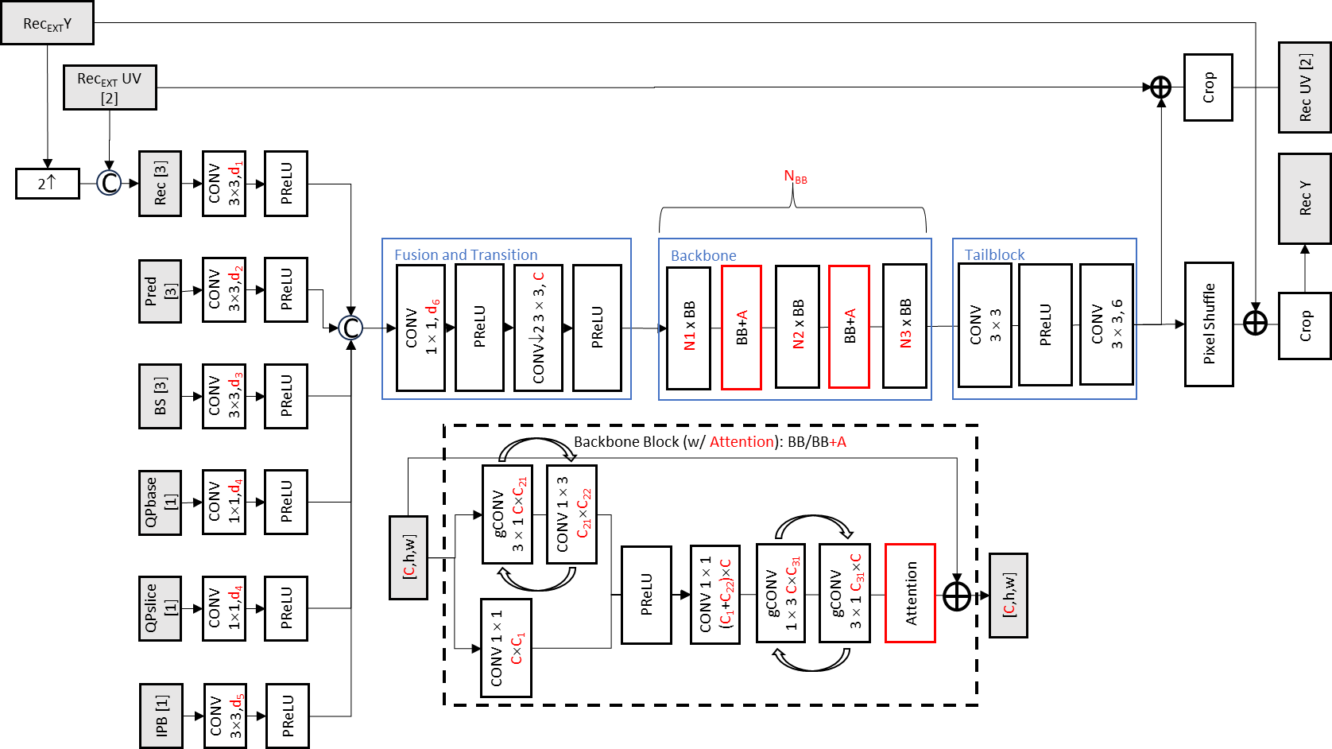
Figure 5. Architecture of NN based ILF for High Operation Point, HOP5 (466kMAC/pixel).
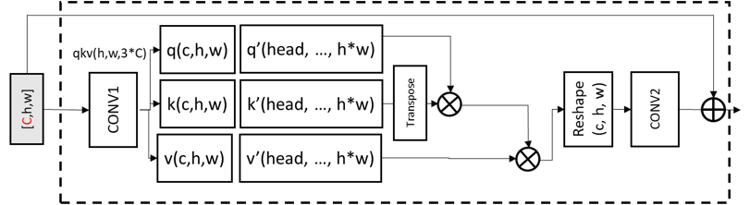
Figure 5. Design of the Attention block.

HOP4 model available in the reference NNVC SW has been trained using Stage 3 HOP dataset.

Table 3 NN Filter network structure aspects
Unified
high tier filter
Joint YUV | √
Intra = Inter model | √
Prediction | √
BS | √
QP base | √
QP slice | √
IPB | √
CONV for side Info | √
Variable number Channels | √
Long Skip connection | √
Long/wide Activation | √
Number ResBlocks | 24
Conv Decomposed | √
multi-scale feature extraction | √
Number of channels | ×16
Training Environment | pytorch 1.9

HOP4 Inference
HOP4 inference is based on Unified Filter Architecture and using SADL interface. Both floating point and fixed-point arithmetic are supported, with respective models (nnlf_hop4_model_float.sadl, nnlf_hop4_model_int16.sadl) are being available in the reference NNVC SW. The HOP network information in the inference stage is provided in Table 4.
Table 4 Network Information of low complexity filter set in Inference Stage
Network Information in Inference Stage
Mandatory | HW environment:
Mandatory | GPU Type | N/A
Mandatory | Framework: | SADL
Mandatory | Number of GPUs per Task | 0
Mandatory | Total Parameter Number | 2.9M
Mandatory | Parameter Precision (Bits) | float: 32  int: 16
Mandatory | Memory Parameter (MB) | float: 5.8 MB  int: 2.9 MB
Mandatory | Multiply Accumulate (kMAC/pixel) | 476
Optional
Optional | Total Conv. Layers | 198
Optional | Total FC Layers | 0
Optional | Total Memory (MB)
Optional | Batch size: | 1
Optional | Patch size | 128x128
Optional | Changes to network configuration or weights required to generate rate points
Optional | Peak Memory Usage
Optional | Other information:

Model usage aspects
The Table 5 gives the model application characteristics.
Table 5 NN Filter interface aspects
Unified
Filter
Pre-processing and post-processing of chroma | √
Enable DBF/SAO | Both
Blending with the DBF/SAO | DBF(*)
Slice-level/Block-level blending with adaptive scale factor | √
Slice-level/Block-level blending with fixed scale factor | √
Separate adaptive scale factor for U and V | √
Base QP adjustment | (-5, +5)
Encoder-only Optimization | ×
Temporal filter | ×
Adaptive inference granularity (128 or 256 block implicit) | √
Configurable inference size (64 or 128 block explicit) | √
configurable block extension size | √
configuration QP params number | √
block-level QP adaptation | √
(*) NNLF comes after De-block but before SAO

Pre-processing of chroma
In the unified HOP filter, the filter with a single model is designed to process three components. Since the resolutions of luma and chroma are different, pre-processing steps are introduced to up-sample chroma components as shown in Figure. 1. In the resampling process, the nearest-neighbor interpolation method is used.
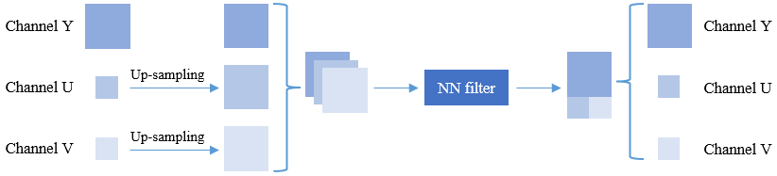
Figure. 4 the pre-processing unit

Adaptive inference granularity
Unified Filter Architecture defined in JVET-AD0380 introduced implicit, content-adaptive block size selection for the inference process, called inference granularity. Adaptive inference granularity with block size selection {128x128 or 256x256} as function of QP, Slice Type and picture width implemented through identical derivation process at the encoder and decoder sides. The larger inference block size is utilized for the Intra-coded Slice, as well as for Inter-coded Slice with picture width being larger than 832 pixels, and QP being above 30. The basic inference size (set as 128 by default) and block extension (set as 8 by default) in the inference region could be be specified at encoder side.
The HOP4 filter does not utilize implicit inference granularity and perform inference with a fixed block sizes.

Picture boundary padding
To mitigate the boundary artifacts and reduce distortion, inference block is extended to include more samples from neighboring blocks. However, for inference blocks located at the picture boundary, neighboring blocks may not exist. In this case, the extended samples of inference block are padded with zero value.

Base QP adjustment
Each slice or block could determine whether to apply the CNN-based filter or not. When the CNN-based filter is determined to be applied to a slice/block, which conditional parameter from a candidate list including two candidates derived from QP could be further decided. Denote the sequence level QP as q, the candidate list includes conditional parameters {Param_1, Param_2}. For low temporal layers, Param_1 = q, Param_2 = q$-$5. For high temporal layers, Param_1 = q, Param_2 = q$+$5. In other words, the second candidate is different across different temporal layers.
The selection process is based on the rate-distortion cost at the encoder side. Indication of on/off control as well as the conditional parameter index, if needed, are signalled in the bitstream. Figure. 6 shows the parameter selection of unified filter at encoder and decoder sides. All blocks in the current frame need to be processed with all conditional parameters first. Then all costs, i.e. Cost_0, Cost_1, ..., Cost_N+1, are calculated and compared against each other to achieve optimum rate-distortion performance. In Cost_0, CNN-based filter is prohibited for all blocks. In Cost_i, {i = 1, 2, ..., N}, the parameter Param_i is used for all blocks. In Cost_N+1, different blocks may prefer different parameters, and the information regarding whether to use CNN-based filter or which parameter to be used is signaled for each block. At decoder side, whether to use CNN-based filter or which parameter to be used for a block is based on the Param_Id parsed from the bit-stream as shown in Figure. 6 (b).
Note that for all-intra configuration, parameter selection is disabled while filter on/off control is still preserved. A shared conditional parameter is used for the two chroma components to ease the burden in worst case at decoder side. In addition, the max number of conditional parameter candidates, i.e. N, could be specified at encoder side (N = 2 by default).
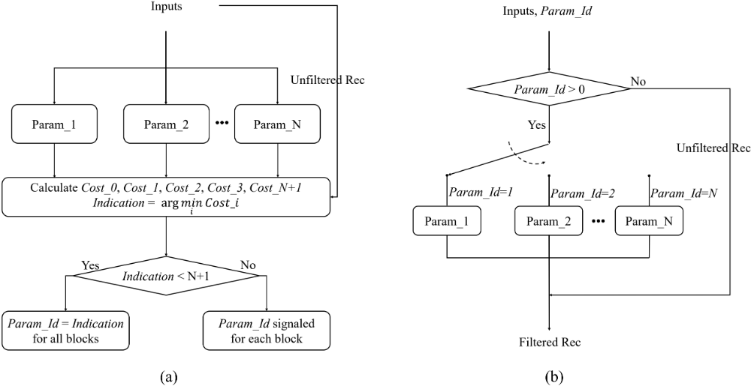
Figure. 6. (a) Parameter selection at encoder side. (b) Parameter selection at decoder side.
In current implementation, the following parameters are used:
- param_1: do not use the CNN
- param_2: use CNN with qpOffset = 0;
- param_3: use one CNN with either qpOffset = -5 or +5
- param_4: us block-level CNN with qpOffset = 0/-5/+5

Blending with DBF
Samples filtered by the deblocking filter and the NN filter are blended together via the following equation, where $R_{NN}$ and $R_{DB}$ refer to the outputs of NN filtering and deblocking filtering respectively, while $w$ stands for the blending weight.
$R_{Refine}$ = ${w×R}_{NN} + (1-w)×R_{DB}$
There are four candidates, i.e. 1, 0.75, 0.5 and adaptive weight, for the blending weight. The adaptive weight is derived using least square method and signaled for each color component in the slice header.

Encoder-only optimization
For a better estimation of rate-distortion (RD) cost in the case the NN filter is used, the proposed encoder introduces NN-based filtering into the rate-distortion optimization (RDO) process of partitioning mode selection. Specifically, a refined distortion is calculated by comparing the NN filtered samples and the original samples. The partitioning mode with the smallest rate-refined distortion cost is selected as the optimal one. To reduce complexity, several fast algorithms are applied. First, NN model is simplified by using a smaller number of residual blocks. Second, parameter selection is not allowed for the NN filtering in the RDO process Third, the proposed technique is only applied to the coding units with height and width no larger than 64. The NN filter used in the RDO process is also implemented with SADL using fixed point-based calculation. This NN-based encoder-only method is disabled by default.

Temporal filter
Pictures could be processed by an additional NN-based in-loop filter, namely temporal fitter, which takes collocated blocks from the first picture in both reference picture lists to improve performance. The two collocated blocks are directly concatenated and fed into the network. When enabling temporal filtering feature, the temporal filter is applied to the luma component of pictures in three highest temporal layers, while the regular luma and chroma filters are used for other cases. By default, this temporal filtering feature is disabled.

Decoder complexity optimization
To optimize the decoder complexity of unified filter, an encoder-only coding tool is proposed to adaptively skip blocks with small filter gains. Specifically, the filter gains of different blocks processed by NNLF are measured using Euclidean distance and calculated by
$$D={(I_{NNLF}-I_{ORG})}^{2}{-(I_{REC}-I_{ORG})}^{2}$$
Where $I_{NNLF}$ denotes the filter result of NNLF, $I_{REC}$ denotes the unfiltered reconstruction and $I_{ORG}$ denotes the original image without compression. $D$ denotes the filter gain of current block and $D<0$ means some filter gains can be achieved by using NNLF. The larger the absolute value of $D$, the greater the filter gain. This NN-based encoder-only tool is disabled by default.
The algorithm process is shown as follows.
- Check the block-level NNLF on/off is enabled.
- Calculate $D$ of each block.
- Sort all the blocks with $D<0$ from small to large filter gains.
- Calculate the gain ratio of each block: $R=D/D^{MAX}$, where $D^{MAX}= {-(I_{REC}-I_{ORG})}^{2}$.
- Compare all $R$ with $r$. If $R< r$, disable NNLF for current block. Specifically, $r$ is a predefined threshold.

Residual offset adjustment
When a NN filter is being applied to reconstructed pictures, a residual offset value is selected and signaled for each color component in the slice header. The offset value candidates are {1, 2}. The residual of NNLF’s output is adjusted by reducing the magnitude of the residual at each pixel by this small offset value before being added to input samples.

Inference details
Network Information in Inference Stage
Mandatory | HW environment:
Mandatory | Framework: | SADL
Mandatory | Number of Parameters (Each Model) | 1 model: 1.45M
Mandatory | Parameter Precision (Bits) | int: 16
Mandatory | Memory Parameter (MB) | 2.8MB
Mandatory | Multiplay Accumulate (MAC)/pixel | HOP1:477 kMAC/pix (assuming block-level input)  HOP3:466 kMAC/pix (assuming block-level input)  HOP5: 466kMAC/pel
Optional
Optional | Total Conv. Layers | 154
Optional | Total FC Layers | 0
Optional | Batch size: | 1
Optional | Patch size | HOP1 to HOP3: 128$×$128, 256$×$256 (+8 border)

NNIP - Neural network-based intra prediction

Neural network inference
The neural network-based intra prediction mode contains $7$ neural networks, each predicting blocks of a different size in $\left\{4×4, 8×4, 16×4, 32×4, 8×8, 16×8, 16×16\right\}$. The neural network predicting blocks of size $w×h$ is denoted $f_{h, w}\left( . ;θ_{h,w}\right)$ where $θ_{h,w}$ gathers its parameters. For a given $w×h$ block $Y$, $f_{h, w}\left( . ;θ_{h,w}\right)$ takes a preprocessed version $\tilde{X}$ of the context $X$ made of $n_{a}$ rows of $n_{l}+2w+e_{w}$ reference samples located above this block and $n_{l}$ columns of $2h+e_{h}$ reference samples on its left side to provide $\tilde{Y}$. The application of a postprocessing to $\tilde{Y}$ yields a prediction $\hat{Y}$of $Y$, see Figure 3. Besides, $f_{h, w}\left( . ;θ_{h,w}\right)$ returns two indices ${grpIdx}_{1}$ and ${grpIdx}_{2}$. ${grpIdx}_{i}$ denotes the index characterizing the LFNST kernel index and whether the primary transform coefficients resulting from the application of the DCT-2 horizontally and the DCT-2 vertically to the residue of the neural network prediction are transposed when $lfnstIdx=i$, $i∈\left\{1, 2\right\}$, see Figure 3. Furthermore, $f_{h, w}\left( . ;θ_{h,w}\right)$ gives the index $repIdx∈⟦0, 66⟧$ of the VVC intra prediction mode (PLANAR or DC or directional intra prediction mode) whose prediction of $Y$ from the reference samples surrounding $Y$ best represents $\hat{Y}$, see Figure 3.
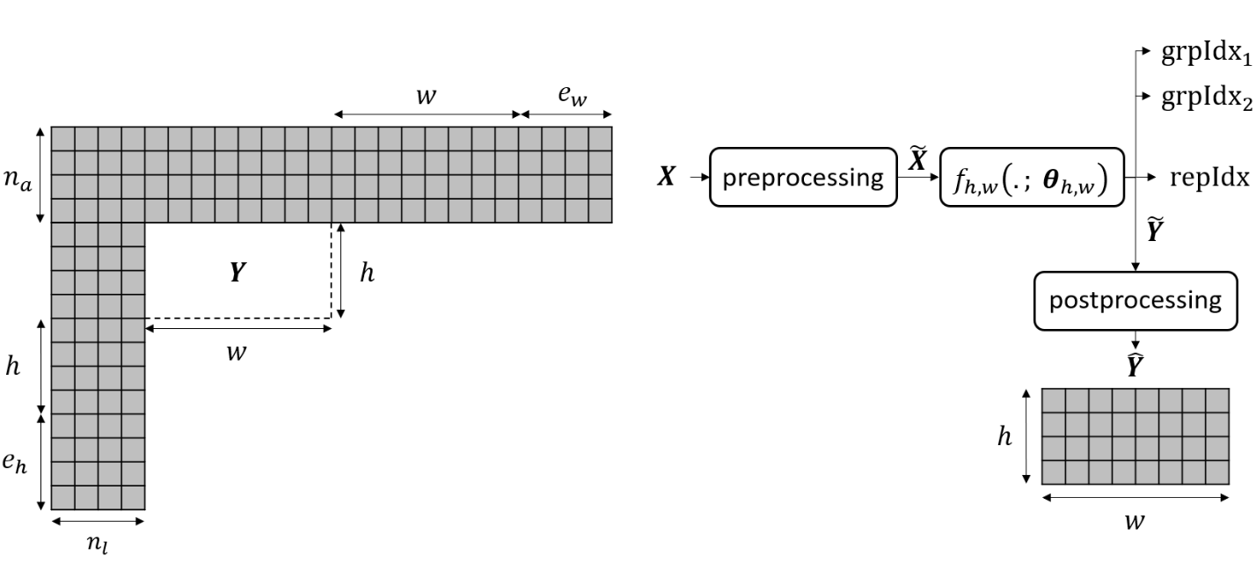
Figure 5: prediction of the current $w×h$ block $Y$ from the context $X$ of reference samples around $Y$ via the neural network-based intra prediction mode. Here, $w=8$ and $h=4.$

If $\min\left(h,w\right)≤8 \&\& hw<256$:
$n_{a}=n_{l}=min\left(h,w\right)$
otherwise:
if $h>8:$
$$n_{a}=h/2$$
otherwise:
$n_{a}=h$
if $w>8:$
$n_{l}=w/2$
otherwise:
$n_{l}=w$

If $h≤8$, $e_{h}=4$. Otherwise, $e_{h}=0.$
If $w≤8$, $e_{w}=4$. Otherwise, $e_{w}=0$.

Preprocessing and postprocessing

Preprocessing of the context of the current block
The “preprocessing” shown in Figure 3 consists in the four following steps.
- The mean $μ$ of the available reference samples $\overline{X}$ in $X$, see Figure 4, is subtracted from $\overline{X}$.
- If the neural network predicting the current block is in floats, the reference samples in the context $X$ are multiplied by $ρ=1/(2^{b-8})$, $b$ being the internal bitdepth, i.e. $10$ in VVC. Otherwise, the reference samples in the context $X$ are multiplied by $ρ=2^{Q_{in}-b+8}$, $Q_{in}$ denoting the input quantizer.
- All the unavailable reference samples $X_{u}$ in $X$, see Figure 4, are set to $0$.
- The context resulting from the previous step is flattened, yielding $\tilde{X}$, a vector of size $n_{a}\left(n_{l}+2w+ e_{w}\right)+(2h+ e_{h})n_{l}$.
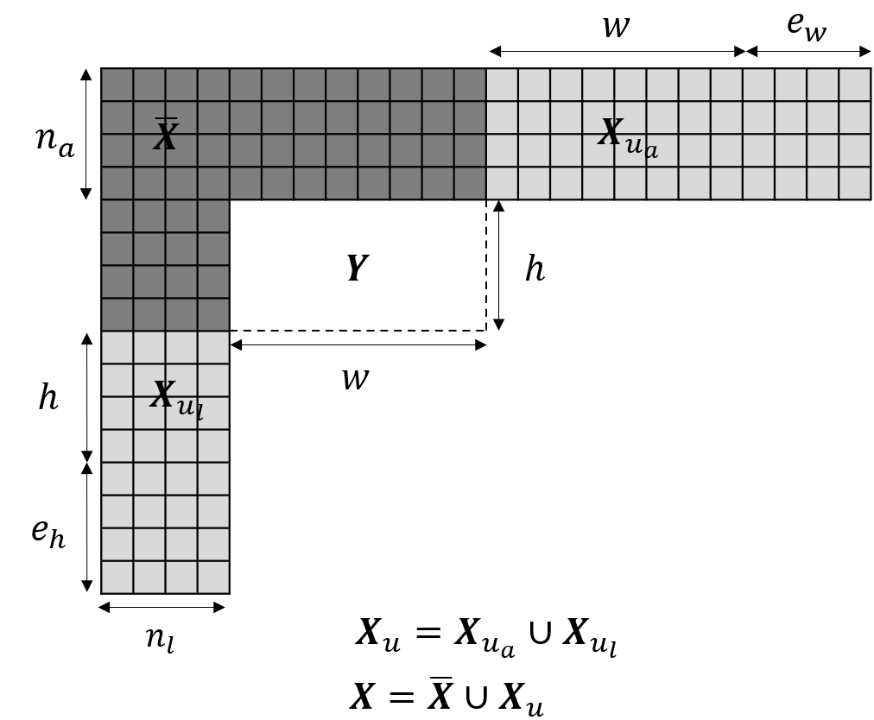
Figure 6: decomposition of the context $X$ of reference samples surrounding the current $w×h$ block $Y$ into the available reference samples $\overline{X}$and the unavailable reference samples $X_{u}$. Here, $w=8$ and $h=4$. In the illustrated case, the number of unavailable reference samples reaches its maximum value.

Postprocessing of the neural network prediction
The “postprocessing” depicted in Figure 3 consists in reshaping the vector $\tilde{Y}$ of size $hw$ into a rectangle of height $h$ and width $w$, dividing the result of the reshape by $ρ$, adding the mean $μ$ of the available reference samples in the context of the current block, and clipping to $\left[0, 2^{b}-1\right].$ Therefore, the postprocessing can be summarized as
$$\hat{Y}=\min\left(\max\left(\frac{\operatorname{reshape}\left(\tilde{Y}\right)}{ρ}+μ, 0\right), 2^{b}-1\right).$$

Adaptation of the derivation of the list of MPMs
When creating the MPM list of a given luma CB, if the “left” luma CB is predicted via the neural network-based intra prediction mode, the neural network-based mode index can be replaced by the $repIdx$ returned during the prediction of the “left” luma CB and become a candidate index to be put into the MPM list. Similarly, if “above” luma CB is predicted via the neural network-based intra prediction mode, the neural network-based mode index can be replaced by the $repIdx$ returned during the prediction of the “above” luma CB and become a candidate index to be inserted into the MPM list.

Signaling of the neural network-based intra prediction mode

Signaling of the neural network-based intra prediction mode in luma
For the current $w×h$ luma CB whose top-left pixel is at position $\left(y,x\right)$ in the current luma channel, the intra prediction mode signaling in luma is split into two cases.
- If $\left(h,w\right)∈T$, nnFlag appears in the intra prediction mode signaling in luma. nnFlag $=1$ means that the neural network-based intra prediction mode is selected to predict the current luma CB and END. nnFlag $=0$ means that the neural network-based intra prediction mode is not selected to predict the current luma CB, then the regular intra prediction mode signaling in luma, denoted $S_{⊂}$, applies, see Figure 5.
- Otherwise, the regular intra prediction mode signaling in luma $S_{⊂}$ applies.
Note that, in the case “$\left(h,w\right)∈T \&\& nnFlag =1",$ if the context of the current luma CB goes out of the bounds of the current luma channel, i.e. $x<n_{l} || y<n_{a}$, the neural network-based intra prediction is replaced by PLANAR.
$$T=\left\{\left(4,4\right), \left(4,8\right), \left(8,4\right), \left(4,16\right), \left(16,4\right), \left(4,32\right), \left(32,4\right), \left(8,8\right), \left(8,16\right), \left(16,8\right),\left(8,32\right), \left(32,8\right), \left(16,16\right),\right.$$
$\left.\left(16,32\right),\left(32,16\right), \left(32,32\right), \left(64,64\right)\right\}$.
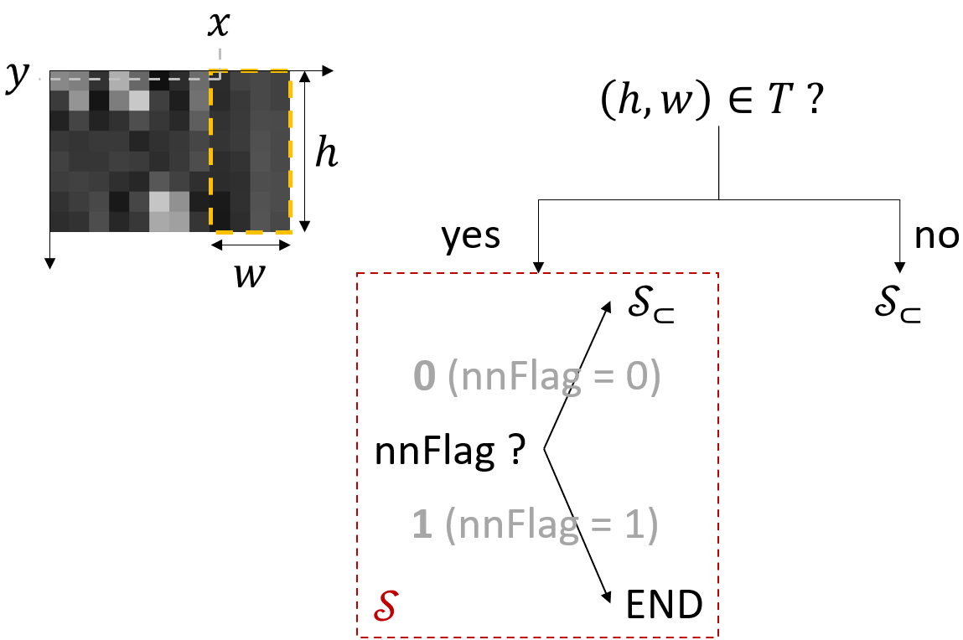
Figure 7: intra prediction mode signaling for the current $w×h$ luma CB framed in orange in dashed line. The coordinates of the pixel at the top-left of this CB are $\left(y, x\right).$ The bin value of a nnFlag value appears in bold gray. Here, $h=8$, $w=4$, $x=8$, and $y=0$.

Signaling of the neural network-based intra prediction mode in chroma
For the current pair of $w×h$ chroma CBs having top-left pixel at position $\left(y,x\right)$ in the current pair of chroma channels, the intra prediction mode signaling in chroma is split into two cases.
- If the luma CB collocated with this pair of chroma CBs is predicted by the neural network-based intra prediction mode:
  - If $\left(h,w\right)∈T,$the DM becomes the neural network-based intra prediction mode$.$
  - Otherwise, the DM is set to PLANAR.
- Otherwise:
  - If $\left(h,w\right)∈T$, nnFlagChroma appears in the intra prediction mode signaling in chroma. nnFlagChroma is placed before the DM flag in the decision tree of the intra prediction mode signaling in chroma. nnFlagChroma $=1$ means that the neural network-based intra prediction mode is selected to predict the current pair of chroma CBs and END. nnFlagChroma $=0$ means that the neural network-based intra prediction mode is not selected to predict the current pair of chroma CBs, then the regular intra prediction mode signaling in chroma resumes from the DM flag.
  - Otherwise, the regular intra prediction mode signaling in chroma applies.
Note that, in the case where “$\left(h,w\right)∈T and the DM becomes the neural network-based intra prediction mode"$and the case where “$\left(h,w\right)∈T \&\& nnFlagChroma =1$”, if the context of the current chroma CB goes out of the bounds of the current chroma channel, i.e. $x<n_{l} || y<n_{a}$, the neural network-based intra prediction is replaced by PLANAR.

Transformation of the context and the neural network prediction
For a given $w×h$ block, if $\left(h,w\right)∈T$, it is possible that the neural network-based intra prediction mode must predict this block but the neural network-based intra prediction mode does not contain $f_{h, w}\left( . ;θ_{h,w}\right)$. In this case, the context of the current block can be down-sampled vertically by a factor $δ$ and/or down-sampled horizontally by a factor $γ$ and/or transposed before the step called “preprocessing” in Figure 3. Then, the prediction of the current block can be transposed and/or up-sampled vertically by the factor $δ$ and/or up-sampled horizontally by the factor $γ$ after the step called “postprocessing” in Figure 3. The transposition of the context of the current block and the prediction, $δ$, and $γ$ are chosen so that a neural network belonging to the neural network-based intra prediction mode is used for prediction, see Table 2.

height and width of the block to be predicted $\left(h, w\right)$ | $$γ$$ | $$δ$$ | transposition | neural network used for prediction
$$\left(4, 4\right)$$ | $$1$$ | $$1$$ | no | $$f_{4, 4}\left( . , θ_{4,4}\right)$$
$$\left(4, 8\right)$$ | $$1$$ | $$1$$ | no | $$f_{4, 8}\left( . , θ_{4,8}\right)$$
$$\left(8, 4\right)$$ | $$1$$ | $$1$$ | yes | $$f_{4, 8}\left( . , θ_{4,8}\right)$$
$$\left(4, 16\right)$$ | $$1$$ | $$1$$ | no | $$f_{4, 16}\left( . , θ_{4,16}\right)$$
$$\left(16, 4\right)$$ | $$1$$ | $$1$$ | yes | $$f_{4, 16}\left( . , θ_{4,16}\right)$$
$$\left(4, 32\right)$$ | $$1$$ | $$1$$ | no | $$f_{4, 32}\left( . , θ_{4,32}\right)$$
$$\left(32, 4\right)$$ | $$1$$ | $$1$$ | yes | $$f_{4, 32}\left( . , θ_{4,32}\right)$$
$$\left(8, 8\right)$$ | $$1$$ | $$1$$ | no | $$f_{8, 8}\left( . , θ_{8,8}\right)$$
$$\left(8, 16\right)$$ | $$1$$ | $$1$$ | no | $$f_{8, 16}\left( . , θ_{8,16}\right)$$
$$\left(16, 8\right)$$ | $$1$$ | $$1$$ | yes | $$f_{8, 16}\left( . , θ_{8,16}\right)$$
$$\left(8, 32\right)$$ | $$2$$ | $$1$$ | no | $$f_{8, 16}\left( . , θ_{8,16}\right)$$
$$\left(32, 8\right)$$ | $$1$$ | $$2$$ | yes | $$f_{8, 16}\left( . , θ_{8,16}\right)$$
$$\left(16, 16\right)$$ | $$1$$ | $$1$$ | no | $$f_{16, 16}\left( . , θ_{16,16}\right)$$
$$\left(16, 32\right)$$ | $$2$$ | $$1$$ | no | $$f_{16, 16}\left( . , θ_{16,16}\right)$$
$$\left(32, 16\right)$$ | $$1$$ | $$2$$ | no | $$f_{16, 16}\left( . , θ_{16,16}\right)$$
$$\left(32, 32\right)$$ | $$2$$ | $$2$$ | no | $$f_{16, 16}\left( . , θ_{16,16}\right)$$
$$\left(64, 64\right)$$ | $$4$$ | $$4$$ | no | $$f_{16, 16}\left( . , θ_{16,16}\right)$$
Table 2: decision of transposing the context of the current$w×h$ block to be predicted and the prediction of this block, the value of $γ$, and the value of $δ$, and the neural network belonging to the neural network-based intra prediction mode used for prediction for each $\left(h, w\right)∈T$.

Description of the neural networks belonging to the neural network-based intra prediction mode

Network information (inference)
Parameter number | block size | Parameter number
Parameter number | $$4×4$$  $$8×4$$  $$16×4$$  $$32×4$$  $$8×8$$  $$16×8$$  $$16×16$$ | $$77477$$  $$120816$$  $$182356$$  $$229048$$  $$194023$$  $$238768$$  $$291311$$
Parameter precision | 16-bit signed integer.
MAC/pixel | block size | MACs/pixel
MAC/pixel | $$4×4$$  $$8×4$$  $$16×4$$  $$32×4$$  $$8×8$$  $$16×8$$  $$16×16$$ | $$4837$$  $$3773$$  $$2848$$  $$1789$$  $$3030$$  $$1865$$  $$1138$$
Total conv. layers
Total FC layers | 4 cascaded fully-connected layers for the neural network predicting $16×16$ blocks.  3 cascaded fully-connected layers for the other six neural networks.
Mem (MB) | 4.9 MB for the whole neural network-based intra prediction mode.
Framework | SADL (C++ with a single thread)

Combination of the neural network-based intra prediction mode and ISP

Restricted combination
In the proposed combination between the neural network-based intra prediction mode and ISP, ISP is allowed in luma exclusively and the same split types as in the original ISP are employed, i.e. horizontal and vertical splits. However, for a given luma CB predicted by the neural network-based intra prediction mode, ISP is ruled by four additional constraints compared to the constraints specific to the original ISP.
- The luma CB can only be split into 4 equal-sized sub-partitions for both prediction and {transform coding, entropy coding of quantized transform coefficients}. For instance, a 8x8 luma CB predicted via the neural network-based intra prediction mode cannot be split vertically into 2 4x8 sub-partitions for prediction and 4 2x8 sub-partitions for {transform coding, entropy coding of quantized transform coefficients}.
- A sub-partition of the luma CB cannot have a dimension strictly smaller than 4. For instance, a 4x16 luma CB predicted via the neural network-based intra prediction mode cannot be split vertically via ISP into 4 1x16 sub-partitions.
- At least one of the two dimensions of the luma CB must be equal to 4.
- The luma CB must belong to a CU in separate tree.
To summarize 1), 2), 3), and 4), for a given luma CB predicted by the neural network-based intra prediction mode, ISP is allowed if $ispAllowed$ is true.
$$ispAllowed=!isPrelim \&\& (\left(h≪2\right)≥4 ∥ \left(w≪2\right)≥4)$$
$$isPrelim=!isSepTree∥h<4 ∥w<4 ∥\left(h !=4 \&\& w !=4\right)$$
$h :$height of the luma CB.
$w$ : width of the luma CB.
$isSepTree$ : true if the luma CB is part of a CU in separate tree.

Additional combination with LFNST
For a given luma CB predicted by a non-neural network-based intra prediction mode, when ISP and LFNST are used, the LFNST implicit signaling is determined by the index of the intra prediction mode, and all the luma TBs arising from the ISP split share the same LFNST implicit signaling. In contrast, for a given luma CB predicted via the neural network-based intra prediction mode, when ISP and LFNST are used, for each luma TB independently, the neural network infers the LFNST implicit signaling for this luma TB while predicting it.

Adaptive LOP/VLOP - Content-adaptive neural networks loop-filter

Neural network
The content adaptation of the loop-filter is applied to the LOP4 loop-filter. That means the architecture is the same as the LOP4 loop-filter plus some multiplier parameters in the luma and chroma branches.
The multipliers are applied after the bias is added to the convolution result:
$$σ\left(\left(W*x+b\right)∙m\right),$$
The inputs to the NN are the same as for the LOP4 filter, except for 2 additional flags that are used to turn on/off the multipliers if needed for certain frames. The multipliers are activated when the value of both flags is equal. The second flag is always 1. For the first flag, 1 indicates that the multipliers are enabled and 0 indicates that the multipliers are disabled.

Content adaptation
The content adaptation is done at the encoder-side for each sequence, sequence QP and random-access segment. Given a certain sequence, sequence QP and random-access segment, the result of this process is a weight-update (difference between base multipliers and over-fitted multipliers) coded with the Neural Network compression and Representation (NNR) standard and carried within a Neural Network Filter Update (NNFU) APS in the first B-frame of the segment.

Inference details
Network Information in Inference Stage
Mandatory | HW environment:
Mandatory | GPU Type | CPU only
Mandatory | Framework: | SADL
Mandatory | Number of GPUs per Task
Mandatory | Number of Parameters  (Each Model) | 249741
Mandatory | Total Number of Parameters (All Models) | 249741
Mandatory | Parameter Precision (Bits) | Int16
Mandatory | Memory Parameter (MB) | 0.5
Mandatory | Multiply Accumulate (kMAC/pixel) | 17.2
Mandatory | Calculation Method | on a block basis
Optional
Optional | Total Conv. Layers
Optional | Total FC Layers
Optional | Total Memory (MB)
Optional | Batch size:
Optional | Patch size | 128x128 / 256x256
Optional | Changes to network configuration or weights required to generate rate points
Optional | Peak Memory Usage (Total)
Optional | Peak Memory Usage (per Model)
Optional | Border handling
Optional | Other information:

Encoder
The content adaptation is done per RA segment independently and once the model is ready to be deployed, the encoding of the RA segment is also done independently from other segments. Adjacent RA segments have overlapping I-frames and these are filtered using the original LOP4 filter.
After a RA segment of a sequence-QP pair has been encoded using the respective adaptive LOP4 filter, a decision is performed to determine whether this segment or the one encoded with the anchor configuration (i.e., with the base model) is better in terms of delta PSNR. Therefore, a final merged bitstream may include some RA segments filtered with the original (base) LOP4 filter and some RA segments filtered with the adaptive LOP3 filter.

Decoder
When the decoder parses an NNFU APS, the reconstruction of the overfitted LOP4 filter is triggered. The process relies on the original (base) LOP4 filter and the decoded NNR bitstream carried within the NNFU APS.

Other loop filters
Content-adaptability is also supported for VLOP, LOP2 and LOP3 loop-filters.

Decomposed content-adaptive neural networks loop-filter
Decomposed content-adaptive neural networks loop-filter is implemented by applying a dimension-wise decomposition on the one-dimensional multiplier. Specifically, for a selected multiplier $m$, it is obtained by overfitting two low-rank matrices as:
$$m=flatten\left(W_{m1}×W_{m2}^{⊤}\right)$$
where $×$ is a product operation, and $W_{m1}∈R^{d_{1}×r}$, $W_{m2}∈R^{d_{2}×r}$ are dimension-wise decomposed components, $d_{1}$ and $d_{2}$ are sizes of decomposition and $d_{1}×d_{2}=c_{m}$, $r$ is the rank of decomposition and $flatten\left(⋅\right)$ is a tensor flattening operation to align the result with the original shape of $m$:
$$R^{d_{1}×d_{2}}→ R^{c_{m}}$$

Size of decomposition
Sizes of decomposition for each multiplier length are pre-configured and a set of most likely size combinations is pre-set. For each segment with a given QP, decomposed content-adaptive models with each combination out of all are trained with very few epochs, and then the optimal sizes to be decomposed is determined based on the PSNR-Bitrate ratio. The optimal sizes are used for coding of each segment.

Implementation of decomposed multiplier
Two vectors being the decomposition components are initialized, each one with length equal to the corresponding size of the decomposition. The reshaped result of their outer product is used as a multiplier layer. During overfitting, these two vectors are directly updated.

Content-adaptive neural network post-filter

Neural network
Figure 6 shows the architecture of the NN. The input consists of the reconstructed luma and chroma samples, as well as the strength control value SliceQP_{Y}.
The architecture also includes multiplier parameters, which are applied after the bias is added to the convolution result:
$$σ\left(\left(W*x+b\right)∙m\right),$$where $W$ is the kernel, $*$ is the convolution operator, $x$ is the input, $b$ is the bias, $m$ is the multiplier and $σ$ is the activation function.
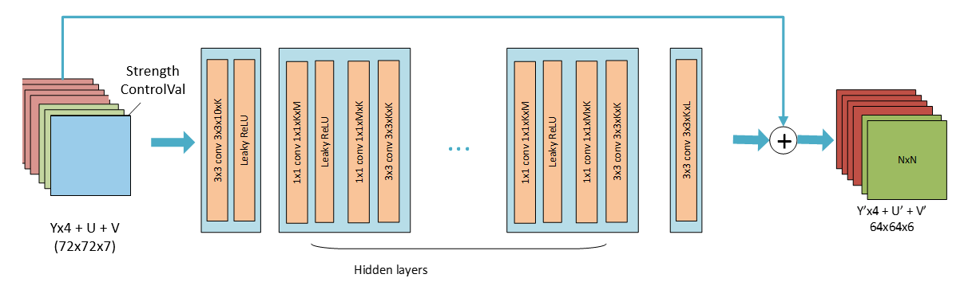
Figure 8. Architecture of the content-adaptive post-filter
Since the luma and chroma components have different resolutions, the input luma component is split into 4 channels following the pixel unshuffled operation. Similarly, the final output luma component is brought back to the real resolution by applying the pixel shuffle operation.

Content adaptation
The content-adaptive post-filter includes four base filters trained offline. The content adaptation is achieved by over-fitting one of them on the test content. The over-fitting is done at the encoder side and only for the multiplier parameters. To recreate the over-fitted model at the decoder end, the resulting weight-update (difference between base multipliers and over-fitted multipliers) is coded with Neural Network compression and Representation (NNR) standard and sent within a Neural Network Post Filter Characteristics (NNPFC) SEI message.

Inference details
Table III shows the network information in inference stage when using SADL int16 fixed-precision.
The content-adaptive post-filter includes the signalling of two NNPFC SEI messages (one with the characteristics of the base model and one with the NNR weight-update) and one Neural Network Post Filter Activation (NNPFA) SEI message. The latter activates/enables an NN post-filter for the whole video encoded video sequence.

Table III. Network Information of the content-adaptive post-filter in inference stage
Network Information in Inference Stage
Mandatory | HW environment:
Mandatory | GPU Type | CPU only
Mandatory | Framework: | SADL
Mandatory | Number of GPUs per Task | 0
Mandatory | Number of Parameters (Each Model) | 109068
Mandatory | Total Number of Parameters (All Models) | 436272 (x4)
Mandatory | Parameter Precision (Bits) | 16
Mandatory | Memory Parameter (MB) | 0,832122803
Mandatory | Multiply Accumulate (kMAC/pixel) | 34 (block)
Optional
Optional | Total Conv. Layers | 35
Optional | Total FC Layers | 0
Optional | Total Memory (MB)
Optional | Batch size: | 1
Optional | Patch size | 144x144
Optional | Changes to network configuration or weights required to generate rate points
Optional | Peak Memory Usage (Total)
Optional | Peak Memory Usage (per Model)

NNSR - Neural network-based super resolution

Neural network for luma component
The neural network architecture of the super resolution is illustrated in Figure 9. The chroma components are upsampled to the same size of luma components before feeding into the network. Then a 1×1 convolution is used to fuse the concatenated features. Split of luma and chroma with different complexity is designed that the chroma branch includes a smaller number of channels and basic backbone blocks compared to luma branch. Scaling ratio (Sr) is set as an input to the model:
- For scaling ratio is 2.0x, Sr = 1;
- For scaling ratio is 1.5x, Sr = 2;
- For scaling ratio is 1.0x, Sr = 0.

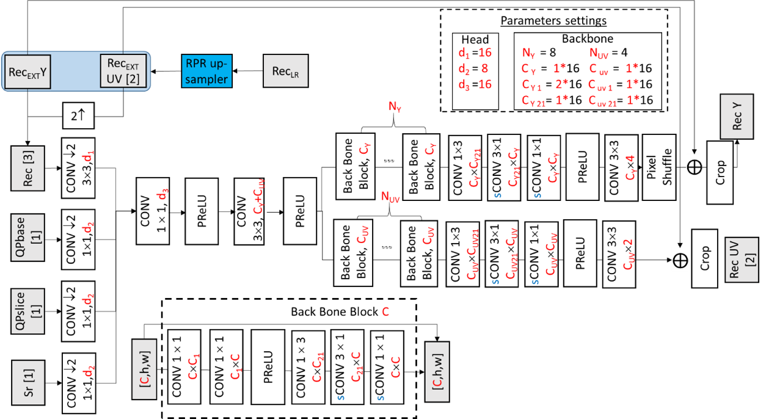
Figure 9 Architecture of the super resolution

GOP level encoding resolution decision
The encoder enables resampling-based method only if $QP≥32$. One of resampling scale ratios {×1.0 (original size), ×2.0 (half size) and ×1.5 (2/3 size)} is selected at GOP level and the same scale ratio is applied on all frames in a common one GOP. To determine the resampling ratio, the PSNR value and initial QP for the first frame of GOP are exploited. Specifically, the first frame of GOP is downscaled to quarter resolution and then resampled to the original resolution by using the existing RPR technology. The PSNR is calculated between the original frame and the down-up scaled frame. Considering the different characteristics between luma and chroma components, PSNRs from different components are calculated in the scale ratio decision. The scale ratio decision process is shown in Figure 10.
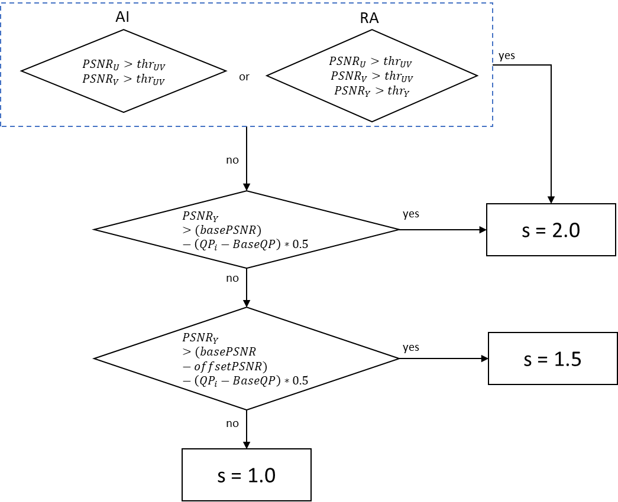
Figure 10 GOP level encoding resolution decision.
- For RA, if ${PSNR}_{U}>{thr}_{UV}$ and ${PSNR}_{V}>{thr}_{UV}$, and ${PSNR}_{Y}>{thr}_{Y}$, scaling ratio is set equal to 2.0.
For AI, if ${PSNR}_{U}>{thr}_{UV}$ and ${PSNR}_{V}>{thr}_{UV}$, scaling ratio is set equal to 2.0.
- else
  - if ${PSNR}_{Y}>(basePSNR)-\left({QP}_{i}-BaseQP\right)*0.5$, scaling ratio is set equal to 2.0.
  - else if ${PSNR}_{Y}>(basePSNR-offsetPSNR)-\left({QP}_{i}-BaseQP\right)*0.5$, scaling ratio is set equal to 1.5.
  - else, scaling ratio is set equal to 1.0.
where ${PSNR}_{y}$, ${PSNR}_{u}$ and ${PSNR}_{v}$ represent down-up scaled luma and chroma PSNR for the first frame of GOP, respectively. basePSNR and $OffsetPSNR$ represent predefined threshold PSNR. $OffsetPSNR$ is set equal to different values for RA and AI, respectively. According to selected scaling ratio for i-th GOP, QP offset is set for ×2.0 and ×1.5 respectively.

Inference details
SADL (see Section 1.3) is used for performing the inference of the CNN filters. Both floating point-based and fixed point-based implementations are supported. In the fixed-point implementation, both weights and feature maps are represented with int16 precision using a static quantization method. The network information in the inference stage is provided in Table 6.
Table 6 Network Information of super resolution in Inference Stage
Network Information in Inference Stage
Mandatory | HW environment: | Intel(R) Xeon(R) Platinum 8260 CPU @ 2.40GHz
Mandatory | Framework: | SADL
Mandatory | Number of GPUs per Task | 0
Mandatory | Number of Parameters (Each Model) | 19.6 K
Mandatory | Total Parameter Number | 19.6 K
Mandatory | Parameter Precision (Bits) | Int 16
Mandatory | Memory Parameter (MB) | 39.2 KB
Mandatory | Multiply Accumulate (MAC) | 4.7 kMAC/pixel

DRF – Deep Reference Frame

Neural network
Fig. 11 illustrates the architecture of the DRF network. The network independently applies a series of convolutional operations to two input frames to build pyramid representations. This results in two lists of features, denoted as $F_{1}^{l}$ and $F_{2}^{l}$, corresponding to three scale levels $l∈\left\{1,2,3\right\}$, for each input respectively. And the optical flow estimation between the two inputs is computed at multiple scales. Specifically, IFRNet small is used to estimate forward and backward optical flows. The resulting flow features are further downsampled to obtain flow representations at three scales, denoted as $O_{f}^{l}$ and $O_{b}^{l}$ for forward and backward directions, respectively, where $l∈\left\{1,2,3\right\}$. After obtaining multi-scale features and optical flows, feature warping and fusion are performed. At each scale level $l$, feature $F_{1}^{l}$ is warped using $O_{f}^{l}$ to produce the forward-warped feature $F_{fw}^{l}$, and $F_{2}^{l}$ is warped using $O_{b}^{l}$ to obtain the backward-warped feature $F_{bw}^{l}$. These two warped features are fused to generate $F_{w}^{l}$. The fused features from all three scales are then processed through a structured arrangement of convolutional layers that capture interactions across different resolutions. Finally, a convolutional layer is applied as a post-processing step to produce the output frame.
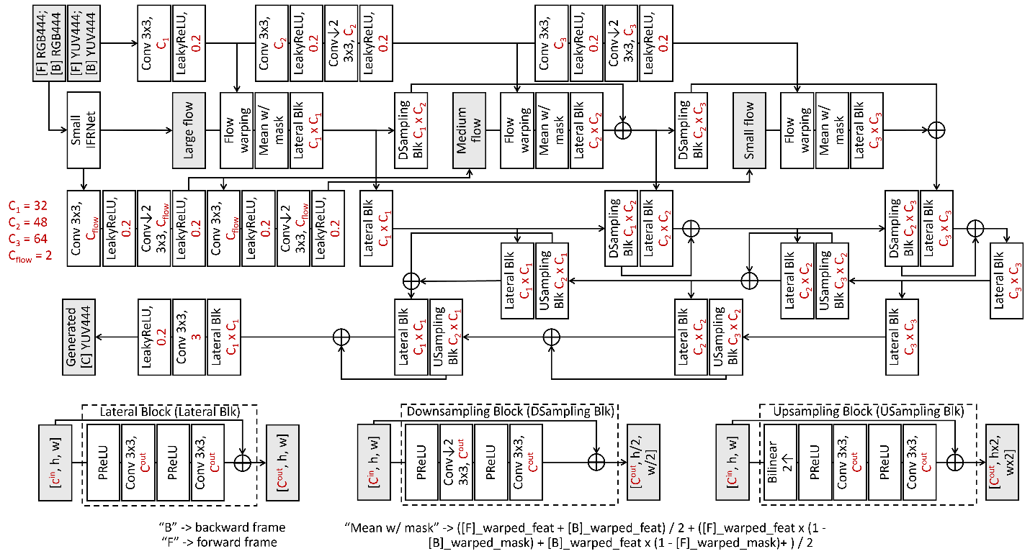
Fig. 11: The architecture of the DRF network

Deep reference frame generation and insertion
In the case of bi-directional inter prediction under RA configuration, the deep reference frame generation network receives a pair of previously encoded frames from DPB to synthesize a new frame. The input frames are temporally symmetric, selected with equal and minimal POC distance from the current encoding frame. The generation process can be formulated as:
$$I_{drf}=F_{inter}\left(I_{p-δp}^{r},I_{p+δp}^{r}\right),L\left(I_{p}\right)>L\left(I_{p±δp}\right)$$
where $I_{drf}$ denotes the generated deep reference frame, $F_{inter}\left(∙\right)$ represents the interpolation network, and $L\left(∙\right)$ denotes the temporal layer of a given frame. $I_{p}^{r}$ is the reconstructed frame of $I_{p}$ with POC equals $p$, and $δp$ is the smallest available POC distance between the current frame and its neighboring encoded frames. The generated frame is inserted into both RPL0 and RPL1 at the second position, and its POC is set to be equal to that of the current encoding frame. As the same inputs and model are used at both encoder and decoder sides, the synthesized frame remains consistent across both ends. This tool is only applied to frames in temporal layers {3,4,5}, where the network input varies according to the temporal hierarchy:
$$I_{drf}=\left\{\begin{aligned}F_{inter}\left(I_{p-4}^{r},I_{p+4}^{r}\right),L\left(I_{p}\right)=3 \\ F_{inter}\left(I_{p-2}^{r},I_{p+2}^{r}\right),L\left(I_{p}\right)=4 \\ F_{inter}\left(I_{p-1}^{r},I_{p+1}^{r}\right),L\left(I_{p}\right)=5\end{aligned}\right.$$

Modification of TMVP
Since the calculation of TMVP involves scaling MV of the collocated CU based on the POC distances among the current frame, the collocated frame, and their respective reference frames, it requires access to the MV of the collocated CU. However, such motion information is unavailable in the deep reference frame generated by the network, so this frame cannot be used as a collocated frame. Moreover, the POC of the deep reference frame is identical to that of the current frame, resulting in a POC distance of zero between the current frame and the reference, as well as between the collocated frame and its deep reference frame. Consequently, if the reference frame of either the current frame or its collocated frame is a deep reference frame, the TMVP will not be constructed.

Inference details
The inference pipeline of the DRF is illustrated in Fig. 12.
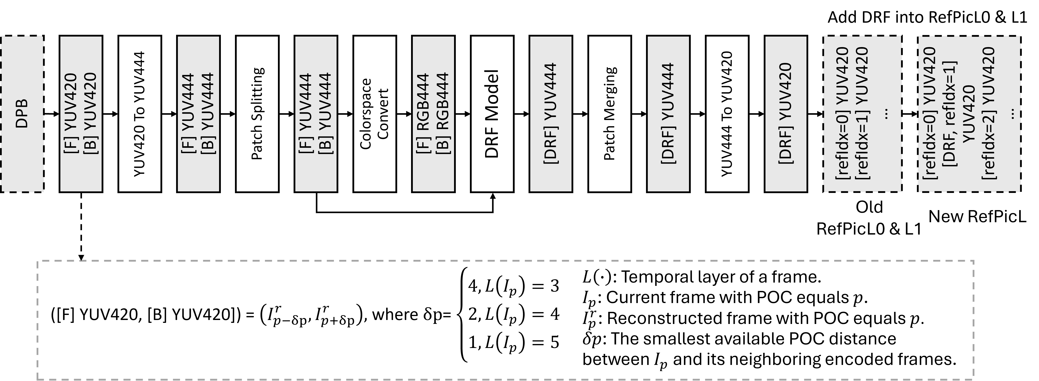
Fig. 12: Inference pipeline diagram of the DRF
In the inference diagram, the patch splitting strategy is as follows: the input frame is first divided into multiple patches of size 240×240, with a predefined boundary width of 8 pixels. Each patch is then extended by 8 pixels in all directions to capture additional contextual information, and the valid pixel range within the input frame is determined accordingly. The extended patch is placed into a temporary variable of fixed size 256×256, with necessary padding applied to ensure consistent dimensions. This 256×256 patch is then fed into the DRF model for processing. Finally, the model’s output patch is mapped back to the corresponding region in the output frame based on the initial patch layout.
The specific inference details are summarized in Table 7.
Table 7 Network Information of deep reference frame generation in Inference Stage
Network Information in Inference Stage
Mandatory | HW environment
Mandatory | GPU Type | CPU only
Mandatory | Framework | SADL
Mandatory | Number of GPUs per Task | 0
Mandatory | Number of Parameters (Each Model) | 3800K
Mandatory | Total Number of Parameters (All Models) | 3800K
Mandatory | Parameter Precision (Bits) | 16
Mandatory | Multiply Accumulate (kMAC/pixel) | 504
Optional | Total Conv. Layers | 101
Optional | Total FC Layers | 0
Optional | Total Memory (MB)
Optional | Batch size | 1
Optional | Patch size | 256x256 (with 16 boundary padding)

Hybrid end-to-end intra coding
NNVC includes a framework to use externally NN-coded frames as I-frames. In the current version, it only specifies the framework and not the NN coder.

Multi-layer encoding (NN-coded reference frame)
P
B
B
B
P
Hybrid codec with AI coded RefPic
AI image codec
Figure 11: Schematic of multi-layer scheme

In this approach, the multi-layer functionality of VTM is used to provide the NN-coded frame as reference frame to the NNVC coded video sequence. This can be achieved by treating the NN-coded frames as base-layer with a temporal subsampling ratio equal to the intra period. The base layer then contains only NN-coded frames and the enhancement layer can use these frames as reference.
During encoding, a NN-based coder is used to generate the reconstructed frame for the base layer. This frame then serves as reference frame for the enhancement layer, which constitutes the actual sequence. The bitstream from the NN-based encoder is included in the main bitstream. During decoding, the base-layer decoder first extracts the NN-coded bitstream. An NN-based decoder then parses and decodes the NN-coded bitstream to generate the reconstructed frame. This frame is then used in the enhancement layer as reference frame.
A flag is included into the bitstream of the enhancement layer to indicate whether an NN-coded I-Frame is used as reference for the current frame. If the current frame uses an NN-coded frame as reference, all motion vectors using during the prediction from this frame are inferred to be zero, since they both share the same temporal position.

The framework currently provides 3 modes of operation:
- Use external scripts to run NN encoder and NN decoder during the execution of NNVC. The NN bitstreams are added into the main bitstream in a specific NAL unit.
- Use an externally NN-coded YUV file and bitstream files for each frame as additional input to the encoder and add the bitstreams into the main bitstream. With a suitable external decoder script for the NN decoder, this bitstream can be decoded
- Use an externally NN-coded YUV file as additional input to the encoder and decoder. No NN bitstream is added, but information about the required bits for each frame can be read from a csv file and can be added to the overall rate to produce correct results. This stream is not decodable without the additional input to the decoder.
If the NN-coded reference frame is encoded during runtime, the encoding of the base-layer now consists of the following steps:
- Write the current frame into a temporary YUV file
- Call an external script which calls the NN-based encoder, producing a bitstream file and a reconstructed YUV file
- Read the reconstructed YUV file and set it as the reconstructed signal of the base-layer
- Read the bitstream file and write it into the main bitstream using a new NAL unit (28)
If during decoding the NAL unit 28 (containing the NN-coded bitstream) is detected, the following steps are performed for decoding
- When the NAL unit 28 is detected, write the bitstream in an external temporary file
- Call an external script which calls the NN-based decoder, generating a reconstructed YUV file by parsing and decoding the NN-coded bitstream
- Read the reconstructed YUV file and set it as the reconstructed frame of the base-layer

The reconstructed frame of the base-layer serves as reference for the decoding of the current picture
The software package contains two example scripts to call the NN encoder and decoder, respectively. To integrate an external NN-coder, these scripts need to be modified. The parameters of the script and their order are fixed in the NNVC software. The last line of the file needs to be modified to include the call to the external coder.

alias PYTHON="python"
CPU=1

INPUTFILE=$1
BITSTREAMFILE=$2
OUTPUTFILE=$3
WIDTH=$4
HEIGHT=$5
BITDEPTH_LUMA=$6
BITDEPTH_CHROMA=$7
QP=$8

PYTHON path/to/AI/encoder.py --InputFile $INPUTFILE --OutputFile $OUTPUTFILE --BitstreamFile $BITSTREAMFILE --CPU $CPU --bitdepthLuma $BITDEPTH_LUMA --bitdepthLuma $BITDEPTH_CHROMA --width $WIDTH --height $HEIGHT --QP $QP

run_NN_encoder_example.py

Small ad-hoc deep learning (SADL) library
SADL (Small Ad-hoc Deep-Learning Library) is a header only small library for inference of neural networks. SADL provides both floating-point-based and integer-based inference capabilities. The inference of neural networks in NNVC is based on the SADL.
The table below summarizes the framework characteristics.
Table 4. Characteristics of SADL

Language | Pure C++, header only.
Footprint | ~10k LOC, library ~600kB, no dependency
Optimization | Some SIMD at hot spots, e.g. convolution (conv2D) and automatic sparse matrix-vector multiplication, packed sparsity operations
Compatibility | Onnx to SADL converter
Layer Supports | constants, add, maxPool, matMul (dense, sparse, packed sparse), reshape, ReLU, conv2D (strided, grouped, separated), mul, concat, max, leakyReLU, shape, expand, PReLU, flatten, transpose, Cond2DTranspose, Slicing, ScatterND, GridSample, Resize, Compare, Where, ReduceMean, Tile
Layer supports experimental | BatchNorm, Sigmoid
Type support | float, int32, int16, int8
Quantization | Support adaptive quantizer per layer
License | BSD 3-Clause

NNVC repository uses SADL as a submodule, pointing to the repository here: https://vcgit.hhi.fraunhofer.de/jvet-ahg-nnvc/sadl.
Documentation is available in the doc directory of the repository.

Training description of Neural Network-based Video Coding Software
The training of NN-based tool typical involve three steps: compressing a dataset and dumping necessary training data, loading training data, training using the loaded training data. The first two steps are usually based on the data dumper and data loader in NNVC, while the third step relies on the training method designed for each specific tool.
A high-level description of training methods for NN-based tools is provided below. To reproduce the training of a specific tool, it is recommended to refer to the training scripts in the NNVC software.

LOP - Low operating point neural network-based loop filter
The following describes the three training stages of LOP2. LOP3 is trained with only Stage 3 using the LOP2 dataset to allow a direct comparison to LOP2.
Three stages of LOP2:
- Stage 1:
  - Images from DIV2K dataset are used. The images are compressed using AI configuration. NNVC SW without NN tools is used for encoding and decoding.
  - A LOP model is trained using the extracted DIV2K dataset.
- Stage 2:
  - Sequences from BVIDVC dataset and TVD dataset are used. The sequences are compressed using RA configuration. NNVC SW with the LOP model from stage 1 is used for encoding and decoding.
  - A stage 2 LOP model is trained using the extracted DIV2K dataset from stage 1 and the extracted BVIDVC and TVD datasets from stage 2.
- Stage 3:
  - Sequences from BVIDVC dataset and TVD dataset are used again. The sequences are compressed using RA configuration. NNVC SW with the LOP model from stage 2 is used for encoding and decoding.
  - A stage 3 LOP model is trained using the extracted DIV2K dataset from stage 1 and the extracted BVIDVC and TVD datasets from stage 3.

VLOP - Very Low operating point neural network-based loop filter set
VLOP2 model available in the reference NNVC SW has been trained using Stage 3 LOP2 dataset following the procedure described in Section 5.1. Details of the training hyper parameters and training strategy are presented in JVET-AI0107.

HOP - High Operating Point model training
HOP4 model available in the reference NNVC SW has been trained using Stage 3 HOP dataset following the procedure described below.
The detailed training description is available in the readme file of the HOP training directory.

Overview
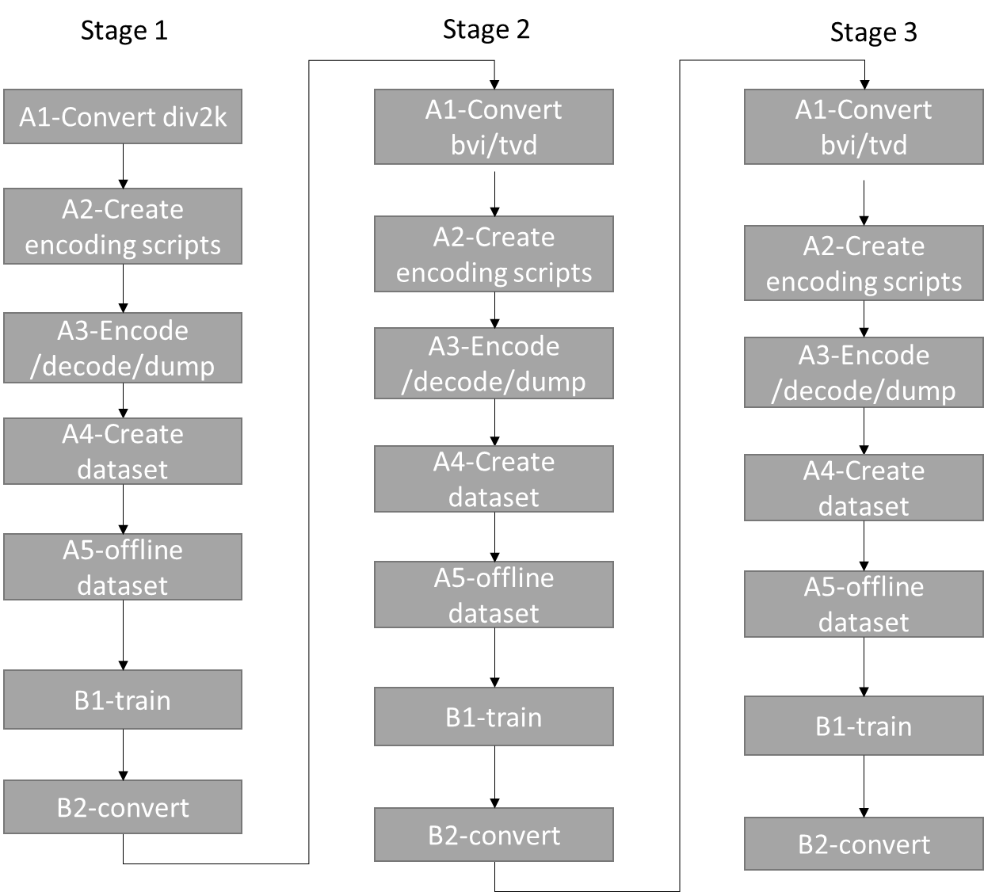
Figure 13 Training steps for HOP model creation
The figure above describes the 3 stages needed to fully train the HOP model:
- Stage I:
  - Extract a dataset of intra coded frames using VTM
  - Train HOP on the dataset: resulting model is HOP.I
- Stage II:
  - Extract a dataset of frames using VTM and HOP model from stage I
  - Train HOP on the dataset: resulting model is HOP.II – Integerized the model.
- Stage III:
  - Extract a dataset of frames using VTM and HOP model from stage II
  - Train HOP on the dataset: resulting model is HOP.III (final model)
Details for training can be found in training description document JVET-AE0191 [7].
All official models can be found in the NNVC repository at https://vcgit.hhi.fraunhofer.de/jvet-ahg-nnvc/VVCSoftware_VTM.

Training characteristics
Network Information for NN-based Video Coding Tool Testing in Training Stage
Network Information in Training Stage
Mandatory | GPU Type | GPU: Tesla-V100-SXM2-32GB/ Tesla-A100-40GB – used memory: 25GB
Mandatory | Framework: | PyTorch v1.9
Mandatory | Number of GPUs per Task | 1
Mandatory | Epoch: | Stage 1: 40, stage 2: 20 (19), stage 3: 20
Mandatory | Batch size: | 64
Mandatory | Training time: | 6-12h/epoch
Mandatory | Training data information: | DIV2K, BVI-DVC, TVD
Mandatory | Training configurations for generating compressed training data (if different to VTM CTC): | See below
 | Loss function: | L1, L2
Optional
Optional | Number of iterations | 101k/epochs
Optional | Patch size | 144$×$144
Optional | Learning rate: | 1e-4
Optional | Optimizer: | ADAM
Optional | Preprocessing: | Data augmentation (offline stage 1, online stage 2 and 3)
Optional | Other information:

Prerequisite
- Dataset to use described in Common Test Conditions document JVET-AD2016 [11]
  - Div2k, BVI, TVD
  - Use original naming, directories.
- Storage preparation:
  - Needed space can be found in the readme.md
- MD5sum:
  - MD5sum: can be found on the wiki of the repository at wiki
  - json files contains md5sum whenever possible
- Repository: https://vcgit.hhi.fraunhofer.de/jvet-ahg-nnvc/VVCSoftware_VTM
- Base for HOP training scripts inside the repository: training/training_scripts/NN_Filtering_HOP
- Preparation:
  - 1 central file to edit everything related to your configuration: paths.json
  - Other parameters are only to adapt your training strategy etc.

Training from scratch
All steps are described in readme.md.

Partial training
The training can be done only from stage 3. In this case, the int16 model from stage 2 is used to generate the dataset of stage III.
MD5sums of stage 3 datasets and encoded files can be found in https://vcgit.hhi.fraunhofer.de/jvet-ahg-nnvc/nnvc-ctc/HOP/md5
The md5sums of datasets (to be checked in the json file) are:
Dataset name | Number of patches | Md5sum
TVD | 432000 | "6468995aa583ca941af37fea2ddac20c"
TVD valid | 48000 | "0fdedc21e41496d4694a2b05dbcb7a5f"
BVI | 2157210 | "9162efd535a6c65f6bd311e405694d0a"
BVI valid | 97790 | "e7231f428e54ed461cff3628af70e241"

The md5sums of individual bitstream for each dataset can be found in the repository above to detect possible issue early.

Training Model stage I

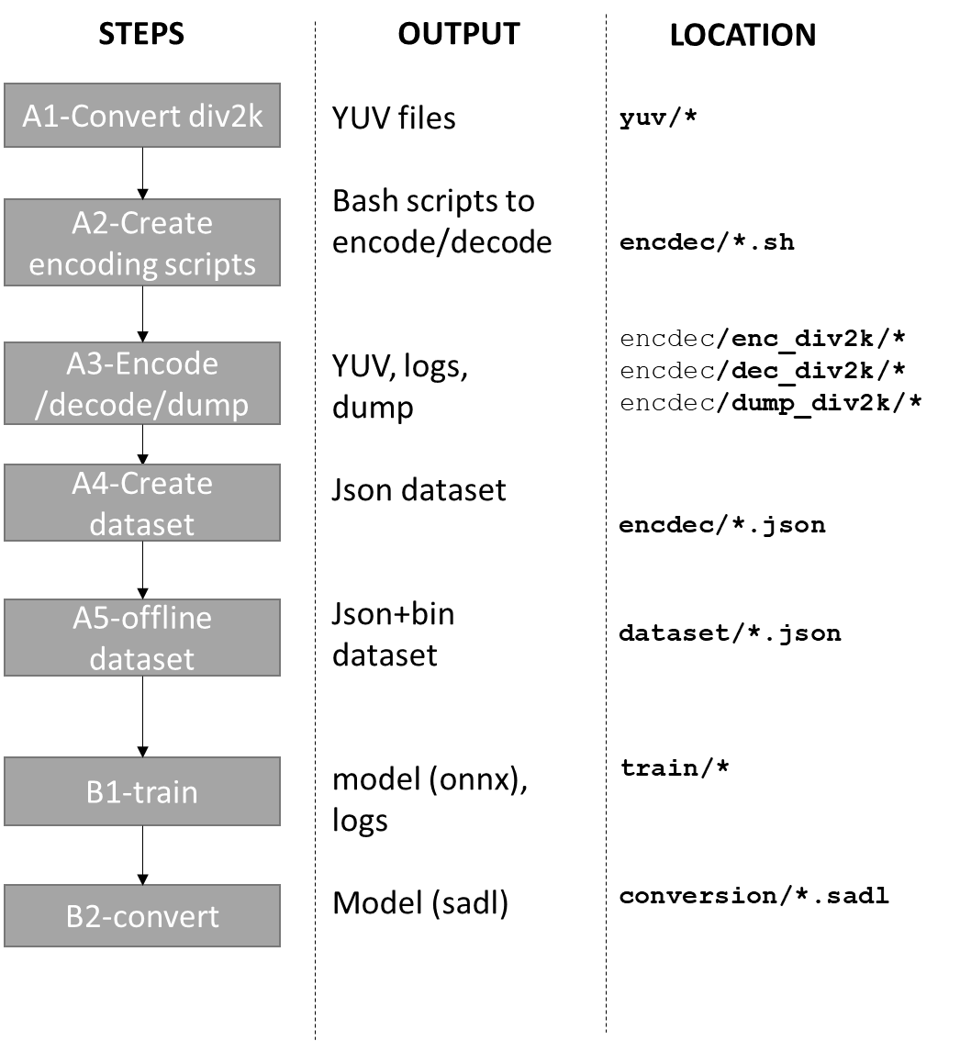

  - Data extraction for intra from vanilla VTM
    - encoder turns on md5sum, just NNVC-5.0 all NNVC tools disabled, encoder_intra_vtm.cfg, just first frame
    - QPs = 22,27,32,37,42 + 19,24,29,34,39
    - DIV2K (4:4:4 RGB YUV420 10 bits, version ffmpeg to be specified,
    - Rotation, flipping, down-sampling (list of output + md5sum)
    - Reconstruction is extracted before de-block
    - All CTUs are extracted (except those on the border)
  - Model stage I training from scratch for Intra data:
    - Random initialization
    - Use all CTUs
    - Luma/chroma balance: 6:1:1
    - Learning Rate: 0.0001, batch size: 64, scheduler: 0.1 decay at epoch 30 and 34
    - Norm switch: L1 up to epoch 37, then L2
    - 40 epochs total

Training Model stage II
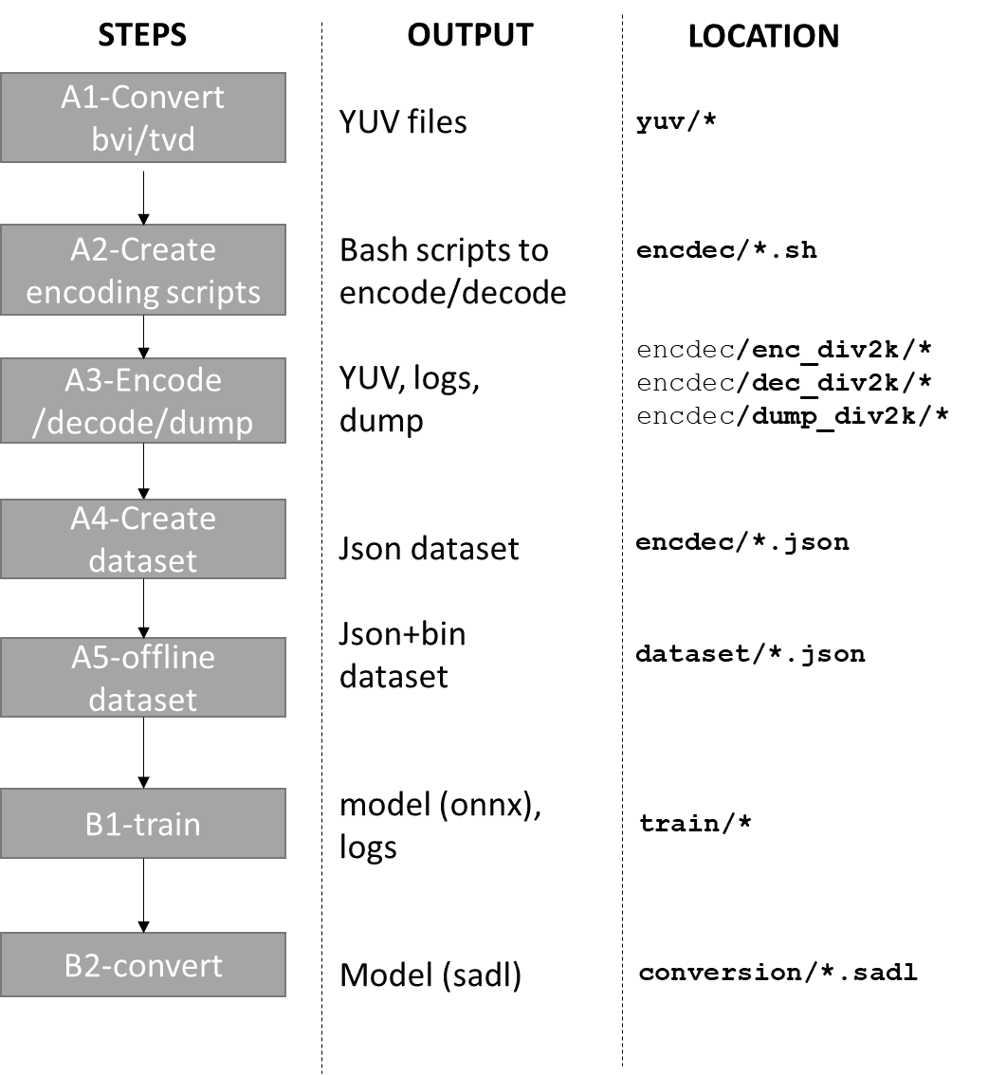
- Data extraction with model#1:
    - encoder turns on md5sum, NNVC-5.0 + Model stage I for I-frames only, encoder_ra_model1.cfg, 65 frames (last is duplicated), Intra Period 64, GOP=32.
    - QPs = 22,27,32,37,42
    - List of sequences
      - TVD: 65 frames, 20 sequences
      - BVI (YUV420), 620 sequences
      - All reconstructed CTU are extracted before de-block for a subset of frames + DVI2K training data as in training stage I
- Model stage II training with extracted data:
    - Random initialization
    - Use all CTUs
    - Rotation and flipping on the fly
    - Luma/chroma balance: 6:1:1
    - Learning Rate: 0.0001, batch size: 64, scheduler: 0.1 decay at epoch 15 and 17
    - Norm switch: L1 up to epoch 18, then L2
    - 19 epochs total

Training stage III
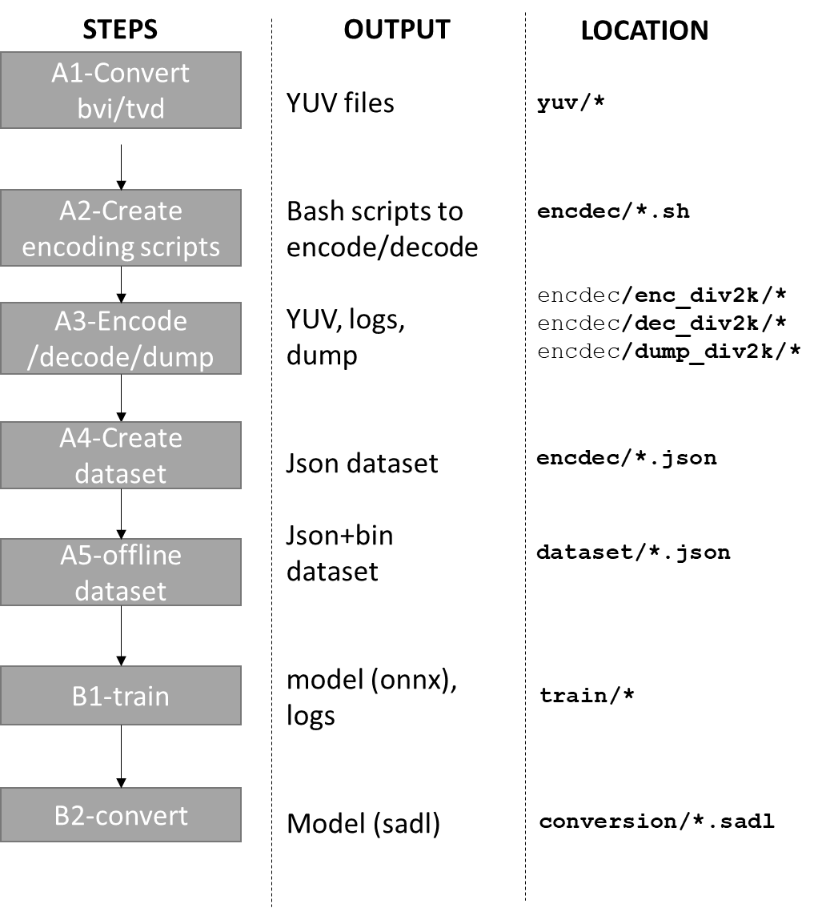
- Data extraction with Model stage II:
    - encoder turns on md5sum, NNVC-5.0 + Model stage II (both Intra and Inter frames), encoder_ra_vtm.cfg + model stage 2, 65 frames (last is duplicated), Intra Period 64, GOP=32.
    - QPs = 22,27,32,37,42
    - Same sequences and frames as for stage 2
- Model Stage III training with extracted data:
    - Random initialization
    - Use all CTUs
    - Rotation and flipping (on the fly augmentation)
    - Luma/chroma balance: 12:1:1
    - Learning Rate: 0.0002, batch size:32, scheduler: 0.1 decay at epoch 15 and 17, 18
    - Norm switch: L1 up to epoch 18, then L2
    - 20 epochs total

NNIP - Neural network-based intra prediction
The workflow of the iterative training of the neural networks belonging to the neural network-based intra prediction mode is displayed in Figure 9.
- At cycle 0, VTM-11-NNVC without the neural network-based intra prediction mode and without any Filter-Set extracts the data for training the neural networks. Then, the 7 neural networks are trained, initializing their parameters randomly.
- At cycle 1, VTM-11-NNVC with the neural network-based intra prediction mode using the parameters trained at cycle 0 and without any Filter-Set extracts the data for training the neural networks. Then, the 7 neural networks are trained, initializing their parameters from their state at the end of cycle 0.
- At cycle 2, VTM-11-NNVC with the neural network-based intra prediction mode using the parameters trained at cycle 1 and without any Filter-Set extracts the data for training the neural networks. Then, the 7 neural networks are trained, initializing their parameters from their state at the end of cycle 1. Then, using the same training data, the trainings of these 7 neural networks are resumed, introducing this time a sparsity constraint on their weights.
- At cycle 3, VTM-11-NNVC with the neural network-based intra prediction mode using the parameters trained at cycle 2 and without any Filter-Set extracts the data for training the neural networks. Then, the transform prediction part of each of the 7 neural networks is trained, initializing their parameters from their state at the end of cycle 2.

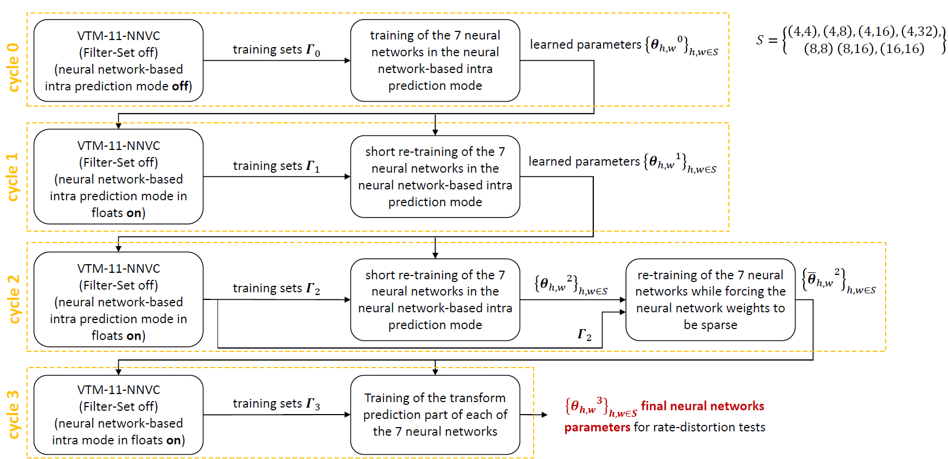
Figure 12: workflow of the iterative of the neural networks belonging to the neural network-based intra prediction mode.

Content-adaptive neural network post-filter
The training of the content-adaptive neural network post-filter consists of two stages as follows,
Stage 1: generation of four base models.
Stage 2: over-fitting of one base model for each test sequence and QP point, followed by weight-update coding with NNC.

Decomposed content-adaptive neural network loop-filter
Multipliers are trained using the decomposed representation, following the same training pipeline as the original content-adaptive models.

Content-adaptive neural network loop-filter
The base model is using LOP2 training procedure. Content adaptation is described in model description.

NNSR - Neural network-based super resolution
The training of neural network-based super resolution is straightforward. The training can be done only from stage 3. The NNVC software with RPR enabled is used to generate training datasets.

DRF – Deep Reference Frame training procedure
The deep reference frame tool only involves a single-stage training process. Vimeo-90k triplet dataset is used as training dataset. In each triplet, the first and third frames serve as inputs, while the second frame is used as the ground truth. Considering the compression artifacts of reconstructed frames, the two input frames in one triplet are compressed using NNVC SW (with NN-tools on) under AI configuration. The QP for each triplet is randomly chosen from 22 to 42 with a fixed distance of 5. For data augmentation, two input frames are randomly cropped into 256 × 256 patches, and their order is randomly swapped. Before training, the pre-trained weights of the IFRNet small network are loaded. The learning rate for IFRNet small is set to 3.5e-5, while the remaining parts of the network are trained with a learning rate of 3.5e-4. The L1 loss function is used and optimized with the Adam optimizer. The batch size is set to 48, and the network is trained for 200 epochs.
The IFRNet small network employs the pre-trained weights of “IFRNet: Intermediate Feature Refine Network for Efficient Frame Interpolation (CVPR 2022)”, using the model file IFRNet_S_Vimeo90K.pth obtained from the official GitHub repository https://github.com/ltkong218/IFRNet.

References
- B. Bross, J. Chen, S. Liu, and Y.-K. Wang "Versatile Video Coding Editorial Refinements on Draft 10," document JVET-T2001, 20th JVET meeting: by teleconference, 7 October – 16 October 2020.
- J. Chen, Y. Ye, S. Kim "Algorithm description for Versatile Video Coding and Test Model 11 (VTM 11) ," document JVET-T2002, 20th JVET meeting, by teleconference, 7 October - 16 October 2020.
- https://vcgit.hhi.fraunhofer.de/jvet-ahg-nnvc/sadl.
- https://vcgit.hhi.fraunhofer.de/jvet/VVCSoftware_VTM/-/tree/VTM-11.0.
- E. Alshina, F. Galpin, “BoG report on NN-filter design unification”, document JVET-AD0380, 30th Meeting, Antalya, TR, 21–28 April 2023
- E. Alshina, F. Galpin, “AhG14 & AHG11: Report on AhG teleconference on high operation point (HOP) unified filter training “, JVET-AE0042, 31st Meeting, Geneva, CH, 11–19 July 2023
- F. Galpin, S. Eadie, D. Rusanovskyy, Y. Li, Y. Li, J. Li, L. Wang, R. Chang, Z. Xie, E. Alshina “AhG11: EE1-0 High Operation Point model”, JVET-AE0191, 31st Meeting, Geneva, CH, 11–19 July 2023
- F. Galpin, S. Eadie, D. Rusanovskyy, Y. Li, Y. Li, J. Li, L. Wang, R. Chang, Z. Xie, E. , “AhG11: HOP training process and models”, JVET-AE0289, 31st Meeting, Geneva, CH, 11–19 July 2023
- D. Rusanovskyy, F.Galpin “AhG11: Performance of the NNVC HOP with quantized Stage II model”, JVET-AE0291, 31st Meeting, Geneva, CH, 11–19 July 2023
- F. Galpin, D. Rusanovskyy, Y. Li, L. Wang, Z. Xie, Y.Li, R. Chang, J. Li, E. Alshina “AhG11: HOP full results”, JVET-AF0041, 32nd Meeting, Hannover, DE, 13–20 October 2023
- E. Alshina, R.-L. Liao, S. Liu, A. Segall, “Common test conditions and evaluation procedures for neural network-based video coding technology”, JVET-AD2016, 30th Meeting, Antalya, TR, 21–28 April 2023

