    Joint Video Experts Team (JVET)  of ITU-T SG21 WP3/21 and ISO/IEC JTC 1/SC 29  39th Meeting, Daejeon, KR, 26 June – 4 July 2025 | Document: JVET-AM0298-v1

Title: | Ultra-low latency demo: Resource-constrained VVC and HEVC software encoding up to 4K
Status: | Input document to JVET
Purpose: | Information
Author(s) or  Contact(s): | Mauricio Alvarez Mesa  Benjamin Bross  Chi Ching Chi | Email: | mauricio.alvarez.mesa@hhi.fraunhofer.de  benjamin.bross@hhi.fraunhofer.de  chi@spin-digital.com
Source: | Fraunhofer HHI, Spin Digital Labs GmbH
_____________________________

Abstract
This document describes a demo setup for ultra-low latency use cases based on HEVC and VVC software encoding. Two synchronised Spin Digital Labs software encoders (spin enc live) are encoding a webcam video live stream at low bit rates on a Mini-PC with a 16 core AMD Ryzen 9 9950x. One spin enc live instance encodes HEVC and the other one encodes VVC video, and both are sent as two synchronised streams in an MPEG-2 transport stream. The input video can be changed from 1080p60 to 2160p30, and each stream can be set to various low bitrates from 200 to 500 kbit/s constant bit rate (CBR). Both encoders are restricted to use 7 cores (14 threads) exclusively. It is shown that the VVC video quality is clearly better than the HEVC video quality for the same low bit rate when both encoders are given the same amount of computing resources. In addition, the use of Gradual Decoder Refresh (GDR) in both HEVC and VVC significantly improves the video quality by allowing the higher rate intra blocks to spread across multiple frames. The demo highlights the usability of VVC for ultra-low latency use cases in resource constraint environments.

Ultra-Low Latency Use Cases
In ultra-low latency applications, the end-to-end delay, also referred to as glass-to-glass latency, cannot be larger than tens or hundreds of milliseconds. Typical ultra-low latency use cases include:
- Real-time communication and video conferencing.
- Remote monitoring control: for example, remote monitoring and control of Unmanned Aerial Vehicles (UAVs) with low bitrate rate and constrained channel bandwidth (e.g. satellite).
- Interactive services: for example, cloud gaming and remote desktop.
- Broadcast contribution: sending (contributing) high quality video from a remote location to a central TV studio, typically at high bit rates.
In this demo we present an optimized VVC and HEVC software encoder and decoder for ultra-low latency applications. The encoder includes a new operation mode for ultra-low latency and includes all the required features for the above-mentioned use cases including state-the-art rate control, HRD buffer model, and gradual decoder intra refresh (GDR).
In some of the target use cases the encoder has to run on resource constrained platforms: small form factor and low power. The encoder has been highly optimized for parallel processing on recent CPU architectures and is able to operate in real-time in small form factor Mini PCs up to 4K resolution.

Demo Setup
The above-described use-cases can be addressed by the setup used for this demo and illustrated in Figure 1. A compact camera is connected to a Mini-PC for encoding and packaging. The video is packaged into an MPEG-2 transport stream (TS) with CBR to be able to fit into bandwidth-restricted links.
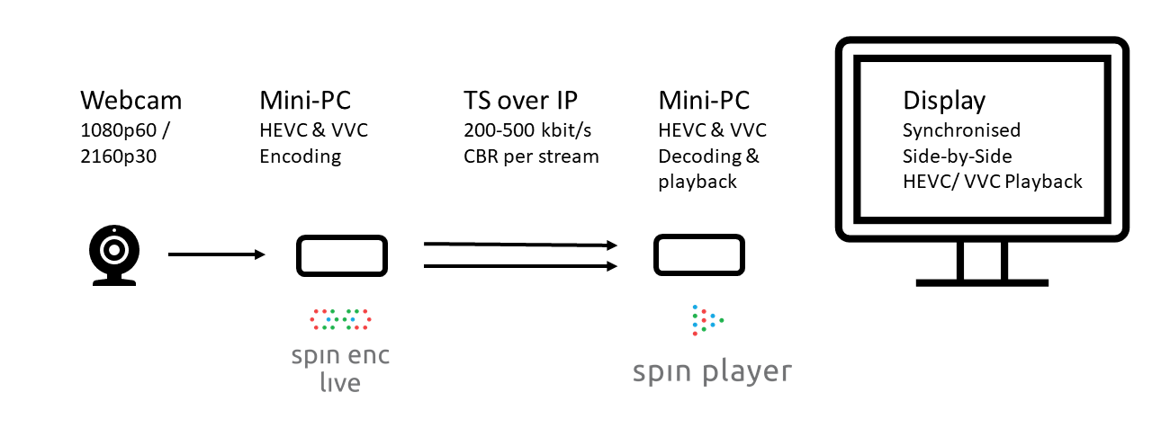
Figure 1 : System overview of low-latency encoding, streaming and playback
Table 1 describes the system specifications of the encoder platform. The encoder runs on an AMD CPU with 16 cores (32 threads with SMT enabled) and AVX-512 instructions. This system is used for encoding 2 4K-UHD streams in real-time: one in HEVC and another one in VVC. The source is a webcam producing live video in 4K (3840x2160) resolution at 30 fps (or 1920x1080 at 60 fps), and 10-bit SDR. The content properties are described in Table 3. The encoder is Spin Digital’s live HEVC and VVC encoder (spin enc live) [1] with new optimizations for ultra-low latency.
The encoding settings are described in Table 4. The HEVC and VVC encoders are configured with very similar settings: CBR rate control, low-latency configuration (GOP-1, 1 frame in flight, 1 frame lookahead), HRD buffer 1s, and gradual intra refresh (GDR). The CPU cores in the encoder platform are assigned evenly to the encoders: 7 cores (14 threads) to HEVC and 7 cores (14 threads) to VVC; and 1 core (2 threads) are reserved for other tasks including camera capture, streaming, etc.
The encoder sends the 2 live streams using MPEG2-TS with RTP on a local network. The media player receives the MPEG2-TS RTP signal, decodes the HEVC and VVC streams, and renders them using the integrated GPU. The media player is Spin Digital’s spin player [3] with new optimizations for low-latency decoding and using a low-latency render option.

Component | Specs
CPU | AMD Ryzen 9 9950x: 16 cores + SMT (32 threads) + AVX 512
DRAM | 48 GB - Dual channel DDR5 5200
OS | Windows 11
Webcam | OBSBOT Meet 2 4K
HEVC and VVC encoders | Spin Enc Live. Based on SDK 7.0.2-dev-354
PC | Minipc: Minisforum MS-A1
Table 1: System specs Encoder

Component | Specs
CPU | AMD Ryzen 9 7940HS  - 8 cores + SMT (16 threads)  - AVX 512
GPU | AMD Radeon 780M (Integrated graphics)
DRAM | 64 GB - Dual channel DDR5 5200
OS | Windows 11
HEVC and VVC decoders / player | Spin Player.  Based on SDK 7.0.2-dev-354
PC | Minipc
Table 2: System specs Player

Settings | 4K | FHD
Resolution | 3840x2160 | 1920x1080
Frame rate | 30 Hz | 60 Hz
Chroma sampling and bitdepth | 4:2:0, 10-bit | 4:2:0, 10-bit
Transfer function, color gamut | BT.709, SDR | BT.709, SDR
Video format from webcam | M-JPEG | Uncompressed
Table 3: Input content properties from the Webcam

Settings | HEVC | VVC
Codecs | HEVC Main 10 | VVC Main 10
Rate control | CBR | CBR
Bitrate | 500 Kbit/s | 500 Kbit/s
Coding structure | GOP 1 (Low-delay P) | GOP 1 (Low-delay B)
Lookahead frames | 1 | 1
Frames in flight | 1 | 1
Intra period | 60 frames | 60 frames
Gradual refresh (GDR) period | 30 frames | 30 frames
HRD buffer | 1000 ms | 1000 ms
Preset | balanced | balanced
CPU cores (threads) | 7 CPU cores (14 threads) | 7 CPU cores (14 threads)
Streaming | MPEG2-TS - RTP | MPEG2-TS - RTP
Table 4: Encoder settings

Latency results
When performing the encoding and decoding according to the settings described in the previous section for the 4Kp30 resolution, it was possible to obtain end-to-end ultra-low-latency. The latency results are described in the table below.

Latency definition | Latency measurement
End-to-end | 160 ms
Encoder system  - Capture  - Filter  - Encoding  - Streaming | 57 ms  36 ms  3 ms  18 ms  0 ms
Decoder system  - Receive  - decode | 12.0 ms  0.0 ms  8.1 ms
Table 5: Latency results
Figure 2 shows the setup used for measuring latency. The webcam points to a stopwatch, with a preview of the webcam output is presented on the screen. On the decoder side the output of the HEVC and VVC decoders are presented side-by-side. The end-to-end latency can be measured by computing the difference from the original stopwatch to the output of the decoder.
The glass-to-glass latency is ~160 ms. It can be noted that a significant part of the end-to-end latency is due to the webcam capture and its internal processing before the encoding process itself starts.
The encoding system consists of four main parts:
- input capture,
- pre-processing filter (pixel format conversion)
- encoding, and
- streaming.
The decoding system consists of two main stages:
- receive and
- decoding.
The player also includes a rendering stage which is not shown as the application cannot measure the entire rendering process which is under control of the OS and the GPU driver.
The encoder and decoder software have been extended with tracing capabilities to measure these internal latencies, which are reported in Table 5. The encoding and decoding latency together amounts to just 26 ms: 18 ms encoding and 8 ms decoding.
These results demonstrate that VVC is ready for the most demanding ultra-low latency applications: very low latency, low bitrate and constraint processing platforms.
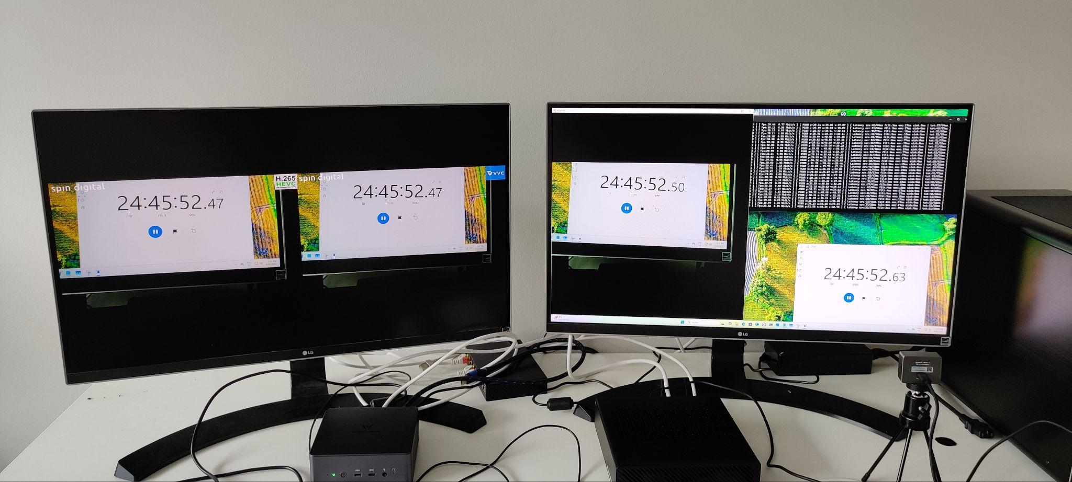
Figure 2: Measurements of end-to-end latency: the webcam is pointing to a stopwatch on the screen. On the right screen we have on the right side the stopwatch and on the left side the preview of the webcam. On the left screen there is the output of the two decoders: the leftmost side is HEVC and the right side is VVC. Notice that most of the latency, 130 ms, is due to the webcam capture. The encoding and decoding latency is around 30ms.

Quality results
The following screenshots compare the visual quality of the HEVC (left side) and VVC (right side) encodings under different conditions of object and camera movement and occlusion. The tests are made with the 2160p30 configuration.
The VVC encoder results in higher visual quality with significantly less coding artifacts and overall better perceptual quality given the low bitrates
The quality benefits of VVC compared to HEVC are significant as both encoders, as mentioned in the encoding settings, are assigned the same compute resources.

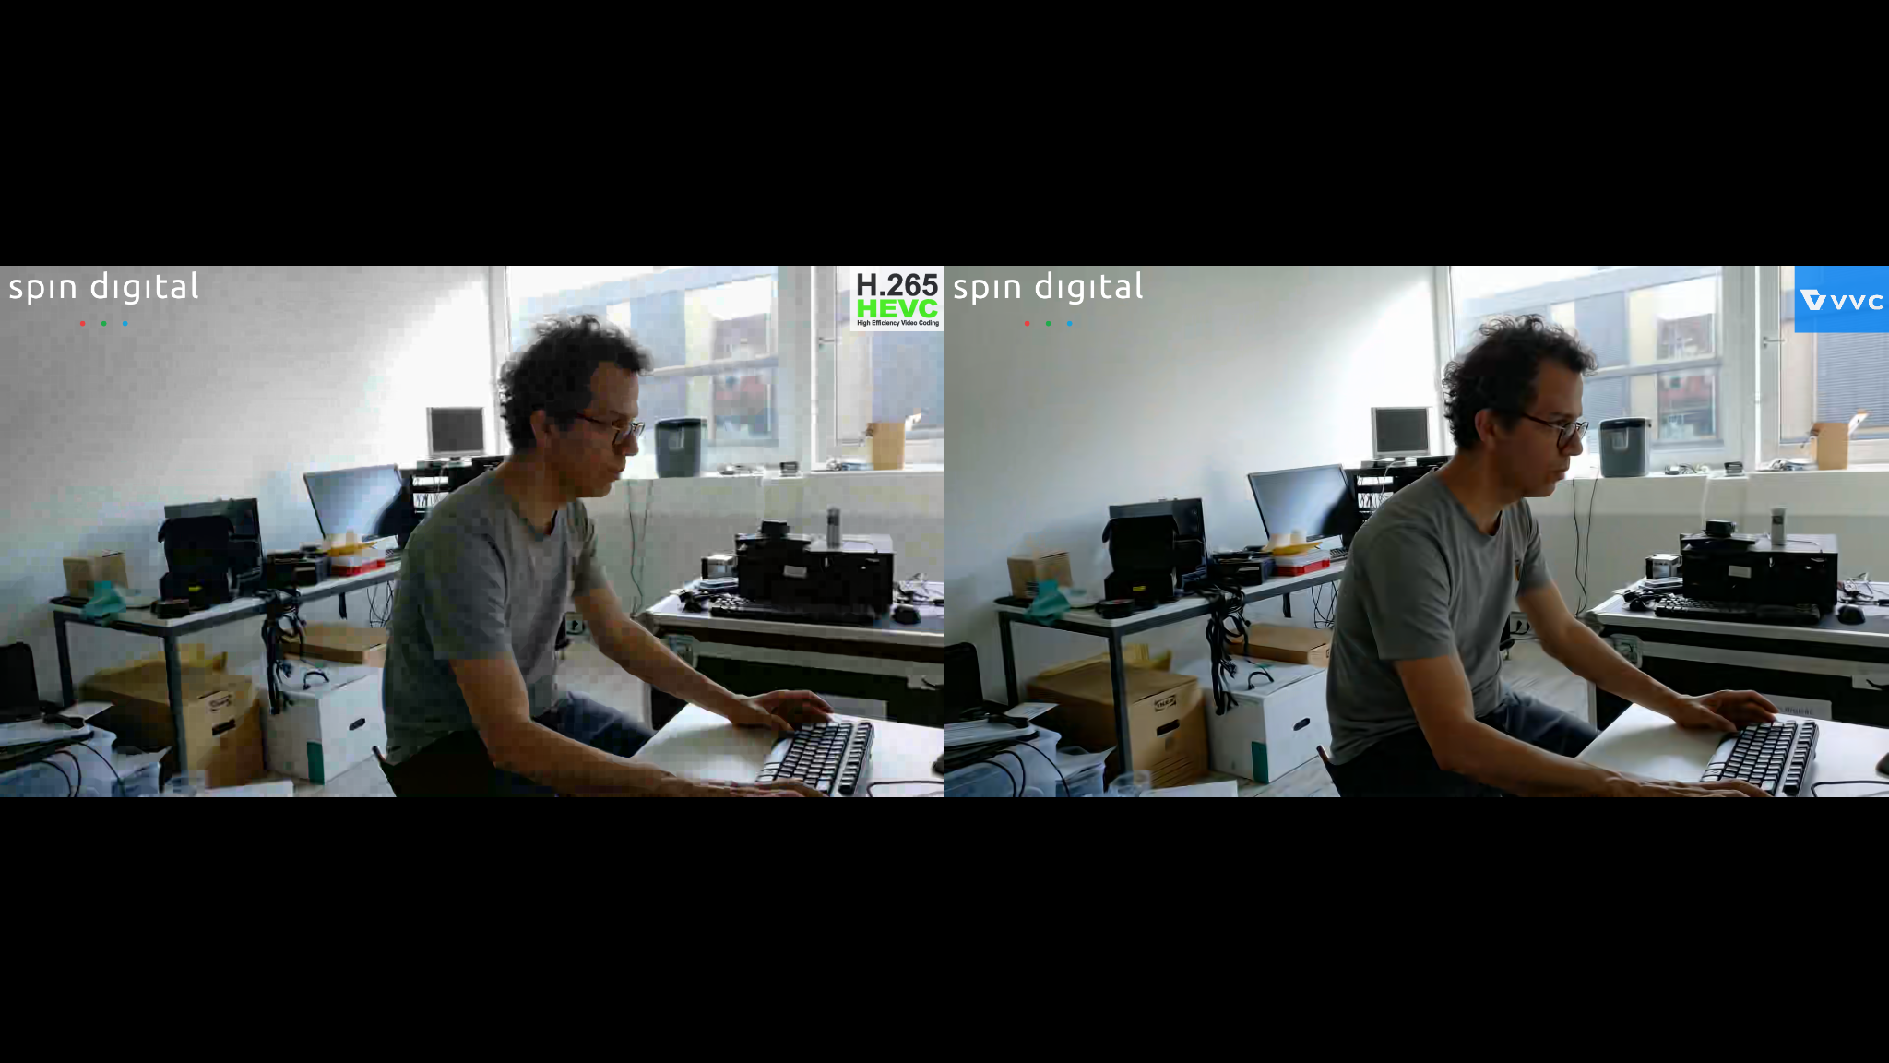
Figure 3a: HEVC (left) vs VVC (right) for 4Kp30 encoding at 500 Kbps. Static scene

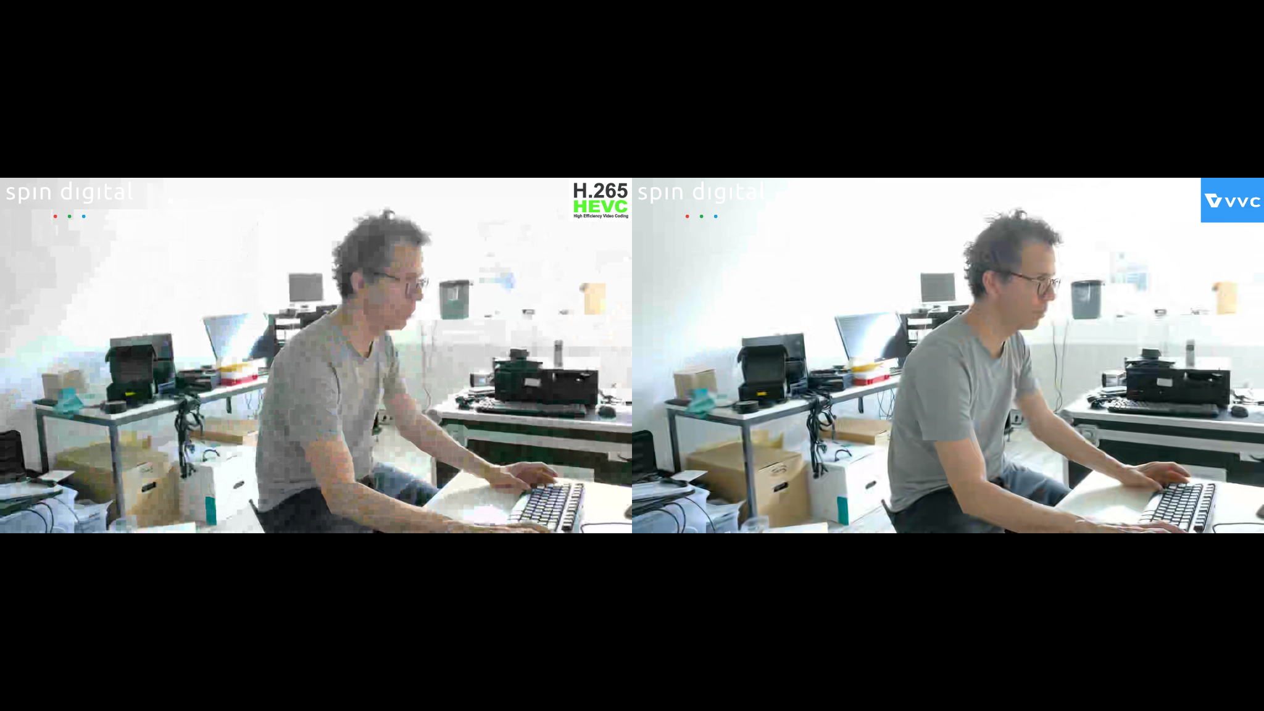
Figure 3b: HEVC (left) vs VVC (right) for 4Kp30 encoding at 500 Kbps. Camera movement. Notice the significant image quality degradation in HEVC.

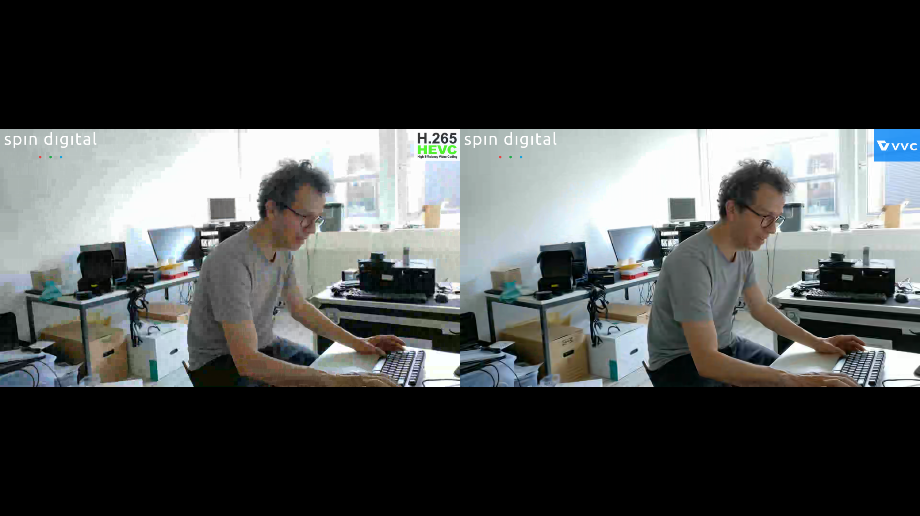
Figure 3c: HEVC (left) vs VVC (right) for 4Kp30 encoding at 500 Kbps

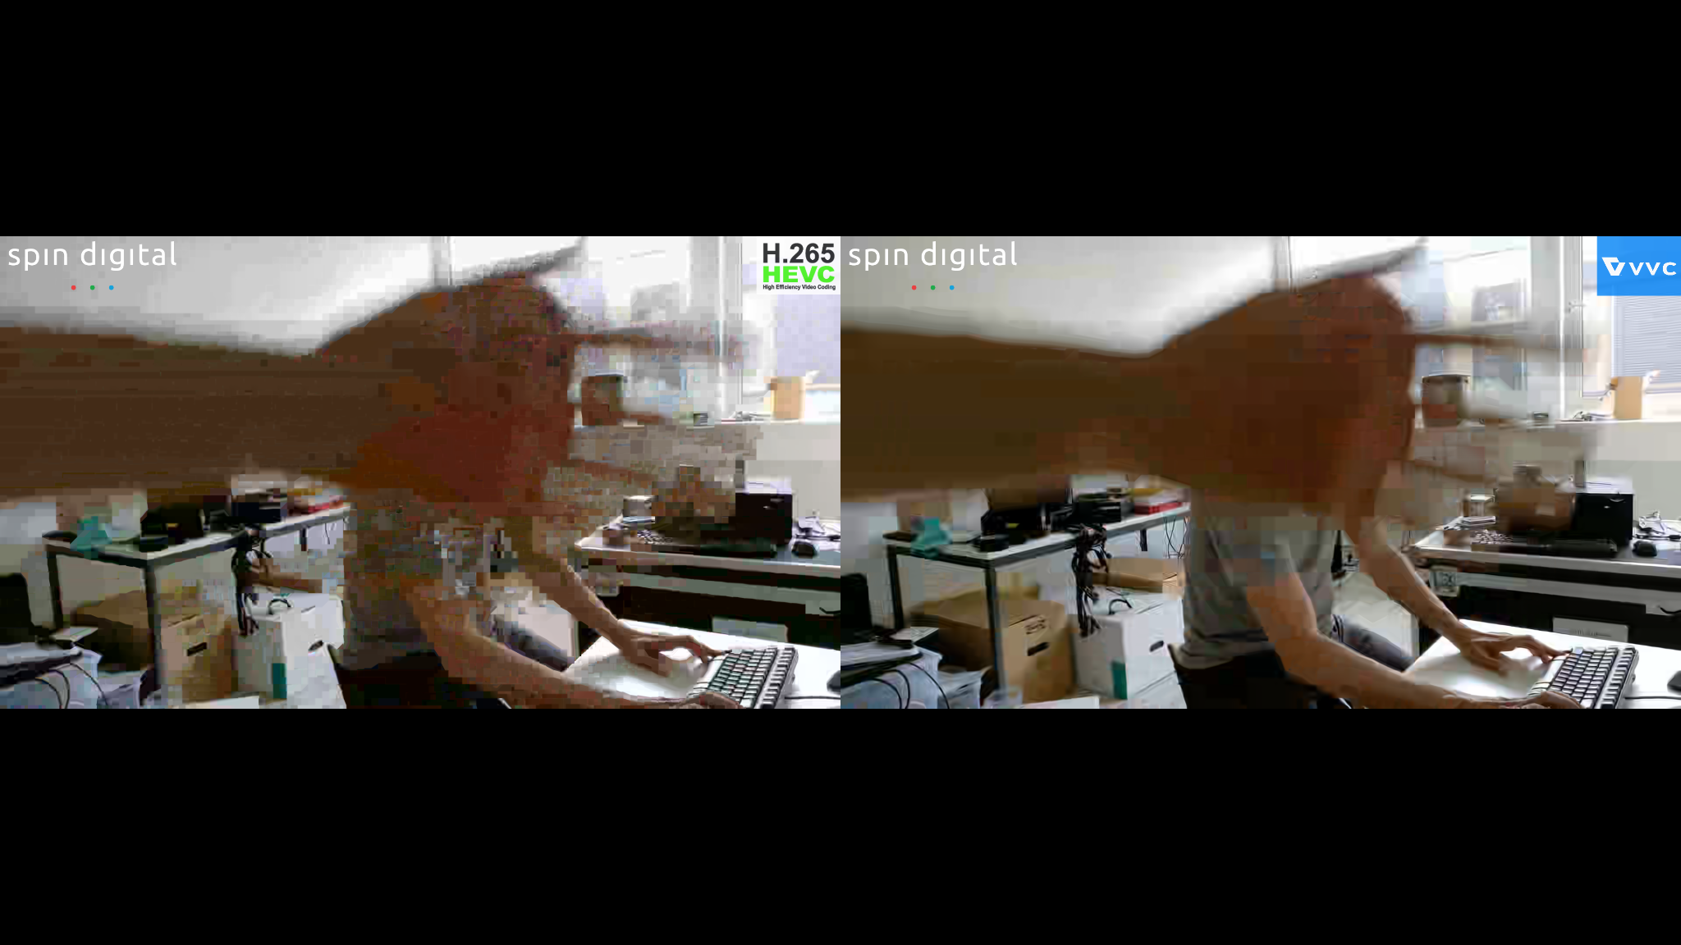
Figure 3d: HEVC (left) vs VVC (right) for 4Kp30 encoding at 500 Kbps. Camera occlusion. Notice the significant image quality degradation in HEVC.

References
[1] S. Sanz-Rodriguez, M. Alvarez-Mesa, C. C. Chi, “A VVC/H.266 real-time software encoder for UHD live applications” , JVET-AB0043, ISO/IEC JTC 1/SC 29 and ITU-T SG16 WP 3 document, Mainz, 20-28 October 2022.
[2] Spin Digital, “HEVC and VVC Real-time Encoder (Spin Enc Live).” Spin Digital Products, 2025. [Online]. Available:. https://spin-digital.com/products/spin_enc_live/
[3] Spin Digital, “Spin Digital Media Player (Spin Player VVC)” Spin Digital Products, 2025. [Online]. Available:. https://spin-digital.com/products/spin_player_vvc/

Patent rights declaration(s)
Fraunhofer HHI and Spin Digital Labs GmbH may have current or pending patent rights relating to the technology described in this contribution and, conditioned on reciprocity, is prepared to grant licenses under reasonable and non-discriminatory terms as necessary for implementation of the resulting ITU-T Recommendation | ISO/IEC International Standard (per box 2 of the ITU-T/ITU-R/ISO/IEC patent statement and licensing declaration form).

