    Joint Video Experts Team (JVET)  of ITU-T SG21 WP3/21 and ISO/IEC JTC 1/SC 29  39th Meeting, Daejeon, KR, 26 June – 4 July 2025 | Document: JVET-AM0287-v1

Title: | [AHG17] On HDR coding and metrics
Status: | Input document to JVET
Purpose: | Proposal
Author(s) or  Contact(s): | D. Rusanovskyy (Nokia), E. Francois (InterDigital) | Tel:  Email: | dmytro.rusanovskyy@nokia.com  edouard.francois@interdigital.com
Source: | Interdigital, Nokia
_____________________________

Abstract
This contribution proposes updates of the CfE document related to HDR content testing. The main proposal is to split HDR PQ and HDR HLG into two different categories, considering that the transfer function is a differentiator at least as important as the picture resolution. Suggestions to clarify in the CfE document the information on VTM/ECM compilation process and configuration needed for deriving the HDR metrics are also proposed. It is also suggested to incorporate the HDR metrics description from Annex C of the VTM/HM HDR CTC document JVET-AC2011, or at least to refer to its Annex. And finally, an analysis of the HDR metrics over a number of test sequences and CfE coding conditions is presented in this document to discuss whether PSNRL100 and DeltaE100 metrics may be considered redundant and be removed from the requirements on responses to the CfE.

Introduction
To assess evidence on improved compression beyond VVC for HDR video content, Draft CfE, JVET-AL2026, defined two test categories: HDR RA 4K (HRU), HDR RA Cropped 8K (HRC).
Sequences of HRU and HRC categories have picture size 3840×2160, chroma format 4:2:0 YCbCr, bit depth 10bit, and comprise a mix of sequences in PQ [BT.2100/PQ] and HLG [BT.2100/HLG] representation, as shown in Table 1. Sequences of HRC category have been cropped from 8K resolution to a picture size of 3840×2160.

Table 1: Test sequences and formats comprising test categories HRU and HRC of Draft CfE [].
 | Sequence ID | Sequence name | Transfer fct.
HRU | HRU1 | AMS06 | HLG10
HRU | HRU2 | MeridianHDR2 | P3 PQ 4000nits
HRU | HRU3 | NeptuneFountain3R1 | HDR10 PQ
HRU | HRU4 | SparksWelding | HDR10 PQ 1000nits
HRC | HRC1 | ChandelierCropBR | HDR10 PQ
HRC | HRC2 | FashionLadyCrop1 | HDR10 PQ
HRC | HRC3 | WaterfallForest | HLG10
HRC | HRC4 | WomenFootball | HLG10

Whereas defining categories as per spatial resolution have been commonly used in MPEG CfE and CfP earlier, mixing the test content of different representations, such as HLG and PQ, may be challenging for aggregation of results of evaluation in subjective and objective metrics.
For the former evaluation, a large difference in peak brightness (up-to 4000nits) in PQ sequences comparing to HLG content may result in a significant impact introduced by tone mapping techniques being employed by the test equipment. And for the later, different objective metrics have been defined in the draft CfE document [2] to assess visual quality: PSNR for HLG content and mix of wPSNR, DeltaE100 and PSNRL100 for PQ content. Aggregating results over different quality metrics within a test category and decision making may be challenging.

Additionally, for coding of HDR content with VTM and ECM and HDR video quality evaluation, clauses 2.5.2 and 4.4 of the Draft CfE [2] specify that Common Test Conditions for HDR/WCG JVET-AC2011 [1] to be followed. However, HDR specific compile instructions and configuration parameters for ECM are not defined in that document.

And finally, clause 4.4 of the Draft CfE [2] specifies that respondents to CfE are expected to calculate and report for content with BT.2100 PQ, the HDR objective metrics, in addition to the conventional PSNR metric. These metrics are weighted PSNR (wPSNR), deltaE100 and PSNRL100 with definitions and reference to software implementation as well as usage instruction being provided in the Common Test Conditions for HDR/WCG [1].
There are evidences, additionally presented in this document, that for Y’CbCr coding applications, a significant correlation may be established between PSNRL100 and wPSNR for Y component, and between DeltaE100 and wPSNR for Cb and Cr components (see data in annex of this contribution). Therefore, a question of whether more complex metrics PSNRL100 and DeltaE100 do provide an additional value, comparing to more straightforward in computation wPSNR. In this proposal, we attempt to address these questions.

Proposal
Separate categorization for BT.2100 PQ and HLG:
To simplify aggregation of results over coded content reported with different objective metrics, as for BT.2100 PQ and HLG representations, as well as to mitigate the impact of different tone mappings utilized for displaying content in these representations it is proposed to categorize tested HDR content per its transfer characteristics, instead of original resolution.
It is also suggested that impact on viewing of resolution specific characteristics of the coding technology may be not as diverse as use of different transfer characteristics and it may be asserted from other test categories of the CfE. Example of candidate categorization is shown in Table below.

Table 1: Test sequences and formats comprising test categories HRU and HRC of Draft CfE [2].
 | Sequence ID | Sequence name | Transfer fct.
PQ | HRU2 | MeridianHDR2 | P3 PQ 4000nits
PQ | HRU3 | NeptuneFountain3R1 | HDR10 PQ
PQ | HRU4 | SparksWelding | HDR10 PQ 1000nits
PQ | HRC1 | ChandelierCropBR | HDR10 PQ
PQ | HRC2 | FashionLadyCrop1 | HDR10 PQ
HLG | HRU1 | AMS06 | HLG10
HLG | HRC3 | WaterfallForest | HLG10
HLG | HRC4 | WomenFootball | HLG10

Instructions to configure ECM for coding of HDR content:
It is proposed to incorporate in CfE document instruction on compilation of ECM with HDR extension and encoder run-time configuration. Suggested text is provided in italic below:

When using the ECM software, the software shall be compiled with modified CMakeLists.txt, EXTENSION_HDRTOOLS shall be set ON.

set( EXTENSION_HDRTOOLS ON CACHE BOOL "If EXTENSION_HDRTOOLS is on, HDRLib will be added" )

To run ECM encoder, the class-specific ECM configuration file, e.g. classA_randomaccess.cfg, is placed prior to the HDR specific configuration file, e.g. per-class/classH2.cfg in order to specify correct HDR parameters.

To enable computation of HDR metrics, ECM encoder parameter CalculateHdrMetrics is set equal to 1.

On use of HDR metrics:
The procedure to calculate HDR metrics (wPSNR, PSNRL100 and DeltaE100) is specified in Annex C of the Common Test Conditions for HDR/WCG [1]. To further simplify interpretation of the CfE document, this information may also be included in the annex of the CfE document.

It is also proposed to assess redundancy of the PSNRL100 and/or DeltaE100 in addition to wPSNR from the results of visual quality assessment conducted during CfE evaluation or from the analysis provided in the Annex of this document. BDR-results based on CTCs and CfE HDR PQ content are provided in Annex of this document to provide some inputs about this proposal.

Reference
[1] VTM and HM common test conditions and evaluation procedures for HDR/WCG video, JVET-AC2021.
[2] Draft Joint Call for Evidence on video compression with capability beyond VVC, JVET-AL2026.

Patent rights declarations
Nokia does not have any current or pending patent rights relating to the technology described in this contribution.

InterDigital does not have any current or pending patent rights relating to the technology described in this contribution.

Annex – BDR results based on CTCs and CfE HDR PQ content
This annex provides some example tables reporting the HDR metrics on various test conditions and test content.

CTCs VTM23.10-ECM16.1
 | DE100 | PSNRL100 | wPsnrY | wPsnrU | wPsnrV
Market | -33.05% | -18.66% | -18.69% | -39.55% | -51.28%
SunRise | -42.69% | -16.04% | -15.15% | -40.30% | -45.82%
ShowGirl2 | -41.60% | -21.12% | -20.83% | -56.31% | -58.38%
BalloonFestival | -33.03% | -21.87% | -19.72% | -38.01% | -37.97%
Hurdles | -47.41% | -24.15% | -23.71% | -50.32% | -50.12%
Starting | -35.07% | -21.60% | -20.68% | -30.95% | -34.81%
Cosmos1 | -34.03% | -16.65% | -16.21% | -53.47% | -75.53%

CfE VTM23.9-ECM16.1
 | DE100 | PSNRL | wPSNRY | wPSNRU | wPSNRV
Meridian HDR2 | -47.60% | -27.52% | -26.70% | -62.18% | -69.90%
NeptuneFountain3R1 | -50.56% | -24.83% | -19.16% | -70.58% | -81.69%
SparksWelding | -35.86% | -22.30% | -18.56% | -42.85% | -43.51%

CfE VTM23.9-ECM16.1 5x
 | DE100 | PSNRL | wPSNRY | wPSNRU | wPSNRV
Meridian HDR2 | -46.38% | -26.10% | -25.28% | -60.70% | -69.08%
NeptuneFountain3R1 | -49.07% | -23.15% | -17.10% | -68.65% | -81.10%
SparksWelding | -32.72% | -20.11% | -16.16% | -38.73% | -39.96%

CfE VTM23.9-VTM23.9 cfg3
 | DE100 | PSNRL | wPSNRY | wPSNRU | wPSNRV
Meridian HDR2 | 32.61% | 20.60% | 20.25% | 33.06% | 52.07%
NeptuneFountain3R1 | 25.47% | 19.87% | 14.19% | 33.60% | 56.50%
SparksWelding | 17.25% | 10.52% | 11.35% | 27.53% | 26.75%
ChandelierPQ | 11.82% | 8.97% | 9.09% | 13.45% | 20.20%
FashionLady_crop1 | 29.55% | 25.24% | 24.15% | 43.06% | 40.64%

CfE VTM23.9-VTM23.9 HP
 | DE100 | PSNRL | wPSNRY | wPSNRU | wPSNRV
Meridian HDR2 | -3.85% | -1.61% | -1.03% | -12.77% | -7.95%
NeptuneFountain3R1 | -5.71% | -2.60% | -0.88% | -9.01% | -15.20%
SparksWelding | -9.50% | -6.68% | -2.52% | -10.55% | -6.74%
ChandelierPQ | -1.99% | -1.73% | -1.30% | -0.91% | -1.77%
FashionLady_crop1 | -1.08% | -0.52% | -0.50% | -2.11% | -2.45%

The plot below illustrates the high correlation between PSNRL100 and wPSNRY.
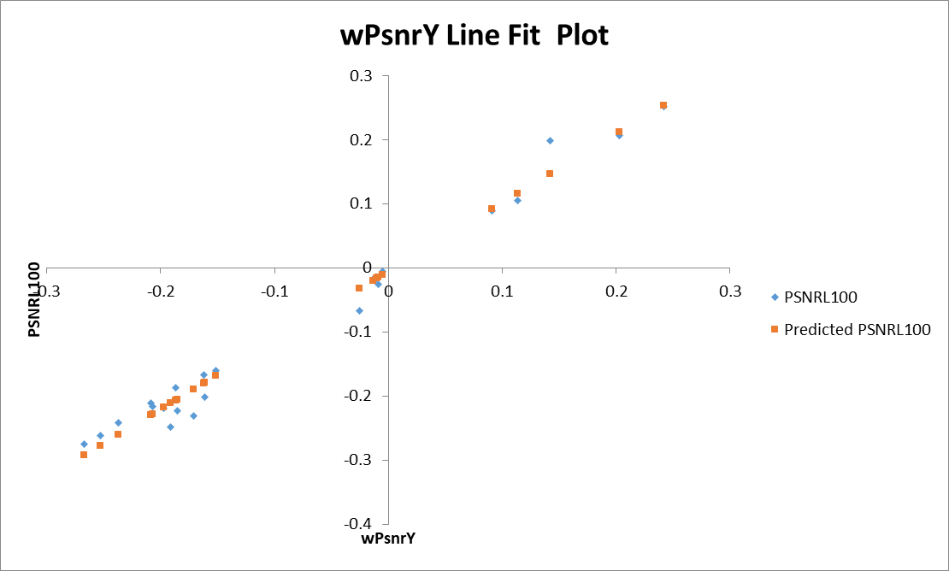
Figure 1. Correlation between PSNRL100 (x-axis) and wPSNRY (y-axis).

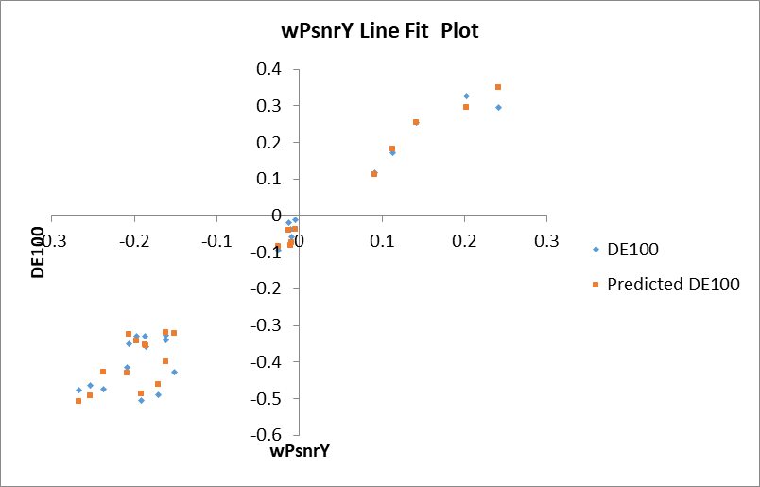

Figure 2. Correlation between deltaE (x-axis) and wPSNR Y, wPSNR U and V (y-axis).

