    Joint Video Experts Team (JVET)  of ITU-T SG21 WP3/21 and ISO/IEC JTC 1/SC 29  39th Meeting, Daejeon, KR, 26 June – 4 July 2025 | Document: JVET-AM0235-v1

Title: | Implementation of error resilient transmission system for scalable services
Status: | Input document to JVET
Purpose: | Proposal
Author(s) or  Contact(s): | Shunsuke Iwamura  Shimpei Nemoto  Yuichi Kondo  Atsuro Ichigaya | Tel:  Email: | iwamura.s-gc@nhk.or.jp
Source: | NHK
_____________________________

Abstract
This contribution reports development of transmission system of multi-resolution video services using VVC multi-layer coding for providing videos with appropriate quality/resolution according to the reception environment. The developed transmission system assumes that different paths are used for the transmission of the base layer and the enhancement layer and introduces bitstream synthesis processing to reconstruct the original multi-layer bitstream from separately transmitted data while compensating for the transmission delay of each path. Furthermore, an error concealment function is incorporated to the system to maintain service quality when the transmission quality of the enhancement layer deteriorates.

Introduction
With the rapid growth of video streaming services and the increasing diversity of user environments, there is a growing demand for transmission systems that can flexibly adapt video quality and resolution to varying reception conditions. In particular, multi-resolution video services have gained attention as a promising approach to deliver scalable video content tailored to device capabilities, network bandwidth, and user preferences.
VVC adopts multi-layer coding features from version 1 that enable efficient representation of video content at multiple resolutions and quality levels. By leveraging multi-layer coding structure, it becomes feasible to transmit a base layer that ensures minimum acceptable quality, along with one or more enhancement layers that refine the video quality or increase the video resolution when reception conditions permit.
This contribution reports the development of a transmission system for multi-resolution video services utilizing VVC multi-layer coding. The proposed system assumes a transmission architecture in which the base layer and enhancement layer are delivered via separate paths. To address the challenges posed by asynchronous delivery and varying transmission delays per layers, the system incorporates a bitstream synthesis mechanism that reconstructs the original multi-layer bitstream from independently received data. Moreover, to ensure service continuity and user experience in the presence of transmission errors or degradation in the enhancement layer, an error concealment function is integrated into the system.

Proposed transmission system
The developed transmission system delivers a multi-layer bitstream over paths with different quality characteristics. In the developed system, the multi-layer bitstream generated by the VVC encoder on the transmission side is separated into base layer (BL) data and enhancement layer (EL) data, which are then transmitted independently over distinct channels. At the receiver side, bitstream synthesis process is performed to reconstruct the original multi-layer bitstream by combining the separately transmitted BL data and EL data. Since transmission over different paths can result in delay discrepancies between the layers, the system incorporates a delay compensation mechanism to align the data streams and ensure proper reconstruction.
When a transmission error occurs in the enhancement layer, multi-layer decoding can no longer be continued due to the dependency between layers. In such cases, the decoder at the receiver side must be reinitialized, and decoding must be switched to BL decoding mode. This reinitialization process may result in a temporary interruption of video playback, during which the service becomes unavailable to the user. Furthermore, when the spatial resolutions of the BL and EL differ, an additional mechanism is required at the receiver to upscale the BL output to the target display resolution. To address the conventional issue of video interruption caused by degradation in the transmission quality of the EL path, the developed system introduces an error concealment technique. This function mitigates the impact of EL data loss and helps maintain overall service quality, even under adverse network conditions.
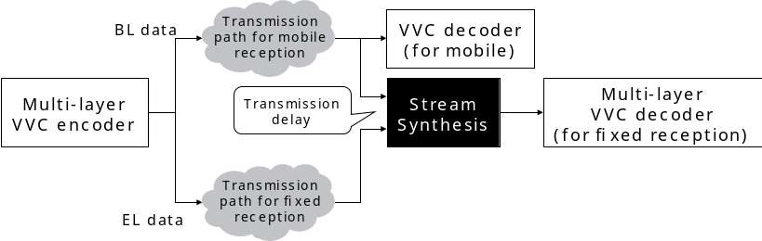
Figure 1. Overview of the developed transmission system

Bitstream synthesis with delay compensation
To enable decoding of the multi-layer bitstream by a VVC decoder at the receiver, it is essential to reconstruct the original bitstream generated by the encoder. However, when the BL and EL data are transmitted over different network paths, differences in arrival times are likely to occur. As a result, simply reordering packets based on their arrival sequence is insufficient for accurate bitstream reconstruction.
The developed system introduces a delay compensation mechanism at the receiver. This mechanism sorts the received packets according to the original transmission order before performing stream synthesis. Figure 1 illustrates the overall structure of the delay compensation process.
The system transmits the multi-layer bitstream using the CMAF over MMT format. During transmission, a common sequential identifier, referred to as the Packet Sequence Number (PSN), is assigned to both BL and EL data in the MMT packet headers. These packets are then transmitted over their respective paths.
At the receiver side, MMT packets from both BL and EL paths are buffered and sorted in ascending order based on their PSN. This sorting ensures that the original multi-layer bitstream can be accurately reconstructed, enabling proper decoding by the VVC multi-layer decoder.

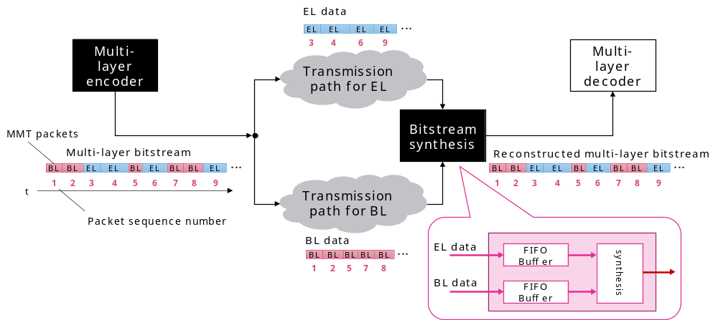
Figure 2. Bitstream synthesis mechanism

Error concealment mechanism
In the developed system, the EL data is transmitted over a channel with higher bandwidth, but lower transmission robustness compared to that for the BL data. Consequently, when the reception quality of the EL transmission path deteriorates, decoding of the EL cannot be sustained. Although switching to BL-only decoding is possible using the reliably received BL data, this approach may result in temporary video interruption.
To address this issue, the developed system introduces an error concealment mechanism that uses pre-stored dummy data to replace missing EL data when packet loss is detected. This allows the stream synthesis process to continue using the correctly received BL data, thereby generating a valid multi-layer bitstream without interruption.
As illustrated in Figure 3(a), under normal reception conditions, block-level prediction is carried out using the partitioning and prediction information signalled in the EL data, which is then combined with residual signals to produce the final decoded EL picture.
When EL data is lost due to poor transmission conditions, the necessary partitioning and prediction information and residual signals for EL are unavailable, making it impossible to continue decoding. To overcome this, the error concealment mechanism replaces the missing EL data with dummy data. As shown in Figure 3(b), the dummy data includes simplified partitioning and prediction information:
- Partitioning information: indicates no further partitioning below the CTU level.
- Prediction information: specifies that only inter-layer prediction from the BL is applied to all CTUs, with motion information of zero vector.
- Residual signal: includes no residual.
Since dummy data depends only on the encoding configuration (e.g., resolution and coding tools enabled for the EL) and not on the input video content, it can be pre-generated. Moreover, the data size is minimal (less than 100 bytes even for 8K resolution), ensuring that memory requirements at the receiver remain unchanged.
Although the decoded picture of EL using dummy data is fundamentally an upscaled BL decoded picture, the ability to continue EL decoding prevents service interruption, effectively addressing the conventional issue of video blackout during transmission degradation.
To enable dummy data substitution, the system must detect packet loss in the EL stream. This is achieved by sorting MMT packets buffered for both BL and EL according to their PSN. If discontinuities are detected in the sequence numbers during stream synthesis, assuming stable BL reception, packet loss is inferred in the EL path. The system then replaces all frames associated with the missing EL packets with dummy data, allowing decoding to proceed without errors.

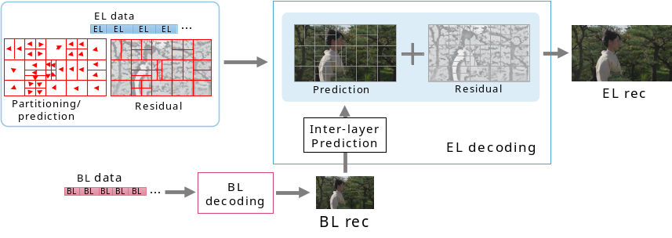
(a) EL decoding at normal reception condition
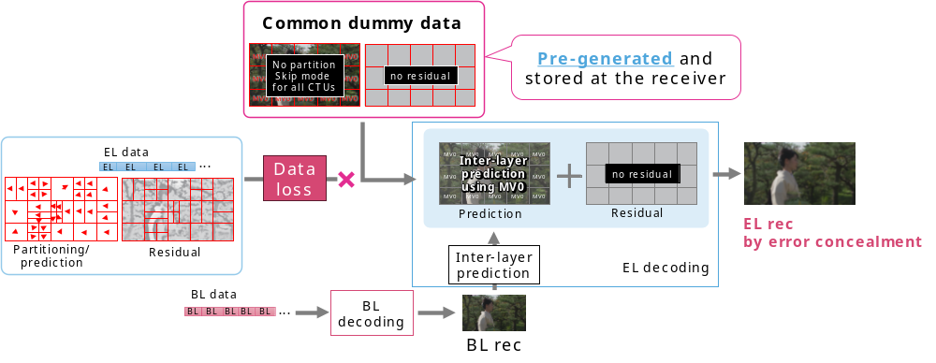
(b) EL decoding with transmission error
Figure 3. Error concealment mechanism

Validation

Bitstream and dummy data preparation
The multi-layer bitstream used in the validation was generated using VTM-18.0. 8K test sequence used in the experiment was selected from “Ultra-high definition/wide-color-gamut standard test sequences – Series A” distributed by the Institute of Image Information and Television Engineers (ITE). The details of the test sequences can be found at https://www.ite.or.jp/content/test-materials/uhdtv_a/.
For the input source of BL, the down-sampled 4K sequence was generated using SHVC down-sampling filter from the original 8K sequence. TAppDownConvert of SHM-12.4 using the following command line arguments are used:
TAppDownConvertStatic 7680 4320 input.yuv 3840 2160 output.yuv 10 10 0 0 0 900 -phase 0 0 0 0
The thumbnails of the test sequence used for the test is shown in Figure 4.

Figure 4. Thumbnail of the test sequence (a04: Umbrella)
Dummy data used for error concealment was generated by modifying the rate-distortion (RD) optimization process in the VTM. Specifically, during 4K/8K multi-layer encoding, the RD optimization for the BL was performed as usual, whereas for the EL, the encoder was configured to disable partitioning and to calculate the RD cost only for the inter-layer prediction with zero motion vector using the BL as the reference picture. Furthermore, the encoder was controlled to suppress the signaling of residuals.

Experimental setup
In this experiment, the multi-layer bitstream was transmitted over separate transmission paths using NHK’s CMAF/MMT-compatible streamer. Each path was connected to a receiver equipped with a stream synthesis process implementing both delay compensation and error concealment functions, as well as a VVC software decoder capable of multi-layer decoding.
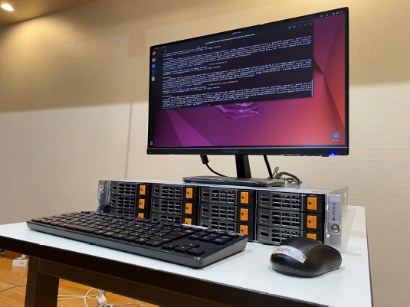
Figure 5. Receiver with stream synthesis and multi-layer VVC decoding functions
To simplify the experiment, the BL and EL transmission paths were directly connected, ensuring no actual transmission errors. Delay differences and packet loss were software-emulated, which allows control over network throughput, latency, and packet loss. It was confirmed that the receiver was able to successfully decode the reconstructed multi-layer bitstream and playback 8K video, even when packet arrival timing was intentionally delayed on one of the transmission paths.
For error compensation testing, the BL and EL transmission paths remained directly connected, while packet loss was intentionally introduced into the EL path. During the experiment, temporary packet loss in the EL path triggered the substitution of missing data with the pre-generated dummy data. The multi-layer VVC decoder successfully switched to displaying error-compensated images—upscaled BL decoded images—without any video interruption. When packet loss ceased, the decoder seamlessly returned to displaying the original 8K EL decoded images, again without any interruption.

Conclusion
This contribution presented the development and demonstration of a transmission system for multi-resolution video services using VVC multi-layer coding, incorporating delay compensation and error concealment mechanisms. Through software implementation and experimental validation, the system was shown to effectively maintain video playback continuity even under conditions of transmission delay and packet loss, thereby enhancing the user experience.
Traditionally, in video coding standards including VVC, transmission errors have been considered a system-layer issue, with no defined behavior for the decoder in the event of such errors. As a result, the handling of playback during transmission failures has been left entirely to the receiver implementation, often leading to inconsistent user experiences.
This contribution demonstrates that by explicitly defining decoder behavior in response to transmission errors—such as through the use of dummy data and controlled fallback mechanisms—video playback can be made more robust and seamless. Therefore, it is recommended that future video coding standards consider incorporating error-handling mechanisms within the specification itself, as part of a broader effort to improve service reliability and user satisfaction.

Patent rights declaration(s)
NHK may have current or pending patent rights relating to the technology described in this contribution and, conditioned on reciprocity, is prepared to grant licenses under reasonable and non-discriminatory terms as necessary for implementation of the resulting ITU-T Recommendation | ISO/IEC International Standard (per box 2 of the ITU-T/ITU-R/ISO/IEC patent statement and licensing declaration form).

