    Joint Video Experts Team (JVET)  of ITU-T SG21 WP3/21 and ISO/IEC JTC 1/SC 29  39th Meeting, Daejeon, KR, 26 June – 4 July 2025 | Document: JVET-AM0231-v5

Title: | EE2-4.5: On performance improvement of NN-ILF in ALF
Status: | Input document to JVET
Purpose: | Proposal
Author(s) or  Contact(s): | Nan Hu, Marta Karczewicz, Muhammed Coban, Hongtao Wang, Yiting Shao, Jianfeng Wang, Yun Li, Vadim Seregin (Qualcomm)  Dmytro Rusanovskyy, Seungwook Hong, Krit Panusopone, Limin Wang, Jani Lainema (Nokia) | Tel:  Email: | mcoban@qti.qualcomm.com  martak@qti.qualcomm.com  dmytro.rusanovskyy@nokia.com
Source: | Qualcomm Inc., Nokia
_____________________________

Abstract
In EE2-4.5, luma only NNILF filters based on EE1-2.1 filter and VLOP3 with encoder improvements are introduced for NNILF interface 2 in ECM.
The proposed method was implemented on top of ECM-17.0 with NNLF_EXTENSION and the simulation results are as follows.
Test 4.5a Interface 2 with luma only version of VLOP3 filter.
AI: -0.37%, 0.00%, 0.00% for Y, U, V respectively, EncT 100.2% DecT 133.9%.
RA: -0.56%, -0.07%, -0.03% for Y, U, V respectively, EncT 98.3% DecT 116.8%.
LB: -0.21%, 0.10%, 0.27% for Y, U, V respectively, EncT 92.5% DecT 103.4%.
Test 4.5b Interface 2 with luma only version of EE1-2.1 filter.
AI: -0.44%, 0.00%, 0.00% for Y, U, V respectively, EncT 100.2% DecT 133.4%.
RA: -0.82%, -0.09%, -0.08% for Y, U, V respectively, EncT 98.7% DecT 123.8%.
LB: -0.47%, 0.12%, 0.35% for Y, U, V respectively, EncT 95.5% DecT 120.1%.
Test 4.5c Interface 1 with luma only version of EE1-2.1 filter.
AI: -0.33% -0.58% -0.64% for Y, U, V respectively, EncT 99.4% DecT 126.2%.
RA: -0.76%, -1.44%, -1.08% for Y, U, V respectively, EncT 99.4% DecT 124.6%.
LB: -0.36%, -0.64%, -0.80% for Y, U, V respectively, EncT 95.9x% DecT 117.2%.

Introduction
The current ECM with NNLF EXTENSION SW supports two NN-ILF interfaces, adopted with JVET-AL0228. Interface 1 has the same design as in AHG14 and supports luma-chroma filters. Interface 2 supports luma-only NN-ILF filters that is integrated into ECM-ALF and alternatively enabled/disabled with Gaussian Filter.

Proposal
The luma-only version of EE1-2.1 and VLOP3 filters are integrated into interface 2 in ECM-17.0. The EE1-2.1 filter was trained as described in JVET-AM0135/AL0166. Luma only VLOP3 training follows that of VLOP3 training.
The luma-only version of EE1-2.1 VLOP filter as shown in Figure 1 has 67603 parameters and 45 convolutional layers with 4.66 kMAC/pixel complexity.
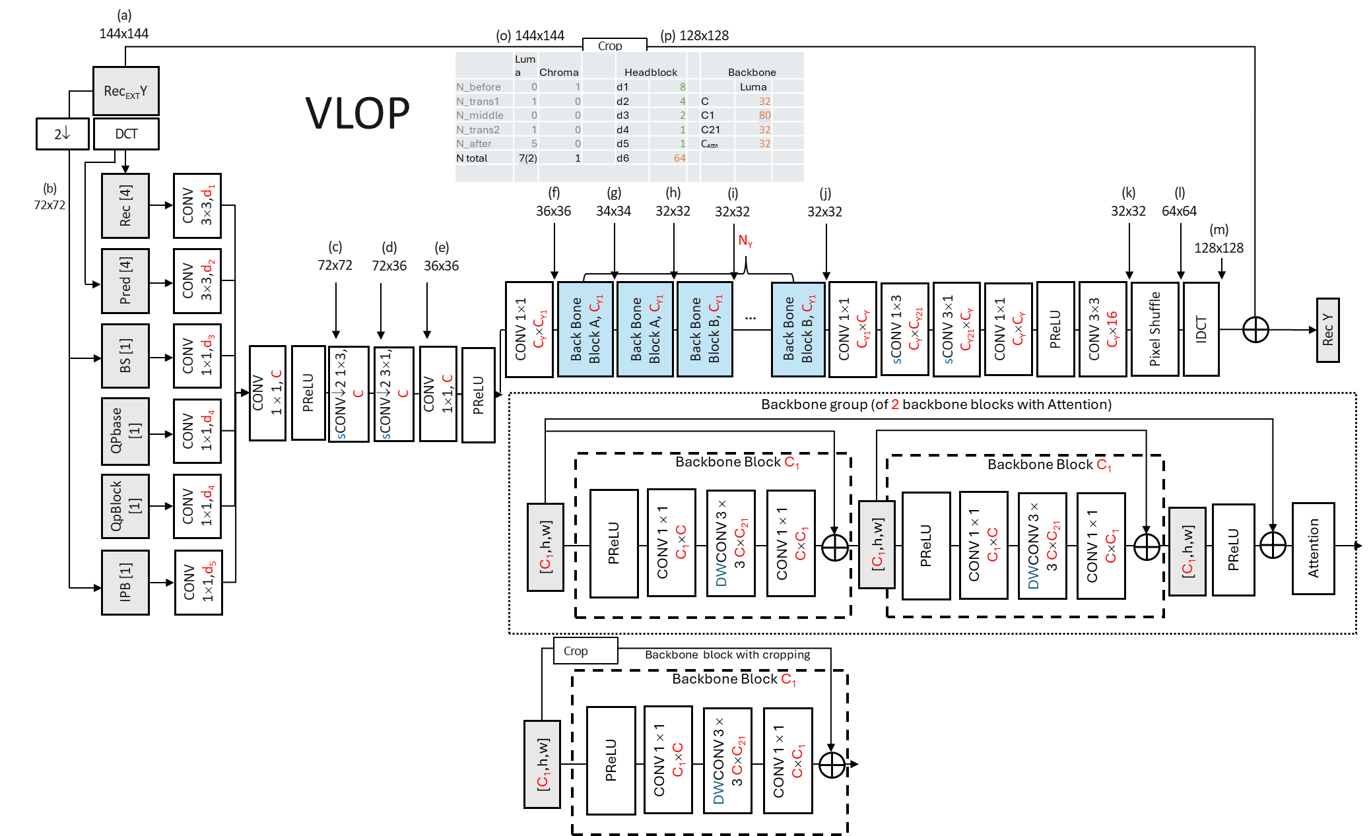
Figure 1. EE1-2.1 VLOP luma-only version.
The luma-only version of VLOP3 filter as shown in Figure 2 has 63904 parameters and 40 convolutional layers with 4.78 kMAC/pixel.
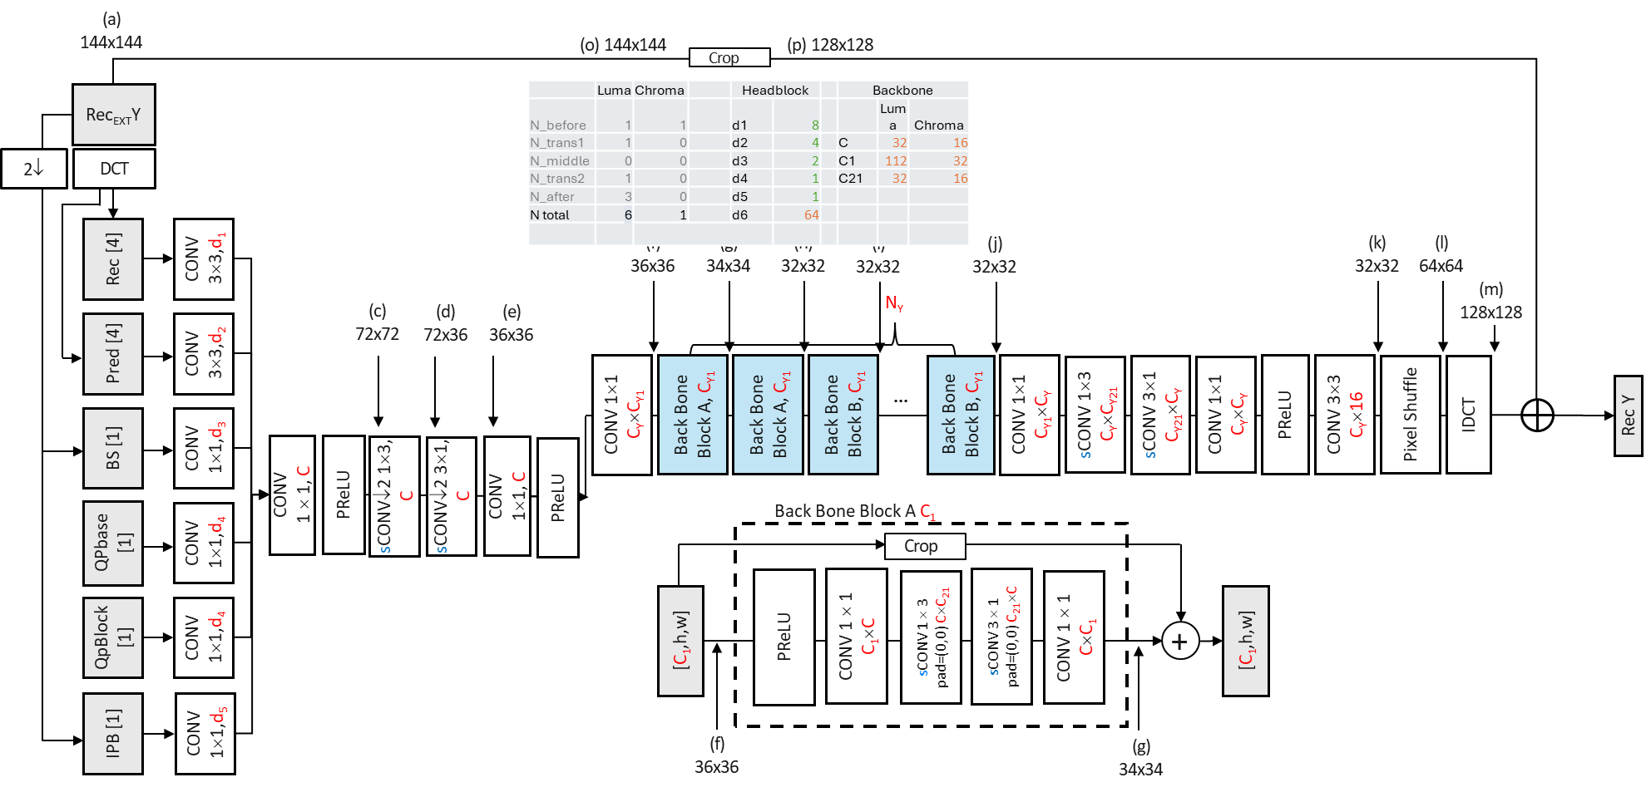
Figure 2. VLOP3 luma only version.
To improve coding gain performance to the decoding run-time ratio, complexity-aware RDO was introduced: NN filtering is disabled for blocks, if provided distortion reduction is found to be below a threshold. A flag is signalled to indicate whether NN-ILF or Gaussian filter is used when ALF is enabled.

Experimental results
The proposed method is implemented with NN-ILF Interface 2 on top of the ECM-17.0 software [1] and tested under common test condition [2].
In Test 4.5a, VLOP3 luma only filter is tested, and results against ECM-17.0 are shown below.
 | All Intra Main 10
 | Over ECM-17.0
 | Y | U | V | EncT | DecT | EncVmPeak | DecVmPeak
Class A1 | -0.32% | 0.00% | 0.00% | 100.6% | 123.5% | 111.5% | 132.3%
Class A2 | -0.32% | -0.01% | -0.01% | 98.1% | 142.6% | 111.4% | 132.0%
Class B | -0.30% | 0.00% | 0.00% | 101.3% | 127.5% | 110.3% | 118.2%
Class C | -0.20% | 0.02% | 0.02% | 100.6% | 128.6% | 110.7% | 110.5%
Class E | -0.84% | 0.00% | 0.00% | 99.6% | 156.1% | 112.0% | 114.0%
Overall | -0.37% | 0.00% | 0.00% | 100.2% | 133.9% | 111.1% | 120.1%
Class D | -0.27% | 0.07% | 0.09% | 100.3% | 131.6% | 106.0% | 108.6%
Class F | -0.16% | 0.03% | 0.03% | 100.9% | 129.7% | 112.1% | 113.3%
Class TGM | 0.01% | 0.01% | 0.01% | 95.2% | 102.5% | 117.2% | 115.9%
 | Random Access Main 10
 | Over ECM-17.0
 | Y | U | V | EncT | DecT | EncVmPeak | DecVmPeak
Class A1 | -0.77% | 0.09% | -0.02% | 99.4% | 125.0% | 140.0% | 152.0%
Class A2 | -0.71% | -0.08% | -0.07% | 98.4% | 110.3% | 140.6% | 151.2%
Class B | -0.55% | -0.19% | -0.07% | 97.6% | 119.0% | 130.0% | 134.4%
Class C | -0.30% | -0.02% | 0.05% | 98.4% | 113.4% | 123.6% | 121.3%
Class E
Overall | -0.56% | -0.07% | -0.03% | 98.3% | 116.8% | 132.2% | 137.2%
Class D | -0.39% | -0.03% | -0.17% | 100.1% | 128.2% | 116.1% | 115.1%
Class F | -0.14% | 0.05% | 0.06% | 94.5% | 110.0% | 123.2% | 126.1%
Class TGM | -0.01% | 0.04% | 0.01% | 90.7% | 87.2% | 122.5% | 130.7%
 | Low delay B Main 10
 | Over ECM-17.0
 | Y | U | V | EncT | DecT | EncVmPeak | DecVmPeak
Class A1
Class A2
Class B | -0.26% | -0.23% | 0.09% | 90.4% | 105.5% | 117.0% | 134.4%
Class C | -0.08% | -0.45% | 0.01% | 93.9% | 103.2% | 113.3% | 121.5%
Class E | -0.29% | 1.39% | 0.91% | 94.3% | 100.3% | 115.6% | 127.0%
Overall | -0.21% | 0.10% | 0.27% | 92.5% | 103.4% | 115.4% | 128.1%
Class D | -0.37% | -0.92% | 0.69% | 96.3% | 121.1% | 109.3% | 115.5%
Class F | -0.11% | 0.83% | 0.52% | 95.1% | 106.1% | 113.2% | 127.3%
Class TGM | -0.05% | 0.01% | -0.08% | 94.7% | 99.6% | 112.9% | 130.6%

In Test 4.5b, EE1-2.1 luma only filter is tested, and results against ECM-17.0 are shown below. Decoding run times are reliable.

 | All Intra Main 10
 | Over ECM-17.0
 | Y | U | V | EncT | DecT | EncVmPeak | DecVmPeak
Class A1 | -0.37% | 0.00% | 0.00% | 100.5% | 124.3% | 111.7% | 132.6%
Class A2 | -0.39% | -0.01% | -0.01% | 97.6% | 144.2% | 111.0% | 132.4%
Class B | -0.34% | 0.00% | 0.00% | 101.8% | 124.7% | 110.6% | 118.4%
Class C | -0.24% | 0.02% | 0.02% | 100.4% | 127.8% | 111.3% | 111.2%
Class E | -1.00% | 0.00% | -0.01% | 99.7% | 156.7% | 111.7% | 114.7%
Overall | -0.44% | 0.00% | 0.00% | 100.2% | 133.4% | 111.2% | 120.6%
Class D | -0.40% | 0.07% | 0.09% | 99.3% | 138.1% | 106.9% | 109.8%
Class F | -0.17% | 0.03% | 0.03% | 103.7% | 126.5% | 110.6% | 113.8%
Class TGM | 0.01% | 0.01% | 0.01% | 104.2% | 102.5% | 118.1% | 116.1%
 | Random Access Main 10
 | Over ECM-17.0
 | Y | U | V | EncT | DecT | EncVmPeak | DecVmPeak
Class A1 | -1.16% | -0.15% | -0.09% | 99.8% | 133.0% | 139.9% | 152.3%
Class A2 | -1.01% | -0.17% | -0.03% | 99.0% | 117.3% | 140.7% | 151.7%
Class B | -0.80% | -0.12% | -0.14% | 98.3% | 125.5% | 130.2% | 135.0%
Class C | -0.44% | 0.04% | -0.02% | 98.4% | 120.2% | 123.9% | 122.1%
Class E
Overall | -0.82% | -0.09% | -0.08% | 98.7% | 123.8% | 132.4% | 137.8%
Class D | -0.61% | 0.14% | -0.17% | 99.1% | 129.8% | 116.4% | 116.4%
Class F | -0.22% | -0.01% | 0.00% | 101.9% | 118.7% | 123.5% | 126.5%
Class TGM | 0.00% | 0.04% | 0.00% | 103.8% | 105.5% | 122.4% | 131.1%
 | Low delay B Main 10
 | Over ECM-17.0
 | Y | U | V | EncT | DecT | EncVmPeak | DecVmPeak
Class A1
Class A2
Class B | -0.47% | -0.05% | -0.07% | 96.8% | 125.1% | 117.2% | 135.4%
Class C | -0.30% | -0.31% | 0.03% | 95.9% | 123.5% | 113.6% | 122.4%
Class E | -0.70% | 0.98% | 1.46% | 92.8% | 108.0% | 115.8% | 127.6%
Overall | -0.47% | 0.12% | 0.35% | 95.5% | 120.1% | 115.7% | 129.0%
Class D | -0.53% | -0.38% | 0.34% | 94.9% | 136.3% | 109.8% | 116.8%
Class F | -0.33% | 0.33% | 0.30% | 93.8% | 123.2% | 113.4% | 127.9%
Class TGM | -0.11% | -0.08% | -0.10% | 97.8% | 108.1% | 114.0% | 131.3%

In Test 4.5c EE1-2.1 filter tested with Interface 1, and results against ECM-17.0 are shown below. Decoding runtimes are reliable. Encoding runtimes for classes C and D for RA, LB configurations are reliable.
 | All Intra Main 10
 | Over ECM-17.0
 | Y | U | V | EncT | DecT | EncVmPeak | DecVmPeak
Class A1 | -0.21% | -0.22% | -0.21% | 100.9% | 118.7% | 111.7% | 132.3%
Class A2 | -0.09% | -0.22% | -0.10% | 96.7% | 112.1% | 111.0% | 131.3%
Class B | -0.32% | -0.45% | -0.37% | 98.7% | 121.9% | 109.8% | 118.1%
Class C | -0.15% | -0.54% | -0.59% | 100.0% | 126.2% | 110.8% | 110.7%
Class E | -0.96% | -1.58% | -2.12% | 101.1% | 160.1% | 111.5% | 115.2%
Overall | -0.33% | -0.58% | -0.64% | 99.4% | 126.2% | 110.8% | 120.3%
Class D | -0.25% | -0.63% | -0.66% | 99.9% | 132.0% | 106.7% | 110.0%
Class F | -0.20% | -0.42% | -0.28% | 103.2% | 131.1% | 111.5% | 114.1%
Class TGM | -0.01% | 0.00% | 0.00% | 104.5% | 105.5% | 118.2% | 116.2%
 | Random Access Main 10
 | Over ECM-17.0
 | Y | U | V | EncT | DecT | EncVmPeak | DecVmPeak
Class A1 | -1.26% | -1.22% | -1.10% | 100.2% | 136.5% | 140.0% | 152.6%
Class A2 | -0.89% | -1.47% | -0.67% | 100.0% | 113.5% | 133.1% | 141.8%
Class B | -0.72% | -1.62% | -1.32% | 98.1% | 125.2% | 130.3% | 135.0%
Class C | -0.26% | -1.31% | -1.03% | 99.9% | 124.2% | 124.1% | 121.2%
Class E
Overall | -0.76% | -1.44% | -1.08% | 99.4% | 124.6% | 131.0% | 135.8%
Class D | -0.39% | -0.98% | -1.21% | 99.7% | 128.4% | 116.7% | 116.2%
Class F | -0.24% | -0.75% | -0.42% | 97.0% | 125.3% | 123.0% | 126.7%
Class TGM | -0.14% | -0.10% | -0.13% | 92.8% | 116.5% | 122.6% | 131.8%
 | Low delay B Main 10
 | Over ECM-17.0
 | Y | U | V | EncT | DecT | EncVmPeak | DecVmPeak
Class A1
Class A2
Class B | -0.40% | -0.86% | -0.69% | 93.1% | 125.3% | 117.3% | 134.7%
Class C | -0.10% | -0.84% | -0.62% | 100.4% | 115.9% | 113.9% | 121.1%
Class E | -0.64% | -0.02% | -1.21% | 94.8% | 106.5% | 116.0% | 127.8%
Overall | -0.36% | -0.64% | -0.80% | 95.9% | 117.2% | 115.9% | 128.3%
Class D | -0.48% | -1.18% | 0.07% | 100.2% | 133.0% | 110.4% | 115.8%
Class F | -0.34% | -0.15% | -0.04% | 92.5% | 120.3% | 113.2% | 127.8%
Class TGM | -0.10% | -0.10% | -0.13% | 95.3% | 113.4% | 113.3% | 131.8%

Conclusions
It is proposed to adopt Test 4.5 improvements to NNLF into next version of ECM NNLF extension.

References
- ECM-17.0, https://vcgit.hhi.fraunhofer.de/ecm/ECM.
- M. Karczewicz, Y. Ye, “Common Test Conditions and evaluation procedures for enhanced compression tool testing”, JVET-Y2017, 25th Meeting, by teleconference, 12–21 January 2022.

Patent rights declaration(s)
Qualcomm Inc. may have current or pending patent rights relating to the technology described in this contribution and, conditioned on reciprocity, is prepared to grant licenses under reasonable and non-discriminatory terms as necessary for implementation of the resulting ITU-T Recommendation | ISO/IEC International Standard (per box 2 of the ITU-T/ITU-R/ISO/IEC patent statement and licensing declaration form).
Nokia may have current or pending patent rights relating to the technology described in this contribution and, conditioned on reciprocity, is prepared to grant licenses under reasonable and non-discriminatory terms as necessary for implementation of the resulting ITU-T Recommendation | ISO/IEC International Standard (per box 2 of the ITU-T/ITU-R/ISO/IEC patent statement and licensing declaration form).

