    Joint Video Experts Team (JVET)  of ITU-T SG21 WP3/21 and ISO/IEC JTC 1/SC 29  39th Meeting, Daejeon, KR, 26 June – 4 July 2025 | Document: JVET-AM0222-v1

Title: | AHG18: On test conditions for ultra-low latency and packet loss resilience
Status: | Input document to JVET
Purpose: | Proposal
Author(s) or  Contact(s): | Sergey Ikonin  Ivan Gribushin  Maxim Sychev  Elena Alshina | Email: | sergey.ikonin@huawei.com  elena.alshina@huawei.com
Source: | Huawei Technologies
_____________________________

Abstract
This contribution proposes simplification of ultra-low latency test by replacing packet trace files by channel bandwidth traces, introduces single frame reconstruction test under various packet loss conditions, and optional configuration of bypassing portion of key important information suitable for scalable coding technologies.

Introduction
Current version of AHG18 simulation software uses network transmission emulation based on packet trace files obtaining from NS-3 simulator emulating indoor Wi-Fi connection. The details can be found in contribution JVET-AK0193. Packet trace file contains packet delivery information: sending time, receiving time, and whether packet was successfully accepted by Wi-Fi station or discarder due to errors.
Packet Number | is lost sending time receiving time
2 1 / 0 5320 us 5360 us
MAC layer retransmission logic is simulated in software to reflect common behavior of Wi-Fi networks, number of retransmission attempts is configurable.
In order to make possible explore behavior on other types of connection like 5G and long distance wired internet without much sophistication of software it will be desirable to make network simulation part more abstract without deep specific of concrete protocol

Bandwidth fluctuation test
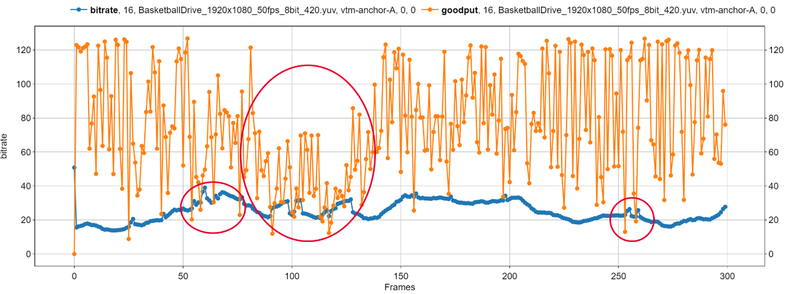
It is proposed to simplify network simulation part by replacing packet trace files with channel bandwidth trace, containing instant channel bandwidth sampled at some reasonable period of time, e.g., 16ms as a time distance between two frames at 60 fps or alike. The channel bandwidth trace can be obtained offline from packets trace files of AHG18 SW by calculating amount of bits successfully delivered during sampling interval.
Coded bitstream
Channel bandwidth
Source of problem
Figure 1 Channel bandwidth fluctuation and coded bitstream
Packets are assumed to be sent one-by-one once they are available after encoding. In this scenario all packet assumed to be delivered without losses but with different receiving time corresponding to the instant channel capacity. The packet transmission time is calculated based packet size and instant channel capacity as below, and can be used for arrival time estimation as before:
$$Packet transmission time=\frac{Packet size, bits}{Channel bandwidth, bits/sec}$$

One concern maybe raised that packet loss is not simulated only late packets. The late packets happen when instant bandwidth is not enough to transmit current picture bitstream in time (red circles on picture above). However, from decoder specific there no difference between lost and late packets. Furthermore, according to analysis of contribution JVET-AL0201 the contribution of late packets is substantially dominating over lost packet. So lost packets can be ignored without noticeable change of decoder behavior at current test conditions in favor of software simplification and future extensibility by channel profiles of other network types.
Figure 1 bellow illustrates packet transmission time simulation as it currently implemented in AHG18 software.
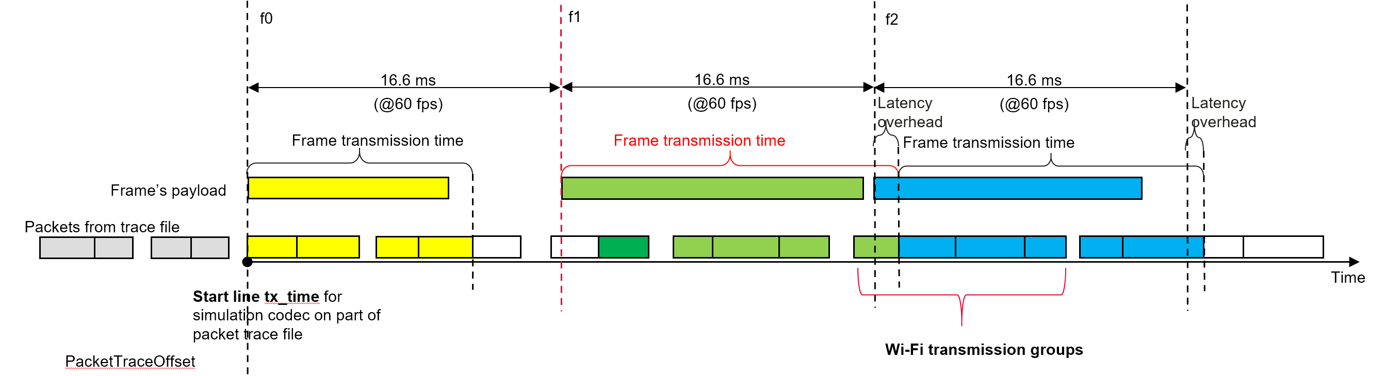
Packet receiving time, read from csv file
Figure 2 Proposed method of calculation transmission time based on instant channel bandwidth
Proposed simplification illustrating packet arrival time calculation based on instant channel bandwidth is depicted on Figure 2. Packet transmission time during interval from 0 to 16ms is calculated using channel bandwidth A. On interval from 16 to 32 based on channel bandwidth B, etc.
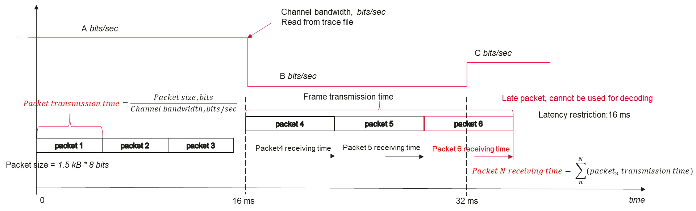
Figure 3 Proposed method of calculation transmission time based on instant channel bandwidth
The proposed modification will help to simplify software and remove emulation of Wi-Fi specific re-transmission logic and corresponding parameters. The simulation software can easily be further extended by channel profiles of another types on network such as 5G and wired Internet.

Packet loss test
Packet loss test was commonly used in the past for evaluation reconstruction resilience to different level of errors. It is convenient to use and easy to implement. However, with increasing resolution of the videos up to 1080p and 4k at the reasonable level of packet loss probability of losing significant part of the frames in a whole video is quite high, especially at high bitrates. As a result, the stall ratio may be too high which makes subjective video tests hardly to be conducted. Figure 4 illustrated the situation.
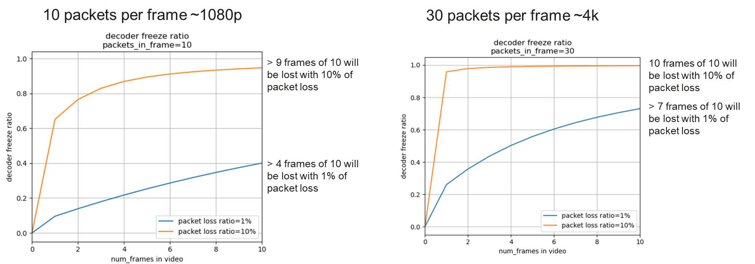
Figure 4 Estimated portion of lost frames of 10-frame video for 1080p and 4k resolution for high bitrates (QP22)
For example, for 10 packets per frame, which roughly corresponds to 1080p resolution coded at QP22 for 10 frames video more than 9 expected to be affected and lost if packet loss ratio is 10%. For 1% of packet loss more than 4 frames fill be lost. For 30 packets frame corresponding to 4k resolution situation is even worse. All that will make conduction of visual tests of videos hardly possible due to extremity high level of frozen frames.
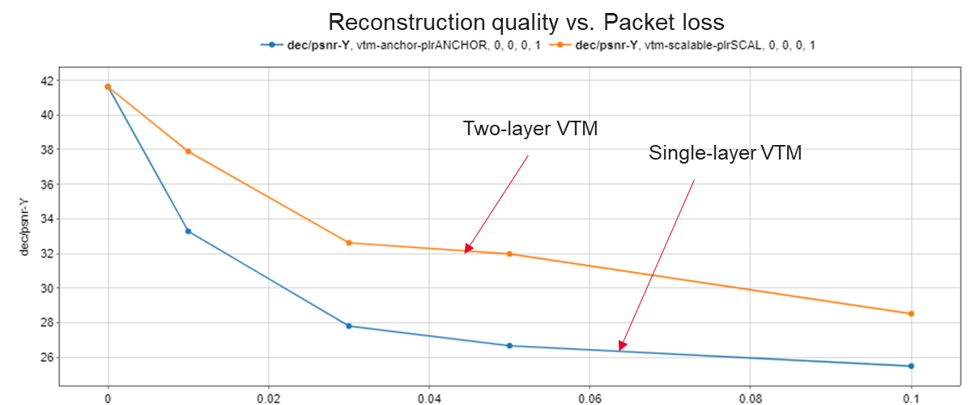
One of the possible solutions to experience reconstruction quality of single (or 2-3) P-frame. For example, take I-P coded slices, bypass I slice and experience different packet loss for P-frame. Due to test simplicity the decoder can be run multiple times, e. g. 100 or more, that will help to get good statistic coverage and prevent to overfitting on some specific packet loss pattern. Averaging reconstruction quality for different packet loss rate will allow to construct plots like in a given example, and compare candidate technologies between each other.
Figure 5 Example of single P-frame decoding test at various packet loss condition of single layer and two-layer scalable coding

Bypass key important information
Some coding solution for example scalable coding may imply different priority of information importance. It is proposed to introduce a testing option of bypassing key important information like Layer0 without packet loss and transmission latency in both described above tests. In order to be able compare technologies in the same conditions several configurations may be considered e.g., 10% of key information of total bitstream size is bypassed, 20% is bypassed etc.

Conclusion
This contribution proposes simplification of ultra-low latency test by replacing packet trace files by channel bandwidth fluctuation traces, introduces single frame reconstruction test under various packet loss conditions, and optional configuration of bypassing portion of key important information suitable for scalable coding technologies. It is proposed to consider described test scenarios for ultra-low latency test conditions.

Patent rights declaration(s)
Huawei Technologies may have current or pending patent rights relating to the technology described in this contribution and, conditioned on reciprocity, is prepared to grant licenses under reasonable and non-discriminatory terms as necessary for implementation of the resulting ITU-T Recommendation | ISO/IEC International Standard (per box 2 of the ITU-T/ITU-R/ISO/IEC patent statement and licensing declaration form).

