    Joint Video Experts Team (JVET)  of ITU-T SG21 WP3/21 and ISO/IEC JTC 1/SC 29  39th Meeting, Daejeon, KR, 26 June – 4 July 2025 | Document: JVET-AM0203-v2

Title: | AHG18: Full VTM tool set in ultra-low latency test scenario
Status: | Input document to JVET
Purpose: | Proposal
Author(s) or  Contact(s): | Vyacheslav Khamidullin  Ivan Gribushin  Sergey Ikonin  Elena Alshina | Email: | vyacheslav.khamidullin1@huawei.com  sergey.ikonin@huawei.com  elena.alshina@huawei.com
Source: | Huawei Technologies
_____________________________

Abstract
Ultra-low latency simulation software of AHG18 is currently using simplified encoding configuration with reduced coding tools set originally as it was originally proposed in contribution JVET-AK0193 for sake of VTM software stability on packet loss scenario and simulations speedup. This contribution proposes to enable back full set of VTM coding tools and reports its performance under ultra-low latency test scenario using fast encoding configuration VTM-Reduced-runtime-3 proposed in JVET-AL0055 and used in draft CfE Section 3 (fast encoding) of JVET-АМ0041.

Introduction
Contribution JVET-AK0193 proposed software and configuration based on VTM for experiments of AHG18 on ultra-low latency and packet loss resilience. For sake of software stability and simulations speedup several tools were disabled. Later in contribution JVET-AL0201 adopted to AGH18 software the stability of decoder was significantly improved. After evaluation of the full set of VTM coding tools it was discovered that on packet loss condition all tools works at least from software perspective except of in-loop filters which carry its parameters in APS section. In these experiments that the VTM-Reduced-runtime-3 assuming configuration is closest to real-time scenario.

Software modifications
Adaptive Parameter Set (APS) section of slice header (or picture header) is used for signalling adaptive parameters of in-loop filters such as ALF, CC ALF and etc. These parameters can be lost during transmission, and special fix is required to handle such scenario.

APS parsing fixes

Problem description
The current VTM software has section of reading (parsing) syntax elements corresponding with ALF and CC ALF. Some part of ALF data contains in the APS NAL Units and parsing separately (filter data), and other part (basically identifiers) contains in slice/picture header. During the testing in packet loss scenario few issues with this mechanism were observed leading to crash of the decoder. The problems as a decoder process interruption arises due to lost some APS while transmission. In the parsing slice header APS identifiers (like LUMA APS ALF identifier), some identifier could refer to non-existent (in our case lost) APS. The following decoder CHECKs could interrupt process:
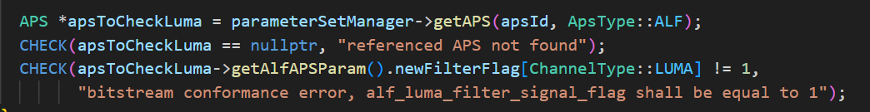
Figure 1. LUMA APS ALF Check.
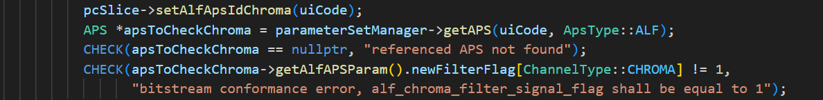
Figure 2. CHROMA APS ALF Check.
Figure 3. CB APS CC ALF Check.
Figure 4. CR APS CC ALF Check.
In accordance with the VTM specification, the scheme of APS parsing procedure, which could interrupt decoding process in ULL scenario, shown below.
Table 1. APS parsing with software checks embedded.
sh_alf_enabled_flag
if( sh_alf_enabled_flag ) {
sh_num_alf_aps_ids_luma
for( i = 0; i < sh_num_alf_aps_ids_luma; i++ )
sh_alf_aps_id_luma[ i ]
CHECK by sh_alf_aps_id_luma[ i ] is APS exists
CHECK is existed APS ALF LUMA Parameters has “newFitleredFlag” attribute as True
if( sps_chroma_format_idc != 0 ) {
sh_alf_cb_enabled_flag
sh_alf_cr_enabled_flag
}
if( sh_alf_cb_enabled_flag | | sh_alf_cr_enabled_flag )
sh_alf_aps_id_chroma
CHECK by sh_alf_aps_id_chroma is APS exists
CHECK is existed APS ALF CHROMA Parameters has “newFitleredFlag” attribute as True
if( sps_ccalf_enabled_flag ) {
sh_alf_cc_cb_enabled_flag
if( sh_alf_cc_cb_enabled_flag )
sh_alf_cc_cb_aps_id
CHECK by sh_alf_cc_cb_aps_id is APS exists
CHECK is existed APS CC ALF Cb Parameters has “newCcAlfFilter” attribute as True
sh_alf_cc_cr_enabled_flag
if( sh_alf_cc_cr_enabled_flag )
sh_alf_cc_cr_aps_id
CHECK by sh_alf_cc_cr_aps_id is APS exists
CHECK is existed APS CC ALF Cr Parameters has “newCcAlfFilter” attribute as True

Solution
The following software fixes were made to increase decoding stability:
- Define the “available” identifiers of APS ALF: if “parameterSetManager” returns APS (not a null pointer) by identifier and this APS has ALF Parameters with “newFilterFlag” attribute as True, then this identifier has “available” status. And the “available” identifier reference to the “available” APS.
- Define the “available” identifiers of APS CC ALF: if “parameterSetManager” returns APS (not a null pointer) by identifier and this APS has CC ALF Parameters with “newCcAlfFilter” attribute as True, then this identifier has “available” status.
- Skip CHECK if parsed ALF APS Id is not “available” and set Enabling filter flag as False. The same logic for CC ALF APS Id.
The fixes for LUMA ALF are the following (red text is new one):
Table 2. Proposed solution with availability check, LUMA.
sh_num_alf_aps_ids_luma
for( i = 0; i < sh_num_alf_aps_ids_luma; i++ )
if ( !( sh_alf_aps_id_luma[ i ] is in available ) ){
continue;
}
sh_alf_aps_id_luma[ i ]
CHECK by sh_alf_aps_id_luma[ i ] is APS exists
CHECK is existed APS ALF LUMA Parameters has “newFitleredFlag” attribute as True
if( sh_num_alf_aps_ids_luma > 0 && size(sh_alf_aps_id_luma[]) == 0){
sh_alf_enabled_flag = 0;
}
The fixes for CHROMA ALF are the following (red text is new one):
Table 3. Proposed solution with availability check, CHROMA.
if( sh_alf_cb_enabled_flag | | sh_alf_cr_enabled_flag )
sh_alf_aps_id_chroma
if ( !( sh_alf_aps_id_chroma is in available) ){
if ( ! (available is empty) ){
sh_alf_aps_id_chroma = available[0];
} else {
sh_alf_cb_enabled_flag = sh_alf_cr_enabled_flag = false;
}
}
if (sh_alf_cb_enabled_flag | | sh_alf_cr_enabled_flag ) {
CHECK by sh_alf_aps_id_chroma is APS exists
CHECK is existed APS ALF CHROMA Parameters has “newFitleredFlag” attribute as True
}
The fixes for CC ALF have similar logic as CHROMA ALF fixes, the “available” status logic was described above in point 2.

APS decoding fix
Another fix is about removing existed APS after parsing received APS if needs. The problem is that decoder interrupts due to existed APS with same ID as parsed APS ID, and these APS have different data (different flags, attributes and coefficients, etc.)
Reason: Due to losses, sometimes, the decoder receives APS NALS, but no NALS for the frame (example NAL Unit type TRAIL). The decoder kept the value of the ID of the received APS. Then the new APS was received, and was parsed ID of this APS, while the old ones was not deleted, because the ID is removed after the frame is decoded. Correspondingly, when checking the new received APS, the ID of the old APS could be matched the ID of the new one received, which caused an error, because new APS and old APS data not the same.
Solution: add condition for checking existed APS in the “xDecodeAPS” method: if identifiers of both existed and new one parsed APS are same, same APS type, same layer ID and same prefix NAL unit, then remove existed APS from APS storage. On the following scheme showed proposed solution:
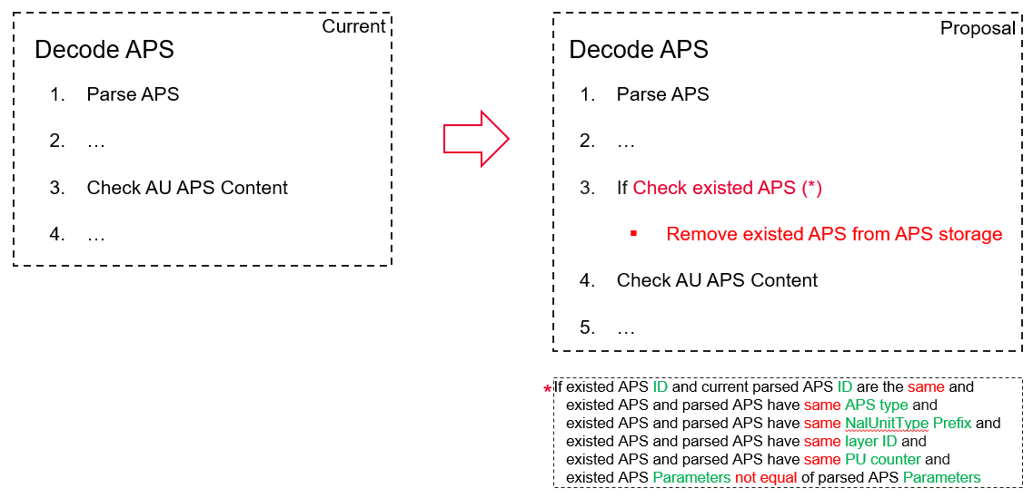
Figure 5. The proposal scheme of fix the “xDecodeAPS” method.

Network model Wi-Fi retransmission ordering fix
In the current version of AHG18 simulation software a software bug related to Wi-Fi retransmission logic was identified. The problem is the following:
- The order of all packets for sending was reversed before each retransmission (for example, the packets with numbers 1, 2, 3 were reordered to 3, 2, 1). The transmission time of retransmitted packets is violated. That affects the delivery status of late packets.
To fix this issue in source/App/EncoderApp/NetworkModel.cpp in the “transmitOverChannel” method the following modification was made correcting retransmission order:
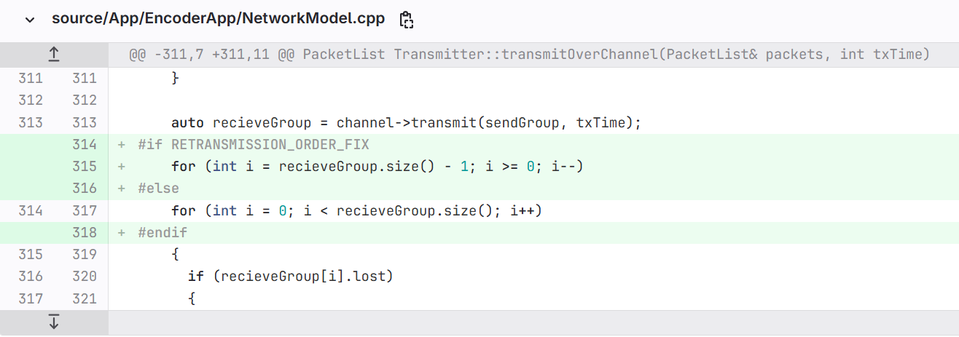
Figure 6. The source code of the Wi-Fi retransmission order bug fix.

Encoding configuration
The contribution JVET-AL0055 proposed to use encoder configuration VTM-Reduced-runtime-3 for restring complexity encoding. Ultra-low latency scenario assumes real-time encoder performance and proposed configuration can be considered as the closest one. Using this configuration with full set coding tools enables experiment was conducted and following results were obtained. It should be noted that combining compression efficiency improvement with restricted encoder complexity configuration results to average bitrate close to bitrate of tests reported in JVET-AL0201. That makes possible to use same existing packet trace files and starting points without re-configuration. The difference in bitrate and performance including run time is as follows:
Table 4. BD-Rate summary. VTM-ULL-AhG18-SW vs. VTM-Reduced-Runtime-3.
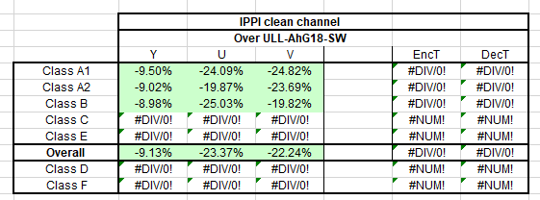
Table 5. BD-PSNR (JVET-AM0325) summary, Reduced-Runtime-3, VTM vs. SVTM.
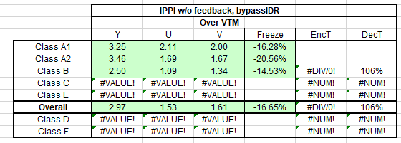
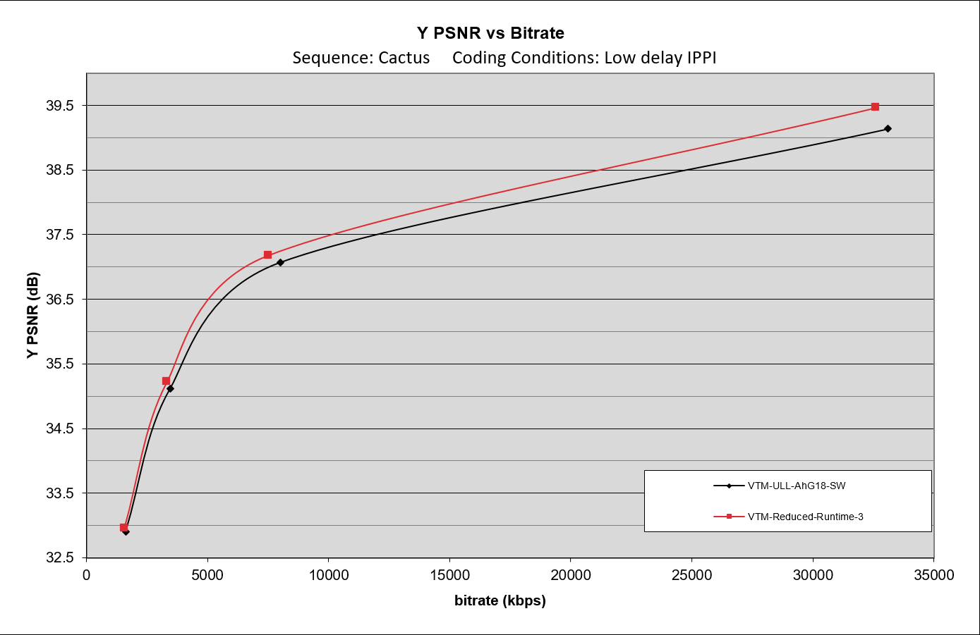
Figure 7. VTM-ULL-AhG18-SW vs. VTM-Reduced-Runtime-3. “Cactus”.

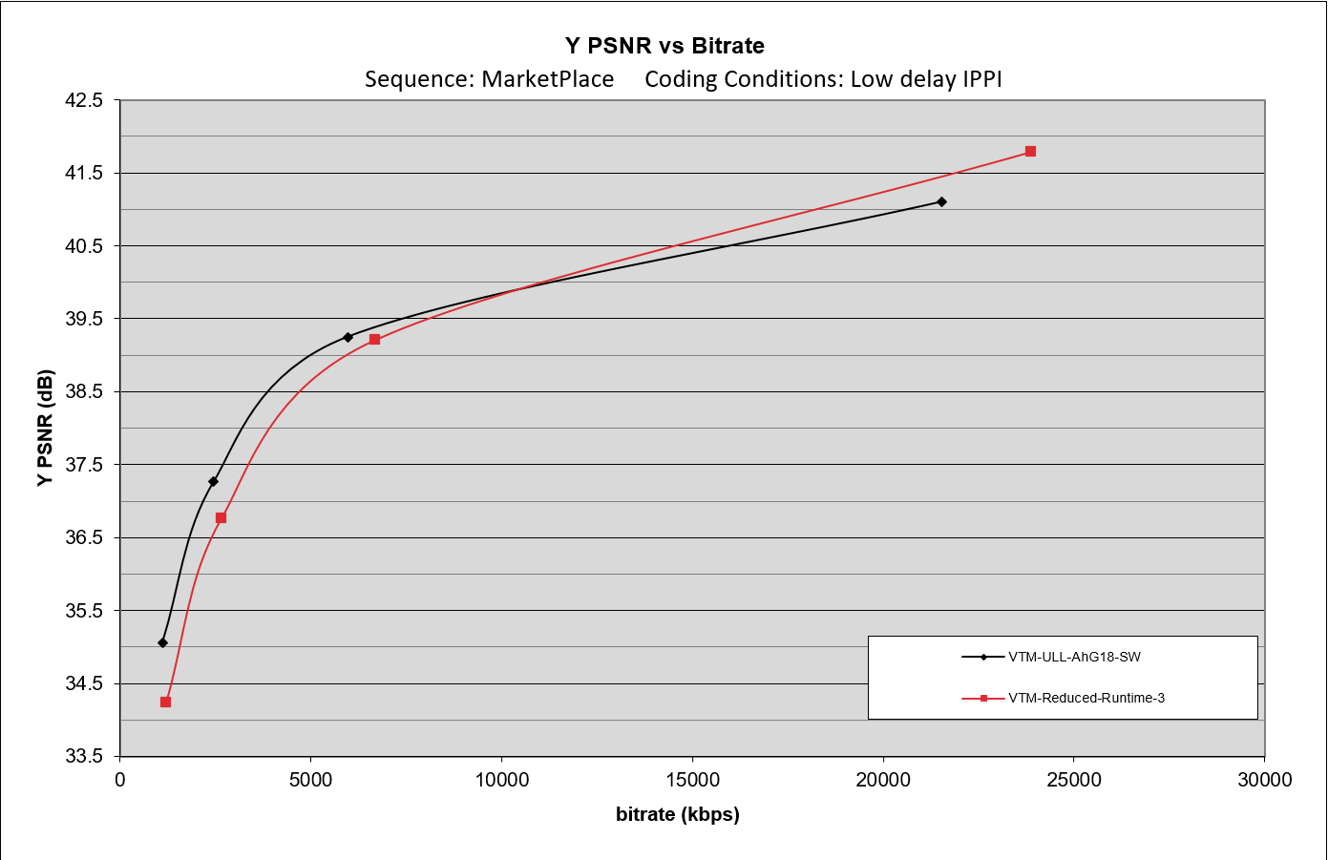
Figure 8. VTM-ULL-AhG18-SW vs. VTM-Reduced-Runtime-3. “MarketPlace”.
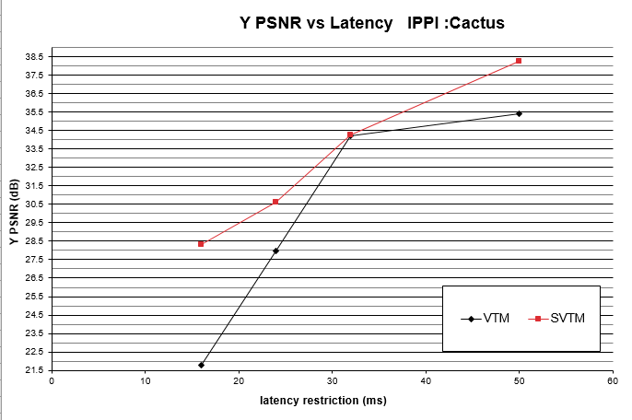
Figure 9. VTM vs. SVTM, Reduced-Runtime-3 configuration. “Cactus”.

Conclusion
This contribution enables back the full set of VTM coding tools, describes software modification required to stability of APS logic in case of packet loss. The performance under ultra-low latency test scenario proposed of full VTM coding tools set using fast encoding configuration VTM-Reduced-runtime-3 (proposed in JVET-AL0055 and currently used in draft CfE Section 3 (fast encoding) of JVET-АМ0041) is reported. Additionally, the software bug of Wi-Fi retransmission logic was identified and fixed. It is proposed to adopt described modifications to AHG18 simulation software.

Patent rights declaration(s)
Huawei Technologies may have current or pending patent rights relating to the technology described in this contribution and, conditioned on reciprocity, is prepared to grant licenses under reasonable and non-discriminatory terms as necessary for implementation of the resulting ITU-T Recommendation | ISO/IEC International Standard (per box 2 of the ITU-T/ITU-R/ISO/IEC patent statement and licensing declaration form).

