    Joint Video Experts Team (JVET)  of ITU-T SG21 WP3/21 and ISO/IEC JTC 1/SC 29  39th Meeting, Daejeon, KR, 26 June – 4 July 2025 | Document: JVET-AM0188-v3

Title: | AHG18: An introduction to the next generation media transport protocol—Media over QUIC(MoQ)
Status: | Input document to JVET
Purpose: | Information
Author(s) or  Contact(s): | Weihang Ding  Xiang Ma  Sergey Ikonin  Elena Alshina | Email: | dingweihang1@huawei.com  maxiang6@huawei.com
Source: | Huawei Technologies Co., Ltd.
_____________________________

Abstract
In this contribution, the progresses of the next generation media transport protocol, i.e., Media over QUIC(MoQ), are introduced. MoQ is designed by IETF to support a wide range of latency requirements ranging from seconds to tens of milliseconds. Its flexible priority mechanism, inherited from QUIC, ensures that critical information is transmitted preferentially, while less-critical data is dropped first during congestion—an attribute particularly advantageous for supporting Real-time Communication (RTC), especially for the ultra-low latency (ULL) application scenarios. Moreover, MoQ inherits from QUIC the capability to transmit both reliable streams and unreliable datagrams over a single connection. The abovementioned capability and MoQ’s unique hierarchical object data model bring new transmission features, and there is a new possibility to enable ULL applications if the video codec can better fit the new transmission features.

Introduction
In recent years, QUIC [1] has emerged as a prominent media transport protocol, offering features like connection migration, encryption, and multiplexed connections. In addition, its unreliable extension enables reliable streams and unreliable datagram flows to share the same QUIC connection [2]. With these characters, QUIC has the potential to support ULL communication. Despite this recognition, a gap persists between QUIC and practical ULL applications. A key reason is that media transport seldom leverages QUIC’s full capabilities. For instance, QUIC’s parallel streams mitigate head-of-line blocking and support content prioritization, but the number of streams is typically limited. Most applications split media into only two streams: audio and video.
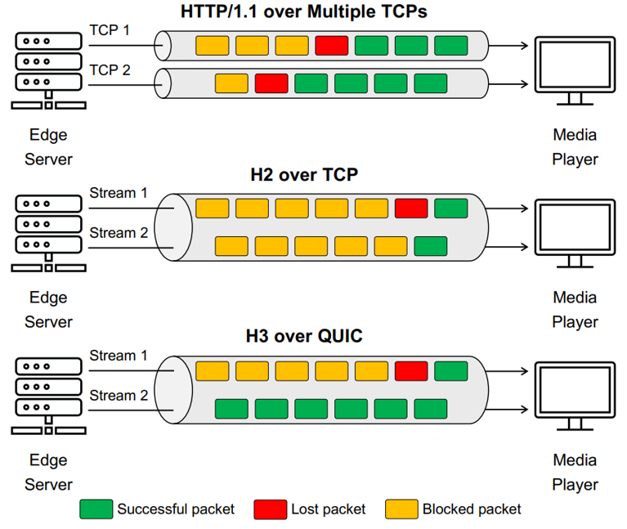
Fig.1 QUIC multi-stream transmission, compared with HTTP/1.1 and H2[3]
To fully leverage the benefits of QUIC, Media over QUIC (MoQ) was proposed. MoQ is a unified low-latency media transport protocol for ingest and distribution of media. This solution addresses use cases including live streaming, gaming, and media conferencing and will scale efficiently [4]. Following discussions initiated in March 2022, the IETF MoQ Group released the first Media over QUIC Transport (MoQT) draft [5] in July 2023. MoQ’s maturity has grown steadily, with the latest MoQT version 11 published in April 2025. The primary MoQ draft is nearing completion, and an RFC is expected to be published by 2027. More than 20 companies (including OS, CDN, OTT, Network providers) contribute to the development of MoQ [6], positioning MoQ as a leading candidate for the next-generation, widely adopted media transport protocol.

MoQ features

Overview
MoQT allows a producer of media to publish data and have it consumed via subscription by a multiplicity of endpoints. Unlike traditional client-server architectures, MoQ supports intermediate relay nodes operated by content distribution networks(CDNs) and is designed for high scale and low latency distribution [4]. MoQ’s architecture leverages QUIC’s encryption, multiplexing, congestion control, and fast connection setup (e.g., 0-RTT) to ensure reliability and resilience. As Fig. 2 shows, MoQ works above QUIC with one layer (MoQT) focuses on media transport [5] and another (WARP) designing a media format [7].
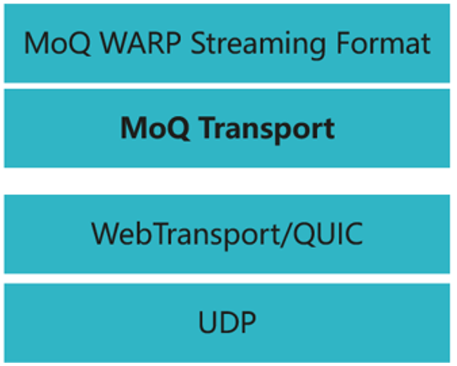
Fig.2 MoQ layered structure

Object data model
MoQ has a hierarchical data model, comprised of tracks which contain groups, and groups that contain objects. Inside of a group, the objects can be organized into subgroups. In the example given by MoQ[5], the video track is sent using a codec of temporal scalability. Each "group of pictures(GoP)" in a video is sent as a group because the first frame is needed to decode later frames. This allows the client to join at the logical points where they can get the information to start decoding the stream. The temporal layers are sent as separate subgroups (corresponds to different streams) to allow the stream-level priority mechanism. Each frame of video on a given layer is sent as a single object.
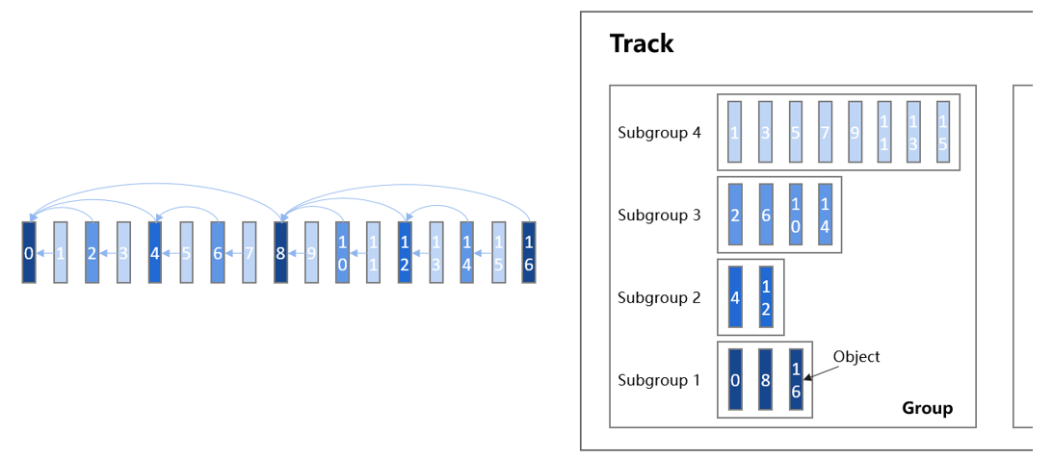
Fig.3 MoQ object data model: an example with SVC. A GoP can fit into a MoQ Group

Priority mechanism
MoQ’s priority mechanism, is designed to schedule media transmission by assigning hierarchical delivery precedence to different data streams, thereby optimizing real-time performance under varying network conditions [8]. Specifically, the mechanism enables fine-grained control over packet prioritization: critical media elements (e.g., key frames, codec metadata) are assigned high priority to ensure reliable and timely delivery, while less-criticle data (e.g., redundant video layers) are designated lower priority. During congestion, the mechanism prioritizes high-priority objects for transmission first, dropping low-priority data to maintain low latency and stream continuity. By integrating this prioritization framework, MoQ ensures that media streams remain resilient and responsive, even in unstable network environments.
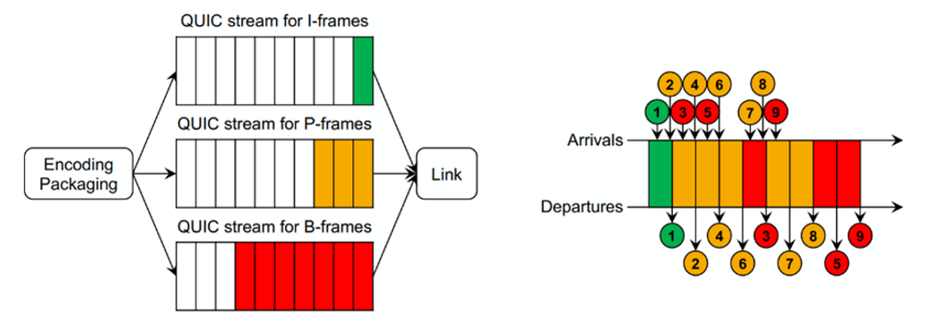
Fig.4 An example illustrating the priority mechanism in MoQ [7].

Reliable and unreliable transmission
MoQ inherits the capability to support both reliable transmission and unreliable transmission in one single connection from QUIC. [9] shows that the co-existence of reliable streams and unreliable datagrams on the same connection shows better performance in terms of observed video quality and freezes.

Discussion on MoQ and ULL RTC
A goal of MoQ is to support existing encoding and packaging schemas, both for backwards compatibility and for interoperability with the established content preparation ecosystem. To achieve ULL, collaborative design between MoQ and video codecs is preferable. Codecs should leverage MoQ’s capabilities to optimize performance in ULL scenarios.
The flexible priority mechanism of MoQ is the key to achieve ULL. MoQ priorities allow a subscriber and original publisher to influence the transmission order of objects within a session. The priority is associated with each subgroup, which enables the nodes in MoQ to drop objects with lower priorities when congestion occurs or the latency limit is ultra-strict. The subgroup with the highest priority should be self-decodable. An object should be recovered without the objects with lower priorities as they are transmitted lastly and may be dropped.
Another advantage of MoQ lies in its capability to support both reliable transmission and unreliable transmission over a single connection. This is enabled by QUIC’s datagram extension designed for real-time transmission. There is a continuous debate on whether reliable transmission or unreliable transmission should be used in RTC. RTC applications tends to use a combination of reliable and unreliable transmissions to ensure the reliability of key information (e.g., control message, I frames, et.al). For example, WebRTC employs FEC to mitigate packet losses, but when the key information is unrecoverable, retransmissions controlled by WebSocket or SCTP occur. MoQ enables reliable transmission of high-priority key information and unreliable transmission of low-priority information. While key information may arrive late, its delivery to the receiver is still guaranteed. Given that decoding time is significantly shorter than the frame interval, delayed data—though unavailable in its original time slot—may still be useful in subsequent slots, thereby preventing long freezes.
Despite MoQ being suitable for SVC, SVC is not good enough in RTC. Key challenges include high encoding/decoding complexity and reduced compression efficiency. For spatial scalable SVC, the resolution can be changed only in GoP level, not in frame level. Some RTC applications such as video conferences opt for temporal scalable SVC. However, results [10] indicate that only 25% of packets may be dropped while ensuring only half the frame rate. This stems from the hierarchical structure, where lower-layer references require more bits for encoding, limiting packet loss tolerance.
In general, MoQ is a media transport protocol that will be standardized, leveraging QUIC’s multi-streaming capabilities. The multi-stream architecture offers differentiated prioritization, transmission modes (reliable/unreliable), and congestion control strategies for different media content during transmission, which is particularly beneficial for ULL scenarios. Therefore, MoQ prefers the video content from encoder to come with multiple "streams" too. Ideally, the video codec should support error-resilient decoding—i.e., maintain decode ability even when lower-priority streams are dropped.

Conclusion
MoQ, a next-generation media transport protocol backed by companies in OS, CDN, and OTT [6], is characterized by its low latency and strong scalability. MoQ achieves low latency by converting random packet loss into selective loss, since loss is inevitable in ULL scenarios. By leveraging QUIC’s priority mechanism and unreliable extension, MoQ ensures reliability for critical data while dropping non-essential packets firstly. These new features of MoQ are highly suitable for ULL scenarios, whereas current video codecs have not fully incorporated these characteristics. If the next-generation video codec includes adaptability designs to align with MoQ’s features, they could fully leverage the protocol’s capabilities to deliver superior ULL experiences.

References
- IETF RFC 9000: "QUIC: A UDP-Based Multiplexed and Secure Transport", < https://www.rfc-editor.org/rfc/rfc9000>.
- IETF RFC 9221: "An Unreliable Datagram Extension to QUIC", < https://www.rfc-editor.org/rfc/rfc9221>.
- A. B. Demir, M. Parlak, Z. Gurel, D. Ugur and A. C. Begen, "Impact of Prioritized HTTP/3 Transport on Low-Latency Live Streaming," 2024 IEEE International Conference on Multimedia and Expo Workshops (ICMEW), Niagara Falls, ON, Canada, 2024, pp. 1-6, < https://ieeexplore.ieee.org/abstract/document/10645374>
- Charter for Media over QUIC (moq) Working Group, < https://datatracker.ietf.org/wg/moq/about/ >.
- IETF draft-ietf-moq-transport-11: "Media over QUIC Transport (MoQT)",
< https://www.ietf.org/archive/id/draft-ietf-moq-transport-11.html>.
- minutes-interim-2025-moq-10-202505061130-00, <https://datatracker.ietf.org/doc/minutes-interim-2025-moq-10-202505061130/>.
- IETF draft-ietf-moq-warp-00: "WARP Streaming Format", <https://www.ietf.org/archive/id/draft-ietf-moq-warp-00.html>.
- Zafer Gurel, Tugce Erkilic Civelek, and Ali C. Begen. 2024. "This is The Way: Prioritization in Media-over-QUIC Transport," In Proceedings of the 3rd Mile-High Video Conference (MHV '24). Association for Computing Machinery, New York, NY, USA, 113–114, < https://dl.acm.org/doi/10.1145/3638036.3640280 >.
- H. K. Ravuri, M. T. Vega, J. D. Van Hooft, T. Wauters and F. De Turck, "Adaptive Partially Reliable Delivery of Immersive Media Over QUIC-HTTP/3," in IEEE Access, vol. 11, pp. 38094-38111, 2023, <https://ieeexplore.ieee.org/document/10103593>.
- Texas Instruments, "Overview of Temporal Scalability With Scalable Video Coding(SVC), " SPRABG3-November 2010 <https://www.tij.co.jp/jp/lit/pdf/sprabg3>

Patent rights declaration(s)
Huawei Technologies does not have any current or pending patent rights relating to the technology described in this contribution.

