    Joint Video Experts Team (JVET)  of ITU-T SG21 WP3/21 and ISO/IEC JTC 1/SC 29  39th Meeting, Daejeon, KR, 26 June – 4 July 2025 | Document: JVET-AM0187-v2

Title: | On Intra Period of Random Access Test Case for HD and below Content
Status: | Input document to JVET
Purpose: | Proposal
Author(s) or  Contact(s): | Xiang Li  Li Zhang  Xianglin Wang  Shan Liu  Alberto Duenas  Andrey Norkin  Wenhao Zhang  Yan Ye  Andrew Segall | Tel:  Email: | xlxiangli@google.com  lizhang.idm@bytedance.com  xianglinwang@kwai.com  shanl@global.tencent.com  alberto.duenas@wbd.com  anorkin@netflix.com  Wenhao.Zhang2@disney.com  yan.ye@alibaba-inc.com  asegall@amazon.com
Source: | Google, Inc., Bytedance Inc., Kwai Inc., Tencent, Warner Bros. Discovery, Inc., Netflix, Disney, Alibaba, Amazon
_____________________________

Abstract
In today’s streaming applications, intra period is reportedly much larger than 1 second used in our CTC, especially when the adaptive intra picture inserting by rate control is excluded. It is proposed to use larger intra period of 2 seconds for content with resolution at or below HD, in random access test cases of CfP and future CTC to better align with practical applications while keeping a reasonable testing runtime.

Introduction
Streaming’s share of total TV viewing (in US) reached a record high in April, according to Nielsen’s monthly report of The Gauge™ [1][2].
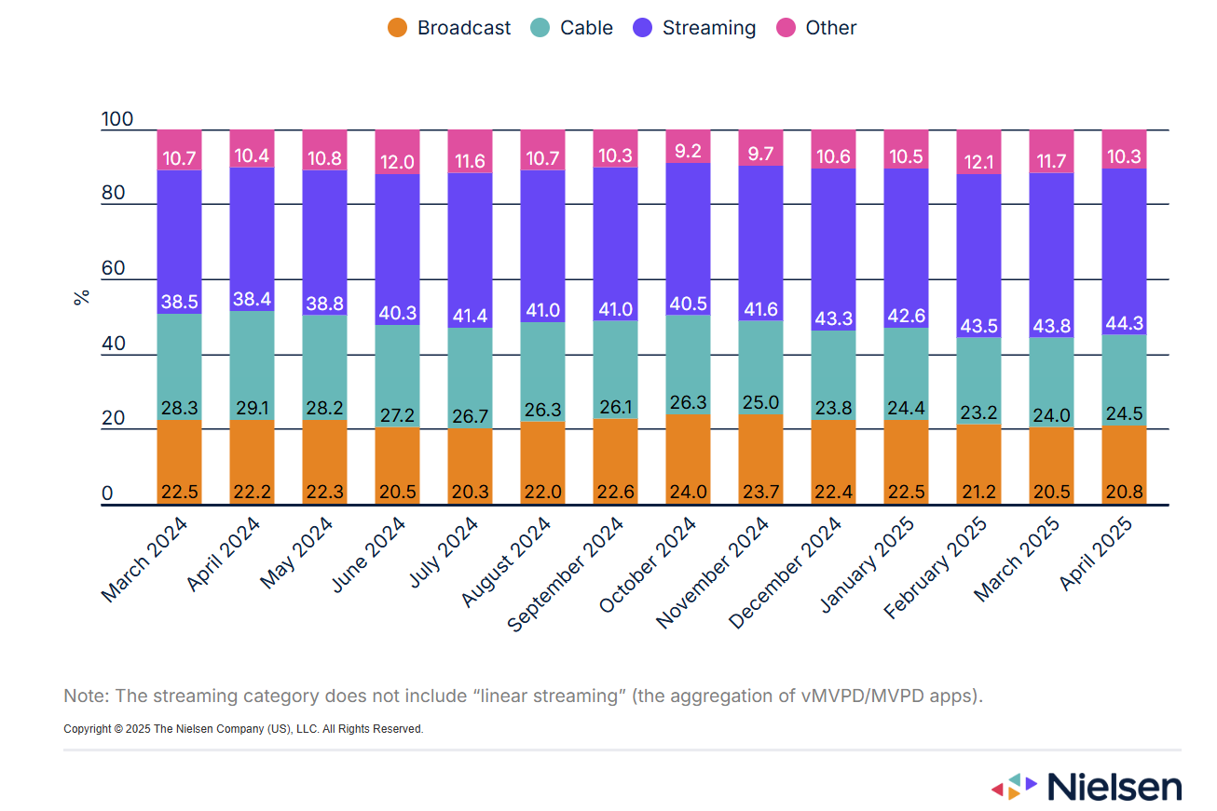
For most streaming services, the intra period is much larger than 1 second when the auto intra picture insertion by rate control is not considered. However, in VTM and ECM CTC, 1-second intra period is still kept for random access test case, which is far from today’s practical streaming applications.
To study the impact of intra period (IP) in RA, CfE sequences defined in [3] were tested with VTM/ECM CTC QPs (22, 27, 32, 37), where VTM-23.9 with 1-second intra period (VTM-23.9-ip1s) was used as the anchor. Note that the intra period in the following tests is not exact 1/2/3/5 seconds, but an approximation to the target, rounding to a multiple of 32.

SDR RA UHD/4K

SDR RA HD

HDR RA UHD/4K

HDR RA Cropped 8K

UGC RA (HD)

From the results, it can be observed that significant coding gain was obtained by using larger intra period with a bit increased the total encoding runtime for VTM-23.9. The trade-off between overall encoding time and coding gain is actually quite good. For HD and UGC content, larger intra period even slightly decreased the overall encoding time of ECM-16.1, which may be due the complicated intra picture encoding by ECM.
However, the larger intra period leads to longer segments in parallel encoding for random access, which introduces some difficulty for the tests, especially for resolutions higher than HD.

Proposal
To better align the random access test conditions with today’s streaming applications, it is proposed to use larger intra period of 2-5 seconds. On the other hand, to keep a reasonable testing runtime, it is proposed to apply an intra period value of 2 seconds, for HD and below content in random access test case of CfP and future CTC during the next generation standardization phase. Experiments show that encoding HD with 2-second intra period will result in similar runtime as encoding 4K/UHD with 1-second intra period, therefore not creating a new worst case. Encoding with 2 seconds also gives the majority performance gain from using a larger intra period.
It is noted that the CfE will benefit from the suggested change as well. However, to avoid the need to regenerate the VTM and ECM test points, the proponents suggest to consider this meaningful change for the CfP and future CTC.

References
[1] https://www.nielsen.com/data-center/
[2] https://www.nielsen.com/news-center/2025/the-gauge-streaming-peaks-again-drawing-from-successful-multiplatform-strategies/
[3] J.-R. Ohm, M. Wien, “Draft Joint Call for Evidence on video compression with capability beyond VVC”, Joint Video Experts Team (JVET), 38th Meeting, by Teleconference, March/April 2025, Doc. JVET-AL2010.

Patent rights declaration(s)
Google, Inc. does not have any current or pending patent rights relating to the technology described in this contribution.
Bytedance, Inc. does not have any current or pending patent rights relating to the technology described in this contribution.
Kwai, Inc. does not have any current or pending patent rights relating to the technology described in this contribution.
Tencent, Inc. does not have any current or pending patent rights relating to the technology described in this contribution.
Warner Bros. Discovery, Inc. does not have any current or pending patent rights relating to the technology described in this contribution.
Netflix does not have any current or pending patent rights relating to the technology described in this contribution.
Disney does not have any current or pending patent rights relating to the technology described in this contribution.
Alibaba does not have any current or pending patent rights relating to the technology described in this contribution.
Amazon does not have any current or pending patent rights relating to the technology described in this contribution.

