    Joint Video Experts Team (JVET)  of ITU-T SG 16 WP 3 and ISO/IEC JTC 1/SC 29  39th Meeting, Daejeon, KR, 26 June – 4 July 2025 | Document: JVET-AM0185-v2

Title: | AhG11: Decomposed Content-Adaptive VLOP
Status: | Input document to JVET
Purpose: | Report
Author(s) or  Contact(s): | Zhuowei Xu  Jacek Konieczny  Alexey Filippov  Christopher Hollmann  Vasily Rufitskiy  Tianyu Dong  Hongdong Qin | Tel:  Email: | zhuowei.xu@tcl.com  jacek.k@tcl.com  alexey.filippov@tcl.com  christopher.hollmann@tcl.com  vasily.rufitskiy@tcl.com  tianyu.dong@tcl.com  hongdong.qin@tcl.com
Source: | TCL

Abstract
This contribution studies the dimension-wise decomposed representation of multiplier in case of content-adaptive VLOP (CAVLOP). The BD-rate gain under RA configuration are reported as below.
- Compared with NNVC-13 with CAVLOP ON, the averaged gain is reported to be:
{-0.09 %, -0.40%, -0.32%, EncT: XX.X%, DecT: XX.X%}

Introduction
In JVET-AK0175 [1], a dimension-wise decomposed representation of layer multipliers is proposed, for a purpose of content adaptation of Neural Network-based Loop Filter (NNLF).
The proposed decomposed multiplier is achieved by applying a dimension-wise decomposition on the one-dimensional multiplier, as illustrated in Fig 1. Specifically, for a selected multiplier $m$, it is obtained by overfitting two low-rank matrices as:
 | $$m=flatten(W_{m1}×W_{m2}^{⊤})$$ | Eq. (1)
where $×$ is a product operation, and $W_{m1}∈R^{d_{1}×r}$, $W_{m2}∈R^{d_{2}×r}$ are dimension-wise decomposed components, $d_{1}$ and $d_{2}$ are sizes of decomposition and $d_{1}×d_{2}=c_{m}$, $r$ is the rank of decomposition and $flatten\left(⋅\right)$ is a tensor flattening operation to align the result with the original shape of $m$:
 | $$R^{d_{1}×d_{2}}→ R^{c_{m}}$$ | Eq. (2)
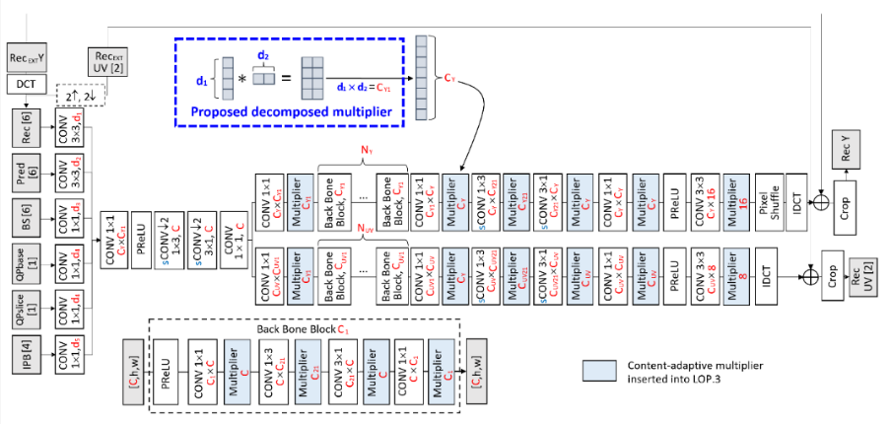
Fig 1. Decomposed multipliers on LOP3 filter [1].
This tool is demonstrated to be useful in the case of content-adaptive model of LOP (i.e., DCALOP3 in JVET-AK0175 [1], DCALOP4 in JVET-AJ0169 [2]) and gets adopted in NNVC-13.

Proposal
In this proposal, the dimension-wise decomposed multiplier is tested under content-adaptive model of VLOP [3] (as DCAVLOP). Experimental results are provided under NNVC-13.

Overfitting
Table 2 shows the details of NN information during the overfitting stage.
Table 3. Network Information for NN-based Video Coding Tool Testing in Training Stage
Network Information in Overfitting Stage
Mandatory | GPU Type | GPU NVIDIA A10-24GB
Mandatory | Framework: | PyTorch 1.12.1
Mandatory | Number of GPUs per Task | 1
Mandatory | Epoch: | 100 epochs
Mandatory | Batch size: | 64
Mandatory | Loss function: | Weighted-MSE
Mandatory | Training time (for 1 model – 1 segment): | A1 & A2: from 1.6h to 5.6h  B: from 0.4h to 2.6h  C: ~ 0.3h  D: ~ 0.1h  F: from 0.2h to 2.5h
Mandatory | Training data information: | JVET CTC RA mandatory sequences
Mandatory | Training configurations for generating compressed training data (if different to VTM CTC):
Optional
Optional | Number of iterations
Optional | Patch size | 144$×$144
Optional | Learning rate: | 2e-3 (for MLB=1,2,3) / 1e-3 (for MLB =0)
Optional | Learning rate update strategy | Constant learning rate
Optional | Optimizer: | ADAM
Optional | Preprocessing: | Up-sample 72x72 UV signal to 144x144 blocks  Normalize to 0~1
Optional | Mini-batch selection process:
Optional | Training data update strategy:
Optional | Other information:

Inference
Table 3 describes the loop-filter information at inference stage.
Table 4. Network Information for NN-based Video Coding Tool Testing in Inference Stage
Network Information in Inference Stage
Mandatory | HW environment:
Mandatory | GPU Type | CPU only
Mandatory | Framework: | SADL
Mandatory | Number of GPUs per Task | 0
Mandatory | Number of Parameters | 16955
Mandatory | Parameter Precision (Bits) | Int16
Mandatory | Memory Parameter (MB) | 0.03
Mandatory | MAC/Pixel (Kilo) | 5.48
Optional
Optional | Total Conv. Layers | 106
Optional | Total FC Layers | 0
Optional | Total Memory (MB)
Optional | Batch size:
Optional | Patch size | 128x128 / 256x256
Optional | Changes to network configuration or weights required to generate rate points
Optional | Peak Memory Usage (Total)
Optional | Peak Memory Usage (per Model)
Optional | Border handling
Optional | Other information:

Experimental results
DCAVLOP is tested over NNVC-13.

Results on VLOP over NNVC-13
Table 3 shows the coding performance of DCAVLOP in the RA configuration, compared with NNVC-13 with CAVLOP [4] ON.
Table 3. Coding performance of DCAVLOP, compared with CAVLOP
 | BD-rate Over NNVC-13+CAVLOP
 | Y-PSNR | U-PSNR | V-PSNR | Y-MSIM | U-MSIM | V-MSIM | EncT | DecT CPU | PSNR Overlap
Class A1 | -0.06% | 0.16% | -0.55% | -0.08% | 0.02% | -0.81%
Class A2 | -0.18% | -0.69% | -0.31% | -0.13% | -0.52% | -0.22%
Class B | -0.04% | -0.75% | -0.43% | -0.05% | -1.36% | -0.22%
Class C | -0.10% | -0.17% | -0.02% | -0.07% | -0.31% | -0.16%
Overall | -0.09% | -0.40% | -0.32% | -0.08% | -0.64% | -0.32%
Class D | -0.03% | -0.19% | -0.19% | 0.00% | -0.29% | -0.36%
Class F | -0.33% | -1.11% | -0.88% | 1.63% | 1.65% | 2.10%

Recommendation
It is recommended to study the DCAVLOP in next round of EE1.

References
- Z. Xu, J. Konieczny. AhG11: AhG11: Dimension-wise decomposed multiplier for content-adaptive loop-filter. JVET-AK0175. Jan 2025.
- Z. Xu, J. Konieczny, A. Filippov, C. Hollmann, V. Rufitskiy, T. Dong. EE1-1.3 Dimension-wise decomposed representation of multiplier for content-adaptive loop-filter. JVET-AJ0169. Apr 2025.
- E. Alshina, R. Chang, F. Galpin, Y. Li, D. Rusanovskyy, M. Santamaria, J. Ström, Z. Xie. Exploration Experiments on Neural Network-based Video Coding (EE1). JVET-AJ2023. Nov 2025.
- R. Yang, M. Santamaria, F. Cricri, M.M. Hannuksela, D.Bugdayci Sansli, A.Hallapuro, J.Lainema, H. Zhang (Nokia), D.Rusanovskyy, Y.Li, M.Karczewicz (Qualcomm). EE1-1.4: Content-adaptive VLOP-filter. JVET-AI0157. Jul 2024.

Patent rights declaration(s)
TCL may have current or pending patent rights relating to the technology described in this contribution and, conditioned on reciprocity, is prepared to grant licenses under reasonable and non-discriminatory terms as necessary for implementation of the resulting ITU-T Recommendation | ISO/IEC International Standard (per box 2 of the ITU-T/ITU-R/ISO/IEC patent statement and licensing declaration form).

