    Joint Video Experts Team (JVET)  of ITU-T SG21 WP3/21 and ISO/IEC JTC 1/SC 29  39th Meeting, Daejeon, KR, 26 June – 4 July 2025 | Document: JVET-AM0177-v3

Title: | AHG11: Deep Reference Frame Generation for Inter Prediction Enhancement with Structural Re-parameterization
Status: | Input document to JVET
Purpose: | Proposal
Author(s) or  Contact(s): | Wenzhuo Zhang, Chengzhuo Gui,  Nianxiang Fu, Xinxin Chen, Wenzhuo Ma, Zhenzhong Chen | Email: | {wenzhuo, chengzgui, nianxiangfu, xinxinchen, mwzgorgeous,  zzchen}@whu.edu.cn
Source: | Wuhan University
_____________________________

Abstract
This proposal builds upon the lightweight deep reference frame generation (LDRF) method of JVET-AG0122 by introducing a structural re-parameterized interpolation diverse branch block (Inter-DBB), which further enhances inter prediction efficiency of the original LDRF in NNVC. During training, Inter-DBB employs multi-branch convolutions to capture diverse spatial-channel correlations, while at inference these branches are converted into a single 3×3 convolution via structural re-parameterization, preserving model structure and computational complexity. It provides average BD-rate gains of about −1.67% for luma (Y) and −0.71%/−0.77% for chroma (U/V) components compared to the NNVC-12.0 anchor for the RA configuration. Relative to the baseline DRF model in JVET-AG0122, the proposed method achieves −0.13 % BD-rate for Y and +0.20 %/+0.06 % for U/V, respectively.

Introduction
JVET-AG0122 [1] proposes a deep reference frame generation (DRF) method to enhance VVC inter prediction. During the encoding and decoding process, the network receives two reconstructed frames from the decoded picture buffer as inputs and generates a new frame. The generated frame will be put into the reference picture lists as an additional reference for the current encoding picture, which enhances the inter prediction.
Building upon the lightweight frame interpolation network (LDRF) from JVET-AG0122, this contribution employs structural re-parameterization to design a tailored interpolation diverse branch block (Inter-DBB) [3], enhancing the performance of LDRF without changing its inference-time network structure or computational complexity. LDRF from JVET-AG0122 and this proposal are both trained on the same dataset and hyperparameters depicted in Table 1.

Proposed Method

Framework
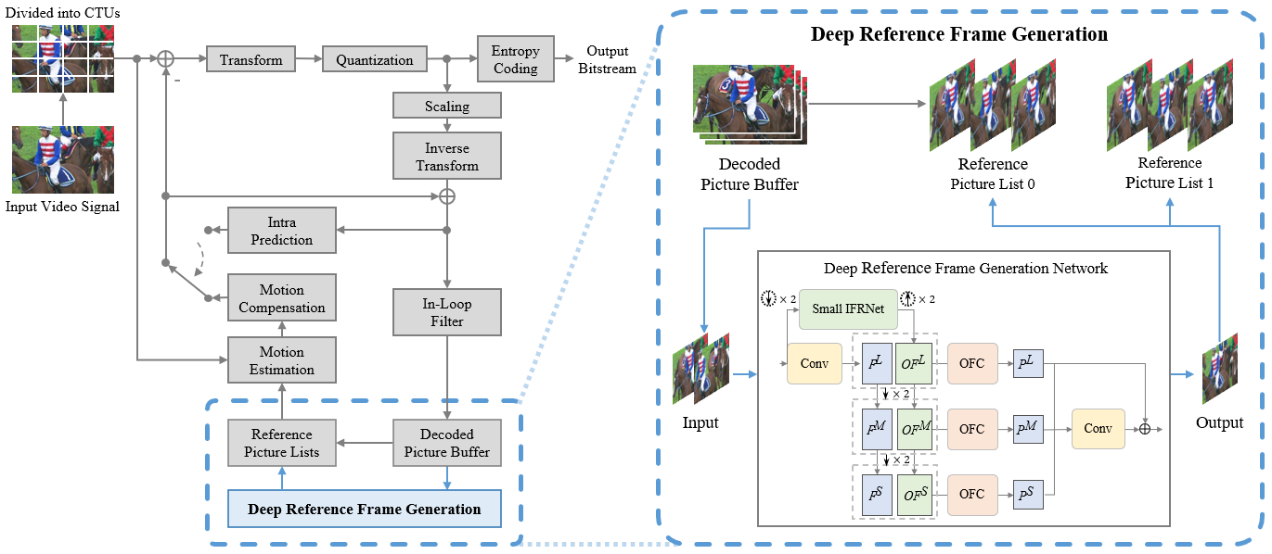
Fig. 1: The framework of the proposed DRF method
The framework of the proposed DRF method is depicted in Fig. 1 [1]. In this approach, two reconstructed frames chosen from the DPB are inputted into the deep reference frame generation network to synthesize a new frame. This synthesized frame is then added to both reference picture list0 and list1, using the same POC as the current encoding frame. It serves as an additional reference frame for subsequent encoding processes.

Network architecture
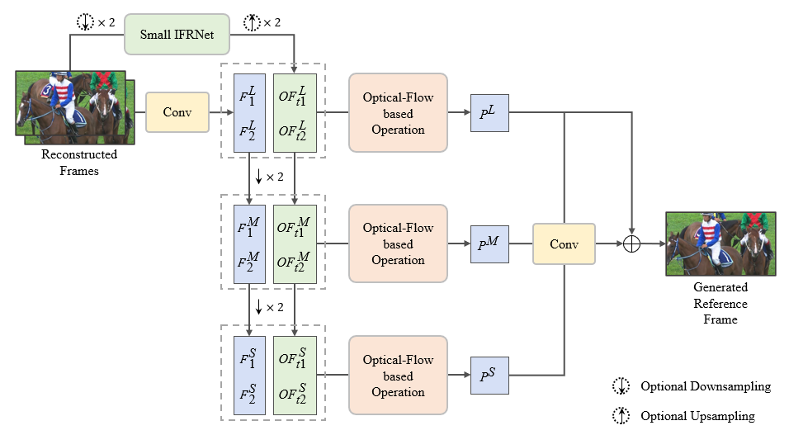
Fig. 2: The architecture of the DRF networks
Fig. 2 [1] illustrates the architecture of the DRF (2900K, 69kMAC/pixel) during inference time. This contribution replaces every 3x3 convolutional layer in the LDRF network—except those inside the optical-flow estimation sub-network—with an interpolation diverse branch block (Inter-DBB). However, at inference time the Inter-DBB branches are converted into single 3 × 3 kernels, yielding numerically identical outputs while keeping the parameter count and per-pixel complexity exactly the same as in the original LDRF network.

Inter-DBB Design
The architecture of the proposed Inter-DBB is shown in Fig. 3. Inter-DBB is designed using structural re-parameterization, adopting different structures during training and inference.
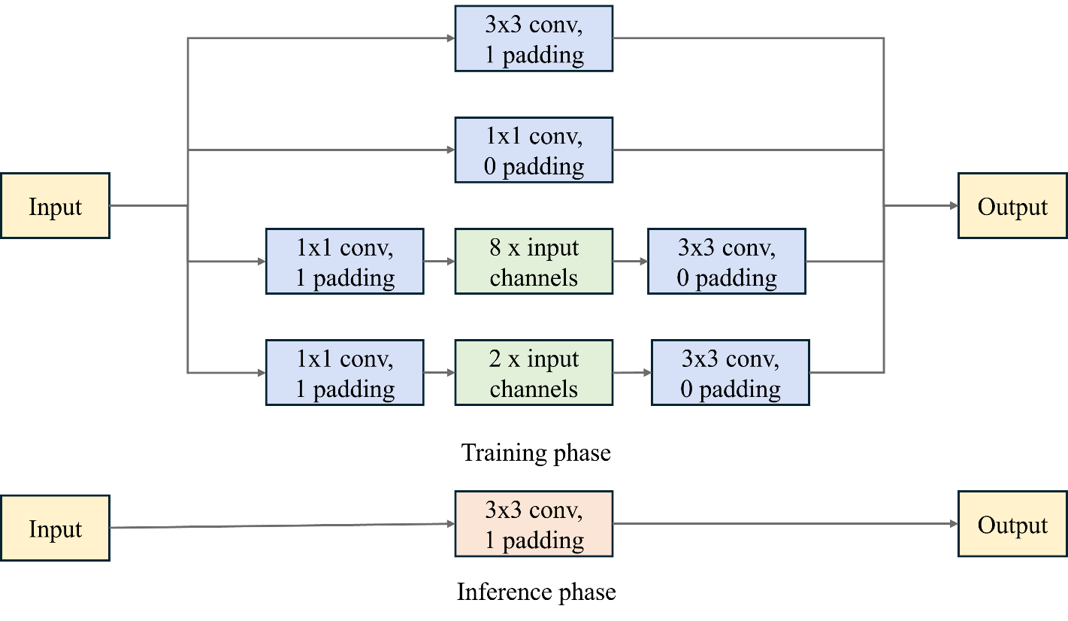
Fig. 3: The architecture of the Inter-DBB module proposed
During training, the proposed Inter-DBB module deploys four parallel pathways: (i) a standard 3 × 3 convolution with one-pixel padding; (ii) a 1 × 1 pointwise convolution without padding; (iii) an expansion branch that first uses a 1 × 1 convolution (padding = 1) to widen the feature width eight-fold, followed by a 3 × 3 convolution (padding = 0); and (iv) an analogous expansion branch whose intermediate width is only twice the input channels. Relative to a single convolutional layer, the multi-branch design simultaneously probes spatial and channel interactions across multiple receptive-field scales, enabling richer feature fusion and thereby delivering superior performance.
The Inter-DBB can convert the trained four training-time branches (Fig. 3, top) into a single 3 × 3 convolutional layer (Fig. 3, bottom) for inference as follows:
1. Kernel normalization of the two elementary branches
• Branch (i): the 3 × 3 convolution with one-pixel padding already matches the target kernel size and is kept unchanged, yielding weights $W_{3×3}$ and bias $b_{3×3}$.
• Branch (ii): the 1 × 1 convolution without padding is embedded into a 3 × 3 support by zero-padding the eight off-centre locations, producing ${\tilde{W}}_{1×1}$ and bias $b_{1×1}$.
2. Composition of the two “expand–convolve” chains
• Branch (iii) first expands the channel dimension eight-fold with a 1 × 1 convolution $W_{8×}^{1×1}$ (padding = 1) and then applies a 3 × 3 convolution $W_{8×}^{3×3}$ (padding = 0). Because both layers are linear, their composition equals a single 3 × 3 kernel.
$${\tilde{W}}_{8×}=W_{8×}^{3×3}W_{8×}^{1×1}, {\tilde{b}}_{8x}=W_{8×}^{3×3}b_{8×}^{1×1}+b_{8×}^{3×3}$$
• Branch (iv) undergoes the same procedure with a two-fold expansion, giving and ${\tilde{W}}_{2×}$ and ${\tilde{b}}_{2×}$.
3. Branch aggregation
The outputs of the four branches are summed element-wise; therefore the effective inference-time kernel and bias are obtained by a simple addition:
$$W_{fused}=W_{3×3}+{\tilde{W}}_{1×1}+{\tilde{W}}_{8×}+{\tilde{W}}_{2×}, b_{fused}=b_{3×3}+b_{1×1}+{\tilde{b}}_{8×}+{\tilde{b}}_{2×}$$
4. Resulting equivalence
The single 3 × 3 layer parameterized by $\{W_{fused}, b_{fused}\}$ reproduces exactly the same numerical output as the original four-way Inter-DBB for any input tensor, while leaving the parameter count and per-pixel complexity identical to those of the baseline LDRF network.

Network information in training stage
Table 1: Network information for the NN-based video coding tool testing in training stage
Network Information in Training Stage
Mandatory | GPU Type | GeForce RTX 3060
Mandatory | Framework | PyTorch 1.13.1
Mandatory | Number of GPUs per Task | 1(LDRF Network),4(this proposal)
Mandatory | Epoch | 300
Mandatory | Batch size | 48 x 3 frames (as a triplet)
Mandatory | Loss function | L1
Mandatory | Training time (for 1 model) | 4.5days(LDRF Network), 6days(this proposal)
Mandatory | Training data information | Vimeo-90K triplet [2]
Mandatory | Training configurations for generating compressed training data (if different to VTM CTC) | VTM-11.0_NNVC-12.0, QP{22, 27, 32, 37, 42}
Optional | Number of iterations
Optional | Patch size | 256x256
Optional | Learning rate | 2e-4
Optional | Learning rate update strategy
Optional | Optimizer | ADAM
Optional | Preprocessing
Optional | Mini-batch selection process
Optional | Training data update strategy
Optional | Other information

Network information in inference stage
Table 2: Network information for the NN-based video coding tool testing in inference stage
Network Information in Inference Stage
Mandatory | HW environment
Mandatory | GPU Type | CPU only
Mandatory | Framework | SADL
Mandatory | Number of GPUs per Task | 0
Mandatory | Number of Parameters (Each Model) | 2900K
Mandatory | Total Number of Parameters (All Models) | 2900K
Mandatory | Parameter Precision (Bits) | 32 (F)
Mandatory | Multiply Accumulate (kMAC/pixel) | 69
Optional | Total Conv. Layers
Optional | Total FC Layers
Optional | Total Memory (MB)
Optional | Batch size | 1
Optional | Patch size | 256x256 (with 16 boundary padding)
Optional | Changes to network configuration or weights required to generate rate points
Optional | Peak Memory Usage (Total)
Optional | Peak Memory Usage (per Model)
Optional | Border handling
Optional | Other information

Results
Implemented on the VTM-11.0_NNVC-12.0 following common test conditions [4] to be used in the context of neural network video coding experiments, the test results of the proposed DRF method with structural re-parameterization under NNVC-RA configuration are presented in Table 3.
Table 3: Performance of the proposed method (NNVC-RA, full length).
 | Random access Main10
 | BD-rate Over VTM-11.0_NNVC-12.0
 | Y-PSNR | U-PSNR | V-PSNR | Y-MSIM | U-MSIM | V-MSIM | EncT | DecT
Class A1 | -1.62% | -1.33% | -1.41% | -1.89% | -1.51% | -1.82% | 137% | 587%
Class A2 | -2.39% | -1.03% | -0.65% | -2.95% | -1.98% | -1.82% | 121% | 555%
Class B | -1.37% | -0.32% | -0.62% | -2.07% | -1.25% | -1.53% | 108% | 662%
Class C | -1.56% | -0.48% | -0.58% | -2.88% | -1.92% | -2.07% | 106% | 642%
Class E
Overall | -1.67% | -0.71% | -0.77% | -2.42% | -1.63% | -1.79% | 115% | 619%
Class D | -1.09% | 1.08% | 1.26% | -2.17% | -0.81% | -0.67% | 103% | 574%
Class F | -0.50% | 0.22% | 0.21% | -0.99% | 0.63% | -0.41% | 124% | 1710%
Class H | #VALUE! | #VALUE! | #VALUE! | #VALUE! | #VALUE! | #VALUE! | #DIV/0! | #DIV/0!
Furthermore, a comparison is conducted between the LDRF with structural re-parameterization proposed in this contribution and the LDRF proposed in JVET-AG0122. Both models were trained using the same dataset and hyperparameters depicted in Table 1 to ensure a fair comparison. The test results of this comparison are shown in Table 4. For reference, the performance of the baseline LDRF relative to the NNVC 12.0 anchor is reported in Table 5.
Table 4: Comparisons on LDRF with Structural Re-parameterization and LDRF (NNVC-RA, full length).
 | Random access Main10
 | BD-rate Over VTM-11.0_NNVC-12.0
 | Y-PSNR | U-PSNR | V-PSNR | Y-MSIM | U-MSIM | V-MSIM | EncT | DecT
Class A1 | -0.03% | 0.27% | -0.07% | -0.02% | 0.29% | -0.07% | 104% | 108%
Class A2 | -0.11% | 0.11% | 0.07% | 0.01% | 0.11% | 0.05% | 102% | 100%
Class B | -0.14% | 0.16% | 0.05% | -0.10% | 0.01% | -0.11% | 98% | 97%
Class C | -0.21% | 0.29% | 0.17% | -0.20% | 0.00% | -0.19% | 99% | 97%
Class E
Overall | -0.13% | 0.20% | 0.06% | -0.09% | 0.08% | -0.09% | 100% | 100%
Class D | -0.19% | 0.60% | 0.55% | -0.23% | 0.09% | 0.13% | 99% | 96%
Class F | -0.01% | 0.33% | -0.04% | 0.04% | 1.25% | -0.13% | 100% | 98%
Class H | #VALUE! | #VALUE! | #VALUE! | #VALUE! | #VALUE! | #VALUE! | #DIV/0! | #DIV/0!

Table 5: Performance of the LDRF method in JVET-AG0122 (NNVC-RA, full length).
 | Random access Main10
 | BD-rate Over VTM-11.0_NNVC-12.0
 | Y-PSNR | U-PSNR | V-PSNR | Y-MSIM | U-MSIM | V-MSIM | EncT | DecT
Class A1 | -1.59% | -1.58% | -1.34% | -1.87% | -1.77% | -1.75% | 132% | 544%
Class A2 | -2.29% | -1.13% | -0.72% | -2.95% | -2.08% | -1.86% | 119% | 555%
Class B | -1.23% | -0.48% | -0.66% | -1.97% | -1.26% | -1.42% | 111% | 680%
Class C | -1.35% | -0.76% | -0.75% | -2.69% | -1.92% | -1.88% | 107% | 663%
Class E
Overall | -1.55% | -0.90% | -0.83% | -2.34% | -1.70% | -1.70% | 115% | 620%
Class D | -0.91% | 0.48% | 0.71% | -1.94% | -0.91% | -0.80% | 104% | 598%
Class F | -0.49% | -0.11% | 0.25% | -1.04% | -0.61% | -0.28% | 124% | 1739%
Class H | #VALUE! | #VALUE! | #VALUE! | #VALUE! | #VALUE! | #VALUE! | #DIV/0! | #DIV/0!

As demonstrated in Table 3, Table 4 and Table 5, compared to the LDRF in JVET-AG0122, structural re-parameterization effectively improves performance while not increasing encoding and decoding complexity.

Conclusions
This contribution extends the LDRF framework of JVET-AG0122 with a structurally re-parameterized interpolation diverse branch block (Inter-DBB). The module leverages four complementary convolutional paths during training to learn richer spatial–channel relationships, yet converts equivalently into a single 3 × 3 kernel for inference, leaving the overall network structure, parameter count, and per-pixel computational complexity unchanged. Experimental results under the RA configuration show that the resulting LDRF with structural re-parameterization delivers average BD-rate gains of −1.67 % for the Y component and −0.71 %/−0.77 % for U/V against the NNVC-12.0 anchor. Compared with the original DRF model in JVET-AG0122, the proposed design yields a BD-rate gain of −0.13 % on the Y component, while producing a BD-rate loss of +0.20 % on U and +0.06 % on V. These findings confirm that structural re-parameterization can provide gains for lightweight frame-interpolation networks without incurring extra complexity in practical NNVC deployments. It is recommended to investigate the proposed approach in future NNVC studies.

Reference
- X. Chen, W. Bao, J. Jia, Z. Chen, Z. Liu, X. Xu, and S. Liu. “EE1-3.1: Deep Reference Frame Generation for Inter Prediction Enhancement”. JVET-AG0122, 33rd Meeting, by teleconference, 17–26 January 2024.
- T. Xue, B. Chen, J. Wu, D. Wei, and W. Freeman. “Video enhancement with task-oriented flow,” International Journal of Computer Vision, vol. 127, pp. 1106-1125, 2019.
- C. Gui, Y. Zhang, W. Bao, Z. Chen, H. Wang, and S. Liu, “Deep Reference Frame for Versatile Video Coding with Structural Re-parameterization,” in 2024 IEEE International Conference on Visual Communications and Image Processing (VCIP), Tokyo, Japan, pp. 1-5, 2024.
- E. Alshina, F. Galpin, R.-L. Liao, S. Liu, A. Segall. “JVET common test conditions and evaluation procedures for neural network-based video coding technology”. JVET-AJ2016, 36th Meeting, Kemer, TR, 1–8 November 2024.

Patent rights declaration(s)
Wuhan University does not have any current or pending patent rights relating to the technology described in this contribution.

