    Joint Video Experts Team (JVET)  of ITU-T SG 16 WP 3 and ISO/IEC JTC 1/SC 29  39th Meeting, Daejeon, KR, 26 June – 4 July 2025 | Document: JVET-AM0175-v3

Title: | EE1-3.2: Deep Reference Frame Generation for Inter Prediction Enhancement
Status: | Input document to JVET
Purpose: | Proposal
Author(s) or  Contact(s): | Xinxin Chen, Nianxiang Fu, Wenzhuo Zhang, Junxi Zhang, Ding Ding, Wenzhuo Ma, Zhenzhong Chen  Wuhan University | Email: | {xinxinchen, nianxiangfu, wenzhuo, sissie_zhang, dingding, mwzgorgeous, zzchen}  @whu.edu.cn
Source: | Wuhan University
_____________________________

Abstract
This contribution reports the EE1-3.2 results of NN-based inter prediction. Based on JVET-AL0184 [1], this contribution implemented the int16 SADL inference process, while adopting the strategy considering the generated frame as an additional reference directly inserted into the reference picture list from JVET-AF0208 [2].
The coding gains under the NNVC-RA configuration (with LOP filter and NN-intra enabled) are reported as follows:
- NNVC-12.0 (NN-Intra and LOP5 filter enabled), float32, SADL implementation [1]:
  - Class B: -2.45% (Y), -1.11% (U), -1.47% (V) EncT: 167% DecT: 3428%
  - Class C: -3.65% (Y), -1.67% (U), -2.52% (V) EncT: 142% DecT: 3168%
  - Class D: -4.41% (Y), 0.22% (U), -0.56% (V) EncT: 132% DecT: 2757%
  - Class F: -1.11% (Y), -0.55% (U), -0.13% (V) EncT: 208% DecT: 9191%
- NNVC-12.0 (NN-Intra and LOP5 filter enabled), int16, SADL implementation:
  - Class B: -1.55% (Y), -0.85% (U), -0.48 (V) EncT: 139% DecT: 2205%
  - Class C: -2.89% (Y), -1.76% (U), -2.00% (V) EncT: 124% DecT: 2069%
  - Class D: -2.93% (Y), -0.04% (U), -0.08% (V) EncT: 125% DecT: 1944%
  - Class F: -0.83% (Y), -0.57% (U), -0.18% (V) EncT: 168% DecT: 5625%
- NNVC-13.0 (NN-Intra and LOP6 filter enabled), int16, SADL implementation:
  - Class A1: -0.96% (Y), -0.37% (U), -0.69% (V) EncT: 137% DecT: 2319%
  - Class A2: -1.86% (Y), -0.94% (U), -1.11% (V) EncT: 130% DecT: 2130%
  - Class B: -1.54% (Y), -0.72% (U), -0.38% (V) EncT: 139% DecT: 2221%
  - Class C: -2.90% (Y), -1.84% (U), -1.81% (V) EncT: 125% DecT: 2098%
  - Overall: -1.85% (Y), -0.99% (U), -0.97% (V) EncT: 133% DecT: 2188%
  - Class D: -2.85% (Y), 0.21% (U), 0.07% (V) EncT: 125% DecT: 1929%
  - Class F: -0.87% (Y), -0.62% (U), -0.26% (V) EncT: 168% DecT: 5572%

Introduction
JVET-AL0184 [1] proposes to replace one of the existing reference frames in the Reference Picture List (RPL) with the generated reference frame. During the encoding and decoding process, the network receives two reconstructed frames from the Decoded Picture Buffer (DPB) as inputs and generates a new frame. The generated frame will be put into the Reference Picture List (RPL) replacing one of the existing reference frames for the current encoding picture, which enhances the inter prediction.
In this contribution, the int16 SADL inference process is implemented based on the method in [1]. The main modifications are summarized as:
- Implement the int16 SADL inference process.
- The generated reference frame is used to insert into the RPL as proposed in JVET-AF0208[2], rather than replacing one of the existing reference frames in it.

Proposed Method

Network architecture
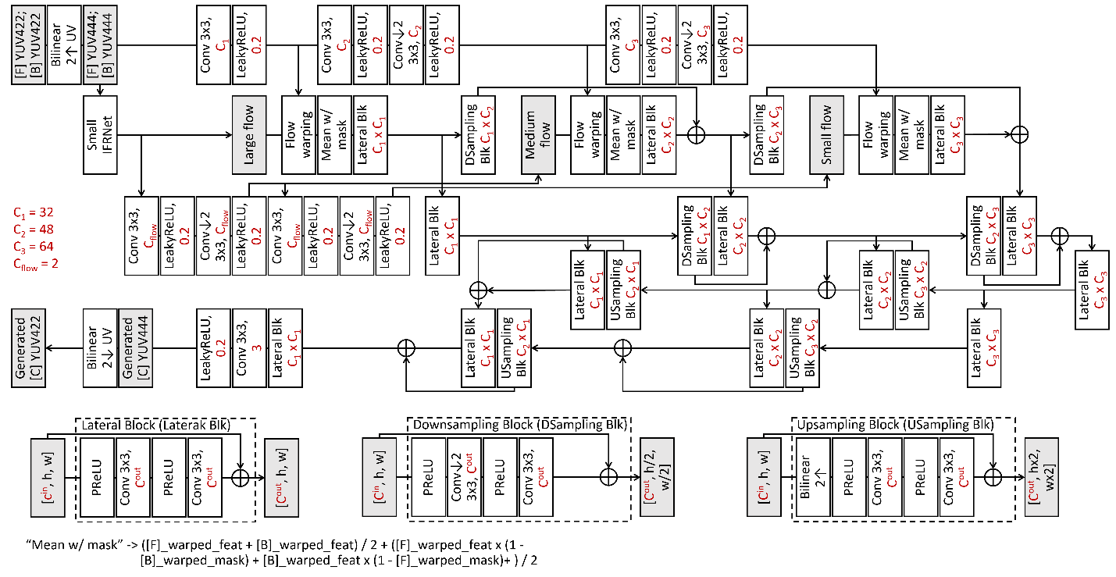
Fig. 1: The architecture of the DRF network
Fig. 1 illustrates the architecture of the DRF network proposed in JVET-AF0208[2].

Network information in training stage
Table 1: Network information for the NN-based video coding tool testing in training stage
Network Information in Training Stage
Mandatory | GPU Type | GeForce RTX 3090
Mandatory | Framework | PyTorch 1.13.1
Mandatory | Number of GPUs per Task | 2
Mandatory | Epoch | 200
Mandatory | Batch size | 48 x 3 frames (as a triplet)
Mandatory | Loss function | L1
Mandatory | Training time (for 1 model) | 60h
Mandatory | Training data information | Vimeo-90K triplet
Mandatory | Training configurations for generating compressed training data (if different to VTM CTC) | VTM-11.0_NNVC-12.0, QP{22, 27, 32, 37, 42}
Optional | Number of iterations
Optional | Patch size | 256x256
Optional | Learning rate | 3.5e-4
Optional | Learning rate update strategy
Optional | Optimizer | ADAM
Optional | Preprocessing
Optional | Mini-batch selection process
Optional | Training data update strategy
Optional | Other information

Network information in inference stage
Table 2: Network information for the NN-based video coding tool testing in inference stage
Network Information in Inference Stage
Mandatory | HW environment
Mandatory | GPU Type | CPU only
Mandatory | Framework | SADL
Mandatory | Number of GPUs per Task | 0
Mandatory | Number of Parameters (Each Model) | 3800K
Mandatory | Total Number of Parameters (All Models) | 3800K
Mandatory | Parameter Precision (Bits) | 16 (I)
Mandatory | Multiply Accumulate (kMAC/pixel) | 504
Optional | Total Conv. Layers | 101
Optional | Total FC Layers | 0
Optional | Total Memory (MB)
Optional | Batch size | 1
Optional | Patch size | 256x256 (with 16 boundary padding)
Optional | Changes to network configuration or weights required to generate rate points
Optional | Peak Memory Usage (Total)
Optional | Peak Memory Usage (per Model)
Optional | Border handling
Optional | Other information

Results
Implemented on the VTM-11.0_NNVC-12.0 following common test conditions [3] to be used in the context of neural network video coding experiments, the test results of the proposed DRF method under NNVC-RA configuration are presented in Table 3 and Table 4.
Table 3: Performance of the proposed method (NNVC-12.0, RA, float32, SADL implementation [1]).
 | Random access Main10
 | BD-rate Over NNVC-12.0
 | Y-PSNR | U-PSNR | V-PSNR | Y-MSIM | U-MSIM | V-MSIM | EncT | DecT
Class A1 | #VALUE! | #VALUE! | #VALUE! | #VALUE! | #VALUE! | #VALUE! | #DIV/0! | #DIV/0!
Class A2 | #VALUE! | #VALUE! | #VALUE! | #VALUE! | #VALUE! | #VALUE! | #DIV/0! | #DIV/0!
Class B | -2.45% | -1.11% | -1.47% | -2.82% | -2.32% | -2.52% | 167% | 3428%
Class C | -3.65% | -1.67% | -2.52% | -4.79% | -3.76% | -4.60% | 142% | 3168%
Class E
Overall | #VALUE! | #VALUE! | #VALUE! | #VALUE! | #VALUE! | #VALUE! | #DIV/0! | #DIV/0!
Class D | -4.41% | 0.22% | -0.56% | -4.75% | -2.83% | -3.83% | 132% | 2757%
Class F | -1.11% | -0.55% | -0.13% | -1.65% | -1.24% | -1.09% | 208% | 9191%
Class H | #VALUE! | #VALUE! | #VALUE! | #VALUE! | #VALUE! | #VALUE! | #DIV/0! | #DIV/0!

Table 4: Performance of the proposed method (NNVC-12.0, RA, int16, SADL implementation).
 | Random access Main10
 | BD-rate Over NNVC-12.0
 | Y-PSNR | U-PSNR | V-PSNR | Y-MSIM | U-MSIM | V-MSIM | EncT | DecT
Class A1 | #VALUE! | #VALUE! | #VALUE! | #VALUE! | #VALUE! | #VALUE! | #DIV/0! | #DIV/0!
Class A2 | #VALUE! | #VALUE! | #VALUE! | #VALUE! | #VALUE! | #VALUE! | #DIV/0! | #DIV/0!
Class B | -1.55% | -0.85% | -0.48% | -2.12% | -2.00% | -1.79% | 139% | 2205%
Class C | -2.89% | -1.76% | -2.00% | -4.05% | -3.42% | -3.78% | 124% | 2069%
Class E
Overall | #VALUE! | #VALUE! | #VALUE! | #VALUE! | #VALUE! | #VALUE! | #DIV/0! | #DIV/0!
Class D | -2.93% | -0.04% | -0.08% | -3.56% | -2.68% | -2.91% | 125% | 1944%
Class F | -0.83% | -0.57% | -0.18% | -1.36% | -1.13% | -0.85% | 168% | 5625%
Class H | #VALUE! | #VALUE! | #VALUE! | #VALUE! | #VALUE! | #VALUE! | #DIV/0! | #DIV/0!
Implemented on the VTM-11.0_NNVC-13.0, the test results of the proposed DRF method under NNVC-RA configuration are presented in Table 5.

Table 5: Performance of the proposed method (NNVC-13.0, int16, SADL implementation).
 | Random access Main10
 | BD-rate Over NNVC-13.0
 | Y-PSNR | U-PSNR | V-PSNR | Y-MSIM | U-MSIM | V-MSIM | EncT | DecT
Class A1 | -0.96% | -0.37% | -0.69% | -1.29% | -1.64% | -1.52% | 137% | 2319%
Class A2 | -1.86% | -0.94% | -1.11% | -2.54% | -2.22% | -2.04% | 130% | 2130%
Class B | -1.54% | -0.72% | -0.38% | -2.08% | -2.01% | -1.82% | 139% | 2221%
Class C | -2.90% | -1.84% | -1.81% | -4.09% | -3.62% | -3.73% | 125% | 2098%
Class E
Overall | -1.85% | -0.99% | -0.97% | -2.55% | -2.41% | -2.32% | 133% | 2188%
Class D | -2.85% | 0.21% | 0.07% | -3.48% | -2.84% | -2.97% | 125% | 1929%
Class F | -0.87% | -0.62% | -0.26% | -1.42% | -1.28% | -1.00% | 168% | 5572%
Class H | #VALUE! | #VALUE! | #VALUE! | #VALUE! | #VALUE! | #VALUE! | #DIV/0! | #DIV/0!

As demonstrated in Table 3, 4 and 5, the int16 implementation effectively reduces run-time despite causing a performance decline.
The updated results after converting the data pre/post-processing stage (yuv420 to yuv444, yuv444 to rgb, and yuv444 to yuv420) to integer operations are as follows:
Table 6: Performance of the proposed method (NNVC-13.0, int16, SADL implementation).
 | Random access Main10
 | BD-rate Over NNVC-13.0
 | Y-PSNR | U-PSNR | V-PSNR | Y-MSIM | U-MSIM | V-MSIM | EncT | DecT
Class A1 | #VALUE! | #VALUE! | #VALUE! | #VALUE! | #VALUE! | #VALUE! | #DIV/0! | #DIV/0!
Class A2 | #VALUE! | #VALUE! | #VALUE! | #VALUE! | #VALUE! | #VALUE! | #DIV/0! | #DIV/0!
Class B | #VALUE! | #VALUE! | #VALUE! | #VALUE! | #VALUE! | #VALUE! | #DIV/0! | #DIV/0!
Class C | -2.95% | -2.09% | -1.25% | -4.10% | -3.69% | -3.54% | 124% | 2103%
Class E
Overall | #VALUE! | #VALUE! | #VALUE! | #VALUE! | #VALUE! | #VALUE! | #DIV/0! | #DIV/0!
Class D | -2.94% | -0.42% | 0.83% | -3.57% | -2.88% | -2.93% | 125% | 1936%
Class F | #VALUE! | #VALUE! | #VALUE! | #VALUE! | #VALUE! | #VALUE! | #DIV/0! | #DIV/0!
Class H | #VALUE! | #VALUE! | #VALUE! | #VALUE! | #VALUE! | #VALUE! | #DIV/0! | #DIV/0!

Conclusions
This contribution presents a deep reference frame generation method for VVC inter prediction enhancement. Compared to NNVC-13.0, the DRF method with int16 SADL implementation can bring the overall {-1.85%, -0.99%, -0.97%} BD-rate improvements for {Y, U, V} components under RA configuration, with effective run-time reduction compared with float32 implementation.

Reference
- D. Ding, X. Chen, and Z. Chen, “EE1-related: Deep Reference Frame Generation for Inter Prediction Enhancement”. JVET-AL0184, 38th Meeting, by teleconference, 26 March – 4 April 2025.
- W. Bao, X. Chen, J. Jia, Y. Zhang, Z. Chen, Z. Liu, X. Xu, and S. Liu. “EE1-2.1: Deep Reference Frame Generation for Inter Prediction Enhancement”. JVET-AF0208, 32nd Meeting, Hannover, DE, 13–20 October 2023.
- E. Alshina, F. Galpin, R.-L. Liao, S. Liu, A. Segall. “JVET common test conditions and evaluation procedures for neural network-based video coding technology”. JVET-AJ2016, 36th Meeting, Kemer, TR, 1–8 November 2024.

Patent rights declaration(s)
Wuhan University does not have any current or pending patent rights relating to the technology described in this contribution.

