    Joint Video Experts Team (JVET)  of ITU-T SG21 WP3/21 and ISO/IEC JTC 1/SC 29  39th Meeting, Daejeon, KR, 26 June – 4 July 2025 | Document: JVET-AM0169-v3

Title: | Non-EE2: Reducing Candidate Modes in DDCCP
Status: | Input document to JVET
Purpose: | Proposal
Author(s) or  Contact(s): | Shuai Wan,  Yujie Yin,  Zhiwei Zhu,  Shaowei Xie,  Xing Zeng,  Cheng Huang | Email: | swan@nwpu.edu.cn  yinyujie@mail.nwpu.edu.cn  zhiweizhu@mail.nwpu.edu.cn  xie.shaowei@zte.com.cn  zeng.xing1@zte.com.cn  huang.cheng5@zte.com.cn
Source: | Northwestern Polytechnical University, ZTE Corporation
_____________________________

Abstract
In ECM 17.0, Decoder-Derived Cross-Component Prediction (DDCCP) derives the best CCP mode from a DDCCP candidate list containing LB-CCP filtering. However, in the current ECM version, LB-CCP filtering is not used for single-model CCCM (S-CCCM), and filtering increases the complexity of the DDCCP derivation process. It is proposed to remove S-CCCM with LB-CCP and MM-CCCM with LB-CCP modes from the DDCCP list, i.e., removing the LB-CCP filtering process from DDCCP.
The experimental results on the top of ECM-17.0 are summarized as follows. The DDCCP derivation process and codec time are reduced with similar coding performance.
AI(Y/U/V): 0.02%/-0.13%/-0.11%, EncT 99.7%, DecT 99.3%

Introduction
Decoder-Derived Cross-Component Prediction (DDCCP) is a chroma prediction mode. This mode signals a DDCCP flag. When this flag is true, it requires constructing a candidate list and deriving the best CCP mode by using a 1×1 template to calculate template costs by comparing reconstructed samples with prediction values generated by the evaluated CCP mode. The DDCCP candidate list comprises: {S-CCLM, S-CCCM, S-CCCM with LB-CCP, MM-CCCM, MM-CCCM with LB-CCP, S-GLCCCM}. Moreover, DDCCP further introduces fusion mode candidates. A fusion candidate is the combination of two CCP modes from the existing CCP mode lists reordered by template costs.
Although DDCCP improves CCP mode signaling efficiency and chroma component performance, applying LB-CCP filtering in DDCCP is not consistent with the other CCP modes apart from DDCCP. In ECM 17.0, LB-CCP is only applied to multi-model CCLM and CCCM, not to single-model CCCM. Additionally, the complex LB-CCP filtering process introduces extra complexity of DDCCP in derivation, whereas the corresponding performance gain is limited.

Proposed Methods
In this contribution, it is proposed to remove the modes of S-CCCM with LB-CCP and M-CCCM with LB-CCP from the DDCCP candidate list, i.e., to remove the filtering process of LB-CCP in DDCCP. Specifically, the DDCCP candidate list is changed from {S-CCLM, S-CCCM, S-CCCM with LB-CCP, M-CCCM, M-CCCM with LB-CCP, S-GLCCCM} to {S-CCLM, S-CCCM, M-CCCM, S-GLCCCM}. The fusion process in DDCCP remains unchanged. The improved DDCCP process is shown in Figure 1:
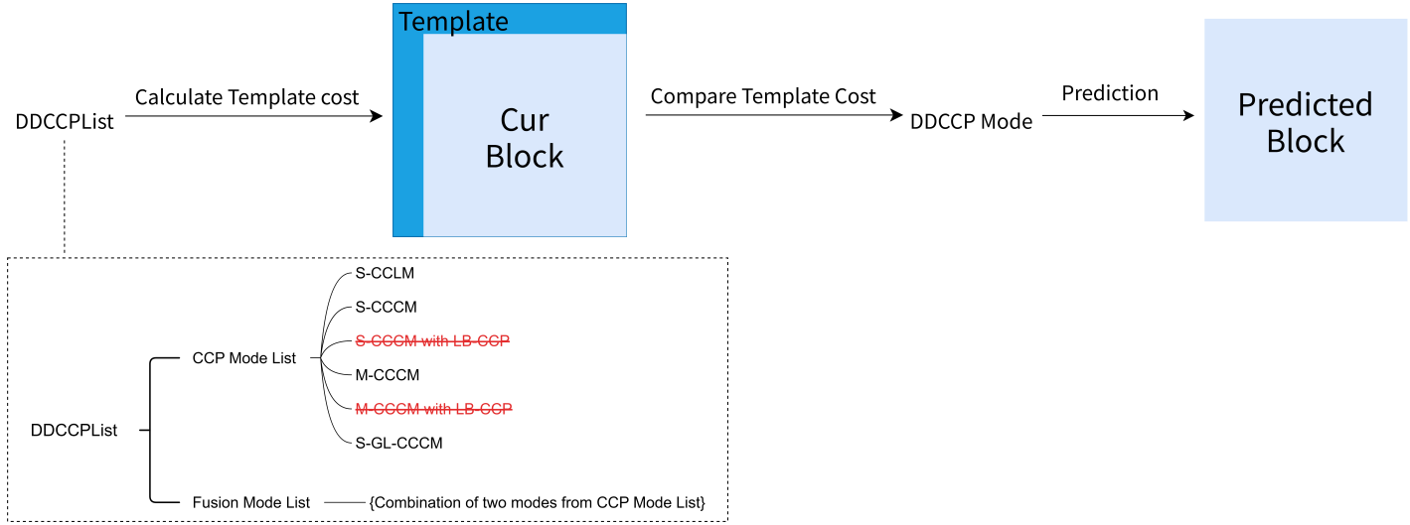
Fig.1 Illustration of the improved DDCCP
The proposed method simplifies the DDCCP derivation process, as shown in Table 1:
Table 1. Comparison of the proposed method with the original DDCCP derivation process
 | Number of non-Fusion modes | Number of Fusion modes | Total Number
Original DDCCP | 6 | 15 | 21
Proposed Method | 4 | 6 | 10
Reduction | 2 | 9 | 11

Experimental results
The proposed method was implemented based on ECM-17.0 under common test conditions[1]. It is observed that the proposed method can reduce coding and decoding complexity without affecting the overall performance. More detailed results can be found in the attached Excel sheets. The test results are summarized below.

Table 2. Simulation results of the proposed method

 | All Intra Main 10
 | Over ECM-17.0
 | Y | U | V | EncT | DecT | EncVmPeak | DecVmPeak
Class A1 | 0.01% | -0.12% | -0.03% | 99.4% | 99.3% | 100.0% | 99.9%
Class A2 | 0.00% | -0.11% | -0.10% | 99.2% | 99.5% | 100.0% | 100.0%
Class B | 0.01% | -0.20% | -0.11% | 99.8% | 98.8% | 100.0% | 100.0%
Class C | 0.02% | -0.11% | -0.08% | 100.0% | 99.0% | 100.0% | 100.0%
Class E | 0.04% | -0.06% | -0.25% | 100.3% | 100.0% | 100.0% | 100.0%
Overall | 0.02% | -0.13% | -0.11% | 99.7% | 99.3% | 100.0% | 100.0%

Conclusions
In this contribution, in order to reduce the complexity of the derivation process in DDCCP and improve the codec efficiency, it is proposed to remove the modes of S-CCCM with LB-CCP and the M-CCCM with LB-CCP from the DDCCP candidate list, i.e., to remove the filtering process of LB-CCP in DDCCP. This method can simplify the DDCCP derivation process and decrease the codec running time without affecting the overall coding performance. It is suggested to investigate in EE.

References
- M. Karczewicz, Y. Ye, “Common Test Conditions and evaluation procedures for enhanced compression tool testing”, JVET-AI2017, July, 2024.

Patent rights declaration(s)
Northwestern Polytechnical University may have current or pending patent rights relating to the technology described in this contribution and, conditioned on reciprocity, is prepared to grant licenses under reasonable and non-discriminatory terms as necessary for implementation of the resulting ITU-T Recommendation | ISO/IEC International Standard (per box 2 of the ITU-T/ITU-R/ISO/IEC patent statement and licensing declaration form).

ZTE Corporation may have current or pending patent rights relating to the technology described in this contribution and, conditioned on reciprocity, is prepared to grant licenses under reasonable and non-discriminatory terms as necessary for implementation of the resulting ITU-T Recommendation | ISO/IEC International Standard (per box 2 of the ITU-T/ITU-R/ISO/IEC patent statement and licensing declaration form).

