    Joint Video Experts Team (JVET)  of ITU-T SG21 WP3/21 and ISO/IEC JTC 1/SC 29  39th Meeting, Daejeon, KR, 26 June – 4 July 2025 | Document: JVET-AM0168-v1

Title: | [AHG9/AHG13] Implementation in VTM TuC of the film grain regions characteristics SEI message
Status: | Input document to JVET
Purpose: | Proposal
Author(s) or  Contact(s): | F. Urban, P. de Lagrange, E. François  Gilles Teniou | Tel:  Email: | fabrice.urban@interdigital.com  philippe.delagrange@interdigital.com  edouard.francois@interdigital.com  teniou@global.tencent.com
Source: | InterDigital, Tencent
_____________________________

Abstract
This contribution provides a status of the VTM software implementation of the Film Grain Regions Characteristics (FGR) SEI message, defined in the VSEI TuC. It states that the single model version (one model per picture), aligned with the TuC specification JVET-AG2032, is available in a branch of the VTM TuC git repository. It also states that the interest of the FGR SEI message, in single model version, has been demonstrated by showcases in JVET-AH0212. It is proposed to include the FGR SEI message in the WD of the next VSEI specification version (v5), when this version is initiated.

FGR SEI message implementation status

Implementation delivered to the VTM TuC git repository
The Film Grain Regions Characteristics (FGR) SEI message from contribution JVET-AG0328 was first documented in the VSEI TuC in JVET-AG2032. In this version, one single film grain model is enabled per picture (either frequency-based, or auto-regressive), and the film grain parameters may be changed per region. In another mode, the synthesized film grain can be modulated by an alpha map. Snapshots of these 2 modes are provided below for illustration.
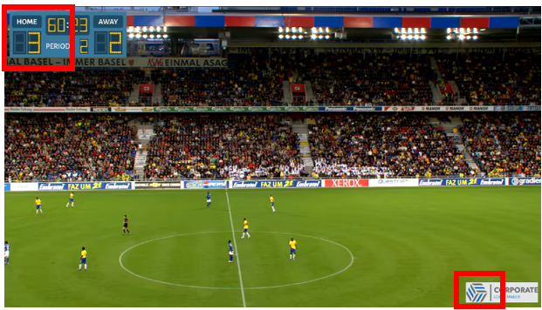
Figure 1. Aloha content coded with VTM-23.1, Random Access configuration, with QP 36.
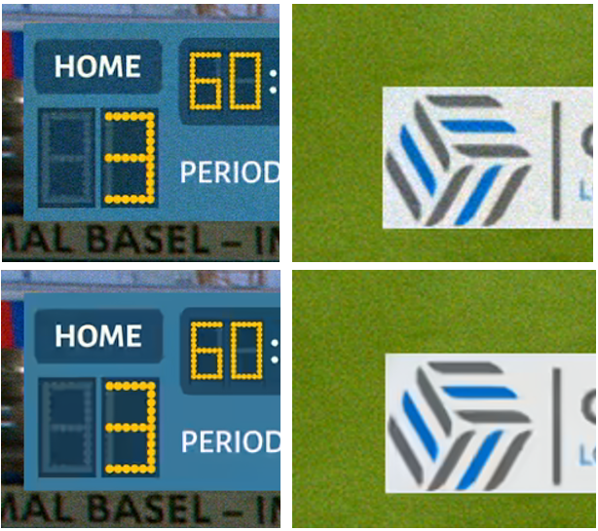
Figure 2. Two snapshots from Aloha content with (top) full-picture grain (bottom) region-based grain.

Figure 3. Decoded picture and related alpha map.
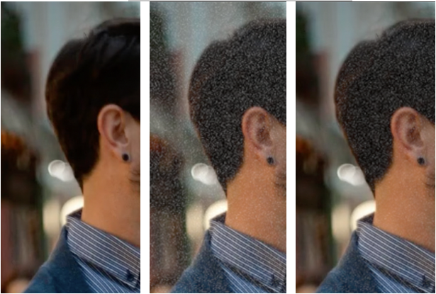
Figure 4. Decoded without grain, with FGC grain, with FGR alpha channel-based grain.
JVET-AH0212 provided a software patch corresponding to the VTM implementation of the FGR SEI message as defined in JVET-AG0328, but the software was not delivered in the VTM TuC git repository.
The contribution also presented showcases demonstrating the interest of this new SEI message. Illustrative mp4 videos can be found in the VQA repository (https://vqa.lfb.rwth-aachen.de) in folder “jvet/ahg/showcases/JVET-AH0112_FilmGrainRegion”.

This contribution informs JVET that the implementation of the FGR SEI message as provided in JVET-AG0328, and aligned with JVET-AG2032, has now been delivered in the following merge request:
FGR SEI code from JVET_AG0328 (!40) · Merge requests · jvet-tuc / VVCSoftware_VTM · GitLab
The delivered software also includes configuration files as examples for usage of the SEI message.

Note that, as in the case of the Film Grain Characteristics (FGC) SEI message, only the frequency model is implemented, while the auto-regressive model is not.

Difference with the most recent TuC specification (JVET-AL2032)
The FGR SEI message has been further extended to enable usage of different film grain models per region (that is, some regions use the frequency model, while others use the auto-regressive model), and not only per picture as initially specified in JVET-AG2032. The latest VSEI TuC document (JVET-AL2032) supports this feature.
However, this feature is not implemented yet in the VTM TuC software and received a limited interest in the service configurations that would require the support of two models.

Recommendations
Given the facts that:
- FGR SEI message has been studied since July 2023
- A stable software implementation of the single model version, corresponding to the VSEI TuC specification JVET-AG2032, has been delivered
- Corresponding show cases have been provided to demonstrate the benefits of this SEI message
it is proposed:
- to agree to include the FGR SEI message in the first version of the WD VSEI v5 specification when created,
- to decide which of the single model version (as defined in JVET-AG2032) or the multi-model version (as documented in JVET-AL2032) is to be moved to v5
  - Such a decision should depend on both the availability of the software implementation and the confirmed interest from the group

Patent rights declaration(s)
InterDigital may have current or pending patent rights relating to the technology described in this contribution and, conditioned on reciprocity, is prepared to grant licenses under reasonable and non-discriminatory terms as necessary for implementation of the resulting ITU-T Recommendation | ISO/IEC International Standard (per box 2 of the ITU-T/ITU-R/ISO/IEC patent statement and licensing declaration form).
Tencent may have current or pending patent rights relating to the technology described in this contribution and, conditioned on reciprocity, is prepared to grant licenses under reasonable and non-discriminatory terms as necessary for implementation of the resulting ITU-T Recommendation | ISO/IEC International Standard (per box 2 of the ITU-T/ITU-R/ISO/IEC patent statement and licensing declaration form).

