    Joint Video Experts Team (JVET)  of ITU-T SG 16 WP 3 and ISO/IEC JTC 1/SC 29  39th Meeting, Daejeon, KR, 26 June – 4 July 2025 | Document: JVET-AM0159-v1

Title: | Non-EE2: On ALF coefficient coding
Status: | Input document to JVET
Purpose: | Proposal
Author(s) or  Contact(s): | Ikram Jumakulyyev  Döne Bugdayci Sansli  Jani Lainema | Email: | ikram.jumakulyyev@nokia.com  jani.lainema@nokia.com
Source: | Nokia
_____________________________

Abstract
In this contribution, two methods are proposed to improve ALF coefficient coding. Method 1 proposes to extend coding groups while method 2 proposes to re-assign the coding groups of coefficients.
The coding efficiency and runtimes of the proposed methods over ECM-17.0 (with Huffman frequency table re-trained) are reported as below {for Y, U, V, EncT, DecT}:
Method 1:
AI { -0.01%, 0.02%, -0.02%, 100.0%, 99.8%}
RA { -0.01%, -0.01%, -0.02%, 99.8%, 99.7%}
LDB { -0.02%, -0.15%, -0.17%, 99.8%, 99.8%}

Method 2:
AI { 0.00%, 0.01%, -0.01%, 99.8%, 99.3%}
RA { -0.01%, 0.03%, 0.02%, 99.7%, 100.2%}
LDB { -0.04%, -0.18%, -0.10%, 99.5%, 99.7%}

Introduction
In ECM 17.0, ALF coefficient filter taps for online training includes spatial taps (#0 - #9), fixed filter output-based taps (#10 - #29), reconstruction buffer before DBF (#30 - #32), residual based taps (#33 - #34), Gaussian smoothed before DBF reconstruction buffer (#35), and Laplacian taps (#36 - #40).

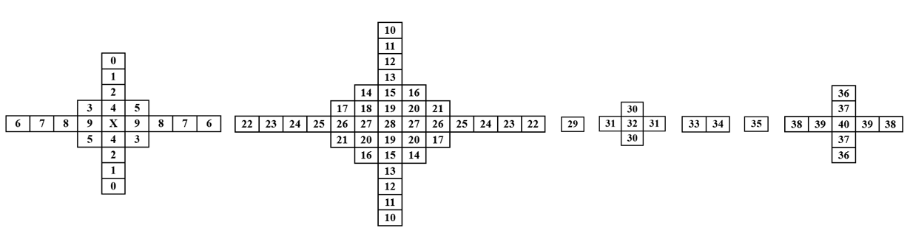
Figure 1 – Online-trained ALF filter shapes in ECM 17.0
ALF coefficients are coded by Huffman coding in two separate coding groups [1]. Group 1 is for the center coefficients (grey colored taps in Fig. 2) and Group 0 for the rest of the coefficients (white colored taps in Fig. 2).
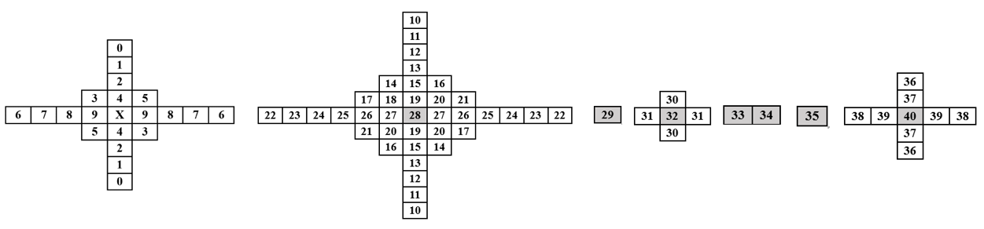
Figure 2 –ALF coefficient coding groups in ECM 17.0
ECM 17.0 codes direct neighboring coefficients within the same group as farther coefficients. However, direct neighboring coefficients have more significance than farther coefficients and coding them in the separate group can enhance redundancy exploitation.

Proposed Methods
The method 1 proposes to code center, direct neighboring and farther coefficients separately in different groups:
- Group 2: For direct neighboring coefficients (green colored in Fig. 3).
- Group 1: For center coefficients (grey colored in Fig. 3).
- Group 0: For the rest of the coefficients (white colored in Fig. 3).
The existing frequency table extended and re-trained, i.e., for the new group, Group 2, frequency numbers are derived, and existing group frequencies are updated by running ECM encoder on BVI-DVC dataset.

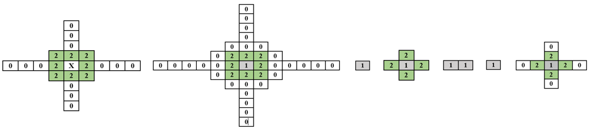
Figure 3 – Method 1: Proposed new grouping for coding ALF coefficients.
The method 2 proposes to code center and direct neighboring in one group and farther coefficients separately in a different group:
- Group 1: For “extended” center coefficients (green colored in Fig. 4).
- Group 0: For the rest of the coefficients (white colored in Fig. 4).
The existing frequency table re-trained in a similar way as mentioned in Method 1 to adapt to new way of grouping.
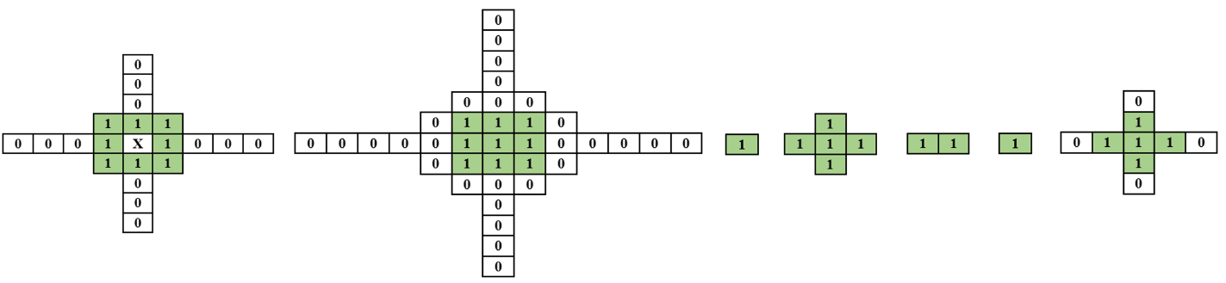
Figure 4 – Method 1: Proposed new grouping for coding ALF coefficients.

Experimental results
The tables below summarize the coding efficiency and runtime impact of the proposed methods in ECM 17.0 using the JVET common test conditions. In both method results’ tables, the anchor is ECM 17.0 with Huffman frequency table re-trained.

Method 1:

 |  | All Intra Main 10
 |  | Over ECM-17.0 + HuffmanFrequencyTableRetrained
 |  | Y | U | V | EncT | DecT | EncVmPeak | DecVmPeak
 | Class A1 | 0.00% | 0.05% | 0.00% | 100.0% | 99.6% | 100.0% | 100.0%
 | Class A2 | 0.00% | 0.02% | -0.02% | 99.7% | 100.2% | 100.0% | 100.0%
 | Class B | 0.00% | 0.02% | -0.03% | 100.1% | 99.7% | 100.0% | 100.0%
 | Class C | 0.00% | 0.01% | 0.00% | 100.0% | 99.4% | 100.4% | 100.0%
 | Class E | -0.01% | 0.02% | -0.03% | 100.2% | 100.1% | 99.0% | 100.0%
 | Overall | -0.01% | 0.02% | -0.02% | 100.0% | 99.8% | 99.9% | 100.0%
 | Class D | -0.01% | 0.01% | -0.02% | 100.0% | 100.4% | 100.0% | 100.0%
 | Class F | 0.00% | -0.02% | 0.00% | 99.6% | 100.2% | 98.9% | 100.1%
 |  | Random Access Main 10
 |  | Over ECM-17.0 + HuffmanFrequencyTableRetrained
 |  | Y | U | V | EncT | DecT | EncVmPeak | DecVmPeak
 | Class A1 | -0.03% | -0.01% | -0.11% | 99.7% | 99.9% | 100.0% | 100.2%
 | Class A2 | 0.01% | -0.17% | 0.00% | 99.7% | 99.6% | 99.4% | 100.0%
 | Class B | -0.01% | 0.03% | -0.01% | 99.8% | 99.7% | 100.0% | 100.1%
 | Class C | -0.03% | 0.07% | 0.02% | 99.8% | 99.6% | 100.0% | 100.0%
 | Class E
 | Overall | -0.01% | -0.01% | -0.02% | 99.8% | 99.7% | 99.9% | 100.1%
 | Class D | 0.02% | -0.15% | 0.17% | 99.8% | 99.7% | 100.0% | 100.1%
 | Class F | 0.00% | -0.15% | 0.02% | 99.8% | 100.8% | 100.0% | 100.0%
 |  | Low delay B Main 10
 |  | Over ECM-17.0 + HuffmanFrequencyTableRetrained
 |  | Y | U | V | EncT | DecT | EncVmPeak | DecVmPeak
Class A1
Class A2
Class B |  | -0.03% | -0.08% | 0.46% | 99.9% | 99.9% | 100.2% | 100.2%
Class C |  | -0.06% | 0.01% | -0.17% | 99.7% | 100.0% | 100.0% | 100.1%
Class E |  | 0.04% | -0.48% | 0.15% | 99.8% | 99.6% | 99.9% | 100.2%
Overall |  | -0.02% | -0.15% | 0.17% | 99.8% | 99.8% | 100.0% | 100.2%
Class D |  | 0.05% | 0.03% | -1.11% | 100.0% | 99.5% | 99.9% | 100.0%
Class F |  | 0.18% | 1.16% | 0.11% | 100.2% | 98.3% | 100.0% | 100.0%

Method 2:

 |  | All Intra Main 10
 |  | Over ECM-17.0 + HuffmanFrequencyTableRetrained
 |  | Y | U | V | EncT | DecT | EncVmPeak | DecVmPeak
 | Class A1 | 0.00% | 0.01% | 0.01% | 99.7% | 99.1% | 100.0% | 100.0%
 | Class A2 | 0.00% | 0.00% | 0.00% | 99.7% | 99.6% | 100.0% | 100.0%
 | Class B | 0.00% | 0.03% | -0.02% | 100.1% | 99.3% | 100.0% | 100.1%
 | Class C | 0.00% | 0.00% | 0.01% | 99.9% | 98.9% | 100.4% | 100.0%
 | Class E | -0.01% | 0.01% | -0.02% | 99.6% | 99.7% | 99.0% | 100.0%
 | Overall | 0.00% | 0.01% | -0.01% | 99.8% | 99.3% | 99.9% | 100.0%
 | Class D | 0.01% | 0.03% | 0.01% | 99.9% | 99.4% | 100.0% | 100.0%
 | Class F | 0.00% | 0.01% | 0.02% | 99.5% | 99.7% | 98.4% | 100.0%
 |  | Random Access Main 10
 |  | Over ECM-17.0 + HuffmanFrequencyTableRetrained
 |  | Y | U | V | EncT | DecT | EncVmPeak | DecVmPeak
Class A1 |  | -0.02% | 0.08% | 0.07% | 99.7% | 99.9% | 100.0% | 100.1%
Class A2 |  | -0.01% | -0.16% | -0.07% | 99.8% | 100.1% | 99.4% | 100.1%
Class B |  | 0.00% | 0.08% | 0.04% | 99.8% | 100.2% | 100.0% | 100.0%
Class C |  | -0.03% | 0.08% | 0.04% | 99.6% | 100.4% | 99.9% | 100.0%
Class E
Overall |  | -0.01% | 0.03% | 0.02% | 99.7% | 100.2% | 99.9% | 100.0%
Class D |  | 0.00% | -0.03% | 0.18% | 100.0% | 100.5% | 100.0% | 100.0%
Class F |  | -0.02% | -0.11% | 0.03% | 100.1% | 100.5% | 100.0% | 100.2%
 |  | Low delay B Main 10
 |  | Over ECM-17.0 + HuffmanFrequencyTableRetrained
 |  | Y | U | V | EncT | DecT | EncVmPeak | DecVmPeak
Class A1
Class A2
Class B |  | -0.04% | -0.11% | -0.09% | 99.5% | 99.5% | 100.0% | 100.0%
Class C |  | -0.06% | 0.01% | -0.48% | 99.2% | 100.1% | 100.0% | 100.1%
Class E |  | -0.01% | -0.54% | 0.41% | 100.0% | 99.6% | 100.3% | 100.1%
Overall |  | -0.04% | -0.18% | -0.10% | 99.5% | 99.7% | 100.1% | 100.1%
Class D |  | 0.06% | 0.36% | -0.41% | 100.1% | 99.3% | 100.0% | 100.0%
Class F |  | -0.01% | 1.02% | 0.77% | 99.6% | 98.7% | 100.1% | 99.8%

ECM 17.0 Huffman frequency table re-training test:

 |  | All Intra Main 10
 |  | Over ECM-17.0
 |  | Y | U | V | EncT | DecT | EncVmPeak | DecVmPeak
 | Class A1 | 0.00% | 0.02% | -0.03% | 100.3% | 100.6% | 100.0% | 100.0%
 | Class A2 | 0.00% | 0.01% | 0.03% | 100.1% | 100.1% | 100.0% | 100.0%
 | Class B | 0.00% | -0.04% | 0.05% | 100.1% | 100.4% | 100.0% | 100.0%
 | Class C | 0.00% | 0.00% | -0.01% | 100.0% | 101.1% | 99.6% | 100.0%
 | Class E | 0.00% | -0.03% | 0.03% | 100.1% | 100.5% | 100.0% | 100.0%
 | Overall | 0.00% | -0.01% | 0.02% | 100.1% | 100.5% | 99.9% | 100.0%
 | Class D | 0.00% | -0.02% | -0.04% | 100.0% | 100.5% | 100.4% | 100.0%
 | Class F | 0.00% | -0.04% | -0.03% | 99.8% | 100.1% | 101.1% | 99.9%
 |  | Random Access Main 10
 |  | Over ECM-17.0
 |  | Y | U | V | EncT | DecT | EncVmPeak | DecVmPeak
Class A1 |  | 0.04% | 0.08% | 0.06% | 100.3% | 100.0% | 99.8% | 100.2%
Class A2 |  | 0.00% | 0.04% | -0.02% | 100.2% | 100.2% | 100.4% | 99.9%
Class B |  | 0.01% | -0.02% | -0.04% | 100.2% | 99.7% | 100.0% | 100.1%
Class C |  | 0.00% | -0.01% | -0.03% | 99.9% | 98.8% | 100.1% | 100.0%
Class E
Overall |  | 0.01% | 0.01% | -0.01% | 100.1% | 99.6% | 100.0% | 100.1%
Class D |  | 0.03% | 0.19% | -0.23% | 99.9% | 99.8% | 100.0% | 100.0%
Class F |  | 0.03% | 0.19% | 0.02% | 100.1% | 100.5% | 100.0% | 100.3%
 |  | Low delay B Main 10
 |  | Over ECM-17.0
 |  | Y | U | V | EncT | DecT | EncVmPeak | DecVmPeak
Class A1
Class A2
Class B |  | 0.06% | 0.06% | 0.11% | 100.2% | 100.1% | 100.0% | 100.1%
Class C |  | -0.01% | -0.19% | 0.35% | 100.2% | 99.9% | 100.0% | 100.0%
Class E |  | -0.07% | 1.52% | 0.96% | 99.8% | 100.1% | 100.3% | 99.8%
Overall |  | 0.00% | 0.34% | 0.40% | 100.1% | 100.0% | 100.1% | 100.0%
Class D |  | 0.07% | -0.58% | 1.43% | 99.6% | 100.3% | 100.2% | 100.0%
Class F |  | -0.07% | -0.23% | -0.36% | 100.1% | 100.6% | 100.0% | 100.1%

References
- V. Shchukin, P. Wennersten, J. Ström. EE2-4.1: Restrictions on ALF coefficient values. JVET-AK0123. January 2025.

Patent rights declaration(s)
Nokia may have current or pending patent rights relating to the technology described in this contribution and, conditioned on reciprocity, is prepared to grant licenses under reasonable and non-discriminatory terms as necessary for implementation of the resulting ITU-T Recommendation | ISO/IEC International Standard (per box 2 of the ITU-T/ITU-R/ISO/IEC patent statement and licensing declaration form).

