    Joint Video Experts Team (JVET)  of ITU-T SG21 WP3/21 and ISO/IEC JTC 1/SC 29  39th Meeting, Daejeon, KR, 26 June – 4 July 2025 | Document: JVET-AM0127-v1

Title: | EE2-3.6 related: Advanced Budget Control for TSRC
Status: | Input document to JVET
Purpose: | Proposal
Author(s) or  Contact(s): | Ruichen Xu,  Wei Zhang,  Fuzheng Yang,  Bin Li,  Fang Xing,  Pengfei Han,  Zhikui Wang,  Wei Song, | Email: | xuruichen@stu.xidian.edu.cn  wzhang@xidian.edu.cn  fzhyang@mail.xidian.edu.cn  libin19@hisense.com  xingfang@hisense.com  hanpengfei4@hisense.com  wangzhikui@hisense.com  songwei15@hisense.com
Source: | Xidian University
_____________________________

Abstract
In TSRC, allocating the context budget with higher priority to syntax elements that have high coding efficiency can yield performance gains, as demonstrated in EE2-3.6b [1][2]. Following this principle, this contribution proposes to increase the priority of coeff_sign_flag, which also possesses a relatively high coding efficiency.
On top of ECM-17.0, simulation results of the proposed method + EE2-3.6b are reported as below:
The proposed method + EE2-3.6b over ECM-17.0 :
All-Intra:
Class F: {-0.12%, -0.01%, -0.10%, xx.x%, xx.x%}
Class TGM: {-0.23%, -0.29%, -0.28%, xx.x%, xx.x%}
The proposed method + EE2-3.6b over EE2-3.6b :
All-Intra:
Class F: {-0.01%, 0.03%, 0.19%, xx.x%, xx.x%}
Class TGM: {-0.04%, -0.03%, -0.02%, xx.x%, xx.x%}

Introduction
In ECM-17.0, once the CABAC bin budget is exhausted, remaining coefficients are directly binarized and coded in bypass mode. Proposal EE2-3.6b demonstrated that prioritizing the context budget for sig_coeff_flag yields significant performance gains, owing to its higher coding efficiency relative to other syntax elements. Building on this principle, statistical analysis reveals that coeff_sign_flag also possesses a similarly higher coding efficiency than other syntaxes. Therefore, increasing the priority of coeff_sign_flag can also lead to performance improvements.

Proposed method
Proposal EE2-3.6b suggests prioritizing the coding of sb_coded_flag for all Coefficient Groups (CGs) within a Transform Unit (TU). This approach allows the number of sig_coeff_flags to be coded to be determined in advance, thereby enabling the reservation of the required context budget for them.
In this contribution, we propose a method to increase the priority of coeff_sign_flag at the CG level. Specifically, instead of processing sig_coeff_flag, coeff_sign_flag, abs_level_gtx_flag[0], and par_level_flag together in a single pass, our proposal is that sig_coeff_flag and coeff_sign_flag be processed together in a dedicated, separate pass. As illustrated in the figure below, this approach effectively implements their higher priority by ensuring they are handled before other syntax elements within the CG.
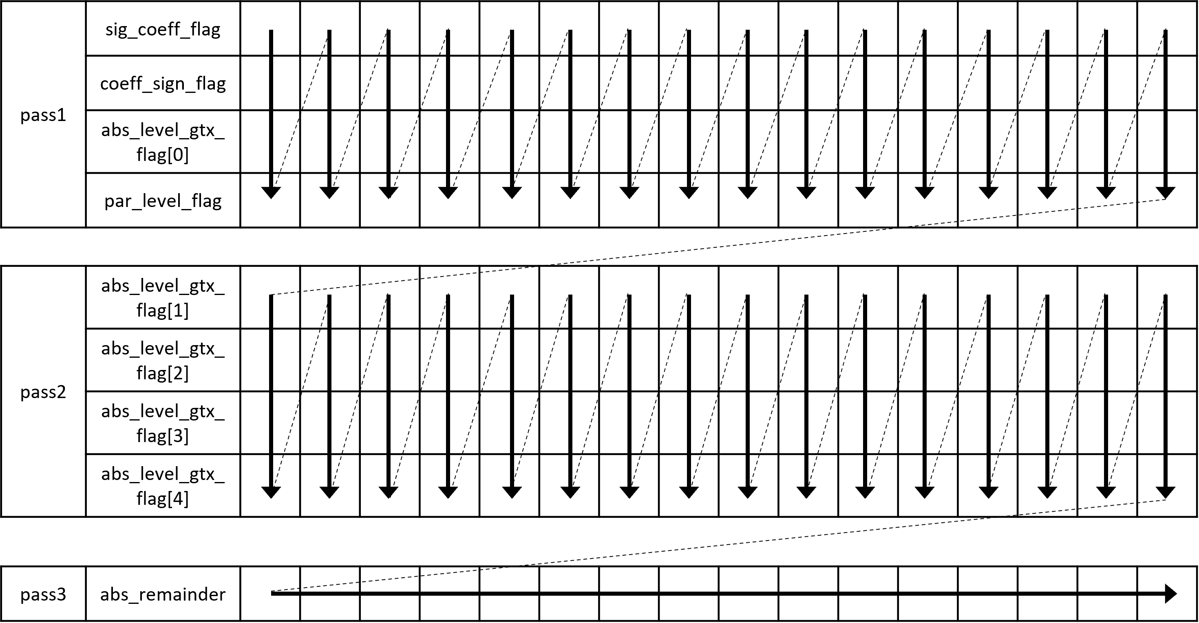
Fig. 1. TSRC encoding process in ECM 17.0
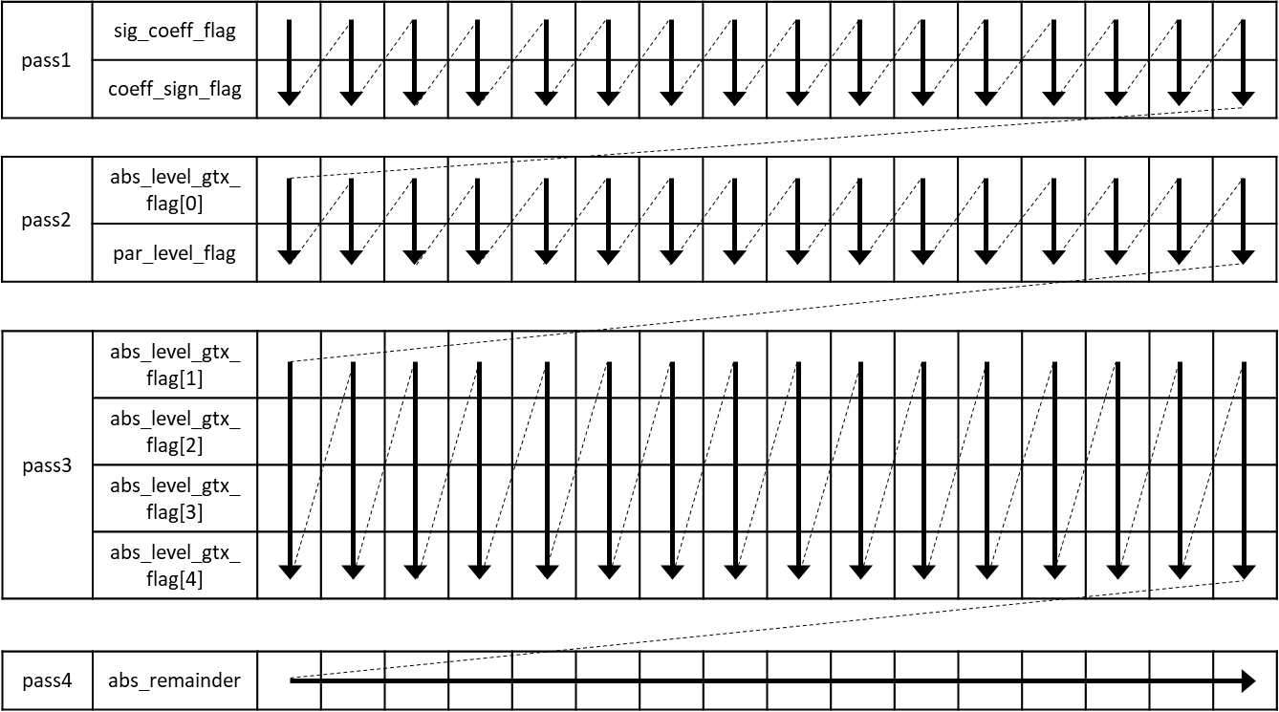
Fig. 2. proposed TSRC encoding process

Simulation results
The proposed method is implemented on top of the ECM-17.0 software [2] and tested based on the common test condition [3]. The test results are summarized below.
Table 1: Test Result of the proposed method + EE2-3.6b over ECM-17.0.
 | All Intra Main 10
 | Over ECM-17.0
 | Y | U | V | EncT | DecT | EncVmPeak | DecVmPeak
Class F | -0.12% | -0.01% | -0.10% | #DIV/0! | #DIV/0! | #DIV/0! | #DIV/0!
Class TGM | -0.23% | -0.29% | -0.28% | #DIV/0! | #DIV/0! | #DIV/0! | #DIV/0!
Table 2: Test Result of the proposed method + EE2-3.6b over EE2-3.6b.
 | All Intra Main 10
 | Over EE2-3.6b
 | Y | U | V | EncT | DecT | EncVmPeak | DecVmPeak
Class F | -0.01% | 0.03% | 0.19% | #DIV/0! | #DIV/0! | #DIV/0! | #DIV/0!
Class TGM | -0.04% | -0.03% | -0.02% | #DIV/0! | #DIV/0! | #DIV/0! | #DIV/0!

Conclusions
In this contribution, without changing the total coding budget, this preferentially allocates the budget to syntax element with high coding efficiency. The proposed method brings noticeable coding gains compared to ECM-17.0 and EE2-3.6b by reducing the bitrate. It is suggested to further study this method in the next round of EE2.

References
- Y. Yu, L. Xu, J. Gan, H. Yu, D. Wang, "EE2-related: On binarization of a coefficient level in TSRC", JVET-AL0109, April, 2025.
- M. Abdoli, R. G. Youvalari, F. Plowman, A. Tissier, "EE2-4.3: On coefficient level binarization in Transform Skip", JVET-AL0158, April, 2025.
- ECM-17.0, https://vcgit.hhi.fraunhofer.de/ecm/ECM/-/tags/ECM-17.0
- M. Karczewicz, Y. Ye, “Common Test Conditions and evaluation procedures for enhanced compression tool testing”, JVET-AI2017, July, 2024.

Patent rights declaration(s)
Xidian University may have current or pending patent rights relating to the technology described in this contribution and, conditioned on reciprocity, is prepared to grant licenses under reasonable and non-discriminatory terms as necessary for implementation of the resulting ITU-T Recommendation | ISO/IEC International Standard (per box 2 of the ITU-T/ITU-R/ISO/IEC patent statement and licensing declaration form).
Hisense Group Co., Ltd., may have current or pending patent rights relating to the technology described in this contribution and, conditioned on reciprocity, is prepared to grant licenses under reasonable and non-discriminatory terms as necessary for implementation of the resulting ITU-T Recommendation | ISO/IEC International Standard (per box 2 of the ITU-T/ITU-R/ISO/IEC patent statement and licensing declaration form).

