    Joint Video Experts Team (JVET)  of ITU-T SG21 WP3/21 and ISO/IEC JTC 1/SC 29  39th Meeting, Daejeon, KR, 26 June – 4 July 2025 | Document: JVET-AM0126-v1

Title: | AHG9: Temporal quality indication for EOI SEI message
Status: | Input document to JVET
Purpose: | Proposal
Author(s) or  Contact(s): | Jie Chen  Yan Ye  Bolin Chen | Tel:  Email: | {jiechen.cj, yan.ye, chenbolin.chenboli}@alibaba-inc.com
Source: | Alibaba Group
_____________________________

Abstract
It is proposed to add an indicator in the encoder optimization information (EOI) SEI message when the value of eoi_type indicates temporal quality optimization has been applied. The proposed indicator can be used to indicate how the quality of a picture associated with the SEI message has fluctuated due to temporal quality optimization. It is asserted that such information could be useful at the decoder side for some applications to improve temporal quality consistency.

Introduction
The encoder optimization information (EOI) SEI message was adopted in VSEI version 4 [1] and further extended in technologies under consideration (TuC) for further extension of VSEI [2]. The EOI SEI message can be used to indicate if the video has been optimized for human viewing or machine analysis and which types of optimization have been applied in pre-processing or encoding. Such information can help the decoder use the video in a way aligned with the intended purpose.
In the current design of EOI SEI message, the syntax element eoi_type is used to signal one of seven different optimization types that may have been applied: object-based optimization, temporal resampling, spatial resampling, termoral quality optimization, spatial quality optimization, privacy protection optmiztion and luma range adaptation optimization. Among these seven optimzation types, except temporal and spatial quaility optimization, all other five optimzation types have further syntax elements signaled in SEI message to give more useful information about the specific optimization. For example, the information about the resampling ratio is signaled when temporal or spatial resampling optimization is applied. But in the case when eoi_type indicates temporal or spatial quality optimization being applied, no other sytax elements are signaled in the SEI message to give more information. Therefore, for example, the decoder doesn’t know which pictures are of higher quality and which pictures are of lower quality when eoi_type indicates temporal quality optimization has been applied that could have resulted in temporal quality fluctuation. It is asserted that such information can be quite useful in the decoder side in some applications.
For example, in JVET-AK0068 [3], a VVC-conformed generaive face video compression (GFVC) scheme, namely VVC GFVC, was proposed, which is shown as Figure 1. In this VVC GFVC scheme, the intra pictures are encoded with a low QP (e.g., QP 22) to achieve high quality and the inter pictures are encoded with a very high QP (e.g., QP 52) to save the bitrates. At the decoder side, the decoded the inter pictures are not suitable for human viewing since they have been encoded with very high QP. Thus, a multi-step asymmetric Cycle GAN based enhancement model is invoked as the post-processing to improve the inter picture quality with the help of the high quality intra pictures. After post-processing, the video sequences are ready for human viewing. During the discussion at the AK meeting, it is commented that “Potentially the EOI SEI could be used to signal that something like that has been done, not recommending the direct decoder output for viewing.”
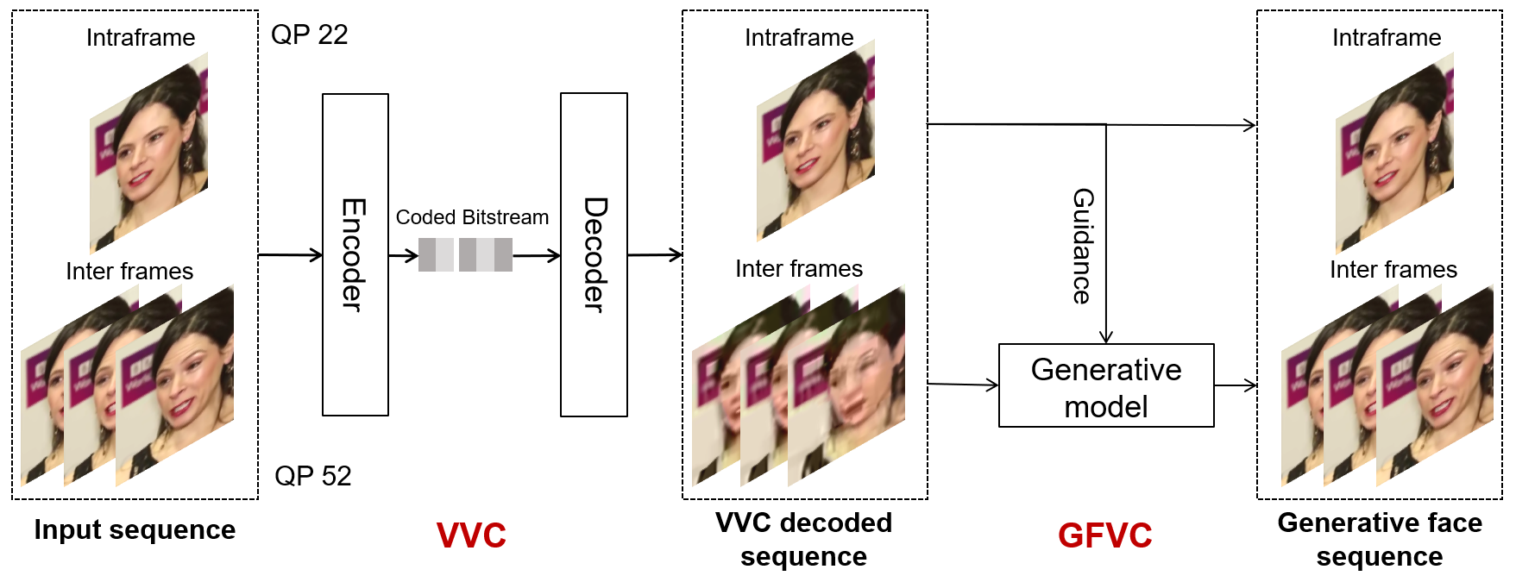
Figure 1. The framework of VVC GFVC

Proposal
Thus, to indicate the quality of each decoded picture when eoi_type indicates temporal quality optimization is applied, it is proposed to add a new indicator in the EOI SEI message.
Three different quality levels can be indicated by the proposed indicator. The first level is high quality level and the indicated picture is not only suitable for human viewing, but also can be used to improve other lower-quality pictures. The second level is the medium quality level and the indicated picture is not so good as the high-quality pictures, but still suitable for human viewing. The third level is low quality level and indicates the picture is not suitable for human viewing. Besides the three quality levels, the fourth option, unknown quality, is also provided to give the encoder flexibility.
With the proposed indicator, in the VVC GFVC scheme proposed in JVET-AK0068, the intra pictures encoded with low QP can be indicated as “good quality” and the inter pictures encoded with high QP can be indicated as “low quality”, such that the decoder can know the decoded inter pictures cannot be directly viewed by human and a quality enhancement post-processing is needed, and the intra pictures can be used to improve the quality of the inter pictures in the post-processing.
The proposed text changes are highlighted with yellow as follows.
encoder_optimization_info(payloadSize ) { | Descriptor
eoi_cancel_flag | u(1)
if( !eoi_cancel_flag ) {
eoi_persistence_flag | u(1)
eoi_for_human_viewing_idc | u(2)
eoi_for_machine_analysis_idc | u(2)
eoi_type | u(16)
if( eoi_persistence_flag ) {
eoi_num_sublayers | u(3)
if( eoi_num_sublayers < 7 )
eoi_min_tid | u(3)
}
if( EoiObjectBasedFlag ) {
eoi_object_based_idc | ue(v)
if( eoi_object_based_idc & 0x02 ) {
eoi_quant_threshold_delta | ue(v)
if( eoi_quant_threshold_delta > 0 )
eoi_pic_quant_object_flag | u(1)
}
}
if( EoiTemporalResamplingFlag ) {
eoi_temporal_resampling_type_flag | u(1)
eoi_num_int_pics | ue(v)
}
if( EoiSpatialResamplingFlag ) {
eoi_orig_pic_dimensions_flag | u(1)
if( eoi_orig_pic_dimensions_flag ) {
eoi_orig_pic_width | u(16)
eoi_orig_pic_height | u(16)
} else
eoi_spatial_resampling_type_flag | u(1)
}
if( EoiSpatialResamplingFlag )
eoi_pic_quality_idc | u(2)
if( EoiPrivacyProtectionFlag ) {
eoi_privacy_protection_method_idc | u(4)
eoi_privacy_info_type | u(8)
}
if( more_data_in_payload( ) && payload_extension_present( ) )
SeiExtensionBitsPresentFlag = 1
if( EoiLumaAdaptationFlag ) {
eoi_luma_adaptation_idc | ue(v)
eoi_ratio_luma_value | u(7)
eoi_ratio_luma_sign_flag | u(1)
if( eoi_luma_adaptation_idc = = 0 )
eoi_display_model | u(4)
else if( eoi_luma_adaptation_idc = = 1 )
eoi_backscale_ratio_value | u(7)
}
}
}
}
…
The variables EoiObjectBasedFlag, EoiTemporalResamplingFlag, EoiSpatialResamplingFlag, EoiTemporalQualityFlag, EoiSpatialQualityFlag, and EoiPrivacyProtectionFlag, specifying whether eoi_type indicates the type of the optimization to include object-based optimization, temporal resampling optimization, spatial resampling optimization, temporal quality optimization, spatial quality optimization, and privacy protection optimization, respectively, are derived as follows:
EoiObjectBasedFlag = ( ( eoi_type & 0x01 ) > 0 ) ? 1 : 0
EoiTemporalResamplingFlag = ( ( eoi_type & 0x02 ) > 0 ) ? 1 : 0
EoiSpatialResamplingFlag = ( ( eoi_type & 0x04 ) > 0 ) ? 1 : 0
EoiTemporalQualityFlag = ( ( eoi_type & 0x08 ) > 0 ) ? 1 : 0
EoiSpatialQualityFlag = ( ( eoi_type & 0x10 ) > 0 ) ? 1 : 0
EoiPrivacyProtectionFlag = ( ( eoi_type & 0x20 ) > 0 ) ? 1 : 0
…
eoi_pic_quality_idc equal to 3 specifies that the current decoded picture is not only suitable for human viewing, but also can be used to improve the quality of other decoded pictures in the CLVS. eoi_pic_quality_idc equal to 2 specifies that the current decoded picture is suitable for human viewing, but should not be used to improve the quality of other decoded pictures. eoi_pic_quality_idc equal to 1 specifies that the current decoded picture is unsuitable for human viewing. eoi_pic_quality_idc equal to 0 specifies that it is unknown if the current decoded picture is suitable for human viewing.

Reference
- J. Boyce, J. Chen, S. Deshpande, M. M. Hannuksela, S. McCarthy, G. J. Sullivan, H. Tan, Y.-K. Wang, “Additional SEI messages for VSEI version 4 (Draft 6)”, JVET-AL2006, teleconference, April 2025.
- S. McCarthy, J. Boyce, J. Chen, S. Deshpande, M. M. Hannuksela, H. Tan, Y.-K. Wang, “Technologies under consideration for future extensions of VSEI (version 8)”, JVET-AL2032, teleconference, April 2025.
- L. Liu, C. Jung, “AHG16: GFVC Extension of VVC Standard”, JVET-AK0068, Geneva, January 2025.

Patent rights declaration(s)
Alibaba Group may have current or pending patent rights relating to the technology described in this contribution and, conditioned on reciprocity, is prepared to grant licenses under reasonable and non-discriminatory terms as necessary for implementation of the resulting ITU-T Recommendation | ISO/IEC International Standard (per box 2 of the ITU-T/ITU-R/ISO/IEC patent statement and licensing declaration form).

