    Joint Video Experts Team (JVET)  of ITU-T SG21 WP3/21 and ISO/IEC JTC 1/SC 29  39th Meeting, Daejeon, KR, 26 June – 4 July 2025 | Document: JVET-AM0125-v2

Title: | AHG17: Analysis on encoding time and mode cost test for draft CfE sequences
Status: | Input document to JVET
Purpose: | Proposal
Author(s) or  Contact(s): | Yasuaki Tokumo  Sujun Hong  Tomohiro Ikai | Tel:  Email: | tokumo.yasuaki@mail.sharp  hong.sujun@mail.sharp  ikai.tomohiro@mail.sharp
Source: | Sharp Corporation
_____________________________

Abstract
This contribution reports analysis on encoding time and mode cost test (the number of RDO search, RDO count) for draft CfE sequences. Experimental results show that runtime ratio of VTM high performance and ECM JVET-AL0245 are roughly 1.3x to 1.9x and 10.4x to 5.3x for R1 to R4, and encoding runtime and RDO count are correlated, and they vary greatly depending on sequences. For SDR_RA_HD, EncT per RDO count is 0.087, 0.082 msec/count in VTM 23.9 under default and high performance configurations respectively. On the other hand, it is 1.060 msec/count in ECM under JVET-AL0245 configuration, which is 13 times larger than that of VTM and it may reflect to 12x DecT in ECM to VTM.
v2 added/fixed experimental results and added the following proposal.
Considering ECM/VTM EncT ratio in CfE operation points are much higher than those of CTC. It is proposed to apply encoding times condition or plot to the highest rate point, R4.

Introduction
As described in the draft CfE document, JVET-AL2026 [1], runtime-constrained encoding is one of the test cases for beyond VVC. We have analyzed encoding runtime and the number of RDO search (RDO count) with draft CfE rate points for SDR_RA_HD sequences. The tests were conducted using VTM 23.9 under default and high performance configuration and ECM 16.1 under JVET-AL0245 [2] configuration. We used DTrace mechanism in VTM/ECM, e.g. DTRACE_MODE_COST() in EncCu.cpp, for counting the number of RDO search.
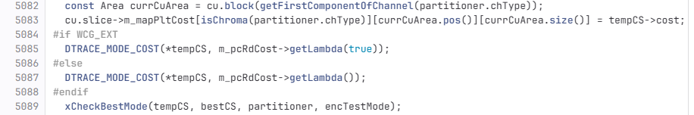

Experimental results

Encoding time for VTM 23.9 default, VTM 23.9 high perf. and ECM AL0245
The following table shows EncT of VTM default, VTM high performance and ECM JVET-AL0245 configurations. The EncT ratio vs VTM default configuration is vary depending on sequences and/or rate points.
The runtime ratio of VTM high performance is 1.3, 1.5, 1.7 and 1.9 at R1, R2, R3 and R4 respectively. With increased MTT depth, a.k.a VTM 2x, encoding runtime increased at high rate point^{*1} than at low bitrate.
The runtime ratio of ECM JVET-AL0245 is 10.4, 8.0, 6.2 and 5.3 at R1, R2, R3 and R4 respectively. With restricting MTT depth, a.k.a VTM 5x, encoding runtime ratio is smaller at high rate point^{*2} than at low bitrate.

Category | SID | Sequence Name | RP | EncT [sec] |  |  | EncT ratio  vs VTM default
 |  |  |  | VTM  default | VTM  high perf. | ECM  AL0245 | VTM  high perf. | ECM  AL0245
SDR_RA_HD | SRH1 | DucksTakeOff | R1 | 24758 | 33532 | 226612 | 1.4 | 9.2
SDR_RA_HD | SRH1 | DucksTakeOff | R2 | 58821 | 98013 | 388266 | 1.7 | 6.6
SDR_RA_HD | SRH1 | DucksTakeOff | R3 | 143439 | 302250 | 699387 | 2.1 | 4.9
SDR_RA_HD | SRH1 | DucksTakeOff | R4 | 308526 | 711732 | 1331490 | 2.3 | 4.3
SDR_RA_HD | SRH2 | DrivingPOV4 | R1 | 12686 | 15051 | 147944 | 1.2 | 11.7
SDR_RA_HD | SRH2 | DrivingPOV4 | R2 | 20702 | 27790 | 184026 | 1.3 | 8.9
SDR_RA_HD | SRH2 | DrivingPOV4 | R3 | 34997 | 53462 | 247566 | 1.5 | 7.1
SDR_RA_HD | SRH2 | DrivingPOV4 | R4 | 55181 | 93213 | 342327 | 1.7 | 6.2
SDR_RA_HD | SRH3 | Seeking | R1 | 15909 | 20016 | 166760 | 1.3 | 10.5
SDR_RA_HD | SRH3 | Seeking | R2 | 26034 | 36685 | 226853 | 1.4 | 8.7
SDR_RA_HD | SRH3 | Seeking | R3 | 42668 | 66980 | 304319 | 1.6 | 7.1
SDR_RA_HD | SRH3 | Seeking | R4 | 69517 | 121994 | 406715 | 1.8 | 5.9
SDR_RA_HD | SRH4 | Umbrella | R1 | 19233 | 26325 | 194832 | 1.4 | 10.1
SDR_RA_HD | SRH4 | Umbrella | R2 | 36452 | 58193 | 283660 | 1.6 | 7.8
SDR_RA_HD | SRH4 | Umbrella | R3 | 69183 | 123930 | 408047 | 1.8 | 5.9
SDR_RA_HD | SRH4 | Umbrella | R4 | 116951 | 222866 | 584627 | 1.9 | 5.0
 |  | average | R1 |  |  |  | 1.3 | 10.4
 |  |  | R2 |  |  |  | 1.5 | 8.0
 |  |  | R3 |  |  |  | 1.7 | 6.2
 |  |  | R4 |  |  |  | 1.9^{*1} | 5.3^{*2}

Encoding time per RDO count for VTM 23.9 default, VTM 23.9 high perf. and ECM AL0245
The following figure shows encoding time per RDO count of VTM default, VTM high performance and ECM JVET-AL0245 configurations. The encoding runtime looks correlated with RDO count.
- Encoding time per RDO count is not so difference between VTM and VTM high perf. It may reflect to decoder is same.
- Encoding time per RDO count in ECM is 13 times larger than that of VTM and it may reflect to 12x DecT in ECM to VTM.
- Intercept in ECM is much larger than that of VTM, which is near zero. It might be due to other part, e.g. loop filter or something’s EncT increase.
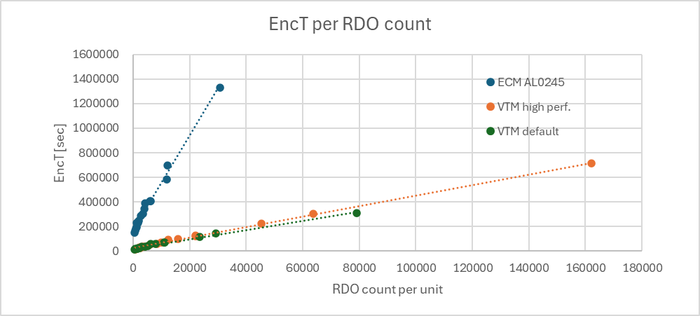

VTM 23.9 under default configuration
Figure 1 shows encoding runtime per RDO count for SDR_RA_HD sequences using VTM 23.9 under default configuration. Table 1 shows RDO count (total, per frame and per unit, 128x128).
The encoding runtime looks correlated with RDO count. Average EncT per RDO count is about 0.087 msec/count. RDO count varies greatly depending on sequences, e.g. RDO count per unit of DucksTakeOff is over 10.6 times larger than that of DrivingPOV4 at the highest rate point.
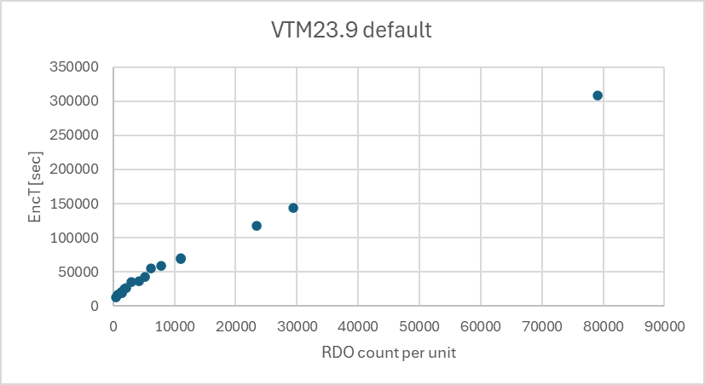
Figure 1 Encoding time per RDO count (VTM default)

Table 1 The number of RDO search (VTM default)
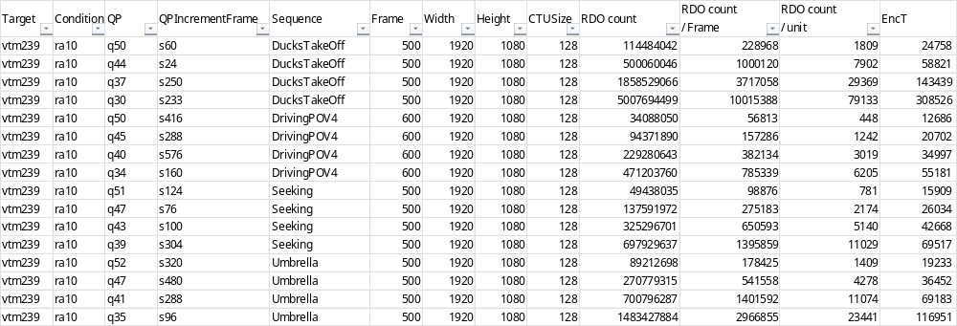

VTM 23.9 under high performance configuration
Figure 2 shows encoding runtime per RDO count for SDR_RA_HD sequences using VTM 23.9 under high performance configuration. Table 2 shows RDO count (total, per frame and per unit, 128x128).
The encoding runtime looks correlated with RDO count. Average EncT per RDO count is about 0.082 msec/count, which is almost the same as that of default configuration. RDO count varies greatly depending on sequences, e.g. RDO count per unit of DucksTakeOff is over 13.1 times larger than that of DrivingPOV4 at the highest rate point.
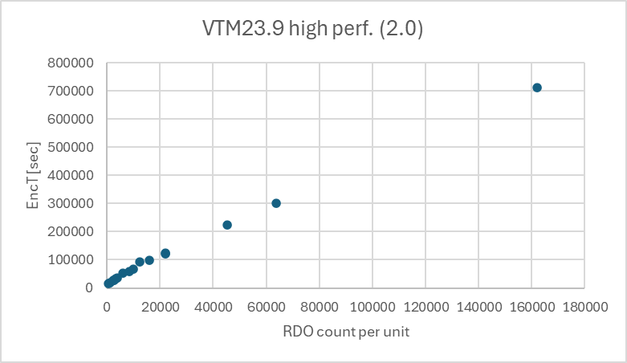
Figure 2 Encoding time per RDO count (VTM high perf.)

Table 2 The number of RDO search (VTM high perf.)
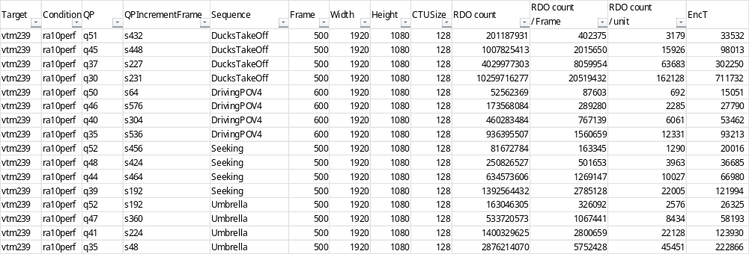

ECM 16.1 under JVET-AL0245 configuration
Figure 3 shows encoding runtime per RDO count for SDR_RA_HD sequences using ECM 16.1 under JVET-AL0245 configuration. Table 3 shows RDO count (total, per frame and per unit, 128x128).
The encoding runtime looks correlated with RDO count. Average EncT per RDO count is about 1.060 msec/count, which is 13 times larger than that of VTM and it may reflect to 12x DecT in ECM. RDO count varies greatly depending on sequences, e.g. RDO count per unit of DucksTakeOff is over 7.8 times larger than that of DrivingPOV4 at the highest rate point.
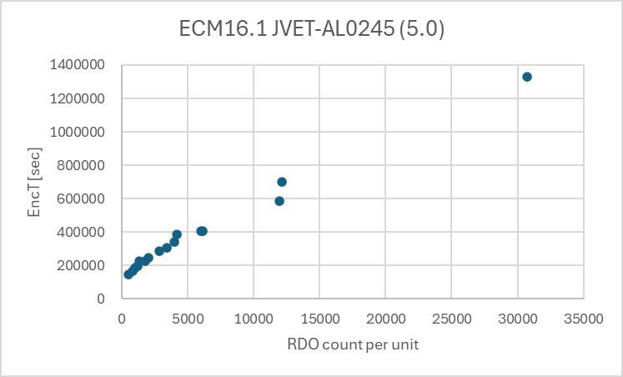
Figure 3 Encoding runtime per RDO count (ECM JVET-AL0245)

Table 3 The number of RDO search (ECM JVET-AL0245)
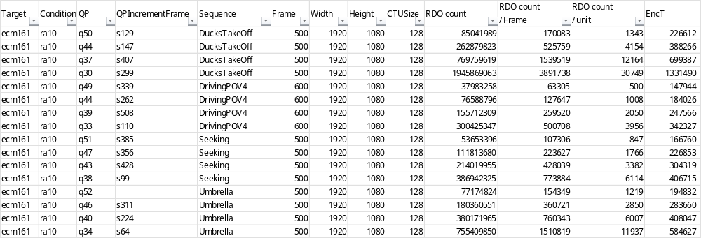

Discussion
In the draft CfE, the following are described as coding conditions.
3.1.2 Coding conditions for anchors
For VVC, bitstreams are generated for the following configurations documented in [5] :
• Reduced encoding time (3 variants, encoding times are approximately 2 to 6 times less than for the default)
3.1.3 Coding conditions for submissions
“Three encoder run time targets are defined as:
• 5 times (500%) the encoder runtime of the VTM anchor”

It is proposed to apply the above conditions to the highest rate point, R4.

Conclusion
We have analyzed encoding runtime and the number of RDO search (RDO count) for SDR_RA_HD draft CfE sequences. Experimental results show that runtime ratio of VTM high performance and ECM JVET-AL0245 are roughly 1.3x to 1.9x and 10.4x to 5.3x for R1 to R4, and encoding runtime and RDO count are correlated, and they vary greatly depending on sequences. For SDR_RA_HD, EncT per RDO count is 0.087, 0.082 msec/count in VTM 23.9 under default and high performance configurations respectively. On the other hand, it is 1.060 msec/count in ECM under JVET-AL0245 configuration, which is 13 times larger than that of VTM and it may reflect to 12x DecT in ECM to VTM.

References
[1] J.-R Ohm, M. Wien, “Draft Joint Call for Evidence on video compression with capability beyond VVC,” JVET-AL2026, April 2025
[2] T. Ikai, K.-W Liang, “[AHG7][AHG17] Further consideration of common test condition,” JVET-AL0245, April 2025

Acknowledgements
These research results were obtained from the grant program (No. JPJ012368G50501) by National Institute of Information and Communications Technology (NICT), Japan

Patent rights declaration(s)
Sharp Corporation may have current or pending patent rights relating to the technology described in this contribution and, conditioned on reciprocity, is prepared to grant licenses under reasonable and non-discriminatory terms as necessary for implementation of the resulting ITU-T Recommendation | ISO/IEC International Standard (per box 2 of the ITU-T/ITU-R/ISO/IEC patent statement and licensing declaration form).

Appendix

Category | SID | Sequence Name | RP | EncT [sec] |  |  | EncT ratio  vs VTM default
 |  |  |  | VTM  default | VTM  high perf. | ECM  AL0245 | VTM  high perf. | ECM  AL0245
SDR_RA_UHD | SRU1 | CrowdRun | R1 | 55127 | 70195 | 736399 | 1.3 | 13.4
SDR_RA_UHD | SRU1 | CrowdRun | R2 | 98452 | 141442 | 936541 | 1.4 | 9.5
SDR_RA_UHD | SRU1 | CrowdRun | R3 | 179665 | 286026 | 1217998 | 1.6 | 6.8
SDR_RA_UHD | SRU1 | CrowdRun | R4 | 331382 | 578984 | 1670444 | 1.7 | 5.0
SDR_RA_UHD | SRU2 | DrivingPOV3 | R1 | 35554 | 41417 | 594613 | 1.2 | 16.7
SDR_RA_UHD | SRU2 | DrivingPOV3 | R2 | 55360 | 69341 | 731419 | 1.3 | 13.2
SDR_RA_UHD | SRU2 | DrivingPOV3 | R3 | 92258 | 125679 | 942819 | 1.4 | 10.2
SDR_RA_UHD | SRU2 | DrivingPOV3 | R4 | 152152 | 227803 | 1215923 | 1.5 | 8.0
SDR_RA_UHD | SRU3 | FireDance | R1 | 19884 | 23876 | 329251 | 1.2 | 16.6
SDR_RA_UHD | SRU3 | FireDance | R2 | 39544 | 51520 | 450766 | 1.3 | 11.4
SDR_RA_UHD | SRU3 | FireDance | R3 | 70971 | 98975 | 598731 | 1.4 | 8.4
SDR_RA_UHD | SRU3 | FireDance | R4 | 138137 | 202513 | 857053 | 1.5 | 6.2
SDR_RA_UHD | SRU4 | HallwayScene | R1 | 12318 | 14244 | 228840 | 1.2 | 18.6
SDR_RA_UHD | SRU4 | HallwayScene | R2 | 23988 | 28778 | 359995 | 1.2 | 15.0
SDR_RA_UHD | SRU4 | HallwayScene | R3 | 48434 | 62114 | 521503 | 1.3 | 10.8
SDR_RA_UHD | SRU4 | HallwayScene | R4 | 99265 | 135348 | 740957 | 1.4 | 7.5
SDR_RA_HD | SRH1 | DucksTakeOff | R1 | 24758 | 33532 | 226612 | 1.4 | 9.2
SDR_RA_HD | SRH1 | DucksTakeOff | R2 | 58821 | 98013 | 388266 | 1.7 | 6.6
SDR_RA_HD | SRH1 | DucksTakeOff | R3 | 143439 | 302250 | 699387 | 2.1 | 4.9
SDR_RA_HD | SRH1 | DucksTakeOff | R4 | 308526 | 711732 | 1331490 | 2.3 | 4.3
SDR_RA_HD | SRH2 | DrivingPOV4 | R1 | 12686 | 15051 | 147944 | 1.2 | 11.7
SDR_RA_HD | SRH2 | DrivingPOV4 | R2 | 20702 | 27790 | 184026 | 1.3 | 8.9
SDR_RA_HD | SRH2 | DrivingPOV4 | R3 | 34997 | 53462 | 247566 | 1.5 | 7.1
SDR_RA_HD | SRH2 | DrivingPOV4 | R4 | 55181 | 93213 | 342327 | 1.7 | 6.2
SDR_RA_HD | SRH3 | Seeking | R1 | 15909 | 20016 | 166760 | 1.3 | 10.5
SDR_RA_HD | SRH3 | Seeking | R2 | 26034 | 36685 | 226853 | 1.4 | 8.7
SDR_RA_HD | SRH3 | Seeking | R3 | 42668 | 66980 | 304319 | 1.6 | 7.1
SDR_RA_HD | SRH3 | Seeking | R4 | 69517 | 121994 | 406715 | 1.8 | 5.9
SDR_RA_HD | SRH4 | Umbrella | R1 | 19233 | 26325 | 194832 | 1.4 | 10.1
SDR_RA_HD | SRH4 | Umbrella | R2 | 36452 | 58193 | 283660 | 1.6 | 7.8
SDR_RA_HD | SRH4 | Umbrella | R3 | 69183 | 123930 | 408047 | 1.8 | 5.9
SDR_RA_HD | SRH4 | Umbrella | R4 | 116951 | 222866 | 584627 | 1.9 | 5.0
SDR_LD_HD | SLH1 | Beatriz | R1 | 10215 | 13831 | 107769 | 1.4 | 10.5
SDR_LD_HD | SLH1 | Beatriz | R2 | 16534 | 24691 | 144417 | 1.5 | 8.7
SDR_LD_HD | SLH1 | Beatriz | R3 | 24220 | 38702 | 198187 | 1.6 | 8.2
SDR_LD_HD | SLH1 | Beatriz | R4 | 37111 | 63681 | 270572 | 1.7 | 7.3
SDR_LD_HD | SLH2 | GregoryCactus2 | R1 | 25862 | 22593 | 121865 | 0.9 | 4.7
SDR_LD_HD | SLH2 | GregoryCactus2 | R2 | 13726 | 48831 | 189693 | 3.6 | 13.8
SDR_LD_HD | SLH2 | GregoryCactus2 | R3 | 47636 | 101065 | 292368 | 2.1 | 6.1
SDR_LD_HD | SLH2 | GregoryCactus2 | R4 | 84022 | 183898 | 454377 | 2.2 | 5.4
SDR_LD_HD | SLH3 | GregoryScarf2 | R1 | 12351 | 17985 | 116944 | 1.5 | 9.5
SDR_LD_HD | SLH3 | GregoryScarf2 | R2 | 28419 | 48738 | 205582 | 1.7 | 7.2
SDR_LD_HD | SLH3 | GregoryScarf2 | R3 | 61185 | 122138 | 335689 | 2.0 | 5.5
SDR_LD_HD | SLH3 | GregoryScarf2 | R4 | 115880 | 256416 | 535520 | 2.2 | 4.6
SDR_LD_HD | SLH4 | OfficeWalkAtWall | R1 | 6599 | 9151 | 68463 | 1.4 | 10.4
SDR_LD_HD | SLH4 | OfficeWalkAtWall | R2 | 11504 | 16823 | 95077 | 1.5 | 8.3
SDR_LD_HD | SLH4 | OfficeWalkAtWall | R3 | 19285 | 30692 | 146218 | 1.6 | 7.6
SDR_LD_HD | SLH4 | OfficeWalkAtWall | R4 | 35801 | 64224 | 201196 | 1.8 | 5.6
HDR_RA_UHD | HRU1 | AMS06 | R1 | 50879 | 63730 | 575384 | 1.3 | 11.3
HDR_RA_UHD | HRU1 | AMS06 | R2 | 86222 | 121509 | 786109 | 1.4 | 9.1
HDR_RA_UHD | HRU1 | AMS06 | R3 | 161134 | 290610 | 1194578 | 1.8 | 7.4
HDR_RA_UHD | HRU1 | AMS06 | R4 | 271686 | 478228 | 1691753 | 1.8 | 6.2
HDR_RA_UHD | HRU2 | MeridianHDR2 | R1 | 30766 | 33628 | 500962 | 1.1 | 16.3
HDR_RA_UHD | HRU2 | MeridianHDR2 | R2 | 56033 | 65063 | 609638 | 1.2 | 10.9
HDR_RA_UHD | HRU2 | MeridianHDR2 | R3 | 86604 | 106404 | 792084 | 1.2 | 9.1
HDR_RA_UHD | HRU2 | MeridianHDR2 | R4 | 137574 | 183215 | 1024777 | 1.3 | 7.4
HDR_RA_UHD | HRU3 | NeptuneFountain3R1 | R1 | 42975 | 52315 | 705719 | 1.2 | 16.4
HDR_RA_UHD | HRU3 | NeptuneFountain3R1 | R2 | 71768 | 94092 | 915118 | 1.3 | 12.8
HDR_RA_UHD | HRU3 | NeptuneFountain3R1 | R3 | 133165 | 196668 | 1209307 | 1.5 | 9.1
HDR_RA_UHD | HRU3 | NeptuneFountain3R1 | R4 | 282460 | 470277 | 1734815 | 1.7 | 6.1
HDR_RA_UHD | HRU4 | SparksWelding | R1 | 47992 | 59517 | 662688 | 1.2 | 13.8
HDR_RA_UHD | HRU4 | SparksWelding | R2 | 85124 | 117384 | 860853 | 1.4 | 10.1
HDR_RA_UHD | HRU4 | SparksWelding | R3 | 169057 | 262574 | 1174593 | 1.6 | 6.9
HDR_RA_UHD | HRU4 | SparksWelding | R4 | 352452 | 599016 | 1728289 | 1.7 | 4.9
HDR_RA_8Kcrop | HRC1 | ChandelierCropBR | R1 | 21433 | 26314 | 421992 | 1.2 | 19.7
HDR_RA_8Kcrop | HRC1 | ChandelierCropBR | R2 | 33353 | 42891 | 537215 | 1.3 | 16.1
HDR_RA_8Kcrop | HRC1 | ChandelierCropBR | R3 | 55593 | 77522 | 679614 | 1.4 | 12.2
HDR_RA_8Kcrop | HRC1 | ChandelierCropBR | R4 | 97729 | 146701 | 854732 | 1.5 | 8.7
HDR_RA_8Kcrop | HRC2 | FashionLadyCrop1 | R1 | 19795 | 23193 | 332360 | 1.2 | 16.8
HDR_RA_8Kcrop | HRC2 | FashionLadyCrop1 | R2 | 31335 | 37969 | 455737 | 1.2 | 14.5
HDR_RA_8Kcrop | HRC2 | FashionLadyCrop1 | R3 | 51742 | 66245 | 599644 | 1.3 | 11.6
HDR_RA_8Kcrop | HRC2 | FashionLadyCrop1 | R4 | 94884 | 126979 | 798743 | 1.3 | 8.4
HDR_RA_8Kcrop | HRC3 | WaterfallForest | R1 | 71402 | 95287 | 750465 | 1.3 | 10.5
HDR_RA_8Kcrop | HRC3 | WaterfallForest | R2 | 135917 | 207361 | 1049366 | 1.5 | 7.7
HDR_RA_8Kcrop | HRC3 | WaterfallForest | R3 | 262101 | 448494 | 1473017 | 1.7 | 5.6
HDR_RA_8Kcrop | HRC3 | WaterfallForest | R4 | 456521 | 826367 | 2290637 | 1.8 | 5.0
HDR_RA_8Kcrop | HRC4 | WomenFootball | R1 | 28633 | 34033 | 402619 | 1.2 | 14.1
HDR_RA_8Kcrop | HRC4 | WomenFootball | R2 | 42839 | 54064 | 489373 | 1.3 | 11.4
HDR_RA_8Kcrop | HRC4 | WomenFootball | R3 | 68553 | 92712 | 599679 | 1.4 | 8.7
HDR_RA_8Kcrop | HRC4 | WomenFootball | R4 | 111897 | 159720 | 771933 | 1.4 | 6.9
Gamin_LD_HD | GLH1 | DOTA2s360 | R1 | 21478 | 33763 | 179945 | 1.6 | 8.4
Gamin_LD_HD | GLH1 | DOTA2s360 | R2 | 30867 | 51119 | 228972 | 1.7 | 7.4
Gamin_LD_HD | GLH1 | DOTA2s360 | R3 | 41827 | 73989 | 282954 | 1.8 | 6.8
Gamin_LD_HD | GLH1 | DOTA2s360 | R4 | 63051 | 119041 | 398338 | 1.9 | 6.3
Gamin_LD_HD | GLH2 | GTAVs090 | R1 | 42834 | 68563 | 366030 | 1.6 | 8.5
Gamin_LD_HD | GLH2 | GTAVs090 | R2 | 62645 | 110555 | 478838 | 1.8 | 7.6
Gamin_LD_HD | GLH2 | GTAVs090 | R3 | 92836 | 177452 | 611086 | 1.9 | 6.6
Gamin_LD_HD | GLH2 | GTAVs090 | R4 | 134420 | 278861 | 814417 | 2.1 | 6.1
Gamin_LD_HD | GLH3 | Level1 | R1 | 34643 | 58535 | 315376 | 1.7 | 9.1
Gamin_LD_HD | GLH3 | Level1 | R2 | 53666 | 104027 | 442533 | 1.9 | 8.2
Gamin_LD_HD | GLH3 | Level1 | R3 | 87073 | 177553 | 606708 | 2.0 | 7.0
Gamin_LD_HD | GLH3 | Level1 | R4 | 135284 | 285815 | 791284 | 2.1 | 5.8
Gamin_LD_HD | GLH4 | Minecraft | R1 | 23558 | 35811 | 216477 | 1.5 | 9.2
Gamin_LD_HD | GLH4 | Minecraft | R2 | 36612 | 60183 | 300516 | 1.6 | 8.2
Gamin_LD_HD | GLH4 | Minecraft | R3 | 54918 | 98608 | 398927 | 1.8 | 7.3
Gamin_LD_HD | GLH4 | Minecraft | R4 | 80151 | 152747 | 514232 | 1.9 | 6.4
UGC_RA_HD | URH1 | Camellia | R1 | 25778 | 39426 | 233905 | 1.5 | 9.1
UGC_RA_HD | URH1 | Camellia | R2 | 41959 | 70328 | 306507 | 1.7 | 7.3
UGC_RA_HD | URH1 | Camellia | R3 | 67079 | 122909 | 412765 | 1.8 | 6.2
UGC_RA_HD | URH1 | Camellia | R4 | 100833 | 192087 | 579257 | 1.9 | 5.7
UGC_RA_HD | URH2 | Hobby-w5xz-backpack | R1 | 4071 | 4992 | 55076 | 1.2 | 13.5
UGC_RA_HD | URH2 | Hobby-w5xz-backpack | R2 | 6452 | 8605 | 66559 | 1.3 | 10.3
UGC_RA_HD | URH2 | Hobby-w5xz-backpack | R3 | 10567 | 15392 | 84814 | 1.5 | 8.0
UGC_RA_HD | URH2 | Hobby-w5xz-backpack | R4 | 17148 | 27805 | 108574 | 1.6 | 6.3
UGC_RA_HD | URH3 | NightLandscapeRunning | R1 | 5867 | 7095 | 69158 | 1.2 | 11.8
UGC_RA_HD | URH3 | NightLandscapeRunning | R2 | 12200 | 16614 | 101700 | 1.4 | 8.3
UGC_RA_HD | URH3 | NightLandscapeRunning | R3 | 25556 | 39518 | 159436 | 1.5 | 6.2
UGC_RA_HD | URH3 | NightLandscapeRunning | R4 | 44658 | 73949 | 228866 | 1.7 | 5.1
UGC_RA_HD | URH4 | Sports-76a2-iceball | R1 | 9393 | 11324 | 117461 | 1.2 | 12.5
UGC_RA_HD | URH4 | Sports-76a2-iceball | R2 | 12361 | 15955 | 133837 | 1.3 | 10.8
UGC_RA_HD | URH4 | Sports-76a2-iceball | R3 | 17157 | 23299 | 154745 | 1.4 | 9.0
UGC_RA_HD | URH4 | Sports-76a2-iceball | R4 | 24364 | 35122 | 184180 | 1.4 | 7.6
UGC_RA_HD | URH5 | VerticalVideo-3709-snow | R1 | 5329 | 6307 | 60445 | 1.2 | 11.3
UGC_RA_HD | URH5 | VerticalVideo-3709-snow | R2 | 7583 | 9382 | 70605 | 1.2 | 9.3
UGC_RA_HD | URH5 | VerticalVideo-3709-snow | R3 | 11004 | 14405 | 83867 | 1.3 | 7.6
UGC_RA_HD | URH5 | VerticalVideo-3709-snow | R4 | 16515 | 22833 | 105983 | 1.4 | 6.4
UGC_RA_HD | URH6 | VerticalVideo-3d96-walk | R1 | 5823 | 6870 | 65006 | 1.2 | 11.2
UGC_RA_HD | URH6 | VerticalVideo-3d96-walk | R2 | 8845 | 11616 | 76483 | 1.3 | 8.6
UGC_RA_HD | URH6 | VerticalVideo-3d96-walk | R3 | 12646 | 17926 | 91606 | 1.4 | 7.2
UGC_RA_HD | URH6 | VerticalVideo-3d96-walk | R4 | 19084 | 27844 | 114444 | 1.5 | 6.0

