    Joint Video Experts Team (JVET)  of ITU-T SG21 WP3/21 and ISO/IEC JTC 1/SC 29  39th Meeting, Daejeon, KR, 26 June – 4 July 2025 | Document: JVET-AM0124-v2

Title: | [AHG9/AHG13]: On typo fix and interface software contribution to the FGRC SEI message
Status: | Input document to JVET
Purpose: | Proposal
Author(s) or  Contact(s): | Shaowei Xie,  Weihong Niu,  Ping Wu,  Ying Gao,  Cheng Huang | Tel:  Email: | xie.shaowei@zte.com.cn,  ping.wu@zte.com.cn,  huang.cheng5@zte.com.cn
Source: | ZTE
_____________________________

Abstract
The document of “Technologies under consideration for future extensions of VSEI (version 8)” (JVET-AL2032) has been finalized in May 2025. In the document, the Film Grain Regions Characteristics (FGRC) SEI message design has been stabilized and the texts, relating to FGRC SEI message, have been fully integrated. During our FGRC SEI message software implementation process, one typo in the document of JVET-AL2032 has been identified. In this meeting contribution, we propose to correct this identified typo, and we also would like to request a merge process on FGRC SEI message interface software integration.

Introduction
In JVET January 2025 meeting, JVET-AK0058 [1] was adopted and the adopted texts have been fully integrated into JVET-AK2023 [2].
In the 33rd JVET meeting, the film grain regions characteristics (FGRC) SEI message was proposed in JVET-AG0328[3], and was adopted into the TuC for future extensions of VSEI. In order to improve the adaptability of this SEI message, JVET-AH0166[4] was proposed for allowing separate “fgr_model_id” to be applied in different regions, and the corresponding showcases were provided in JVET-AI0099[5]. While the model adaptation method proposed in JVET-AH0166 was adopted into the VSEI TuC doc, some model-adaptive modifications to the related syntax and semantics for the FGRC SEI message were proposed in JVET-AJ0091[6], -AJ0092[7], and -AK0058 to ensure the standard usage of the model-adaptive film grain technology. After careful discussion in JVET January 2025 meeting, JVET-AK0058 was finally adopted into the VSEI TuC doc, i.e., JVET-AK2032.
In detail, the method of JVET-AG0328 allows using a single film grain model in some specific regions. In these regions, a film grain model is applied, while film grain is not applied in others. In order to allow different film grain models to be applied in different regions, JVET-AK0058 was proposed. In JVET-AK0058, the film grain model applied in different regions can be indicated with the field “fgr_regions_model_id”, and its values are same as “fgr_model_id”, as shown in Table 1.
Table 1 – fgr_model_id values

Value | Description
0 | Frequency filtering
1 | Auto-regression
So far, only above two models can be supported by the current FGRC SEI message.

On typo fix
As showed in FGRC SEI message syntax of JVET-AL2032, the syntax element “fgr_comp_model_present_flag[m][c]” is defined as a 2-D array.
While “fgr_comp_model_present_flag[m][c]” is indicated for different film grain model with model id m, the following “fgr_comp_model_present_flag[c]” for specific regions highlighted in 8.38.1 needs to be fixed into:
- “fgr_comp_model_present_flag[fgr_model_id][ c ]”, while fgr_single_model_flag is equal to 1;
- “fgr_comp_model_present_flag[fgr_regions_model_id[ i ]][ c ] ” under the condition that fgr_single_model_flag is equal to 0, where fgr_regions_model_id[ i ] indicates the specific model used in region i.
The reason for this modification is that, during the application of the models, the specific model used in each region is already determinated, so the corresponding model should be incorporated into “fgr_comp_model_present_flag”, as shown in Figure 1
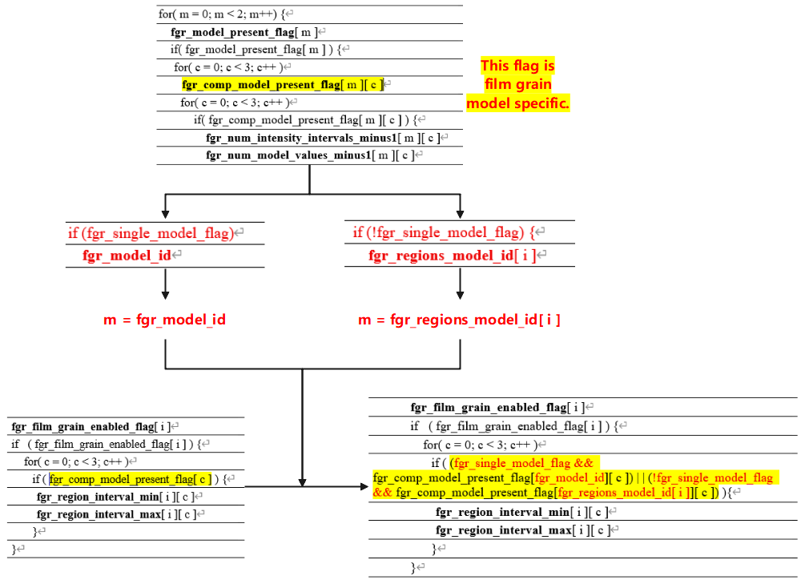
Figure 1 A typo fix on the FGRC SEI message

8.38 Film grain regions characteristics SEI message

8.38.1 Film grain regions characteristics SEI message syntax
film_grain_regions_characteristics( payloadSize ) { | Descriptor
fgr_cancel_flag | u(1)
if( !fgr_cancel_flag ) {
fgr_single_model_flag | u(1)
if (fgr_single_model_flag)
fgr_model_id | u(2)
fgr_separate_colour_description_present_flag | u(1)
if( fgr_separate_colour_description_present_flag ) {
fgr_bit_depth_luma_minus8 | u(3)
fgr_bit_depth_chroma_minus8 | u(3)
fgr_full_range_flag | u(1)
fgr_colour_primaries | u(8)
fgr_transfer_characteristics | u(8)
fgr_matrix_coeffs | u(8)
}
fgr_blending_mode_id | u(2)
fgr_log2_scale_factor | u(4)
for( m = 0; m < 2; m++) {
fgr_model_present_flag[ m ] | u(1)
if( fgr_model_present_flag[ m ] ) {
for( c = 0; c < 3; c++ )
fgr_comp_model_present_flag[ m ][ c ] | u(1)
for( c = 0; c < 3; c++ )
if( fgr_comp_model_present_flag[ m ][ c ] ) {
fgr_num_intensity_intervals_minus1[ m ][ c ] | u(8)
fgr_num_model_values_minus1[ m ][ c ] | u(3)
for( i = 0; i <= fgr_num_intensity_intervals_minus1[ m ][ c ]; i++ ) {
fgr_intensity_interval_lower_bound[ m ][ c ][ i ] | u(8)
fgr_intensity_interval_upper_bound[ m ][ c ][ i ] | u(8)
for( j = 0; j <= fgr_num_model_values_minus1[ m ][ c ]; j++ )
fgr_comp_model_value[ m ][ c ][ i ][ j ] | se(v)
}
}
}
}
fgr_region_information_present_flag | u(1)
if( fgr_region_information_present_flag ) {
fgr_region_based_adaptation_flag | u(1)
if( fgr_region_based_adaptation_flag ) {
fgr_active_regions_number_minus1 | u(8)
for( i = 0; i <= fgr_active_regions_number_minus1; i++ ) {
fgr_region_top[ i ] | u(16)
fgr_region_left[ i ] | u(16)
fgr_region_width[ i ] | u(16)
fgr_region_height[ i ] | u(16)
if (!fgr_single_model_flag) {
fgr_regions_model_id[ i ] | u(2)
}
fgr_film_grain_enabled_flag[ i ] | u(1)
if ( fgr_film_grain_enabled_flag[ i ] ) {
for( c = 0; c < 3; c++ )
if ( (fgr_single_model_flag && fgr_comp_model_present_flag[fgr_model_id][ c ]) | | (!fgr_single_model_flag && fgr_comp_model_present_flag[fgr_regions_model_id[ i ]][ c ]) ){
fgr_region_interval_min[ i ][ c ] | u(8)
fgr_region_interval_max[ i ][ c ] | u(8)
}
}
}
}
else
fgr_alpha_channel_adaptation_flag | u(1)
}
fgr _persistence_flag | u(1)
}
}

Interface software
We have finished the implementation of JVET-AK0058 based on the implementation of JVET-AH0212[8], which corresponds to the method of JVET-AG0328.
For out implementation, the configuration file example is shown as follows:
In the 1st part of the configuration file, “SEIFGRSingleModelFlag” is added to indicate whether the film grain regions use a single model or different models. And then, “SEIFGRModel0PresentFlag” and “SEIFGRModel1PresentFlag” indicate whether model0 and model1 is available or not, respectively.
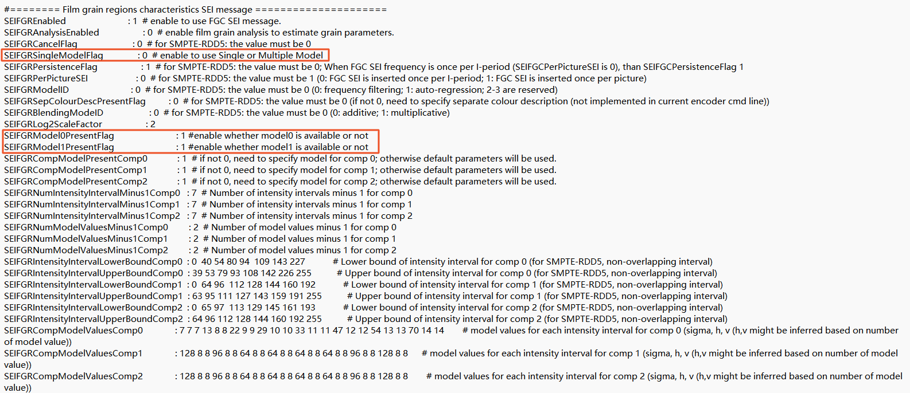
In the 2nd part of the configuration file, “SEIFGRegionModelID” is newly added to indicate which film grain model is used in each region, as specified in Table I.
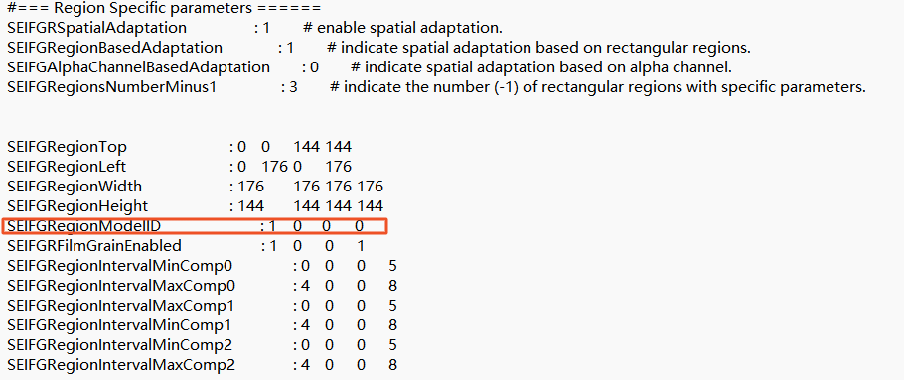
The attached file provides the configuration file. And we will try our best to contribute SEI interface software for the implementation of FGRC SEI message.
Additional to the configure information, the source codes for JVET-AK0058 adopted flags, such as “fgr_model_present_flag[ m ]”, etc., have all been implemented and tested, which enable the FGRC SEI message software interface codes matching the TuC texts precisely.

Reference
- Shaowei Xie, Ping Wu, Ying Gao, Yaxian Bai, Cheng Huang (ZTE), AHG9: Comments on Film grain regions characteristics SEI message, JVET-AK0058, Jan. 2025.
- Sean McCarthy, Jill Boyce, Jie Chen, Sachin Deshpande, Miska M. Hannuksela, Hendry Tan, Ye-Kui Wang, Technologies under consideration for future extensions of VSEI (version 7), JVET-AK2032, Jan. 2025.
- Stephan Wenger, Arianne Hinds, Gilles Teniou (Tencent), P. de Lagrange, E. François, D. Doyen, M. Le Pendu, C. Salmon-Legagneur (Interdigital), Ying Gao, Shaowei Xie, Yaxian Bai, Menghu Jia, Cheng Huang, Ping Wu (ZTE), AHG9/AHG13: unified proposal on film grain regions characteristics SEI message, JVET-AG0328, Jan. 2024.
- Shaowei Xie, Ping Wu, Ying Gao, Yaxian Bai, Menghu Jia, Weihong Niu, Cheng Huang (ZTE), AHG9: Improvements to the film grain regions characteristics SEI message, JVET-AH0166, Apr. 2024.
- Shaowei Xie, Ping Wu, Ying Gao, Yaxian Bai, Menghu Jia, Weihong Niu, Cheng Huang (ZTE), AHG9: Showcases on the implementation of applying separate film grain models in different regions, JVET-AI0099, Jul. 2024.
- Shaowei Xie, Ping Wu, Ying Gao, Yaxian Bai, Cheng Huang (ZTE), AHG9: Updates on Film grain regions characteristics SEI message, JVET-AJ0091, Nov. 2024.
- Shaowei Xie, Ping Wu, Ying Gao, Yaxian Bai, Cheng Huang (ZTE), AHG9: Comments on Film grain regions characteristics SEI message, JVET-AJ0092, Nov. 2024.
- Gilles Teniou (Tencent), Philippe De Lagrange, Edouard François (InterDigital), AHG9: Updates on the implementation of film grain regions characteristics SEI message, JVET-AH0212, Apr, 2024.

Patent rights declaration(s)
ZTE Corporation may have current or pending patent rights relating to the technology described in this contribution and, conditioned on reciprocity, is prepared to grant licenses under reasonable and non-discriminatory terms as necessary for implementation of the resulting ITU-T Recommendation | ISO/IEC International Standard (per box 2 of the ITU-T/ITU-R/ISO/IEC patent statement and licensing declaration form).

