    Joint Video Experts Team (JVET)  of ITU-T SG21 WP3/21 and ISO/IEC JTC 1/SC 29  39th Meeting, Daejeon, KR, 26 June – 4 July 2025 | Document: JVET-AM0073-v3

Title: | [AHG11] Comparison of execution time of NN on different devices
Status: | Input document to JVET
Purpose: | Information
Author(s) or  Contact(s): | Name(s)  Alexander Karabutov  Elena Alshina  Fabian Brand | Email: | karabutov.alexander@huawei.com  elena.alshina@huawei.com  fabian.brand@huawei.com
Source: | AHG11
_____________________________

Abstract
This contribution provides information about the execution time of neural networks across different devices using the JPEG-AI framework. Two devices were tested: a Huawei Mate50 Pro and a high-end PC with an RTX 3090 GPU. Experiments focused on decoding a 4K stream and varying image sizes, with the prediction and synthesis parts of the codec optimized into a single model for efficiency. The results showed that the ratio between running time of a NN model on CPU and GPU depends on the model complexity in terms of kMAC/px and number of processed pixels. It was proposed empirical formula to calculate the ratio of inferencing time on CPU/GPU for used hardware in the experiments. It is applicable to convolutional type of networks. For attention-based networks it was observed non-linear dependency between CPU and GPU running time, therefore they were excluded from consideration. The formula shows that considering only CPU runtime and complexity in kMAC/px NN model is not sufficient for prediction actual time of its inference on GPU.

Introduction
The rapid advancement of artificial intelligence (AI) and machine learning (ML) has led to the widespread adoption of neural networks across various applications, ranging from computer vision and natural language processing to autonomous systems. As neural networks grow in complexity, their deployment across diverse hardware platforms becomes increasingly challenging. Execution time, a critical metric for evaluating the performance of neural networks, is heavily influenced by the underlying hardware architecture, software optimizations, and the specific characteristics of the neural network model itself. Understanding how neural networks perform on different devices is essential for optimizing their deployment in real-world applications.
The JPEG AI standard [1] has emerged as a significant framework for integrating AI capabilities into image compression and processing pipelines. This standard provides a unified platform for benchmarking and evaluating neural network performance across various devices, enabling researchers and developers to compare execution times and resource utilization in a standardized manner.
This proposal focuses on the measurement of execution time for neural networks deployed on various devices, leveraging the JPEG-AI framework as a foundation for analysis. By examining the performance of neural networks on devices ranging from low-power edge devices to high-performance GPU card, this study aims to provide insights into the factors that influence execution time and the trade-offs involved in deploying neural networks in different environments.

Experimental setup
For the experiments on measurement an execution time of the JPEG AI two devices were used. The information about them and used frameworks are:
- Huawei Mate50 pro:
  - Processor: Snapdragon 8+ Gen 1 4G Mobile Platform.
  - NPU: 7th Gen Qualcomm AI Engine.
  - RAM: 8 GB.
  - Framework: C++ implementation of JPEG-AI (DIS version of the reference SW) with SNPE library.
- PC with GPU:
  - Processor: AMD Ryzen 9 5950X 16-Core Processor.
  - GPU: Nvidia Geforce RTX 3090, 24 GB.
  - RAM: 64 GB DDR4 2133 MHz.
  - Framework: python implementation of JPEG-AI (DIS version of the reference SW) based on PyTorch.

Structure of JPEG AI’s decoder
The high-level diagram of encoder and decoder is shown on Figure 1 [1]. Encoder operations are informative, specified here only to facilitate the description of decoder operations.
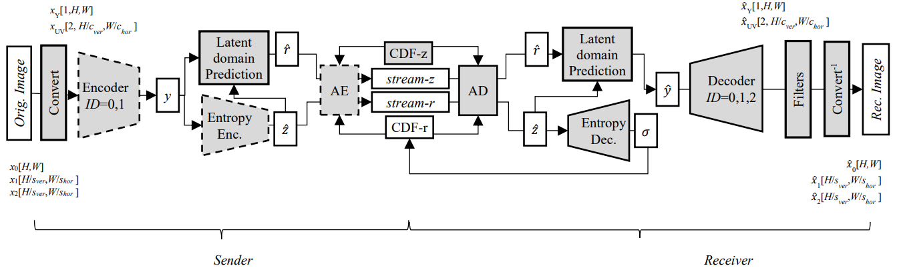
Encoder
Decoder
Figure 1. General JPEG AI encoder and decoder diagram
The decoder performs parsing hyper tensor 𝑧̂ (entropy parameters are part of the trained model), processing by the hyper scale decoder to produce entropy parameters for residual decoding, processing by the hyper decoder to produce explicitly signaled component of prediction and latent domain prediction which combines prediction with residual, forming reconstructed latent representation of the image 𝑦̂. The synthesis transform for the primary component operates independently, secondary component synthesis transform receives latent representations for both secondary component and primary component as auxiliary input.
Prediction of the latent space for the components is processed differently. In a case of the Luma component, two steps are used. At the beginning, the initial prediction is generated by a Hyper decoder (Figure 2) and further enhanced by Multistage Context Model (Figure 3). In the case of Chroma component, only one step with a Hyper decoder is performed. The Hyper decoders have similar structure, except the number of the channels and weights.
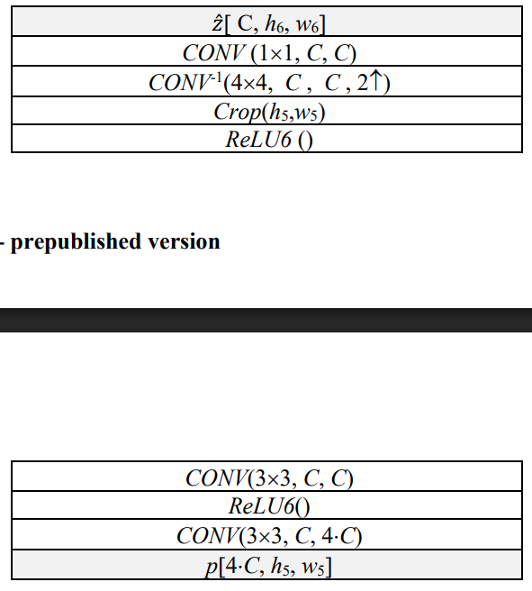
Figure 2. Structure of the Hyper decoder
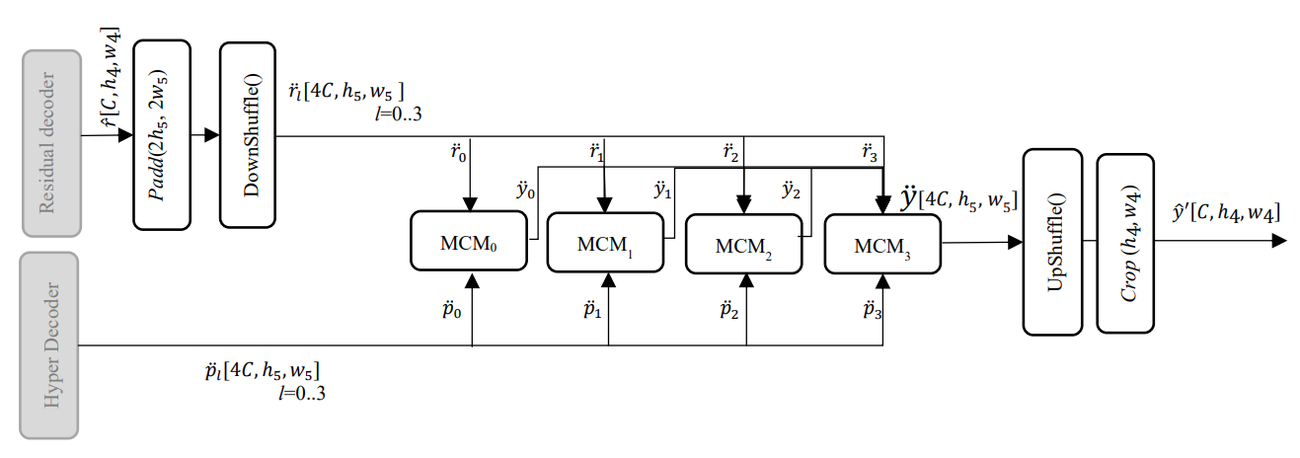
Figure 3. Structure of the Multistage Context Model (MCM)

JPEG AI supports to decode the same stream by different types of decoder networks. They are different in terms of complexity and the reconstruction quality and presented in JEPG AI’s profiles:
- simple profile, its complexity is about 7 kMAC/px,
- base profile, its complexity is about 20 kMAC/px,
- high profile, its complexity is about 200 kMAC/px.
All the prediction networks are the same for all of the profiles. The difference between the profiles is in the synthesis network that is marked as “DecoderID=0,1,2” on Figure 1.

Simple profile
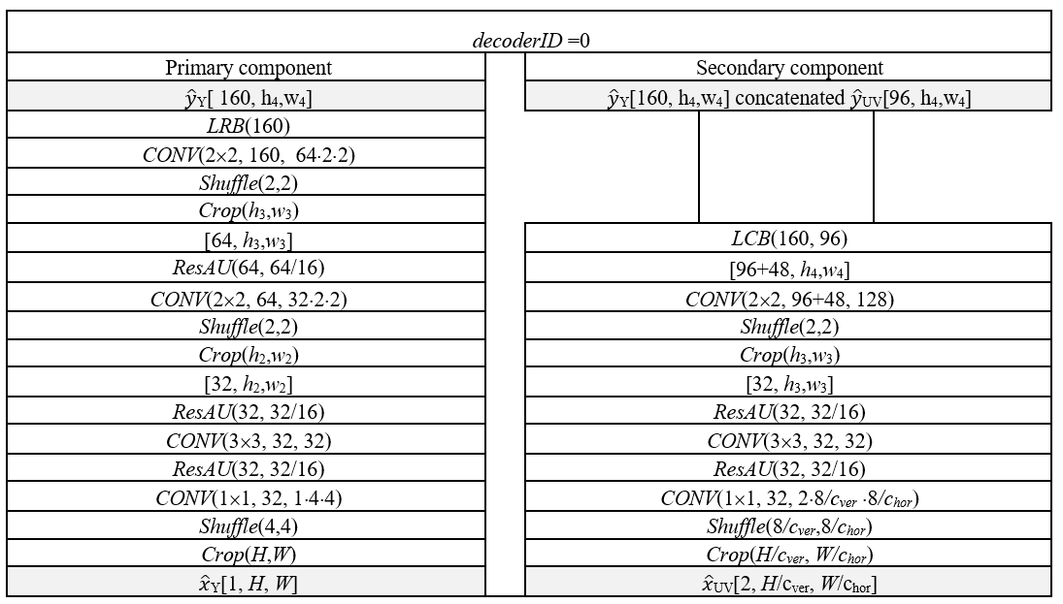
Figure 4. Structure of the decoder network that is used in Simple profile.
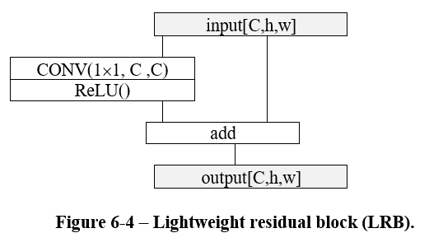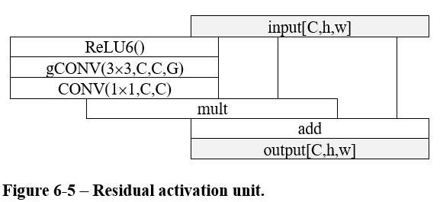
(a) Lightweight residual block (LRB)
(b) Residual activation unit (ResAU)
Figure 5. Structure of LRB (a) and ResAU (b) elements
The structure of the used decoder network is presented on Figure 1. It has two separated branches. The network was designed with low complexity to be friendly to run on mobiles CPU.

Base profile
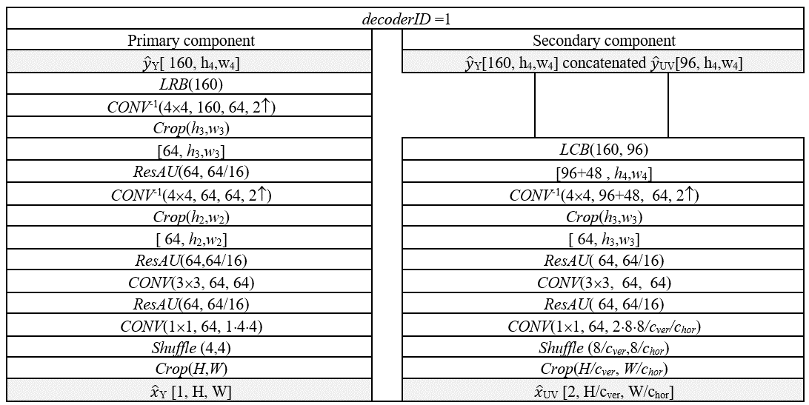
Figure 6. Structure of the decoder network that is used in BAse profile.
In Base profile the decoder network has similar structure as in Simple profile, except using invert convolution operation instead of Shuffle for up-sampling. The profile was designed to be used on NPU of mobile devices.

High profile
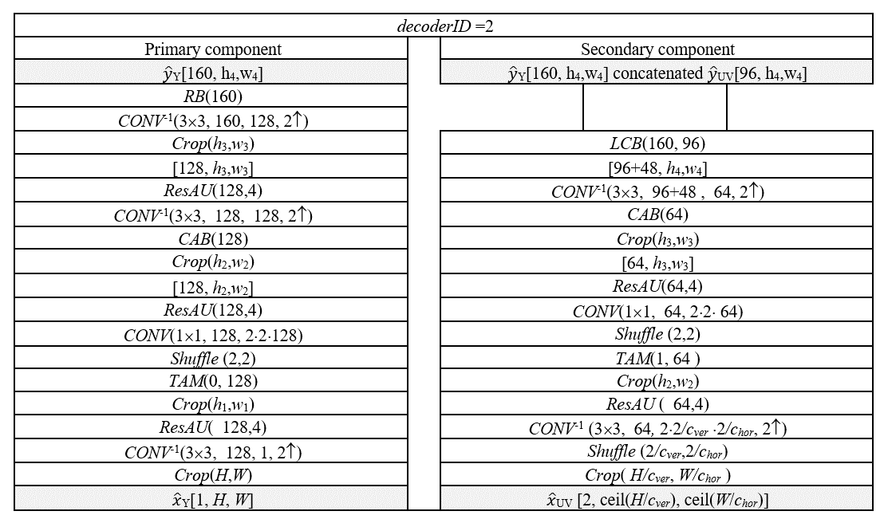
Figure 7. Structure of the decoder network that is used in High profile
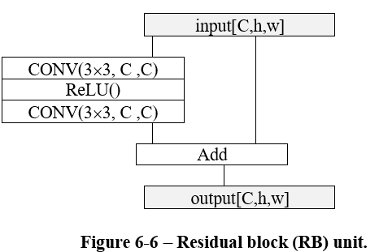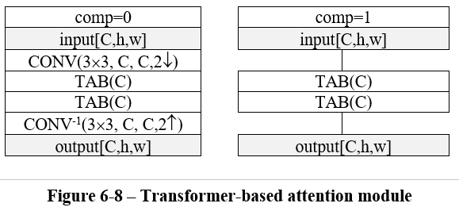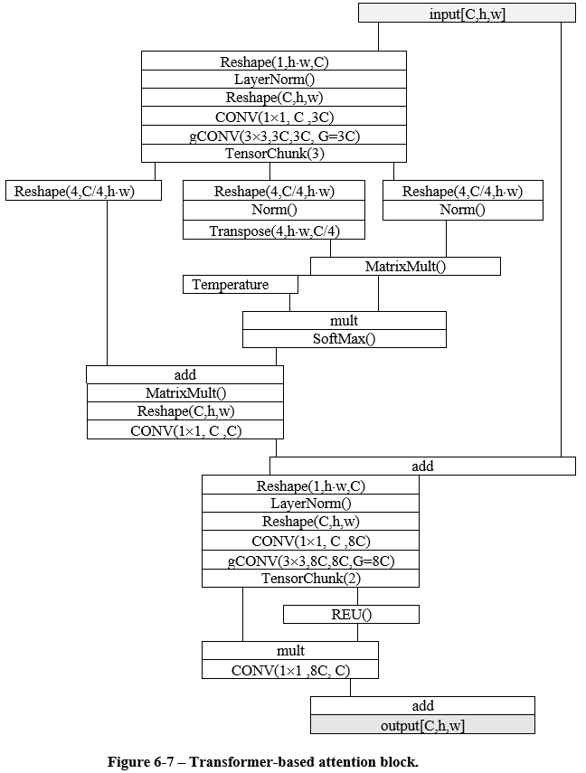
(a) Residual block (RB) unit
(b) Transformer-based attention module
(c) Transformer-based attention block
Figure 8. Neural networks modules used in High profile decoder
High profile was designed to run on PC’s GPU and it has attention blocks that increases complexity of its decoder network.

Latent space tiling
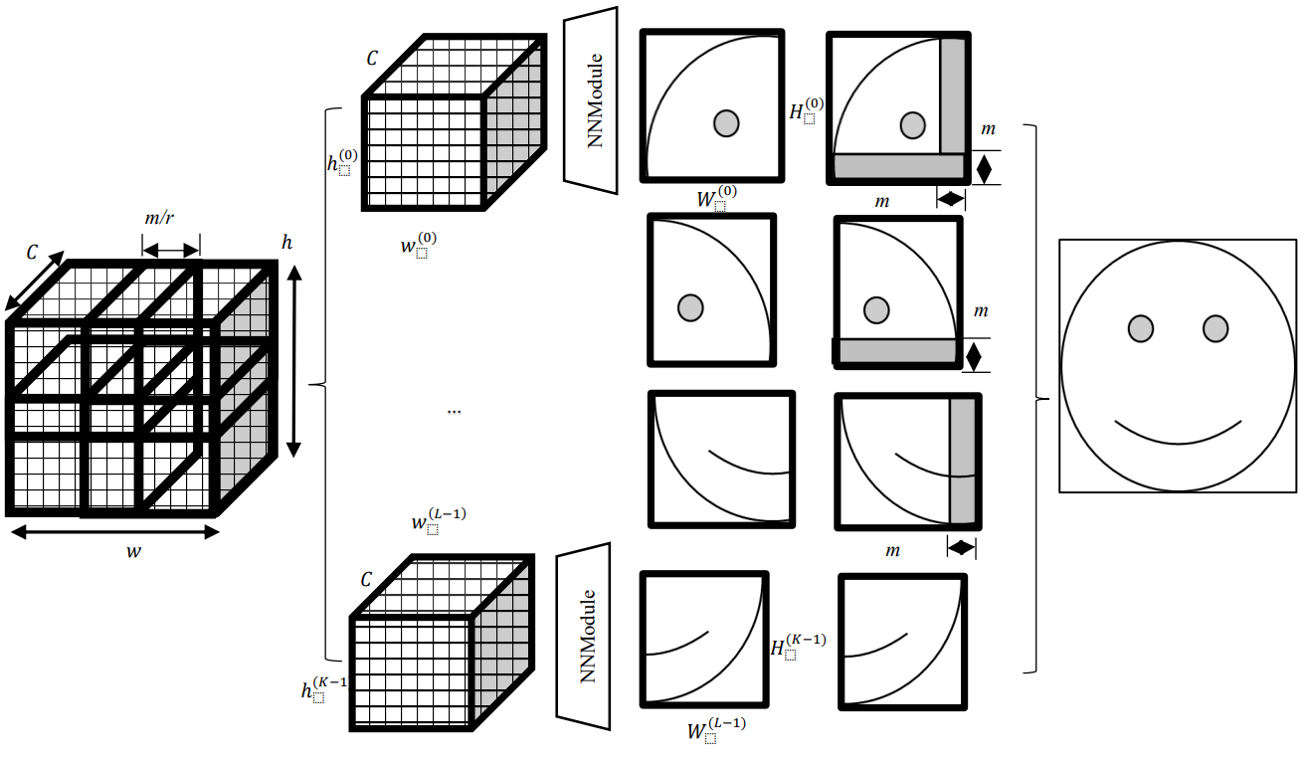
Figure 9. Example of splitting a latent space into tiles
As well as in the conventional image and video codecs, JPEG AI supports tiling to run the decoder on devices with wide range of memory size. The tiling mechanism performs with overlap. It means that a part of the reconstructed tile (right or/and bottom) doesn’t store to the output buffer. This part is needed because of the receptive field of the synthesis network. The convolution layers have padding on all of the borders therefore in the case of right and bottom borders (m lines and columns on Figure 9) they have zeros instead of decoded data. As result, these parts have incorrectly reconstructed signal that is replaced by the next tile.
The size of the tiles and the overlap are signaled in a bitstream.

Results
In the following experiments the complexity of JPEG AI was investigated in terms of kMAC/px and time of execution on different devices. In all following experiments the complexity of the latent space prediction and synthesis networks was investigated. These parts of the codec were selected, because the rest of the codec, i.e. entropy part, performed strictly on CPU to guaranty device interoperability of the decoding process in a case of the mobile device.
All time measurements were performed 10 times for each configuration.

Decoding of the same stream on the mobile phone and PC

The first experiment was done with usage of a bitstream that was encoded on PC by the reference software [2]. It has 1856x3520 resolution (Figure 9) and was encoded by Base profile (see section 3.2). For the mobile device, the complexity of reconstruction was assessed using both the CPU and NPU. Additionally, for the PC, the process was conducted using both the CPU and GPU.
To improve an execution time of the model on the mobile device, prediction and synthesis parts of the codec were coupled into a single model. Its inputs are residuals and $\hat{z}$ from the bitstream and outputs are luminance and chrominance components of the reconstructed image. The software doesn’t support multithreading on CPU.
On PC the reference software [2] was used. It is written on Python and uses PyTorch. To align execution conditions on CPU of mobile device and PC, the single-thread configuration was used.


Figure 10. The image that was used to measure decoding time on the mobile device and PC
The results of the experiment are in the Table 1. For the implementation on the mobile device, data loading time was measured and. It is almost the same for CPU and NPU. Compared to the inference time on CPU it is less than 1%, but on NPU the inference is faster therefore the data loading time is 23%. The ration between CPU and NPU is higher than CPU and GPU. The reason for that is that mobile CPU is weaker than PC’s CPU. Meanwhile execution time on NPU and GPU are comparable. Based on these data for that configuration of the model can be seen similarity between NPU and GPU in terms of complexity. It is not enough data to extrapolate this similarity on other conditions and models, but further analysis of CPU/GPU interaction is useful for interpolation execution time of a model on NPU.

Table 1. Results of decoding the bitstream on PC and the mobile device. The model's complexity is 22.9 kMAC/px.
 | Action | Time on CPU, ms | Time on NPU/GPU, ms | Ratio
Huawei Mate 50 pro | Data loading | 29±4 | 33±2
Huawei Mate 50 pro | Model inference | (46±8)·100 | 114±4 | 40
Huawei Mate 50 pro | All above | (46±8)·100 | 147±4 | 31
PC + GPU | Data loading + Model inference | (354±6)·10 | 162±2 | 21

Decoding a set of streams of images with different shapes on PC’s CPU and GPU

The second experiment was conducted using a dataset created from the image in Figure 9. The image was resized across a range of dimensions, starting from 64x121 and going up to 1856x3520, with each side increased by 64 pixels at a time, and the resized versions were stored in the dataset. Only PC was used to perform the experiment. Bitstreams generation process was performed on GPU for all possible profiles and tile sizes 256, 512 and 1024. The bitstreams were decoded on CPU and GPU.
The results were interpolated linearly without offset. The slope coefficient is the ratio between CPU and GPU time. The results for Simple, Base and High profiles are presented on Figure 11, Figure 12 and Figure 13. The smaller the size of the tile, the closer the execution time on the GPU to the CPU time. It comes from inefficient utilization of parallelization features on GPU. In addition to this, the execution time on CPU for Simple and Base profiles increases for smaller tiles. The possible reason for that behaviour might be inefficient memory usage.

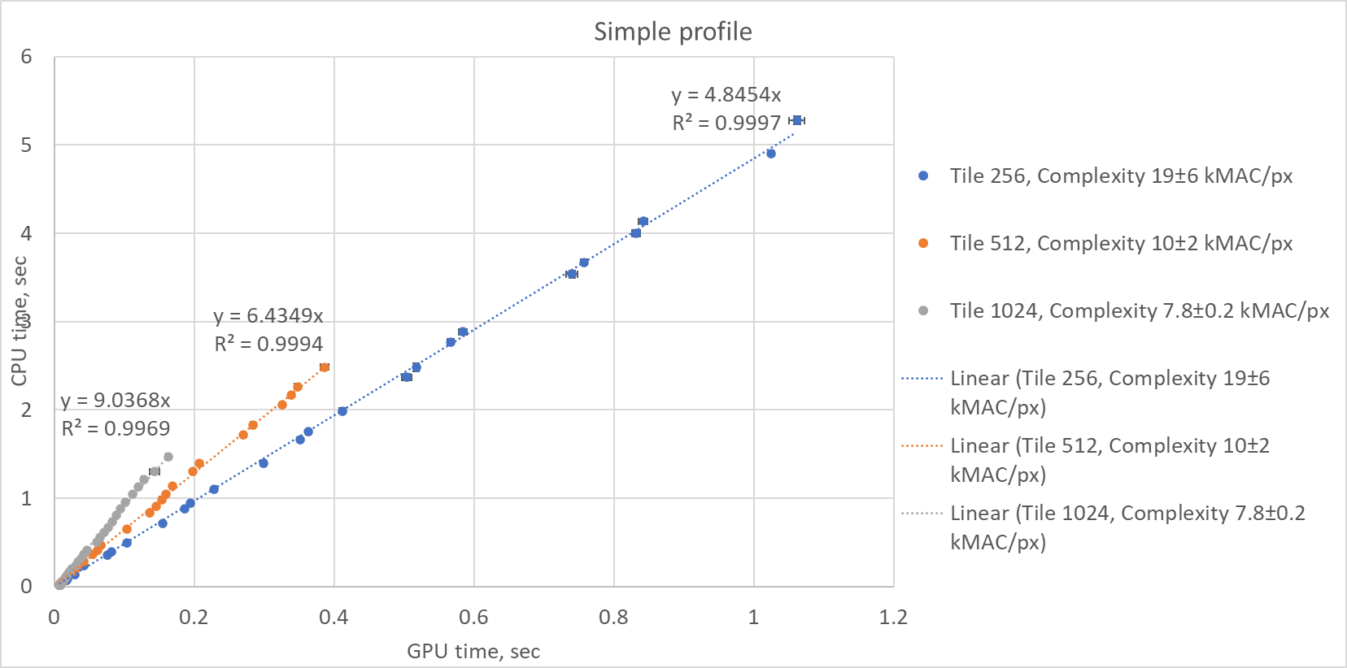
Figure 11. Ratio between decoding time on CPU and GPU for simple profile.

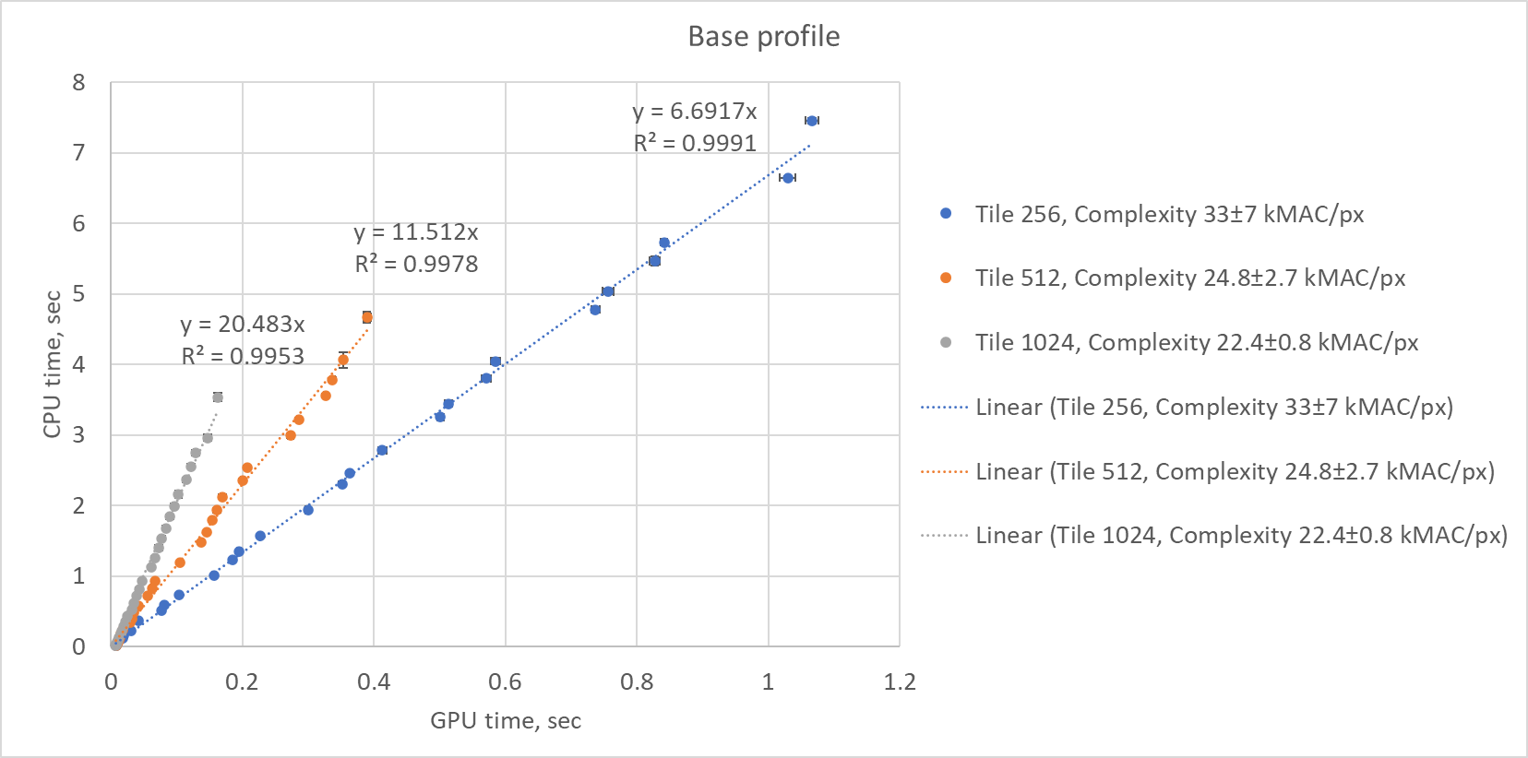
Figure 12. Ratio between decoding time on CPU and GPU for base profile.
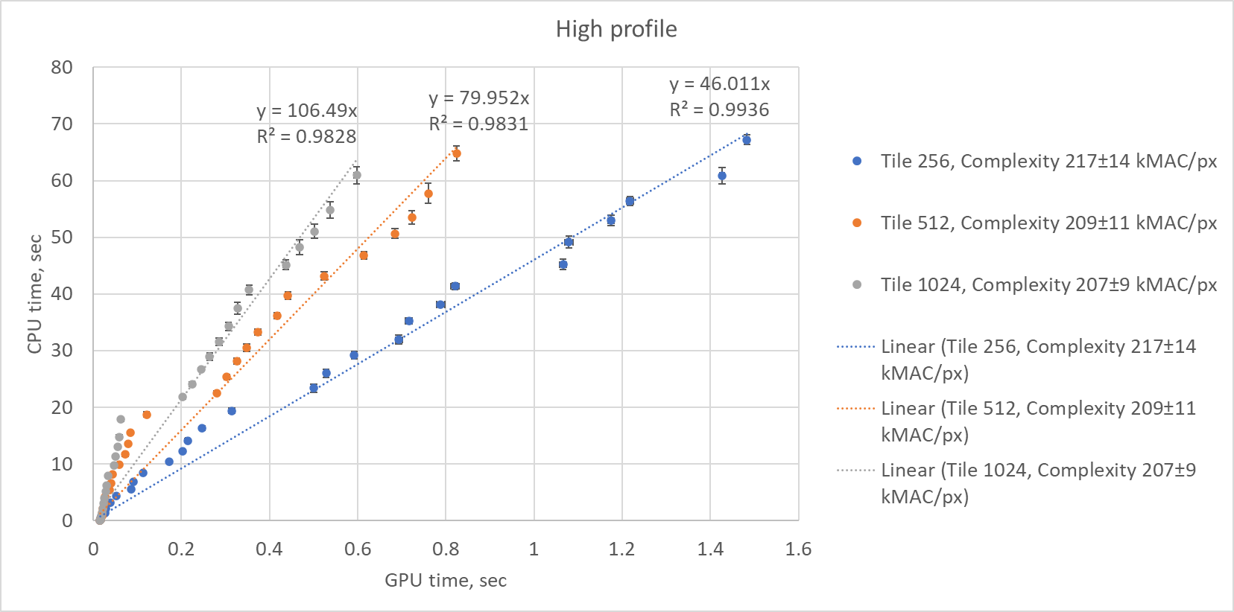
Figure 13. Ratio between decoding time on CPU and GPU for high profile.
The behavior of High profile isn’t so linear as of Simple and Base profiles. The plots on Figure 14 shows that on CPU the execution time is linearly dependent on the number of input pixels.
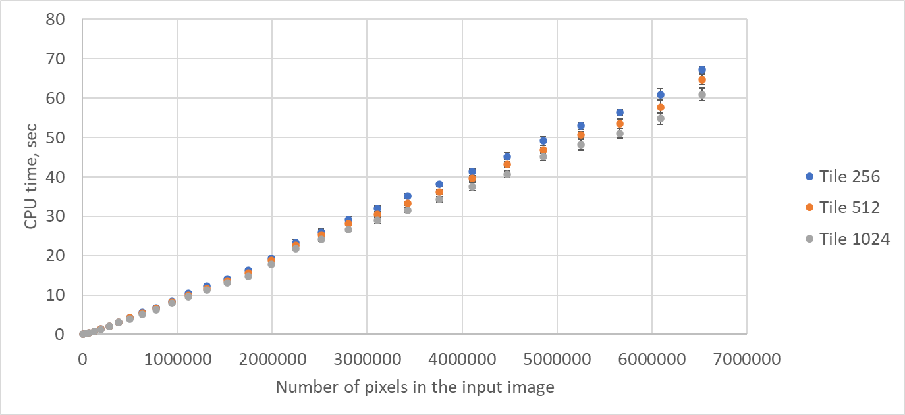
Figure 14. Execution time on CPU for High profile depending on number of pixels in the input picture
The execution time on GPU (Figure 15) has non-linear plots, therefore the results of High profile cannot be used to calculate ratio between CPU and GPU runtimes.
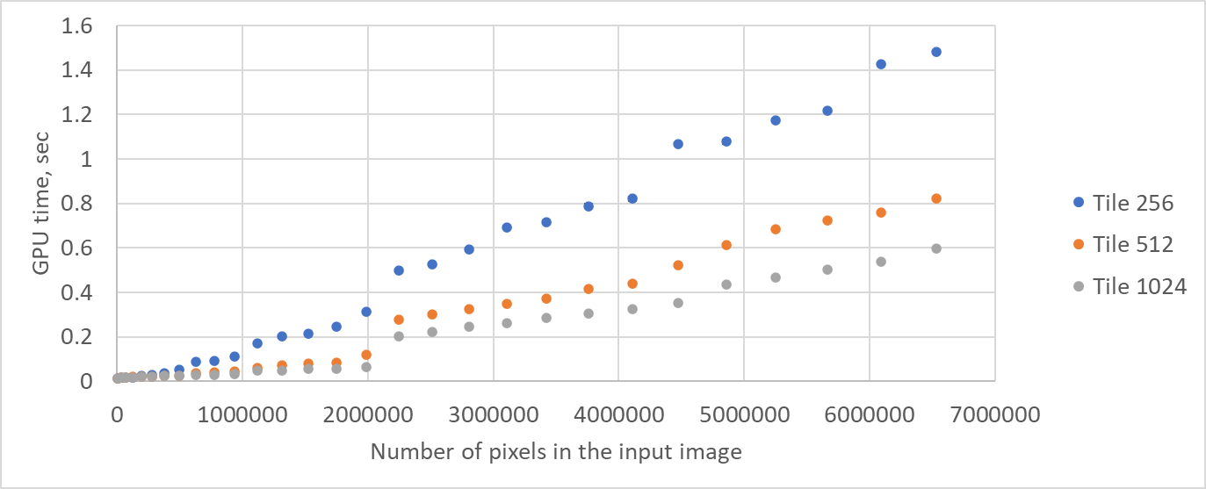
Figure 15. Execution time on GPU for High profile depending on number of pixels in the input picture
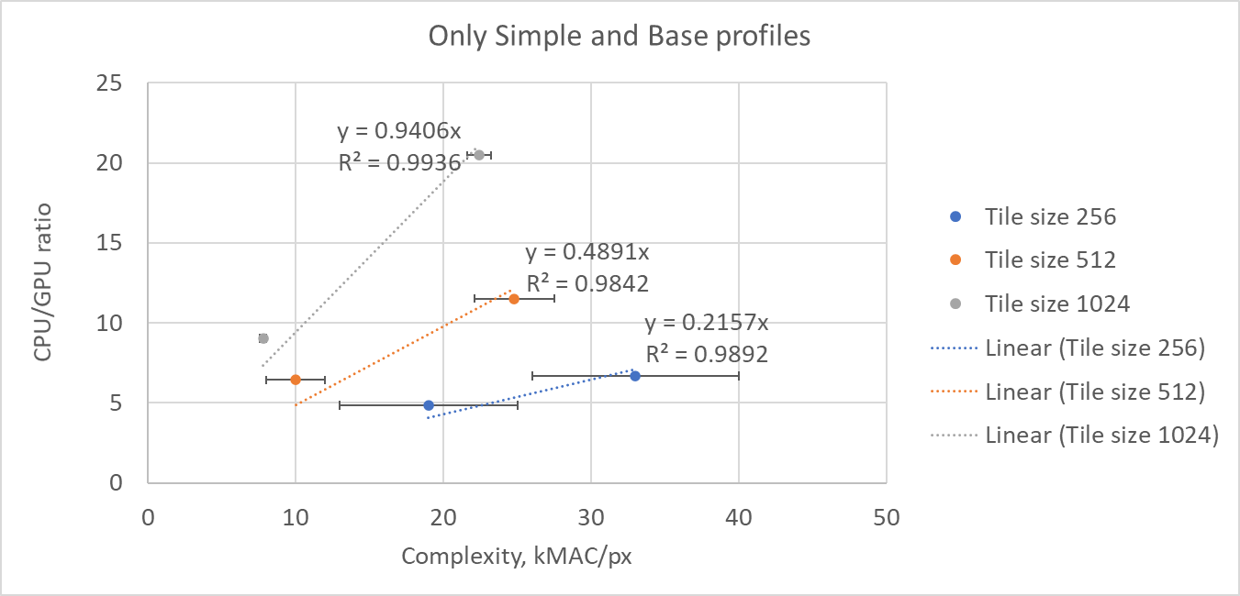
Figure 16. Plot with CPU/GPU ratio dependent on complexity
The ratio between CPU and GPU dependent on models complexity is presented on Figure 16. There are three lines that corresponds to 256, 512 and 1024 tile sizes. Based on the slop of the interpolated lines the target CPU/GPU ratio for particular complexity and for one of the presented tile’s size.
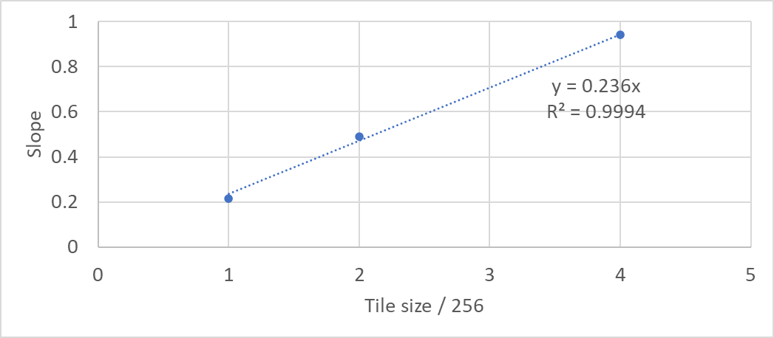
Figure 17. Dependency of the slop on normalized area of a tile
The tile sizes in the experiment increases twice from one to another and the slop increases twice as well. On Figure 17 it is shown that even the slops can be linearly interpolated with high precision. The empirical relation between CPU and GPU runtime can be written in the following way:
TCPU=0.236∙C∙TS256∙TGPU
( 1 )
or
TGPU=2560.236∙TCPUC∙TS
where TS is the tile’s size in pixels, C is the complexity in kMAC/px, TCPU and TGPU are execution times of models on CPU and GPU.
The formula can give only an estimation of the execution time on GPU. To check the boundaries of its applicability, the values of the real time of execution on GPU from our experiments were compared with the estimation values. The results for tiles of sizes 256, 512 and 1024 are presented on Figure 18, Figure 19 and Figure 20.
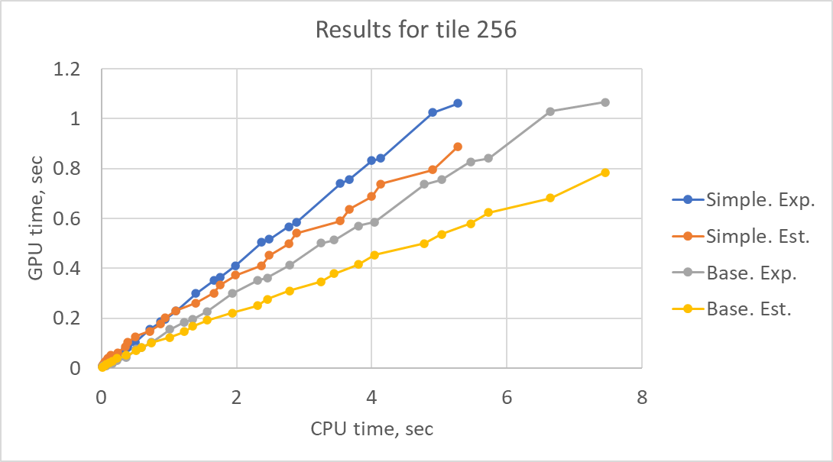
Figure 18. GPU runtime results from experiments and estimation for tile size 256
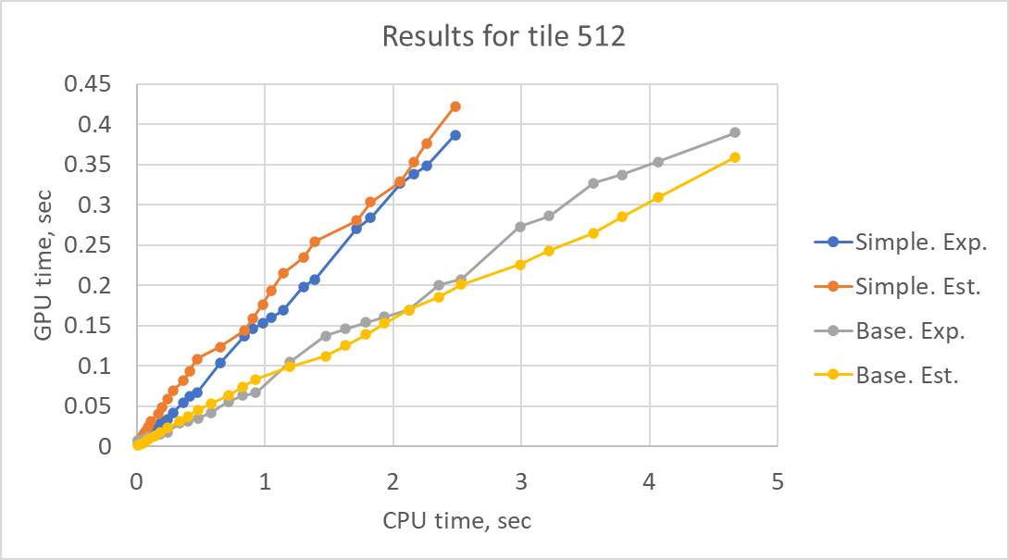
Figure 19. GPU runtime results from experiments and estimation for tile size 512
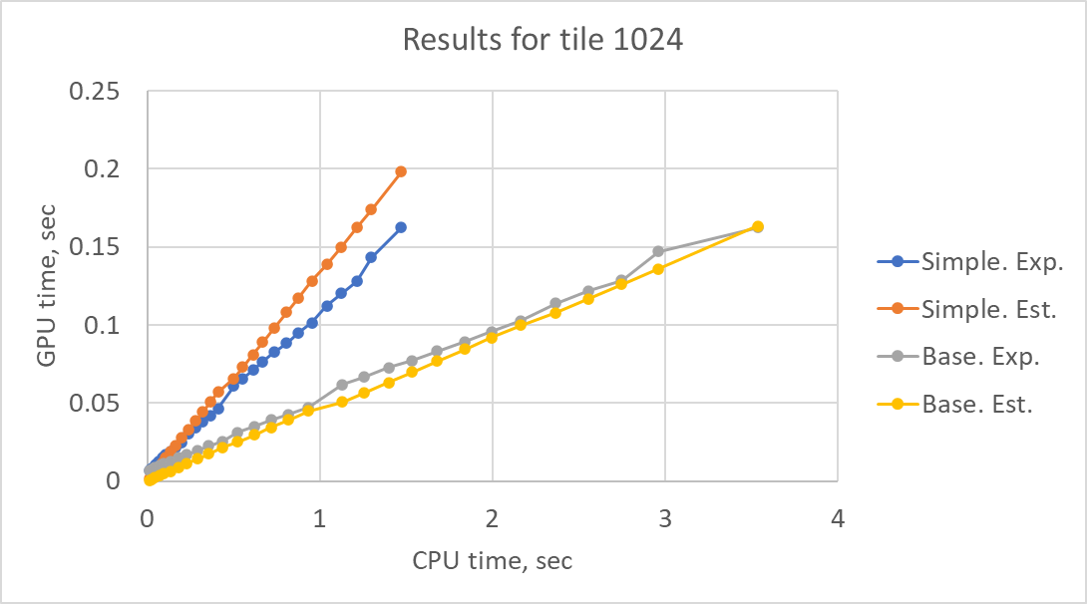
Figure 20. GPU runtime results from experiments and estimation for tile size 1024
The figures show that accuracy of the estimation increases with increasing complexity and tile size. For low size of the tile, it tends to underestimate, but for the higher values it can overestimate the value. Increment of the complexity shows underestimation tendency.
The formula ( 1 ) can be used to calculate border value of the tile size, where inferencing on GPU is faster than on CPU:
TSmin=256/(0.236∙C)
The formula shows that to run on GPU models with the reasonable complexity (~20 kMAC/px), the tile size should be 54 pixels or bigger. From the other side, for tiles with smaller size the execution time on GPU will be even higher than on CPU.
In the case of LOP in-loop filter [3] with the complexity 16.6 kMAC/px, the tile size should be more than 66 pixels to have benefits from running on GPU.
The graph with the frontier where CPU and GPU are the same is presented on Figure 18. Above and/or right the graph the inference of NN on GPU is faster, below and/or left the graph the inference on CPU is faster.
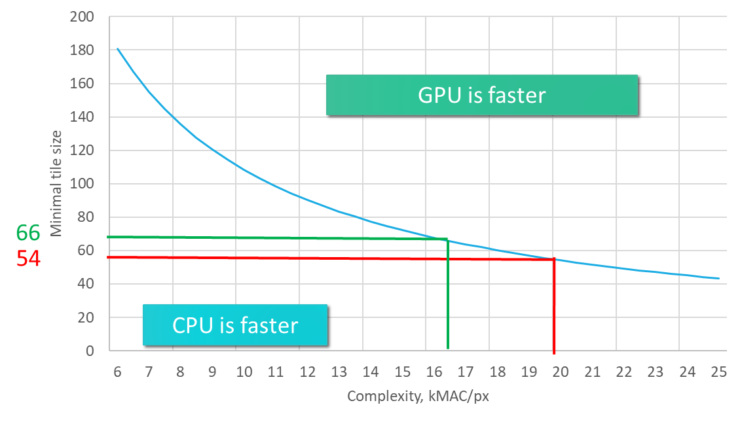
Figure 21. Graph with dependence between the minimum tile size on Complexity at which inference of NN on GPU is faster
The formula with relation between TCPU and TGPU can be used to estimate execution time of NN tools on GPU in a case of inferencing them on CPU like it does in EE1. The process can be following:
- Measurement the execution time of the anchor (w/o NN tools). Let’s call this time as TAnchor.CPU .
- Measurement with NN tool:
  - TAnchor+NN. CPU – the execution time,
  - CAnchor+NN.CPU – the complexity of the model in kMAC/px,
  - L – the tile size of the area processed by NN tool.
- In that case pure time of NN execution is TNN. CPU=TAnchor+NN. CPU-TAnchor. CPU.
- Recalculation NN CPU time to GPU time: TNN. GPU=α∙TNN. CPUL∙CAnchor+NN.CPU, where α=256/0.236 for the devices used in our experiments. This constant needs to be recalculated to each pair of CPU/GPU devices.
- The final time will be TAnchor+NN.GPU=TAnchor.CPU+TNN.GPU.

Conclusion
Based on the empirically obtained formula we can conclude that model’s complexity in kMAC/px and an execution time on CPU would not be enough to predict inference time of the model in a product with powerful processors designed for AI tasks like GPU/NPU.
It is suggested to study further a relationship between CPU and GPU/NPU run time targeting to work out GPU/NPU run time modelling (based on tile size, network structure, kMAC/pxl) which would simplify comparison of AI based methods with classical coding algorithms based on CPU run time.

References
- Recommendation ITU-T T.840.1 and ISO/IEC 6048-1 “Information technology - JPEG AI learning based image coding system: Core coding system“.
- The reference software of JPEG AI (DIS version): https://gitlab.com/wg1/jpeg-ai/jpeg-ai-reference-software/-/tree/DIS?ref_type=tags
- E. Alshina, R. Chang, F. Galpin, Y.Li, Y. Li, M. Santamaria, T. Shao, J. Ström, and Z. Xie, “EE1: Summary report of exploration experiment on neural network-based video coding”, JVET-AM0023, Joint Video Experts Team (JVET) of ITU-T SG21 WP3/21 and ISO/IEC JTC 1/SC 29, 39th Meeting, Daejeon, KR, 26 June – 4 July 2025

Patent rights declaration(s)
Huawei Technologies may have current or pending patent rights relating to the technology described in this contribution and, conditioned on reciprocity, is prepared to grant licenses under reasonable and non-discriminatory terms as necessary for implementation of the resulting ITU-T Recommendation | ISO/IEC International Standard (per box 2 of the ITU-T/ITU-R/ISO/IEC patent statement and licensing declaration form).

