    Joint Video Experts Team (JVET)  of ITU-T SG21 WP3/21 and ISO/IEC JTC 1/SC 29  39th Meeting, Daejeon, KR, 26 June – 4 July 2025 | Document: JVET-AM0069-v2

Title: | Non-EE2: On Sign Prediction
Status: | Input document to JVET
Purpose: | Proposal
Author(s) or  Contact(s): | Yuhuai Zhang  Luhang Xu  Yue Yu  Jonathan Gan  Haoping Yu  Dong Wang | Tel:  Email: | zhangyuhuai@oppo.com
Source: | OPPO
_____________________________

Abstract
This contribution proposes to include non-sign prediction coefficients in the calculation of hypotheses corresponding to the last two sign prediction coefficients. The modified hypotheses are used to calculate the boundary continuity for sign prediction. The method was implemented on top of ECM-17.0 and experimental results following CTC are summarized as follows:
AI: -0.01% (Y) -0.01% (U) 0.01% (V) 101.0% (EncT) 100.3% (DecT)
RA: -0.02% (Y) 0.02% (U) 0.06% (V) xx.0% (EncT) xx.0% (DecT)
LD: -0.09% (Y) 0.32% (U) 0.26% (V) 100.5% (EncT) 100.2% (DecT)

Introduction
In the current [1] sign prediction, signs of up to N non-zero coefficients (e.g., N = 8 in ECM17.0) within a specified sign prediction (SP) area can be predicted. If the number of non-zero coefficients exceeds the allowed number N of predicted signs, signs of the remaining non-zero coefficients are not predicted, and are instead still signalled directly as bypass bins. For example, as shown in Figure 1 below, if there are 15 non-zero coefficients in a block and 12 of them are located inside the SP area, the four signs associated with the smallest coefficient magnitude inside the SP area and three signs outside the SP area will not be predicted.
For each SP coefficient, two hypotheses of its contribution to the residual may be calculated through inverse transform of the coefficient with either a positive or negative sign. Combining the contributions from all coefficients results in 2^N hypothesis residual blocks, each of which is assessed for boundary continuity to determine the most likely hypothesis, and correspondingly the predicted signs of the SP coefficients.

Proposal
This proposal introduces the concept of linked sign prediction (LSP) coefficients. Specifically, the proposed method adds the residual contribution from non-sign predicted (non-SP) coefficients to the residual contribution of an LSP when assessing boundary continuity. Up to two SP coefficients with the lowest magnitude are converted to LSPs. The proposed method consists of three parts: (1) non-SP coefficients linking process, (2) the residual hypothesis of the linked coefficient group, (3) sign correction of non-SP coefficients.

Non-SP coefficients linking process
First, all non-SP coefficients are classified into the following two groups.
Type A: The non-SP coefficients inside the SP area.
Type B: The non-SP coefficients outside the SP area.
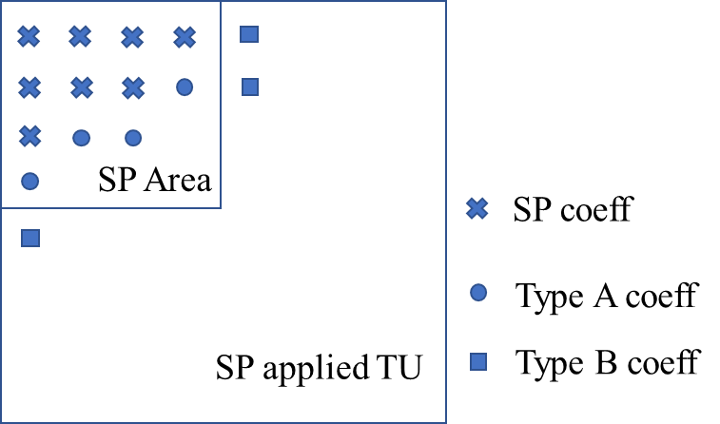
Fig.1 An example of different coefficient types, SP coefficient, type A non-SP coefficient, type B non-SP coefficient
If neither type A nor type B coefficients exist (i.e. there are no non-SP coefficients) then the proposed method is not used.
If only type A or B coefficients exists, these non-SP coefficients will be linked to the SP coefficient with the smallest coefficient magnitude. Together, these coefficients constitute a linked coefficient group (LCG). The linked coefficients are used together to calculate two hypotheses for their combined contribution to the residual.
If both type A and B coefficients exist, type A non-SP coefficients will be linked to the SP coefficient with the smallest coefficient magnitude. Type B non-SP coefficients will be linked to the SP coefficient with the second-smallest coefficient magnitude. Each LCG will be used to calculate two hypotheses respectively for their combined contribution to the residual.
An example of linked coefficients grouping is shown in Figure 2.

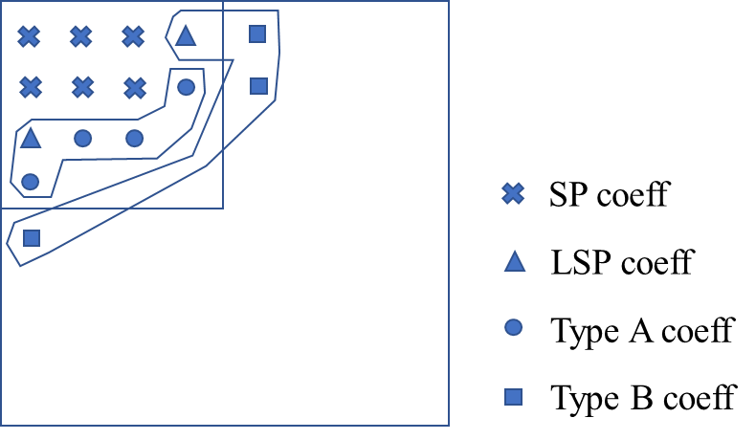
Fig.2 An example of the proposed linked coefficient groups

The residual hypothesis of the linked coefficient group
Similar to the current sign prediction method, each LCG is used to calculate two hypotheses of its contribution to the residual where the included LSP has either a positive or negative sign. The modification is that the contribution of the LCG is calculated from the sum of the contributions from each of its coefficients, including the LSP and the non-SP coefficients.
The two hypotheses for the combined residual contribution for each LCG can be calculated by adding residuals for the LSP and all non-SP coefficients in the LCG together as follows:
$${rl}_{x,y}= {rs}_{l x,y}+\sum_{i=0}^{n-1}{r_{i x,y}}$$
or
$${rl}_{x,y}= -{rs}_{l x,y}-\sum_{i=0}^{n-1}{r_{i x,y}}$$
where ${rl}_{x,y}$ represents the combined residual contribution at the x-th and y-th position of the current block for one hypothesis of the LCG; ${rs}_{l x,y}$represents the residual contribution at the x-th and y-th position of the current block from the LSP coefficient assuming it has a positive sign; $r_{i x,y}$ represents the residual contribution at the x-th and y-th position of the current block from the i-th non-SP coefficient with signs applied as signalled by their corresponding bypass coded sign bits; and $n$ represents the number of non-SP coefficients in the LCG.

Sign correction of non-SP coefficients
The signs for both type A and B coefficients remain bypass coded. However, when they are included into an LCG, the meaning of these signalled sign bits is modified.
If the LSP predicted sign is correct, then the signs of its linked non-SP coefficients are the same as indicated by their sign bits. However, if the LSP predicted sign is incorrect, then the signs of its linked non-SP coefficients are interpreted as the reverse of what was signalled by their sign bits.

Experimental results
The proposed method is implemented on top of the ECM-17.0 software [1] and tested based on the common test conditions [2]. The test results are summarized below.

 | All Intra Main 10
 | Over ECM17.0
 | Y | U | V | EncT | DecT | EncVmPeak | DecVmPeak
Class A1 | -0.01% | -0.05% | 0.06% | 100.8% | 100.2% | 100.0% | 100.0%
Class A2 | -0.02% | 0.00% | -0.04% | 101.0% | 100.0% | 100.0% | 100.1%
Class B | -0.02% | 0.02% | 0.07% | 101.0% | 100.2% | 101.8% | 100.1%
Class C | 0.01% | -0.05% | -0.06% | 101.1% | 100.5% | 100.5% | 100.0%
Class E | 0.00% | 0.02% | 0.01% | 101.0% | 100.3% | 102.1% | 100.0%
Overall | -0.01% | -0.01% | 0.01% | 101.0% | 100.3% | 101.0% | 100.0%
Class D | 0.00% | 0.14% | -0.06% | 101.1% | 100.9% | 100.3% | 100.0%
Class F | 0.06% | 0.10% | -0.12% | 101.6% | 100.1% | 98.1% | 100.0%
Class TGM | #VALUE! | #VALUE! | #VALUE! | #NUM! | #NUM! | #NUM! | #NUM!

 | Random Access Main 10
 | Over ECM17.0
 | Y | U | V | EncT | DecT | EncVmPeak | DecVmPeak
Class A1 | -0.05% | -0.06% | 0.07% | 100.1% | 100.7% | 100.0% | 100.8%
Class A2 | -0.01% | 0.15% | -0.07% | #NUM! | #NUM! | 99.9% | 100.3%
Class B | 0.00% | 0.02% | -0.07% | 100.3% | 100.6% | 100.0% | 100.5%
Class C | -0.02% | -0.01% | 0.33% | 100.4% | 100.4% | 100.2% | 100.7%
Class E
Overall | -0.02% | 0.02% | 0.06% | #NUM! | #NUM! | 100.0% | 100.6%
Class D | -0.02% | 0.18% | -0.59% | 100.3% | 100.1% | 100.2% | 100.8%
Class F | -0.02% | 0.10% | 0.59% | 100.4% | 101.3% | 99.3% | 100.6%
Class TGM | #VALUE! | #VALUE! | #VALUE! | #NUM! | #NUM! | #NUM! | #NUM!

 | Low delay B Main 10
 | Over ECM17.0
 | Y | U | V | EncT | DecT | EncVmPeak | DecVmPeak
Class A1
Class A2
Class B | -0.02% | -0.01% | -0.14% | 100.2% | 100.6% | 100.0% | 100.0%
Class C | -0.12% | 0.25% | 0.13% | 100.5% | 100.1% | 100.0% | 99.9%
Class E | -0.16% | 0.94% | 1.09% | 101.1% | 99.6% | 100.0% | 100.0%
Overall | -0.09% | 0.32% | 0.26% | 100.5% | 100.2% | 100.0% | 99.9%
Class D | 0.07% | -1.39% | 0.80% | 99.5% | 98.2% | 100.0% | 100.0%
Class F | -0.14% | 0.69% | 1.01% | 100.2% | 99.8% | 99.1% | 100.2%
Class TGM | #VALUE! | #VALUE! | #VALUE! | #NUM! | #NUM! | #NUM! | #NUM!

Conclusion
This contribution proposes to include non-SP coefficients in the calculation of hypotheses for linked sign prediction coefficients. Simulations show coding gains compared to ECM-17.0. It is suggested to further study the proposed method in the next round of EE2.

References
- ECM-17.0, https://vcgit.hhi.fraunhofer.de/ecm/ECM/-/tree/ECM-17.0
- M. Karczewicz, Y. Ye, “Common test conditions and evaluation procedures for enhanced compression tool testing” JVET-AI2017, July 2024

Patent rights declaration(s)
Guangdong OPPO Mobile Telecommunications Corp., Ltd. (OPPO) may have current or pending patent rights relating to the technology described in this contribution and, conditioned on reciprocity, is prepared to grant licenses under reasonable and non-discriminatory terms as necessary for implementation of the resulting ITU-T Recommendation | ISO/IEC International Standard (per box 2 of the ITU-T/ITU-R/ISO/IEC patent statement and licensing declaration form).

