    Joint Video Experts Team (JVET)  of ITU-T SG21 WP3/21 and ISO/IEC JTC 1/SC 29  39th Meeting, Daejeon, KR, 26 June – 4 July 2025 | Document: JVET-AM0058-v1

Title: | AHG16: Lightweight Multi-resolution CFTE Model and Color Calibration Post-processing Algorithm for Generative Face Video Compression
Status: | Input document to JVET
Purpose: | Proposal
Author(s) or  Contact(s): | Zihan Zhang, Shanzhi Yin, Shiqi Wang (CityUHK)  Bolin Chen, Ru-Ling Liao, Jie Chen, Yan Ye (Alibaba) | Email: | Zhzhang38-c@my.cityu.edu.hk  shanzhyin3-c@my.cityu.edu.hk  shiqwang@cityu.edu.hk  chenbolin.chenboli@alibaba-inc.com  ruling.lrl@alibaba-inc.com  jiechen.cj@alibaba-inc.com  yan.ye@alibaba-inc.com
Source: | City University of Hong Kong, Alibaba Group
_____________________________

Abstract
This contribution proposes replacing the current single-resolution lightweight CFTE model in AHG16 GFVC software with a multi-resolution lightweight CFTE model through architectural (i.e., depthwise separable convolution) and operational (i.e., pruning) optimizations. Additionally, we propose incorporating the color calibration method into the AHG16 GFVC software to address the occasional color shift issues observed in some generated video frames. Experimental results illustrate that our proposed lightweight scheme can reduce the complexity and number of parameters whilst maintaining the coding performance, while color calibration noticeably improves the subjective quality of the generated video frames, as summarized below,
- Compared to the current multi-resolution CFTE model, our proposed lightweight approach reduces the number of parameters by 89.7%, and kMACs per pixel by 83.1% and 79.7% at resolutions of 256×256 and 512×512, respectively. Besides, at 256×256 resolution, the overall bitrate savings of the proposed method in terms of Rate-DISTS and Rate-LPIPS are {2.56%, 2.57%}. At 512×512 resolution, the overall bitrate savings of the proposed method in terms of Rate-DISTS and Rate-LPIPS are {5.57%, 9.03%}.
- Compared to GFVC models without color calibration, those using it can produce more natural reconstruction results that are closer to the corresponding original video.

Introduction
The current AHG16 GFVC software employs a single-resolution lightweight CFTE model, optimized through methods from JVET-AG0139 [1] and JVET-AH0109 [3]. JVET-AG0139 [1] proposed the integration of depthwise separable convolution into the dense motion module of the CFTE [2] method for generative face video compression (GFVC), reducing the computational complexity and the number of parameters while maintaining comparable performance. JVET-AH0109 [3] proposed to reduce the number of channels and selectively replace some of the 3x3 convolutions within the generation module with depthwise separable convolution layers. The lightweight model from JVET-AH0109 has been incorporated into the AHG16 software.
However, it was observed that, the main components, particularly the hourglass networks in the feature extraction modules and the dense motion modules, still contain excessive parameters. Furthermore, the aforementioned lightweight methods were implemented based on the single-resolution CFTE model. In contrast, at the latest 36th JVET meeting, a multi-resolution pipeline proposed in JVET-AJ0052 [4] was adopted into the AHG16 GFVC software, supporting multiple resolutions within a single model. Therefore, building on the current AHG16 GFVC software, we propose to optimize the multi-resolution CFTE model through two primary strategies: (1) architectural optimization, i.e., optimizing the hourglass network architecture with more lightweight architecture to reduce parameter redundancy, and (2) operational optimization, i.e., implementing efficient pruning techniques across the multi-resolution CFTE model.
Additionally, we propose to integrate the color calibration algorithm from JVET-AL0156 [5], as a post-processing step into the AHG16 GFVC software. This will address the occasional color shift issues in the generated face images, improving the subjective quality of the GFVC algorithms.

Proposed methods

Proposed Lightweight Multi-resolution CFTE Method
Figure 1 illustrates the architecture of the lightweight multi-resolution CFTE model. This lightweight design extended optimizations from prior efforts in the current AHG16 GFVC software, to reduce computational complexity and model size while maintaining comparable performance. Specifically, we replaced a subset of 3×3 convolutions with depthwise separable convolutions in the feature extraction, dense motion, and generation modules, significantly reducing computational complexity and the number of parameters. Additionally, in the generation modules, the number of channels was halved to further decrease computational requirements. Moreover, as highlighted in Figure 1, we applied a pruning strategy to eliminate redundant channels.
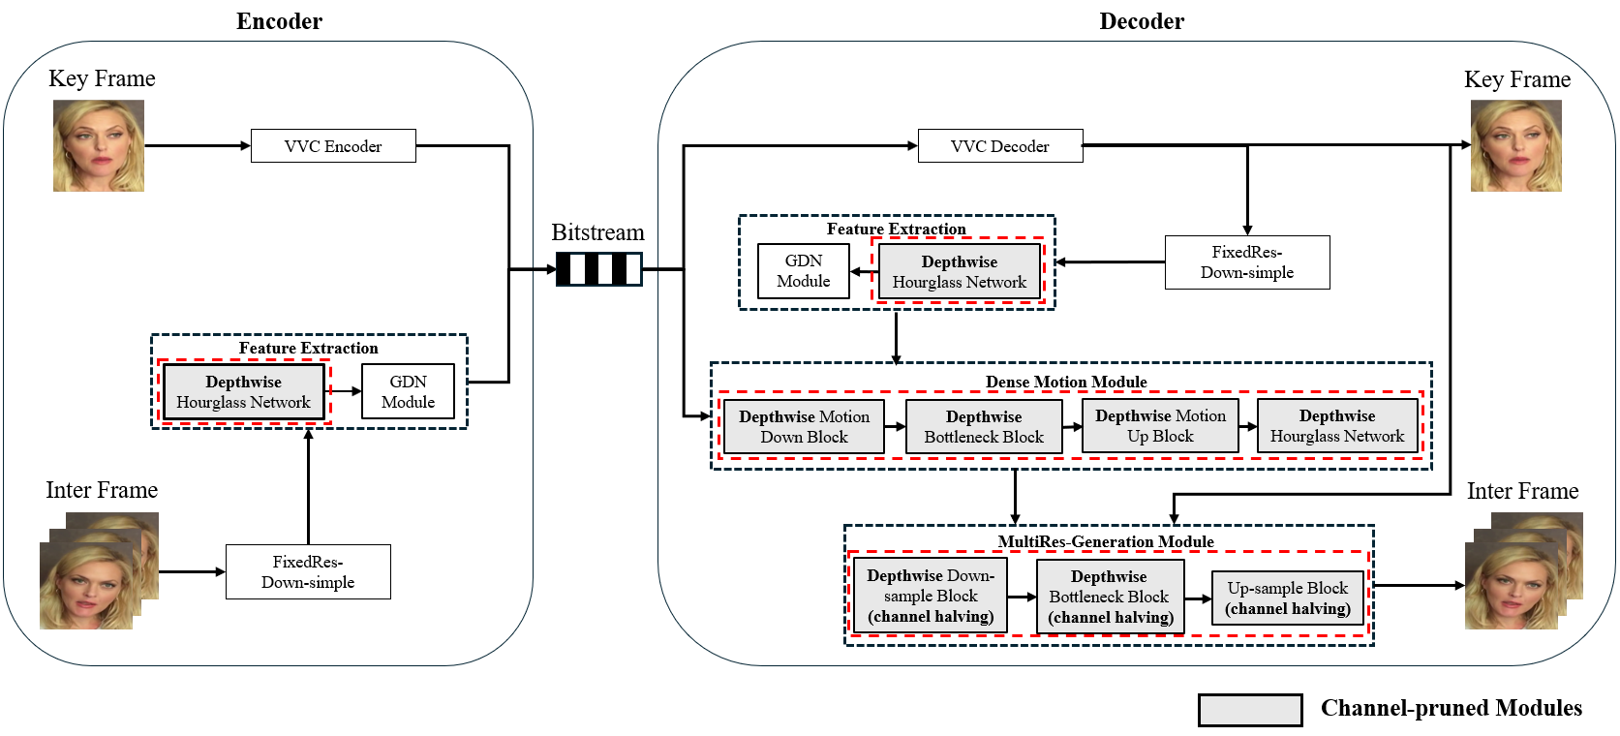
Figure 1 - Illustration of framework of lightweight multi-resolution CFTE

Architectural Optimization: Depthwise Separable Convolutions
Building on the single-resolution lightweight CFTE model in the current AHG16 GFVC software, we extend the use of depthwise separable convolutions to hourglass networks in the feature extraction and dense motion modules for multi-resolution CFTE. As shown in Table 1, the hourglass networks account for the majority of parameters in both the feature extraction and dense motion modules.
Table 1 - Parameter distribution details in single-resolution lightweight CFTE
Module | Feature Extraction |  |  | Dense motion Module
Network Structure | Hourglass Network | Others | Total | Hourglass Network | Others | Total
Lightweight CFTE (Single-resolution) | 13.2M | 0.9M | 14.1M | 9.3M | 3.0M | 12.3M
To optimize this, we replace all 3×3 convolution layers in the hourglass network of both modules with depthwise separable convolutions, as illustrated in Figure 2. By separating spatial and channel-wise convolutions, we further reduce computational complexity and parameter amount.
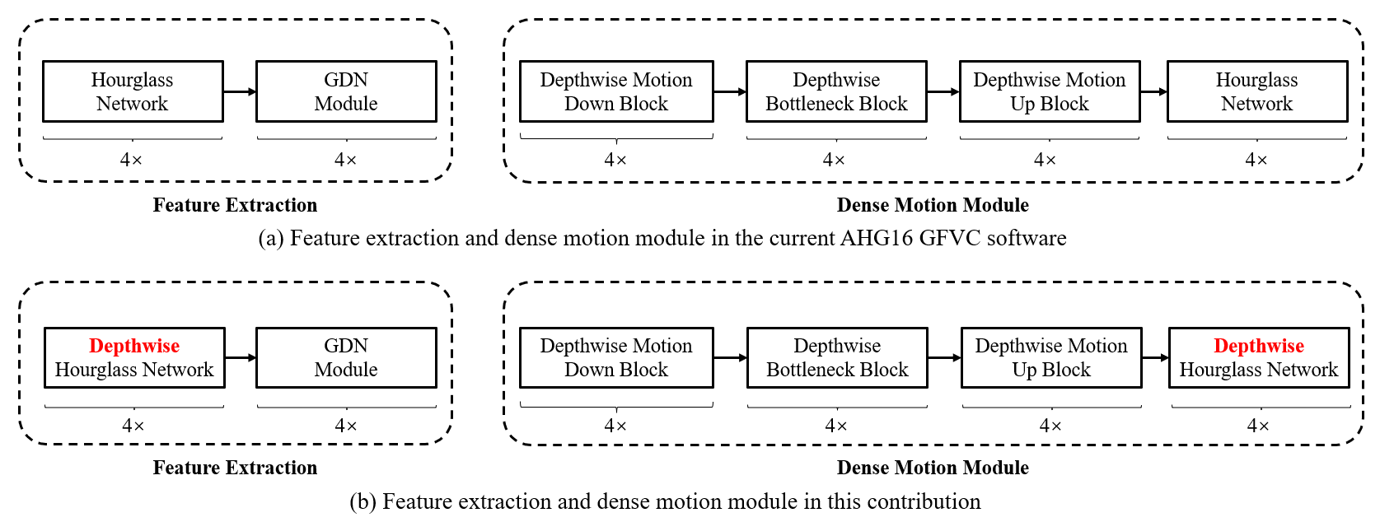
Figure 2 - Illustration of modifications in feature extraction and dense motion module

Operational Optimization: Pruning
As illustrated in Figure 3, we propose to apply a channel pruning strategy to further optimize the multi-resolution CFTE model.
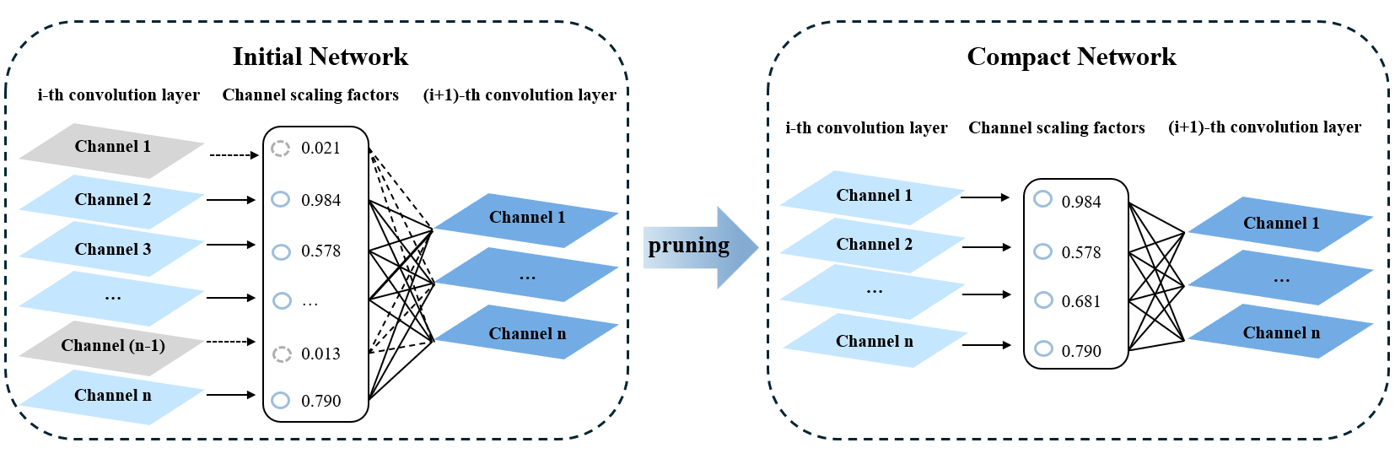
Figure 3 - Channel pruning mechanism based on BatchNorm scaling factors
The pruning mechanism, detailed in Figure 3, is inspired by Network Slimming framework [6] and uses scaling factors (γ) in BatchNorm layers to identify and remove less important channels based on their magnitude. Channels with γ values below a calculated threshold are removed. Finally, we fine-tune the pruned lightweight model to compensate for loss caused by channel removal.

Color Calibration for Generative Face Video Coding
To improve the generation quality of GFVC, JVET-AL0156 [5] proposed to utilize channel-wise distribution calibration as an optional post-processing step in GFVC decoding in order to adjust the color distribution of the generated frames to match that of the original frames. By doing so, the subjective quality of generated frames can be improved. JVET-AL0156 proposed to modify the GFV VSEI message in order to accomplish the color calibration step. In this contribution, the same algorithm is proposed only as a post-processing module in the AHG16 software without any modification to the GFV VSEI message.
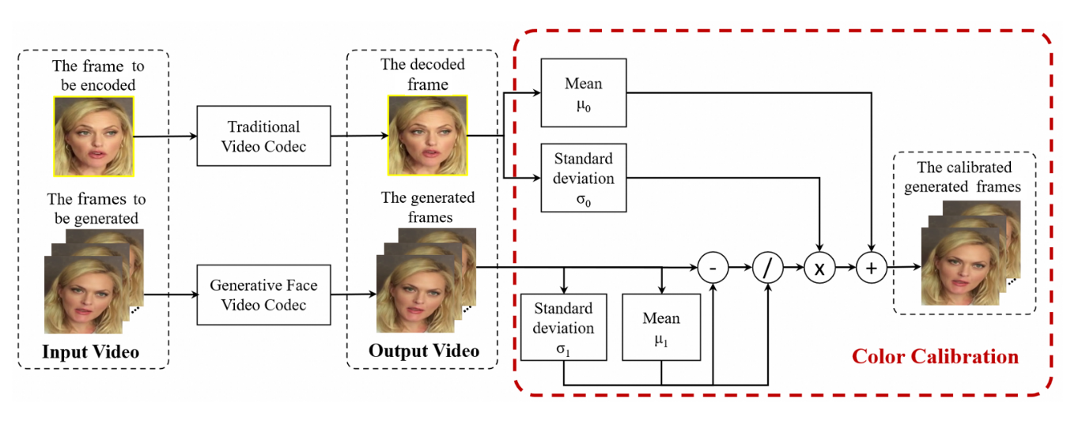
Figure 4 - Diagram of proposed color calibration
As shown in Figure 4, at the decoder after frame generation, the distribution parameters of the decoded frame and generated frame are calculated for each color component. Let $μ_{0, c}$ and $σ_{0,c}$ be the mean and the standard deviation of the samples in the VVC-decoded frame for color component $c$, respectively, and $μ_{1, c}$ and $σ_{1,c}$ be the mean and the standard deviation of the samples in the generated frame for color component $c$, respectively. These parameters can be derived as follows,
$μ_{0, c}=\frac{\sum_{y=1}^{H}{\sum_{x=1}^{W}{\hat{I_{d}}[c,x,y]}}}{H×W}$ (1)
$σ_{0,c}=\sqrt{\frac{\sum_{y=1}^{H}{\sum_{x=1}^{W}{(\hat{I_{d}}[c,x,y] - μ_{0})^{2}}}}{H×W}}$ (2)
$μ_{1, c}=\frac{\sum_{y=1}^{H}{\sum_{x=1}^{W}{\hat{I_{g}}[c,x,y]}}}{H×W}$ (3)
$σ_{1,c}=\sqrt{\frac{\sum_{y=1}^{H}{\sum_{x=1}^{W}{(\hat{I_{g}}[c,x,y] - μ_{0})^{2}}}}{H×W}}$ (4)
where $\hat{I_{d}}[c,x,y]$is the decoded sample value at coordinate $(x,y)$ of the decoded frame for color component $c$, $\hat{I_{g}}[c,x,y]$is the generated sample value at coordinate $(x,y)$ of the generated frame for color component $c$, $H$ and $W$ are the frame height and width, respectively.
After the distribution parameters calculation, the proposed channel-wise color calibration is performed by normalizing each channel of the generated frame with its own distribution parameters and then shifting to the target distribution of the corresponding VVC decoded frame. The calibration process can be described as follows
$\overline{I_{g}}[c,x,y]=(\frac{\hat{I_{g}}[c,x,y] -{ μ}_{1,c} }{σ_{1, c}})×σ_{0,c}+μ_{0,c}$ (5)
where $\overline{I_{g}}[c,x,y]$ is the calibrated sample value at coordinate $(x,y)$ of the generated frame for color component $c$.

Experimental results
We follow the test conditions and software reference configurations for GFVC testing specified in JVET-AJ2035 [7]. For VVC, we use the VTM22.2 platform in Low-Delay Bidirectional mode with quantization parameters (QPs) set to 37, 42, 47 and 52. For CFTE, its key frame is compressed using the VTM 22.2 with the QPs of 22, 32, 42 and 52, and subsequent frames are compressed with the GFVC model. For the testing sequences, we utilized 33 test sequences for each of the 256×256 and 512×512 resolutions, as specified in JVET-AJ2035 [7].
  - Lightweight Multi-resolution CFTE Results

Reduction of Model Parameters and Complexity Computation
Table 2 summarizes the number of parameters and kMACs per pixel (kMACs/pixel) of the multi-resolution CFTE model, the single-resolution lightweight CFTE model, and the proposed lightweight multi-resolution CFTE. Compared to the current multi-resolution CFTE model, the number of parameters is reduced from 58.2M to 6.0M, a decrease of 89.7%. The kMACs/pixel is reduced from 1072.8 to 180.9 at the resolution of 256×256, a decrease of 83.1%. When the resolution is 512×512, the kMACs/pixel is reduced from 392.9 to 79.9, representing a decrease of 79.7%.
Additionally, compared to the single-resolution lightweight CFTE model, our approach reduces the number of parameters from 28.3M to 6.0M, a reduction of 78.8%, and decreases kMACs/pixel at 256×256 resolution from 209.3 to 180.9, a reduction of 13.6%.
Table 2 - kMACs/pixel and total parameter number of the multi-resolution CFTE, single-resolution lightweight CFTE, and proposed lightweight CFTE
 | Parameters | kMACs/pixel  @256px | kMACs/pixel  @512px
Multi-resolution CFTE | 58.2M | 1072.8 | 392.9
Single-resolution Lightweight CFTE | 28.3M | 209.3 | -
Proposed Lightweight Multi-resolution CFTE | 6.0M | 180.9 | 79.9

Rate-Distortion Performance
Figure 5 shows the rate distortion performance comparisons among the VVC codec, the multi-resolution CFTE model, the single-resolution lightweight CFTE model and the proposed lightweight CFTE model in terms of Rate-DISTS and Rate-LPIPS. After lightweight optimization, the proposed model shows acceptable performance drop compared with the multi-resolution model, and both outperform the VVC codec with a large margin.
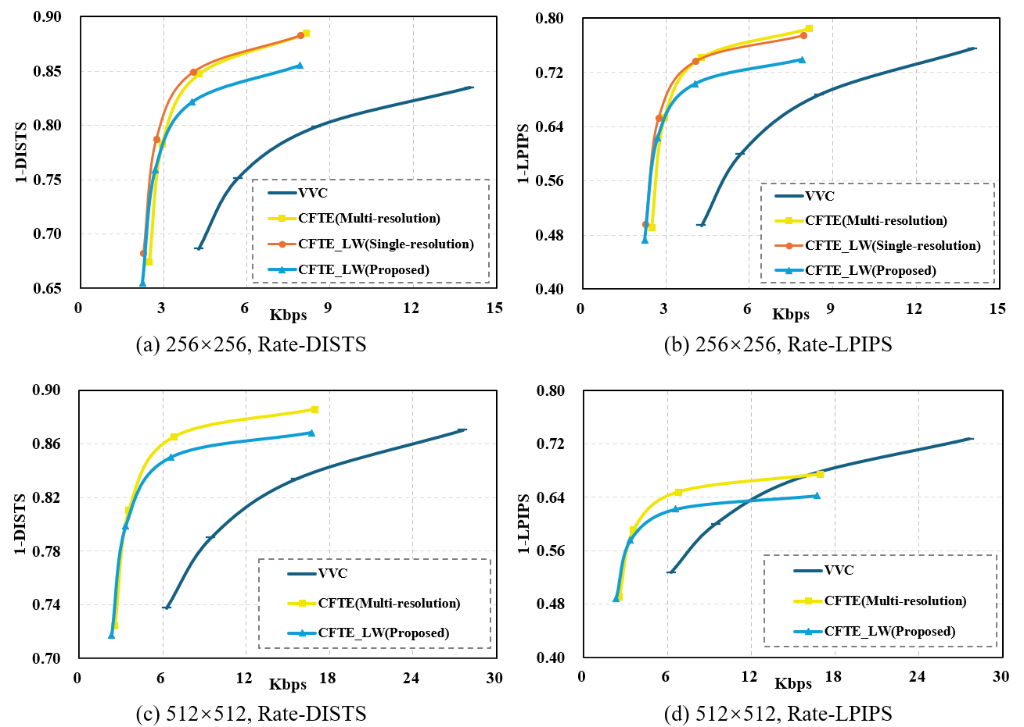
Figure 5 - Rate-Distortion performance of VVC, multi-resolution CFTE, single-resolution lightweight CFTE, and proposed lightweight CFTE at different resolutions in terms of rate-DISTS and rate-LPIPS

BD-Rate Savings
The BD-Rate saving of the proposed lightweight CFTE against VVC and the multi-resolution CFTE on 256x256 and 512x512 scenario is shown in Table 3 and Table 4, respectively. Compared to VVC, the proposed lightweight multi-resolution CFTE can achieve 57.63% and 47.68% BD-Rate savings in terms of Rate-DISTS and Rate-LPIPS. Compared to the multi-resolution CFTE, the proposed lightweight CFTE can achieve 4.07% BD-Rate savings in terms of Rate-DISTS and exists 5.81% performance loss in terms of Rate-LPIPS.
Table 5 shows that, compared to the single-resolution lightweight CFTE, the proposed lightweight CFTE incurs 11.94% and 10.00% performance loss for 256×256 resolution in terms of Rate-DISTS and Rate-LPIPS, respectively. The performance loss is within an acceptable range given the large complexity and parameter reductions. It should be mentioned that the result “#VALUE!” means the RD curves cross over each other for some sequences so that the BD-rate cannot be calculated.
Table 3 - Average bit-rate savings for proposed lightweight multi-resolution CFTE compared with the traditional VVC codec
 | Over VTM-22.2
 | DISTS | LPIPS | RGB444_PSNR | RGB444_SSIM | YUV420_PSNR | YUV420_SSIM
Class A(256px) | -60.21% | -59.66% | 0.00% | -26.74% | 0.00% | -17.46%
Class B(256px) | -46.34% | -38.94% | -1.28% | -16.36% | -0.42% | -15.61%
Class C(512px) | -66.65% | -52.61% | 0.00% | -4.20% | 0.00% | 0.00%
Class D(512px) | -59.24% | -43.00% | -1.06% | 7.07% | 0.00% | -2.02%
Overall | -57.63% | -47.86% | -0.64% | -9.57% | -0.11% | -8.78%
Table 4 - Average bit-rate savings for proposed lightweight multi-resolution CFTE compared with the multi-resolution CFTE
 | Over the multi-resolution CFTE
 | DISTS | LPIPS | RGB444_PSNR | RGB444_SSIM | YSNR | YUV420_SSIM
Class A(256px) | -0.70% | -2.68% | 3.44% | 4.29% | 5.73% | 1.16%
Class B(256px) | 5.82% | 7.83% | 10.47% | 4.13% | 0.79% | 0.89%
Class C(512px) | 4.97% | 8.60% | 10.80% | 1.74% | 4.58% | 18.09%
Class D(512px) | 6.17% | 9.47% | 0.61% | 9.06% | 4.87% | 9.29%
Overall | 4.07% | 5.81% | 6.33% | 4.81% | 3.99% | 7.36%
Table 5 - Average bit-rate savings for proposed lightweight multi-resolution CFTE compared with the single-resolution lightweight CFTE
 | Over single-resolution lightweight CFTE
 | DISTS | LPIPS | RGB444_PSNR | RGB444_SSIM | YUV420_PSNR | YUV420_SSIM
Class A(256px) | 7.48% | 4.01% | 9.44% | 13.00% | 3.41% | #VALUE!
Class B(256px) | 16.40% | 16.00% | 12.61% | 11.33% | 8.54% | 10.94%
Overall | 11.94% | 10.00% | 11.03% | 12.16% | 5.97% | #VALUE!

Subjective Quality Comparisons
Reconstructed face images are shown in Figure 6 to provide subjective comparison of reconstruction quality using multi-resolution CFTE, single-resolution lightweight CFTE, proposed lightweight CFTE, and VVC at ultra-low bitrates.
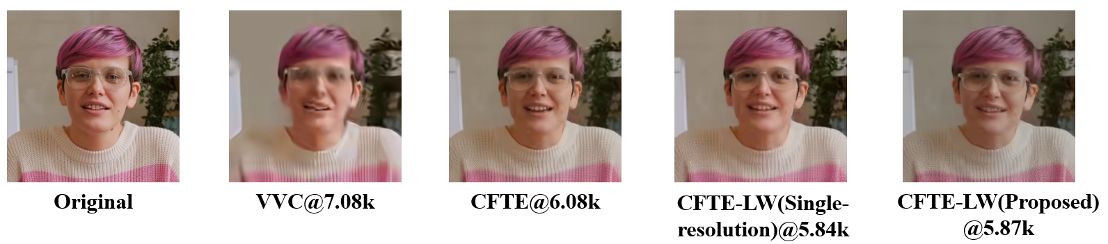
(a) ClassB Seq 005
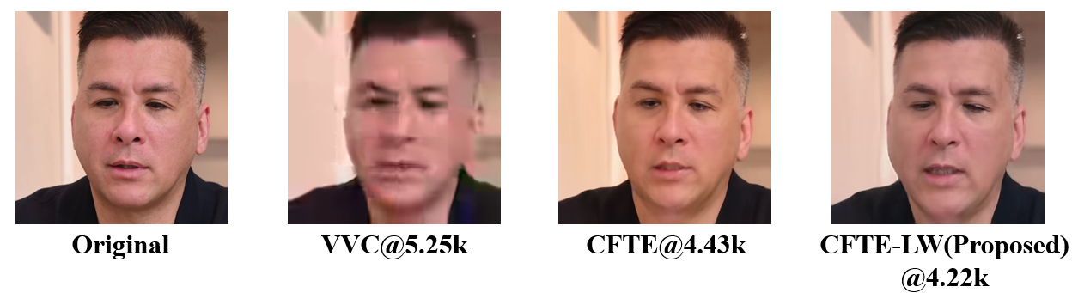
(b) ClassC Seq 013 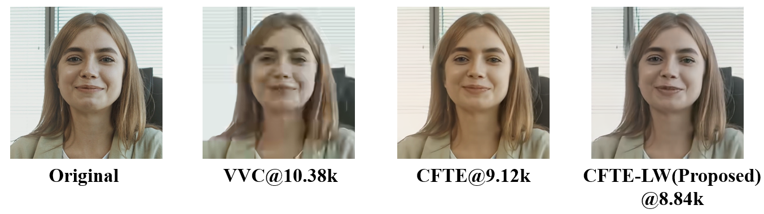
(c) ClassD Seq 004
Figure 6 - Visual quality comparison of VVC, the multi-resolution CFTE, single-resolution lightweight CFTE, and the proposed lightweight CFTE
  - Color Calibration Results
Figure 7 and Figure 8 show the color calibration results for the proposed lightweight multi-resolution CFTE models, with and without color calibration. Figure 7 compares their rate distortion performance in terms of Rate-DISTS and Rate-LPIPS, while Figure 8 shows subjective quality. It can be seen that after calibration is applied, the rate distortion performance can be further improved, and some generated frames appear more natural and closer to the respective original frames.

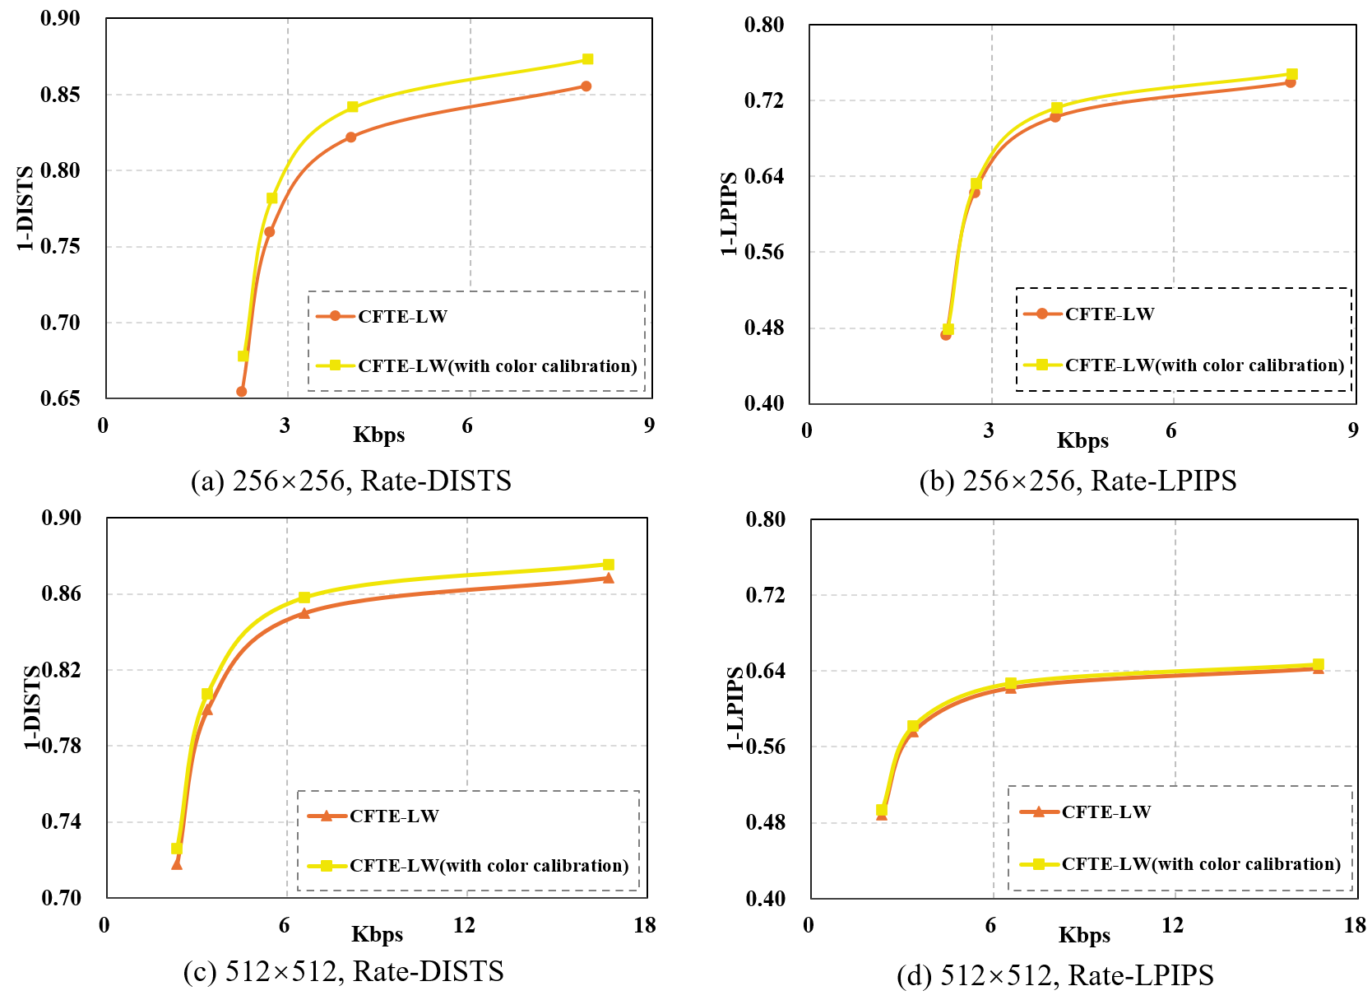
Figure 7 - Rate-Distortion performance of proposed lightweight CFTE (with and without color calibration) at different resolutions in terms of rate-DISTS and rate-LPIPS
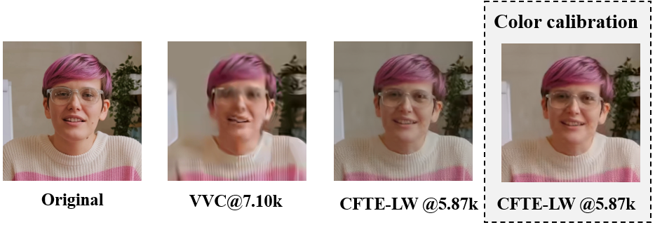
(a) ClassB Seq 005
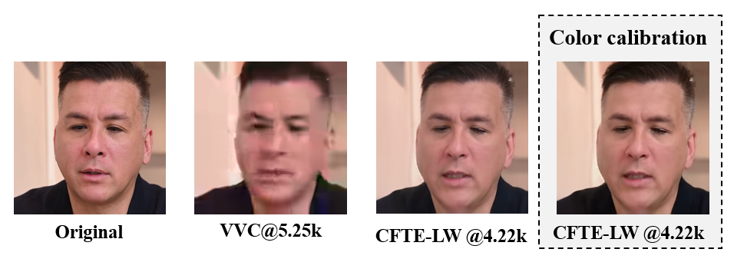
(b) ClassC Seq 013

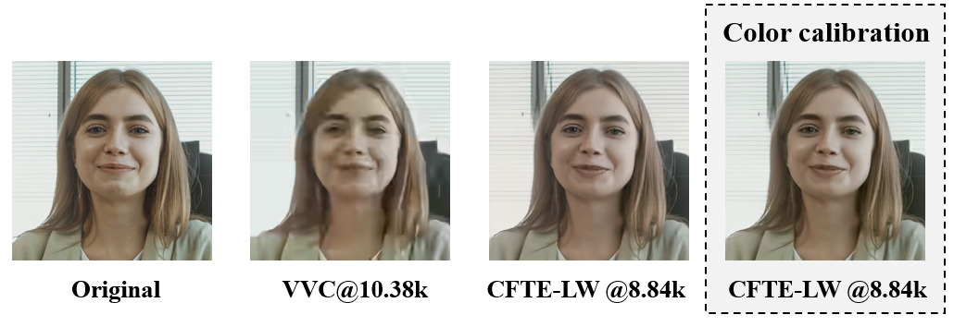
(c) ClassD Seq 004
Figure 8 - Visual quality comparison of VVC and proposed lightweight CFTE model (with and without color calibration).
In Figure 9, this color calibration algorithm is also applied to other GFVC models (i.e. CFTE, DAC, FOMM, FV2V) in the AhG16 software. It can be seen that after color calibration, the reconstructed video can be more natural and closer to the corresponding original video.
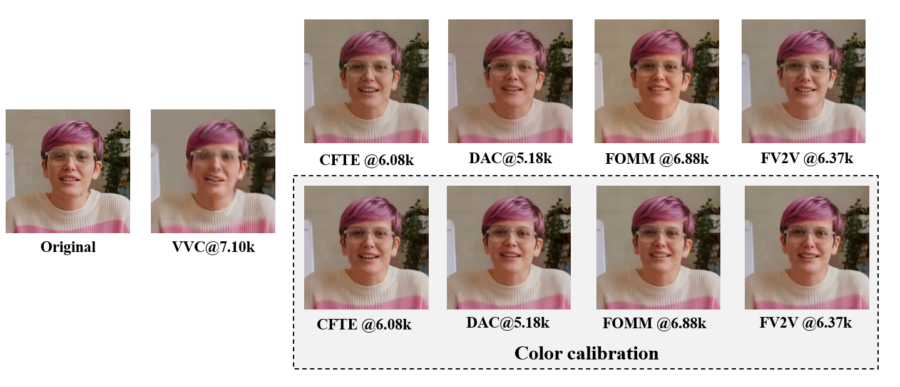
(a) ClassB Seq 005
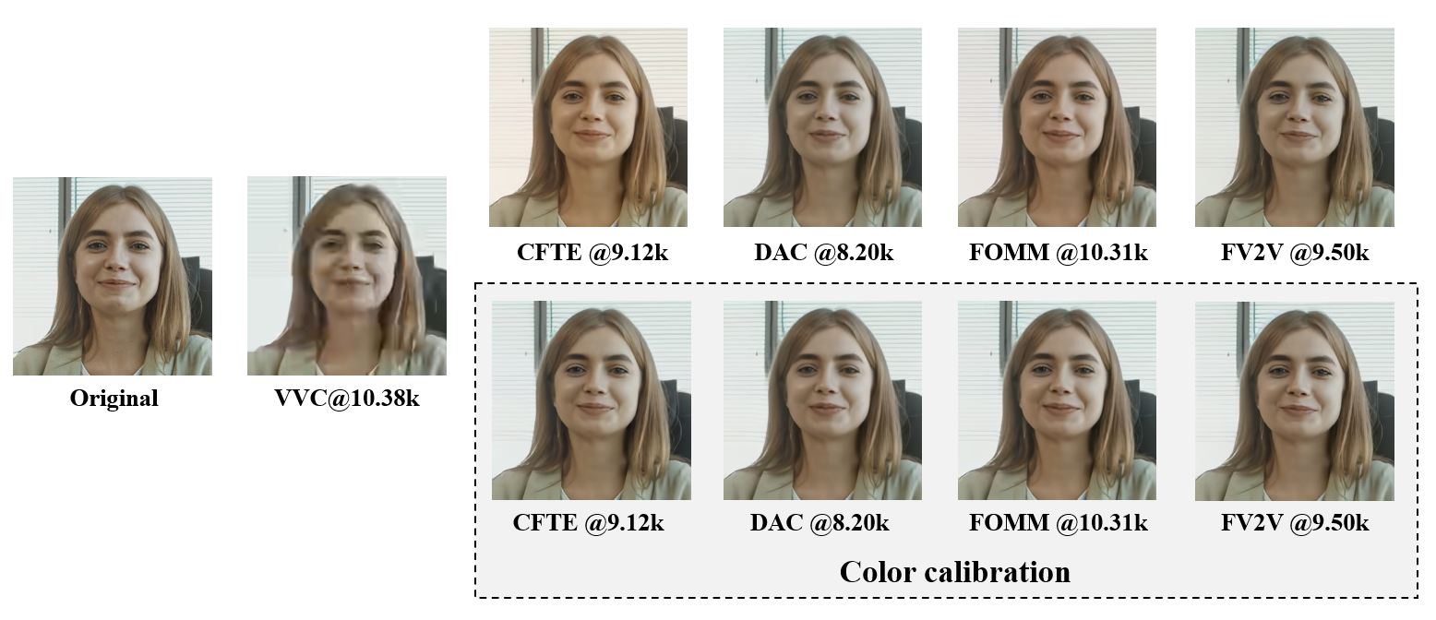
(b) ClassD Seq 004
Figure 9 - Visual quality comparison of VVC and multi-resolution GFVC models (with and without color calibration).

Conclusion
This contribution proposes a lightweight multi-resolution CFTE model for generative face video compression that significantly reduces the number of parameters and computation while maintaining competitive RD performance. We also introduce color calibration as an optional post-processing step in GFVC decoding to solve the color shift issue and improve the subjective quality. We recommend to 1) replace the existing lightweight CFTE model in the AHG16 GFVC software with the proposed lightweight multi-resolution CFTE model, and 2) adopt color calibration algorithm as a post-processing technique in the AhG 16 software.

References
- R. Zou, R.-L. Liao, et al., “AHG16: Depthwise separable convolution for generative face video compression,” The Joint Video Experts Team of ITU-T SG 16 WP 3 and ISO/IEC JTC 1/SC 29, doc. no. JVET-AG0139, January 2024.
- Chen B, Wang Z, Li B, et al. Beyond keypoint coding: Temporal evolution inference with compact feature representation for talking face video compression[C]//2022 Data Compression Conference (DCC). IEEE, 2022: 13-22.
- R. Zou, B. Chen, et al., “AHG16: Removal of the analysis model on the decoder side and lightweight design,” The Joint Video Experts Team of ITU-T SG 16 WP 3 and ISO/IEC JTC 1/SC 29, doc. no. JVET- AH0109, April 2024.
- S. Yin, S. Wang, et al., “AHG16: Multi-resolution models for generative face video compression,” The Joint Video Experts Team of ITU-T SG 16 WP 3 and ISO/IEC JTC 1/SC 29, doc. no. JVET-AJ0052, November 2024.
- J. Chen, B. Chen, et al., “AHG9/AHG16: Colour calibration for generative face video coding” The Joint Video Experts Team of ITU-T SG 16 WP 3 and ISO/IEC JTC 1/SC 29, doc. no. JVET-AL0156, April 2025.
- Liu Z, Li J, Shen Z, et al. Learning efficient convolutional networks through network slimming[C]//Proceedings of the IEEE international conference on computer vision. 2017: 2736-2744.
- S. McCarthy, B. Chen. “Test conditions and evaluation procedures for generative face video coding,” The Joint Video Experts Team of ITU-T SG 16 WP 3 and ISO/IEC JTC 1/SC 29, doc. no. JVET- AJ2035, November 2024.

Patent rights declaration(s)
City University of Hong Kong and Alibaba Group may have current or pending patent rights relating to the technology described in this contribution and, conditioned on reciprocity, is prepared to grant licenses under reasonable and non-discriminatory terms as necessary for implementation of the resulting ITU-T Recommendation | ISO/IEC International Standard (per box 2 of the ITU-T/ITU-R/ISO/IEC patent statement and licensing declaration form).

