    Joint Video Experts Team (JVET)  of ITU-T SG 21 WP 3/21 and ISO/IEC JTC 1/SC 29  39th Meeting, Daejeon, KR, 26 June – 4 July 2025 | Document: JVET-AM0007-v2

Title: | AHG report: ECM tool assessment (AHG7)
Status: | Input document to JVET
Purpose: | Report
Author(s) or  Contact(s): | Xiang Li (chair)  Lien-Fei Chen  Zhipin Deng  Jonathan Gan  Edouard François  Ryo Ishimoto  Hong-Jheng Jhu  Jani Lainema  Xinwei Li  Johan Pardo  Alan Stein  Hongtao Wang (vice chairs) | Tel:  Email: | xlxiangli@google.com  lienfeichen@global.tencent.com  zhipin.deng@bytedance.com  v-jonathan.gan@oppo.com Edouard.Francois@interdigital.com  ishimoto.ryo@mail.sharp  jhuhong-jheng@kwai.com  jani.lainema@nokia.com  sid.lxw@alibaba-inc.com  johan.esprit.pardo1@huawei.com  alan.stein@v-nova.com  hongtaow@qti.qualcomm.com
Source: | AhG7 on ECM tool assessment
_____________________________

Abstract
This report summarizes the activities of the AHG7 on ECM tool assessment that has taken place between the 38th and 39th JVET meetings.

Mandates
The mandates given to the AHG are:
- Investigate methodology of tool assessment, such as the aspects of memory access and bandwidth, number of maximum processing cycles, block decoding dependencies, number of context coded bins, pipeline and parallelization.
- Coordinate with AHG6 on resolving tool-off test related software issues (missing tool controls and software bugs).
- Prepare configuration files and generate bitstreams and results of tool-on/tool-off testing.
- Prepare reporting of tool assessment results.
- Coordinate with AHG17 to collect simulation results on non-CTC sequences (e.g., those used in previous verification tests), and identify a set of non-CTC sequences that would be appropriate for additional testing
- Develop methodology of more reliable runtime measurement

Conference call on Assessment Perspectives of Codec/Coding Tools
The call was on April 22 Tuesday UTC 13:00-14:37. The report was uploaded as JVET-AM0042.

Group off tests

Test settings and crosschecking
The following five groups of tools were defined.
- Group 1: Inter template matching tools
- Group 2: Coding tools that interleave the (merge/skip/AMVP/subblock/IBC/etc) list derivation with the intra prediction/reconstruction process
- Group 3: Intra and IBC template matching (with search) related tools
- Group 4: Tools that require more processing on the neighboring reconstructed samples than VVC
- Group 5: Tools with large memory access
The testers and crosscheckers are planed in the table below.

Tests | Testers / Crosscheckers | Testers / Crosscheckers
Group 1 off | Johan Pardo (johan.esprit.pardo1@huawei.com) | Charles Salmon-Legagneur (charles.salmon-legagneur@interdigital.com)
Group 2 off | Jonathan Gan  (v-jonathan.gan@oppo.com) | Xinwei Li  (sid.lxw@alibaba-inc.com)
Group 3 off | Ryo Ishimoto (ishimoto.ryo@mail.sharp) | Zhipin Deng (zhipin.deng@bytedance.com)
Group 4 off | Hong-Jheng Jhu  (jhuhong-jheng@kwai.com) | Xiang Li  (xlxiangli@google.com)
Group 5 off | Lien-Fei Chen (lienfei.chen@global.tencent.com) | Jani Lainema (jani.lainema@nokia.com)
Group 1-5 off | Xiang Li  (xlxiangli@google.com) | Hongtao Wang  (hongtaow@qti.qualcomm.com)

ECM-17.0 was used in the AHG7 tool off tests. The cfg files used are included in the ECM software package.

Group 1 off
Group 1 includes inter template matching tools. The offgroup1.cfg was used in addition to ECM CTC settings.
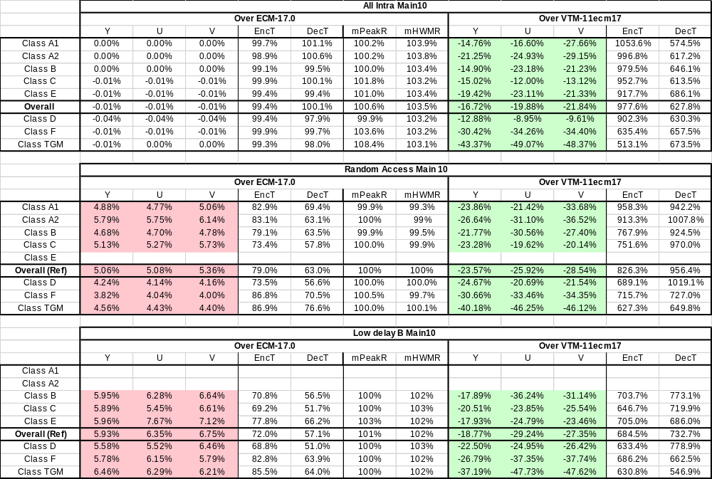

Group 2 off
Group 2 includes coding tools that interleave the (merge/skip/AMVP/subblock/IBC/etc) list derivation with the intra prediction/reconstruction process. The offgroup2.cfg was used in addition to ECM CTC settings.
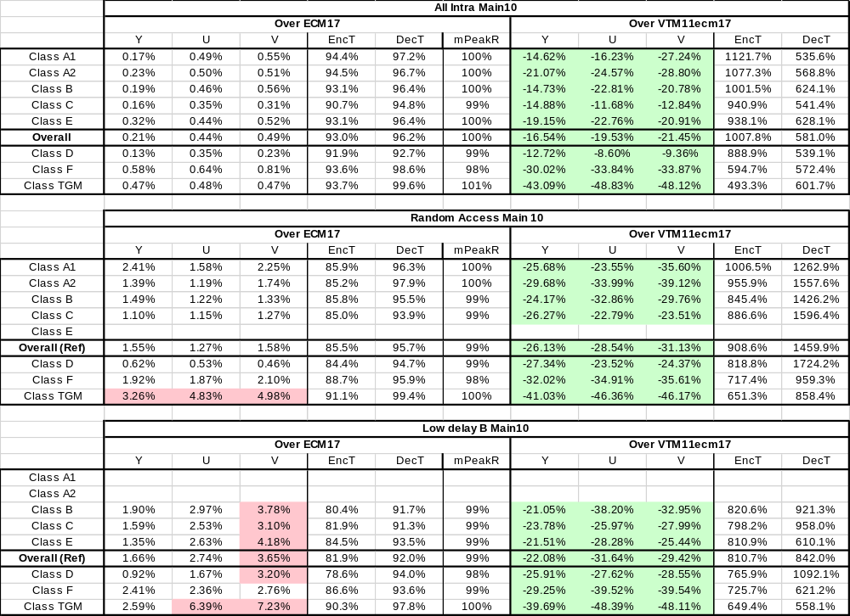

Group 3 off
Group 3 includes intra and IBC template matching (with search) related tools. The offgroup3.cfg was used in addition to ECM CTC settings.
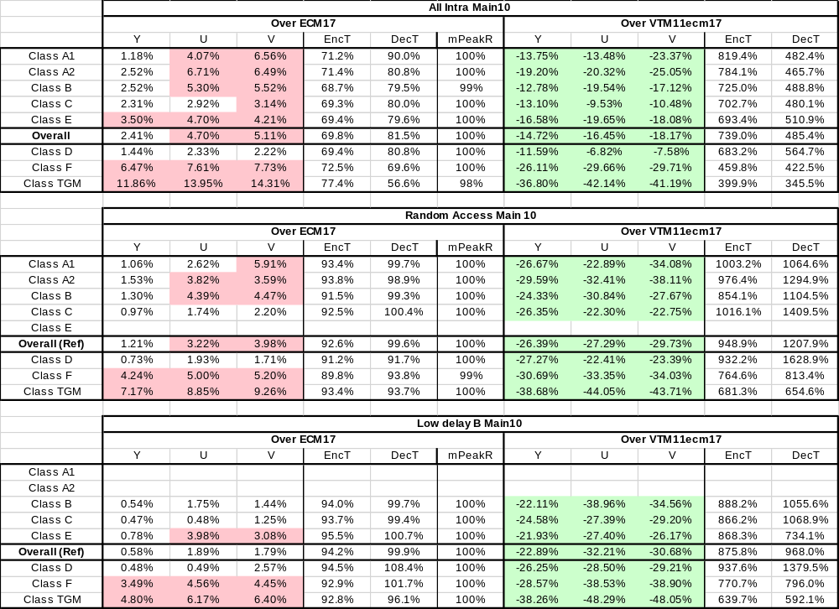

Group 4 off
Group 4 includes tools that require more processing on the neighboring reconstructed samples than VVC.
The offgroup4.cfg was used in addition to ECM CTC settings.
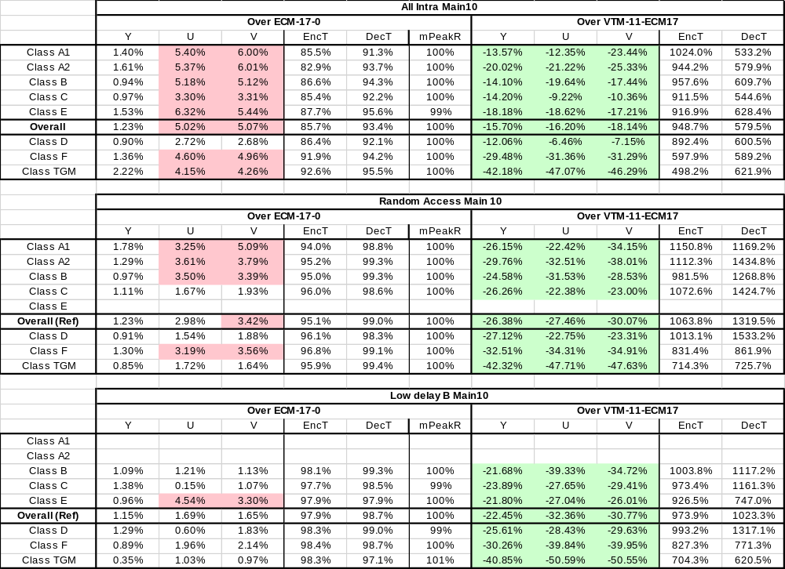

Group 5 off
Group 5 includes tools which need large memory access.
The offgroup5.cfg was used in addition to ECM CTC settings.
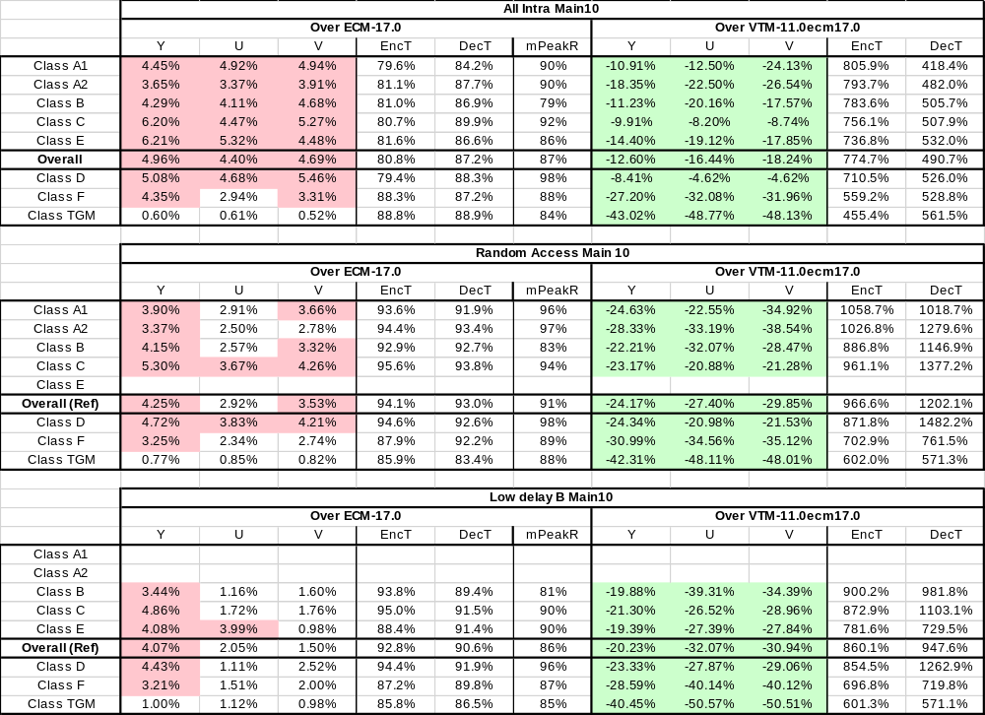

Group 1-5 off
In this test, all the tools in the group 1-5 are switched off. The offgroup1-5.cfg was used in addition to ECM CTC settings.
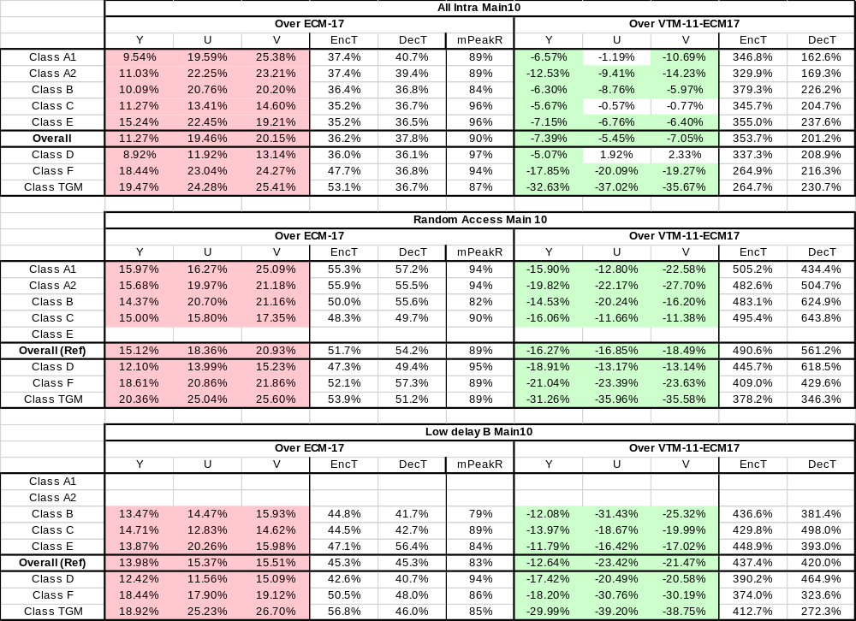

Summary
The tool-off results on top of the recent ECM versions are summarized below for BD-PSNR-Y. Note that SCC results are not included.

Issues

Resolved issues
- #109, Current master tip (7fee7e00d) has decoding mismatch with AHG7 group1-5 off
- #107, Current master tip (06c21da0) decoding mismatch with AHG7 group2 off
- #106, Current master tip (06c21da0) fails MD5sum check at decoding with AHG7 group1 off
- #105, Current master tip (06c21da0) has encoding crash with AHG7 group1 off
- #104, Current master tip (d3a1301a) has encoding crash with AHG7 group1-5 off

Open issues
- #91, MaxTU setting
- #87, ECM-15.0 decoder crashes when "InterLFNST=0"
- #80, Compilation Issue ECM14.0 when disabling GPM reordering
- #78, Encoder crash in RA with --LMChroma=0
- #77, Encoder crash in RA with --DepQuant=0 --NumSignPred=0
- #71, Encode/decode mismatch when using single tree
- #66, Difference in encoding results of ECM-12.0 in AhG7 group 2 tool off test
- #65, Different encoding results of ECM12 in AHG7 group1-4 off tests
- #64, Encode/decode mismatch and decoder crash when inter-CCCM is disable
- #53, Decoding mismatch was observed when AMVR is off

Input contributions
JVET-AM0042 | m72844 | 2025-04-22 18:52:59 | 2025-04-22 19:28:04 | 2025-05-20 02:43:45 | Report of AHG7 conference call on Assessment Perspectives of Codec/Coding Tools | X. Li
JVET-AM0044 | m72866 | 2025-05-20 18:41:53 | 2025-05-20 18:45:18 | 2025-05-20 18:45:18 | AHG7: Summary on the Tool Analysis in Earlier Proposals/Reports | X. Li (Google)
JVET-AM0134 | m73044 | 2025-06-19 11:56:43 | 2025-06-19 14:19:37 | 2025-06-19 14:19:37 | AHG7: ECM tool combination | R. Ishimoto, Z. Fan, T. Chujoh, T. Ikai (Sharp)
JVET-AM0194 | m73108 | 2025-06-19 17:50:35 | 2025-06-19 17:56:52 | 2025-06-19 17:56:52 | On Analyzing and Reporting Encoding and Decoding Complexity | A. Stein, S. Ferrara (V-Nova)
JVET-AM0221 | m73137 | 2025-06-19 22:17:19 | 2025-06-19 23:23:08 | 2025-06-19 23:23:08 | AHG7: TMRL Tool-Off Bug Fix | Z. Xiang, R. Chernyak, B. Wang, S. Liu (Tencent)
JVET-AM0227 | m73143 | 2025-06-19 22:53:02 | 2025-06-23 20:11:35 | 2025-06-23 20:11:35 | AhG7: On bin to bit ratio in ECM | T. N. Canh, P. Yin, S. McCarthy (Dolby), J. N. Shingala (Ittiam)
JVET-AM0295 | m73624 | 2025-06-25 06:18:58 | 2025-06-25 06:25:43 | 2025-06-25 06:25:43 | [AHG7] External memory bandwidth evaluation | Y. Kim, L. Li, M. W. Park, M. Park, M. Budagavi, K. P. Choi (Samsung)

Recommendations
- Continue and improve tool assessment
- Resolve identified software issues related to the tool assessment
- Review all the input documents

