    Joint Video Experts Team (JVET)  of ITU-T SG21 WP3/21 and ISO/IEC JTC 1/SC 29  38th Meeting, by teleconference, 26 March – 4 April 2025 | Document: JVET-AL0326-v1

Title: | AHG9/AHG18: Modification to error recovery SEI message
Status: | Input document
Purpose: | Proposal
Author(s) or  Contact(s): | Hendry Tan*  Miska M. Hannuksela†  Jill Boyce† | Email: | dr.hendry@lge.com  miska.hannuksela@nokia.com  jill.boyce@nokia.com
Source: | LG Electronics Inc.* and Nokia†
_____________________________

Abstract
This contribution proposes some changes on top of the error recovery SEI message that is proposed in JVET-AL0069. The proposed changes are for incorporating temporal sub layers into the signalling of the proposed error recovery SEI message. It is asserted that the support for temporal sub layers is desirable as with it the error recovery SEI message allows encoder to use better reference pictures in the event of picture loss during transmission.

Introduction
Contribution JVET-AL0069 proposes a new SEI message called error recovery SEI message that is asserted enables encoders to signal information to decoders when the underlying system supports backchannel for feedback following network losses. The design relies on the case such that upon receiving the feedback from decoders about the lost pictures during transmission, encoders may be able to adjust the encoding future pictures such as to avoid using reference pictures that are impacted by network losses and then they may inform decoders about it.
The design of error recovery SEI message proposed in JVET-AL0069 does not incorporate the aspect of temporal sub layers. It is asserted that the support for temporal sub layers is desirable as with it the error recovery SEI message allows encoder to use better reference pictures in the event of picture loss during transmission as described in the section below.
In section 2, we describe the case that shows the inclusion of temporal sub layers in the design of the SEI is beneficial. In section 3, we provide the proposed changes to the syntax and semantics of error recovery SEI message.

Use-case description
Figures below illustrates how the inclusion of temporal sub layers can improve the design of error recovery SEI when handling a lost picture. Assume the coding structure as shown below in the low delay configuration with three temporal sub layers. Pictures in Tid 0 each refers to one previous Tid 0 picture, pictures in Tid 1each refers to one previous Tid 0 picture and one previous Tid 1 picture, and finally pictures in Tid 2 each refers to one previous Tid 0 picture, one previous Tid 1 picture, and one previous Tid 2 picture.
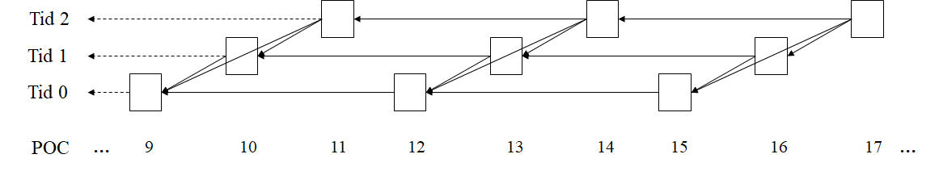
When picture 11, which is a Tid 2 picture, is lost and the msg from decoder is received by encoder prior to encoding of picture 15, encoder ha to change the reference pictures for picture 15, 16, and 17, and so forth as depicted below. Using the proposed SEI, all of them need to change since in this example picture 12, 13, and 14 automatically can not be used as reference pictures anymore since encoder will be only allowed to use reference picture from picture 10 or earlier. This is actually not optimal since picture 12 and 13 are clearly still good for reference.
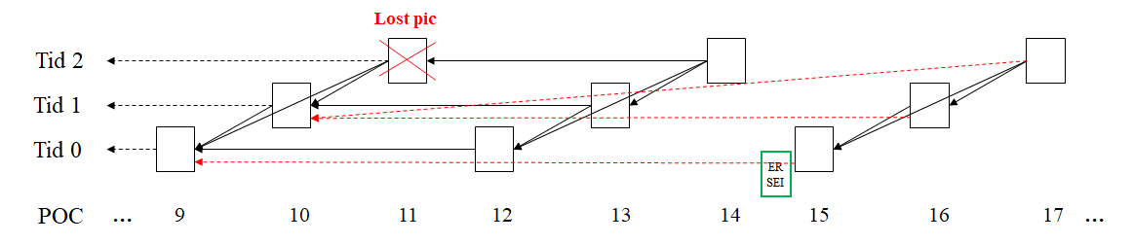
If the signalling incorporates temporal sublayer, then only pictures at temporal sublayer where the picture is lost needs to change as shown in the three figures below. Since the lost picture is at Tid 2, pictures at Tid 0 and Tid 1 are not really affected. Using the example above, the encoder actually has several options to change the referencing for picture in Tid 2 (i.e., picture 17) as shown in the next 3 pictures below:
Possibility 1: Instead of referring to pic 11, pic 17 can refer to previous Tid 2 picture (e.g., pic 8)
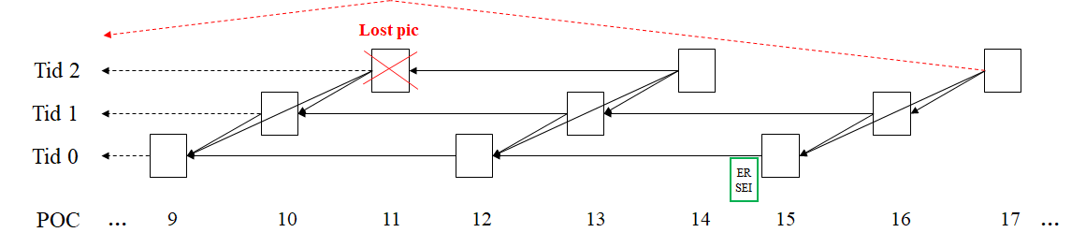
Possibility 2: Instead of referring to pic 11, pic 17 can refer to next nearest available ref pic (e.g., pic 13)
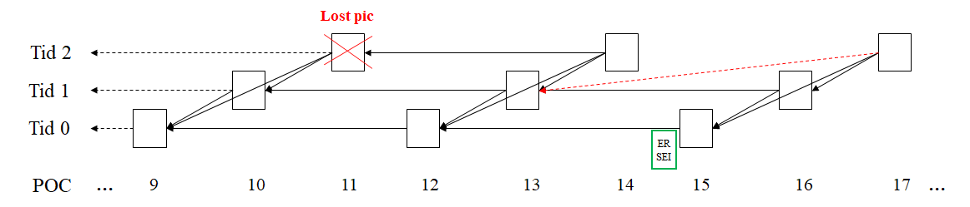
Possibility 3: Instead of referring to pic 11, pic 17 can refer to next nearest available ref pic that precedes the lost picture (e.g., pic 10)
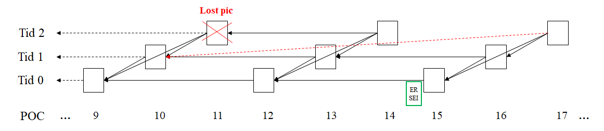
Any of the three possibilities above would give a better compression performance since they can better utilize pictures that are deemed unusable for reference by the proposed SEI message.
If the signalling is designed to take into account temporal sublayer, for the given example above, the ER SEI would contains the following POC values:
- Tid 0: 12
- Tid 1: 13
- Tid 2: 8

Proposed changes

Syntax
error_recovery( payloadSize ) { | Descriptor
er_num_sublayers_minus1 | u(3)
er_ref_subpic_info_present_flag | u(1)
if( !er_ref_subpic_info_present_flag )
for( i = 0; i <= er_num_sublayers_minus1; i++ )
er_ref_pic_delta_poc_minus1[ i ] | ue(v)
else {
er_num_subpics_minus2 | ue(v)
for( i = 0; i < er_num_subpics_minus2 + 2; i++ )
for( j = 0; j <= er_num_sublayers_minus1; j++ )
er_ref_subpic_delta_poc_minus1[ i ][ j ] | ue(v)
}
}

Semantics
The error recovery SEI message indicates a range of picture order count values for one or more temporal sublayers for which the current picture and subsequent pictures in decoding order, or subpictures of those pictures, do not have active entries in a reference picture list.
NOTE – In a system where missing coded pictures or subpictures of coded pictures are detected and reported to the encoding system through external means, the error recovery SEI message may be used to determine which coded pictures or subpictures are expected to be suitable for display.
Use of this SEI message requires the definition of the following variables:
- A picture order count of the current picture, denoted by CurrPoc.
- A subpicture count, denoted by NumSubpics.
er_num_sublayers_minus1 plus 1 specifies the number of temporal sublayers for which picture order count value is indicated.
er_ref_subpic_info_present_flag equal to 0 indicates that the er_ref_pic_delta_poc_minus1 syntax element is present. er_ref_subpic_info_present_flag equal to 0 indicates that the er_num_subpics_minus2 syntax element is present.
er_ref_pic_delta_poc_minus1[ i ] + plus 1 specifies a picture order count difference value of a reference picture in the i-th temporal sublayer relative to the current picture. The value of er_ref_pic_delta_poc_minus1[ i ] shall be in the range of 0 to CurrPoc – 1, inclusive.
For each value of i in the range of 0 to er_num_sublayers_minus1, inclusive, and each value of j in the range of 0 to i, inclusive, it is a requirement of bitstream conformance that the current picture and all subsequent coded pictures with temporal sublayer identifier equals to i in the CLVS, in decoding order, shall not have an active entry of a reference picture list that has with picture order count in the range of CurrPoc – er_ref_pic_delta_poc_minus1[ j ] to CurrPoc – 1, inclusive, and temporal sublayer identifier equals to j.
er_num_subpics_minus2 + plus 2 specifies the number of subpictures for which the picture order count differences are signalled.
When er_num_subpics_minus2 is present, it is a requirement of bitstream conformance that NumSubpics equals er_num_subpics_minus2 + 2.
er_ref_subpic_delta_poc_minus1[ i ][ j ] +plus 1 specifies a picture order count difference value of a reference picture in the j-th temporal sublayer of the i-th subpicture relative to the current picture. The value of er_ref_subpic_delta_poc_minus1[ i ][ j ] shall be in the range of 0 to CurrPoc – 1, inclusive.
When not present, the value of er_ref_subpic_delta_poc_minus1[ i ][ j ] is inferred to be equal to er_ref_pic_delta_poc_minus1[ j ].
For each value of i in the range of 0 to er_num_subpics_minus2 + 1, inclusive, each value of j in the range of 0 to er_num_sublayers_minus1, inclusive, and each value of k in the range of 0 to j, inclusive, it is a requirement of bitstream conformance that the current picture and all subsequent coded pictures with temporal sublayer identifier equals to j in the CLVS, in decoding order, shall not have an active entry of a reference picture list of the i-th subpicture with picture order count in the range of CurrPoc – er_ref_pic_subpic_delta_poc_minus1[ i ][ k ] to CurrPoc – 1, inclusive, and temporal sublayer identifier equals to k.
The variable SubpicRefPoc[ i ] is set equal to CurrPoc – ( er_ref_subpic_delta_poc_minus1[ i ] + 1 ), for i in the range of 0 .. NumSubpics – 1, inclusive.
The function PicOrderCnt( picX ) is specified as follows:
PicOrderCnt( picX ) = PicOrderCntVal of the picture picX
When the error recovery SEI message is present, it is a requirement of bitstream conformance that subpicture i, for i in 0 .. NumSubpics – 1, inclusive, of the current picture and all subsequent coded pictures in the CLVS, in decoding order, has no slices that refer to a reference picture, refPic, in an active entry of a reference picture list for which SubpicRefPoc[ i ] < PicOrderCnt( refPic ) < CurrPoc.

Patent rights declaration(s)
LG Electronics Inc. and Nokia may have current or pending patent rights relating to the technology described in this contribution and, conditioned on reciprocity, is prepared to grant licenses under reasonable and non-discriminatory terms as necessary for implementation of the resulting ITU-T Recommendation | ISO/IEC International Standard (per box 2 of the ITU-T/ITU-R/ISO/IEC patent statement and licensing declaration form).

