    Joint Video Experts Team (JVET)  of ITU-T SG21 WP3/21 and ISO/IEC JTC 1/SC 29  38th Meeting, by teleconference, 26 March – 4 April 2025 | Document: JVET-AL0246-v1

Title: | Crosscheck of JVET-AL0084 (EE1-1.2: LOP5 improvement with parallel 1x3/3x1 Backbone)
Status: | Input document to JVET
Purpose: | Cross-check report
Author(s) or  Contact(s): | Yue Li | Email: | yue.li@bytedance.com
Source: | Bytedance
_____________________________

Abstract
This contribution reports the cross-check results for EE1-1.2 (JVET-AL0084). In EE1-1.2, the parallel 1x3/3x1 convolutions are applied in the luma path, replacing the original 1x3/3x1 layers in both the backbone and attention modules.
Inference crosscheck has been finished. The cross-checker was able to reproduce inference BD-rate results for this test. Training crosscheck is in progress.

Introduction
To reduce the number of sequential convolutional layers and latency, EE1-1.2 proposes a parallel 1x3/3x1 backbone block design as shown in Figure 1. The sequential 1x3/3x1 layers in both the backbone and attention modules of LOP5 luma branch are replaced by the proposed parallel design.
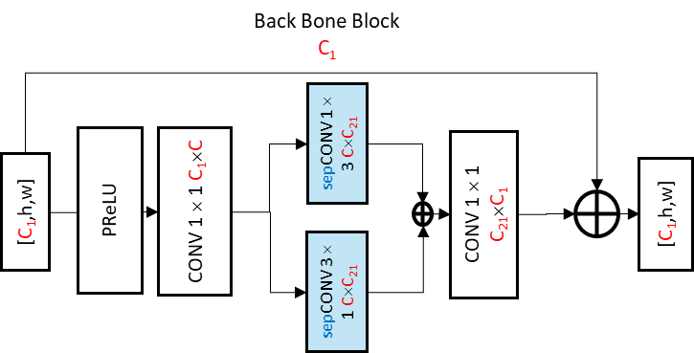
Figure 1. Parallel 1x3/3x1 backbone block design.

Cross-check of the Inference
Simulation results using the model shard by the proponents are reported in Table 1.
Table 1. Summary of the inference test results from crosschecker, test EE1-1.2. vs NNVC12 anchor.
 | Proposed a vs NNVC12 anchor
 | All Intra |  |  |  |  | Random Access
 | Y-PSNR | U-PSNR | V-PSNR | EncT | DecT | Y-PSNR | U-PSNR | V-PSNR | EncT | DecT
Class A1 | 0.30% | -0.40% | -1.48% | 103% | 103% | 0.16% | -0.04% | -0.18% | 99% | 99%
Class A2 | 0.09% | 0.40% | -0.24% | 101% | 98% | 0.05% | 0.40% | -0.22% | 100% | 101%
Class B | 0.05% | -0.32% | -0.34% | 100% | 101% | 0.00% | -0.46% | -0.18% | 100% | 97%
Class C | 0.02% | -0.24% | -0.45% | 101% | 93% | 0.03% | -0.22% | -0.49% | 99% | 96%
Class E | 0.07% | -0.01% | -0.46% | 98% | 95%
Overall | 0.10% | -0.15% | -0.56% | 101% | 98% | 0.05% | -0.14% | -0.27% | 100% | 98%
Class D | -0.02% | -0.61% | -0.61% | 101% | 99% | -0.01% | -0.44% | -0.91% | 98% | 97%
Cross-checker was able to reproduce inference bd-rate results.

Cross-check of the training
Training is in progress and expected to be finished in one week.

