    Joint Video Experts Team (JVET)  of ITU-T SG21 WP3/21 and ISO/IEC JTC 1/SC 29  38th Meeting, by teleconference, 26 March – 4 April 2025 | Document: JVET-AL0246-v3

Title: | Crosscheck of JVET-AL0084 (EE1-1.2: LOP5 improvement with parallel 1x3/3x1 Backbone)
Status: | Input document to JVET
Purpose: | Cross-check report
Author(s) or  Contact(s): | Yue Li, Chaoyi Lin, Junru Li | Email: | yue.li@bytedance.com
Source: | Bytedance
_____________________________

Abstract
This contribution reports the cross-check results for EE1-1.2 (JVET-AL0084). In EE1-1.2, the parallel 1x3/3x1 convolutions are applied in the luma path, replacing the original 1x3/3x1 layers in both the backbone and attention modules.
Inference crosscheck has been finished. The cross-checker was able to reproduce inference BD-rate results for this test. Training crosscheck has been finished. Given the close results between the models trained by the crosschecker and the proponents, it is asserted that EE1-1.2 passes training crosscheck.

Introduction
To reduce the number of sequential convolutional layers and latency, EE1-1.2 proposes a parallel 1x3/3x1 backbone block design as shown in Figure 1. The sequential 1x3/3x1 layers in both the backbone and attention modules of LOP5 luma branch are replaced by the proposed parallel design.
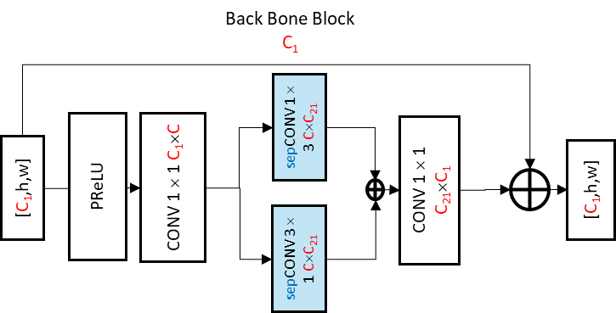
Figure 1. Parallel 1x3/3x1 backbone block design.

Cross-check of the Inference
Simulation results using the model shard by the proponents are reported in Table 1.
Table 1. Summary of the inference test results from crosschecker, test EE1-1.2. vs NNVC12 anchor.
 | Proposed vs NNVC12 anchor
 | All Intra |  |  |  |  | Random Access
 | Y-PSNR | U-PSNR | V-PSNR | EncT | DecT | Y-PSNR | U-PSNR | V-PSNR | EncT | DecT
Class A1 | 0.30% | -0.40% | -1.48% | 103% | 103% | 0.16% | -0.04% | -0.18% | 99% | 99%
Class A2 | 0.09% | 0.40% | -0.24% | 101% | 98% | 0.05% | 0.40% | -0.22% | 100% | 101%
Class B | 0.05% | -0.32% | -0.34% | 100% | 101% | 0.00% | -0.46% | -0.18% | 100% | 97%
Class C | 0.02% | -0.24% | -0.45% | 101% | 93% | 0.03% | -0.22% | -0.49% | 99% | 96%
Class E | 0.07% | -0.01% | -0.46% | 98% | 95%
Overall | 0.10% | -0.15% | -0.56% | 101% | 98% | 0.05% | -0.14% | -0.27% | 100% | 98%
Class D | -0.02% | -0.61% | -0.61% | 101% | 99% | -0.01% | -0.44% | -0.91% | 98% | 97%
Cross-checker was able to reproduce inference bd-rate results.

Cross-check of the training

Simulation results using the model reproduced by crosschecker are reported in Table 2.
Table 2. Summary of the test results from crosschecker, EE1-1.2 reproduced model vs EE1-1.2 proponents model.
 | reproduced vs proposed
 | All Intra |  |  |  |  | Random Access
 | Y-PSNR | U-PSNR | V-PSNR | EncT | DecT | Y-PSNR | U-PSNR | V-PSNR | EncT | DecT
Class A1 | -0.17% | -0.05% | 0.31% | 92% | 96% | -0.02% | 0.14% | -0.12% | 95% | 95%
Class A2 | -0.04% | -0.35% | 0.59% | 94% | 96% | -0.01% | 0.24% | 0.65% | 95% | 96%
Class B | -0.07% | 0.73% | 0.43% | 93% | 95% | -0.08% | 0.72% | 0.18% | 92% | 94%
Class C | -0.05% | 0.31% | 0.60% | 92% | 93% | -0.02% | 0.77% | 0.46% | 91% | 91%
Class E | -0.04% | 0.57% | 0.83% | 93% | 94%
Overall | -0.07% | 0.30% | 0.54% | 93% | 94% | -0.04% | 0.52% | 0.29% | 93% | 94%
Class D | -0.03% | 0.19% | 0.64% | 89% | 89% | -0.09% | 0.64% | 0.99% | 88% | 83%
Cross-checker was able to reproduce the training successfully.

