    Joint Video Experts Team (JVET)  of ITU-T SG21 WP3/21 and ISO/IEC JTC 1/SC 29  38th Meeting, by teleconference, 26 March – 4 April 2025 | Document: JVET-AL0230-v1

Title: | AhG11/AhG12: Performance of the NNVC ILF in ECM
Status: | Input document to JVET
Purpose: | Informational
Author(s) or  Contact(s): | Dmytro Rusanovskyy,  Krit Panusopone,  Seungwook Hong,  Limin Wang | Email: | dmytro.rusanovskyy@nokia.com
Source: | Nokia
_____________________________

Abstract
An integration of NN-ILF into ECM targeting luma-only filtering have been proposed in JVET-AJ0210 and further studied in JVET-AK0183 and JVET-AK0184. In this contribution, implementation of JVET-AK0183 has been modified and NNVC ILF filters (VLOP, LOP and HOP) have been placed in parallel to deblocking filter and tested for joint YCbCr filtering.
The VLOP filter the following results are reported:
- AI: {-0.7%, -1.8% and -1.8%} and 101% of encoder and 306% decoder run time.
- RA: {-0.9%, -1.7% and -1.2%} and 101% of encoder and 284% decoder run time.
The LOP filter the following results are reported:
- AI: {-1.3%, -4.9% and -5.2%} and 102% of encoder and 527% decoder run time.
- RA: {-1.7%, -5.8% and -5.3%} and 102% of encoder and 468% decoder run time.
The HOP filter the following results are reported:
- AI: {-3.4%, -10.3% and -11.1%} and 110% of encoder and 6533% decoder run time.
- RA: {-5.2%, -13% and -12.9%} and 108% of encoder and 5646% decoder run time.

Introduction
Unified Filter Architecture for In-Loop Filtering of NNVC as well as inference process and training procedure was originally defined in JVET-AD0380 for High-performance Operation Point (HOP, 460kMAC/Pixel) and further extended to Low Operation Point (LOP, 17kMAC/pixel) in JVET-AE0281and Very Low Operation Point (VLOP, 5kMAC/pixel) in JVET-AH0051.
Simplified block diagram of the NN ILF for LOP and VLOP, which may be considered as relevant for integration into ECM, are shown in Figure 1. This method takes reconstructed pixels (Luma and chroma), prior to the deblocking, prediction pixels, coding context information (e.g. QP, BS, coding modes), extract input features and jointly process these features by Luma and Chroma backbones (sequences of convolution layers), independently.
The output of NN-ILF is combined with output of the deblocking filter, with the weights and the offsets derived at the encoder side and signalled in the bitstream. Resulting pixels are further processed by VVC SAO and ALF.

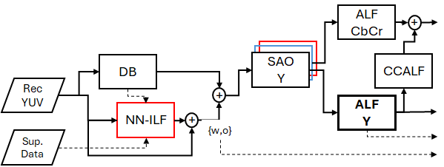
Figure 1. Simplified block diagram of the Unified ILF adopted by NNVC.
Input contribution JVET-AK0183 presented an alternative integration, where a low complexity luma-only filtering was derived from VLOP1 and applied for luma filtering in ECM-ALF. Simplified block diagram on integration on NN-ILF into ECM, proposed in JVET-AK0183 is shown Figure 2.
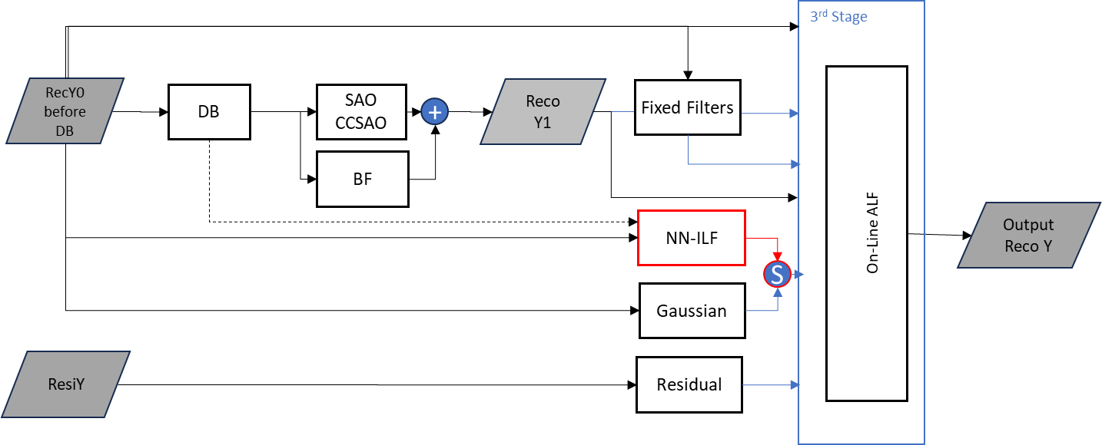
Figure 2. Integration of the NN filter into ECM ALF, JVET-AK0183.
Input contribution JVET-AK0184 additional reported simulation results of this ECM-ALF integration with NNVC adopted filters (VLOP, LOP and HOP).

Conducted tests:
In this contribution, an implementation of JVET-AK0183 has been extended and NNVC ILF filters (VLOP, LOP and HOP) have been tested for joint YCbCr filtering and placed in parallel to the deblocking filtering, thus following system design adopted by NNVC.
Simulation results have been conducted with ECM CTC, and following results are reported for VLOP1, LOP2 and HOP3 filters, respectively.

Table 1. Comparative performance of the VLOP1 vs ECM.
VLOP | AI |  |  |  |  | RA
vs ECM | Y | U | V | EncT | DecT | Y | U | V | EncT | DecT
Class A1 | -0.77% | -1.33% | -1.59% | 102.1% | 419.0% | -1.37% | -1.33% | -1.16% | 100.2% | 314.0%
Class A2 | -0.81% | -2.12% | -1.14% | 101.4% | 344.1% | -1.23% | -1.37% | -0.55% | 100.9% | 262.2%
Class B | -0.58% | -2.04% | -1.94% | 100.5% | 301.2% | -0.82% | -2.13% | -1.36% | 100.7% | 302.8%
Class C | -0.30% | -1.71% | -1.80% | 100.9% | 248.4% | -0.49% | -1.77% | -1.42% | 100.8% | 255.3%
Class E | -1.10% | -1.91% | -2.22% | 101.5% | 319.3%
Overall | -0.67% | -1.84% | -1.76% | 101.2% | 310.9% | -0.92% | -1.72% | -1.17% | 100.7% | 283.2%
Class D | -0.53% | -1.71% | -1.81% | 101.4% | 222.3% | -0.75% | -1.86% | -1.58% | 101.3% | 227.4%

Table 2. Comparative performance of the LOP2 vs ECM.
LOP | AI |  |  |  |  | RA
vs ECM | Y | U | V | EncT | DecT | Y | U | V | EncT | DecT
Class A1 | -1.35% | -3.93% | -4.20% | 103.5% | 772.0% | -2.33% | -3.85% | -3.87% | 104.2% | 523.0%
Class A2 | -1.22% | -5.41% | -4.05% | 106.5% | 613.1% | -2.76% | -7.47% | -4.50% | 104.4% | 471.9%
Class B | -1.05% | -5.00% | -5.53% | 102.3% | 520.5% | -1.57% | -6.27% | -5.78% | 102.3% | 490.0%
Class C | -0.90% | -5.17% | -5.80% | 99.4% | 385.3% | -0.96% | -5.93% | -6.15% | 100.4% | 404.6%
Class E | -2.04% | -4.57% | -5.99% | 101.2% | 530.8%
Overall | -1.26% | -4.86% | -5.20% | 102.3% | 527.1% | -1.73% | -5.82% | -5.29% | 102.5% | 468.1%
Class D | -1.25% | -5.47% | -6.11% | 99.7% | 342.5% | -1.41% | -7.20% | -6.98% | 101.1% | 369.6%

Table 3. Comparative performance of the HOP3 vs ECM.
HOP | AI |  |  |  |  | RA
vs ECM | Y | U | V | EncT | DecT | Y | U | V | EncT | DecT
Class A1 | -2.93% | -8.64% | -10.61% | 118.4% | 9676.1% | -5.49% | -10.19% | -12.23% | 111.2% | 6750.9%
Class A2 | -2.85% | -10.45% | -8.60% | 110.9% | 7135.4% | -8.03% | -16.90% | -12.87% | 110.9% | 5464.3%
Class B | -2.82% | -10.13% | -11.34% | 108.1% | 6519.9% | -4.89% | -13.59% | -13.41% | 109.6% | 6034.1%
Class C | -3.55% | -11.05% | -12.36% | 104.4% | 4415.4% | -4.59% | -14.62% | -15.11% | 103.7% | 4876.1%
Class E | -5.21% | -10.84% | -12.00% | 111.7% | 6836.3%
Overall | -3.40% | -10.26% | -11.10% | 110.0% | 6533.7% | -5.38% | -13.63% | -13.57% | 108.5% | 5646.5%
Class D | -3.81% | -11.24% | -12.76% | 102.0% | 3688.4% | -5.52% | -15.60% | -16.43% | 105.3% | 4250.4%

Conclusion
In this contribution, NN-ILF integration of JVET-AK0183 has been modified and NNVC ILF filters (VLOP, LOP and HOP) have been placed in parallel to deblocking filter and tested for joint YCbCr filtering.
For VLOP1 filter the following results are reported:
- AI: {-0.7%, -1.8% and -1.8%} and 101% of encoder and 306% decoder run time.
- RA: {-0.9%, -1.7% and -1.2%} and 101% of encoder and 284% decoder run time.
For LOP filter the following results are reported:
- AI: {-1.3%, -4.9% and -5.2%} and 102% of encoder and 527% decoder run time.
- RA: {-1.7%, -5.8% and -5.3%} and 102% of encoder and 468% decoder run time.
For HOP filter the following results are reported:
- AI: {-3.4%, -10.3% and -11.1%} and 110% of encoder and 6533% decoder run time.
- RA: {-5.2%, -13% and -12.9%} and 108% of encoder and 5646% decoder run time.

References:
[1] D. Rusanovskyy, Y. Li, M. Karczewicz, JVET-AK0183, Jan. 2025.
[2] D. Rusanovskyy, Y. Li, M. Karczewicz, JVET-AK0184, Jan. 2025.
[3] M. Karczewicz, Y. Ye, “Common Test Conditions and evaluation procedures for enhanced compression tool testing,” JVET-AI2017, July 2024.

Patent rights declaration(s)
Nokia may have current or pending patent rights relating to the technology described in this contribution and, conditioned on reciprocity, is prepared to grant licenses under reasonable and non-discriminatory terms as necessary for implementation of the resulting ITU-T Recommendation | ISO/IEC International Standard (per box 2 of the ITU-T/ITU-R/ISO/IEC patent statement and licensing declaration form).

