    Joint Video Experts Team (JVET)  of ITU-T SG21 WP3/21 and ISO/IEC JTC 1/SC 29  38th Meeting, by teleconference, 26 March – 4 April 2025 | Document: JVET-AL0225-v3

Title: | EE2-related: On In-Loop Filtering in ECM
Status: | Input document to JVET
Purpose: | Proposal
Author(s) or  Contact(s): | Dmytro Rusanovskyy,  Maria Santamaria,  Nam Le,  Francesco Cricri,  Krit Panusopone,  Seungwook Hong,  Limin Wang,  Jani Lainema (Nokia)  Y. Li,  M. Karczewicz,  J. Wang,  L. Kerofsky (Qualcomm) | Email: | dmytro.rusanovskyy@nokia.com  maria.santamaria_gomez@nokia.com  nam.le@nokia.com  francesco.cricri@nokia.com  krit.panusopone@nokia.com  seungwook.hong@nokia.com  limin.2.wang@nokia.com  jani.lainema@nokia.com
Source: | Nokia, Qualcomm
_____________________________

Abstract
An integration of NN-ILF into ECM have been originally proposed in JVET-AJ0210 and being studied in JVET-AK0183 and JVET-AK0184. This contribution presents a development of the loop filtering proposed in JVET-AK0183. Loop filtering is being constrained by encoder to minimize the complexity-aware cost function and thus reducing the encoder and decoder run-times.
Proposed method was tested with ECM16 CTC, and reportedly provides the following BD-rate PSNR {Y, Cb, Cr} changes against the respective anchor:
- AI: {-0.3%, -0.9% and -0.7%} and approximately 92.3% of encoder and 200% decoder run time.
- RA: {-0.4%, -0.6% and -0.1%} and approximately 92.8% of encoder and 151% decoder run time.
It is proposed to study this method in EE2.

Introduction
Simplified block diagram on integration on NN-ILF into ECM, originally proposed in JVET-AJ0210 and tested in JVET-AK0183 is shown Fig. 1. NN-ILF operates on input reconstructed pixels before deblocking and in parallel to existing deblocking, BIF/SAO, Fixed Filters, Residual and Gaussian filters and its output is introduced into Online filter of the ALF.
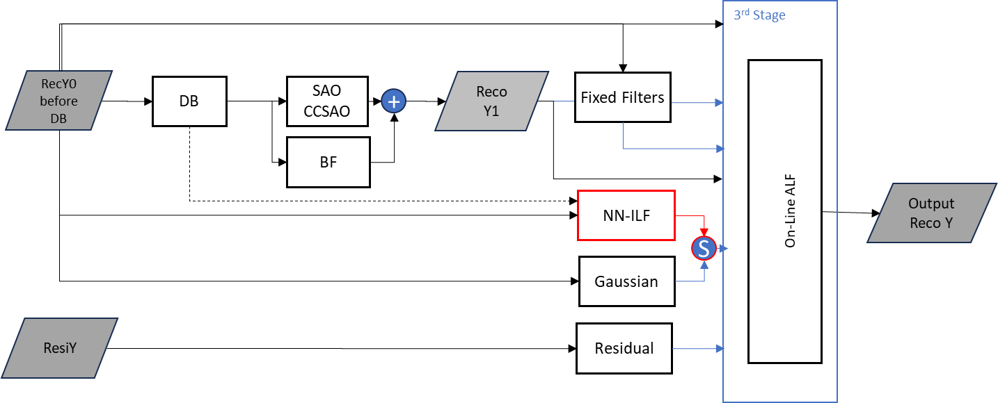
Figure 1. Integration of the NN filter into ECM ALF, JVET-AK0183.

Proposed method
In this contribution, NN filter integration with ECM presented in JVET-AK0183 was extended to support YCbCr filter and tested with NNVC VLOP1. This filter has complexity of 5kMAC/pixel and 15K parameters. Luma output of the proposed filter is introduced into the online training stage of ECM-ALF. Enabling of the NNVC filter, in combination with other filters of the first stage, was controlled by complexity-aware RDO.
Simplified block diagram of the proposed method is shown below:
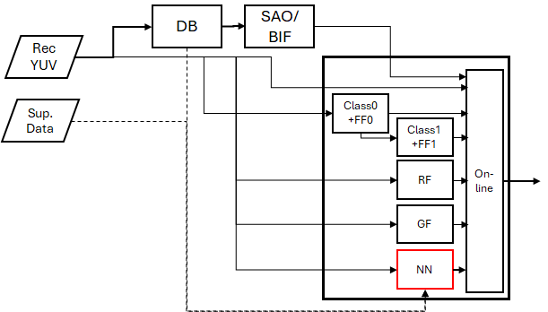
Figure 2. Tested integration of proposed NNILF with ECM ALF.

Simulation results
Proposed method has been tested on top ECM16.0 under CTC, and its simulation results are reported in Table 1.
Table 1. Comparative performance of the proposed method vs. ECM16.0, under CTC.
Test vs | AI |  |  |  |  | RA
ECM16 | Y | U | V | EncT | DecT | Y | U | V | EncT | DecT
Class A1 | -0.42% | -0.21% | -0.59% | 90.1% | 268.1% | -0.84% | -0.10% | 0.15% | 91.0% | 149.6%
Class A2 | -0.35% | -1.53% | -0.28% | 91.9% | 224.7% | -0.65% | -0.67% | 0.25% | 92.0% | 146.3%
Class B | -0.21% | -1.44% | -0.86% | 91.2% | 203.7% | -0.38% | -1.09% | -0.25% | 92.8% | 170.7%
Class C | -0.01% | -0.47% | -0.56% | 96.5% | 137.1% | -0.07% | -0.46% | -0.21% | 95.0% | 136.0%
Class E | -0.51% | -0.45% | -1.13% | 91.2% | 219.8%
Overall | -0.27% | -0.87% | -0.70% | 92.3% | 201.0% | -0.44% | -0.64% | -0.06% | 92.8% | 151.7%
Class D | -0.17% | -0.68% | -0.43% | 96.3% | 164.1% | -0.29% | -0.06% | 0.90% | 96.0% | 171.3%

Conclusion
This contribution presents a development of the NN-ILF architecture of JVET-AJ0183 and NN-ILF integration with ECM. Proposed method was tested with ECM16 CTC, and preliminary provide the following BD-rate PSNR {Y, Cb, Cr} changes against the respective anchor:
- AI: {-0.3%, -0.9% and -0.7%} and approximately 92.3% of encoder and 200% decoder run time.
- RA: {-0.4%, -0.6% and -0.1%} and approximately 92.8% of encoder and 151% decoder run time.
It is proposed to study this method in EE2.

References:
[1] D. Rusanovskyy, Y. Li, M. Karczewicz JVET-AJ0210, Oct. 2024.
[2] D. Rusanovskyy, Y. Li, M. Karczewicz, JVET-AK0183, Jan. 2025.
[3] Y. Li, M. Karczewicz, J. Wang, L.Kerofsky, “EE2-5.4: On the performance improvement of NN-based ILF in ALF”, March, 2025.
[3] M. Karczewicz, Y. Ye, “Common Test Conditions and evaluation procedures for enhanced compression tool testing,” JVET-AI2017, July 2024.

Patent rights declaration(s)
Nokia may have current or pending patent rights relating to the technology described in this contribution and, conditioned on reciprocity, is prepared to grant licenses under reasonable and non-discriminatory terms as necessary for implementation of the resulting ITU-T Recommendation | ISO/IEC International Standard (per box 2 of the ITU-T/ITU-R/ISO/IEC patent statement and licensing declaration form).
Qualcomm Incorporated may have current or pending patent rights relating to the technology described in this contribution and, conditioned on reciprocity, is prepared to grant licenses under reasonable and non-discriminatory terms as necessary for implementation of the resulting ITU-T Recommendation | ISO/IEC International Standard (per box 2 of the ITU-T/ITU-R/ISO/IEC patent statement and licensing declaration form).

