    Joint Video Experts Team (JVET)  of ITU-T SG 21 WP 3 and ISO/IEC JTC 1/SC 29  38th Meeting, by teleconference, 26 March – 4 April 2025 | Document: JVET-AL0221-v2

Title: | AHG9: EOI SEI message with luma range adaptation for machine analysis
Status: | Input document to JVET
Purpose: | Proposal
Author(s) or  Contact(s): | Tero Partanen  Miska M. Hannuksela  Honglei Zhang  Alireza Aminlou | Email: | tero.partanen@tuni.fi  miska.hannuksela@nokia.com  honglei.1.zhang@nokia.com  alireza.aminlou@nokia.com
Source: | Nokia, Tampere University
_____________________________

Abstract
The contribution proposes to include the TuC design of luma range adaptation for the encoder optimization information (EOI) SEI message into VSEI v4 with the following changes:
- Addition of eoi_luma_adaptation_idc, which specifies the type or method for luma range adaptation and for which the following values are specified:
  - Value 0 specifies that the luma value range has been adapted for display power saving.
  - Value 1 specifies that luma sample values have been pre-processed by multiplying with lumaRatioMult, which is derived from eoi_ratio_luma_value and eoi_ratio_luma_sign_flag.
- Gating of the presence of eoi_display_model by eoi_luma_adaptation_idc equal to 0.
- When eoi_luma_adaptation_idc is equal to 1, addition of eoi_backscale_ratio_value, which indicates whether and by which factor the decoded luma sample values were scaled back in the encoding system when deriving performance metrics (e.g., mAP) used for optimizing the luma range. Decoding systems can use the same back-scaling ratio in their operation.
The contribution provides experiment results as a showcase for demonstrating the usefulness of the proposed signalling for machine analysis tasks. Experiments on the OpenImages dataset on object detection and segmentation task show that the proposed adaptive luma down-scaling and back-scaling predictions achieve -28.6% and -25.0% BD-rate reduction. Version 2 of the contribution adds showcase results on the SFU dataset on object detection task, with -13.2% (LD), -11.7% (RA), and -9.7% (AI) BD-rate reductions.

Introduction
JVET-AK0155 [1] proposed additions to the encoder optimization information (EOI) SEI message with information related to potential optimization for energy saving achieved in displaying. As an outcome of the JVET concluded to include the luma range adaptation optimization in the EOI SEI message additions in the VSEI Technologies under Consideration (TuC, JVET-AK2032 [2]).
JVET-AH0115 [3] proposed the addition of bit-depth truncation as an optimization type for the EOI SEI message, following JVET-AG0178 [4], which provided simulation results relevant for machine analysis.
In [5], the proponents of this contribution studied luma value range adaptation for multiplicative linear scaling factors 0.2, 0.3, …, 0.9 to be applied as pre-processing prior to encoding. Significant compression gains were achieved for machine analysis tasks. Section 4 of this contribution extends the proponents' earlier work by providing results achieved with automated neural-network-based selection of luma scaling and back-scaling factors. Experiments on the OpenImages dataset on object detection and segmentation task show that the proposed adaptive luma down-scaling and back-scaling predictions achieve -28.6% and -25.0% BD-rate reduction. Experiments on the SFU dataset for object detection task achieve -13.2% (LD), -11.7% (RA), and -9.7% (AI) BD-rate reductions.

Overview of the proposed changes
The contribution proposes to include the TuC design of luma range adaptation for the EOI SEI message into VSEI v4 with the following changes:
- Addition of eoi_luma_adaptation_idc, which specifies the type or method for luma range adaptation and for which the following values are specified:
  - Value 0 specifies that the luma value range has been adapted for display power saving.
  - Value 1 specifies that luma sample values have been pre-processed by multiplying with lumaRatioMult, which is derived from eoi_ratio_luma_value and eoi_ratio_luma_sign_flag.
- Gating of the presence of eoi_display_model by eoi_luma_adaptation_idc equal to 0.
- When eoi_luma_adaptation_idc is equal to 1, addition of eoi_backscale_ratio_value, which indicates whether and by which factor the decoded luma sample values were scaled back in the encoding system when deriving performance metrics (e.g., mAP) used for optimizing the luma range. Decoding systems can use the same back-scaling ratio in their operation.

Proposed specification text changes
Yellow highlights are changes under consideration in the TuC (JVET-AK2032). Strikethroughs and green highlights indicate the changes proposed in this contribution.
  - Encoder optimization information SEI message
    - Encoder optimization information SEI message syntax

encoder_optimization_info(payloadSize ) { | Descriptor
eoi_cancel_flag | u(1)
if( !eoi_cancel_flag ) {
eoi_persistence_flag | u(1)
eoi_for_human_viewing_idc | u(2)
eoi_for_machine_analysis_idc | u(2)
eoi_type | u(16)
if( EoiObjectBasedFlag ) {
eoi_object_based_idc | ue(v)
if( eoi_object_based_idc & 0x02 ) {
eoi_quant_threshold_delta | ue(v)
if( eoi_quant_threshold_delta > 0 )
eoi_pic_quant_object_flag | u(1)
}
}
if( EoiTemporalResamplingFlag ) {
eoi_temporal_resampling_type_flag | u(1)
eoi_num_int_pics | ue(v)
}
if( EoiSpatialResamplingFlag ) {
eoi_orig_pic_dimensions_flag | u(1)
if( eoi_orig_pic_dimensions_flag ) {
eoi_orig_pic_width | u(16)
eoi_orig_pic_height | u(16)
} else
eoi_spatial_resampling_type_flag | u(1)
}
if( EoiPrivacyProtectionFlag ) {
eoi_privacy_protection_method_idc | u(4)
eoi_privacy_info_type | u(8)
}
if( EoiLumaAdaptationFlag ) {
eoi_luma_adaptation_idc | ue(v)
eoi_ratio_luma_value | u(7)
eoi_ratio_luma_sign_flag | u(1)
if( eoi_luma_adaptation_idc = = 0 )
eoi_display_model | u(4)
if( eoi_luma_adaptation_idc = = 1 )
eoi_backscale_ratio_value | u(7)
}
}
}
    - Encoder optimization information SEI message semantics
…
Table x1 – Definition of eoi_type
bitMask | Interpretation
0x01 | Object-based optimization; the pictures for which this SEI message persists have been pre-processed or encoded so that detected objects in the pictures are optimized with respect to other parts of the pictures for the indicated optimization purposes
0x02 | Temporal resampling optimization
0x04 | Spatial resampling optimization
0x08 | Temporal quality optimization in a manner that quality fluctuates temporally
0x10 | Spatial quality optimization; the pictures for which this SEI message persists have been pre-processed or encoded to reduce unnecessary information or improve the quality of necessary information.(e.g to reduce the amount of noise and remove speckles at the picture-level)
0x20 | Privacy protection optimization; the pictures for which this SEI message persists have been pre-processed or encoded to protect personal information. (e.g. removal or replacing of personal identifiable information, pseudonymization, anonymization)
0x40 | Luma range adaptation optimization; the pictures for which this SEI message persists have been pre-processed or encoded to adapt the average luma computed on the whole picture by decreasing or increasing its level (e.g. to reduce the amount of energy consumption at the display)
The variables EoiObjectBasedFlag, EoiTemporalResamplingFlag, EoiSpatialResamplingFlag, EoiTemporalQualityFlag, EoiSpatialQualityFlag, and EoiPrivacyProtectionFlag and EoiLumaAdaptationFlag, specifying whether eoi_type indicates the type of the optimization to include object-based optimization, temporal resampling optimization, spatial resampling optimization, temporal quality optimization, spatial quality optimization, privacy protection optimization, and luma adaptation optimization, respectively, are derived as follows:
EoiObjectBasedFlag = ( ( eoi_type & 0x01 ) > 0 ) ? 1 : 0
EoiTemporalResamplingFlag = ( ( eoi_type & 0x02 ) > 0 ) ? 1 : 0
EoiSpatialResamplingFlag = ( ( eoi_type & 0x04 ) > 0 ) ? 1 : 0 (xx)
EoiTemporalQualityFlag = ( ( eoi_type & 0x08 ) > 0 ) ? 1 : 0
EoiSpatialQualityFlag = ( ( eoi_type & 0x10 ) > 0 ) ? 1 : 0
EoiPrivacyProtectionFlag = ( ( eoi_type & 0x20 ) > 0 ) ? 1 : 0
EoiLumaAdaptationFlag = ( ( eoi_type & 0x40 ) > 0 ) ? 1 : 0
…
eoi_luma_adaptation_idc specifies the type or method of luma range adaptation. eoi_luma_adaptation_idc equal to 0 specifies that the luma value range has been adapted for display power saving. eoi_luma_adaptation_idc equal to 1 specifies that luma sample values have been multiplied by lumaRatioMult derived below as a part of the pre-processing prior to encoding. Values of 2 to 255, inclusive, for eoi_luma_adaptation_idc are reserved for future use by ITU-T | ISO/IEC and shall not be present in bitstreams conforming to this version of this Specification. When the value of eoi_luma_adaptation_idc is in the range of 2 to 255, inclusive, decoders conforming to this version of this Specification shall ignore this SEI message.
eoi_ratio_luma_value specifies the percentage of average luma variation through luma samples decrease or increase (accordingly with the value of the eoi_ratio_luma_sign_flag field) that was achieved by applying the luma range adaptation. The percentage of luma range adaptation is to be considered relatively to the average luma of the content before the encoder optimization through luma range adaptation. The percentage ratio lumaRatio is computed as follows:
lumaRatio = eoi_ratio_luma_value / 100 (xx)
The luma range adaptation is considered in relation to the values of samples in a representation of luma samples. The conversion process for converting the sample values of a decoded picture to luma values is not specified in this Specification.
eoi_ratio_luma_sign_flag specifies whether the adaptation of the luma is an increase or a decrease of its average value. If eoi_ratio_luma_sign_flag equals 0, the adaptation results in an increase of the average luma. If eoi_ratio_luma_sign_flag equals 1, the adaptation results in a decrease of the average luma.
The variables ratioSign, which is equal to −1 when the luma range adaptation has resulted in a decrease of average luma values and equal to 1 when the luma range adaptation has resulted in an increase of average luma values, lumaRatioPercentage, indicating the average luma value resulting from the luma range adaptation in relation to the average luma value of the respective source pictures in percentage, and lumaRatioMult, indicating the ratio of the average luma value resulting from the luma range adaptation relative to the average luma value of the respective source pictures, are derived as follows:
ratioSign = 1 − 2 * eoi_ratio_luma_sign_flag
lumaRatioPercentage = 100 + ratioSign * eoi_ratio_luma_value
lumaRatioMult = lumaRatioPercentage ÷ 100
It is a requirement of bitstream conformance that the values of eoi_ratio_luma_value and eoi_ratio_luma_sign_flag shall be such that the value of lumaRatioPercentage is not equal to 0:
NOTE – The value of eoi_ratio_luma_value can be computed at the encoder side as Round( ratioSign * 100 * ( lumaNew − lumaOld ) /÷ lumaOld ), where lumaOld and lumaNew are the average luma sample values of the pictures for which this SEI message persists before and after applying the luma range adaptation, and ratioSign is equal to ( 1 − 2 * eoi_ratio_luma_sign_flag ).
eoi_display_model is a bit field mask which indicates the recommended display technologies targeted by the luma range adaptation.
Table x5 – Interpretation of eoi_display_model
bitMask | Interpretation
0x01 | Transmissive pixel technology
0x02 | Emissive pixel technology
eoi_backscale_ratio_value indicates whether and how the decoded luma sample values were scaled back when performing the optimization for luma range adaptation. eoi_backscale_ratio_value equal to 0 indicates that the decoded luma sample values were not scaled back when performing the optimization for luma range adaptation. eoi_backscale_ratio_value greater than 0 indicates that the decoded sample values were multiplied by lumaBackscaleMult for the performed luma range adaptation optimization, where lumaBackscaleMult was derived as follows:
lumaBackscaleMult = eoi_backscale_ratio_value ÷ lumaRatioPercentage
NOTE – Luma range optimization for machine analysis can be done so that the back-scaled decoded luma sample arrays are used as input to one or more machine analysis tasks that produce task accuracy metrics, which are used for luma range optimization. Similarly, decoding systems can use lumaBackscaleMult to multiply the decoded luma sample values to produce back-scaled luma sample arrays, which can be used as input to a machine analysis task.

Experiments

System setup
A diagram of the system that was used in experiments is presented in Figure 1.
The signals presented in Figure 1 are described as follows:
- $V$ represents the input image/video source
- $l$ represents the luma scaling information, which includes the down-scaling factor and optionally back-scaling factor.
- $l_{b}$ is back-scaling factor, which can be included into the bitstream and may be derived based on the luma scaling information $l$.
- $V^{l}$ is the down-scaled input, which is provided as input to an encoder.
- ${\hat{V}}^{l}$ is a reconstructed down-scaled image/video. ${\hat{V}}^{l}$ is input to a “luma back-scaling” module.
- ${\hat{V}}^{lb}$ is back-scaled reconstructed image
The functional modules presented in Figure 1 are described as follows:
- The input analyzer module is a neural network that was trained to predict optimal luma down-scaling and back-scaling factors to provide limited luma range that maximizes rate-distortion performance for machine analysis applications.
- The luma down-scaling module performs the down-scaling of a luma component of the input image/video source.
- The encoder outputs a bitstream that represents an encoded image/video.
- The decoder decodes bitstream to obtain a reconstructed down-scaled image/video ${\hat{V}}^{l}$ and the back-scaling factor $l_{b}$.
- The luma back-scaling module scales back the output of the decoder based on the back-scaling factor $l_{b}$
- A machine vision/analysis task, such as image classification, inputs ${\hat{V}}^{lb}$ (back-scaled reconstructed image) and produces task results.
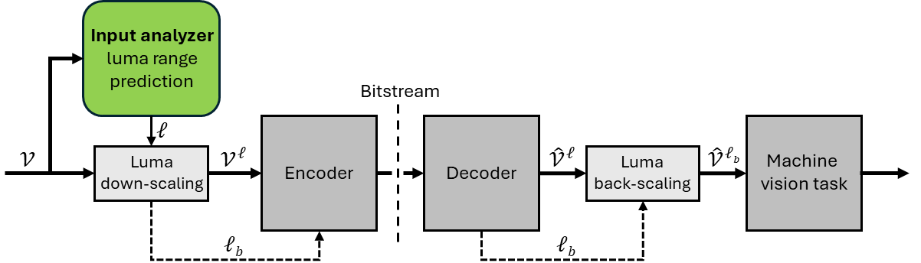
Figure 1 –Block diagram of the system used in experiments.

Experiment setup
The input analyzer was implemented using a pre-trained ShuffleNetV2 X0_5 backbone from PyTorch. The model comprises approximately 855k parameters and requires roughly 700k FLOPs per inference. The input analyzer module was trained on 15000 images randomly selected from OpenImages v6 dataset [7].
The system's performance was evaluated following the common test conditions specified in JVET-AI2031 [6]. The evaluation was conducted using the OpenImages v6 dataset on object detection and instance segmentation tasks and SFU-HW dataset on object detection task. For the SFU-HW dataset, two additional low-end QP values were added to the QP range defined in [6] for the downscaled sequences to enhance the reliability of BD-rate calculations. For the SFU video sequences, the luma downscaling factor is predicted using the first frame of the sequence, and this downscaling factor is subsequently applied to all remaining frames.

Experiment results
For a reference, Table 1 presents evaluation results from the OpenImages dataset on object detection task when constant luma down-scaling factor is used (no adaptive luma prediction enabled). The results demonstrate that applying constant luma down- and up-scaling factors across highly diverse content (5000 images) yields moderate - 7.5% Bjontegaard delta rate (BD-rate) gains. However, when enabling the proposed adaptive luma down-scaling and back-scaling predictions, significantly higher gains are reached Table 2 presents BD-rate and BD-mAP results obtained on the OpenImages dataset, comparing adaptive and full backscaling methods when luma downscaling prediction is enabled. RD-curves with adaptive backscaling are shown in Figure 2 and 3.

Table 1. BD-rate results for constant luma down-scaling factor with different back-scaling options on JVET-CTC OpenImages Object Detection.
Down-scaling  factor | No back-scaling | BD-Rate (%)  Half back-scaling | Full back-scaling
0.2 | 125.8 | 13.8 | 22.2
0.3 | 57.9 | 0.2 | -5.6
0.4 | 32.8 | -2.4 | -6.4
0.5 | 13.1 | -5.3 | -7.4
0.6 | 8.4 | -3.4 | -3.8
0.7 | 0.8 | -3.9 | -4.6
0.8 | 0.7 | -3.5 | -2.1
0.9 | -5.3 | -7.5 | -6.4

Table 2. OpenImages datasets, comparing adaptive and full backscaling configurations when luma downscaling prediction is enabled.
Test | Adaptive backscaling |  | Full backscaling
Test | BD-rate | BD-mAP | BD-rate | BD-mAP
OpenImages  object detection | -28.6% | +2.7 | -27.3% | +2.6
OpenImages  instance segmentation | -25.0% | +2.2 | -19.7% | +1.8

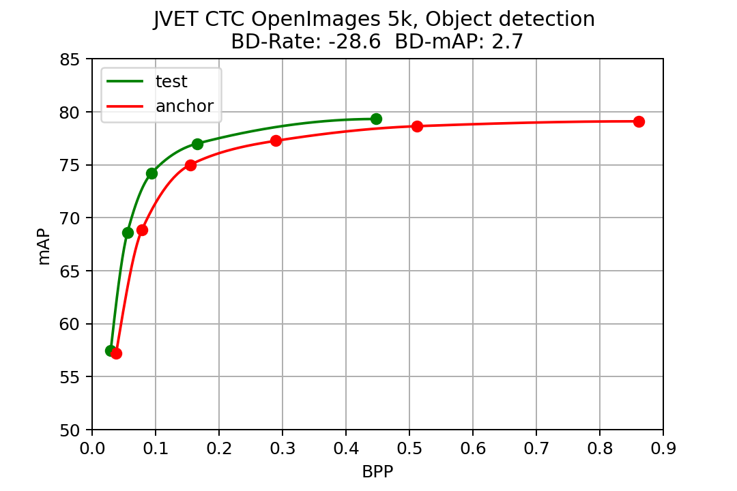
Figure 2 – RD-curves for object detection task on OpenImages dataset.
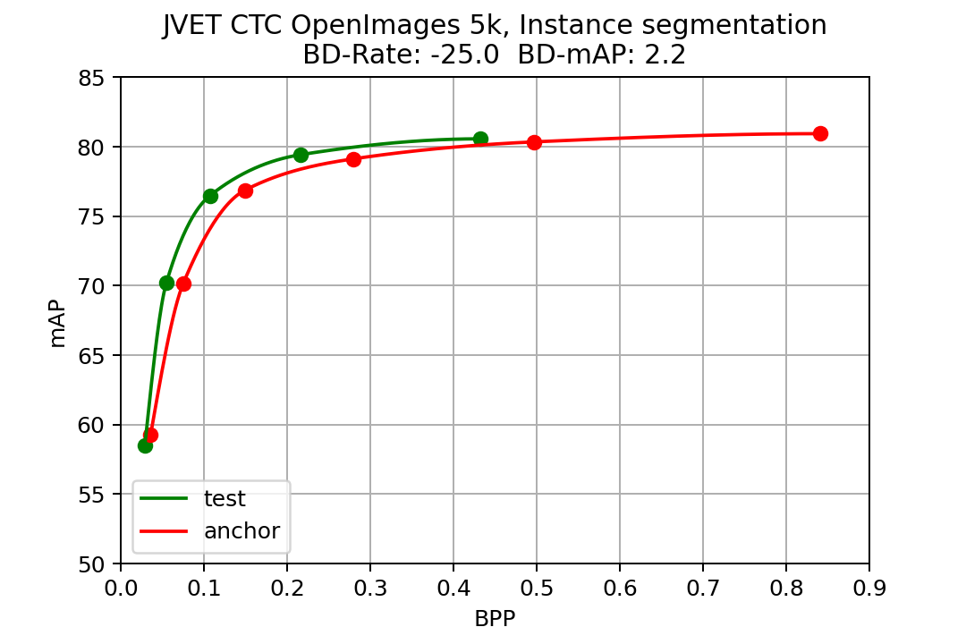
Figure 3 – RD-curves for instance segmentation task on OpenImages dataset.
Table 3, 4, and 5 presents the SFU dataset results comparing adaptive and full backscaling methods for low delay, random access, and all intra configuration, respectively.

Table 3. SFU dataset results with low delay configuration, comparing adaptive and full backscaling configurations.
SFU  Low delay | Adaptive backscaling |  | Full backscaling
SFU  Low delay | BD-rate | BD-mAP | BD-rate | BD-mAP
Traffic | -35,4 | 10,8 | -33,7 | 11,0
ParkScene | -14,6 | 1,4 | -13,6 | 1,4
Cactus | -1,7 | 0,3 | 6,5 | -3,6
BasketballDrive | -11,1 | 2,3 | -9,9 | 2,0
BQTerrace | -8,5 | 3,2 | -7,1 | 2,7
ClassAB average | -14,3 | 3,6 | -11,6 | 2,7
BasketballDrill | -18,9 | 2,7 | -19,4 | 2,7
BQMall | -3,9 | 0,6 | -7,8 | 1,2
PartyScene | -19,3 | 5,1 | -7,9 | 2,2
RaceHorses | -14,5 | 1,4 | -18,3 | 1,8
ClassC average | -14,2 | 2,7 | -13,0 | 2,1
BasketballPass | -0,3 | -0,2 | -0,2 | -0,1
BQSquare | -28,8 | 2,4 | -25,8 | 2,1
BlowingBubbles | -5,2 | 0,9 | -4,3 | 0,7
RaceHorses | -9,1 | 1,1 | -11,8 | 1,4
ClassD average | -11,5 | 1,4 | -11,0 | 1,2
Total Average | -13,2 | 2,6 | -11,9 | 2,0

Table 5. SFU dataset results with all intra configuration, comparing adaptive and full backscaling configurations.
SFU  All intra | Adaptive backscaling |  | Full backscaling
SFU  All intra | BD-rate | BD-mAP | BD-rate | BD-mAP
Traffic | -32,5 | 11,6 | -30,2 | 11,1
ParkScene | -18,4 | 2,2 | -20,2 | 2,2
Cactus | 19,0 | -6,0 | 36,0 | -10,8
BasketballDrive | -5,3 | 1,1 | -2,6 | 0,5
BQTerrace | -9,8 | 2,7 | -7,1 | 2,0
ClassAB average | -9,4 | 2,3 | -4,8 | 1,0
BasketballDrill | -15,5 | 2,4 | -14,9 | 2,3
BQMall | -7,0 | 1,3 | -10,6 | 2,0
PartyScene | -3,3 | 0,8 | -1,2 | 0,3
RaceHorses | -1,6 | 0,2 | -4,1 | 0,5
ClassC average | -7,4 | 1,4 | -7,1 | 1,2
BasketballPass | -2,6 | 0,3 | -1,5 | 0,1
BQSquare | -24,4 | 3,0 | -20,3 | 2,0
BlowingBubbles | -7,6 | 1,8 | -5,6 | 1,4
RaceHorses | -6,6 | 0,8 | -7,6 | 0,9
ClassD average | -9,7 | 1,5 | -8,4 | 1,1
Total Average | -8,8 | 1,7 | -6,8 | 1,1

Table 4. SFU dataset results with random access configuration, comparing adaptive and full backscaling configurations.
SFU  Random access | Adaptive backscaling |  | Full backscaling
SFU  Random access | BD-rate | BD-mAP | BD-rate | BD-mAP
Traffic | -3,3 | 0,1 | -4,5 | 0,5
ParkScene | -29,3 | 2,9 | -27,9 | 2,8
Cactus | 11,6 | -5,5 | 28,2 | -14,0
BasketballDrive | -16,2 | 2,8 | -14,1 | 2,4
BQTerrace | -9,0 | 2,3 | -7,6 | 2,0
ClassAB average | -9,2 | 0,5 | -5,2 | -1,3
BasketballDrill | -27,8 | 4,1 | -27,7 | 4,1
BQMall | -0,3 | 0,0 | -6,7 | 0,9
PartyScene | -8,5 | 1,9 | -10,8 | 2,4
RaceHorses | -13,4 | 1,2 | -14,4 | 1,3
ClassC average | -11,8 | 1,5 | -13,0 | 1,5
BasketballPass | -0,3 | 0,0 | -2,1 | 0,1
BQSquare | -25,1 | 1,2 | -21,8 | 1,0
BlowingBubbles | -14,1 | 3,6 | -14,8 | 3,8
RaceHorses | -18,2 | 1,4 | -20,5 | 1,6
ClassD average | -13,9 | 1,5 | -14,4 | 1,6
Total Average | -11,7 | 1,2 | -10,9 | 0,6

References
- JVET-AK0155 AHG9: On Encoder optimization information SEI message [C. H. Demarty, E. François, F. Aumont, O. Le Meur (InterDigital)]
- JVET-AK2032 Technologies under consideration for future extensions of VSEI (version 7) [S. McCarthy, J. Boyce, J. Chen, S. Deshpande, M. M. Hannuksela, H. Tan, Y.-K. Wang]
- JVET-AH0115 AHG9: Bit-depth truncation as optimization type in EOI SEI message [C. Kim, Hendry, J. Lim, S. Kim (LGE), D. Ding, R. Chernyak, G. Teniou, S. Wenger, S. Liu (Tencent)]
- JVET-AG0178 AHG8: Truncating bit depth in video coding for machine tasks [D. Ding, X. Zhao, S. Liu]
- T. Partanen et al., "Luma Range Scaling for Enhanced VVC Efficiency in Video Coding for Machines," 2024 IEEE 26th International Workshop on Multimedia Signal Processing (MMSP), Oct. 2024, doi: 10.1109/MMSP61759.2024.10743894. Online: https://ieeexplore.ieee.org/document/10743894.
- S. Liu, C. Hollmann, "Common test conditions for optimization of encoders and receiving systems for machine analysis of coded video content," Joint Video Experts Team (JVET) of ITU-T SG 16 WP 3 and ISO/IEC JTC 1/SC 29 35th Meeting, JVET-AI2031, Sapporo, JP, 12–19 July 2024.
- A. Kuznetsova et al., “The Open Images Dataset V4: Unified image classification, object detection, and visual relationship detection at scale,” IJCV, 2020.

Patent rights declaration(s)
Nokia and Tampere University may have current or pending patent rights relating to the technology described in this contribution and, conditioned on reciprocity, is prepared to grant licenses under reasonable and non-discriminatory terms as necessary for implementation of the resulting ITU-T Recommendation | ISO/IEC International Standard (per box 2 of the ITU-T/ITU-R/ISO/IEC patent statement and licensing declaration form).

