    Joint Video Experts Team (JVET)  of ITU-T SG21 WP3/21 and ISO/IEC JTC 1/SC 29  38th Meeting, by teleconference, 26 March – 4 April 2025 | Document: JVET-AL0214-v1

Title: | EE2-3.6: MV refinement for TMVP
Status: | Input document to JVET
Purpose: | Proposal
Author(s) or  Contact(s): | Zhi Zhang, Jian-Liang Lin, Yan Zhang,  Han Huang, Vadim Seregin,  Marta Karczewicz | Email: | zhizhang@qti.qualcomm.com
Source: | Qualcomm Incorporated
_____________________________

Abstract
This contribution reports the experiment results of EE2-3.6. It proposes to apply MV refinement for TMVP. The MV refinement is performed for a reference picture using collocated block as a template and the scaled to the reference picture collocated MV as a starting point, wherein, the scaling factor is (reference picture POC – collocated picture POC) / (collocated reference picture POC – collocated picture POC). A refined MV is determined by checking SATD cost between a reference template in the reference picture and the collocated block in the collocated picture. The refined MV which has the minimum SATD cost is scaled to derive TMVP MV for the current block, wherein, the scaling factor is (reference picture POC – current picture POC) / (reference picture POC – collocated picture POC). When a TMVP candidate has two MVs, it derives each refined MV independently. The proposed method was implemented on top of ECM-16.1 and the test results are summarized as follows.
RA: -0.03% (Y), 0.05% (U), 0.05% (V), 100.1% (EncT), 100.1% (DecT), 101.2% (EncVmPeak), 100.0% (DecVmPeak)
LDB: -0.23% (Y), -0.17% (U), -0.05% (V), 100.0% (EncT), 100.7% (DecT), 101.0% (EncVmPeak), 99.9% (DecVmPeak)

Introduction
In ECM-16.1, TMVP coded blocks derive TMVP MV in a reference picture from a collocated MV with scaling. The collocated MV is a motion vector of the collocated block in the collocated reference picture. The scaling factor is derived as (reference picture POC – current picture POC) / (collocated reference picture POC – collocated picture POC).

Proposal
This contribution proposes to apply MV refinement for TMVP. The refinement process is to find a MV in a reference picture (CurRefPic) which has the minimum SATD cost between a reference template in CurRefPic and the collocated template (ColTmpl) in the collocated picture (ColPic). The size of ColTmpl is up to 16x16, which is derived from grouping similar 4x4 blocks surrounding the collocated block (ColBlk) in ColPic.
The refinement starting point (ColScaledMv) is derived from the collocated MV (ColMv) in the collocated reference picture (ColRefPic) with scaling. The scaling factor is (CurRefPoc – ColPoc) / (ColRefPoc – ColPoc).
When CurRefPic is between ColPic and ColRefPic, the search area consists of { ColBlk position, ColBlk position + ColMv }, otherwise, the search area is around ColBlk position + ColScaledMv with search range { -SR, SR }.
When ColRefPic is between CurRefPic and ColPic, SR is set to (ColMv – ColScaledMv), otherwise, SR is set to ColScaledMv. Figure 1 shows two examples of deriving the refined MV (RefinedColScaledMv) in CurRefPic.
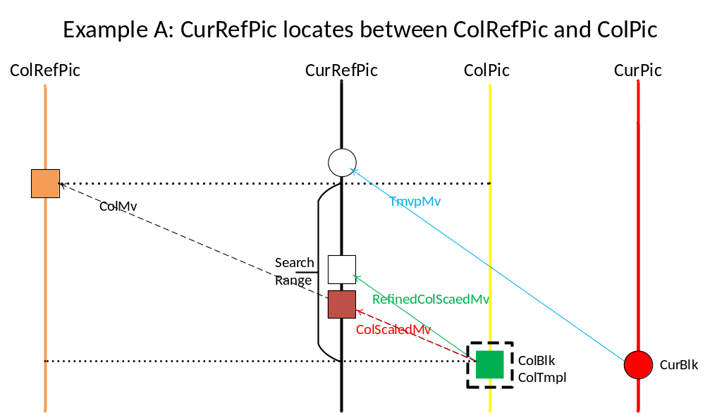
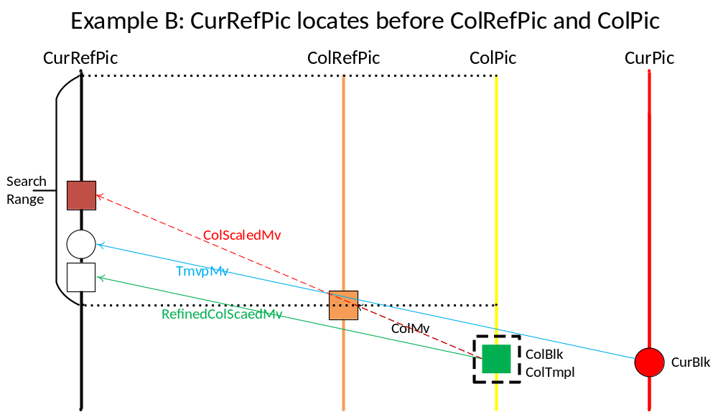
When ColBlk has two MVs, it derives each RefinedColScaledMv independently. TMVP MV is derived from RefinedColScaledMv with scaling, wherein, the scaling factor is (CurRefPoc – CurPoc) / (CurRefPoc – ColPoc).

Simulation results
 | Random Access Main 10
 | Over ECM-16.1
 | Y | U | V | EncT | DecT | EncVmPeak | DecVmPeak
Class A1 | -0.03% | 0.04% | 0.20% | 99.9% | 99.5% | 101.2% | 99.8%
Class A2 | 0.00% | 0.04% | 0.04% | 99.6% | 99.6% | 102.3% | 100.2%
Class B | -0.02% | 0.06% | -0.02% | 100.2% | 100.2% | 101.1% | 99.9%
Class C | -0.05% | 0.05% | 0.04% | 100.3% | 100.9% | 100.3% | 100.0%
Class E
Overall | -0.03% | 0.05% | 0.05% | 100.1% | 100.1% | 101.2% | 100.0%
Class D | -0.05% | -0.07% | -0.02% | 100.3% | 100.6% | 100.0% | 100.0%
Class F | -0.01% | 0.03% | 0.05% | 100.3% | 100.2% | 101.1% | 100.0%
Class TGM | -0.08% | -0.04% | -0.09% | 100.0% | 101.0% | 100.6% | 100.1%

 | Low delay B Main 10
 | Over ECM-16.1
 | Y | U | V | EncT | DecT | EncVmPeak | DecVmPeak
Class A1
Class A2
Class B | -0.10% | 0.19% | 0.06% | 99.8% | 100.1% | 101.4% | 99.5%
Class C | -0.14% | -0.57% | -0.34% | 99.8% | 100.2% | 100.5% | 100.2%
Class E | -0.59% | -0.24% | 0.17% | 100.5% | 102.3% | 101.0% | 100.4%
Overall | -0.23% | -0.17% | -0.05% | 100.0% | 100.7% | 101.0% | 99.9%
Class D | -0.18% | -0.85% | -0.58% | 99.0% | 100.6% | 100.1% | 100.1%
Class F | -0.19% | -0.57% | -0.13% | 99.7% | 100.5% | 100.7% | 100.0%
Class TGM | -0.10% | -0.08% | -0.09% | 100.2% | 101.0% | 100.9% | 99.9%

References
[1] ECM-16.1, https://vcgit.hhi.fraunhofer.de/ecm/ECM.
[2] M. Karczewicz, Y. Ye, “Common Test Conditions and evaluation procedures for enhanced compression tool testing”, JVET-V2017, Apr. 2021.

Patent rights declaration(s)
Qualcomm may have current or pending patent rights relating to the technology described in this contribution and, conditioned on reciprocity, is prepared to grant licenses under reasonable and non-discriminatory terms as necessary for implementation of the resulting ITU-T Recommendation | ISO/IEC International Standard (per box 2 of the ITU-T/ITU-R/ISO/IEC patent statement and licensing declaration form).

