    Joint Video Experts Team (JVET)  of ITU-T SG21 WP3/21 and ISO/IEC JTC 1/SC 29  38th Meeting, by teleconference, 26 March – 4 April 2025 | Document: JVET-AL0200-v1

Title: | AHG18: Simulation software description
Status: | Input document to JVET
Purpose: | Information
Author(s) or  Contact(s): | Sergey Ikonin  Vyacheslav Khamidullin  Roman Shabaev  Ivan Gribushin  Maxim Sychev  Elena Alshina | Email: | sergey.ikonin@huawei.com  vyacheslav.khamidullin1@huawei.com  gribushin.ivan@huawei.com  sychev.maxim@huawei.com  elena.alshina@huawei.com
Source: | Huawei Technologies
_____________________________

Abstract
This contribution describes the simulation software submitted for AGH18 on ultra-low latency and packet loss resilience based on contribution JVET-AK0193. The purpose of this document is to give an introduction and help to be familiar with software. The document describes main modifications of encoder and decoder applications of VTM, entry point for network transmission emulation, and basic logic of main modules. Content of this document was mainly presented during AHG18 teleconference call on 2025-02-19. The software is available in https://vcgit.hhi.fraunhofer.de/jvet-ahg-ull/VVCSoftware_VTM/

Introduction
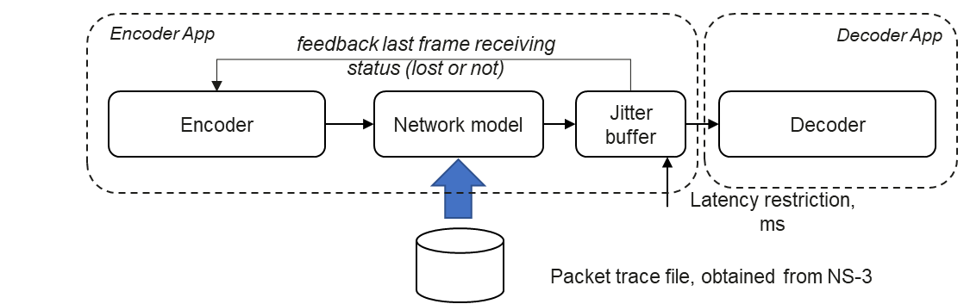
To simulate video communication under ultra-low latency restriction in practical communication channel a following test environment based on VTM v23.5 has been constructed:
The test environments includes VTM Encoder, Network model, and Jitter buffer model combined in Encoder App. Depending on transmission status frame maybe available for decoding or not. The receiving status is identified by Jitter buffer and feedback to Encoder in order to adjust the reference picture to be used instead of missed one. The NAL units received in time are stored to the disk and can be decoder by Decoder App in a usual way. Decoder application has just one modification allowing to identify missed frames and repeat the last successfully decoded frame instead of missed one. The more detailed description can be found in JVET-AK0193.

Running sample

Encoder
The following sample can be used to run encoder with network simulation enabled with latency restriction set to 16 ms.
./bin/EncoderAppStatic -c ./cfg/alternative/encoder_IPPP_vtm_fast_DPB.cfg -q 22 -f 300
-fr 60 -i BQTerrace_1920x1080_60fps_8bit_420.yuv -wdt 1920 -hgt 1080 -b bitstream.bin
--PacketTracePath=./cfg/wifi_simulation_trace/080mbps_room16x8_bw20MHz_nb10mbps_140s.csv
--PacketTraceStartLine=87476 --LatencyRestriction=16

Decoder
Use the following command line to decode obtained bitsteam:
bin/DecoderAppStatic bitstream.bin -o dec.yuv --NumFrames=300
Here NumFrames specifies to decoder how many frames were originally encoded since this information cannot be available from bitstream. In case of tail of bitstream is lost and decoding application will repeat last successfully decoded frame until the total frames reaches the specified number.

Additional command line options

Encoder
The following options were introduce to encoder application:
--LatencyRestriction=<ms>: Specifies latency restriction in ms.
--PacketTracePath=</path/to/packet/trace/file> : Path to packet trace file.
--PacketTraceStartLine=<line_num> : Start line for packet trace file.
--PacketTraceEndLine=<line_num> : End line for packet trace file.
--BypassIDR : Bypass network model for IDR, will be transmitted without loss. Debug option, disabled by default.
--RetransmissionTimes=<num> : Lost packets retransmission attempts, 5 times is default.

Decoder
The following option was introduced to decoder application:
--NumFrames=<num> : Number of frames requested to produce by decoder. Can be useful if tail of bitstream is lost and decoder cannot know how many frames was originally encoded. If specified, the last decoded frame will be repeated till total decoded frames number reaches specified value.

Software modifications
The software modifications required to enable encoding with network simulations are enclosed by JVET_AK0193_NETWORK_MODEL macro defined in TypeDef.h.
The following picture illustrates the list of modified files. Mainly encoder and decoder application files are changed. No changes in decoder itself. Encoder has one modification related to reference picture selection.

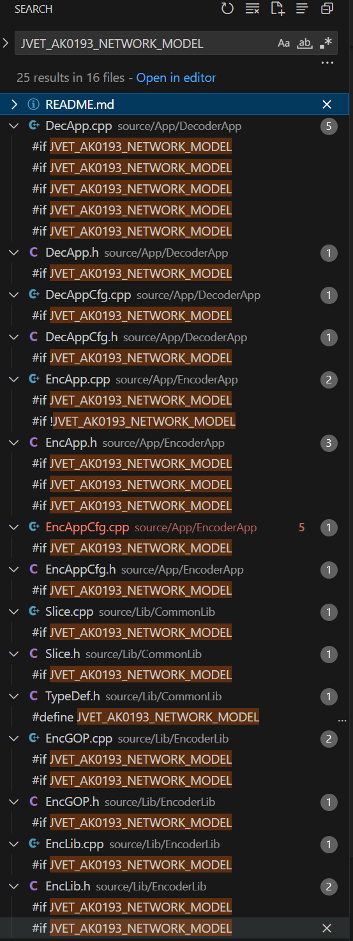

Encoder
The main entry point for encoder simulation is located in outputAU function. In original VTM implementing is used to store encoded bitstreams of access unit to the disk once encoding slice is complete.
Encoder call stack:
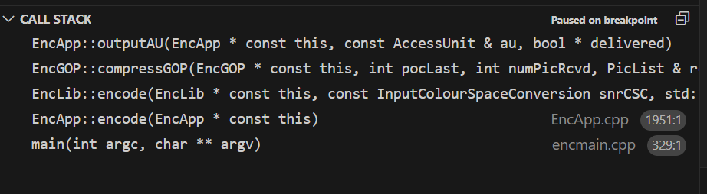

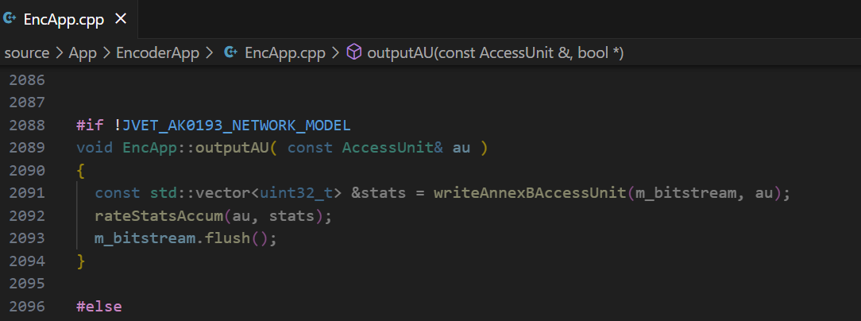
outputAU - network simulation entry point

Network model
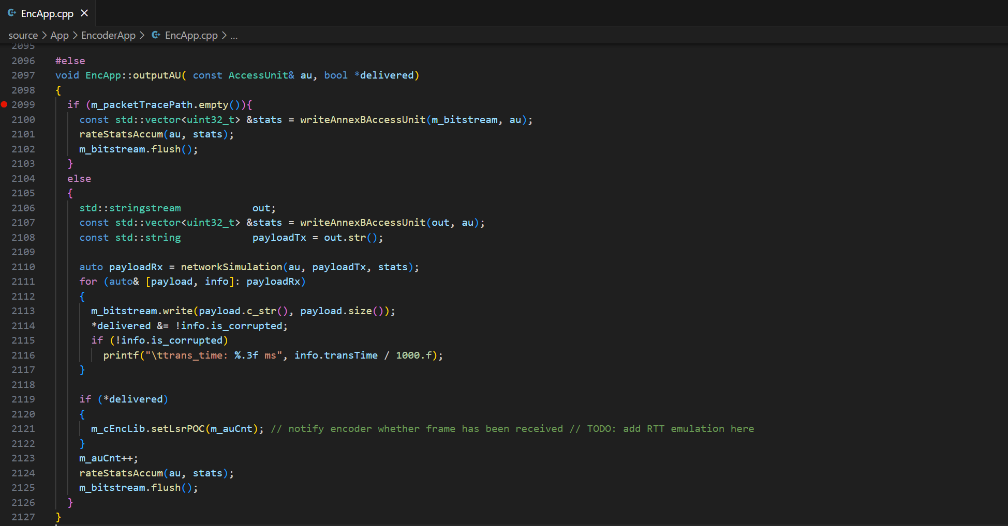
If JVET_AK0193_NETWORK_MODEL macro is enabled the outputAU function is overridden introducing the following logic. If packet trace file is not specified then application behaviour is same as default – just store bitstream to the disk. Otherwise if packet trace is specified the frame bitstream is written to string buffer corresponding sending payload of current slice and sent to networkSimulation function implementing to network model. Once payload is received from network model it is stored to disk. The delivery status success or not is obtained from network model and used for EncLib notification about last successfully received POC.
If network model is not enabled: same as default - dump on disk
Write to string to get payload
Simulate payload transmission over network
Dump to the disk what we got from network
Print transmission time, for information
Notify encoder about last successfully received POC
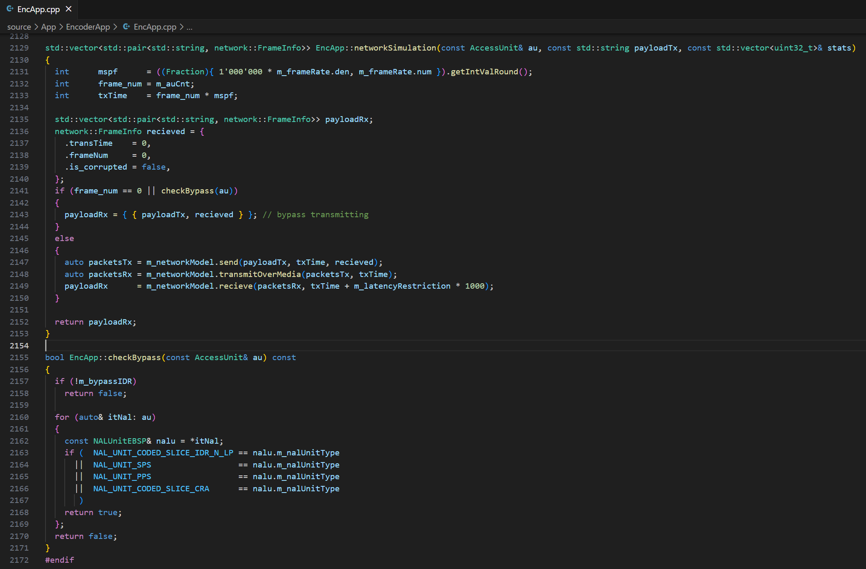
The picture below illustrates network simulation details. Firstly, transmission time is defined as current frame number multiplied by time distance between two frames. Then the check whether current AU needs to be bypassed for transmission. If not, then transmission payload is cut on list of IP packets. The list of IP packets is fed to transmission media, and list of received packets is obtained as return. Starting from this point the receiving side is emulated. The packet list obtained from transmission channel is fed to receiving pipeline of network model containing Jitter buffer model inside. As a second parameter acceptable packets receiving time controlled by latency restriction is specified. Finally, received payload constrained by latency restriction is combined with receiving status returned as output of network simulation.
Bypass first frame, and other IDRs if requested
Frame sending time: current frame * ms/frame, e.g. 16.6 ms for 60 fps
- Chop payload on IP packets
- Transmit over channel
- Collect payload back from packets received by latencyRestriction time

Jitter buffer
The logic of Jitter buffer model is illustrated in a picture below. As a first step, packets headers are removed and packets payload is added to jitter buffer. This part corresponds to packets arrival from network. As a second step the jitter buffer process method is invoked, corresponding to desired decoded frame generation time. The time of decoding is specified as input for jitter buffer processing function. Inside of the function the analysis of packets availability and frame integrity is performed. Once compete payload is available it is extracted from internal buffer and returned as a receiving process output.
Inside of jitter buffer process function the packets available by latency restriction time are firstly extracted from the buffer, and collected by frames. Then the frame integrity check is performed ensuring all the packets for the frame are available. If all the necessary packets are received in time then final supplemental information for the payload is filled in, and obtained frame’s payload is stored to internal buffer. Otherwise, the message about lost status is outputted to stdout.
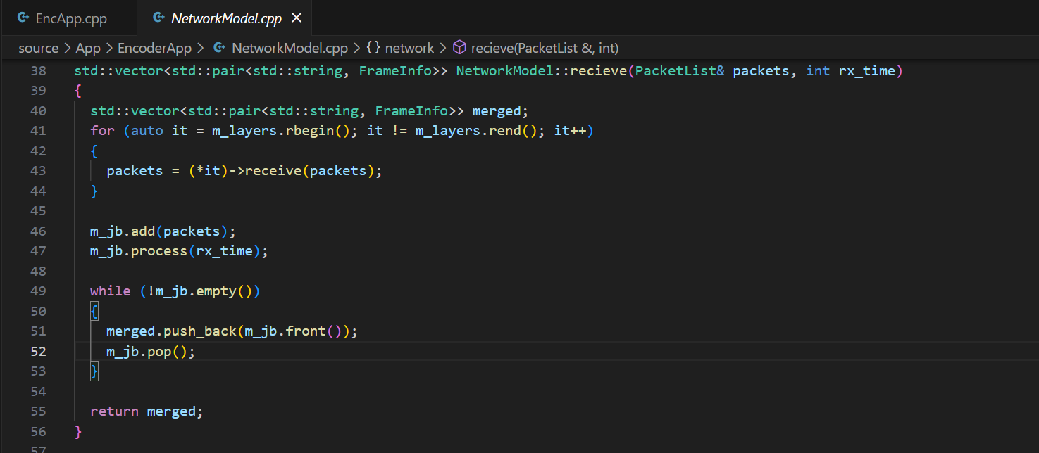
1. Add packets to Jitter Buffer
2. Collect payload from packets received by rx_time
Remove headers
Pop what payload we have in JB and return
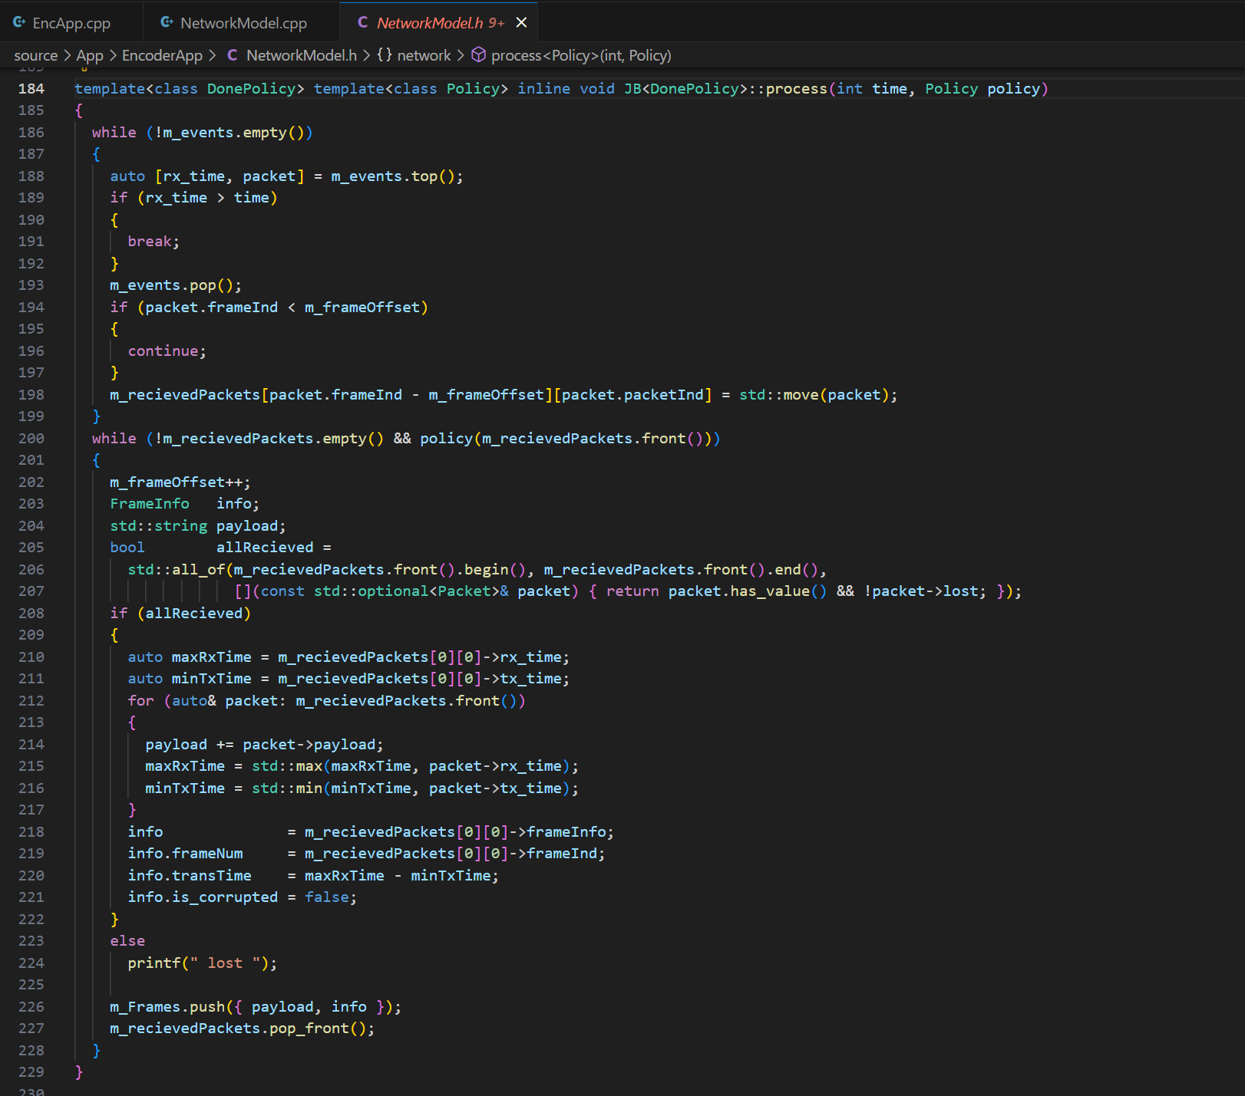
Check if all packets are received
Process only packets with receiving time below requested time
If all received Collect payload, set tx, rx_times
Collect packets by frame
Ignore late packets
Notify about loss otherwise

Decoder
The modifications of Decoder application contains storing of last successfully decoded picture in internal YUV buffer. Once gap in POC order is identified the stored picture is repeated for the dumping and corresponding message outputted to the user.
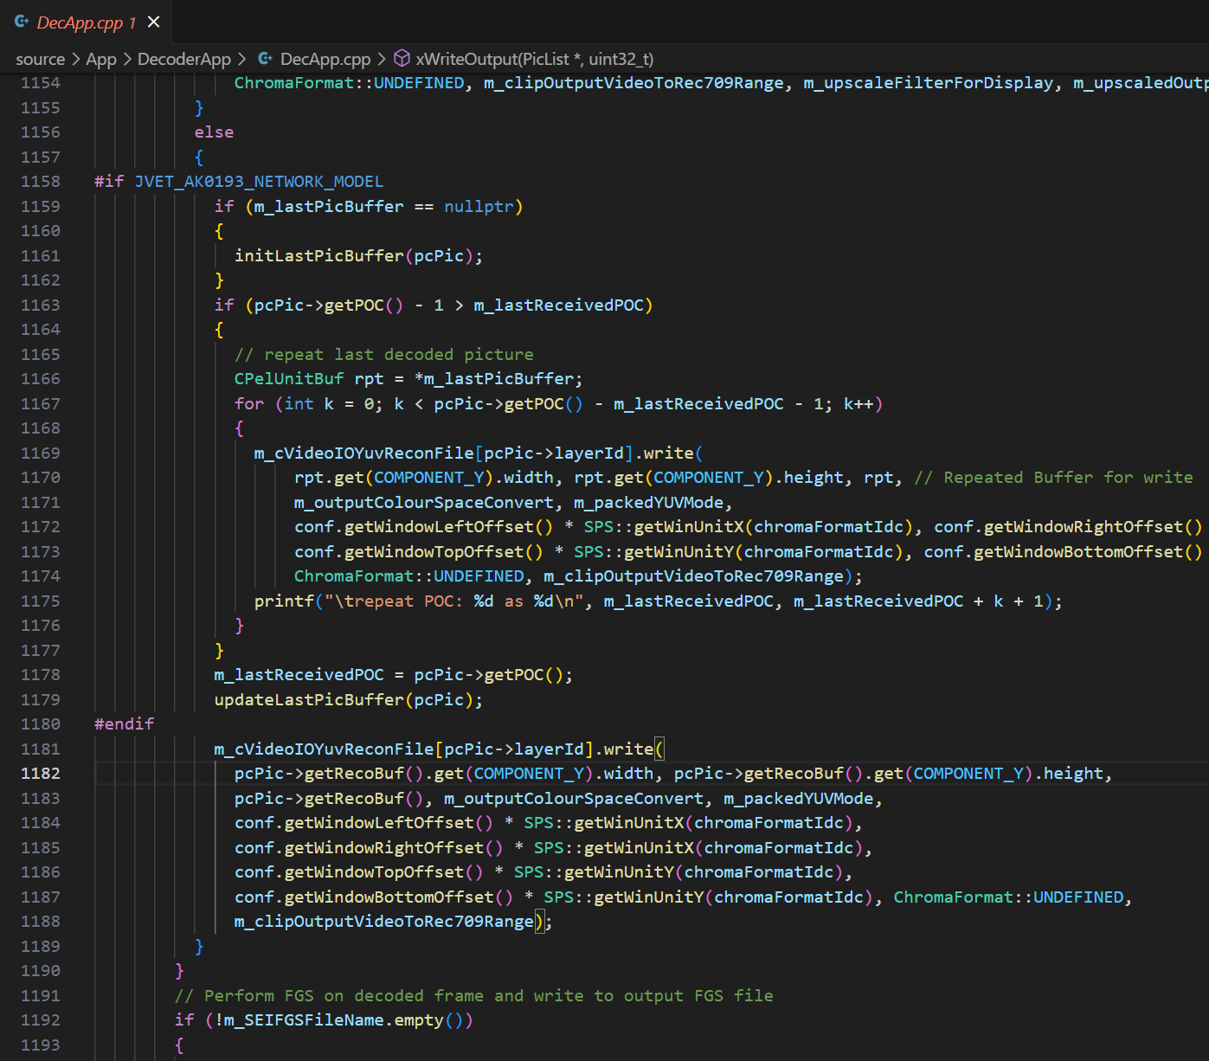
Repeat dumping of last decoded picture if current POC is ahead of last picture
Regular YUV dumping
Update by last decoded picture
Similar dumping repetition is performed if amount of outputted pictures is less then requested.
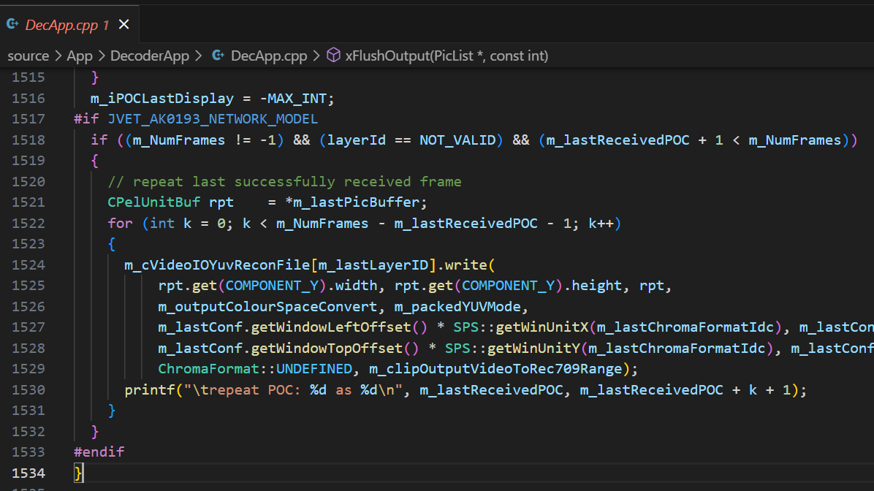

Network bandwidth simulation point
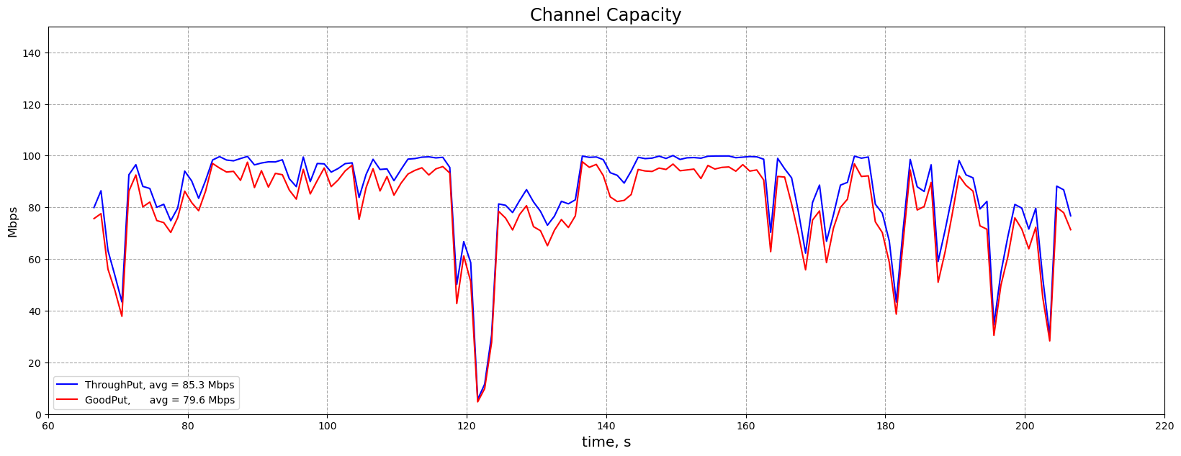
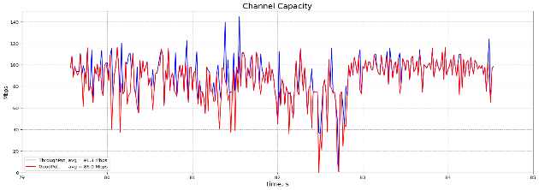
In a picture below the bandwidth of packet trace file is illustrated. The total file is ~140 seconds long. Any part of the trace file can be used by specifying PacketTraceStartLine parameter.
In a given encoder run sample the following part of 5 seconds long is used.
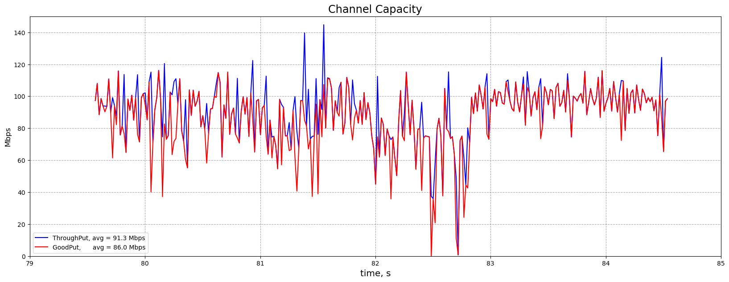

Patent rights declaration(s)
Huawei Technologies does not have any current or pending patent rights relating to the technology described in this contribution.

