    Joint Video Experts Team (JVET)  of ITU-T SG21 WP3/21 and ISO/IEC JTC 1/SC 29  38th Meeting, by teleconference, 26 March – 4 April 2025 | Document: JVET-AL0176-v2

Title: | AHG18: Proposed methodology and test conditions for ultra-low latency and error resilience performance evaluation
Status: | Input document to JVET
Purpose: | Proposal
Author(s) or  Contact(s): | Sergey Ikonin  Xiang Ma  Ivan Gribushin  Maxim Sychev  Elena Alshina | Email: | sergey.ikonin@huawei.com  maxiang6@huawei.com  gribushin.ivan@huawei.com  sychev.maxim@huawei.com  elena.alshina@huawei.com
Source: | Huawei Technologies
_____________________________

Abstract
In 37th JVET an AHG18 on ultra-low latency and packet loss resilience was established. This contribution proposes evaluation methodology and test conditions suggested to be used for performance assessment in context of the AHG18 work. The document proposes objective quality metrics to be evaluated, and corresponding excel template for quality plots construction and summary collecting.

Introduction
The contribution proposes to use objective quality indicators such as average PSNR, worst-case PSNR, and frame freeze ratio to assess the reconstruction quality in ultra-low latency and packet loss resilience conditions. At the same time, it is understood that in presence packet loss and freeze conditions objective numbers may not fully reflect the perceived quality. It is anticipated that further subjective quality evaluation may be required to verify and confirm the conclusions made based on objective numbers.
Proposed test conditions mainly correspond to general purpose content screen casting scenario aiming to provide high resolution, high reconstruction quality and high user experience.

Test sequences
High resolution classes A1/A2 and B of JVET CTC are suggested to be used reflecting high quality content for general purpose screen casting scenario. The detailed description of the sequences, formats and location can be found in [1]
Table 1 defines the set of test sequences to be used for ultra-low latency conditions. All frames (as defined by frame count in the table) shall be encoded for all sequences and test cases described below.
For each sequence the single QP for testing is defined with corresponding bandwidth point (packet trace file and start line) for simulation.
Table 1 Test sequences
Class | Sequence name | Frame count | Frame rate | Bit depth | QP | Bandwidth point
A1 | Tango2 | 294 | 60 | 10 | 22 | BwP-3
A1 | FoodMarket4 | 300 | 60 | 10 | 22 | BwP-2
A1 | Campfire | 300 | 30 | 10 | 22 | BwP-4
A2 | CatRobot | 300 | 60 | 10 | 22 | BwP-3
A2 | DaylightRoad2 | 300 | 60 | 10 | 22 | BwP-4
A2 | ParkRunning3 | 300 | 50 | 10 | 22 | BwP-4
B | MarketPlace | 300 | 60 | 10 | 22 | BwP-2
B | RitualDance | 300 | 60 | 10 | 22 | BwP-1
B | Cactus | 300 | 50 | 8 | 22 | BwP-2
B | BasketballDrive | 300 | 50 | 8 | 22 | BwP-2
B | BQTerrace | 300 | 60 | 8 | 22 | BwP-3

Table 2 defines the set of bandwidth points, corresponding packet trace file and start line for simulation.

Table 2 Bandwidth points
Bandwidth point | Paket trace file | Start line | Average channel capacity in 5s range
BwP-1 | 057mbps_room16x8_bw20MHz_nb20mbps_255s.csv | 864657 | 38 Mbps
BwP-2 | 057mbps_room16x8_bw20MHz_nb20mbps_255s.csv | 333907 | 66 Mbps
BwP-3 | 080mbps_room16x8_bw20MHz_nb10mbps_140s.csv | 87476 | 86 Mbps
BwP-4 | 237mbps_room16x8_bw80MHz_nb20mbps_255s.csv | 1430973 | 274 Mbps
Packet trace files are located in folder ./cfg/wifi_simulation_trace/ of AHG18 simulation software [6].

Test conditions for screen casting scenario
- Low delay, P slices only, single reference picture
- QP22, single rate point, targeting high reconstruction quality
- Coding condition as specified in AHG18 simulation software [6]
- Single network bandwidth point using transmission channel emulation, sequence specific to operate on close-to-channel-saturation point.
- Experiencing reconstructed quality against latency restriction. Four latency restrictions are evaluated: 16, 24, 32 and 50 ms. Potentially, can be adjusted per test case to make subjective difference visible, similarly to QP adjustment for MOS tests.
- 300 frames

Reported Metrics
- Average PSNR for Y, Cb and Cr
- Freeze ratio: portion of frames that were replaced by last received frame
- Worst case PSNR: reconstruction quality of worst 5% and 10% or frames for Y, Cb and Cr

Test cases

Unicast scenario
- Feedback channel is available, RTT well above 10ms

Multicast/Broadcast scenario
- No feedback channel is allowed. Periodic IDR/GDR-frame insertion every 1 second

Clean channel performance verification
To verify BD-rate overhead of assessed methods the common RD curves in no-loss and no latency restriction conditions should be reported, two options are possible:
- ULL CTC described in this document are used with no channel model and latency restriction specified using regular QP set of 22, 27, 32, and 37.
- JVET CTC are used for complete BD-rate impact verification full set JVET CTC [1].

Transmission channel emulation
To simulate video communication service under ultra-low latency restriction in Wi-Fi network a following test environment based on VTM has been constructed:
Decoder
Encoder
Network model
Packet trace file
Jitter buffer
Latency restriction, ms
Figure 1 Ultra-low latency video communication test environment

The test environment includes VTM Encoder, Decoder, Network model with packetization and transmission emulation based on pre-recorded packet trace file, and Jitter Buffer collecting NAL units back from packets received by the time defined by the latency restriction. The latency restriction is command line parameter specified in milliseconds and can be configured by any number. In current scenario only communication latency is considered, all other processing times are assumed to be zero.

Network channel model
Network channel model generates packet losses and delays based on pre-recorded packet trace from NS-3 network simulator using exemplary Wi-Fi connection in office or home environment with interfering transmitting stations. See 10.2 for details.
Every bandwidth point consists of packet trace file and start line and specified per sequence in Table 1. The start line can be adjusted to keep decoding performance of compared technologies at reasonable reconstruction quality level, i.e. observing some transmission problems but not leading to complete freezing of decoding process.

Jitter buffer and latency model
Jitter buffer collects all packets corresponding to the encoded frame arrived at the moment restricted by latency, thus converting delayed packets into lost ones.
In the unicast scenario with channel feedback the frame loss information is reported to the sending side, currently without delay for simplicity, in order to let encoder change the reference picture, for example, to last successfully received picture from DPB for the next frame coding.

Anchors
VTM single layer, scalable or any other coding configuration. AHG18 to be mandated on best performing anchor selection.

Software
The ULL metrics evaluation framework [10.1] based on AGH18 simulation software is proposed to be used. Software location: https://vcgit.hhi.fraunhofer.de/jvet-ahg-ull/VVCSoftware_VTM

Annex A

ULL metrics evaluation framework
The Figure 2 illustrates the ULL metrics evaluation framework based on AHG18 simulation software and HDR tools. The more detailed description can be found in JVET-AL0201 [2]. The corresponding reporting template is provided with contribution.
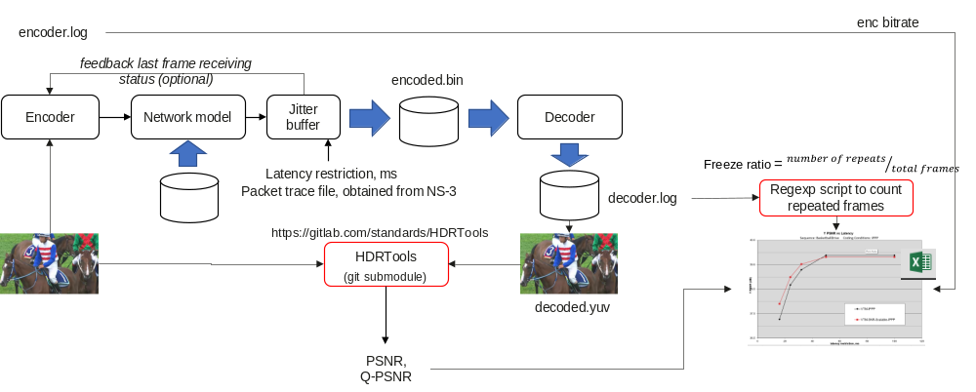
Figure 2 ULL metric calculation framework

Packet trace files generation
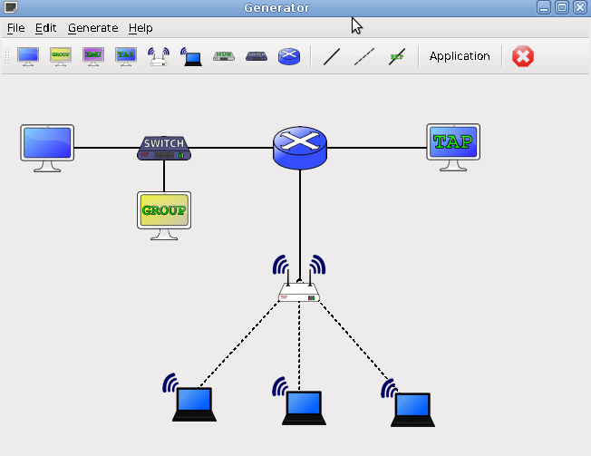
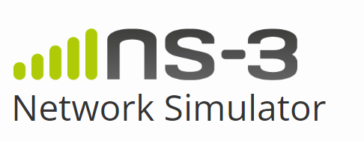
Packet trace file

The packet trace files were obtained using NS-3 simulator [3], [4]. The more details can be found in JVET-AK0193 [5].

Figure 3 Packet trace file generation using NS-3 simulator

The NS-3 simulator was configured to emulate office or home usage scenario with following exemplary parameters:
- 16m x 8m room.
- 1 Wi-Fi station (STA) connected to Access Point (AP) down streaming the video VVC encoded video under evaluation with low latency constrain.
- Wi-Fi parameters: X MHz bandwidth, TX power = 16 dBm (~40mW).
- Neighboring interfering Wi-Fi network is located in a room of same size, but on the next floor (+3m height) and shifted to the right. Interfering traffic is emulated by Y Mbps neighborhood interference.
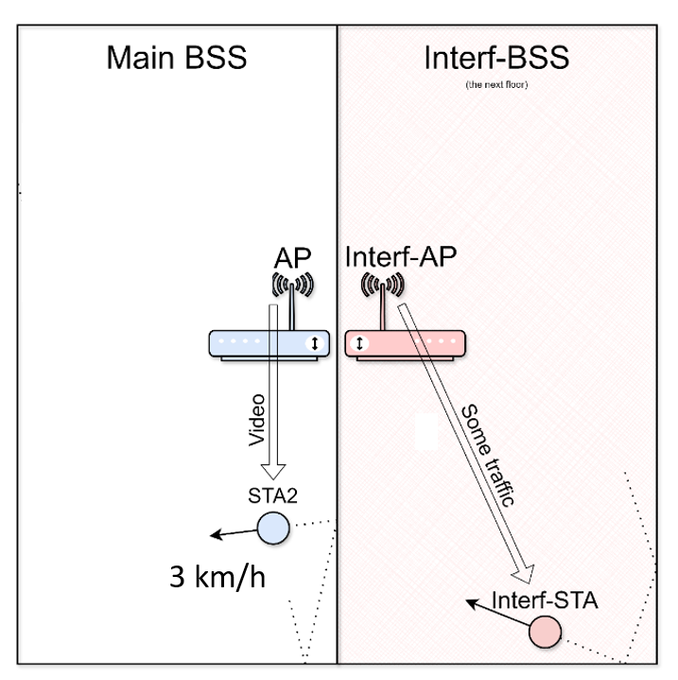
- STAs are moving in their rooms with a speed of 3 km/h (walking speed).
Figure 4 Physical room configuration used for NS-3 simulation
Varying the physical room and Wi-Fi configuration parameters packet trace files with different average channel bitrate can be obtained. Depending on values of channel bandwidth X MHz and interfering bitrate Y Mbps bandwidth points with different channel goodput were generated.

Table 3. Bandwidth points simulation details
Band-width point | Packet trace file | Start line | Channel bandwidth  X MHz | Interfering bitrate  Y Mbps | Average channel capacity in 5s range
BwP-1 | 057mbps_room16x8_bw20MHz_nb20mbps_255s.csv | 864657 | 20 | 20 | 38 Mbps
BwP-2 | 057mbps_room16x8_bw20MHz_nb20mbps_255s.csv | 333907 | 20 | 20 | 66 Mbps
BwP-3 | 080mbps_room16x8_bw20MHz_nb10mbps_140s.csv | 87476 | 20 | 10 | 86 Mbps
BwP-4 | 237mbps_room16x8_bw80MHz_nb20mbps_255s.csv | 1430973 | 80 | 20 | 274 Mbps
The examples of pre-recorded packet trace files corresponding to bandwidth points different average channel capacity (goodput) are presented below.
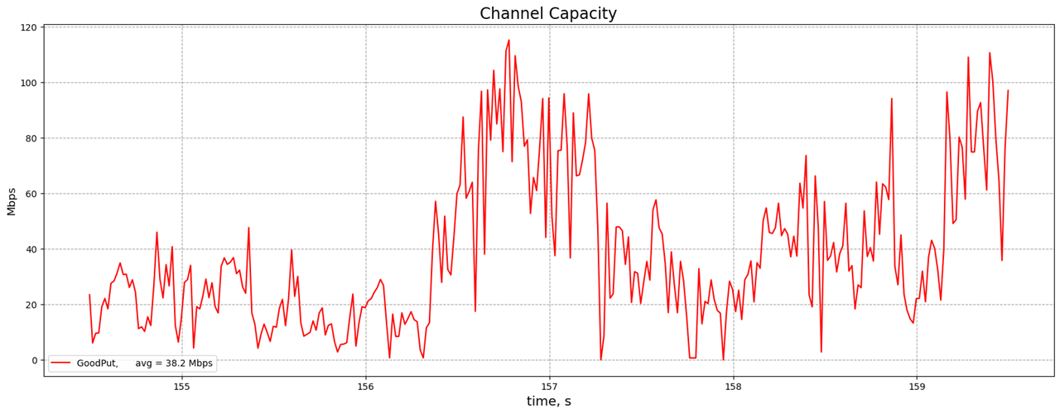
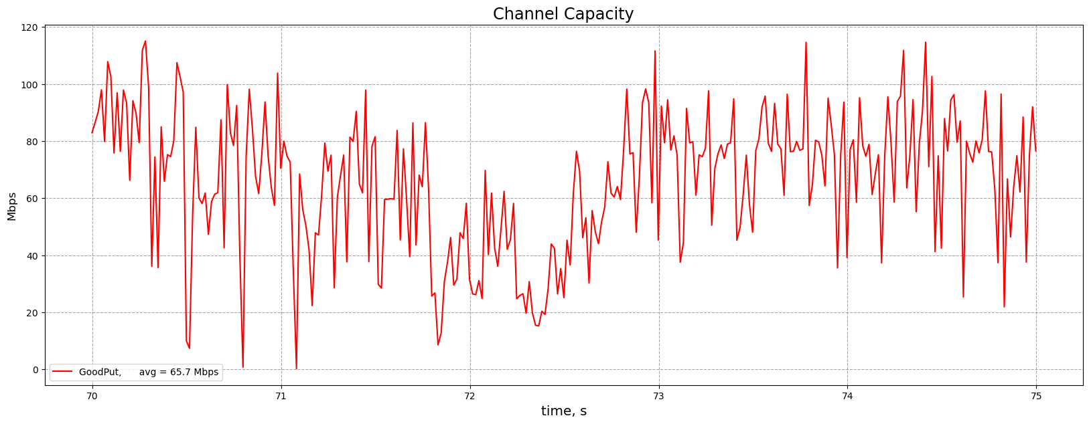
Figure 5 Channel capacity (goodput) of BwP-1
Figure 6 Channel capacity (goodput) of BwP-2
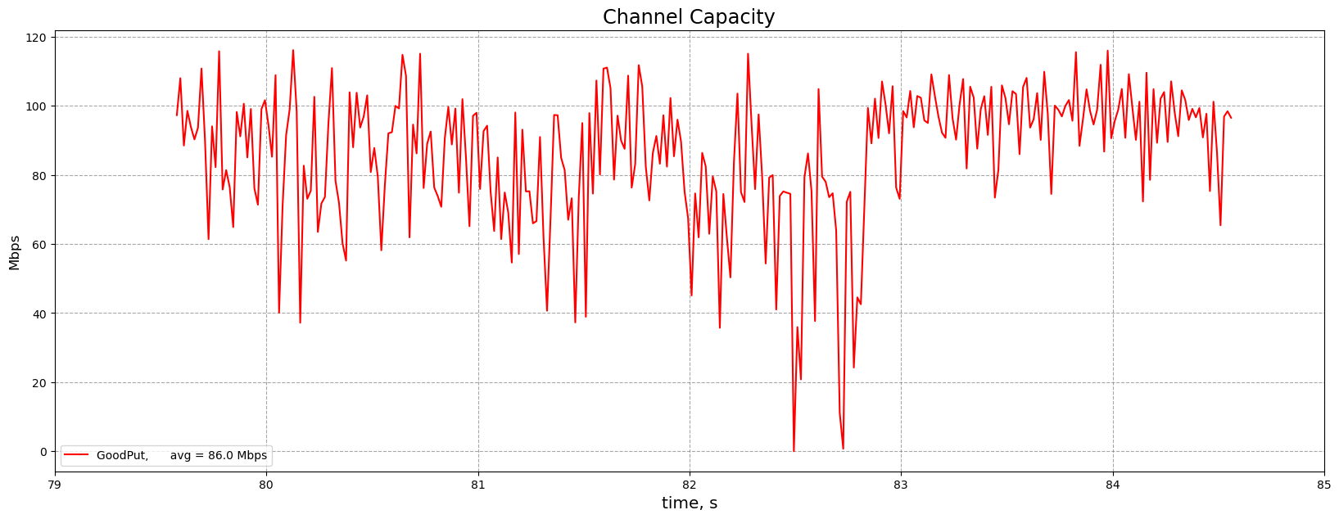
Figure 7 Channel capacity (goodput) of BwP-3
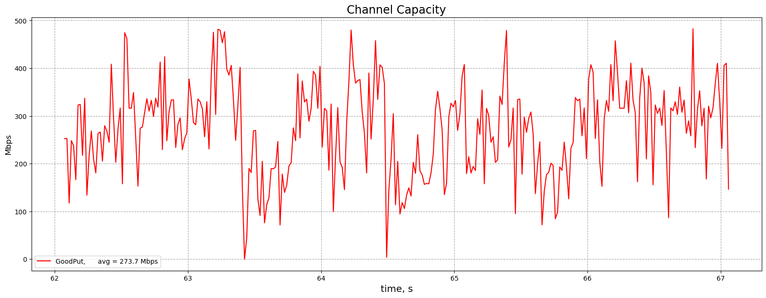
Figure 8 Channel capacity (goodput) of BwP-4

References
- “VTM and HM common test conditions and software reference configurations for SDR 4:2:0 10 bit video”, Joint Video Experts Team (JVET), 37th Meeting, Geneva, January 2025, Doc. JVET-AK2010.
- “AHG18: Performance evaluation of VTM under proposed ULL test conditions and proposed software modifications”, Joint Video Experts Team (JVET), 38th Meeting, Online, April 2025, Doc. JVET-AL0201.
- https://www.nsnam.org/
- Wireless Next Generation (WNG) Standing Committee within IEEE 802.11, doc: IEEE 11-24-1139-01-0wng, https://mentor.ieee.org/802.11/dcn/24/11-24-1139-01-0wng-ns-3-rel-42-43-wi-fi-model-updates-and-network-simulations.pptx
- “Low latency Wi-Fi transmission simulation and suggestions on codec requirements”, Joint Video Experts Team (JVET), 37th Meeting, Geneva, January 2025, Doc. JVET-AK0193.
- https://vcgit.hhi.fraunhofer.de/jvet-ahg-ull/VVCSoftware_VTM

Patent rights declaration(s)
Huawei Technologies does not have any current or pending patent rights relating to the technology described in this contribution.

