    Joint Video Experts Team (JVET)  of ITU-T SG 16 WP 3 and ISO/IEC JTC 1/SC 29  38th Meeting, by teleconference, 26 March – 4 April 202 | Document: JVET-AL0168-v7

Title: | EE2-5.4: On the performance improvement of NN-based ILF in ALF
Status: | Input document to JVET
Purpose: | Proposal
Author(s) or  Contact(s): | Yun Li, Marta Karczewicz, Jianfeng Wang, Louis Kerofsky, Hongtao Wang, Nan Hu, Ruoyang Yu, Muhammed Coban, Vadim Seregin  Tangi Poirier, Franck Galpin, Fabrice Le Léannec, Edouard François (InterDigital)  Dmytro Rusanovskyy, Krit Panusopone, Seungwook Hong, Limin Wang (Nokia) | Tel:  Email: | yli30@qti.qualcomm.com  martak@qti.qualcomm.com  jianfwa@qti.qualcomm.com  kerofsky@qti.qualcomm.com  firstname.lastname@interdigital.com  dmytro.rusanovskyy@nokia.com
Source: | Qualcomm Inc., Interdigital, Nokia
_____________________________

Abstract

This contribution reports the EE2-5.4 test results with an improvement of the filter in terms of both BD-rate and running speed. The improvements are with respect to the following: 1) attention mechanism is applied in the filter to enhance its performance; 2) SADL SIMD implementation is upgraded to that of NNVC12, which contains latest changes to accelerate filter execution; 3) the latest LOP/VLOP input interface has been integrated into the software, which results in a reduced spatial dimension of the features.
In addition, this contribution also includes the integration of the NNVC original interface (the interface is switchable between NN ALF and NNVC positions) and the inference results for VLOP3.
The proposed luma-only filtering system (all tools on) provides BD-rate changes over ECM16.1 as follows
AI: {-0.56%, 0.02%, 0.06%} for the (Y, Cb, Cr) with 98.9% EncT and 151.4% DecT
RA: {-0.75%, -0.05%, -0.01%} for the (Y, Cb, Cr) with 98.2% EncT and 123.7% DecT

The integrated NNVC original interface with VLOP3 provides BD-rate changes over ECM16.1 as follows
AI: {-0.79%, -1.81%, -1.70%} for the (Y, Cb, Cr) with 98.6% EncT and 206.5% DecT
RA: {-0.x%, 0.0x%, 0.0x%} for the (Y, Cb, Cr) with xx.x% EncT and xxx.x% DecT

It is suggested that software supporting two NN filter interfaces, the NNVC one and the one studied in EE2, should be made optional in the ECM code as a result of this work.

Introduction
Unified Filter Architecture for In-Loop Filtering of NNVC as well as inference process and training procedure was originally defined in JVET-AD0380[1] for High-performance Operation Point (HOP, 460kMAC/Pixel). The unified Low Operation Point (LOP, 17kMAC/pixel) was proposed in JVET-AE0165 [2] and refined in JVET-AF0043[3], and Very Low Operation Point (VLOP, 5kMAC/pixel) was derived in JVET-AH0051[4]. The latest VLOP development was presented in JVET-AK0150[5] featuring an attention mechanism on top of VLOP3.
Prior a current EE software included two interface options differing in the position of the NN loop filter. In the first interface option (interface 1), corresponding to the NNVC filter position, the NN loop filter is applied in parallel to Deblocking Filter and before SAO, BIF, and ALF. This interface was used in EE1 testing.
The second interface option (interface 2) was studied in JVET-AK0184 and has the chroma channel removed in addition to placing the NN filter in parallel to the existing Fixed, Residual and Gaussian filter shown in Figure 4.
Simplified block diagram of the NN ILF for LOP and VLOP, which may be considered as relevant for integration into ECM, are shown in Figure 1. This method takes reconstructed pixels (Luma and chroma), prior to the deblocking, prediction pixels, coding context information (e.g. QP, BS, coding modes), extract input features and jointly process these features by Luma and Chroma backbones (sequences of convolution layers) independently.
The output of NN-ILF is combined with output of the deblocking filter, with the weights and the offsets derived at the encoder side and signalled in the bitstream. Resulting pixels are further processed by VVC SAO and ALF.
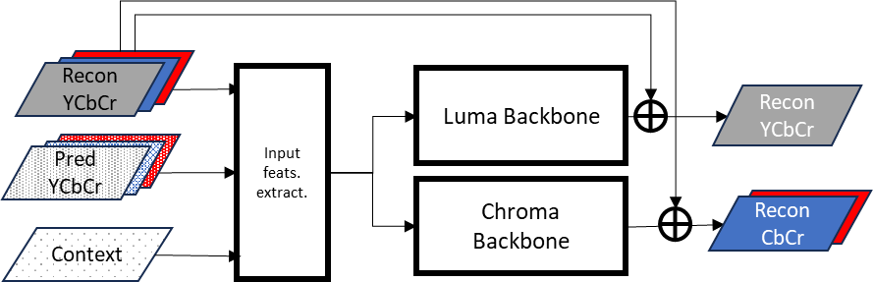

Figure 1. Simplified Unified Filter Architecture of NNVC (LOP, VLOP).
The NN-ILF is placed in parallel with deblocking filter, followed by SAO and ALF. This is referred to as NN-ILF with NNVC position (interface 1), shown in Figure 2.

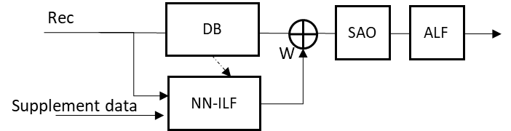
Figure 2. An overview of the unified ILF used in NNVC.
In this EE contribution, the EE2-5.4 test results are reported with an improvement of filter performance.

Proposed method
In this contribution, the improvements are with respect to the following: 1) attention mechanism is applied in the filter to enhance its performance; 2) SADL SIMD implementation is upgraded to that of NNVC12, which contains latest changes to accelerate filter execution; 3) latest LOP/VLOP input interface has been integrated into the software, for which the spatial dimensions of the inputs have been rearranged and reduced.
Specifically, the VLOP with attention shown in Figure 3 from JVET-AK0150 is utilized to provide a better filtering performance in addition to the SIMD acceleration and input interface changes.
The proposed method has been trained following the training procedure specified in JVET-AF0043. The training is being conducted with a target of 60 epochs as specified by the guidance and trained on the standard VTM-extracted LOP dataset for EE1.
The entire VLOP filter was trained as it is in JVET-AK0150 (there is no retraining of the filter). The chroma branch is removed later after the training resulting a filter of 4.7kMAC/pixel with 7.3k number of parameters, and the model is quantized to int16 precision. The chroma inputs are filled with a constant during inference.

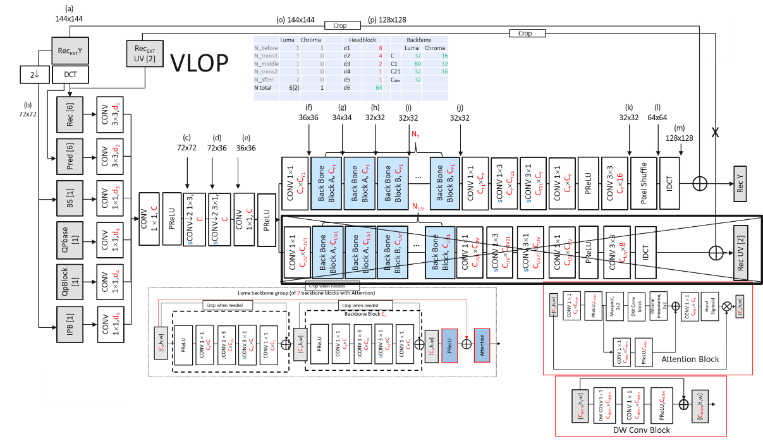
Figure 3 The VLOP with attention architecture with chroma branch removed.
Inference interface of NNVC ILF was implemented in ECM, with NN-ILF being introduced as an extension of the ECM-ALF filter. NN-filter operates on input reconstructed pixels in parallel to existing Fixed, Residual and Gaussian filters and provides additional coding gain on top of these filters.
To improve coding gain performance to the decoding run-time ratio, complexity-aware RDO was introduced: NN filtering is disabled for blocks, if provided distortion reduction is found to be below a threshold. A flag is signalled to indicate whether the weight W1 for the NN-ILF is equal to 1 or 0, and the weight W2 for the Gaussian filter is derived as W2=1-W1.
Simplified block diagram of the ECM-ALF extension with NN-ILF is shown in Figure 4.

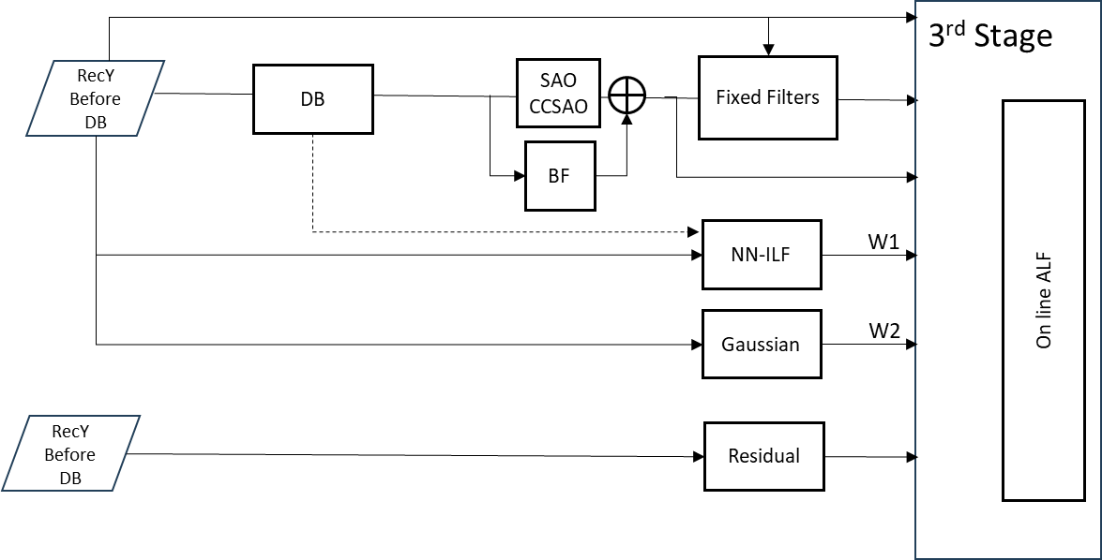
Figure 4 Simplified block diagram of the NN-ILF as part of ECM-ALF extension.

Simulation results
Proposed method was tested on ECM16.1 in test configuration specified in JVET-AK2024 (EE2 tests description using interface 2) following ECM CTC. The missing QP point results for RA configuration test have been populated from results with GeoBlendIntra tool off version of the test (earlier mismatch issues at SW release time for the RA configuration for QP 22, 27, and 32 was addressed by turning off the GeoBlendIntra tool, later the mismatch issues were resolved and simulations were relaunched).
In addition, results from VLOP3 with the NNVC original interface (interface 1) integrated and switchable in the software are also presented.
Summary of the inference results are reported below, complete results in CTC template are provided along with this document.
Comparative results to the ECM16.1 anchor are shown in the following tables.

Table 1 Proposed method (int16) vs ECM16.1 anchor for AI using interface 2.
 | AI
 | Y-PSNR | U-PSNR | V-PSNR | EncT | DecT
Class A1 | -0.65% | 0.05% | 0.07% | 98.6% | 149.0%
Class A2 | -0.24% | 0.04% | 0.00% | 98.1% | 138.5%
Class B | -0.45% | 0.01% | 0.07% | 99.1% | 149.8%
Class C | -0.40% | -0.01% | 0.11% | 99.3% | 147.9%
Class E | -1.18% | 0.05% | -0.01% | 99.3% | 176.9%
Overall | -0.56% | 0.02% | 0.06% | 98.9% | 151.4%
Class D | -0.58% | 0.00% | 0.25% | 97.3% | 148.4%
Class F | -0.21% | 0.05% | 0.06% | 99.6% | 142.2%

As observed Table 1 in Table 2, the proposed filter (all tools on) outperforms the ECM16.1 anchor by {-0.56%, 0.02%, 0.06%} for the AI configuration {-0.75%, -0.05%, -0.01%} for the RA configuration, respectively. It further outperforms the anchor by {xx.x%, xx.x%, xx.x%} for the LDB configuration, shown in Table 3.
Table 2 Proposed method (int16, all tools on)) vs ECM16.1 anchor for RA using interface 2.
 | RA
 | Y-PSNR | U-PSNR | V-PSNR | EncT | DecT
Class A1 | -1.17% | -0.06% | 0.14% | 98.7% | 131.8%
Class A2 | -0.80% | 0.08% | -0.07% | 97.6% | 114.2%
Class B | -0.72% | -0.04% | 0.01% | 97.3% | 124.1%
Class C | -0.44% | -0.17% | -0.12% | 99.6% | 124.8%
Class E
Overall | -0.75% | -0.05% | -0.01% | 98.2% | 123.7%
Class D | -0.64% | -0.03% | 0.19% | 99.9% | 135.0%
Class F | -0.17% | 0.00% | 0.01% | 99.9% | 116.8%

Table 3 Proposed method (int16, all tools on)) vs ECM16.1 anchor for LDB using interface 2.
 | LDB
 | Y-PSNR | U-PSNR | V-PSNR | EncT | DecT
Class A1 | #VALUE! | #VALUE! | #VALUE! | #DIV/0! | #DIV/0!
Class A2 | #VALUE! | #VALUE! | #VALUE! | #DIV/0! | #DIV/0!
Class B | #VALUE! | #VALUE! | #VALUE! | #DIV/0! | #DIV/0!
Class C | -0.30% | -0.39% | -0.12% | 104.2% | 146.9%
Class E | -0.58% | -0.59% | 0.53% | 101.9% | 110.7%
Overall | #VALUE! | #VALUE! | #VALUE! | #DIV/0! | #DIV/0!
Class D | -0.60% | -0.67% | -0.10% | 100.3% | 144.4%
Class F | #VALUE! | #VALUE! | #VALUE! | #DIV/0! | #DIV/0!

As observed in Table 4 and 5, the VLOP3 with the NNVC interface outperforms the ECM16.1 anchor by {-0.79%, -1.81%, -1.70%} for the AI configuration and {-x.x%, x.x%, x.x%} for the RA configuration, respectively.

Table 4 VLOP3(int16) vs ECM16.1 anchor for AI using NNVC interface.
 | AI
 | Y-PSNR | U-PSNR | V-PSNR | EncT | DecT
Class A1 | -1.17% | -1.59% | -1.56% | 99.5% | 253.2%
Class A2 | -0.84% | -1.96% | -1.29% | 99.0% | 214.9%
Class B | -0.67% | -1.97% | -1.84% | 98.3% | 205.0%
Class C | -0.32% | -1.45% | -1.32% | 97.0% | 170.5%
Class E | -1.17% | -2.11% | -2.54% | 99.9% | 211.4%
Overall | -0.79% | -1.81% | -1.70% | 98.6% | 206.5%
Class D | -0.43% | -1.40% | -1.24% | 98.9% | 158.6%
Class F | #VALUE! | #VALUE! | #VALUE! | #VALUE! | #VALUE!

Table 5 VLOP3(int16) vs ECM16.1 anchor for RA using NNVC interface.
 | RA
 | Y-PSNR | U-PSNR | V-PSNR | EncT | DecT
Class A1 | #VALUE! | #VALUE! | #VALUE! | #NUM! | #NUM!
Class A2 | #VALUE! | #VALUE! | #VALUE! | #DIV/0! | #DIV/0!
Class B | -1.01% | -2.24% | -1.47% | 95.5% | 200.6%
Class C | -0.50% | -1.64% | -1.42% | 97.6% | 184.3%
Class E
Overall | #VALUE! | #VALUE! | #VALUE! | #DIV/0! | #DIV/0!
Class D | -0.62% | -1.49% | -1.02% | 99.0% | 179.9%
Class F | -0.39% | -0.71% | -0.55% | 98.1% | 169.2%

Conclusion
This contribution reports the results of EE2-5.4 test. Attention mechanism was applied to the filtering process in ECM as a part of ECM-ALF extension. The filter was trained on the EE1 LOP standard dataset following the EE1 training guideline. The chroma branch is removed after the training. In addition, results of VLOP3 with the integrated NNVC interface are also reported.
With respect to the performance, the proposed filter (all tools on) outperforms the ECM16.1 anchor by {-0.56%, 0.02%, 0.06%} for the AI configuration and {-0.75%, -0.05%, -0.01%} for the RA configuration, respectively
For the NNVC interface, the VLOP3 provides BD-Rate changes of {-0.79%, -1.81%, -1.70%} for the AI configuration and {-x.x%, x.x%, x.x%} for the RA configuration against the ECM16.1 anchor.
The proposed method has provided a significant coding gain compared to the existing anchor. Both coding performance improvement and runtime reduction have been achieved during the EE development.
It is suggested that software supporting two NN filter interfaces (NNVC and the one studied in EE2) should be made optional in the ECM code as a result of this work.

References

- E. Alshina, F. Galpin, BoG report on NN-filter design unification, JVET-AD0380, April 2023.
- Y. Li, D. Rusanovskyy, M. Karczewicz (Qualcomm), EE1-4.4: Low complexity NN filter with design elements of Unified Filter Architecture and EE1-1.2 and EE1-1.3, JVET-AE0165, July 2023.
- D. Rusanovskyy, Y. Li, M. Karczewicz (Qualcomm), T. Shao, P. Yin, S. McCarthy (Dolby), J. N. Shingala, A. Shyam, A. Suneja, S. P. Badya (Ittiam), J. Li, Y. Li, C. Lin, K. Zhang, L. Zhang (Bytedance), R. Chang, L. Wang, X. Xu, S. Liu (Tencent), AHG11: Status of the joint EE1-0 (LOP.2) unified filter training, JVET-AF0043, October 2023.
- D. Rusanovskyy, Y. Li, M. Karczewicz (Qualcomm), J. Li, Y. Li, C. Lin, K. Zhang, L. Zhang (Bytedance), Z. Xie, Y. Yu, H. Yu, D. Wang (OPPO), EE1-5: Study of the NN architecture at Very Low Operational Point , JVET-AH0051, April 2024.
- Y. Li, D. Rusanovskyy, S. Eadie, M. Karczewicz, J. Wang, L. Kerofsky (Qualcomm), EE1-1.2: LOP with improved Attention and residual groups, JVET-AK0150, 2025.

Patent rights declaration(s)
Qualcomm may have current or pending patent rights relating to the technology described in this contribution and, conditioned on reciprocity, is prepared to grant licenses under reasonable and non-discriminatory terms as necessary for implementation of the resulting ITU-T Recommendation | ISO/IEC International Standard (per box 2 of the ITU-T/ITU-R/ISO/IEC patent statement and licensing declaration form).
InterDigital may have current or pending patent rights relating to the technology described in this contribution and, conditioned on reciprocity, is prepared to grant licenses under reasonable and non-discriminatory terms as necessary for implementation of the resulting ITU-T Recommendation | ISO/IEC International Standard (per box 2 of the ITU-T/ITU-R/ISO/IEC patent statement and licensing declaration form).
Nokia may have current or pending patent rights relating to the technology described in this contribution and, conditioned on reciprocity, is prepared to grant licenses under reasonable and non-discriminatory terms as necessary for implementation of the resulting ITU-T Recommendation | ISO/IEC International Standard (per box 2 of the ITU-T/ITU-R/ISO/IEC patent statement and licensing declaration form).

