    Joint Video Experts Team (JVET)  of ITU-T SG 16 WP 3 and ISO/IEC JTC 1/SC 29  38th Meeting, Teleconference, 26 March – 4 April 2025 | Document: JVET-AL0153-v1

Title: | EE2-5.1: ALF-CCCM
Status: | Input document to JVET
Purpose: | Proposal
Author(s) or  Contact(s): | Pekka Astola  Ikram Jumakulyyev  Done Bugdayci Sansli  Jani Lainema | Email: | firstname.lastname@nokia.com
Source: | Nokia
_____________________________

Abstract

This contribution presents the experimental results for the EE2 Test 5.1 on ALF-CCCM. The proposed loop filter utilizes the CCCM method for obtaining the cross-component filter coefficients at the decoder-side.

The impact on coding efficiency and runtimes of the proposed method over ECM-16.1 are reportedly {for Y, U, V, EncT, DecT, EncVmPeak, DecVmPeak}:

AI {not applicable}
RA {0.03%, -1.34%, -1.24%, 100.5%, 101.2%, 100.2%, 100.2%}
LDB {0.02%, -3.69%, -2.83%, 100.8%, 101.3%, 100.2%, 100.2%}
LDP {0.03%, -4.22%, -2.72%, 101.1%, 101.2%, 100.3%, 100.3%}

Introduction

In ECM-16.1, the sample adaptive offset (SAO) and the adaptive loop filter (ALF) are used to improve the quality of the reconstructed luma and chroma samples. The CC-SAO and the CC-ALF are further used to refine the chroma reconstruction samples using luma reconstruction samples. For ALF and CC-ALF, the filter coefficients are signaled. In EE2 Test 5.1, an additional cross-component loop filtering scheme is examined where the cross-component filters are derived at the decoder-side.

Proposed Method

The proposed method aims to improve the quality of the reconstructed chroma samples. A decoder-side diagram of the proposed method is illustrated in Figure 1.

In the proposed filtering scheme, each CTU is divided into non-overlapping blocks and for each block the cross-component filter coefficients are derived using the SAO/CC-SAO luma and chroma outputs. The convolution is applied on the SAO/CC-SAO luma output. To obtain a correction signal, the SAO/CC-SAO chroma samples are subtracted from the convolution output samples. The correction is weighted by 0.5 and added to the ALF chroma output to improve chroma reconstruction samples (i.e., the chroma reconstruction becomes chromaRec = alfChromaOutput + ccAlfOutput + 0.5*cccmCorrection). The method is disabled for intra-slices.

The encoder decides the best block size for each CTU using a rate-distortion optimization (RDO) loop. There are eight possible blocks sizes 4x4, 8x2, 2x8, 8x8, 16x16, 32x32, 64x64, 128x128. For filter derivation the blocks are extended by one sample on each side. The extension is clipped against CTU boundaries.

For each CTU, the encoder’s RDO decides the best cross-component model from eight possible models. The list of all models can be found in Table 1, where the cardinal directions indicate co-located luma sample position in the chroma grid (north up, south down). The nonlinear and bias terms are the same as in the 7-tap CCCM model. The CCCM solver is used for deriving the filter coefficients. The 6-tap down sampling filter (used in CCCM and CCLM) is used for mapping the co-located luma into the chroma grid.

For each CTU, the choice of the block size and the choice of the cross-component model are signaled using CABAC coded flags.

A CTU may inherit both the block size and the model type from the above or left CTU. This choice is signaled using a single CABAC coded flag for each CTU when ALF-CCCM is present in the left and/or above CTU. If two CTU candidates available, another CABAC coded flag is signaled to indicate the choice.

A picture may inherit the block sizes and model types for all CTUs from a reference picture. The reference picture is derived from the L0 and L1 lists. Only reference pictures with ALF-CCCM present in at least one CTU are considered. The reference picture with the smallest POC distance to the current POC is selected. If activated, the picture level inheritance will skip the CTU-level signaling completely for the current picture. This choice is signaled using a single CABAC coded flag if a reference picture with at least one CTU utilizing ALF-CCCM is present.

model 0 | center | north | south | west | east | nonlinear | bias
model 1 | center | bias
model 2 | center | nonlinear | bias
model 3 | center | north | south | west | east | bias
model 4 | center | west | east | nonlinear | bias
model 5 | center | north | south | nonlinear | bias
model 6 | center | north | south | west | east | north-west | north-east | south-west | south-east | nonlinear | bias
model 7 | center | north | south | west | east | north-west | north-east | south-west | south-east | bias
Table 1 The eight cross-component models of ALF-CCCM.
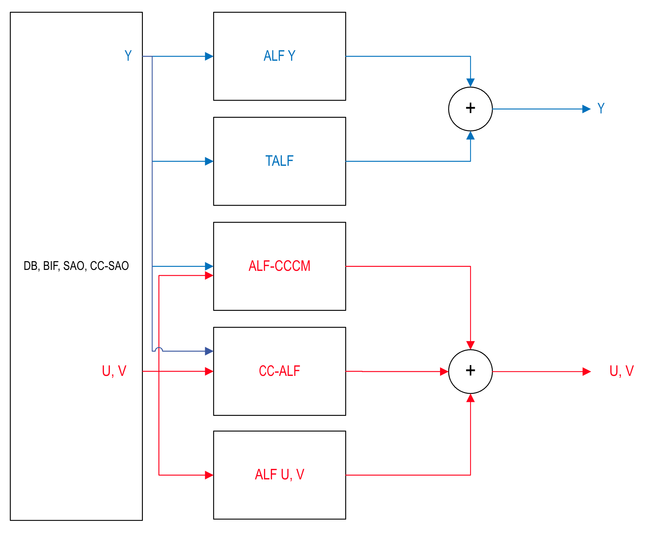
Figure 1 Decoder-side of the proposed loop filter with the ALF-CCCM process parallel to the ALF stages.

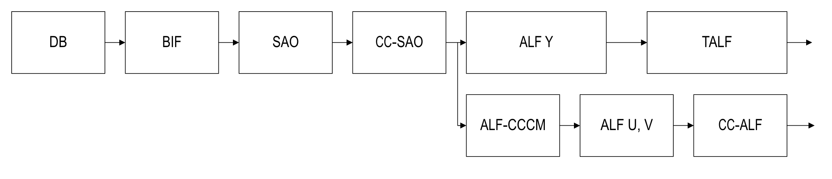
Figure 2 Encoder-side of loop filtering with ALF-CCCM.

Experimental results

The performance of the proposed method was studied in ECM-16.1 and the BD-rate performance over the CTC is given in the tables below. The method is not applicable for intra-slices.

 | Random Access Main 10
 | Over ECM-16.1
 | Y | U | V | EncT | DecT | EncVmPeak | DecVmPeak
Class A1 | 0.02 % | -1.29 % | -1.67 % | 100.7% | 102.1% | 100.4% | 100.1%
Class A2 | 0.05 % | -1.01 % | -1.52 % | 100.4% | 101.2% | 100.4% | 100.3%
Class B | 0.02 % | -1.77 % | -1.05 % | 100.5% | 100.9% | 100.2% | 100.2%
Class C | 0.01 % | -1.10 % | -0.95 % | 100.6% | 100.8% | 100.0% | 100.1%
Class E
Overall | 0.03 % | -1.34 % | -1.24 % | 100.5% | 101.2% | 100.2% | 100.2%
Class D | 0.00 % | -0.81 % | -0.65 % | 99.9% | 100.3% | 100.1% | 100.0%
Class F | 0.03 % | -0.72 % | -0.67 % | 100.6% | 100.5% | 100.1% | 100.0%
Class TGM | 0.04 % | -0.76 % | -0.94 % | 101.1% | 102.2% | 100.1% | 100.3%
 | Low delay B Main 10
 | Over ECM-16.1
 | Y | U | V | EncT | DecT | EncVmPeak | DecVmPeak
Class A1
Class A2
Class B | -0.01 % | -5.49 % | -3.30 % | 100.5% | 102.5% | 100.3% | 100.5%
Class C | 0.00 % | -3.18 % | -3.92 % | 100.6% | 101.2% | 100.1% | 100.0%
Class E | 0.10 % | -1.40 % | -0.62 % | 101.3% | 99.7% | 100.4% | 99.8%
Overall | 0.02 % | -3.69 % | -2.83 % | 100.8% | 101.3% | 100.2% | 100.2%
Class D | -0.09 % | -4.21 % | -3.42 % | 100.7% | 100.1% | 99.9% | 100.0%
Class F | -0.13 % | -3.12 % | -3.55 % | 101.1% | 101.3% | 100.2% | 100.3%
Class TGM | 0.00 % | -1.12 % | -1.22 % | 101.5% | 100.2% | 100.3% | 100.4%
 | Low delay P Main 10
 | Over ECM-16.1
 | Y | U | V | EncT | DecT | EncVmPeak | DecVmPeak
Class A1
Class A2
Class B | -0.04 % | -5.59 % | -2.69 % | 101.1% | 101.8% | 100.4% | 100.6%
Class C | -0.01 % | -3.16 % | -3.82 % | 100.7% | 101.3% | 100.1% | 100.1%
Class E | 0.22 % | -3.34 % | -1.32 % | 101.7% | 100.2% | 100.4% | 100.1%
Overall | 0.03 % | -4.22 % | -2.72 % | 101.1% | 101.2% | 100.3% | 100.3%
Class D | 0.04 % | -3.39 % | -2.90 % | 100.8% | 100.4% | 100.1% | 100.0%
Class F | -0.06 % | -3.24 % | -3.70 % | 101.5% | 101.2% | 100.1% | 100.2%
Class TGM | -0.04 % | -1.39 % | -1.32 % | 101.6% | 102.3% | 100.2% | 100.5%

Conclusion

A CCCM-based loop filter is proposed to improve the quality of chroma reconstruction samples. The coding efficiency and runtime impact of the proposed method are demonstrated over ECM-16.1. It is suggested to adopt the method into the next version of ECM.

Patent rights declaration(s)
Nokia may have current or pending patent rights relating to the technology described in this contribution and, conditioned on reciprocity, is prepared to grant licenses under reasonable and non-discriminatory terms as necessary for implementation of the resulting ITU-T Recommendation | ISO/IEC International Standard (per box 2 of the ITU-T/ITU-R/ISO/IEC patent statement and licensing declaration form).

